Manager application used by Customer Service Delivery Service Outage Management

SOM Skills Specialilst

Network & Service Incident

Manager

SOM Incident Management

Customer Service Delivery

**Summary**

The purpose of this work instruction is to provide a user operating guide to the Pattern

Craig Goodwin

(SOM) to identify potential outages from related fault patterns.

TELSTRA CORPORATION LIMITED (ABN 33 051 775 556) |

| | SYSTEM GENERATED | 017921W14 PATTERN MANAGER 6.0

PAGE 1/86

6

User Guide



Author’s name

Sub-business unit

Issue number

Lambley, Jason

Service Outage Management

**017921w14 Pattern Manager 6.0**

Business unit

Issue date

Telstra ID

Customer Service Delivery

AAV-3348

Process Owner

Implementation Approval

Jason Lambley

**9.**

**Form PGS fault pattern**

**9.4.1.**

**26**

**9.4. PGS Fault Patterning Rules**

**24**

**9.3. PGS Exchange screen**

**24**

**9.2. Select Exchange**

**23**

**9.1. Select Region**

**23**

**PGS Patterner Version 6.0**

**26**

**21**

**8.7. Check off CAN Fault Pattern**

**20**

**8.6. Create NODS from CAN Patterner**

**8.5. Analyse CAN Fault Pattern 19**

**17**

**Special CAN patterning and display rules**

**8.4.3.**

**17**

**Display CAN fault pattern**

**8.4.2.**

**16**

**31**

PAGE 2/86

| | SYSTEM GENERATED | 017921W14 PATTERN MANAGER 6.0

TELSTRA CORPORATION LIMITED (ABN 33 051 775 556) |

**32**

**9.6. Create NODS from PGS Patterner**

**9.5. Analyse PGS Fault Pattern 32**

**Form CAN fault pattern**

**Special PGS patterning and display rules**

**9.4.5.**

**30**

**PGS in secondary exchange**

**9.4.4.**

**27**

**CMUX patterning & display rules**

**9.4.3.**

**27**

**Display PGS fault pattern**

**9.4.2.**

**Overview of Pattern Manager 6.0**

**Login & Navigation**

**7.**

**8**

**Get Access to Pattern Manager**

**6.**

**7**

**User Profiles**

**5.**

**6**

**Overview of major upgrade 2016**

**4.**

**5**

**9**

**3.**

**5**

**Scope**

**2.**

**5**

**Purpose**

**1.**

**Contents**



**12**

**8.4.1.**

**16**

**8.4. CAN Fault Patterning Rules**

**14**

**8.3. CAN Exchange screen**

**14**

**8.2. Select Exchange**

**13**

**8.1. Select Region**

**13**

**CAN Patterner Version 6.0**

**8.**

017921w14 Pattern Manager 6.0 (continued)

**7.6. Pattern Manager Navigation**

**11**

**7.5. Pattern Manager Home Menu screen**

**10**

**7.4. Log into Pattern Manager**

**10**

**7.3. Basic Navigation**

**9**

**7.2. Home Menu Screen**

**9**

**7.1. Log in to NODS-PM**

**12.2. Priority Patterning Rules - Unchecked**

**12.3.2.2.**

**55**

**PGS Patterner**

**12.3.2.1.**

**55**

**Network Element rules**

**12.3.2.**

**54**

**Patterner Hierarchy rule**

**12.3.1.**

**54**

**12.3. Priority Patterning Rules - Fast**

**53**

**Switch Patterner**

**52**

**12.1. Priority Outage Display**

**51**

**Priority Outage Dashboard**

**12.**

**50**

**BVH Check off code**

**11.7.1.**

**49**

**11.7. Check off BB CAN Fault Pattern**

**49**

**11.6. Create NODS**

**61**

PAGE 3/86

| | SYSTEM GENERATED | 017921W14 PATTERN MANAGER 6.0

TELSTRA CORPORATION LIMITED (ABN 33 051 775 556) |

**63**

**Pattern Manager Admin Version 2.0**

**13.**

**48**

**12.6. Action Priority Pattern**

**60**

**12.5. Investigate Priority Pattern**

**59**

**12.4. Priority Pattern Auto NODS**

**56**

**CAN Patterner**

**12.3.2.4.**

**56**

**BB CAN Patterner**

**12.3.2.3.**

**55**

**10.3. Switch Node screen**

**10.6. Create NODS from Switch Patterner**

**40**

**10.5. Analyse Switch Fault Pattern**

**39**

**Display Switch fault pattern**

**10.4.2.**

**39**

**Form Switch fault pattern**

**10.4.1.**

**38**

**10.4. Switch Fault Patterning Rules**

**37**

**40**

**36**

**10.2. Select Node**

**35**

**10.1. Select Region**

**35**

**Switch Patterner Version 6.0**

**10.**

**33**

**9.7. Check off PGS Fault Pattern**



**11.4.1.**

**11.5. Analyse BB CAN Fault Pattern**

**48**

**Special patterning & display rules**

**11.4.4.**

**47**

**CMUX display rules in BB CAN Patterner**

**11.4.3.**

**47**

**Display BB CAN fault pattern**

**11.4.2.**

**46**

**Form BB CAN fault pattern**

017921w14 Pattern Manager 6.0 (continued)

**46**

**11.4. BB CAN Fault Patterning Rules**

**44**

**11.3. BB CAN Exchange screen**

**11.2. Select Exchange 44**

**43**

**11.1. Select Region**

**43**

**Broadband Patterner Version 2.0**

**11.**

**41**

**10.7. Check off Switch Fault Pattern**

**14.8. Table Check Off Codes**

**Attachments**

**16.**

**86**

**References**

**15.**

**85**

**14.9. Patterner Refresh Rates and Timings**

**84**

**87**

**82**

**14.7. Check off Codes**

**82**

**14.6. Service Types**

**80**

**14.5. Create NODS from Patterner**

**79**

**14.4. Table of ADSL Symptom Codes**

**17.**

**Definitions**

**87**

**18.**

**Document Control Sheet**

**88**

TELSTRA CORPORATION LIMITED (ABN 33 051 775 556) |

| | SYSTEM GENERATED | 017921W14 PATTERN MANAGER 6.0

PAGE 4/86

**13.3. Update Patterner Thresholds**

**13.7. Update PGS Type 70**

**69**

**13.6. Update Symptom Code**

**69**

**13.5. Update Checklist Code**

**68**

**13.4. Update Age of Patterning Data**

**67**

**13.8. Update Exchange 71**

**65**

**13.2. Update Priority Thresholds**

**65**

**13.1. Guidelines for Pattern Manager Admin changes**



017921w14 Pattern Manager 6.0 (continued)

**13.9. Update Auto Outage Exchange**

**72**

**13.10. Audit Trail Report**

**73**

**13.11. Pattern Manager Admin Messages**

**75**

**14.**

**Functionality common to all Patterners**

**76**

**14.1. Plain Text View**

**76**

**14.2. Hyperlinks to Other Patterners**

**77**

**14.3. Table of PSTN Symptom Codes**

**78**

**CAN Patterner 6.0**

window - and then applies patterning rules to identify common network elements e.g.

customer faults having the same Pillar or same Pair Gain System.

Patterned faults are stored until certain display criteria are met and then are displayed in a

Graphical User Interface (GUI) screen as colour-differentiated groups along with key

information to facilitate pattern analysis by SOM consultants. (*Refer Figure 1*)

Faults (new and existing) are re-analysed every 10 minutes.

A Check code field allows the user to mark off patterns with the determination made/action

taken.

A SOM Administrator option allows SOM managers and complex consultants to adjust fault

pattern display thresholds and to make some other basic changes (e.g. to add or remove

symptom and/or check-off codes) in response to operational requirements.

There are 4 different fault Patterners within the Pattern Manager application:

**1.**

FNN types, symptom codes and plant types and which are within a 72 hour reporting

Identifies related fault patterns on CAN copper cable elements e.g. main cable

**2.**

**PGS Patterner 6.0**

TELSTRA CORPORATION LIMITED (ABN 33 051 775 556) |

| | SYSTEM GENERATED | 017921W14 PATTERN MANAGER 6.0

PAGE 5/86

monitor, analyse or action related fault patterns as part of outage management.



**1. Purpose**

The purpose of this work instruction is to provide a user operating guide to the Pattern

Manager application used by Customer Service Delivery Service Outage Management

(SOM) to identify potential outages from related customer fault patterns.

**2. Scope**

This document is a system user guide for Pattern Manager 6.0.

It describes and explains the features, screen elements, field values, and patterning and

display rules and provides instructions on login, navigation, support and using the various

functions.

This document does not directly cover the business processes used by SOM consultants to

017921w14 Pattern Manager 6.0 (continued)

For details of these procedures refer to work instructions 017921w06 Outage Identification

& Setup and 017921w07 Pattern Manager – Identification & Actioning of Related Fault

Patterns.

**3. Overview of Pattern Manager 6.0**

Pattern Manager 6.0 is a web based application which interfaces with SIIAM.

Pattern Manager (PM) is used to identify related fault patterns with a common network

element which may indicate an outage.

An outage is any significant disruption to the network affecting multiple services and with a

single or related technical cause.

PM gathers SIIAM data for customer fault reports which meet certain criteria – e.g. specific

9.

**4. Overview of major upgrade 2016**

In November 2016 a major upgrade of Pattern Manager occurred to introduce the following

enhancements:

5.

Transition TADA Pattern Manager to a shared java-script web-GUI along with NODS

6.

Implement Priority Patterning of rapid forming and large fault patterns

7.

Implement automatic NODS creation from Priority Patterns

8.

Implement manual creation of NODS direct from within Pattern Manager

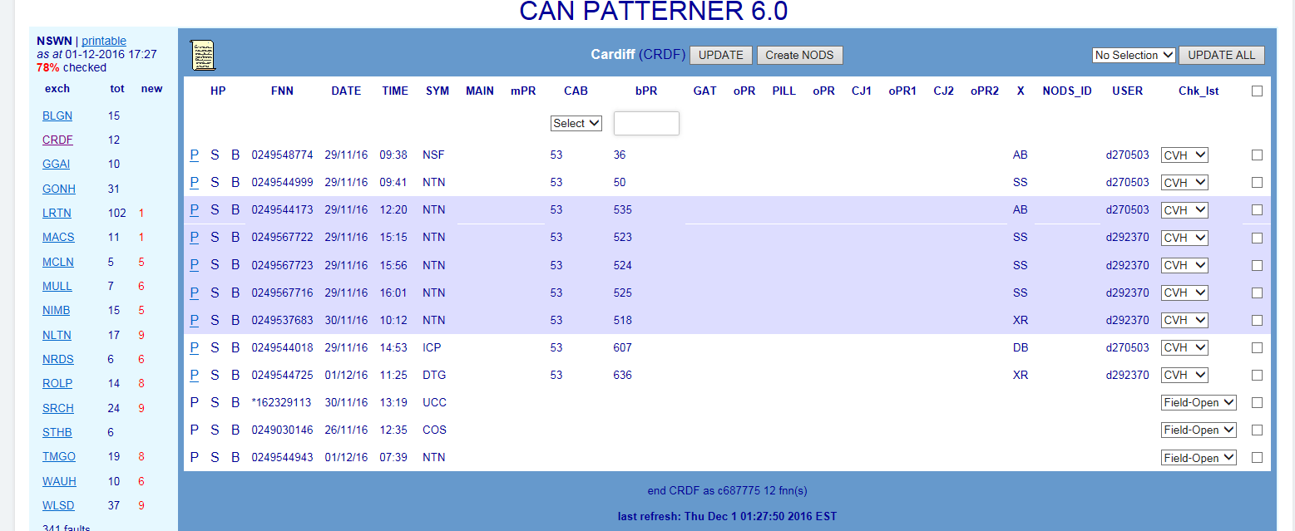

Improve fault patterning and display by adding additional functions:

TELSTRA CORPORATION LIMITED (ABN 33 051 775 556) |

| | SYSTEM GENERATED | 017921W14 PATTERN MANAGER 6.0

PAGE 6/86

Faults can appear in more than one Patterner. For example, a fault with both common



Identifies related fault patterns on Pair Gain Systems e.g. RIM or RAM 8

**3.**

**Switch Patterner 6.0**

Identifies related fault patterns on Exchange Switches e.g. AXE or S12

**4.**

**Broadband CAN Patterner 2.0**

Identifies related broadband fault patterns on CAN copper cable elements e.g. Pillar

017921w14 Pattern Manager 6.0 (continued)

Switching and CAN elements may appear in both CAN and Switch Patterners (e.g. When it

is “fed” by both the same pillar and is in the same AXE Exchange Magazine). In these

cases, an active hyperlink will allow the user to toggle between the 2 patterns or view them

side by side. Faults with common PGS and CAN elements will also be hyperlinked. This

facilitates analysis of the true underlying common network element.

Related fault patterns formed and displayed in Pattern Manager are indications of potential

outage only and must be investigated and analysed by SOM Complex Consultants, using a

range of other systems and tools, e.g. SULTAN, NPAMS, GDD, CASINO, etc. and/or by

consulting with CT’s or other technical workgroups before a final determination and scope

of an outage can be confirmed.

Able to create NODS; able to update, cease user & interface created NODS

**16.Level 2 NODS-PM**

Systems Security and Access only

Access to user management functions only

**17.Super User NODS-PM**

Typically SOM Complex Consultants

Able to create NODS; able to update, cease user & interface created NODS

Able to view and update Pattern Manager

Able to access and change Pattern Manager Configuration settings

**18.Read/Write NODS-PM**

Typically SOM Simplex Consultants & CNSC Data and Afterhours Testers

Access to all functions

TELSTRA CORPORATION LIMITED (ABN 33 051 775 556) |

| | SYSTEM GENERATED | 017921W14 PATTERN MANAGER 6.0

PAGE 7/86

In parallel with the NODS/Pattern Manager Enhancement, the newly developed Mozart



10. Gateway in all Patterners

11. Exchange in Switch Patterner

12. Full network address for AXE and System 12 Switches

13. ‘Update All’ capability

14. Update User Management to align with current business roles and security

requirements.

017921w14 Pattern Manager 6.0 (continued)

CONEN to NODS solution on the PUMA platform developed by Telstra Service Ops (TSO)

Network Automations enables NODS to be created automatically from CONEN notifications

raised by Service Assurance Ops (SAO) for network incidents (i.e. unplanned outages

affecting core network).

**5. User Profiles**

There are 5 User Profiles or Access Levels available in the combined NODS-Pattern Manager

web application:

**15.Level 3 NODS-PM**

System developers and IT support only

For NODS-Pattern Manager application password reset

23. Service Desk Online

24. Software Applications

25. NODS – National Outage Database System

26. Then select either:

NODS New Access

To apply for new access to NODS-Pattern Manager application

▪

NODS/Modify/Delete

To modify access level or delete access to NODS-Pattern Manager application

▪

NODS Password Reset

▪

NODS Fault

TELSTRA CORPORATION LIMITED (ABN 33 051 775 556) |

| | SYSTEM GENERATED | 017921W14 PATTERN MANAGER 6.0

PAGE 8/86

**NOTE**: This profile does NOT include access to NODS



Able to view and update Pattern Manager

**19.Read/Write NODS**

Typically SOM Partner agents

Able to create NODS; able to update, cease user & interface created NODS

NOTE: This profile does NOT include access to Pattern Manager

**20.Read-only PM**

Typically GOC consultants

Able to view Pattern Manager only (i.e. Read-only)

017921w14 Pattern Manager 6.0 (continued)

**6. Get Access to Pattern Manager**

Pattern Manager is now bundled with NODS. New Access or changes to existing access

level to NODS-Pattern Manager web-application is by online request via the Telstra Intranet.

The stand-alone Read-Only Pattern Manager access level must also be requested via the

NODS New access form.

21. MyIT website

22. Log an IT fault or service request

29. Create Outage

At the Log In screen enter your Telstra account-01 User ID & password (‘LAN Log in’)

3.

Click Submit button

4.

The Welcome to NODS Home Menu screen displays

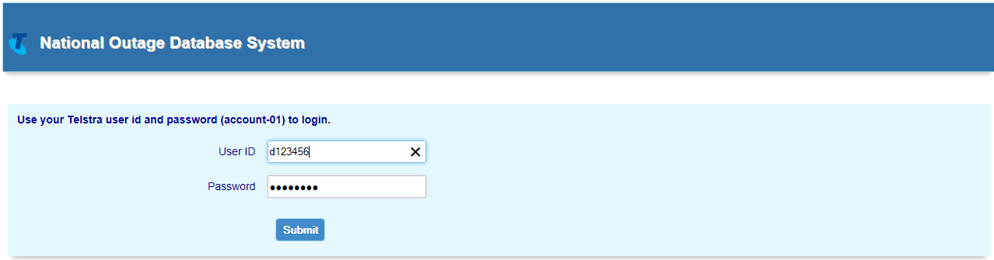

**7.2. Home Menu Screen**

Depending on user Access level, the following menu items may be available as hyperlinks

to access required NODS and Pattern Manager functions:

27. Active Outage Search

28. Archive Outage Search

2.

30. Admin Menu

31. Pattern Manager

TELSTRA CORPORATION LIMITED (ABN 33 051 775 556) |

| | SYSTEM GENERATED | 017921W14 PATTERN MANAGER 6.0

PAGE 9/86

Account-01 login and password via MyIT as above.



For faults with the NODS-Pattern Manager application (e.g. unable to log in, slow

▪

response, etc.)

New or changed access requests will need to specify the required access level according to

the user’s business role (refer section 7) and will require the approval of the user’s one up

manager.

**NOTE**: The previous generic logins for Read-only access to Pattern Manager are no longer

available. Users requiring Read-only access to Pattern Manager must apply for an individual

017921w14 Pattern Manager 6.0 (continued)

**7. Login & Navigation**

The following sections describe how to login and navigate to the main NODS-Pattern

Manager UI and in the dedicated Pattern Manager application.

**7.1. Log in to NODS-PM**

Pattern Manager is bundled with NODS in the NODS-Pattern Manager Web UI.

To Log into NODS-Pattern Manager web application follow these steps:

1.

Click on the URL https://nods:8443/NODS/login

35. Click the browser back arrow to view the previous screen

PAGE 10/86

| | SYSTEM GENERATED | 017921W14 PATTERN MANAGER 6.0

TELSTRA CORPORATION LIMITED (ABN 33 051 775 556) |

and to other Pattern Manager functions. Refer Section 6.5 for more detail.

Pattern Manager Home menu screen will display which provides access to the 4 Patterners

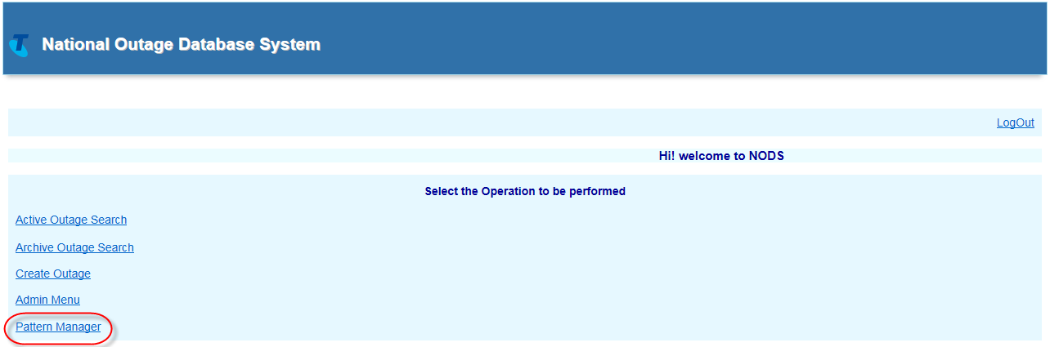

At the NODS-PM Home menu, click Pattern Manager link.

**7.4. Log into Pattern Manager**

017921w14 Pattern Manager 6.0 (continued)

34. Click Logout in top right corner to log out of NODS Pattern Manager web application

33. Click Home hyperlink at top left at any time to return to the Home menu

32. Click the required menu hyperlink to access that option

Navigation within web NODS-PM is very simple:

**7.3. Basic Navigation**

Pattern Manager option on the Home Screen. All other options will be blanked out.

**NOTE**: Read-only users of Pattern Manager will only see and only have access to the

Admin. Other users will see a blank space.

**NOTE**: User Admin option is only visible to and accessible by L2 Access and L3 System



Pattern manager application in general. Refer section 6.3 above.

**Priority Outage Dashboard**

•

Click to view & analyse Priority fault patterns & auto-created NODS

**Pattern Manager Admin Version 2.0**

•

Click to view & modify fault patterner configuration settings

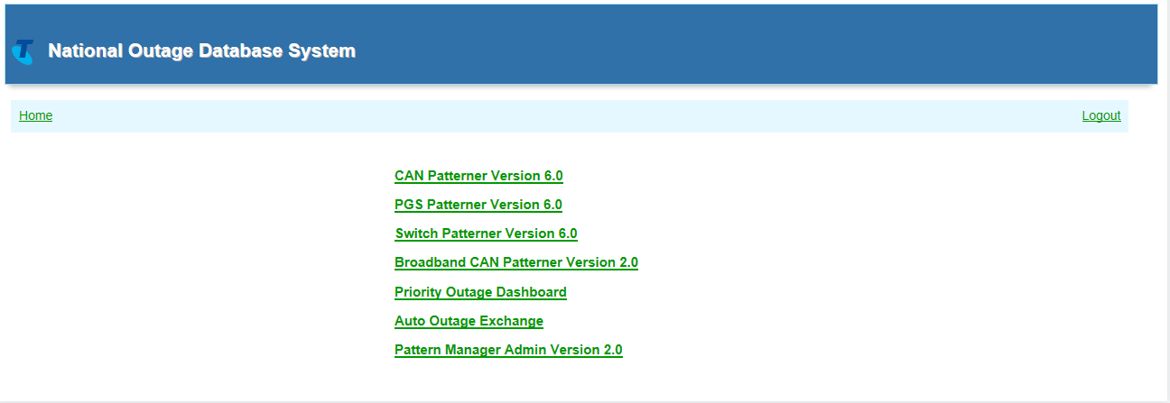

**7.6. Pattern Manager Navigation**

Basic navigation methods within Pattern Manager are the same as those for the NODS-

Click to view & analyse related broadband fault patterns on CAN cables

TELSTRA CORPORATION LIMITED (ABN 33 051 775 556) |

| | SYSTEM GENERATED | 017921W14 PATTERN MANAGER 6.0

PAGE 11/86

Click to view & analyse related fault patterns on CAN cables



**7.5. Pattern Manager Home Menu screen**

The Pattern Manager Home screen contains a menu of 6 hyperlinked options used to access

all the functions of Pattern Manager:

**CAN Patterner Version 6.0**

•

017921w14 Pattern Manager 6.0 (continued)

**PGS Patterner Version 6.0**

•

Click to view & analyse related fault patterns on PGS

**Switch Patterner Version 6.0**

•

Click to view & analyse related fault patterns on Exchange Switches

**Broadband CAN Patterner Version 2.0**

•

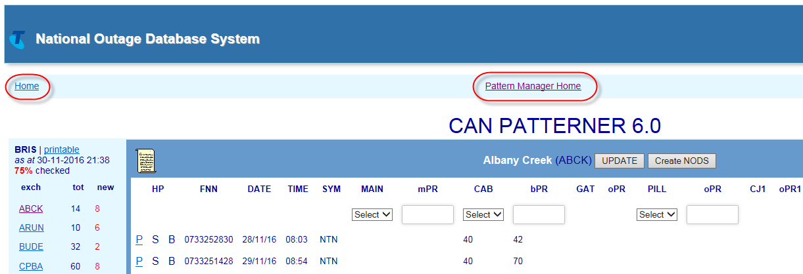

PAGE 12/86

| | SYSTEM GENERATED | 017921W14 PATTERN MANAGER 6.0

TELSTRA CORPORATION LIMITED (ABN 33 051 775 556) |

017921w14 Pattern Manager 6.0 (continued)

Users can also click the **Home** link to go right back to the main NODS-PM menu screen.

main Pattern Manager Home menu.

always be available at the top centre of the screen to enable quick navigation back to the

When users are on any Pattern Manager screen a ‘**Pattern Manager Home**’ link will

within the each relevant section later on in this document.

Some specific navigation options within various Pattern Manager screens will be described



% = percentage of patterned faults in region not yet analysed and actioned

**37.Determine the region requiring the greatest focus**

with the highest percentage of unchecked faults

with the largest volume of unchecked faults

**38.Access the required region by clicking the Region name link**

Regions are state-based with metro and country areas of the same state grouped

together

Regions are listed geographically North to South; East to West

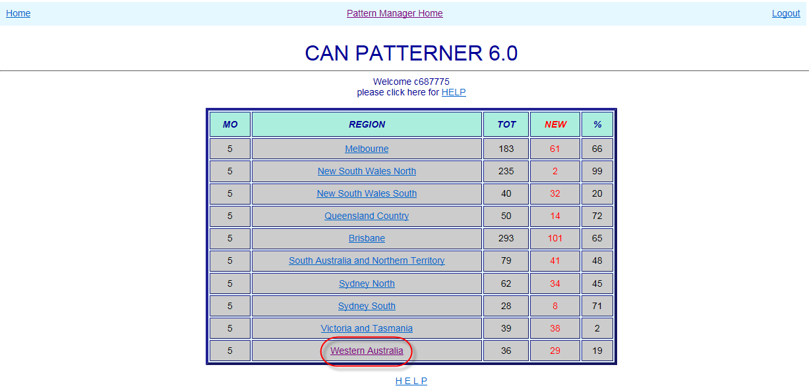

NEW = number of patterned faults in region not yet analysed and actioned

TELSTRA CORPORATION LIMITED (ABN 33 051 775 556) |

| | SYSTEM GENERATED | 017921W14 PATTERN MANAGER 6.0

PAGE 13/86

**8.1. Select Region**



**8. CAN Patterner Version 6.0**

CAN Patterner 6.0 forms and displays fault patterns related by a common CAN copper cable

network element e.g. main cable, cabinet, gateway, pillar or control joint.

Click the CAN Patterner Version 6.0 link from the Pattern Manager home screen to access

CAN Patterner.

017921w14 Pattern Manager 6.0 (continued)

When the CAN Patterner Version 6.0 link is clicked, the CAN Patterner Region Dashboard will

open displaying the various geographical regions of the PSTN network and the number of

patterned faults in each.

The Region Dashboard allows a user to:

**36.Quickly assess the relative volumes of patterned faults per region**

MO = Mode of Operations – the number of faults which must meet patterning

criteria before a fault pattern will display in that region

TOT = total number of patterned faults per region

patterns present in the exchange along with key information to assist with initial analysis.

▪

Number unchecked faults in region

▪

**40.Determine the exchange requiring the greatest focus**

with the highest percentage of unchecked faults

with the largest volume of unchecked faults

**41.Access the required exchange by clicking the Region name link**

Regions are listed alphabetically

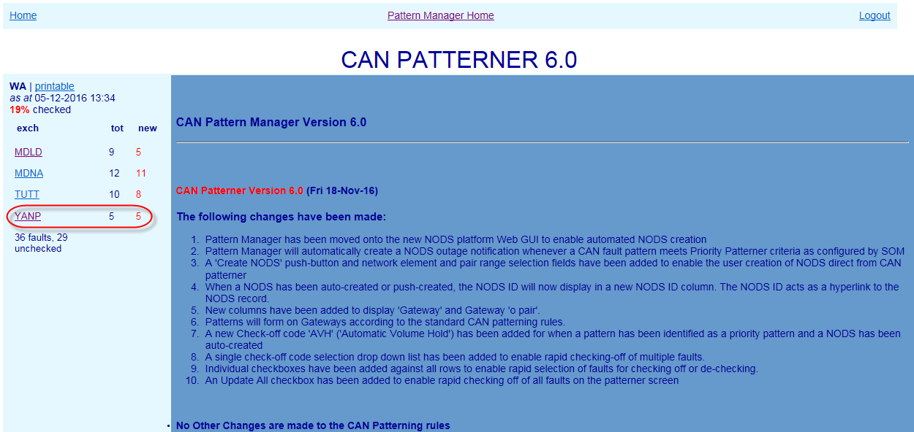

**8.3. CAN Exchange screen**

When an Exchange is clicked, the Exchange screen will present, displaying any related fault

Total faults in region

Exchange List remains visible at left to allow quick selection of the next exchange.

TELSTRA CORPORATION LIMITED (ABN 33 051 775 556) |

| | SYSTEM GENERATED | 017921W14 PATTERN MANAGER 6.0

PAGE 14/86

new = number of patterned faults in exchange not yet analysed and actioned



**8.2. Select Exchange**

When a Region link is clicked, the CAN Patterner Exchange List will open displaying the

various exchanges which contain fault patterns and the number of patterned faults in each.

To the right of the Exchange List a version history gives details of the changes introduced in

each successive version of Pattern Manager.

The Exchange List allows a user to:

**39.Quickly assess the relative volumes of patterned faults per exchange**

tot = total number of patterned faults per exchange

017921w14 Pattern Manager 6.0 (continued)

Above the exchange list are displayed:

Region name

▪

‘Printable’ link providing plain text view of region

▪

Last refresh date

▪

% faults unchecked in region

▪

Below the exchange list are displayed:

14.8)

47. ‘X’ – Service Type as recorded in NPAMS e.g. XR = ADSL service – SS = PSTN service

(see table section 14.6)

48. NODS ID

If a NODS has been created automatically by Priority Patterner or manually from

within CAN Patterner, the NODS ID will display here

NODS manually created in native NODS will NOT display

NODS auto-created by Mozart or other external interfaces will NOT display

49. User ID of the user who has Checked off the fault pattern

50. Check List (‘Chk_lst’) indicating determination made/action taken on fault pattern

e.g. CVH – Confirmed Volume Hold – NYV – Not Yet Volume Hold (refer table section

or pattern it is necessary to use the hyperlinks (if active) or consult Shazbot or NPAMS.

TELSTRA CORPORATION LIMITED (ABN 33 051 775 556) |

| | SYSTEM GENERATED | 017921W14 PATTERN MANAGER 6.0

PAGE 15/86

43. Faulty FNN (Full National Number)



The main section of the screen displays basic details of customer faults reports which meet

CAN patterning criteria (see next section 8.4).

The following details are displayed from left to right in the middle section of the screen

42. HP Hyperlinks – if the fault also appears in a fault pattern in another Patterner (e.g.

PGS) the hyperlink letter will be bold and underlined:

P (PGS) – S (Switch) – B (BB CAN)

017921w14 Pattern Manager 6.0 (continued)

44. Date & Time of fault report

45. Fault Symptom code (e.g. NTN – No Tone)

46. CAN Network Elements

Main cable/mpair – Cabinet/bpair – Gateway/opair – Pillar/opair – Control Joints/opair

Only the first 2 Control Joints from the exchange end are displayed

If a Network Element column is blank, that type of network element is not present in

that FNN’s service

NOTE: to simplify the display and make analysis easier, only CAN network elements are

displayed in CAN Patterner. To see Pair Gain Systems or Switch devices present in a service

Access Level via the Pattern Manager Admin function. All other rules are hard coded

Where there is no Gateway, in the same Cabinet

or…

Where there is no Pillar, Control joint, Gateway or Cabinet, in the same Main Cable

and…

The O, branch or main pair is within 30 pairs of the lowest pair in the pattern

Fault pattern will be retained for 72 hours from fault report date or for the timeframe

•

configured by SOM in the ‘Update Age of Pattern Data’ table of Pattern Manager

Admin 2.0

Only the valid Symptom Code and Age of Pattern Data timeframe rules can be

•

changed by SOM. Changes can only be made by a user with NODS-PM Super User

Where there is no Pillar or Control Joint, in the same Gateway

into Pattern Manager.

**NOTE**: ADSL Symptom codes for connectivity issues most indicative of exchange line

problems have been added to the normal exchange line symptom code list.

TELSTRA CORPORATION LIMITED (ABN 33 051 775 556) |

| | SYSTEM GENERATED | 017921W14 PATTERN MANAGER 6.0

PAGE 16/86

**8.4.1.**

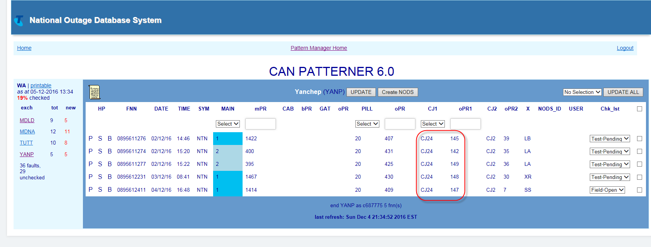

**8.4. CAN Fault Patterning Rules**

In CAN Patterner there are separate rules for:

Forming a pattern of faults

▪

Displaying a pattern of faults

▪

Special CAN Patterning & Display Rules

▪

017921w14 Pattern Manager 6.0 (continued)

**Form CAN fault pattern**

A related fault pattern will form **in the background** in CAN Patterner whenever:

2 or more SIIAM customer trouble reports meet the following criteria:

•

Symptom code is one of: CBO, CTK, EXO, ICP, NSF, NSY, NTN, NWO, OGP, PLR, SSI,

SSS, TSM, UCC, ULI, ULL, VMT, CCO, COS, DTP, DTI, DTG, DTD, DTH, and…

Faults are in the same Exchange Service Area (ESA)

and…

Faults are in the same Pillar

or…

Where there is no pillar, in the same Control Joint (closest to the exchange)

or…

In addition to the above basic CAN patterning and display rules there are some special

Access Large PGS = absence of main cable (although services fed by

The presence of PGS can also be suspected by the following evidence:

If the FNN is also in a PGS pattern, the P (PGS) hyperlink will be active

when present in the service

To simplify the display, PGS will not appear in CAN patterner network elements even

•

**Pair Gain Systems**

rules:

▪

**Special CAN patterning and display rules**

**8.4.3.**

•

CJ faults are only patterned on the CJ closest to the exchange. CJ 2 is display only

•

Only the 2 Control Joints (CJ) closest to the exchange are displayed

•

Each 30 pair grouping is distinguished by a band of different background colour

‘secondary’ or ‘out of area’ PGS may have main cables and pairs)

CAN Electronic Small PGS = presence of CJ (although straight lines can also

▪

run through CJs)

ADSL DSLAM = ‘x’ service type is XR or XS

▪

TELSTRA CORPORATION LIMITED (ABN 33 051 775 556) |

| | SYSTEM GENERATED | 017921W14 PATTERN MANAGER 6.0

PAGE 17/86

For example, when the Threshold Setting is set to ‘5’ a fault pattern will only display when



**8.4.2.**

**Display CAN fault pattern**

While a basic CAN fault pattern will ALWAYS form in the background of CAN Patterner, fault

patterns will only become visible in an Exchange screen in CAN Patterner when the

following criteria are met:

The above patterning rules have been met and patterns have formed in the

•

background

The number of patterned faults is equal to or greater than the patterning threshold

•

configured by SOM in the Update Patterning Threshold’ table of Pattern Manager

Admin 2.0

017921w14 Pattern Manager 6.0 (continued)

there are 5 patterned faults in the same exchange and the same pillar, etc.

Faults so displayed can be in the one 30 pair grouping or in a combination of 30 pair

•

patterns

e.g. If the Threshold was set to 5 then the rule would be met if there were:

5 faults in one 30 pair group

E.g. P5 – pairs 3 + 9 +10 +18 +25

▪

2 faults in one 30 pair group plus 3 faults in another 30 pair group or “2+3”:

E.g. P5 – pairs 3 + 9 plus 74 + 87 + 91

▪

2 faults in one 30 pair group plus 2 faults in another plus 2 faults in another or

“2+2+2”:

E.g. P5 – pairs 3 + 9 plus 51 + 56 plus 89+ 97

▪

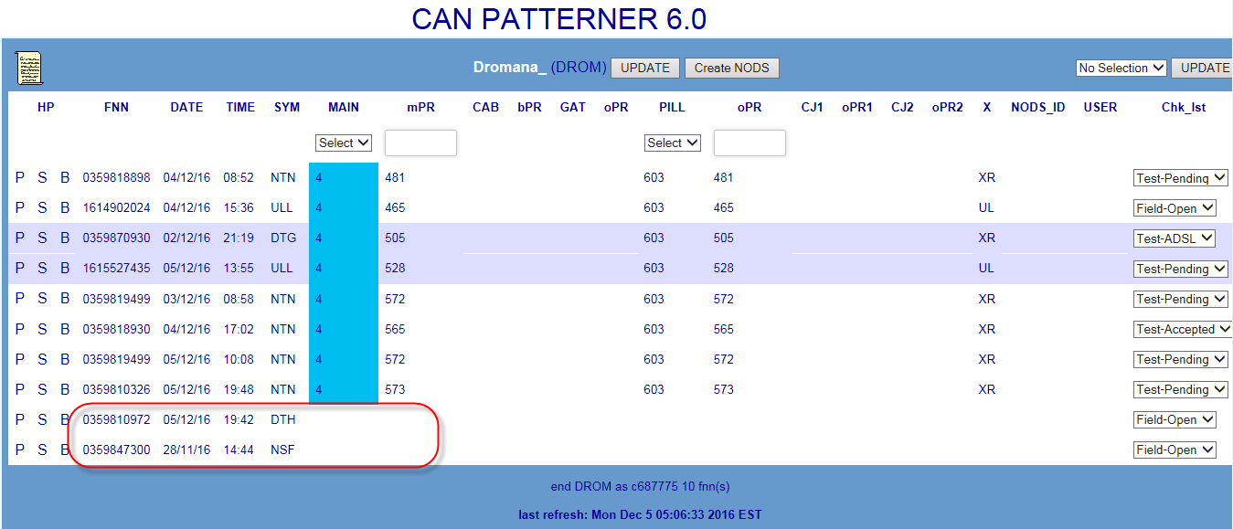

A fault has been created for a data line where the cable details have not

▪

been available from NPAMS to populate the Cable Details tab

A fault has been created for the exchange or auxiliary line of an ISDN service

▪

A fault has been created to log a fault on multiple services for a business

▪

An error has occurred during case creation

▪

The details of DummyFNN faults must be investigated in SIIAM to determine

whether or not they are related to the fault pattern in the exchange.

CSLL services)

**DummyFNN cases**

•

TELSTRA CORPORATION LIMITED (ABN 33 051 775 556) |

| | SYSTEM GENERATED | 017921W14 PATTERN MANAGER 6.0

PAGE 18/86

CAN Patterner will also display any faults which have no cable details whenever the



**Control Joints**

•

Only the first CJ closest to the exchange will be used for patterning

Only the first 2 CJs closest to the exchange will be visible

Any subsequent CJs in the cable route will be ignored for patterning and will not be

visible on the screen

**Faults with no cable details**

•

017921w14 Pattern Manager 6.0 (continued)

exchange in which the fault occurs also has a valid displayed fault pattern

E.g. a case with no cable details is reported in an exchange but the current

threshold for displaying fault patterns (5) has not yet been met – the no cable

details case does not display. However, when a fault pattern meets the display

criteria and appears in the exchange, so too will case with no cable details

Faults with no cable details may have ANY Symptom code.

Faults with no cable details generally occur for one of 5 main reasons:

A fault has been created for a service which is working over copper network

▪

which has now been asset transferred to Nbnco (known as ‘Continuity’ or

5.

1.

Investigate fault and network detail within the CAN pattern e.g. fault report times,

symptom codes and contiguity of affected pairs

2.

Use hyperlinks to compare fault and network detail in other Patterners e.g. which fault

pattern gives the clearer and more compelling evidence

3.

Investigate individual customer and fault details of each FNN in pattern, e.g. SIIAM case

details, history and notes

4.

Run a SIIAM query to identify any related faults which did not meet patterning display

criteria

The below sequence describes the basic general approach:

Investigate customer type and address patterns and pair occupancy of range in CASINO

(Clarification of Affected Services in Network Outage) tool or NPAMS

TELSTRA CORPORATION LIMITED (ABN 33 051 775 556) |

| | SYSTEM GENERATED | 017921W14 PATTERN MANAGER 6.0

PAGE 19/86

Damage related P&E cases have an FNN formed from the text ‘DummyFNN’ and the



CAN Patterner will also display any Plant & Equipment cases with a symptom code

of UCC (Underground Cable Cut) whenever the exchange in which the fault occurs

also has a valid displayed fault pattern

Plant & Equipment cases with a Symptom code of UCC are created whenever a

damage is reported to an underground cable.

E.g. a UCC damage case is reported in an exchange but the current threshold for

displaying fault patterns (5) has not yet been met – the DummyFNN case does not

display. However, when a fault pattern meets the display criteria and appears in the

exchange, so too will the UCC DummyFNN case

017921w14 Pattern Manager 6.0 (continued)

Case number e.g. ‘DummyFNN131234567’. In CAN Patterner this FNN will appear

shortened by replacing the ‘DummyFNN’ with an asterisk e.g. ‘*131234567’

The details of DummyFNN faults must be investigated in SIIAM to determine

whether or not they are related to the fault pattern in the exchange.

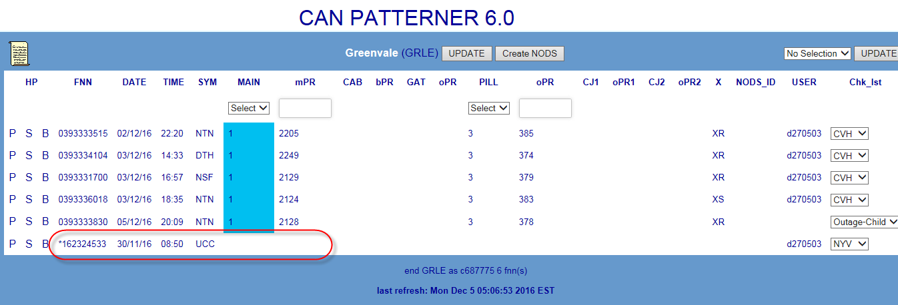

**8.5. Analyse CAN Fault Pattern**

A related fault pattern in CAN Patterner is only an indication of a potential outage. To

confirm the presence of an outage to a single network element having caused all the faults

in the pattern, further detailed investigation and analysis must be conducted by SOM

Complex Consultants using both the information in Pattern Manager itself and in external

systems.

confirmed that there were no faults beyond pair 50.

Click the ‘Create NODS’ button

4.

After a brief pause the NODS ID that has been created will display in the NODs ID

column

5.

The NODS can be opened directly using this link, allowing changes to be made (e.g.

adding Parent case and CONEN IDs)

NOTE: Round out to the actual pair range of the affected cable as determined by

investigation of CASINO, NPAMS and/or GDD e.g. a pattern in comprising related faults on a

common Pillar P5 between 7 and 46 would typically be rounded out to the standard size of

a 50 pair cable (pairs 1-50) once further investigation (e.g. in SIIAM and SULTAN) had

3.

Refer also Section 14.5

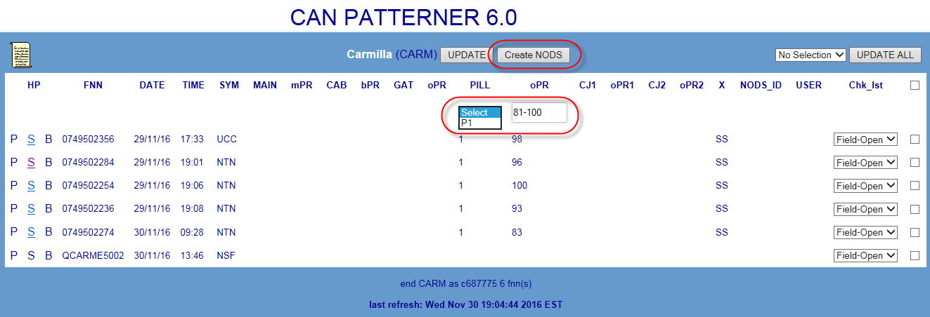

TELSTRA CORPORATION LIMITED (ABN 33 051 775 556) |

| | SYSTEM GENERATED | 017921W14 PATTERN MANAGER 6.0

PAGE 20/86

**8.6. Create NODS from CAN Patterner**



6.

Check cable location and route and relative location of faults using GDD (Graphical Data

Display) network maps

7.

Test services in SULTAN particularly when there is an apparent gap in the affected range

(“testing within the range”)

8.

Ring CT’s or Team leaders for more information

017921w14 Pattern Manager 6.0 (continued)

If an outage has been confirmed on a CAN network element included in the fault pattern,

create a NODS notification directly from within CAN Patterner using the ‘Create NODS’

button.

This provides the quickest response to the outage and ensures that FOH consultants and

customers will be advised of the outage at the earliest opportunity.

Follow these basic steps:

1.

Select the affected network element e.g. Main Cable or Pillar ID using the Network

Element selection field

2.

Enter the affected pair range in the Pair Selection field e.g. 1-50

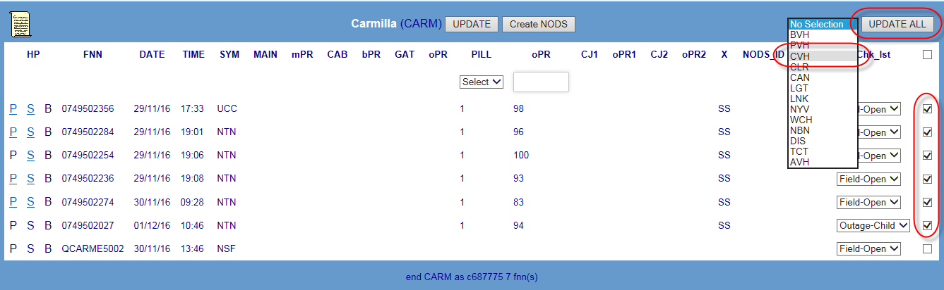

2.

Apply the correct code

3.

Click the Update or Update All buttons to save the code and update the exchange

display and the totals in the Exchange list and Region Dashboard

**NOTE**: Users with a PM Read-only Access Level can view the Check off code that has been

applied by SOM but are unable to add or change Check off codes.

For detailed instructions on the above, refer section 14.7

For a table of valid check off codes and their meanings refer to section 14.8

exchange are part of the one outage use Method 1

TELSTRA CORPORATION LIMITED (ABN 33 051 775 556) |

| | SYSTEM GENERATED | 017921W14 PATTERN MANAGER 6.0

PAGE 21/86

There are 3 methods of applying a check-off code:



**8.7. Check off CAN Fault Pattern**

Once the pattern has been analysed and a determination made as to the findings and the

action to be taken, each fault in the pattern must be ‘checked off’ to indicate this

finding/action e.g. CVH = Confirmed Volume Hold or NYV = Not Yet Volume Hold.

Initially, when first appearing, faults in a pattern will display the SIIAM case status of the

fault when it first met Pattern Manager criteria e.g. Test-Pending or Field-Open.

017921w14 Pattern Manager 6.0 (continued)

1.

Apply a common code to all faults in the Exchange using the Update All function

2.

Apply a common code to selected faults in the Exchange using the selection boxes

3.

Apply a single code to each individual fault using the individual drop down lists

To apply a check off action code to each fault in the pattern follow these basic steps:

1.

Choose the most appropriate Check off method from the above e.g. if all faults in the

% = percentage of patterned faults in region not yet analysed and actioned

**52.Determine the region requiring the greatest focus**

with the highest percentage of unchecked faults

with the largest volume of unchecked faults

**53.Access the required region by clicking the Region name link**

Regions are state-based with metro and country areas of the same state grouped

together

Regions are listed geographically North to South; East to West

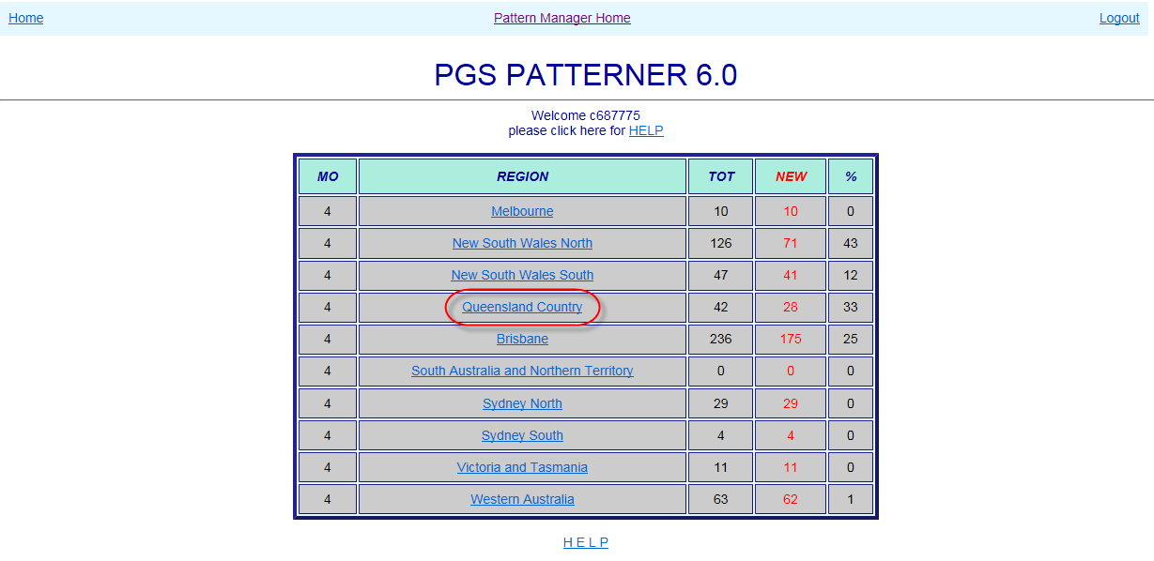

NEW = number of patterned faults in region not yet analysed and actioned

TELSTRA CORPORATION LIMITED (ABN 33 051 775 556) |

| | SYSTEM GENERATED | 017921W14 PATTERN MANAGER 6.0

PAGE 22/86

**9.1. Select Region**



**9. PGS Patterner Version 6.0**

PGS Patterner 6.0 forms and displays fault patterns related by a common Pair Gain System

network element e.g. Access Core Large PGS or CAN Electronic Small PGS.

Click the PGS Patterner Version 6.0 link from the Pattern Manager home screen to access

PGS Patterner.

017921w14 Pattern Manager 6.0 (continued)

When the PGS Patterner Version 6.0 link is clicked, the PGS Patterner Region Dashboard will

open displaying the various geographical regions of the PSTN network and the number of

patterned faults in each.

The Region Dashboard allows a user to:

**51.Quickly assess the relative volumes of patterned faults per region**

MO = Mode of Operations – the number of faults which must meet patterning

criteria before a fault pattern will display in that region

TOT = total number of patterned faults per region

patterns present in the exchange along with key information to assist with initial analysis.

▪

Number unchecked faults in region

▪

**55.Determine the exchange requiring the greatest focus**

with the highest percentage of unchecked faults

with the largest volume of unchecked faults

**56.Access the required exchange by clicking the Region name link**

Regions are listed alphabetically

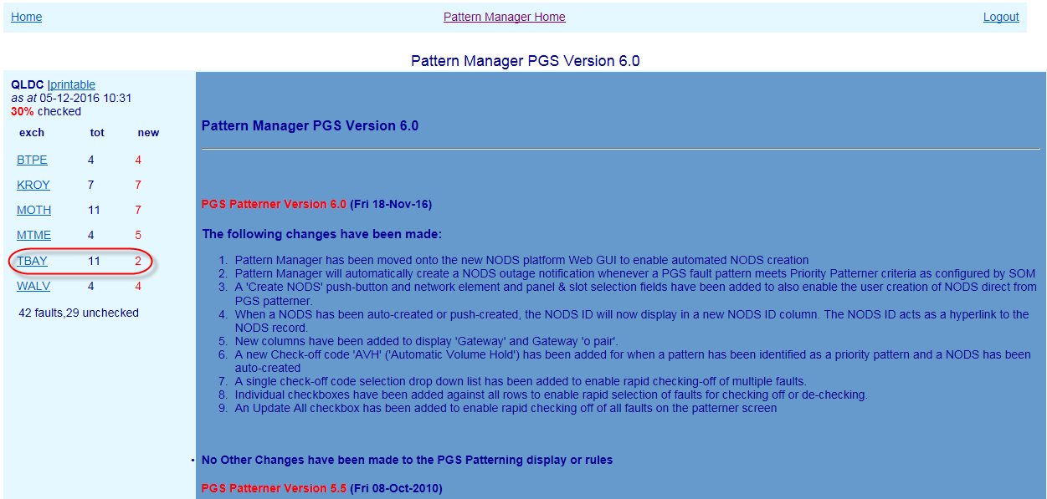

**9.3. PGS Exchange screen**

When an Exchange is clicked, the Exchange screen will present, displaying any related fault

Total faults in region

Exchange List remains visible at left to allow quick section of the next exchange.

TELSTRA CORPORATION LIMITED (ABN 33 051 775 556) |

| | SYSTEM GENERATED | 017921W14 PATTERN MANAGER 6.0

PAGE 23/86

new = number of patterned faults in exchange not yet analysed and actioned



**9.2. Select Exchange**

When a Region link is clicked, the PGS Patterner Exchange List will open displaying the

various exchanges which contain fault patterns and the number of patterned faults in each.

To the right of the Exchange List a version history gives details of the changes introduced in

each successive version of Pattern Manager.

The Exchange List allows a user to:

**54.Quickly assess the relative volumes of patterned faults per exchange**

tot = total number of patterned faults per exchange

017921w14 Pattern Manager 6.0 (continued)

Above the exchange list are displayed:

Region name

▪

‘Printable’ link providing plain text view of region

▪

Last refresh date

▪

% faults unchecked in region

▪

Below the exchange list are displayed:

DCS20 and SSNMUX

62. NODS ID

If a NODS has been created automatically by Priority Patterner or manually from

within CAN Patterner, the NODS ID will display here

NODS manually created in native NODS will NOT display

NODS auto-created by Mozart or other external interfaces will NOT display

63. User ID of the user who has Checked off the fault pattern

64. Check List (‘Chk_Lst’) indicating determination made/action taken on fault pattern

e.g. CVH – Confirmed Volume Hold – NYV – Not Yet Volume Hold (refer table section

14.8)

**NOTE**:

The left hand PGS columns display details for Access Core Large PGS e.g. CMUX, RIM, RCM,

(see table section 14.6)

The right hand PGS columns display details for CAN Electronic Small PGS e.g. 2/4 DPGS,

RAM 8, 6/15-16, 16/96, SCaDS

TELSTRA CORPORATION LIMITED (ABN 33 051 775 556) |

| | SYSTEM GENERATED | 017921W14 PATTERN MANAGER 6.0

PAGE 24/86

60. Fault Symptom code (e.g. NTN – No Tone)



The main section of the screen displays basic details of customer faults reports which meet

PGS patterning criteria (see next section 9.4).

The following details are displayed from left to right in the middle section of the screen

57. HP Hyperlinks – if the fault also appears in a fault pattern in another Patterner (e.g.

PGS) the hyperlink letter will be bold and underlined:

C (CAN) – S (Switch) – B (BB CAN)

58. Faulty FNN (Full National Number)

59. Date & Time of fault report

017921w14 Pattern Manager 6.0 (continued)

PGS & basic CAN Network Elements

Access Core large PGS ID – Type – P/S/C (Panel/Slot/Channel) e.g. CMUX or RIM

Main cable/mpair – Cabinet/bpair – Gateway/opair – Pillar/opair

CAN Electronic small PGS ID – Type – P/S/C e.g. 6/16 or RAM 8

If a Network Element column is blank, that type of network element is not present in

that FNNs service

NOTE: to simplify the display and make analysis easier, only Access and CAN Electronic PGS

and basic CAN network elements are displayed in PGS Patterner. To see other CAN or Switch

devices present in a service or pattern it is necessary to use the hyperlinks (if active) or

consult Shazbot or NPAMS.

61. ‘X’ – Service Type as recorded in NPAMS e.g. XR = ADSL service – SS = PSTN service

configured by SOM in the ‘Update Age of Pattern Data’ table of Pattern Manager

and…

Faults are in the same ESA

and…

Faults are in the same PGS Id

When faults contain both Access Core and CAN Electronic PGS the pattern will be

•

formed on the PGS Id with the greatest number of faults

Where there are equal numbers of faults with the same two PGS Id (i.e. Access Core

•

and CAN Electronic), the pattern will be formed on the Access Core PGS

Faults are retained in a pattern for 72 hours from report date.

•

Fault pattern will be retained for 72 hours from fault report date or for the timeframe

•

MLC 6/15, 6/16, 16/96 or SCADS)

Admin 2.0

Only the valid Symptom Code and Age of Pattern Data timeframe rules can be

•

changed by SOM. Changes can only be made by a user with NODS-PM Super User

TELSTRA CORPORATION LIMITED (ABN 33 051 775 556) |

| | SYSTEM GENERATED | 017921W14 PATTERN MANAGER 6.0

PAGE 25/86

**9.4.1.**



ADSL DSLAM PGS do not display in PGS patterner – they display in BB CAN Patterner.

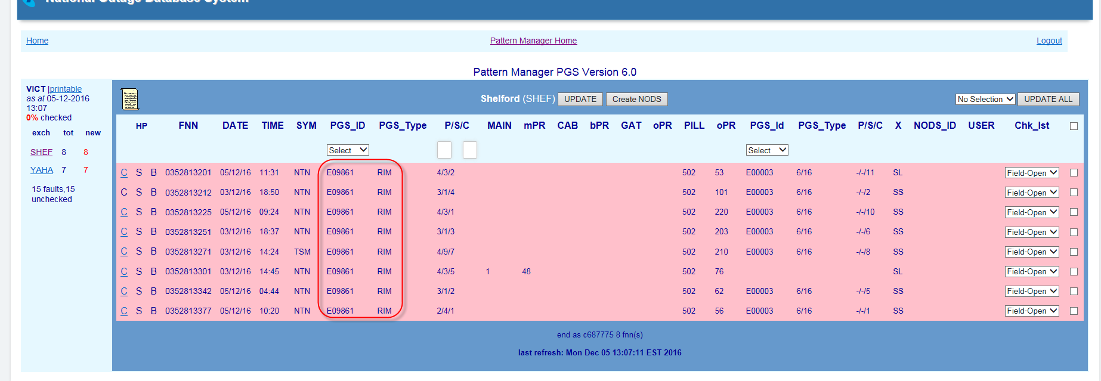

**9.4. PGS Fault Patterning Rules**

In PGS Patterner there are separate rules for:

Forming a pattern of faults

▪

Displaying a pattern of faults

▪

Special PGS Rules

▪

017921w14 Pattern Manager 6.0 (continued)

**Form PGS fault pattern**

A related fault pattern will form **in the background** in PGS Patterner whenever:

2 or more SIIAM customer trouble reports meet the following criteria:

•

Symptom code is one of: CBL, CBO, CCO, CEF, COS, CTK, EXO, ICP, NSF, NSY, NTN,

NWO, OGP, TSM, UCC, VMT, DTP, DTD, DTG, DTI,

and…

Faults have a PGS type of:

Access Core (CMUX, SSNMUX, RIM, RCM or DCS20)

and/or…

▪

CAN Electronic (1+4W, 2DPGS, 4DPGS, RAM8 Ph1, RAM8 Ph2, RAM8V90,

▪

▪

CMUX have 2 main physical configurations:

•

**Master**

An exchange based Network Unit (NU) feeding a remote based Access Unit

▪

(AU) either in the street or in a multi-storey building. Called a ‘master’ unit

in common terminology.

Appear in Pattern Manager with a PGS ID like “E04003”

▪

**Slave Unit**

An exchange based Network Unit (NU) feeding a series of remote Slave

▪

Units each with its own remote unit (AU). Each Slave Unit supplies services

to a different geographical locality.

Slave Units appear separately in Pattern Manager with PGS ID like

Service), broadband (ADSL), ISDN and/or narrowband special services (data lines).

‘E04003/2, E04003/3, etc.’

PGS Patterner 6.0 forms and displays patterns by treating Slave Units as a separate

•

PGS Id:

4 faults each on a different Slave of the one PGS Id e.g. E7/2, E7/3, E7/5 and E7/7

will NOT form a valid pattern

TELSTRA CORPORATION LIMITED (ABN 33 051 775 556) |

| | SYSTEM GENERATED | 017921W14 PATTERN MANAGER 6.0

PAGE 26/86

background



Access Level via the Pattern Manager Admin function. All other rules are hard coded

into Pattern Manager.

**NOTE:** Fault patterns are NOT formed on other PGS types (e.g. DSLAM or CAN Radio)

**NOTE**: ADSL Symptom codes for connectivity issues most indicative of exchange line

problems have been added to the normal exchange line symptom code list.

**9.4.2.**

**Display PGS fault pattern**

While a basic PGS fault pattern will ALWAYS form in the background of PGS Patterner, fault

patterns will only become visible in an Exchange screen in PGS Patterner when the

following criteria are met:

The above patterning rules have been met and patterns have formed in the

•

017921w14 Pattern Manager 6.0 (continued)

The number of patterned faults is equal to or greater than the patterning threshold

•

configured by SOM in the Update Patterning Threshold’ table of Pattern Manager

Admin 2.0 for PGS

For example, when the Threshold Setting is set to ‘4’ a fault pattern will only display when

there are 4 patterned faults in the same exchange and the same PGS ID, etc.

**9.4.3.**

**CMUX patterning & display rules**

Due the ability of CMUX (Customer Multiplexer) PGS to perform various network roles for a

service according to the card and port type installed, PGS patterner uses some additional

rules for CMUX patterning and display:

**CMUX Master and Slave types**

CMUX are complex Pair Gain Systems which can function in a variety of ways and

•

configurations to deliver a combination of telephony (‘POTS’ – Plain Old Telephone

2B1Q

ADSL*

DSLAM (ADSL) only

Combination (Access Core + DSL)

Access Core (ISDN) only

POTS*

Access Core (PSTN) only

POTS, 2B1Q, ADSP or ADSLP i.e. Access Core or combination Access Core/DSL.

PAGE 27/86

| | SYSTEM GENERATED | 017921W14 PATTERN MANAGER 6.0

TELSTRA CORPORATION LIMITED (ABN 33 051 775 556) |

•

PGS Patterner will form a fault pattern on a CMUX whenever the card/port type is

ADSP*, ADSLP*

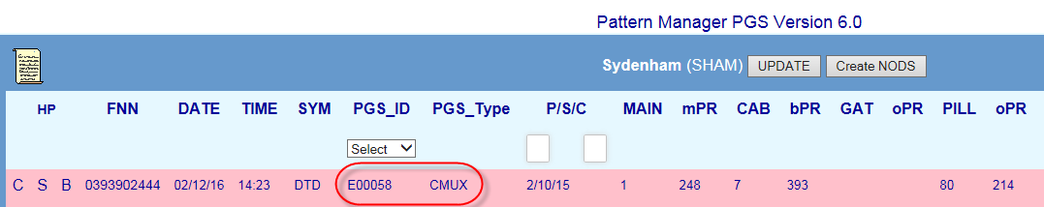

plays in providing customer service as indicated by the NPAMS Port type (refer Table

•

In PGS Patterner 6.0 CMUX faults pattern and display according to the role the CMUX

internet service or both depending on the type of card or port used.

service (i.e. dial tone) in lieu of copper main cable or as DSLAM to provide ADSL

•

CMUX may function in a customer’s service as either Access Core to provide exchange

**CMUX Network Role**

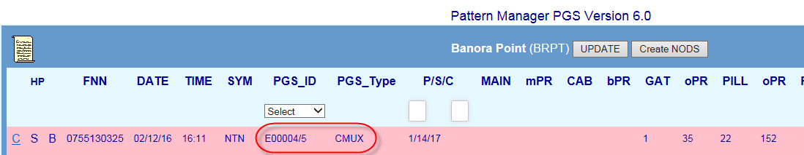

4):

providing a clue to the widespread nature of the outage

Slave Units they too will appear – as separate colour-differentiated patterns –

reached for one of the affected Slave Units. As the threshold is reached for other

Outages affecting multiple Slave Units will not appear until the threshold is

pattern

4 faults on the same slave unit e.g. E7/6, E7/6, E7/6 and E7/6 will form a valid



**Port (card) Type**

**Role**

017921w14 Pattern Manager 6.0 (continued)

**Table CMUX network role and Port/card types**

Combination (Access Core and ADSL)

DSLAM (ADSL)

Access Core (PSTN or ISDN)

extensive failure the following patterns would be visible:

(Panel/Slot/Channel of ‘POTS’ card) of the CMUX in the left hand PGS columns

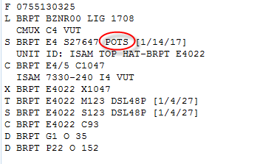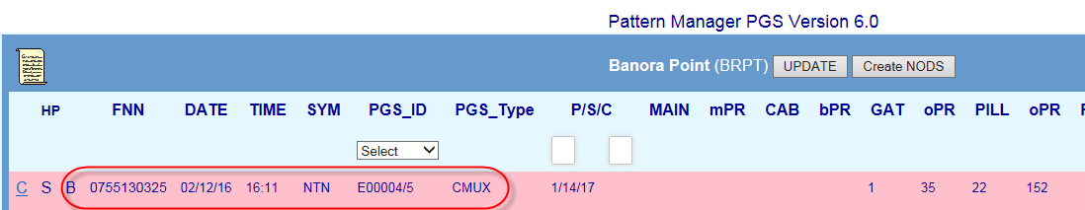

**CMUX DSLAM catastrophic failure**

Catastrophic failure of a CMUX which is only providing ADSL broadband service can **in**

**rare circumstances** result in a loss of telephony service along with internet.

As PGS Patterner does not form or display patterns on faults where the CMUX is only

providing ADSL (i.e. via an ADSL* card/port) such an outage may not be immediately

obvious as a PSTN outage on that CMUX, although it is highly likely that in the event of an

In these instances PGS Patterner will pattern on and display the POTS component

TELSTRA CORPORATION LIMITED (ABN 33 051 775 556) |

| | SYSTEM GENERATED | 017921W14 PATTERN MANAGER 6.0

PAGE 28/86

appear in other Patterners e.g. BB CAN Patterner



PGS Patterner will NOT form fault patterns on a CMUX where the card/port type is

•

ADSL (i.e. functioning as DSLAM in service only) although these faults may be

included in otherwise valid patterns in which case the CMUX ADSL component will be

“hidden’ in the right hand PGS columns (as with other types of DSLAM) but will be

indicated by the presence of an ‘XR’ or ‘XS’ ADSL ‘X’ code. These faults may also

017921w14 Pattern Manager 6.0 (continued)

Sometimes 2 different CMUX will be deployed to provide service to a customer FNN –

•

one to provide telephony (‘POTS’) and another to provide Broadband (‘ADSL’) e.g.

CMUX E7 (using ‘POTS’ card) and CMUX E2 (using ‘ADSL2’ card)

In these instances PGS Patterner will pattern on the Access Core CMUX and display

it in the left hand PGS columns

Sometimes different cards within the same CMUX will be used to provide service to a

•

customer e.g. CMUX E7 (‘POTS’ card) and CMUX E7 (separate ‘ADSL2’ card)

•

This arrangement will result in the customer and their copper cable pairs (e.g. main cable

and pillar) belonging to one exchange (e.g. LOST Lost River) and the Access PGS ‘feeding’

their service being in another exchange (e.g. GLBN Goulburn)

Pattern Manager will display this like:

In **PGS Patterner**:

•

Pattern will form in exchange to which the customer and main cable belongs

PGS will display in this pattern without any indication of belonging to another

exchange

The usual clue though is the presence of BOTH Access PGS AND Main Cable

(normally an Access PGS REPLACES main cable)

In **CAN Patterner**:

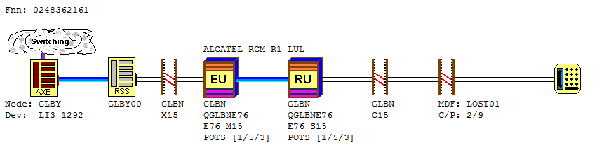

Pattern will form in exchange to which the customer and main cable belongs

A clue may be the presence of BOTH a Main Cable AND an active hyperlink to PGS

Patterner (providing a pattern has formed in PGS Patterner as well)

TELSTRA CORPORATION LIMITED (ABN 33 051 775 556) |

| | SYSTEM GENERATED | 017921W14 PATTERN MANAGER 6.0

PAGE 29/86

displaying the failed CMUX in the right hand DSLAM column



PGS Patterner – a pattern BOTH PSTN (‘NTN’) and ADSL (‘DT*”) on the CMUX POTS,

•

RIM or other Access PGS which is providing the Exchange Access component of the

customers’ services

CAN Patterner – pattern(s) BOTH PSTN (‘NTN’) and ADSL (‘DT*”) on common Pillar,

•

Cabinet or Main Cable

BB CAN Patterner – pattern of ADSL faults on common Pillar, Cabinet or Main Cable

•

017921w14 Pattern Manager 6.0 (continued)

Switch Patterner – pattern of BOTH PSTN (‘NTN’) and ADSL (‘DT*”) faults formed on

•

common Switch Id with Device type ‘LIG’ or ‘xxV’ e.g. ‘30V’

SOM staff should contact SAO to confirm PSTN impact if in doubt.

**9.4.4.**

**PGS in secondary exchange**

Sometimes services are delivered by employing an Access PGS in a larger ‘secondary’

exchange to provide exchange access to a smaller sub-exchange. This is most commonly

used in rural and remote areas. Typically the Remote Unit (RU) of the PGS will be co-located

with exchange MDF in the sub-exchange building where the local main pairs will connect to

the PGS C pairs. The RU then links back to the larger secondary exchange via its fibre link

to the Exchange Unit (EU) of the PGS.

coded to display Access Core PGS and another on the right to display CAN Electronic

The right hand PGS column is blank AND…

▪

An ADSL ‘X’ code such as ‘XR’ or ‘XS’ will indicate the presence of a DSLAM

▪

A remote or island exchange (e.g. THUT Thursday Island) may include a CAN

▪

Radio PGS

**Limitation on number of PGS displayed**

•

PGS Patterner 6.0 screen has only 2 sets of PGS display columns – one on the left

The presence of other types of PGS can be only identified by the following clues:

PGS.

TELSTRA CORPORATION LIMITED (ABN 33 051 775 556) |

| | SYSTEM GENERATED | 017921W14 PATTERN MANAGER 6.0

PAGE 30/86

this way for these scenarios.

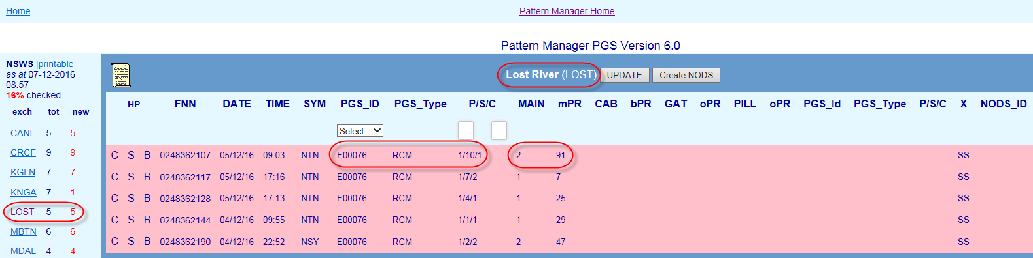

SOM Complex Consultants will need to be alert to these clues and to confirm the presence

of a ‘secondary exchange’ PGS by checking cable details in Shazbot.

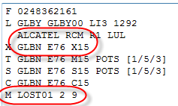

A native NODS will need to be loaded on BOTH the PGS ‘secondary’ exchange and the

customer exchange.

Priority Patterner (and Mozart CONEN to NODS automation) will automatically load NODS in

017921w14 Pattern Manager 6.0 (continued)

**9.4.5.**

**Special PGS patterning and display rules**

In addition to the above basic PGS patterning and display rules there are some special

rules:

**Display of PGS types**

•

Only Access Core or CAN Electronic PGS types are displayed in PGS Patterner.

If a FNN in a PGS pattern contains another type of PGS e.g. FTTP, DSLAM or CAN

Radio these PGS will not be displayed.

Element selection field

Investigate customer type and address patterns in CASINO (Clarification of Affected

Services in Network Outage) tool

8.

Check relative location of faults using GDD (Graphical Data Display) network maps

9.

Ring CT’s or GOC for more information

**9.6. Create NODS from PGS Patterner**

If an outage has been confirmed on a PGS network element included in the fault pattern,

create a NODS notification directly from within PGS Patterner using the ‘Create NODS’

button.

This provides the quickest response to the outage and ensures that FOH consultants and

customers will be advised of the outage at the earliest opportunity.

Follow these basic steps:

1.

Select the affected network element e.g. large or Small PGS ID using the Network

7.

2.

Enter the affected Panel and or Panel and Slot range in the Panel & Slot Selection fields

e.g. Panel 3 Slots 1-3

3.

Click the ‘Create NODS’ button

TELSTRA CORPORATION LIMITED (ABN 33 051 775 556) |

| | SYSTEM GENERATED | 017921W14 PATTERN MANAGER 6.0

PAGE 31/86

Check CONEN for an Network Incident on the affected Access Large PGS



This means that (comparatively rare) instances of where there are 2 Access Core

PGS + 1 Small PGS or where there is one Access PGS and 2 Small PGS, one of the

PGS will NOT be displayed. In these cases PGS Patterner will pattern and display the

PGS closest to the exchange.

**9.5. Analyse PGS Fault Pattern**

A related fault pattern in PGS Patterner is only an indication of a potential outage. To

confirm the presence of an outage to a single network element having caused all the faults

in the pattern, further detailed investigation and analysis must be conducted by SOM

Complex Consultants using both the information in Pattern Manager itself and in external

systems.

The below sequence describes the basic general approach:

1.

017921w14 Pattern Manager 6.0 (continued)

2.

Check ‘! SOM Production’ mailbox for an email advice of Small PGS outage

3.

Investigate fault and network detail within the PGS pattern e.g. fault report times,

symptom codes and common Panel and Slot

4.

Use hyperlinks to compare fault and network detail in other Patterners e.g. which fault

pattern gives the clearer and more compelling evidence

5.

Investigate individual customer and fault details of each FNN in pattern, e.g. SIIAM case

details, history and notes

6.

Run a SIIAM query to identify any related faults which did not meet patterning display

criteria

applied by SOM but are unable to add or change Check off codes.

Apply a single code to each individual fault using the individual drop down lists

To apply a check off action code to each fault in the pattern follow these basic steps:

1.

Choose the most appropriate Check off method from the above e.g. if all faults in the

exchange are part of the one outage use Method 1

2.

Apply the correct code

3.

Click the Update or Update All buttons to save the code and update the exchange

display and the totals in the Exchange list and Region Dashboard

**NOTE**: Users with a PM Read-only Access Level can view the Check off code that has been

3.

For detailed instructions on the above, refer section 14.7

TELSTRA CORPORATION LIMITED (ABN 33 051 775 556) |

| | SYSTEM GENERATED | 017921W14 PATTERN MANAGER 6.0

PAGE 32/86

**9.7. Check off PGS Fault Pattern**



4.

After a brief pause the NODS ID that has been created will display in the NODs ID

column

5.

The NODS can be opened directly using this link, allowing changes to be made (e.g.

adding Parent case and CONEN IDs)

Refer also Section: 14.5

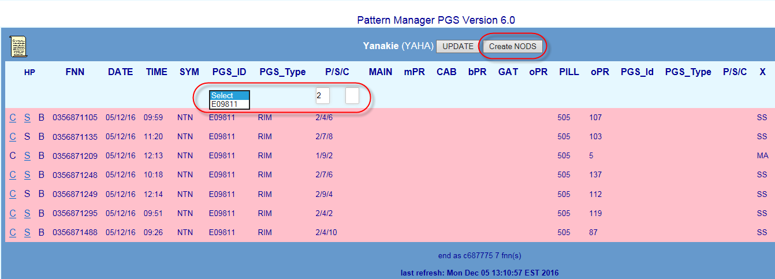

017921w14 Pattern Manager 6.0 (continued)

Once the pattern has been analysed and a determination made as to the findings and the

action to be taken, each fault in the pattern must be ‘checked off’ to indicate this

finding/action e.g. CVH = Confirmed Volume Hold or NYV = Not Yet Volume Hold.

Initially, when first appearing, faults in a pattern will display the SIIAM case status of the

fault when it first met Pattern Manager criteria e.g. Test-Pending or Field-Open.

There are 3 methods of applying a check-off code:

1.

Apply a common code to all faults in the Exchange using the Update All function

2.

Apply a common code to selected faults in the Exchange using the selection boxes

017921w14 Pattern Manager 6.0 (continued)



For a table of valid check off codes and their meanings refer to section 14.8

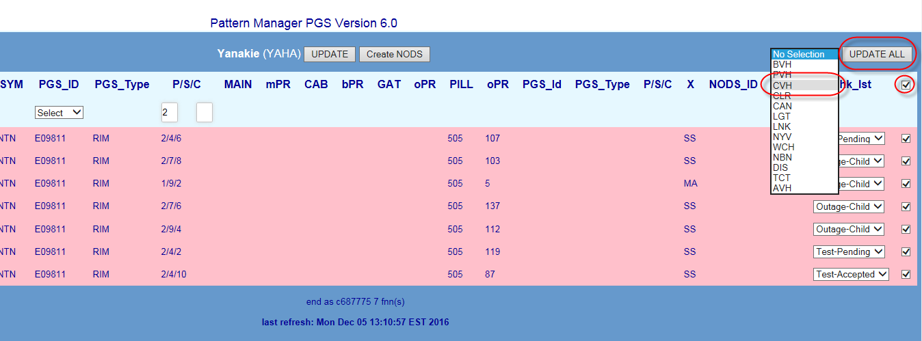

TELSTRA CORPORATION LIMITED (ABN 33 051 775 556) |

| | SYSTEM GENERATED | 017921W14 PATTERN MANAGER 6.0

PAGE 33/86

% = percentage of patterned faults in region not yet analysed and actioned

**66.Determine the region requiring the greatest focus**

with the highest percentage of unchecked faults

with the largest volume of unchecked faults

**67.Access the required region by clicking the Region name link**

Regions are state-based with metro and country areas of the same state grouped

together

Regions are listed geographically North to South; East to West

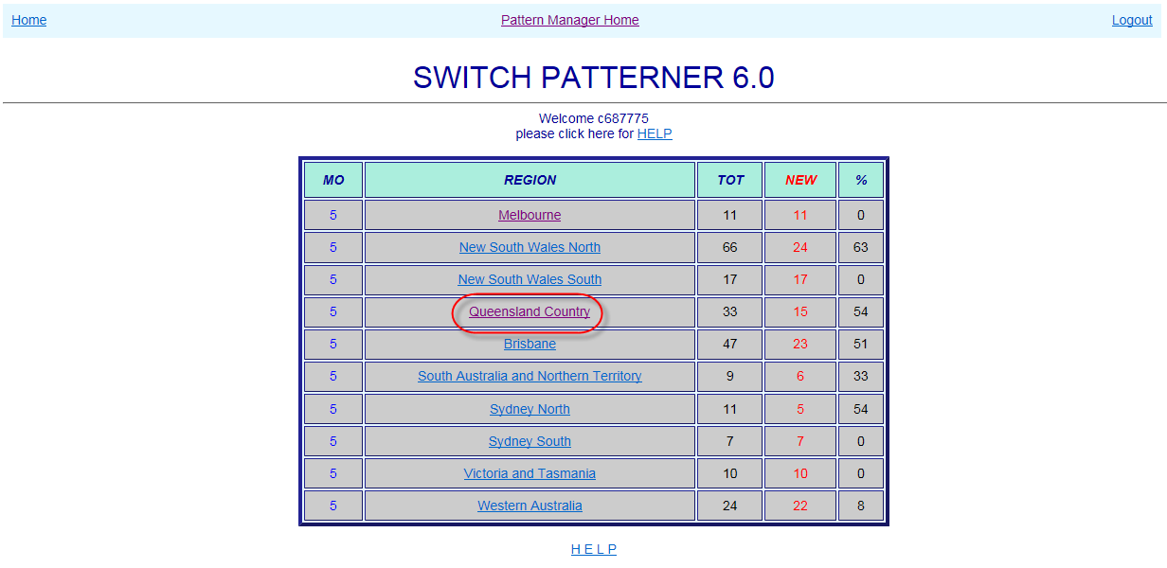

NEW = number of patterned faults in region not yet analysed and actioned

TELSTRA CORPORATION LIMITED (ABN 33 051 775 556) |

| | SYSTEM GENERATED | 017921W14 PATTERN MANAGER 6.0

PAGE 34/86

**10.1. Select Region**



**10.**

**Switch Patterner Version 6.0**

Switch Patterner 6.0 forms and displays fault patterns related by a common Exchange

Switching network element e.g. AXE or System 12 switching technology.

Click the Switch Patterner Version 6.0 link from the Pattern Manager Home screen to access

Switch Patterner.

017921w14 Pattern Manager 6.0 (continued)

When the Switch Patterner Version 6.0 link is clicked, the Switch Patterner Region

Dashboard will open displaying the various geographical regions of the PSTN network and

the number of patterned faults in each.

The Region Dashboard allows a user to:

**65.Quickly assess the relative volumes of patterned faults per region**

MO = Mode of Operations – the number of faults which must meet patterning

criteria before a fault pattern will display in that region

TOT = total number of patterned faults per region

**70.Access the required Node by clicking the Node link**

▪

% faults unchecked in region

▪

Below the exchange list are displayed:

Total faults in region

▪

Number unchecked faults in region

▪

**69.Determine the Node requiring the greatest focus**

with the highest percentage of unchecked faults

with the largest volume of unchecked faults

Last refresh date

Regions are listed alphabetically

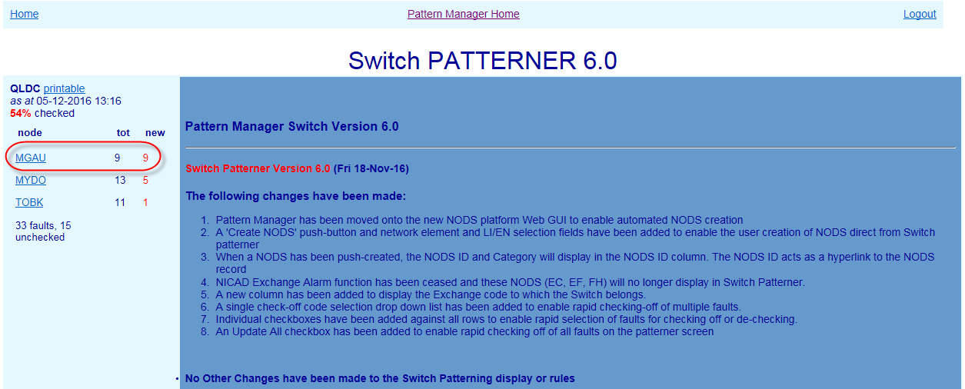

TELSTRA CORPORATION LIMITED (ABN 33 051 775 556) |

| | SYSTEM GENERATED | 017921W14 PATTERN MANAGER 6.0

PAGE 35/86

pattern screen (see section 10.3 below)



**10.2. Select Node**

When a Region link is clicked, the Switch Patterner Node List will open displaying the

various AXE or S12 Exchange Nodes which contain fault patterns and the number of

patterned faults in each.

**NOTE**: Unlike the other Patterners, Switch patterner organises related fault patterns by AXE

or S12 Node. A Node is a ‘master’ exchange which controls the operation of several smaller

local exchanges.

The actual exchange to which a Switch Pattern belongs can be seen within the Node

017921w14 Pattern Manager 6.0 (continued)

To the right of the Node List a version history gives details of the changes introduced in

each successive version of Pattern Manager.

The Node List allows a user to:

**68.Quickly assess the relative volumes of patterned faults per Node**

tot = total number of patterned faults per node

new = number of patterned faults in node not yet analysed and actioned

Above the node list are displayed:

Region name

▪

‘Printable’ link providing plain text view of region

▪

▪

**AXE Switch**

RSS (Remote Switching Stage) Switch ID

▪

LI (line Interface) AXE Device Type

▪

LI number

▪

NPAMS 128 pair grouping

▪

**System 12 Switch**

RSA (Remote Subscriber Access) Switch ID

▪

Network Address

77. Switch Elements:

EN number

▪

Network Address group

▪

TELSTRA CORPORATION LIMITED (ABN 33 051 775 556) |

| | SYSTEM GENERATED | 017921W14 PATTERN MANAGER 6.0

PAGE 36/86

72. Faulty FNN (Full National Number)



**10.3. Switch Node screen**

When a Node is clicked, the Node screen will present, displaying any related fault patterns

present in the node along with key information to assist with initial analysis.

Node List remains visible at left to allow quick selection of the next node.

The main section of the screen displays basic details of customer faults reports which meet

Switch patterning criteria (see next section 10.4).

The following details are displayed from left to right in the middle section of the screen

71. HP Hyperlinks – if the fault also appears in a fault pattern in another Patterner (e.g.

PGS) the hyperlink letter will be bold and underlined:

C (CAN) - P (PGS) – B (BB CAN)

017921w14 Pattern Manager 6.0 (continued)

73. Date & Time of fault report

74. Fault Symptom code (e.g. NTN – No Tone)

75. Exchange to which Switch belongs

76. Primary CAN Network Elements

Main Cable ID – if any

CAN Distribution element closest to the exchange e.g. Cabinet (‘C’), Gateway (‘G’),

Pillar (‘P’) or Control Joint (‘CJ’)

**NOTE**: to simplify the display and make analysis easier, only Switch network elements are

displayed in Switch Patterner plus the exchange and the primary CAN elements. To see Pair

Gain Systems or other CAN elements present in a service or pattern it is necessary to use

the hyperlinks (if active) or consult Shazbot or NPAMS.

14.8)

PAGE 37/86

| | SYSTEM GENERATED | 017921W14 PATTERN MANAGER 6.0

TELSTRA CORPORATION LIMITED (ABN 33 051 775 556) |

▪

Forming a pattern of faults

In Switch Patterner there are separate rules for:

**10.4. Switch Fault Patterning Rules**

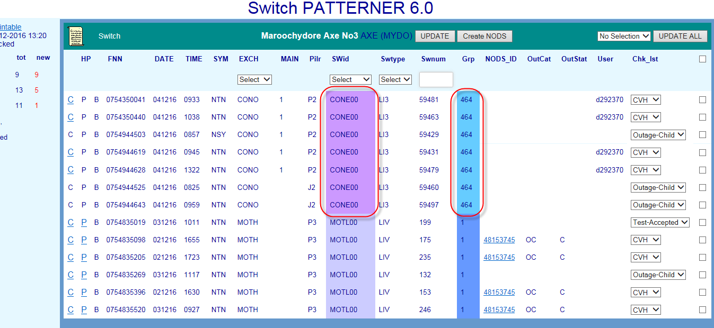

**NOTE**: ‘X’ Service Type does not display in Switch Patterner

017921w14 Pattern Manager 6.0 (continued)

e.g. CVH – Confirmed Volume Hold – NYV – Not Yet Volume Hold (refer table section

82. Check List (‘Chk Lst’) indicating determination made/action taken on fault pattern

81. User ID of the user who has Checked off the fault pattern

80. NODS status e.g. A (Active) or (Ceased)

79. NODS category e.g. SA (CAN) or SB (Network)

NODS auto-created by Mozart or other external interfaces will NOT display

NODS manually created in native NODS will NOT display

within Switch Patterner, the NODS ID will display here

If a NODS has been created automatically by Priority Patterner or manually from

78. NODS ID

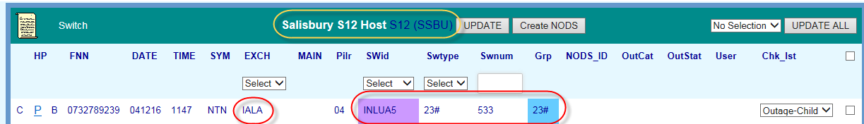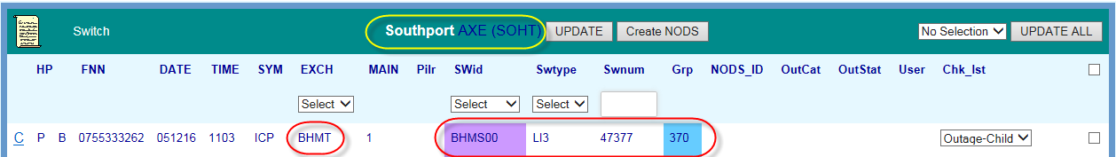

For example, when the Threshold Setting is set to ‘5’ a fault pattern will only display when

Manager Admin function. All other rules are hard coded into Pattern Manager.

**10.4.2.**

**Display Switch fault pattern**

While a basic CAN fault pattern will ALWAYS form in the background of Switch Patterner,

fault patterns will only become visible in a Node screen in Switch Patterner when the

following criteria are met:

The above patterning rules have been met and patterns have formed in the

•

background

The number of patterned faults is equal to or greater than the patterning threshold

•

configured by SOM in the Update Patterning Threshold’ table of Pattern Manager

Admin 2.0

can only be made by a user with NODS-PM Super User Access Level via the Pattern

there are 5 patterned faults in the same Switch ID and same Group, etc.

Each different Switch and Magazine Group pattern will be distinguished by a different

•

band of background colour

TELSTRA CORPORATION LIMITED (ABN 33 051 775 556) |

| | SYSTEM GENERATED | 017921W14 PATTERN MANAGER 6.0

PAGE 38/86

and…



Displaying a pattern of faults

▪

Special patterning & display rules

▪

**10.4.1.**

**Form Switch fault pattern**

A related fault pattern will form **in the background** in Switch Patterner whenever:

2 or more SIIAM customer trouble reports meet the following criteria:

•

Any Symptom code (either PSTN or ADSL)

017921w14 Pattern Manager 6.0 (continued)

Faults are in the same Node and…

Faults are in the same Switch ID

and…

Faults are in the same Group (AXE 128 LI grouping or S12 Network address)

and…

Faults have been reported within 24 hours of earliest fault in group

Fault pattern will be retained for 72 hours from fault report date or for the timeframe

•

configured by SOM in the ‘Update Age of Pattern Data’ table of Pattern Manager

Admin 2.0

Only the valid Age of Pattern Data timeframe rules can be changed by SOM. Changes

•

This provides the quickest response to the outage and ensures that FOH consultants and

Run a SIIAM query to identify any related faults which did not meet patterning display

criteria

6.

Investigate customer type and address patterns in CASINO (Clarification of Affected

Services in Network Outage) tool

7.

Ring GOC or CT’s for more information

**10.6. Create NODS from Switch Patterner**

If an outage has been confirmed by GOC on a Switch network element included in the fault

pattern, create a NODS notification directly from within Switch Patterner using the ‘Create

NODS’ button.

5.

customers will be advised of the outage at the earliest opportunity.

TELSTRA CORPORATION LIMITED (ABN 33 051 775 556) |

| | SYSTEM GENERATED | 017921W14 PATTERN MANAGER 6.0

PAGE 39/86

1.



**10.5. Analyse Switch Fault Pattern**

A related fault pattern in Switch Patterner is only an indication of a potential outage. To

confirm the presence of an outage to a single network element having caused all the faults

in the pattern, further detailed investigation and analysis must be conducted by SOM

Complex Consultants using both the information in Pattern Manager itself and in external

systems.

The below sequence describes the basic general approach:

017921w14 Pattern Manager 6.0 (continued)

Check CONEN for an network Incident on the affected Access Large PGS

2.

Investigate fault and network detail within the PGS pattern e.g. fault report times,

symptom codes and common Panel and Slot

3.

Use hyperlinks to compare fault and network detail in other Patterners e.g. which fault

pattern gives the clearer and more compelling evidence

4.

Investigate individual customer and fault details of each FNN in pattern, e.g. SIIAM case

details, history and notes

1.

finding/action e.g. CVH = Confirmed Volume Hold or NYV = Not Yet Volume Hold.

Initially, when first appearing, faults in a pattern will display the SIIAM case status of the

fault when it first met Pattern Manager criteria e.g. Test-Pending or Field-Open.

There are 3 methods of applying a check-off code:

1.

Apply a common code to all faults in the Exchange using the Update All function

2.

Apply a common code to selected faults in the Exchange using the selection boxes

3.

Apply a single code to each individual fault using the individual drop down lists

To apply a check off action code to each fault in the pattern follow these basic steps:

action to be taken, each fault in the pattern must be ‘checked off’ to indicate this

Choose the most appropriate Check off method from the above e.g. if all faults in the

exchange are part of the one outage use Method 1

TELSTRA CORPORATION LIMITED (ABN 33 051 775 556) |

| | SYSTEM GENERATED | 017921W14 PATTERN MANAGER 6.0

PAGE 40/86

4.



Follow these basic steps:

1.

Select the affected network element i.e. Switch ID and Switch Type using the Network

Element selection fields

2.

Enter the affected LI/EN range in the LI/EN Selection field e.g. 1-256

3.

Click the ‘Create NODS’ button

017921w14 Pattern Manager 6.0 (continued)

After a brief pause the NODS ID that has been created will display in the NODs ID

column

5.

The NODS can be opened directly using this link, allowing changes to be made (e.g.

adding Parent case and CONEN IDs)

NOTE: The exact LI or EN range of an affected AXE or S12 Switch ID and/or magazine can

be determined by using the JC08 ‘Display FF/LI (Digital) query in NPAMS.

Refer also Section: 14.5

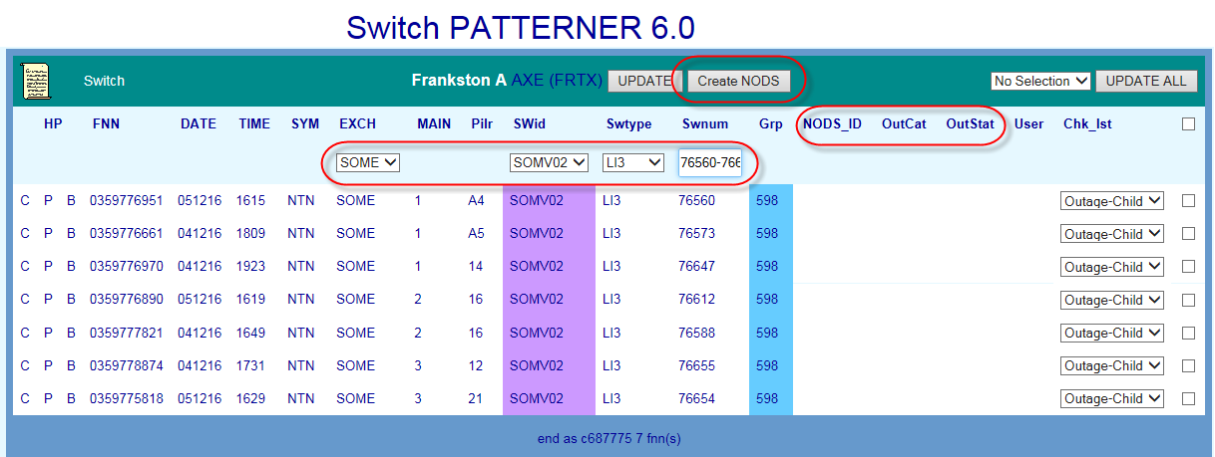

**10.7. Check off Switch Fault Pattern**

Once the pattern has been analysed and a determination made as to the findings and the

For a table of valid check off codes and their meanings refer to section 14.8

PAGE 41/86

| | SYSTEM GENERATED | 017921W14 PATTERN MANAGER 6.0

TELSTRA CORPORATION LIMITED (ABN 33 051 775 556) |

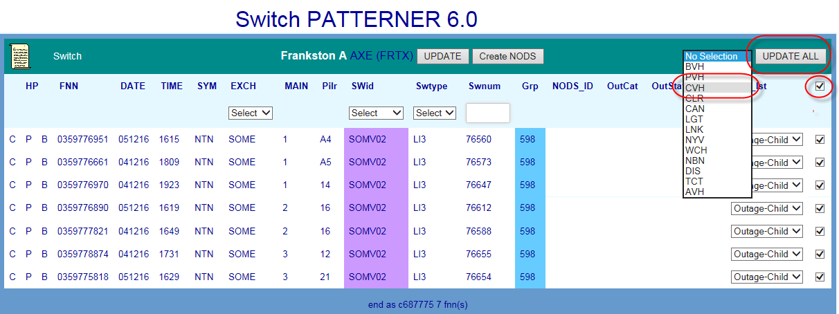

017921w14 Pattern Manager 6.0 (continued)

For detailed instructions on the above, refer section 14.7

display and the totals in the Exchange list and Region Dashboard

Click the Update or Update All buttons to save the code and update the exchange

3.

Apply the correct code

2.



various exchanges which contain fault patterns and the number of patterned faults in each.

**84.Determine the region requiring the greatest focus**

with the highest percentage of unchecked faults

with the largest volume of unchecked faults

**85.Access the required region by clicking the Region name link**

Regions are state-based with metro and country areas of the same state grouped

together

Regions are listed geographically North to South; East to West

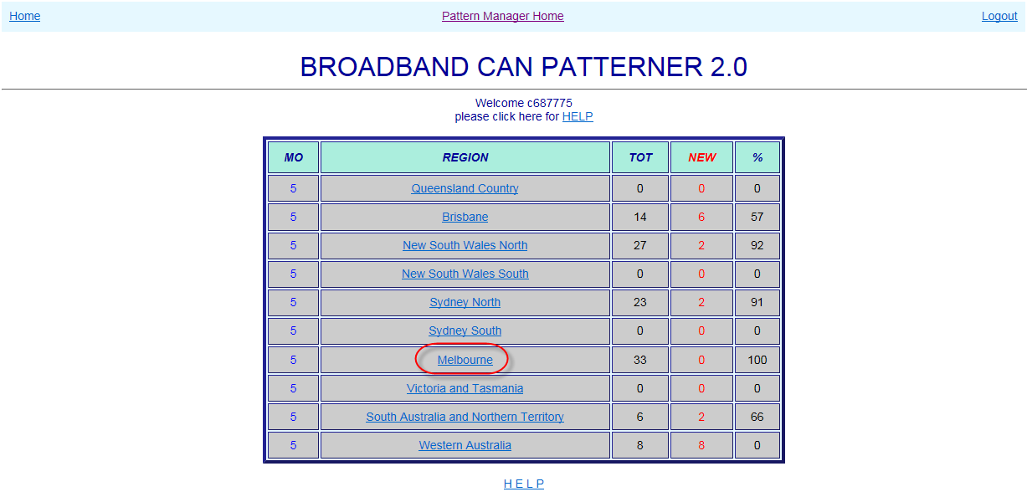

**11.2. Select Exchange**

When a Region link is clicked, the BB CAN Patterner Exchange List will open displaying the

% = percentage of patterned faults in region not yet analysed and actioned

TELSTRA CORPORATION LIMITED (ABN 33 051 775 556) |

| | SYSTEM GENERATED | 017921W14 PATTERN MANAGER 6.0

PAGE 42/86

**11.1. Select Region**



**11.**

**Broadband Patterner Version 2.0**

Broadband (BB) CAN Patterner 2.0 forms and displays broadband fault patterns related by a

common CAN copper cable network element e.g. main cable, cabinet, gateway, or pillar.

Click the BB CAN Patterner Version 2.0 link from the Pattern Manager home screen to

access BB CAN Patterner.

017921w14 Pattern Manager 6.0 (continued)

When the BB CAN Patterner Version 2.0 link is clicked, the BB CAN Patterner Region

Dashboard will open displaying the various geographical regions of the PSTN network and

the number of patterned faults in each.

The Region Dashboard allows a user to:

**83.Quickly assess the relative volumes of patterned faults per region**

MO = Mode of Operations – the number of faults which must meet patterning

criteria before a fault pattern will display in that region

TOT = total number of patterned faults per region

NEW = number of patterned faults in region not yet analysed and actioned

The following details are displayed from left to right in the middle section of the screen

with the highest percentage of unchecked faults

with the largest volume of unchecked faults

**88.Access the required exchange by clicking the Exchange link**

Exchanges are listed alphabetically

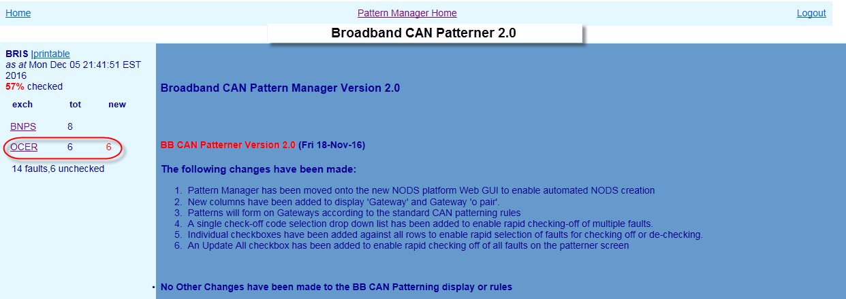

**11.3. BB CAN Exchange screen**

When an Exchange is clicked, the Exchange screen will present, displaying any related fault

patterns present in the exchange along with key information to assist with initial analysis.

Exchange List remains visible at left to allow quick selection of the next exchange.

The main section of the screen displays basic details of customer ADSL faults reports which

meet BB CAN patterning criteria (see next section 11.4).

**87.Determine the exchange requiring the greatest focus**

89. HP Hyperlinks – if the fault also appears in a fault pattern in another Patterner (e.g.

PGS) the hyperlink letter will be bold and underlined:

TELSTRA CORPORATION LIMITED (ABN 33 051 775 556) |

| | SYSTEM GENERATED | 017921W14 PATTERN MANAGER 6.0

PAGE 43/86

▪



To the right of the Exchange List a version history gives details of the changes introduced in

each successive version of Pattern Manager.

The Exchange List allows a user to:

**86.Quickly assess the relative volumes of patterned faults per exchange**

tot = total number of patterned faults per exchange

new = number of patterned faults in exchange not yet analysed and actioned

Above the exchange list are displayed:

Region name

017921w14 Pattern Manager 6.0 (continued)

‘Printable’ link providing plain text view of region

▪

Last refresh date

▪

% faults unchecked in region

▪

Below the exchange list are displayed:

Total faults in region

▪

Number unchecked faults in region

▪

The right hand PGS columns display details for DSLAM PGS e.g. AM31, AM35, ASAM, ISAM

within CAN Patterner, the NODS ID will display here

NODS manually created in native NODS will NOT display

NODS auto-created by Mozart or other external interfaces will NOT display

96. User ID of the user who has Checked off the fault pattern

97. Check List (‘Chk Lst’) indicating determination made/action taken on fault pattern

e.g. CVH – Confirmed Volume Hold – NYV – Not Yet Volume Hold (refer table section

14.8)

**NOTE**:

The left hand PGS columns display details for Access Core Large PGS e.g. CMUX, RIM, RCM,

DCS20 and SSNMUX

If a NODS has been created automatically by Priority Patterner or manually from

and CMUX (with ADSL port/card type)

TELSTRA CORPORATION LIMITED (ABN 33 051 775 556) |

| | SYSTEM GENERATED | 017921W14 PATTERN MANAGER 6.0

PAGE 44/86

DSLAM (Digital Subscriber Line Access Multiplexer) ID – Type – P/S/C e.g. AM35



C (CAN) – P (PGS) - S (Switch)

90. Faulty FNN (Full National Number)

91. Date & Time of fault report

92. Fault Symptom code (e.g. DTG - NSYN – No Sync)

93. PGS,DSLAM & basic CAN Network Elements

Access Core large PGS ID – Type – P/S/C (Panel/Slot/Channel) e.g. CMUX or RIM

Main cable/mpair – Cabinet/bpair – Gateway/opair – Pillar/opair

017921w14 Pattern Manager 6.0 (continued)

If a Network Element column is blank, that type of network element is not present in

that FNNs service

NOTE: to simplify the display and make analysis easier, only Access and DSLAM PGS and

basic CAN network elements are displayed in PGS Patterner. To see other CAN or Switch

devices present in a service or pattern it is necessary to use the hyperlinks (if active) or

consult Shazbot or NPAMS.

94. ‘X’ – Service Type as recorded in NPAMS e.g. XR = ADSL service – SS = PSTN service

(see table section x.x)

95. NODS ID

•

or…

Where there is no Pillar, in the same Gateway

Where there is no Gateway, in the same Cabinet

or…

Where there is no Pillar, Gateway or Cabinet, in the same Main Cable

and…

The O, branch or main pair is within 30 pairs of the lowest pair in the pattern

Fault pattern will be retained for 72 hours from fault report date or for the timeframe

•

configured by SOM in the ‘Update Age of Pattern Data’ table of Pattern Manager

Admin 2.0

Only the valid Symptom Code and Age of Pattern Data timeframe rules can be

Faults are in the same Pillar

changed by SOM. Changes can only be made by a user with NODS-PM Super User

Access Level via the Pattern Manager Admin function. All other rules are hard coded

into Pattern Manager.

TELSTRA CORPORATION LIMITED (ABN 33 051 775 556) |

| | SYSTEM GENERATED | 017921W14 PATTERN MANAGER 6.0

PAGE 45/86

Special patterning & display rules

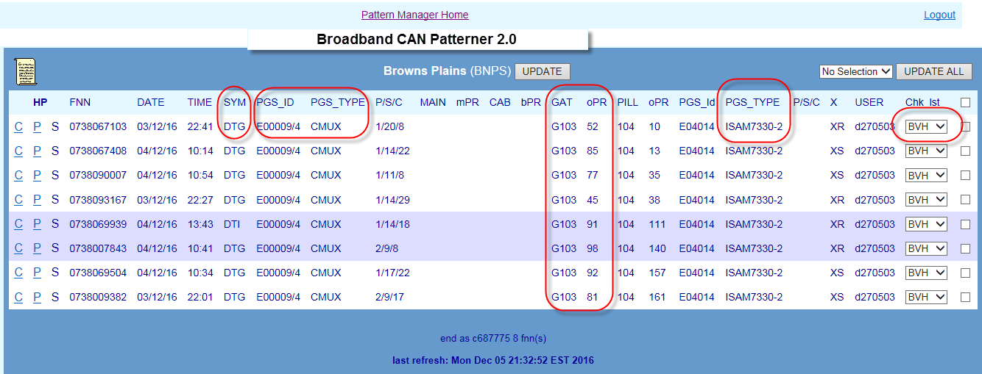

**11.4. BB CAN Fault Patterning Rules**

In CAN Patterner there are separate rules for:

Forming a pattern of faults

▪

Displaying a pattern of faults

▪

CMUX Display rules

▪

017921w14 Pattern Manager 6.0 (continued)

▪

**11.4.1.**

**Form BB CAN fault pattern**

A related fault pattern will form **in the background** in BB CAN Patterner whenever:

2 or more SIIAM customer trouble reports meet the following criteria:

•

Symptom code is one of: DTG, DTI, URS, SSI, SSS, DTA, DTB, DTC, DTD, DTE, DTF,

DTH, DTJ, DTK, DTL, DTM, DTN, DTO, DTP, DTQ, DTR, DTS, DTT, DTU, DTV, DTW,

DTX, ULI,

and…

Faults are in the same Exchange Service Area (ESA)

and…

**CMUX provides ADSL DSLAM**

E.g. P5 – pairs 3 + 9 plus 51 + 56 plus 89+ 97

▪

Each 30 pair grouping is distinguished by a band of different background colour

•

**11.4.3.**

**CMUX display rules in BB CAN Patterner**

There are special rules for the display of CMUX in BB CAN patterner:

CMUX will display differently in BB CAN Patterner depending on the network roles they play

in providing customers’ services.

**CMUX provides Access Core**

•

will display in the left hand PGS column when the CMUX is performing an Access

Core using a POTS or ISDN 2B1Q port/card or combined Access/DSLAM role using a

combination (‘combo’) port/card

“2+2+2”:

•

will display in the right hand PGS column when the CMUX is performing a purely

DSLAM role using an ADSL port/card

Refer PGS Section 9.4.3 for more detail

TELSTRA CORPORATION LIMITED (ABN 33 051 775 556) |

| | SYSTEM GENERATED | 017921W14 PATTERN MANAGER 6.0

PAGE 46/86

Admin 2.0



**11.4.2.**

**Display BB CAN fault pattern**

While a basic BB CAN fault pattern will ALWAYS form in the background of BB CAN

Patterner, fault patterns will only become visible in an Exchange screen in BB CAN Patterner

when the following criteria are met:

The above patterning rules have been met and patterns have formed in the

•

background

The number of patterned faults is equal to or greater than the patterning threshold

•

configured by SOM in the Update Patterning Threshold’ table of Pattern Manager

017921w14 Pattern Manager 6.0 (continued)

For example, when the Threshold Setting is set to ‘5’ a fault pattern will only display when

there are 5 patterned faults in the same exchange and the same pillar, etc.

Faults so displayed can be in the one 30 pair grouping or in a combination of 30 pair

•

patterns

e.g. If the Threshold was set to 5 then the rule would be met if there were:

5 faults in one 30 pair group

E.g. P5 – pairs 3 + 9 +10 +18 +25

▪

2 faults in one 30 pair group plus 3 faults in another 30 pair group or “2+3”:

E.g. P5 – pairs 3 + 9 plus 74 + 87 + 91

▪

2 faults in one 30 pair group plus 2 faults in another plus 2 faults in another or

symptom codes and contiguity of affected pairs and whether services are provided over

systems.

A primary method of determining if the BB CAN pattern is more likely to indicate a CAN

issue versus a DSLAM issue is to check the right hand PGS column:

Fault pattern with common DSLAM is more likely to be due to a broadband issue

•

Fault pattern with multiple DSLAMs may indicate a CAN issue – investigate further

•

1.

Check CONEN for a network Incident on the affected DSLAM

2.

Check WFC Outage board for a known ADSL outage on the affected DSLAM

3.

Investigate fault and network detail within the BB CAN pattern e.g. fault report times,

Complex Consultants using both the information in Pattern Manager itself and in external

common DSLAM or not.

4.

Use hyperlinks to compare fault and network detail in other Patterners e.g. which fault

pattern gives the clearer and more compelling evidence

TELSTRA CORPORATION LIMITED (ABN 33 051 775 556) |

| | SYSTEM GENERATED | 017921W14 PATTERN MANAGER 6.0

PAGE 47/86

ULL/SSS services for other Service Providers may appear in BB CAN Patterner but do

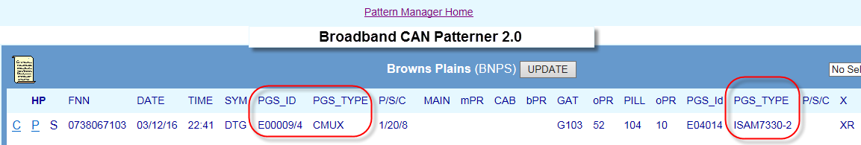

**11.4.4.**

**Special patterning & display rules**

There are some special patterning and display rules in BB CAN Patterner rules for the

display of CMUX in BB CAN Patterner:

**Control Joints**

•

Control Joints are not considered for patterning and are not displayed

**ULL/SSS services**

•

017921w14 Pattern Manager 6.0 (continued)

not utilise a Telstra DSLAM device. The right hand DSLAM PGS column will always

appear blank for ULL/SSS services

**Non-Broadband services appearing in BB CAN Patterner**

•

Some non-Broadband services are also reported using a DTP (Data Transmission

Problem) symptom code but this is not an ADSL code.

These may be ISDN, Faxstream or Dial-up Internet. These will also appear in BB CAN

Patterner. In these cases, the right hand DSLAM PGS columns will always be blank

and the ‘X’ code will be non-ADSL (e.g. ‘SS’ or ‘RA’)

**11.5. Analyse BB CAN Fault Pattern**

A related fault pattern in BB CAN Patterner is only an indication of a potential outage. To

confirm the presence of an outage to a single network element having caused all the faults

in the pattern, further detailed investigation and analysis must be conducted by SOM

2.

finding/action e.g. CVH = Confirmed Volume Hold or NYV = Not Yet Volume Hold.

Initially, when first appearing, faults in a pattern will display the SIIAM case status of the

fault when it first met Pattern Manager criteria e.g. Test-Pending or Field-Open.

There are 3 methods of applying a check-off code:

1.

Apply a common code to all faults in the Exchange using the Update All function

2.

Apply a common code to selected faults in the Exchange using the selection boxes

3.

Apply a single code to each individual fault using the individual drop down lists

To apply a check off action code to each fault in the pattern follow these basic steps:

1.

Choose the most appropriate Check off method from the above e.g. if all faults in the

exchange are part of the one outage use Method 1

action to be taken, each fault in the pattern must be ‘checked off’ to indicate this

Apply the correct code

3.

Click the Update or Update All buttons to save the code and update the exchange

display and the totals in the Exchange list and Region Dashboard

TELSTRA CORPORATION LIMITED (ABN 33 051 775 556) |

| | SYSTEM GENERATED | 017921W14 PATTERN MANAGER 6.0

PAGE 48/86

Display) network maps



5.

Investigate individual customer and fault details of each FNN in pattern, e.g. SIIAM case

details, history and notes

6.

Run a SIIAM query to identify any related faults which did not meet patterning display

criteria

7.

Investigate customer type and address patterns and pair occupancy of range in CASINO

(Clarification of Affected Services in Network Outage) tool or NPAMS

8.

Check cable location and route and relative location of faults using GDD (Graphical Data

017921w14 Pattern Manager 6.0 (continued)

9.

Test services in SULTAN or OATS particularly when there is an apparent gap in the

affected range (“testing within the range”)

10. Ring CT’s or WFC for more information

**11.6. Create NODS**

There is no functionality to enable NODS to be created directly in BB CAN Patterner.

If the evidence points strongly towards a CAN issue affecting Broadband services, this

should be brought to the attention of Assurance Ops Workflow Coordinators (WFC) so that

further investigation can be undertaken.

If it was deemed necessary to create a NODS for a BB CAN pattern, this will need to be

done in native NODS.

**11.7. Check off BB CAN Fault Pattern**

Once the pattern has been analysed and a determination made as to the findings and the

both. BVH will be applied to either an Active of Ceased WFC outage as these outages also

PAGE 49/86

| | SYSTEM GENERATED | 017921W14 PATTERN MANAGER 6.0

TELSTRA CORPORATION LIMITED (ABN 33 051 775 556) |

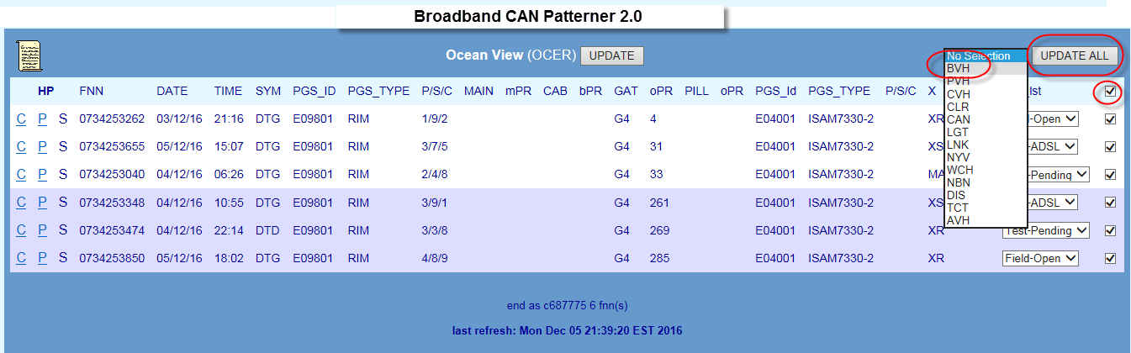

For a table of valid check off codes and their meanings refer to section 14.8

For detailed instructions on Checking off patterns, refer section 14.7

use a Callbacks process to verify restoration.

017921w14 Pattern Manager 6.0 (continued)

The WFC Outage board contains both Active and Ceased outage lists. SOM need to check

http://outageboard.in.telstra.com.au/ob/outageboard.php

This can be identified by checking the WFC Outage Board on the following URL:

BVH (Broadband Volume Hold)

SOM as belonging to an ADSL Outage already set up by WFC:

There is a specific Check Off code to indicate a fault pattern which has been identified by

**BVH Check off code**

**11.7.1.**



off with the Check Off code ‘AVH’ (Automatic Volume Hold)

CAN Patterner

•

PGS Patterner

•

Switch Patterner

•

BB CAN Patterner

•

Auto-NODS will only be created by Pattern Manager for:

CAN Priority Patterns

•

PGS Priority Patterns

•

When an Auto-NODS has been created, faults in the pattern will be automatically checked

meet the Priority patterning criteria:

SOM Complex Consultants investigate, validate and manage Priority Patterns by use of the

Priority Outage Dashboard.

Click the Priority Outage Dashboard link from the Pattern Manager home screen to access

Priority Dashboard.

TELSTRA CORPORATION LIMITED (ABN 33 051 775 556) |

| | SYSTEM GENERATED | 017921W14 PATTERN MANAGER 6.0

PAGE 50/86

•



**12.**

**Priority Outage Dashboard**

Priority Outage Dashboard displays key details of fault patterns in any of the 4 Patterners

which have met the criteria for a fast forming or large unchecked Priority Pattern (PP) alert.

Priority Patterns (PP) are those which pose the greatest risk to customer service and

business operations.

The Priority Patterning functionality is designed to assist SOM in periods of peak fault

volumes and/or natural disaster when the capability of SOM and other workgroups to

respond to the very high fault volumes can be severely tested.

There are 2 triggers for the forming and display of a Priority Pattern alert in the Dashboard:

**Fast**

017921w14 Pattern Manager 6.0 (continued)

A fault pattern has formed rapidly in a short timeframe

Configured by SOM in ‘Update Priority Thresholds’ in Pattern Manager Admin

Configured as ‘x’ number of faults per ‘y’ hours e.g. 12/6 = 12 faults in 6 hours

Fast PPs form on specific Network Elements e.g. main cables or PGS

Pattern Manager will automatically create a NODS (‘Auto-NODS’)for CAN or PGS PPs

**Unchecked**

•

A large fault pattern has not been checked off

Configured by SOM in ‘Update Priority Thresholds’ in Pattern Manager Admin

Configured as ‘x’ number of faults e.g. 20 = 20 faults unchecked

Unchecked PPs just form on the whole exchange

Auto-NODS are never created for Unchecked PPs

Priority Pattern alerts can be triggered from fault patterns in any of the 4 Patterners, if they

•

to the first FNN in the pattern for that exchange within the relevant AXE/S12 Node

**Network Element**

•

The Network element on which the Priority Pattern has formed

CAN = Main, cabinet, Gateway, Pillar or Control Joint

PGS = PGS Type e.g. RIM or RAM 8

Switch = Switching technology i.e. AXE or S12

BB Can = as per CAN

**NE ID**

If the Priority Pattern has formed on a Switch, the Exch hyperlink will take the user

TELSTRA CORPORATION LIMITED (ABN 33 051 775 556) |

| | SYSTEM GENERATED | 017921W14 PATTERN MANAGER 6.0

PAGE 51/86

•

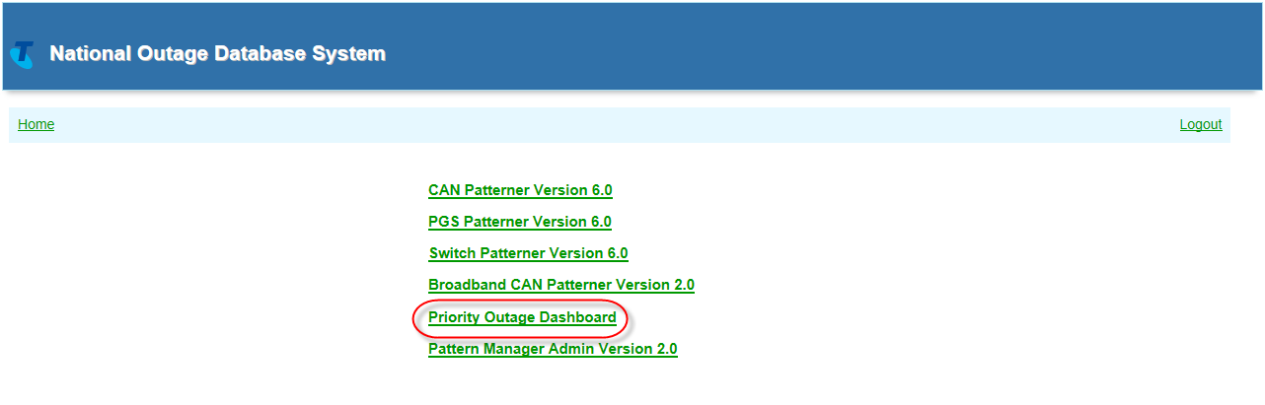

The Priority Outage Dashboard will display:

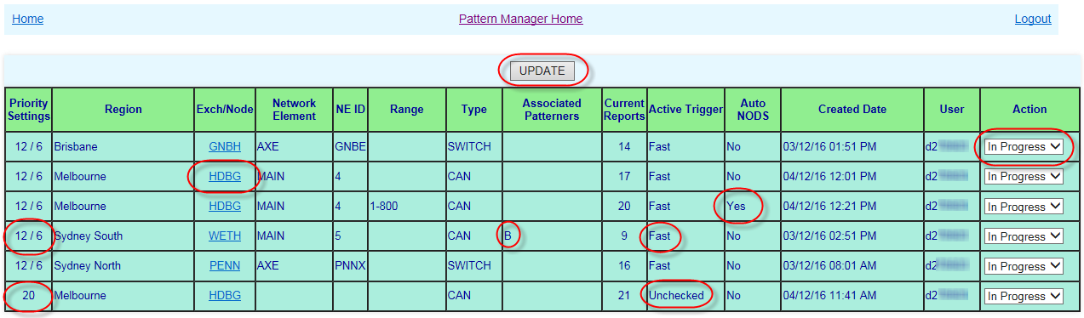

**12.1. Priority Outage Display**

The Priority Outage Dashboard displays the following information:

**Priority Settings**

017921w14 Pattern Manager 6.0 (continued)

The currently configured threshold for the type of Priority pattern e.g. 12/6 (Fast) or

20 (Unchecked)

**Region**

•

The standard pattern Manager Region in which the Priority Pattern has formed

**Exch/Node**

•

The Exchange in which the Priority Pattern has formed

Is an active hyperlink to the Exchange where the Priority pattern has formed

An Unchecked Priority Pattern (PP) will be formed in any of the 4 Patterners when the

may relate to a number of network elements e.g. more than one PGS ID

•

The PP alert will display in the Priority Outage dashboard on the whole exchange and

Unchecked Reports Threshold set by SOM in Pattern Manager Admin e.g. 20

•

The number of unchecked patterned faults in an exchange has met or exceeded the

Very simple rules apply to the patterning rules for Unchecked PPs:

current Priority Patterning criteria as configured in Pattern Manager Admin are met.

An Auto-NODS will never be created

**12.2. Priority Patterning Rules - Unchecked**

Pattern

The determination made/action taken by SOM after investigation of the Priority

•

**Action**

Dashboard

The SOM User who has actioned the Priority pattern record in the Priority Outage

•

•

**12.3. Priority Patterning Rules - Fast**

More complex rules apply to the patterning and display of Fast PPs:

The number of patterned faults has met or exceeded the threshold number set by SOM

•

in Priority Manager Admin for a particular timeframe threshold in a region e.g. a pattern

TELSTRA CORPORATION LIMITED (ABN 33 051 775 556) |

| | SYSTEM GENERATED | 017921W14 PATTERN MANAGER 6.0

PAGE 52/86

The Pair or LI/EN device range on which the Priority Pattern has formed

Since the Priority pattern record in the Dashboard represents a number of faults it is

in the Priority pattern also belong

The Standard hyperlink code letter of any other Patterners in which any of the faults

•

**Associated Patterners**

The Patterner in which the pattern has formed e.g. CAN, PGS, Switch or BB CAN

•

**Type**

not possible for this to be an active hyperlink

•

**Range**

formed

The Cable, Pillar, etc. number or PGS or Switch ID on which the Priority pattern has



017921w14 Pattern Manager 6.0 (continued)

**Current Reports**

•

The number of fault reports in the Priority patterns at the time it formed

If new fault reports again meet the Priority patterning criteria, a new Priority pattern

will be formed and displayed

**Active Trigger**

•

The trigger which caused the Priority pattern to form i.e. ‘Fast’ or ‘Unchecked’

**Auto NODS**

•

Whether or not an Auto-NODS has been created – Yes/No

**Created Date**

•

The Date and Time the Priority pattern was formed

**User**

on the RIM in PGS Patterner in Priority Outage Dashboard along with a C entry in the

E.g. a pattern of faults on a Switch meets PP criteria but is also on a main cable in

CAN patterner – a PP is formed on the main cable in CAN patterner in Priority Outage

Dashboard along with a S entry in the hyperlink column

If a fault pattern in both PGS and CAN Patterners meets PP criteria, form the PP on the

•

one with the greater number of faults in it.

E.g. a pattern of faults on a Pillar in CAN Patterner meets PP criteria but is also on a

Small PGS in PGS Patterner. There are more faults in the CAN pattern– a PP is formed

on the Pillar in CAN Patterner and displayed in Priority Outage Dashboard along with

a P entry in the hyperlink column

If a fault pattern in both PGS and CAN Patterners meets PP criteria, and the number of

•

faults in each is equal, form the PP on the PGS Patterner and element

E.g. a pattern of faults on a Cabinet in CAN Patterner meets PP criteria but is also on

a RIM in PGS Patterner. There are an equal number of faults in each – a PP is formed

next 2 rules

hyperlink column

**12.3.2.**

**Network Element rules**

As well as determining which Patterner a Priority Pattern must be formed in, Patten

Manager also has to determine on which of the Network Elements present in the faults in

the pattern it should create the PP (and the Auto-NODS).

TELSTRA CORPORATION LIMITED (ABN 33 051 775 556) |

| | SYSTEM GENERATED | 017921W14 PATTERN MANAGER 6.0

PAGE 53/86

▪



of 6 faults has been reported within a timeframe of 5 hours for NSWN region which

meets the threshold set by SOM of 6 faults in 5 hours for that region.

In addition to this basic trigger rule, additional rules apply as to:

•

Which Patterner the PP will be formed in if FNNs exist in more than one Patterner

E.g. a Fast pattern of FNNs in PGS Patterner is also present in CAN

▪

Which Network Element the PP will be formed on

E.g. will a Fast CAN pattern be formed on main cable or Pillar

▪

Which pair range (if any) the PP will be formed on

E.g. will the Fast pattern be formed on the whole PGS or just a C pair range

017921w14 Pattern Manager 6.0 (continued)

Whether a NODS will be auto-created for the Fast pattern

See the following sub-sections for details of these rules.

**12.3.1.**

**Patterner Hierarchy rule**

The Priority Patterner hierarchy rule determines in which Patterner and on which network

element the PP (and auto-NODS) is created:

If a fault pattern in any of the 4 Patterners meets PP criteria and is NOT in any other

•

patterner, form the PP on that Patterner and NE

E.g. a pattern of faults on a Switch meets PP criteria – a PP is formed on the Switch

and displayed in Priority Outage Dashboard

If a fault pattern in either Switch and/or BB CAN meets PP criteria but is also in either

•

CAN and/or PGS patterners, form the PP on either CAN or PGS Patterner according to the

Switch magazines and LI/EN ranges will always be ignored when Switch Priority

Create an Auto-NODS according to whichever of the above rules applies

•

**12.3.2.2.**

**Switch Patterner**

The following rules are used by Pattern Manager to determine the Network Element on

which to form a Fast Switch Priority pattern

If, according to Patterner Hierarchy rule, the PP will be formed on the Switch pattern…

•

Priority Pattern will form on the alpha character component of the Switch ID which

•

meets the PP Trigger criteria e.g. VPNS

E.g. If the combined total of faults across Switch Ids VPNS01, VPNS02 and VPNS03

•

meets the criteria for PP, a single PP will be created across faults in all 3 Switch IDs

and display in Priority Outage Dashboard as a single PP alert on AXE VPNS SWITCH

above rules applies

•

patterns are being created

Display PP alert details in the Priority Outage dashboard according to the above rules

•

**NOTE**: An Auto-NODS is never created for a Switch Priority Pattern

TELSTRA CORPORATION LIMITED (ABN 33 051 775 556) |

| | SYSTEM GENERATED | 017921W14 PATTERN MANAGER 6.0

PAGE 54/86

•



Pattern Manager determines the network element on which to set up a PP by the following

rules.

There are different rules for each Patterner:

**12.3.2.1.**

**PGS Patterner**

The following rules are used by Pattern Manager to determine the Network Element and

range on which to form a Fast PGS Priority pattern and Auto-NODS

If, according to Patterner Hierarchy rules, the PP will be formed on the PGS pattern…

•

Priority Pattern will form on the PGS ID e.g. TBNE RIM E9801

•

If PGS Type is RIM or CMUX and all faults are on same Panel AND Slot, create PP just

017921w14 Pattern Manager 6.0 (continued)

on that on Panel and Slot of the PGS ID e.g. TBNE RIM E9801 Panel 3 Slot 4

If PGS Type is RIM or CMUX and all faults are on same Panel but different Slots, create

•

PP just on that on the Panel of the PGS ID e.g. TBNE RIM E9801 Panel 3

If PGS Type is RIM or CMUX and faults are on different Panels, create PP on whole PGS

•

ID e.g. TBNE RIM E9801

If PGS Type is RCM, DC20 or SSNMUX create PP on whole PGS ID e.g. STHE DCS20 E20

•

If PGS Type is CAN Electronic Small PGS e.g. 6/16 or RAM 8 create PP on whole PGS ID

•

e.g. CHLT RAM8 Ph1 E7

Display PP alert details in the Priority Outage dashboard according to whichever of the

•

If no, are all services on one Gateway

Due to the number of possible Network Elements and valid cable Pair ranges involved in

CAN fault patterns, the rules which Pattern Manager uses to determine on which Network

Element and pair range to set up a CAN Priority Pattern and Auto-NODS are quite complex

If, according to Patterner Hierarchy rules, the PP will be formed on the CAN pattern…

•

Priority Pattern will form on the CAN Network Element in order of the closest to the

•

exchange which meets CAN rules #1, #2 and #3:

**CAN PP Rule #1 First decide on the Network Element on which all the faults are:**

are all services on one Main Cable

If no, are all services on one Cabinet

range on which to form a Fast CAN Priority pattern and Auto-NODS.

If no, are all services on one Pillar

If no, are all services on one Control Joint

TELSTRA CORPORATION LIMITED (ABN 33 051 775 556) |

| | SYSTEM GENERATED | 017921W14 PATTERN MANAGER 6.0

PAGE 55/86

Priority Pattern will form on the CAN Network Element closest to the exchange

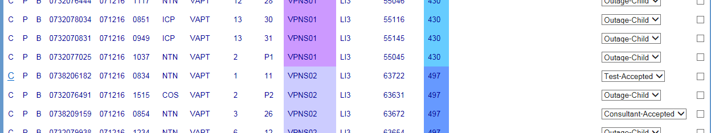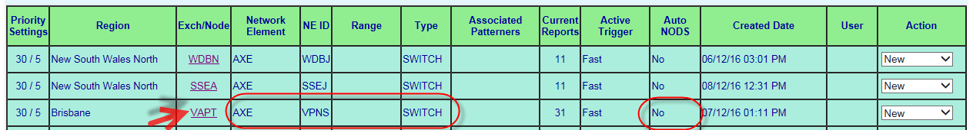

**12.3.2.3.**

**BB CAN Patterner**

The following rules are used by Pattern Manager to determine the Network Element on

which to form a Fast BB CAN Priority pattern

If, according to Patterner Hierarchy the PP will be formed on the BB CAN pattern…

•

017921w14 Pattern Manager 6.0 (continued)

•

according to the same criteria as for CAN Patterner 6.0 above

Display PP alert details in the Priority Outage dashboard according to the above rules

•

**NOTE**: An Auto-NODS is never created for a BB CAN Priority Pattern



**12.3.2.4.**

**CAN Patterner**

The following rules are used by Pattern Manager to determine the Network Element and

the following rule to determine the start and end pairs of the pair range to be used:

If yes, the does the Pillar O Pair range (if present) include a break in contiguity of >

50 pairs

If yes, the does the CJ O Pair range (if present) include a break in contiguity of > 30

pairs

If NO network element can meet either Rules #1 and #2 or #1 and #3, Pattern

•

Manager will NOT create an Auto-NODS but will display a Priority Pattern alert on the

Dashboard

If Rules #1 and #3 can be met, the first CAN network element and pair range which

•

meets Rules #1 and #3 will be selected by Pattern Manager on which to create the

CAN Priority Pattern and Auto-NODS

However, before an CAN Auto-NODS can be created, Pattern Manager must consult

•

> 50 pairs

**Rule #4 Rounding out the CAN pair ranges**

**Main Cable**

the start pair of the Auto-NODS range will be rounded down to the next even ‘100

+1’ below the lowest displayed value, including 0.

TELSTRA CORPORATION LIMITED (ABN 33 051 775 556) |

| | SYSTEM GENERATED | 017921W14 PATTERN MANAGER 6.0

PAGE 56/86

pairs



**Rule #2 next, selecting the first CAN NE above which meets Rule #1, apply Pair**

**Range Contiguity Rule #2, as follows:**

If Main Cable, does the main pair range include a break in contiguity of > 100 pairs

If yes, then does the Cabinet B Pair range (if present) include a break in contiguity of

> 50 pairs

If yes, the does the Gateway O Pair range (if present) include a break in contiguity of

> 50 pairs

If yes, the does the Pillar O Pair range (if present) include a break in contiguity of >

30 pairs

If yes, the does the CJ O Pair range (if present) include a break in contiguity of > 30

017921w14 Pattern Manager 6.0 (continued)

The first CAN network element and pair range which meets Rules #1 and #2 will be

•

selected by Pattern Manager on which to create the CAN Priority Pattern and Auto-

NODS

If NO CAN network element meets BOTH Rule #1 and #2 but can meet Rule #1 then

•

Pattern manager will use Rule #3 below

**Rule #3 next, selecting the first CAN NE above which meets Rule #1, apply Pair**

**Range Contiguity Rule #2, as follows:**

If Main Cable, does the main pair range include a break in contiguity of > 200 pairs

If yes, then does the Cabinet B Pair range (if present) include a break in contiguity of

> 100 pairs

If yes, the does the Gateway O Pair range (if present) include a break in contiguity of

▪

be Pair 800

**Pillar or Control Joint**

the start pair of the Auto-NODS range will be rounded down to the next even ‘10

+1’ below the lowest displayed value, including 0.

E.g. if the lowest pair in the pattern was 21 the start pair of the NODS range

▪

will be Pair 21

if the lowest pair in the pattern was 245 the start pair of the NODS range will

▪

be Pair 240

the end pair of the Auto-NODS range will be rounded up to the nearest ‘10’

E.g. if the highest pair in the pattern was 21 the end pair of the NODS range

▪

will be Pair 30

if the highest pair in the pattern was 383 the end pair of the NODS range will

▪

be Pair 380

**12.4. Priority Pattern Auto NODS**

As well as triggering a Priority Pattern alert on the Priority Outage dashboard, Pattern

Manager will also attempt to automatically create a NODS on the Exchange, network

element and pair range on which the Priority Pattern was formed.

Priority Patterner auto-NODS will only be created on:

TELSTRA CORPORATION LIMITED (ABN 33 051 775 556) |

| | SYSTEM GENERATED | 017921W14 PATTERN MANAGER 6.0

PAGE 57/86

will be Pair 201



E.g. if the lowest pair in the pattern was 71 the start pair of the NODS range

▪

will be Pair 1

if the lowest pair in the pattern was 245 the start pair of the NODS range will

▪

be Pair 201

the end pair of the Auto-NODS range will be rounded up to the nearest ‘100’

E.g. if the highest pair in the pattern was 71 the end pair of the NODS range

▪

will be Pair 1500

if the highest pair in the pattern was 1483 the end pair of the NODS range

▪

017921w14 Pattern Manager 6.0 (continued)

**Cabinet or Gateway**

the start pair of the Auto-NODS range will be rounded down to the next even ‘50

+1’ below the lowest displayed value, including 0.

E.g. if the lowest pair in the pattern was 71 the start pair of the NODS range

▪

will be Pair 51

if the lowest pair in the pattern was 245 the start pair of the NODS range will

▪

be Pair 201

the end pair of the Auto-NODS range will be rounded up to the nearest ‘100’

E.g. if the highest pair in the pattern was 21 the end pair of the NODS range

▪

will be Pair 50

if the highest pair in the pattern was 783 the end pair of the NODS range will

When a new Priority pattern appears in the Priority Outage Dashboard it will need to be

Auto-NODS created by Pattern Manager will have the identical attributes to one created in

native NODS by a SOM user with the following exceptions:

An Expected Restoration and ETR will ALWAYS be derived from the SOM Outage ETR

•

matrix table

There will be NO Outage Parent case or CONEN entered in the Outage Description text

•

Source System will be Pattern Manager

•

Created User will be Auto-CAN or Auto-PGS

•

Refer also work Instruction 017921w08 NODS for Service Outage Management

**12.5. Investigate Priority Pattern**

Auto-NODS are NEVER created for Switch or BB CAN Priority Patterns.

investigated by a SOM Complex Consultant.

Investigation of a Priority pattern has 3 objectives:

Validate the Priority Patterning

•

TELSTRA CORPORATION LIMITED (ABN 33 051 775 556) |

| | SYSTEM GENERATED | 017921W14 PATTERN MANAGER 6.0

PAGE 58/86

a secondary exchange which is feeding services in a smaller sub-exchange, Pattern



CAN Priority Patterns

•

PGS Priority patterns

•

Pattern Manager will use the same logic for creating the CAN or PGS Auto-NODS as it uses

to create the Priority pattern itself. Refer previous sections 12.2 and 12.3.

E.g. a Priority Pattern has been triggered by Fast criteria and has been created according to

the Patterning rules in sections 12.2 and 12.3 on PTMA PGS RIM E2013 Panel 4. An Auto

NODS will also be created on PTMA PGS RIM E2013 Panel 4.

If a PGS on which a Priority pattern and an Auto-NODS is being created is one belonging to

017921w14 Pattern Manager 6.0 (continued)

Manager will create the Auto-NODS on the secondary PGS exchange but also add the

customer sub-exchange. Refer section 9.4.4.

When Pattern Manager has been able to create an Auto-NODS for a priority pattern, the

following will occur:

The ‘Auto-NODS’ column in Priority Outage Dashboard will have a ‘Yes’ entry

•

The Auto-NODS ID will be added to the ‘NODS_ID’ column of all FNNs in the relevant

•

Patterner

If, despite using the rules in sections 12.1 and 12.3, Pattern Manager has not been able to

determine the correct Network Element and range, it will create the PP and display on the

Priority Outage Dashboard but will NOT create an Auto-NODS. The ‘auto-NODS’ column on

the dashboard will display ‘No’

Is there a valid outage?

faults)?

What needs to be done to set up the outage or perform other response (e.g. link

d.

Is the Auto-NODS correctly created?

c.

range?

Has Pattern Manager correctly identified the affected network element and

b.

8.

a.

Determine the following:

7.

procedures

Analyse the Pattern as per BAU Pattern Manager related fault pattern analysis

6.

NODS ID will be present if NODS auto-created

PAGE 59/86

| | SYSTEM GENERATED | 017921W14 PATTERN MANAGER 6.0

TELSTRA CORPORATION LIMITED (ABN 33 051 775 556) |

b.

Create manual NODS from within Patterner

c.

Update auto-NODS or…

b.

Place on Watch in dashboard and patterner(s) if more evidence required or…

a.

Carry out required actions or delegate to other SOM staff or Partners:

SOM Complex Consultants will follow this basic routine to manage Priority Outage

4.

Select ‘In Progress’ in the Action drop down list

3.

Action ‘New’ PP alerts as they appear

2.

Monitor Priority Outage Dashboard frequently and regularly thought the day

1.

Dashboard:

Review the key details of the PP in the Dashboard to quickly get a picture of size, risk

•

Perform any other required Outage Set-up actions or delegate to other SOM staff

•

Update the Auto-NODS (if one was created)



d.

PP will be Checked off ‘AVH’

a.

formed:

Click the Exchange link to open the Exchange or Node in which the Priority Pattern has

5.

What Network Element and range has the PP formed on?

e.

Where is the outage?

017921w14 Pattern Manager 6.0 (continued)

Has an Auto NODS been created

c.

How many faults in the outage?

b.

What is the Trigger?

a.

and urgency:

‘Watch’ – Priority pattern has been investigated but findings are inconclusive - awaiting

•

further evidence

‘Complete’ – Priority pattern has been investigated and validated All required actions

•

have been completed or delegated to other staff to complete e.g. update Auto-NODS,

Set up Outage, etc.

When ‘Complete’ action is selected & updated the record will clear from the Priority

Outage Dashboard but the actual related fault pattern in the relevant patterner will

remain

change the Action code to one of two outcome Actions (and click Update button):

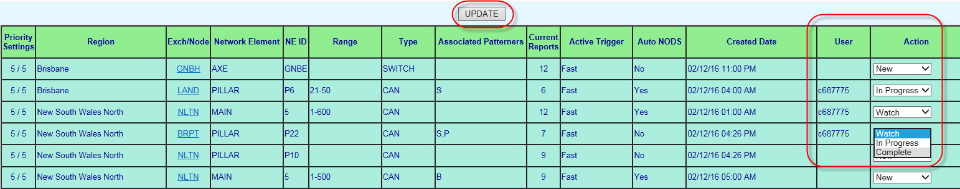

TELSTRA CORPORATION LIMITED (ABN 33 051 775 556) |

| | SYSTEM GENERATED | 017921W14 PATTERN MANAGER 6.0

PAGE 60/86

9.



d.

Set up outage Parent, Query SIIAM, create CNO Log, etc. or…

e.

Email SOM Simplex or Partners to complete the Outage setup or…

f.

Cease auto-NODS and update Patterner Check off code if an alternative

response is required e.g. Linking faults

017921w14 Pattern Manager 6.0 (continued)

Action the PP alert in the Dashboard according to the findings, as per section 12.5

below

10. Repeat the above process for the next ‘New’ PP alert

**12.6. Action Priority Pattern**

When a new Priority Pattern alert first appears in the Priority Outage Dashboard the Action

field will display ‘New’ to alert SOM Complex consultants to the need to investigate it.

When the SOM Complex Consultant commences their investigation they will change the

Action code to ‘In progress’ and click the ‘Update’ button. This will update the User field

with their User ID.

After completing required investigations and actions, the SOM Complex consultant will

2.

PAGE 61/86

| | SYSTEM GENERATED | 017921W14 PATTERN MANAGER 6.0

TELSTRA CORPORATION LIMITED (ABN 33 051 775 556) |

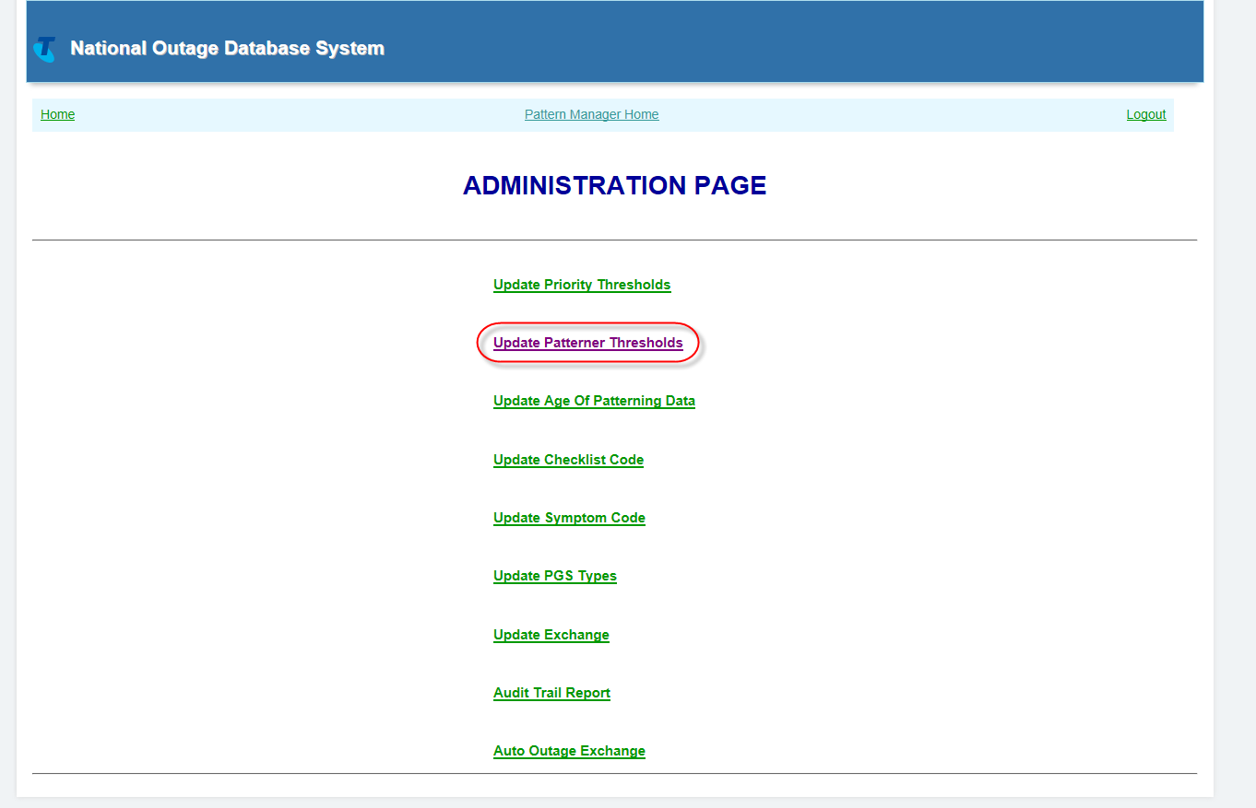

Select the required ‘Update’ option

3.

Configuration options will display

Administration Page listing the various available Threshold and Value

017921w14 Pattern Manager 6.0 (continued)

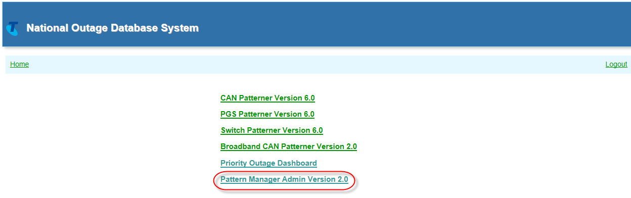

2.0 option

On the Patterner Manager Home screen, select the Pattern Manager Admin Version

1.

To access Pattern Manager Admin to make changes follow these steps:

the Pattern Manager Admin Version 2.0 link from the Pattern Manager Home screen.

Only SOM staff with SOM NODS-PM Super User access level are able to see and access

Manager forms and displays fault patterns.

Pattern Manager Admin Version 2.0 allows SOM staff to configure the way Pattern

**Pattern Manager Admin Version 2.0**

**13.**



Allows SOM Manager to keep track of changes in order to ensure that

**Update PGS Types**

Allows SOM to include new PGS types into Pattern Manager or to delete obsolete types

withdrawn from service

**104.**

**Update Exchange**

Allows SOM to add new or delete obsolete exchanges or to move exchanges between

Regions (e.g. to align with Regional restructures)

**105.**

**Auto Outage Exchange**

Allows SOM to exclude exchanges from having NODS auto-created. This is most

commonly done for exchanges which have been asset transferred to Nbnco

**106.**

**Audit Trail Report**

**103.**

Required changes have been made

▪

Due process and governance has been followed

▪

TELSTRA CORPORATION LIMITED (ABN 33 051 775 556) |

| | SYSTEM GENERATED | 017921W14 PATTERN MANAGER 6.0

PAGE 62/86

**99.Update Patterner Thresholds**



The following functions can be configured from Pattern Manager Admin Version 2.0

option:

**98.Update Priority Thresholds**

Allows SOM to change the thresholds at which a fault pattern will be deemed a Priority

Pattern

There are 2 Priority Patterning thresholds:

Fast Forming

▪

Large Unchecked

▪

017921w14 Pattern Manager 6.0 (continued)

Allows changes to be made to the minimum number of patterned faults which will be

displayed in a pattern for each Patterner and Region.

Allows SOM to respond quickly to changes in workload, staffing and other operational

requirements in order to maintain the most efficient, effective outage identification

**100.**

**Update Age of Patterning data**

Allows SOM to change the timeframe in which faults will remain in Pattern Manager

**101.**

**Update Checklist Code**

Allows SOM to add new check-off codes or delete obsolete ones

**102.**

**Update Symptom Code**

Allows SOM to modify the types of faults considered as candidates for patterning.

pattern

Review results of the change

•

Document adopted changes

•

Long term general changes should be documented by updating this work instruction

017921w14 Pattern Manager 6.0

Short Term changes which are likely to be adopted as a Mode of Operations may need

to be documented in other work instructions such as 017921w01 SOM Natural

Disasters as well this work instruction.

**13.2. Update Priority Thresholds**

The Update Priority Threshold option allows SOM Super Users to reconfigure the triggers

for forming Priority Patterns:

Reset number of faults and required timeframe to form a ‘Fast Forming’ priority

•

the change

Reset number of unchecked faults required to form an ‘Unchecked’ priority pattern

•

The ‘Current Priority Outage Threshold values’ table displays the current thresholds for

each Priority pattern type and each region.

TELSTRA CORPORATION LIMITED (ABN 33 051 775 556) |

| | SYSTEM GENERATED | 017921W14 PATTERN MANAGER 6.0

PAGE 63/86

changes to systems, process or business objectives



**NOTE:** Changes made in SOM Admin 2.0 will only take effect at the next system update.

Pattern Manager updates (refreshes) approximately every 10 - 15 minutes. Refer to

Section 8.3 Patterner System Refresh Rates Table 9 for details on how to calculate when

the changes will take effect.

**13.1. Guidelines for Pattern Manager Admin changes**

Changes to Pattern Manager Admin settings can be made in order to implement:

General, long-term system, process and operational performance improvements as a

•

result of

continuous improvement, new initiatives, troubleshooting, feedback, etc. or

017921w14 Pattern Manager 6.0 (continued)

Short Term, local changes to manage a local, short duration issue e.g.

•

Peak workload or natural disaster

To ensure that changes made to pattern Manager have the desired positive outcomes, the

following guidelines should be followed:

Propose changes on the basis of clear thinking and evidence

•

Test changes in a low risk way, e.g. by introducing to one region

•

Advise other users of the change and the reason

•

Advise other users of any changes to their ways of working as a result of

•

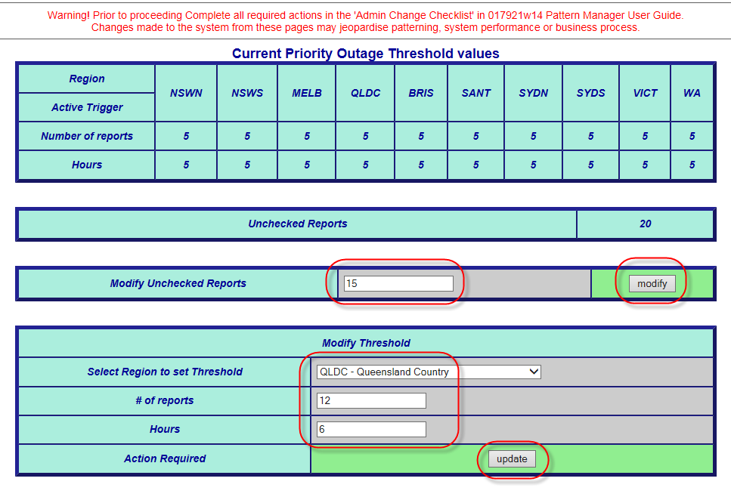

In ‘# of reports’ type the number of faults necessary to trigger a Priority pattern

e.g. ‘12’

4.

In ‘Hours’ type the number of hours in which the above number of faults must be

reported in order to trigger a Priority Pattern e.g. ‘6’

5.

Click Update button

**NOTE**: Different thresholds can be set for different regions. The threshold for fast

patterns will apply to ALL Patterners in the selected Region

3.

TELSTRA CORPORATION LIMITED (ABN 33 051 775 556) |

| | SYSTEM GENERATED | 017921W14 PATTERN MANAGER 6.0

PAGE 64/86

3.



**To re-configure the Priority Pattern Unchecked Threshold follow these steps:**

1.

On Administration Page select the ‘Update Priority Thresholds’ option

2.

In ‘Modify Unchecked Reports’ type the new number of faults at which a Priority

pattern will be triggered e.g. ‘15’

017921w14 Pattern Manager 6.0 (continued)

Click Modify button

**NOTE**: The Unchecked value always applies to ALL Patterners in ALL Regions

**To re-configure the Priority Pattern Fast Forming Threshold follow these steps:**

1.

On Administration Page select the ‘Update Patterner Thresholds’ option

2.

In ‘Select Region to set Threshold’ select the required Region from the drop down

list e.g. QLDC – Queensland Country

when change will occur.

c.

Required Patterner

3.

Click ‘Update’ button

4.

To make multiple selections, repeat steps ‘6’ and ‘7’

5.

Return to selected Patterner Region dashboard – ‘MO’ (Mode of Operations) column

will now display new updated threshold in **blue**

6.

Change to fault threshold will take place at next refresh - note time on the Exchange

Selection list that the system was last refreshed and add 10 minutes to calculate

Required Region

7.

Advise users

TELSTRA CORPORATION LIMITED (ABN 33 051 775 556) |

| | SYSTEM GENERATED | 017921W14 PATTERN MANAGER 6.0

PAGE 65/86

If Brisbane and QLDC are then reset to 3, fault patterns will appear earlier in those



**13.3. Update Patterner Thresholds**

The Update Patterner Threshold option allows SOM Super Users to reset the number of

faults in a pattern at which a Pattern Manager will display a related fault pattern.

Different threshold can be applied for different Patterners and for different regions in

Patterners

E.g. If all regions in CAN Patterner are set to a threshold of ‘5’, patterns will not be

presented until there are at least 5 faults in the same exchange and same pillar

which are in 30 pair groupings.

017921w14 Pattern Manager 6.0 (continued)

particular regions, when there are only 3 faults in a pattern.

The fault display threshold settings for each Patterner/Region are also known as the Mode

of Operation (‘MO’). The Patterner Threshold applied will appear.

To re-configure the Patterner Thresholds follow these steps:

1.

On Administration Page select the ‘Update Patterner Thresholds’ option

2.

In the ‘Modify Thresholds’ window enter the required values:

a.

New Threshold number

b.

In Modify Data Age, in data Age (in days) select the required number of days the

PAGE 66/86

| | SYSTEM GENERATED | 017921W14 PATTERN MANAGER 6.0

TELSTRA CORPORATION LIMITED (ABN 33 051 775 556) |

**NOTE**: The Age of Data value selected will apply to ALL Patterners in ALL Regions

Click Update button

4.

fault pattern is to remain active in Pattern Manager e.g. ‘5’

017921w14 Pattern Manager 6.0 (continued)

3.

‘Age of patterning data (days)’ field displays the current setting

2.

On Administration Page select the ‘Update Age of Patterning Data’ option

1.

To re-configure the Age of Patterning Data timeframe follow these steps:

timeframe on which a fault pattern will be retained in Pattern Manager prior to expiring.

The Update Age of Patterning Data option allows SOM Super Users to modify the

**13.4. Update Age of Patterning Data**

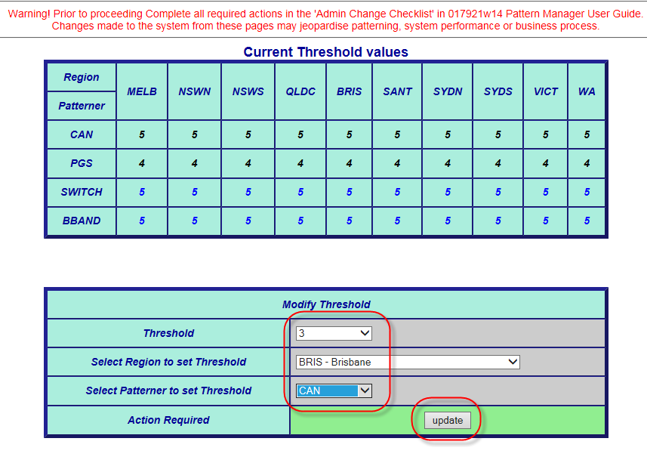

5.

To make multiple selections, repeat steps ‘6’ and ‘7’ or ‘6’ and ‘8’

6.

The new code will now be available immediately in the Check code drop down list

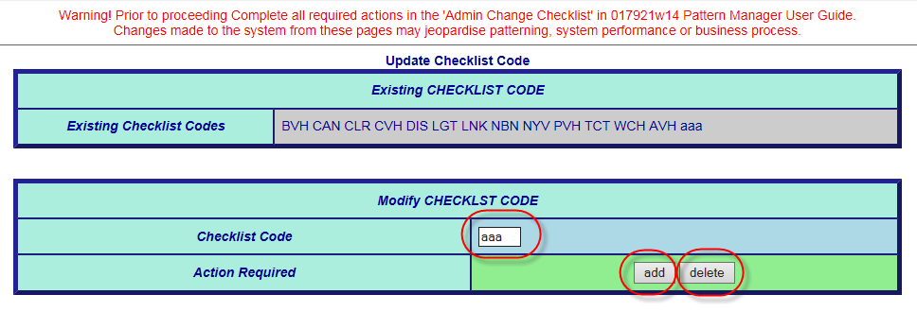

**13.6. Update Symptom Code**

The Update Symptom Codes option allows SOM Super Users to add new or delete existing

SIIAM fault symptom codes.

To re-configure the Symptom Code List follow these steps:

Click ‘Delete’ button to delete an existing code

TELSTRA CORPORATION LIMITED (ABN 33 051 775 556) |

| | SYSTEM GENERATED | 017921W14 PATTERN MANAGER 6.0

PAGE 67/86

To re-configure the Check Off Code List follow these steps:

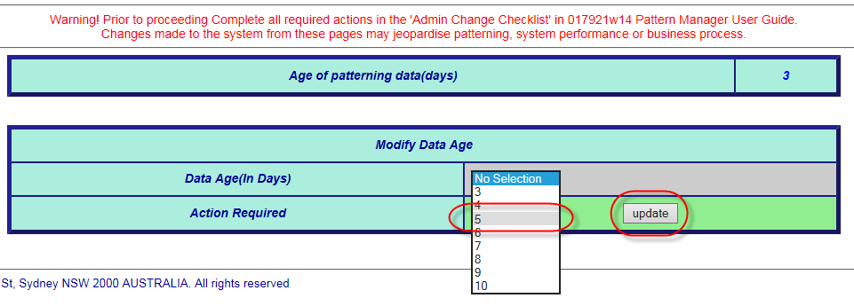

**13.5. Update Checklist Code**

The Update Checklist Codes option allows SOM Super Users to add new or delete or

modify existing Checklist codes

Checklist codes represent standard options for the way SOM actions related fault

patterns.

017921w14 Pattern Manager 6.0 (continued)

1.

On the Administration page, select the ‘Update Checklist Codes’ option

2.

In the ‘Modify Checklist Codes’ window enter the required Checklist code to be

added or deleted:

3.

Click ‘Add’ button to add a new code

4.

•

Gain System (PGS) types.

Changes to PGS type would normally only be made when:

New PGS Types are introduced into service

•

Older existing PGS types are withdrawn from service

•

Pattern Manager only recognises PGS Types which are entered in the precise format used

by SIIAM – the system from Pattern Manager collects its data.

Each PGS Type must be allocated a ‘PGS Class’ i.e. network role. There are 3 PGS Network

roles recognised by pattern Manager:

Access Core (large PGS e.g. CMUX, RIM, etc.)

The Update PGS types option allows SOM Super Users to add new or delete existing Pair

CAN electronic (small PGS e.g. RAM 8, SCADS, etc.)

•

TELSTRA CORPORATION LIMITED (ABN 33 051 775 556) |

| | SYSTEM GENERATED | 017921W14 PATTERN MANAGER 6.0

PAGE 68/86

Click ‘Delete’ button to delete an existing code



1.

On the Administration Page, select the ‘Update Symptom Codes’ option

2.

In the ‘Modify Symptom Codes’ window enter the required Symptom code to be

added or deleted:

3.

Click ‘Add’ button to add a new code

4.

017921w14 Pattern Manager 6.0 (continued)

To make multiple selections, repeat steps ‘6’ and ‘7’ or ‘6’ and ‘8’

5.

6.

Change to symptom codes included in fault patterns will take place at next refresh

- note time on the Exchange Selection list that the system was last refreshed and

add 10 minutes to calculate when change will occur.

7.

Advise other users of change and reason

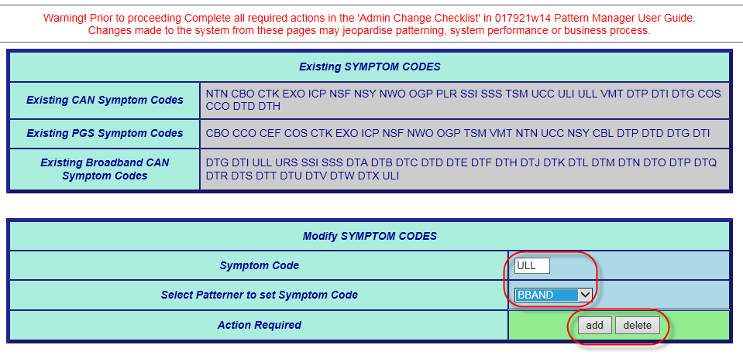

**13.7. Update PGS Type**

•

Advise other users

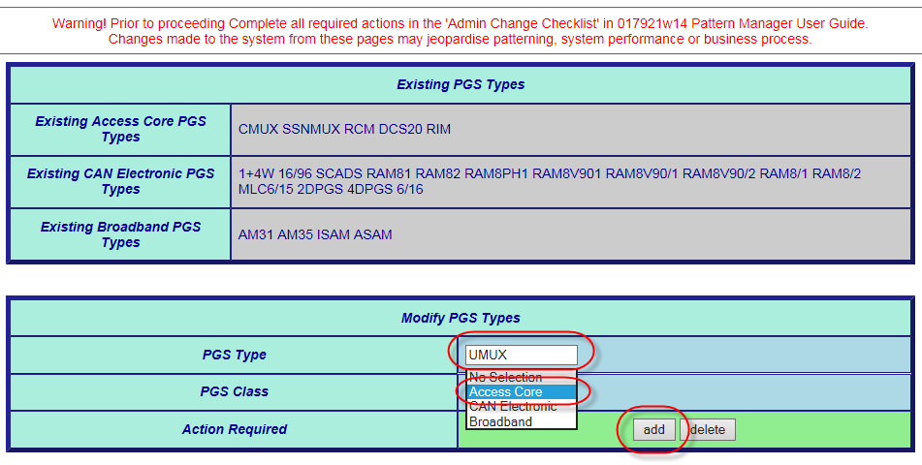

**13.8. Update Exchange**

Clicking the Update Exchange option allows SOM Super Users to add new or delete

existing Exchanges or to move an existing exchange from one Pattern Manager Region to

another (e.g. from country to metro).

Changes to Exchange will be rare and would normally only be made when:

New exchange has been commissioned

•

Old exchange has been decommissioned

•

A Regional restructure has caused an exchange previously in a country area

8.

to now be metro (or vice versa)

To re-configure the Exchange List follow these steps:

TELSTRA CORPORATION LIMITED (ABN 33 051 775 556) |

| | SYSTEM GENERATED | 017921W14 PATTERN MANAGER 6.0

PAGE 69/86

3.



ADSL DSLAM (e.g. AM35, ISAM, etc.)

•

To re-configure the PGS Type List follow these steps:

1.

On Administration Page, select the ‘Update PGS Types’ option

2.

In the ‘Modify PGS Types’ window enter the required ‘PGS Type’ to be added or

deleted:

017921w14 Pattern Manager 6.0 (continued)

In the ‘PGS Class’ field enter the required network role e.g. ‘Access Core’

4.

Click ‘Add’ button to add a new type

5.

Click ‘Delete’ button to delete an existing type

6.

To make multiple selections, repeat steps ‘8’, ‘9’ and ‘10’ or ‘8’, ‘9’ and ‘11’

7.

Change to PGS Type included in fault patterns will take place at next refresh - note

time on the Exchange Selection list that the system was last refreshed and add 10

minutes to calculate when change will occur.

removed

Clicking the Update Auto Outage Exchange option allows SOM Super Users to add

Exchanges to an ‘exclusion’ list which will prevent Pattern Manger from creating auto-

outages on these exchanges.

This is primarily used to prevent inappropriate outages being automatically set up on

exchanges whose CAN copper cables have been asset-transferred to Nbnco.

To update the Auto-Exchange exclusion List follow these steps:

1.

On Administration Page, select the ‘Update Auto Exchange’ option

2.

In the ‘Modify Exchange’ window enter the required ‘Exchange code’ to be added

or deleted:

3.

In the ‘Region from’ field enter the Region from which the exchange is to be

**13.9. Update Auto Outage Exchange**

4.

In the ‘Region to’ field enter the Region to which the exchange is to be moved

5.

Click ‘Add’ button to add a new exchange

TELSTRA CORPORATION LIMITED (ABN 33 051 775 556) |

| | SYSTEM GENERATED | 017921W14 PATTERN MANAGER 6.0

PAGE 70/86

5.



1.

On Administration Page, select the ‘Update Exchange’ option

2.

In the ‘Modify Exchange’ window enter the required ‘Exchange code’ to be added

or deleted:

3.

In the ‘Region from’ field enter the Region from which the exchange is to be

removed

4.

In the ‘Region to’ field enter the Region to which the exchange is to be moved

017921w14 Pattern Manager 6.0 (continued)

Click ‘Add’ button to add a new exchange

6.

Click ‘Delete’ button to delete an existing exchange

7.

Click ‘Move’ button to move an existing exchange

8.

To make multiple selections, repeat steps ‘8’, ‘9’ and ‘10’ or ‘8’, ‘9’ and ‘11’

9.

Change to Exchange included in fault patterns will take place at next refresh - note

time on the Exchange Selection list that the system was last refreshed and add 10

minutes to calculate when change will occur.

10. Advise other users

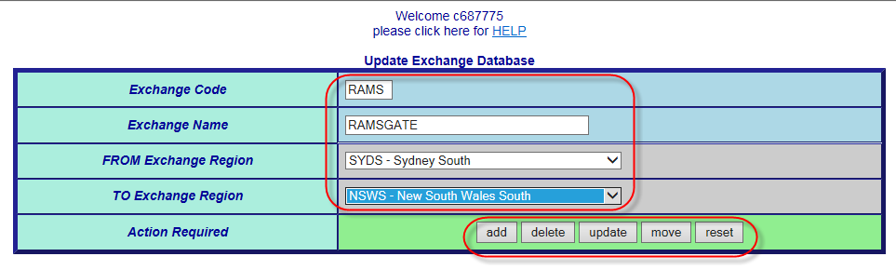

Click ‘Submit’ button to produce the report

Identify a valid business need to access the Audit Trail report

2.

On the main Patterner Selection screen, select the SOM Administrator option

3.

On the SOM Administration screen, select the ‘Audit Trail Report’ option

4.

In the ‘Audit Trail Report’ window enter the following details:

a.

From date (dd/mm/yyyy)

b.

To date (dd/mm/yyyy)

c.

Module (i.e. SOM Admin setting change e.g. Symptom Codes)

5.

1.

6.

At the ‘File Download’ window (Audit Trail.csv) click the following buttons:

a.

‘Open’ – to open the Report as csv file on user’s desktop

TELSTRA CORPORATION LIMITED (ABN 33 051 775 556) |

| | SYSTEM GENERATED | 017921W14 PATTERN MANAGER 6.0

PAGE 71/86

10. Advise other users



6.

Click ‘Delete’ button to delete an existing exchange

7.

Click ‘Move’ button to move an existing exchange

8.

To make multiple selections, repeat steps ‘8’, ‘9’ and ‘10’ or ‘8’, ‘9’ and ‘11’

9.

Change to Exchange included in fault patterns will take place at next refresh - note

time on the Exchange Selection list that the system was last refreshed and add 10

minutes to calculate when change will occur.

017921w14 Pattern Manager 6.0 (continued)



**13.10. Audit Trail Report**

Clicking the ‘Audit Trail Report’ option allows users with a SOM Administrator access

profile to produce a report listing all SOM Administrator changes made, when and by

whom for the specified period.

This report is normally accessed by the SOM Team Manager to:

Ensure due governance over Pattern Manager changes

•

Maintain the integrity of Pattern Manager patterning effectiveness

•

Investigate issues, complaints or Post Incident Reviews (PIR)

•

**Step-by-step instructions for accessing Audit Trail Report**

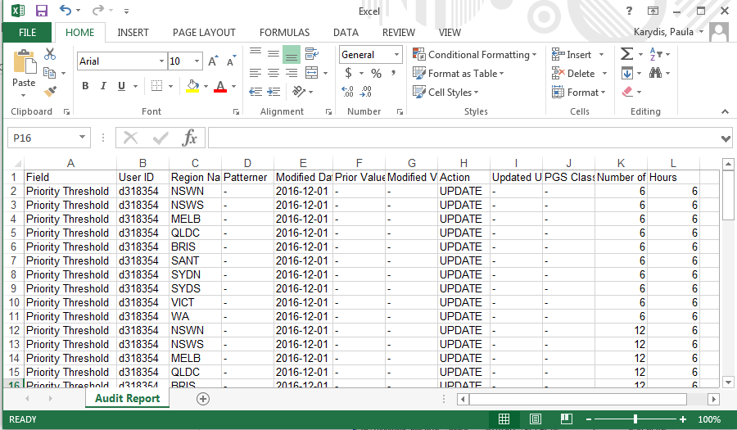

PAGE 72/86

| | SYSTEM GENERATED | 017921W14 PATTERN MANAGER 6.0

TELSTRA CORPORATION LIMITED (ABN 33 051 775 556) |

017921w14 Pattern Manager 6.0 (continued)

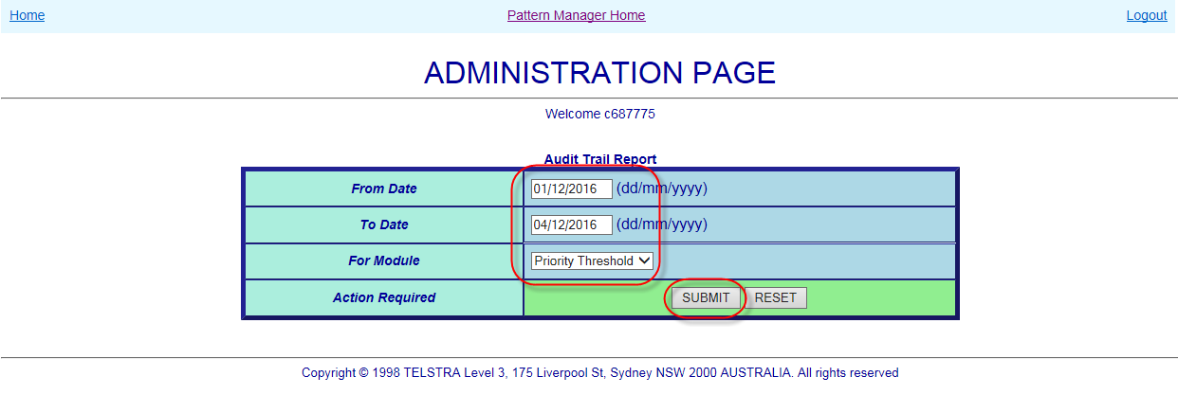

The csv report will display/be available as in the example below.

7.

drive

‘Save’ – to save the report as csv file to selected location on user’s hard

b.



Click ‘OK’ to return to the Administration Page and enter correct/missing information.

PAGE 73/86

| | SYSTEM GENERATED | 017921W14 PATTERN MANAGER 6.0

TELSTRA CORPORATION LIMITED (ABN 33 051 775 556) |

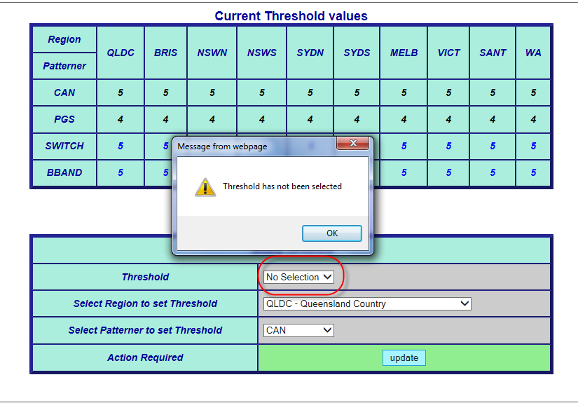

017921w14 Pattern Manager 6.0 (continued)

Manager Admin options, a pop-up error message will display similar to below

If invalid information is entered or required information is not entered on any of the Pattern

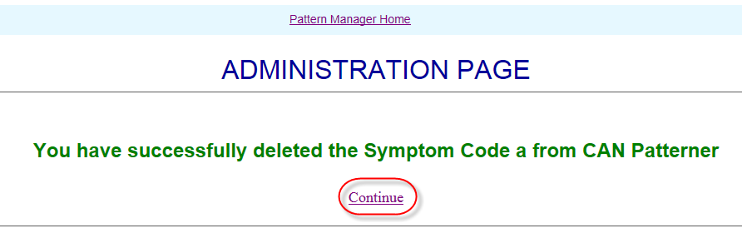

Select ‘Continue’ to return to Administration Page

completed, a success message will display.

When an Update to one of the Pattern Manager Admin settings has been successfully

**13.11. Pattern Manager Admin Messages**

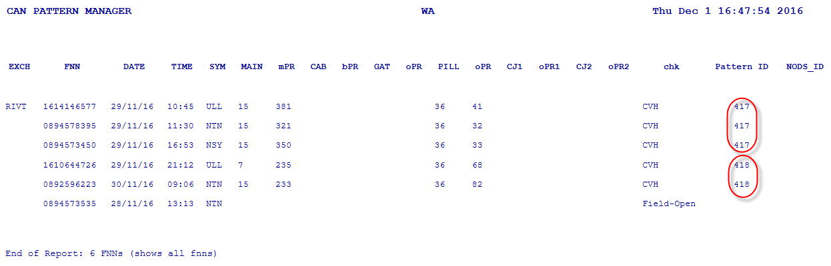

1.

Click on the ‘Scroll’ icon at the left of the blue banner

2.

A new tab will open displaying the exchange fault pattern in plain text

3.

The individual patterns will be denoted by separate Pattern Ids

**Region Fault Pattern plain text view**

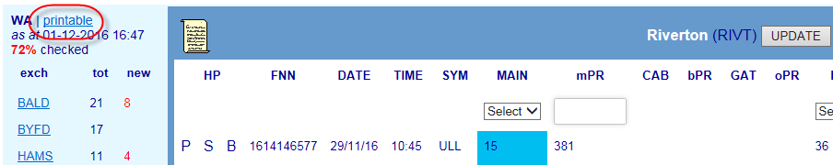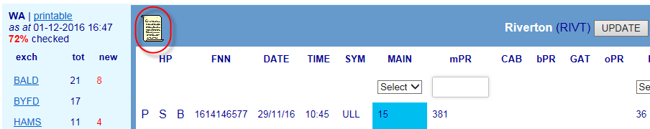

TELSTRA CORPORATION LIMITED (ABN 33 051 775 556) |

| | SYSTEM GENERATED | 017921W14 PATTERN MANAGER 6.0

PAGE 74/86

**14.1. Plain Text View**



**14.**

**Functionality common to all Patterners**

The following sections describe key functionality, common to all the patterners, in detail.

The order of the following sections follows the approximate order in which each function will

be encountered in the Patterners from left to right.

017921w14 Pattern Manager 6.0 (continued)

Each Exchange and Region can be viewed in plain text view for printing, emailing etc. One

advantage of the plain view is that each separate pattern is identified by a unique ID.

There are 2 plain views available:

Exchange plain text view

•

Region plain text view

•

**Exchange plain text**

When a FNN also appears in another Patterner, that code letter will be “active” – i.e.

C

CAN Patterner

−

P

PGS Patterner

−

S

Switch Patterner

−

B

Broadband CAN Patterner

−

Patterner has been allocated a ‘HP’ hyperlink code letter:

•

blue underlined text e.g. P

TELSTRA CORPORATION LIMITED (ABN 33 051 775 556) |

| | SYSTEM GENERATED | 017921W14 PATTERN MANAGER 6.0

PAGE 75/86

The ‘HP’ columns at the extreme left of the Exchange Pattern screen contain hyperlinks to

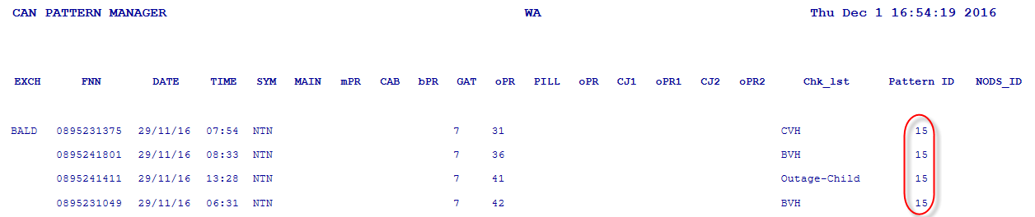

1.

Click on the ‘printable’ hyperlink above the Region List

2.

A new tab will open displaying ALL exchange fault patterns in the region in plain

text

The individual patterns in each exchange will be denoted by separate Pattern Ids

3.

**14.2. Hyperlinks to Other Patterners**

017921w14 Pattern Manager 6.0 (continued)

other Patterners whenever an FNN in one Patterner also appears in another e.g. when a

fault which has patterned on a common Pillar in CAN Patterner may also appears in PGS

Patterner because it has patterned on a common RIM PGS.

Hyperlink function allows cross-referencing between Patterners to discover the true

underlying common network element.

Hyperlink function is used because it is not practical to pattern on and display all network

elements that might provide a service on the one screen.

•

E

a

ch

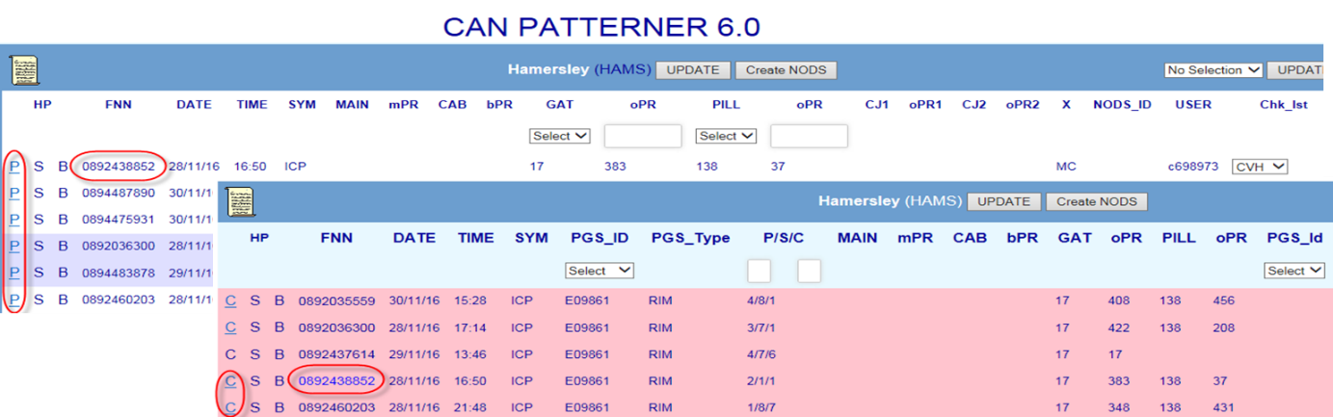

❒





Outgoing (call) Problem

OGP

❒





IVR created fault on Network Facility NODS

NWO



❒

❒

Pillar (damage / wires exposed)

PLR





Noisy

NSY

❒

❒





Non-Standard Fault

NSF

NTN

❒





No Tone



❒



Unconditioned Local (Loop) Interference

ULI

❒





PAGE 76/86

| | SYSTEM GENERATED | 017921W14 PATTERN MANAGER 6.0

TELSTRA CORPORATION LIMITED (ABN 33 051 775 556) |

Underground Cable Cut



❒



Unconditioned Local Loop

ULL



❒



Spectrum Sharing Service

SSS



❒



Spectrum Sharing (Service) Interference

SSI

❒

UCC





Transmission Problems

TSM

Cable (on customers’ premises) Problem

❒



❒

CBL

❒



❒

Calls Cutting Off

CCO

❒





IVR created fault on Cable Cut NODS

CBO

The windows can then be arranged to best view and compare the pattern

service and which appear in P{pattern manager fault pattern displays:

consultants to represent the problem being experienced by the customer with their PSTN

The following table lists standard SIIAM Symptom (Report) codes selected by FOH

**14.3. Table of PSTN Symptom Codes**

Clicking the ‘X’ in the new tab will close it and return the user to the original Patterner.

information

−

screen with the selected FNN highlighted in blue text

−

The other Patterner will open - in a new tab - displaying its Exchange Fault Pattern

•

When an active hyperlink is clicked the following will occur:

then the FNN does not appear in that Patterner.

•

If a code letter against a particular FNN appears in plain black text and not underlined



**N**

**S**

**CODE**

**CA**

**CAN**

**DESCRIPTION**

**PG**

**SYM**

**BB**

IVR created fault on Exchange NODS

EXO





❒

❒

Data Transmission Problem e.g. ISDN, Fax or Dial-up

DTP

❒





Incoming Call Problem

ICP

❒





❒

COS

❒

Customer Equipment Fault

CEF

❒





Cross-talk

CTK

017921w14 Pattern Manager 6.0 (continued)

❒



❒

Cut Off (while) Speaking

WIRELESS DROP

wireless

DTO

DTN

Loss of connectivity/intermittent problem -

DTR

WIRELSS NNSY

DTQ

No sync – new service - wireless

WIRELESS NDAT

No data flow - wireless

Self-instal failure

DTK

DOCT

WIRELESS DOCT

Tech visit required-wireless

DTM

WIRELESS AUTH

Fails to authenticate on connection-wireless

DTL

Connectivity issues - wireless

DTX

Web browser issues - wireless

DTV

PAGE 77/86

| | SYSTEM GENERATED | 017921W14 PATTERN MANAGER 6.0

TELSTRA CORPORATION LIMITED (ABN 33 051 775 556) |

screen as soon as an outage has been analysed and confirmed.

outage notification (which will appear in SIIAM) directly from within the Patterner Exchange

The Create NODS functionality allows SOM consultants to immediately create a NODS

**14.5. Create NODS from Patterner**

DTS

WIRELESS SPEE

Speed-related issue - wireless

WIRELESS NSYNC

No sync – existing service - wireless

WIRELESS TIME

Email issues - wireless

DTU

Tech visit required

Times out when connecting - wireless

DTT

character Symptom (Report) codes selected by FOH consultants to represent the problem

**SIIAM SYM**

manager fault pattern displays:

being experienced by the customer with their ADSL service and which appear in Pattern

**DESCRIPTION**

The following table lists the 3 character code conversion from the standard SIIAM 4

**14.4. Table of ADSL Symptom Codes**

❒

Fails to authenticate on connection

DTC



**CODE**

**ADSL SYM CODE**

Unconditioned (Local Loop) Reliability Standard (breached)

URS







Voices Music Tones (on line)

VMT



❒

NSYN

Speed-related issue

DTH

No sync – existing service

DTG

DTJ

TIME

Times out when connecting

DTI

SPEE

DTE

DROP

Loss of connectivity/intermittent problem

DTD

AUTH

NNSY

No sync – new service

DTF

017921w14 Pattern Manager 6.0 (continued)

NDAT

No data flow

Created User of the name of the consultant who used the function

3.

Click Create NODS button

A NODS will be created ‘semi-automatically’

NODS ID will appear in the NODS column

User can click the NODS ID link to view and update the NODS

The NODS will be created by Pattern Manager with the standard values, ETR and

Outage Description as used by SOM to create manual NODS

A CVH check-off code will be automatically applied

Some information, e.g. Parent case and CONEN ID and instructions to offer interims

will have to be manually added by using the NODs Update button

NODS created this way will have a Source System of ‘Pattern Manager’ and a

Enter the pair range 81-100



TELSTRA CORPORATION LIMITED (ABN 33 051 775 556) |

| | SYSTEM GENERATED | 017921W14 PATTERN MANAGER 6.0

PAGE 78/86

Switch Patterner



This reduces the amount of time and ‘swivel-chairing’ necessary to set-up outages and to

notify FOH and customers.

The Create NODS functionality is available in the following Patterners:

CAN Patterner

•

PGS Patterner

•

017921w14 Pattern Manager 6.0 (continued)

•

Follow these steps to Create a NODS using the PM Create NODS function

1.

From the information in Pattern Manager and external systems (e.g. CASINO, GDD, etc.)

confirm the outage and determine the correct network element and pair range

E.g. network element Pillar P1 and O pair range 81-100 have been determined as

the correct scope

2.

Using the drop down boxes select:

The CAN network element - P1

017921w14 Pattern Manager 6.0 (continued)

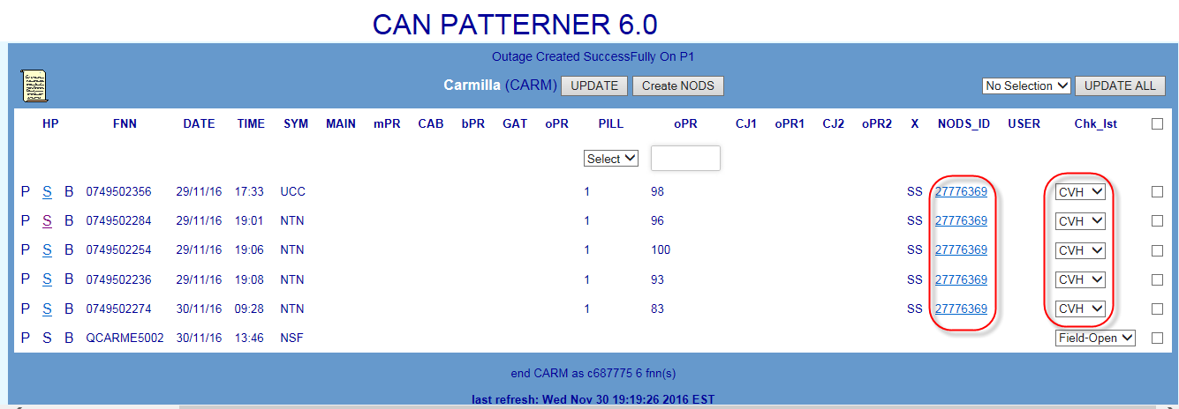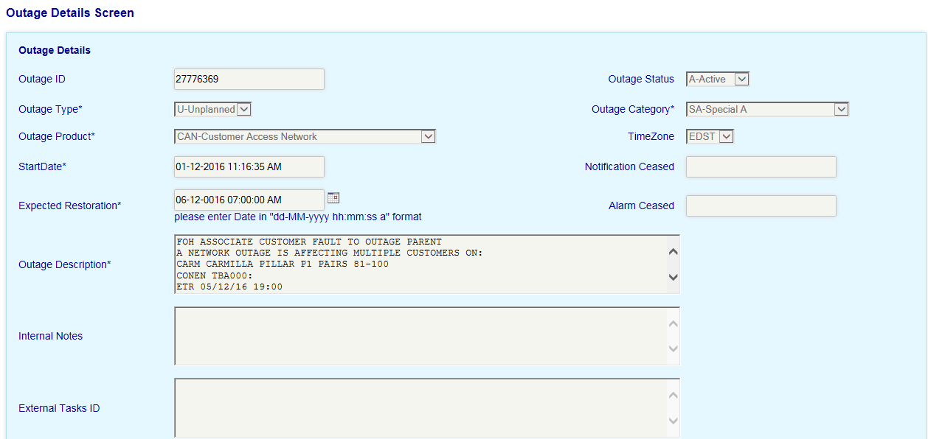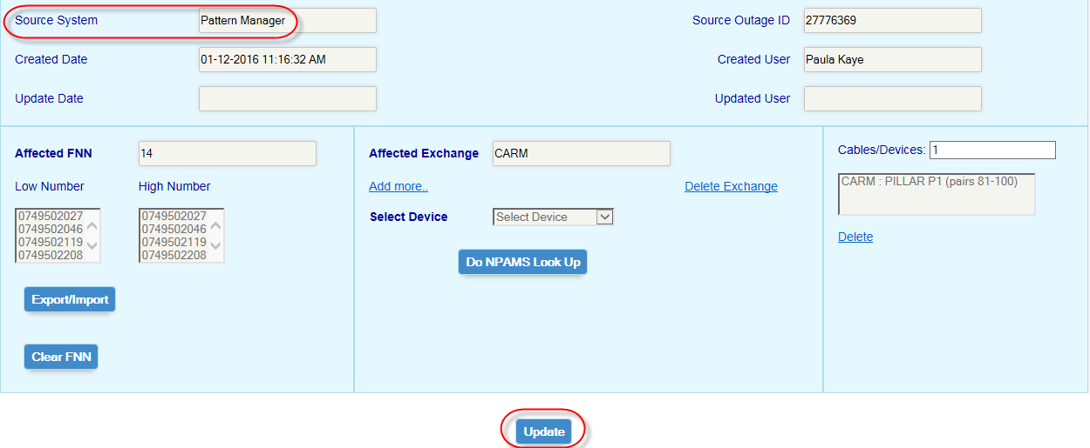

TELSTRA CORPORATION LIMITED (ABN 33 051 775 556) |

| | SYSTEM GENERATED | 017921W14 PATTERN MANAGER 6.0

PAGE 79/86

**XS**

**ADSL - Silent**

**xxxxxxxxxxxxxxxxxxxxxxxx**

**RA**

**ISDN Auxiliary**

**MA**

**Faxstream Primary**

**XR**

**ADSL**

**MC**

**Faxstream Auxiliary**

Click the Update button in the centre of the banner

The user Id of the staff member who last actioned a check-off code will be recorded in the

User column.

Once a Check code has been selected the screen changes must be saved by use of the

‘Update’ button.

There are three methods of checking off fault patterns:

**Individual Update**

•

Click the Chk_Lst Drop Down against the fault and select the required code e.g.

NYV

Patterner display in the GOC which helps alert SAO to potential Switch issues

TELSTRA CORPORATION LIMITED (ABN 33 051 775 556) |

| | SYSTEM GENERATED | 017921W14 PATTERN MANAGER 6.0

PAGE 80/86

To indicate that a pattern has been analysed and actions

**14.7. Check off Codes**

When a fault pattern first displays in Pattern Manager, each fault in the pattern will display

its SIIAM case status at the time the pattern was formed e.g. Field-Open or Test-Pending.

This status appears in a field called the Chk_Lst (Check List) which also contains a series of

3 character codes used by SOM to indicate the results of their analysis of the fault pattern

e.g. ‘CVH’ when an outage has been confirmed or ‘NYV’ when an outage has not yet been

confirmed.

The Check Code is used:

•

To alert users to new faults which have arrived within a pattern or which have

•

formed new patterns

To display the respective volumes and percentages of checked vs unchecked faults

•

in each exchange and region which is an indication of workload and potential risk

By the Blackhawk interface to display colour coded alerts on the Sauron Switch

•

**AB**

**Line Hunt Auxiliary**

**RK**



**14.6. Service Types**

The following table lists the various NPAMS Service Type codes which indicate the basic

service type of each FNN e.g. whether PSTN, ADSL or ISDN

**ISDN Primary**

**X Code**

**Service Type**

**X Code**

**Service Type**

**SS**

**PSTN**

**LB**

**Line Hunt ADSL Primary**

**UL**

**ULL**

**DB**

**Line Hunt Primary**

**SL**

017921w14 Pattern Manager 6.0 (continued)

**PSTN - Silent**

**LA**

**Line Hunt ADSL Auxiliary**

Click the ‘No Selection’ drop down list next to the Update All button

PAGE 81/86

| | SYSTEM GENERATED | 017921W14 PATTERN MANAGER 6.0

TELSTRA CORPORATION LIMITED (ABN 33 051 775 556) |

Click the Update All at the right of the banner

faults on the screen

Tick the check box at the top – this will auto-tick all checkboxes against all

Select the required Check code e.g. LNK

017921w14 Pattern Manager 6.0 (continued)

•

**Update All**



Click the Update All at the right of the banner

Tick the check boxes next to each of the faults to be checked off

Select the required Check code e.g. CVH

Click the ‘No Selection’ drop down list next to the Update All button

•

**Multiple Update**

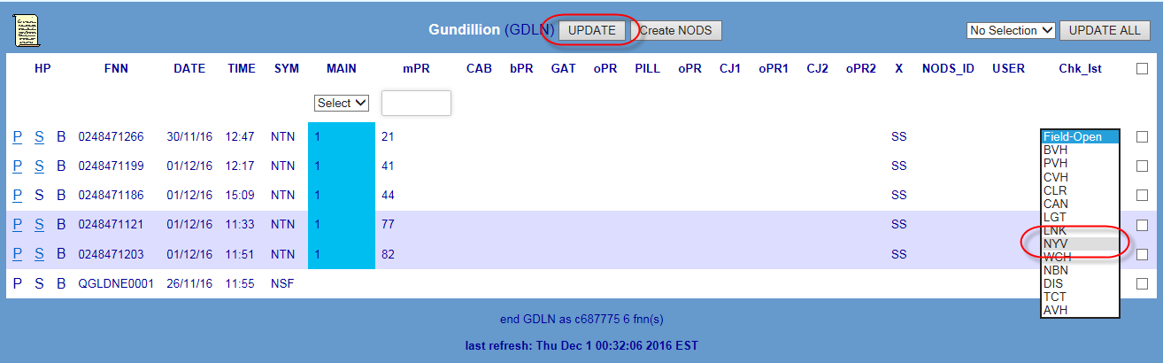

and a Volume Hold Queue has been set up.

Fault is being managed as part of a CAN

Pattern Manager

Also applied when a NODS is created from within

Hold

CVH

Confirmed Volume

CAN

Sufficient evidence exists for a potential outage

performance issues.

Patterner after actioning to prevent system

Very large volumes of faults removed from

Cleared

CLR*

Fault is part of a CNO has been dismantled after

PAGE 82/86

| | SYSTEM GENERATED | 017921W14 PATTERN MANAGER 6.0

TELSTRA CORPORATION LIMITED (ABN 33 051 775 556) |

advice from Field staff that patterned faults are not

from Patterner or…

Dismantled

DIS

NO CNO

Rehabilitation project in a SOM CAN Rehab queue –

CAN Rehab

updated with AVH – no user ID will be recorded.

The following table lists standard check off codes in use by SOM and their meanings:

**14.8. Table Check Off Codes**

Refer Table Check-off codes

If a NODS has been auto-created by Priority Patterner, the Check List will be automatically

automatically updated with CVH and the User ID of the consultant who created the NODS.

If a user has created a NODS from within Pattern Manager, the Check List will be

next 10-minute system refresh.

to immediately update the totals in the Exchange list. Otherwise totals will update at the

Once the exchange screen has been updated, the browser refresh button can be clicked

the code can be changed to ‘CVH’.

‘Update’ e.g. if a pattern checked off as ‘NYV’ was subsequently found to be an outage,

Actioned check-off codes can be changed by simply re-selecting a new code and clicking

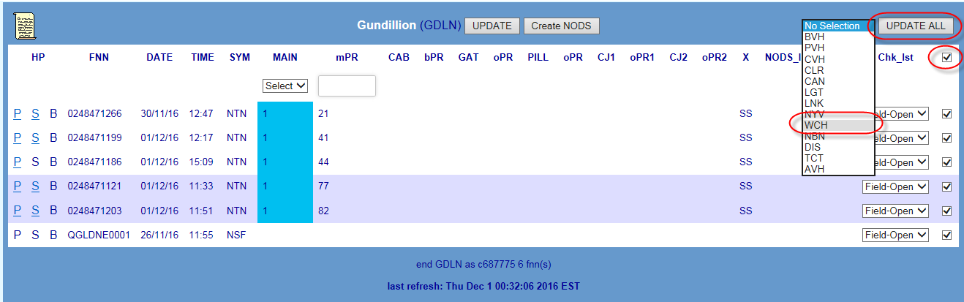

significance to fault pattern and has been removed

Fault has been confirmed as having no valid

NODS has been automatically created

Hold

AVH

Pattern meets Priority Patterning criteria and a

017921w14 Pattern Manager 6.0 (continued)

Automatic Volume

**Use**

**Meaning**

**Code**

**Average**

**Refresh**

**Refresh Job**

**Refresh**

**Refresh**

**Task**

**Rate /**

**Timings**

**Run Days**

**Run Hours**

**Interval**

**(*example*)**

**Duration**

SOM Super User changes CAN Patterner Threshold at 9:27

Strong evidence for a potential outage exists but

waiting on confirmation from another workgroup

(e.g. NS). No CNO has yet been set up - this pattern

MUST be followed up and watched closely

**14.9. Patterner Refresh Rates and Timings**

The following table provides an indication of the timeframes and frequency for system

refresh of data in each of the Patterners.

Example:

Fault

Changes will take until 9:30-9:31 to be processed

New patterns according to changed thresholds will display at next System update 9:35

**Refresh**

Download

mins

10:10

from SIIAM

10:20

10:30

10:40

10:50

3-4 mins

TELSTRA CORPORATION LIMITED (ABN 33 051 775 556) |

| | SYSTEM GENERATED | 017921W14 PATTERN MANAGER 6.0

PAGE 83/86

Everyday

0300 - 2300

Watch!

Every 10

…10:00

Fault has been deemed better managed by linking

LNK

Linked

in Connect. Linking team advised – NO CNO

required – NO CNO

National Broadband

NBN

Fault is an NBN Access Seeker service

Network



part of an outage

Fault has been confirmed as caused by lightning

strike with NO common affected network element

LGT

Lightning

AND individual attendance of customer premises is

managed by TCT-SOM

Fault is part of an outage on Continuity copper

Telstra Continuity

TCT

cable asset transferred to Nbnco and is being

Team

Strong but so far inconclusive evidence exists for a

potential outage. No CNO has yet been set up but

this pattern MUST be watched closely or…

WCH

Insufficient evidence exists AT THIS TIME for a

NYV

Not Yet Volume Hold

potential outage and a Volume Hold Queue has

NOT yet been set up.

017921w14 Pattern Manager 6.0 (continued)

Fault is part of a CNO set up to manage a large

PVH

Planned Volume Hold

number of faults associated with a CAN Rehab

Planned Outage

Outage Identification & Setup

017921w07

Pattern Manager – Identification & Actioning of Related Fault

Patterns

017921w06

017921w08

NODS for Service Outage Management

**16.**

**Attachments**

**15.**

**References**

Document number

Title

017921

SOM Procedure

ARMES

Alarm Receipt and Monitoring Evaluation System

Asynchronous Digital Subscriber Line

AXE

Automatic Exchange Equipment (switching technology)

TELSTRA CORPORATION LIMITED (ABN 33 051 775 556) |

| | SYSTEM GENERATED | 017921W14 PATTERN MANAGER 6.0

PAGE 84/86

Document number

Title

11:00…

**17.**

**Definitions**

Term

Definition

ADSL

10:25

CAN

Every 10

Everyday

0300 - 2300

10:35

3-4 mins

Patterning

mins

10:45

10:55

11:05…

10:15

…10:00

10:10

10:20

PGS

Every 10

Everyday



11:00…

0300 - 2300

…10:05

11:10

11:25

11:40…

mins

Everyday

0300 - 2300

…10:00

3-4 mins

10:05

10:15

Broadband

Every 10

10:25

CAN

mins

10:35

Patterning

10:45

10:55

10:30

3-4 mins

Patterning

mins

10:40

10:50

11:00…

017921w14 Pattern Manager 6.0 (continued)

…10:10

10:25

10:40

Switch

Every 15

Everyday

0300 - 2300

10:55

3-4 mins

Patterning

POTS

Remote Subscriber Access (S12 Switch)

RSA

Plain Old Telephone Service

Post Incident Report

PIR

System 12 (switching technology)

S12

Remote Switching Stage (AXE Switch)

RSS

Network Outage Database System

NODS

National ISDN Customised Alarm Display

NICAD

Pair Gains System

PGS

National Plant Assignment Management System

NPAMS

Spectrum Sharing Service

Test and Diagnostics Application

TADA

SSS

Service Outage Management

SOM

PAGE 85/86

| | SYSTEM GENERATED | 017921W14 PATTERN MANAGER 6.0

TELSTRA CORPORATION LIMITED (ABN 33 051 775 556) |

Telstra Service Ops

TSO

and Axis, including a schematic cable details diagram view

associated service details from a number of sources e.g. NPAMS

Application which acts as a user friendly interface to display

Shazbot

Service Assurance Operations

SAO

Sultan Line Circuit Test

SLCT

Line Interface (AXE device)

customer fault management system

Service Improvement In Assurance Management – core

SIIAM

Customer Network Support Centre

Cable Pressure Alarm System

CPAS

CNSC

Customer Multiplexer

CMUX

Digital Subscriber Line

DSL

Communications Technician

CT

Broadband

BB

Definition

Term



Clarification of Associated Services in Network Outages

CASINO

Customer Access Network

CAN

Global Operations Centre

GOC

Graphical Data Display

GDD

LI

Integrated Services Digital Network

ISDN

Intelligent Services Access Manager

ISAM

Exchange Magazine

EM

EMG

Digital Subscriber Line Access Multiplexer

DSLAM

Equipment Number (S12 device)

Fibre To The Premises

FTTP

017921w14 Pattern Manager 6.0 (continued)

EN

Exchange Magazine Group

2 Jun 2015

Correct content on CMUX DSLAM failures in Section 5.3 as provided

previously by TSO SME Adam Edwards. Update SOM and TSO

business unit names PK

5

8 December

Completely revised content and screenshots to support deployment of

2016

Priority Patterner Enhancement on web-NODS platform on 9 December

2016. New sections on Priority outage Dashboard, priority patterning

and Auto-NODS creation. PK

changes. PK

3

8 Oct 2010

Revised to incorporate system changes as a result of Pattern Manager

Upgrade Project Phase 2 Drop 4 October 2010. New section on

DummyFNN in CAN Patterner. Revised sections on CMUX handling in

PGS & BB CAN Patterners. PK

4

This publication has been prepared and written by Telstra Corporation Limited (ABN 33 051 775 556), and is

copyright. Other than for the purposes of and subject to the conditions prescribed under the Copyright Act,

no part of it may in any form or by any means (electronic, mechanical, microcopying, photocopying,

recording or otherwise) be reproduced, stored in a retrieval system or transmitted without prior written

permission from the document controller. Product or company names are trademarks or registered

trademarks of their respective holders.

Note for non-Telstra readers: The contents of this publication are subject to change without notice. All efforts

have been made to ensure the accuracy of this publication. Notwithstanding, Telstra Corporation Limited does

not assume responsibility for any errors nor for any consequences arising from any errors in this publication.

TELSTRA CORPORATION LIMITED (ABN 33 051 775 556) |

| | SYSTEM GENERATED | 017921W14 PATTERN MANAGER 6.0

PAGE 86/86

6

21 July 2017

Selection Dashboard, Fault Display Thresholds and SOM Administrator

Completely revised content and screenshots to support deployment of

Priority Patterner Enhancement on web-NODS platform on 9 December

2016. New sections on Priority outage Dashboard, priority patterning

and Auto-NODS creation. PK

Lambley, Jason

Name

Position

Process Specialist

Phone

0415 350 012



Term

Definition

ULL

Unconditioned Local Loop

**18.**

**Document Control Sheet**

Who to reach out to if you have any queries, questions, changes or concerns.

2

st

1

2 Dec 2009

1

issue incorporating system changes and improvements introduced in

Pattern Manager Upgrade project Phase 1 & Phase 2 Drop 1 & 2 - PK

3 May 2010

Revised to incorporate system changes as a result of Pattern Manager

Upgrade Project Phase 2 Drop 3 April 2010. Added sections for Region

Email

Jason.Lambley@team.telstra.com

If you have a suggestion for improving this document, please contact the person listed

above.

Issue number

Issue date

Details on the change

017921w14 Pattern Manager 6.0 (continued)