12/01/2019

Aryan Kafley

109333237

Battle of Grids

Problem Description

This program is about the battle between two ships in which one is the computer itself and another is the player who is playing it. The game will be played with four grids in total out of which 2 is dedicated to each of the player. One grid will be used to mark fleet of ships. The location of the first. Two grids will be hidden to not let the opponent know about the position of the opponent grid. Both the players will be alternating turn making one going after another and not overlapping. While talking about the main objective of the game, it is to destroy the opponent entire fleet. Each player is always guessing and will not know the location of the opponent ships. Firing torpedo is the actual way of

taking a guess at the opponent fleets.

Input

You will be asked the input file name right after the program starts. Type the file name. For example in this case: ship_placement.csv . Then it will ask the user to enter the target location. The input will be (A1-J10) meaning a1,a2,a3…..j8,j8,j10. Both uppercase and lowercase for the words accepted. The program will show error if you only type a alphabet or a number. But will not do anything if the user enters anything such as k9 or k10, it will just keep on asking for input in such case. The program is designed, keeping in mind the user will use the correct input as much as he/she can. That will be it for the input, nothing else needs to be entered.

Output

After the user enters the file name. It will show two grids with the ships being placed in their grids. After that user is shown the sentence asking for the input for the game. When the program gets the input then the user will be shown two grids with hits and miss represented by X and 0 also letting you know about if it was a hit or miss, Game is divided into rounds meaning every attempt will be considered as a round. When the next round starts, user will be shown where the computer hit user at and was it a miss or hit. If a ship is sunk it will show a message such as : Ship S just sunk!. An example of the output after the ship sinking, will be attached in the zip file.

Problem Solution Discussions

I decided to distribute the program into 7 files, letting the grid,person and ship its own files where I can handle those problems. Grid file deals with the grids, person with the players one meaning the user and the other being the computer itself. And the ship is for the ships itself. In the grid.cpp, I created grid starting with no ship and method to create the battlefield. Then it get contents, see the space available for the ship and then place the ships accordingly. In the player.cpp. Inheritance has been implemented with person being the main class and the user and computer are the child classes respectively. IN ship.cpp, ships have been created and implemented. There is no use of any unusual algorithm as I can remember, everything used was part of the class. I have attempted the extra credit though, the first output where which ship sunk can be seen while playing the game, or in the screenshot in the attached zip file. The computer hitting on one ship can be seen in the function Computer :: MakeMove() in Person.cpp.

Uml Diagram

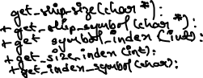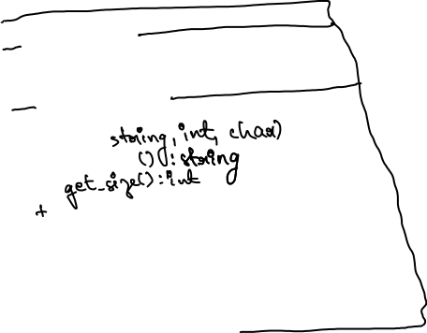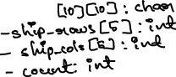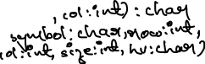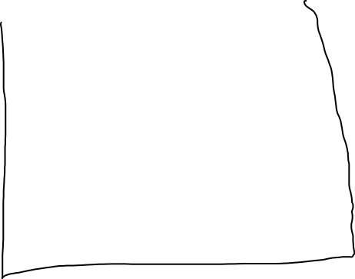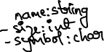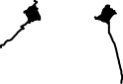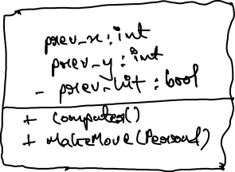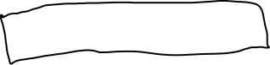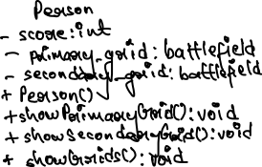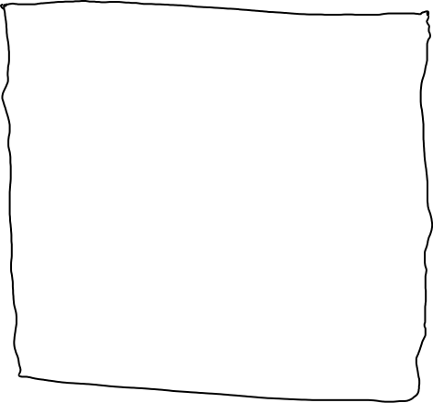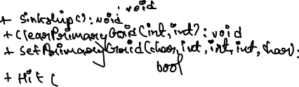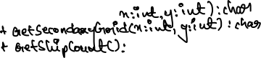

Software Architecture

Many of the functions have a comment on its start mentioning what it is doing. When it comes to major functions place_ship is the important one which is placing ships into the grid. MakeMove as mentioned above is for the extra-credit part making the computer to target one ship, and hit is for finding and hitting the ships.