DECORATORS
These decorators support the integration with collabur prototyper
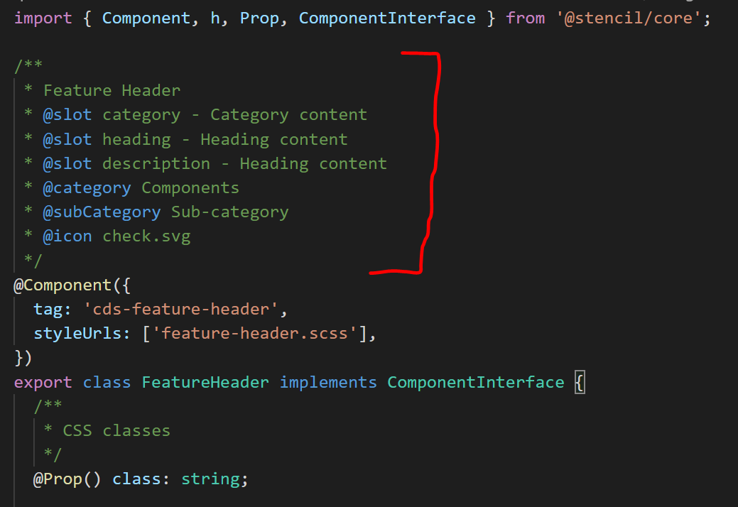
@slot name – description: for named slots.
@slot – description: for root slots
@category: component category
@subCategory: component sub-category
@icon: component icon
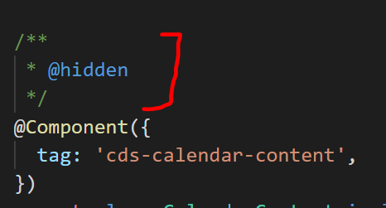
@hidden: apply for private components that been used in other components and can’t be used as a standalone component.
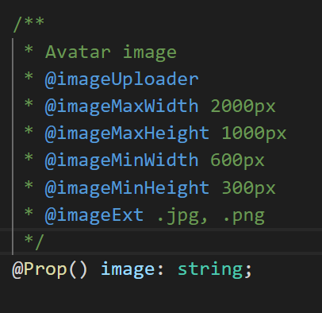
@imageUploader: this prop will use an image uploader to upload image and pass url string as its value.
@imageMaxWidth, @imageMaxHeight, @imageMinWidth, @imageMinHeight: image size allowed to upload.
@imageExt: file extensions allowed to upload
SAMPLEs
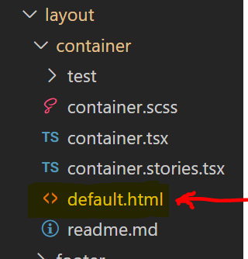
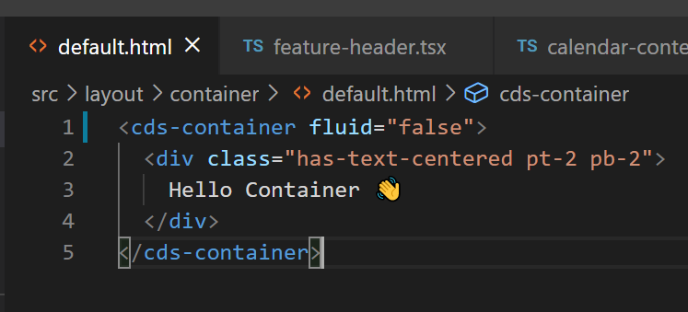
Default.html: contains sample html code for current component to be used in prototype to prevent an empty component when render.

