The Tweakomatic

We think that the Tweakomatic might be pretty cool, but we aren’t sure. The Tweakomatic started out to be one thing, veered off in another direction, and then ended up being two things. (We do know it must be twice as good as the Scriptomatic, because each time you make a selection it writes two scripts for you, one for retrieving the current value of a setting, the other for configuring a new value for that setting.) The Tweakomatic is pretty slick, but we might have inadvertently made it a little confusing to use (because we were too lazy to change the UI even when we changed our minds about what the Tweakomatic was supposed to do). If that’s the case, please let us know.

Oh, right: what does the Tweakomatic do? Well, the Tweakomatic is supposed to be roughly equivalent to Tweak UI, the nifty little Microsoft utility that lets you configure OS parameters that are otherwise difficult (or downright impossible) to configure. (Why are they so hard to configure? Because the values are stored in the registry and, in many cases, there is no way to view/set those values without directly editing the registry.) Tweak UI is pretty cool (we highly recommend it) and it’s much prettier than the Tweakomatc, but Tweak UI works only on the local computer (and it’s a GUI tool, so you can’t automate it in any fashion). Tweakomatic writes WMI scripts that read/modify the registry, meaning these scripts can be run on any computer (even remote ones).

Quick caveat. The Tweakomatic is really designed for Windows XP, although many (most?) of the settings also apply to Windows 2003 and to Windows 2000. However, at the moment we’ve done very little testing on either of those platforms, and we have no idea what would happen on Windows NT 4.0 or Windows 98. It’s highly unlikely that anything bad would happen to your computer if you ran this on something other that Windows XP, but we don’t want anyone saying, “Hey, you didn’t tell us that this was really designed for XP.” Therefore, we’re telling you: this was really designed for XP. Before we release this to the world (remember, you guys are beta testers here), we’ll test it on other platforms, and get a better idea of what does and does not work.

But who cares about that right? The important thing is that the Tweakomatic consists of two files: tweakomatic.mdb (a database containing all the relevant information), and tweakomatic.hta, the front-end to that database. To use the Tweakomatic, make sure the two files are in the same folder, and double-click tweakomatic.hta. You should see something akin to this:

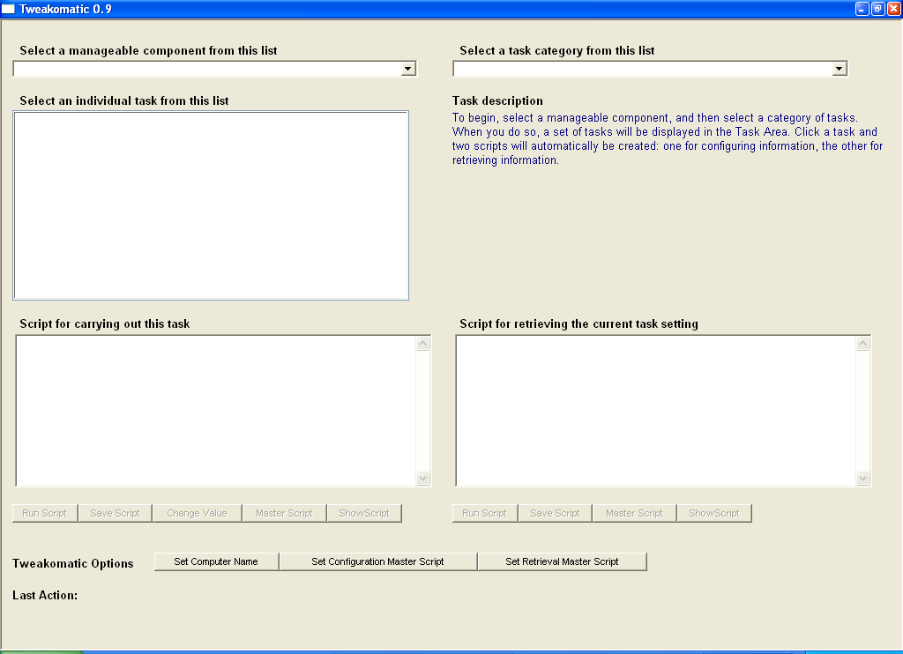

So far so good. Now, click the Select a manageable component from this list dropdown, and select a, well, manageable component. Right now you have two options: Internet Explorer Settings and Windows Settings.

Note. The Tweakomatic is fully-extensible; if an application keeps configuration in the registry, we can add support for that application without too much trouble. In fact, if people find Tweakomatic useful, we’ll occasionally release some “Tweakomatic Management Packs,” which will just be data that can be added to the database, and thus allow Tweakomatic to, say, configure Microsoft Word or Microsoft Excel.

After you select a component, pick something from the Select a task category from this list dropdown. When you do that, a list of tasks will appear in the Select an individual task from this list listbox. (Yes, we know, it does sound like a lot of work, doesn’t it?) Click one of the tasks, and three things will happen:

- A script will appear in the spot labeled Script for carrying out this task. As the name implies, this script can be used to configure the registry setting in question.
- A script will appear in the spot labeled Script for retrieving the current task setting. If you were to run this script as-is, it would return the registry value as currently configured on the local computer.
- Information will appear in the spot labeled Task description describing what the task actually entails, and what the values actually mean. (For example, if this value is 1, then it means whatever we’re talking about is enabled. If the value is 0, then whatever we’re talking about is disabled.)

Your screen should look something like this:

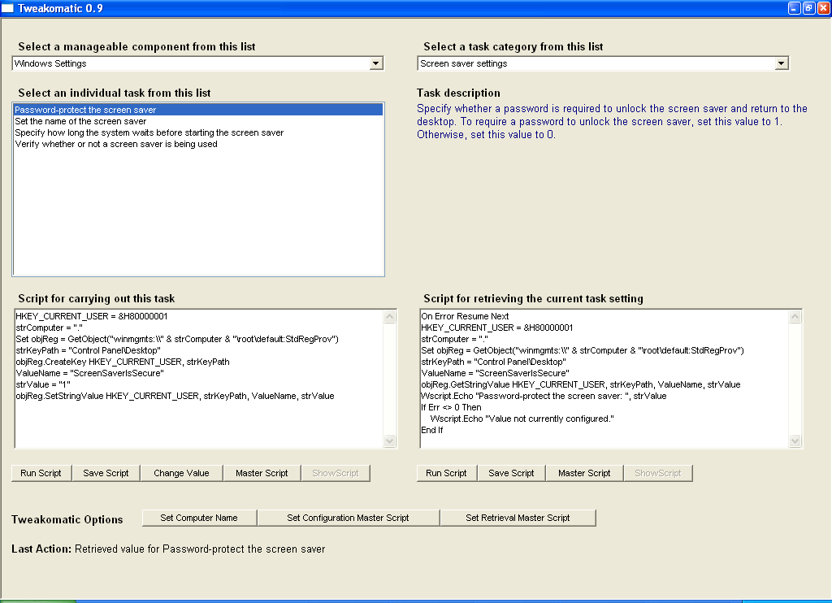

This is actually pretty straightforward, and maybe we should have just stopped here and called it good. We decided to add a few additional capabilities, however, and while we think these are useful, it might not be so obvious what they are. With that in mind, here’s a quick rundown of what the various Tweakomatic buttons do:

Run Script button
Ok, well this one is pretty obvious: it runs the script. The only thing to keep in mind here is that there are two scripts (one for configuring info, one for retrieving info), and thus two Run buttons. Don’t get confused and click the button for configuring info (the one on the left) rather than the one for retrieving info. To help you out at least a little, there is a little status box at the bottom of the screen (labeled Last Action) which will tell you what you just did.

Save Script button
Well, OK, this one is pretty obvious, too. Click it, type in a name, and whatever script is onscreen at the time will get saved. Again, the only thing to remember is that you have two different scripts, and thus two different Save buttons.

Change Value button
Here’s some good news: there’s only one Change Value button! The Change Value button is found only in the configuration part of the Tweakomatic. What does it do? Well, the Tweakomatic will write a default script for you that, say, enables X. Thus the script might set the value of X to 1. But suppose you’d really like to disable X, meaning you have to set the value to 0. Well, you can either directly edit the script code, or you can click Change Value, type in the new value (0), and let the Tweakomatic make the change for you. (Yes, you would have to be pretty lazy to go this route, wouldn’t you?)

Master Script button
This is actually a good idea, but not a very good name. Initially we had the Save Script button, which allowed you to save the current script to a file. That’s cool. But then it occurred to us that -- considering the nature of what the Tweakomatic does -- well, maybe you don’t want hundreds of individuals scripts here; that is, one script that tells you whether Run appears on the Start menu, another that tells you whether My Documents appears on the Start menu, another that tells you whether Printers and Faxes appears on the Start menu, etc. etc. Instead, you might like to have one script that carries out all these functions.

Therefore, we came up with the idea of a “master” script. Click the Master Script button (and there are two of them, one for retrieval, one for configuration), and the script currently onscreen will automatically be added to your “master” script. (Unless you haven’t told the Tweakomatic the name of your master script. In that case, the first time you click this button you’ll need to enter a file name.) We think if you use this a few times you’ll see that it’s actually quite handy; we just aren’t sure that the name Master Script is the name we were looking for. (But it could be worse: initially this was called the Append Script, we guess because you appended data to it.)

Show Script button
This just pops the appropriate Master Script up in Notepad. Hey, what more would you want it to do?

Set Computer Name button
By default, each time the Tweakomatic writes a script for you, it sets the name of the computer to “.” (which, in WMI-speak, represents the local computer). Suppose you’d rather have it, by default, set the name of the computer to computer1? No problem; click Set Computer Name, type computer1 in the resulting dialog box, and then click OK. If you ever want to switch back, click the button, type . in the dialog box, and click OK.

Set Configuration Master Script button
Ok, again, not the most obvious of button titles, but this one allows you to specify the name of the “Master Script” for scripts that actually configure a setting.

Set Retrieval Master Script button
And, as you might have guessed, this one allows you to specify the name of the “Master Script” for scripts that retrieve the current value of a setting.

