Pre-Paging vs Demand-Paging Memory Simulation
Gary Steelman, CS284, Dr. Sriram Chellappan
It is necessary in computing nowadays to have a reliable, fast, and efficient operating system to make easy use of a computer. Without such software, the olden days of having to create punch cards and the like and manually flip switches would still be the primary way to do computing.
The operating system software is expected to control memory management for the user in a fast, efficient, and reliable way. It is also expected to allow the user to run any program he or she wishes, even if that program will not fit directly into main memory. Thus we have paging, the ability to break a program into smaller parts and load only the relevant parts into main memory. This is very useful for large programs. However, using this system can also lead to problems in that moving pages from main memory to the page file on disk and back takes time and there is overhead involved.
Therefore It is necessary to have an efficient algorithm with which to select which page(s) to swap from memory to disk and back at different times to keep the user running as quickly as possible. In this assignment we used 3 different algorithm types: First-in-First-out (FIFO), Least Recently Used (LRU), and Clock. We ran each algorithm with different page sizes and graphed the number of page swaps that occurred with each. Why test different algorithms? To see which one is best, of course. The relative complexities of each algorithm differ greatly depending on page size and memory size. In general, FIFO, while the least complicated to write and least overhead intensive, is the least efficient. Next in efficiency is the LRU algorithm. It generally is more efficient than the FIFO algorithm, making less page swaps on average. This algorithm requires slightly more tracking on the part of the operating system and generally has about the same overhead as FIFO. The most efficient of the algorithms used was the clock. This algorithm requires a lot of background checking and overhead on the operating system, but this leads to less page swaps overall.
The results of the simulation are on the following page(s) in the graphs. The results were very surprising. The results show that the clock algorithm is extremely inefficient, probably due to incorrect implementation. The FIFO and LRU algorithms followed expected patterns, showing that LRU makes less overall page swaps than FIFO. One observation that is made is that pre-paging in this simulation is overall less efficient than demand paging. This is a counterintuitive result. This could be explained given the nature of not-actually-random program trace performed. If completely random accesses to memory had been used instead of the somewhat-patterned approach provided, the results would have most likely more clearly shown that the clock algorithm would be the most efficient, according to theory. It would have probably also showed that the pre-paging used in this simulation would have been even less effective than it already is shown to be.
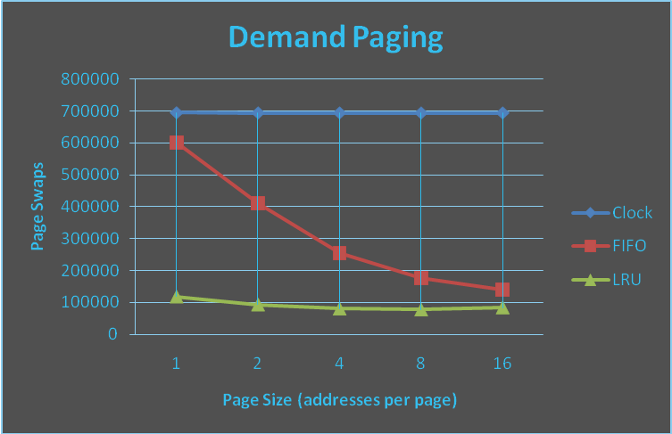
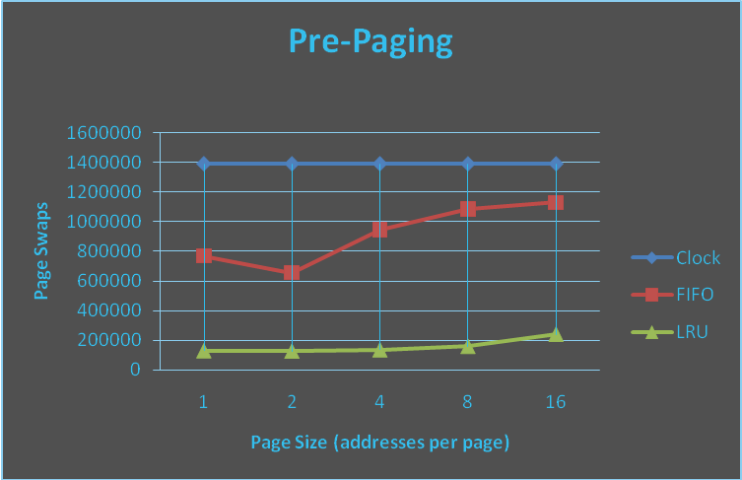
 | demand |  |  | pre
 | clock | fifo | lru | clock | fifo | lru
1 | 694686 | 600686 | 118330 | 1388861 | 765501 | 127871
2 | 694426 | 410644 | 93114 | 1388601 | 654611 | 125265
4 | 694296 | 254707 | 80219 | 1388471 | 944115 | 133725
8 | 694236 | 176579 | 77277 | 1388411 | 1085413 | 156983
16 | 694206 | 139652 | 83956 | 1388381 | 1128623 | 238257

