**CSE2022 Computer Programming**

**Lab Report Week 2**

Student ID:2016112124

Name:박해웅

Problem X.

Result (Mostly captured images. Leave Youtube links for videos.) 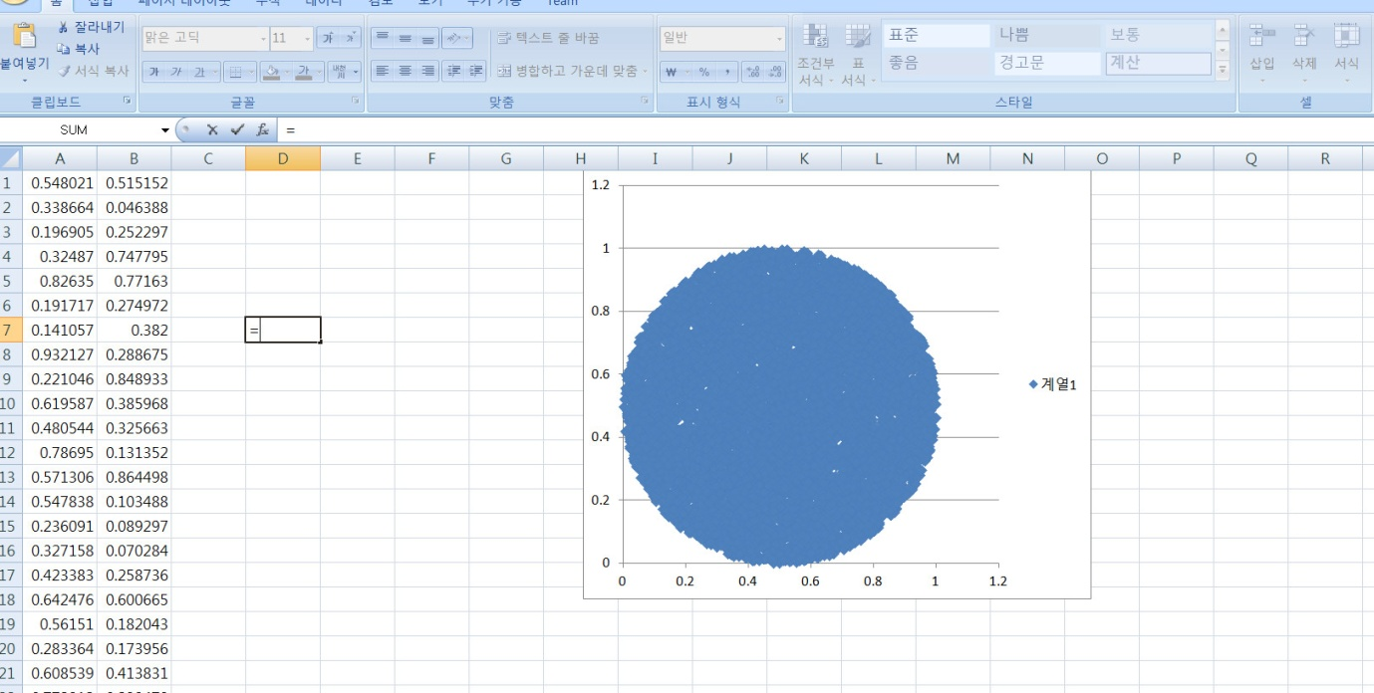

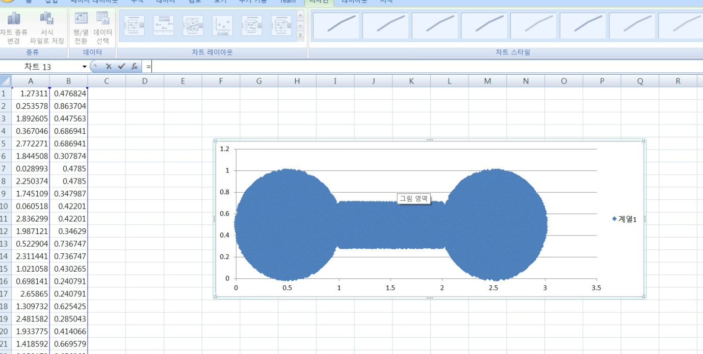

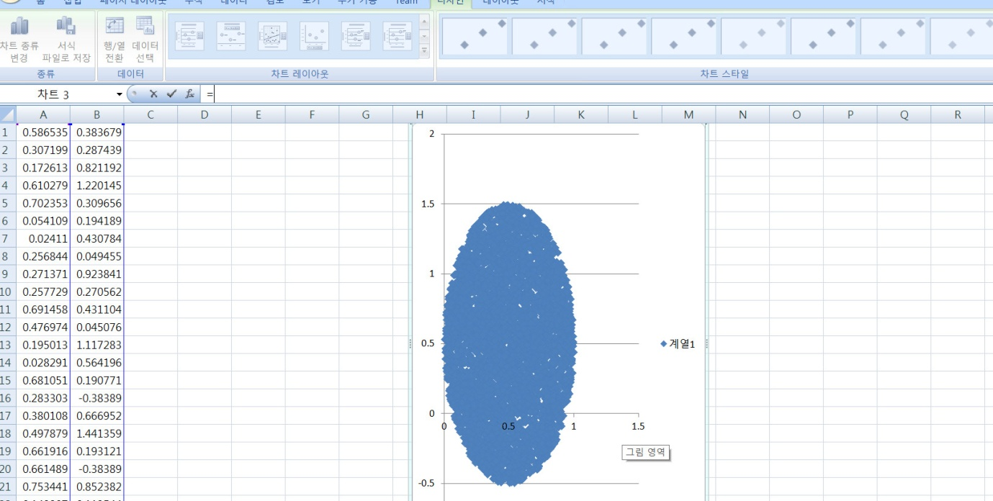

Codes (github link)