ACS 560 Software Engineer

HW3, 09/17/2013

Yei-Sol Woo

(1)

<https://github.com/wooy01>

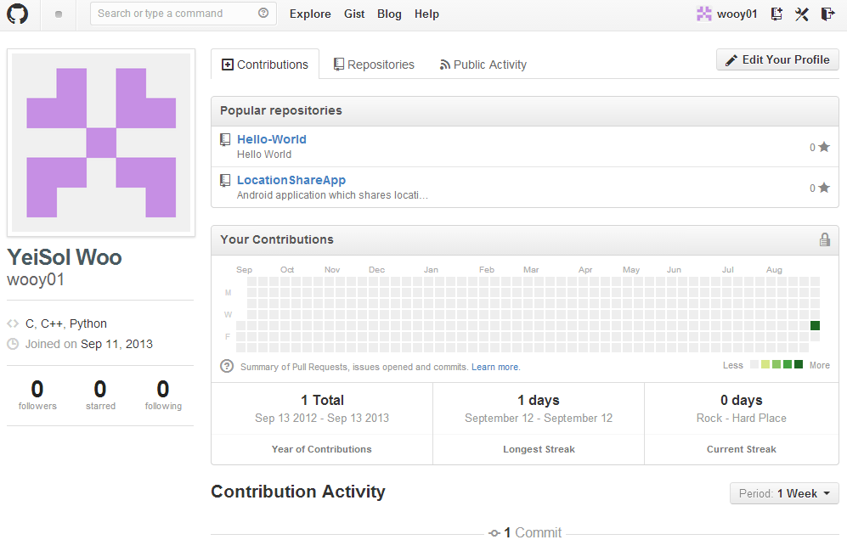

(2)

Set up complete!

(3)

<https://github.com/wooy01/Hello-World>

