WoPeD project group
Quick Reference for the tokengame simulation with WoPeD
Manual tokengame simulation

Tilman Glaser, Ralf Lehmann and Anthony Soprano
06.03.2008

General Remarks
This document is intended to explain the handling of the new tokengame simulation functionality within WoPeD.
There are two methods for tokengame simulation: New Tokengame Controller and interaction within petrinet.

Tokengame Controller Views
Three Views were implemented for different skill user.
- iView (beginner)
- SlimView (normal user)
- ExpertView (expert)
If you have designed a petrinet and set a number of tokens you can activate tokengame simulation by using Tokengame symbol on menubar. When Tokengame simulation is started you can not change the petrinet anymore till simulation is stopped again. The standard View is SlimView. The new implemented Controller will appear on the bottom of your petrinet graph. You can change view over the “Playback Properties” on ExpertView. By clicking on XXX you switch from SlimView to ExpertView.
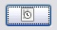
Display “Playback Properties” by clicking on .
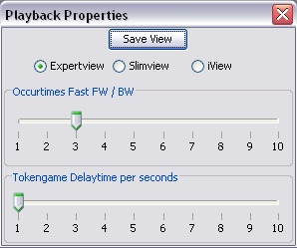
To switch view select it and click “Save View”.

iview
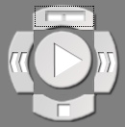
You can use iView for simple play. This view provide the possibility to activate Tokengame (“play”), to stop or reset tokengame (“stop”) and occur tokengame forward or backward (<< / >>). If you click on the button on top the view will switch to ExpertView.
Transition Choice: If you can occur more than one transition you have to interact. The iView displays the possible choice within a dialog. You can also interact within petrinet graph.
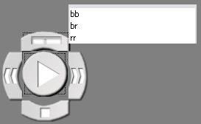

slimview
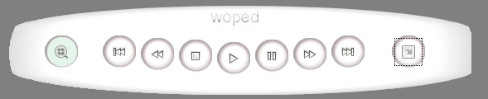
In additional to iView this View provides the feature to occur fast forward/backward. You can also switch “autoplayback” on. This let the tokengame occur with a delay automatically. The standard delaytime is 1 second – you can change this within playback properties. You can switch to ExpertView over the Button .
 switch “autoplayback”
fast backward
fast forward
switch to ExpertView
Transition Choice: If you can occur more than one transition you have to interact. The SlimView displays the possible Choice within a dialog. You can also interact within petrinet graph.
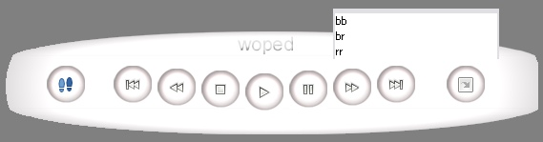

Expertview
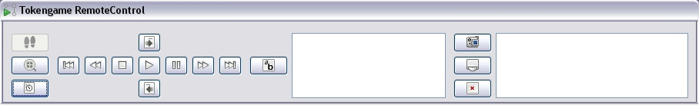
This view provides all functionalities for the new Tokengame Controller.
We can split the view in 4 subareas
- Playback properties
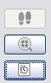
In this area you can change default stepwise playback to autoplayback. Also you can display “Playback Properties” dialog, as mentioned above. You can switch view, set step size for fast forward/backward and increase delaytime for autoplayback.
stepwise playback (default)
autoplayback
“Playback Properties” dialog
- Playback
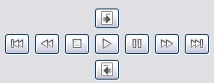
The ExpertView provides all playback options. You can start, stop and interrupt (for autoplayback) the tokengame, you can occur forward / backward but also occur fast forward / backward and you have two buttons for “step-into – subprocess” and “step-over – subprocess”.
step-over subprocess
step-into subprocess
- Transition Choice
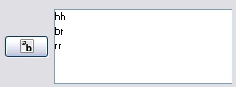
Unlike to iView and SlimView the ExpertView provides an area for transition choice. Within this area you can also switch “autooccur” on. In the listbox you can choose a transition you want to occur. If “autoccur” is on the system will choose one of the possible transition (it will actually not include the percentage for occur possibility). You can also interact within petrinet graph.
- Playback Records
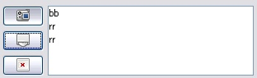
This area is a very interesting new feature. You can now record your simulation (occurred transition). You can activate “Recording Mode”, open History Manager or clear recorded simulation.
Activate “Recording Mode”. If you click on this button the Play button will change to: You can only activate this mode if tokengame is stopped before. Your simulation will be recorded and the transitions you occur are displayed in the recording listbox provided on the ExpertView.
Open History Manager
Clear recorded simulation

History Manager
A nice feature of “Recording Mode” is the “History Manager”. Simulations can be recorded and will be saved within the .PNML file. User can share their simulation with other users within the .PNML file to exchange simulation events (e.g. error in one specific way of occurrence). Through a fingerprint the petrinet is checked for changes to warn of possibly invalid simulations. This is important because if the petrinet has changed you may not be able to replay recorded simulations on this petrinet anymore.
The History Manager Dialog:
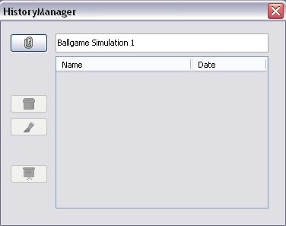
Within this Manager you can
- Save a new simulation with a givin name
- Delete simulation
- Overwrite simulation
- Load selected simulation

- If you want to save a new simulation after you have recorded it, you open the History Manager, enter a name for the simulation in the text field and click on save button or simply press enter to commit. The textfield for entering the simulation name is only active if you have recorded a new simulation before opening the History Manager. The History Manager gets closed with saving a simulation. Opening it again the simulation should be displayed in the list bellow:
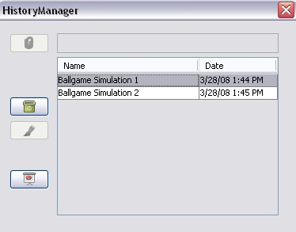
- To delete a simulation select it and click on delete button.
- If you have changed your recorded simulation and want to overwrite a saved simulation, select the simulation and press overwrite button or simply double-click it. Manually entering an already existing simulation name will do the same.
- To load simulation you have to select one and press open simulation button.
At every time you will be provided with information dialogs to prevent overwriting or deleting simulations.

