Thesis:

The “Smart Home” movement has shown and will continue to show exponential growth, and we believe that this market will be one of the defining markets of this decade if not century. We will continue to see exponential growth in the market, with the number of products on the market doubling or tripling every year.

In order for the Smart Home market to fully reach its potential, its products will need a unified construct which will allow them to easily interact with the digital and physical space of a home. We propose such a construct: A “Smart Home Address”: a destination address which will completely define the digital space of a home as well as define its relationship to the physical space of the home occupies.

This “Smart Home Address” (Referred to as SHA) will securely define the digital space of a home in the same way a mailing address defines its physical space and location. This address could be provided free to all existing homes in America.

We have several core goals:
- To foster innovation and growth in the Technology Sector
- To reduce the risk of an income based digital divide
- To securely increase public access to digital resources including the internet of things (IOT).

Outline

- Introduction
- Part 1 - A projected market of home network devices
- Part 2 - Problems with the market - http://fortune.com/2015/10/16/smart-home-problems/
  - Difficulties setting up devices
  - Difficulties managing devices
  - Difficulties with security
  - Difficulties with price / will soon be obsolete
- Part 3 - Platform wars
  - Every product wants to be a platform
  - Hurts the industry as a whole
- Part 4 - Smart Home Address Proposal
  - Philosophy: A simple platform that will add value to customers and to product developers.
  - Philosophy: the platform should be a government or Municipal program (similarly to the mailing address and zip code programs) to reduce monopoly conflicts.
  - The platform should require little to no additional hardware for home owners.
  - The Platform will utilize carrier cell signals, Home Wi-Fi, Ethernet, and in rare instances Bluetooth, to transmit data.
  - Home address data stream will be valuable, stable, and small in size.
  - Data stream will define physical location and act as a stable container for the Smart Home digital space.
  - Devices will be matched to their SH address, and automatically create an optimal LAN to serve and fetch the SH address service.
  - Data will be securely stored on devices.
- Advantages
- Extremely stable connections for wireless devices.
- Allows for some interesting ideas.
- Secure, easy, and Universal microplatform-service.
- Pure location based contextually aware software that knows the importance of a home.
- Challenges
  - Basic integration
  - Storage or cloud computing requirements?
  - Simple product management

Introduction

The software and electronics markets can be honestly described as both volatile and instable. Progress in the development and implementation of new technologies has been exponential for the last 3 decades, and there is no appearance that this trend will change any time soon.

We live in a digital age, and this characteristic of our technology has greatly influenced our culture, our work, our families, even our religions. Never before in recent history has one market defined so much of our cultural and personal identities, and never before in recent history have we been so enabled to produce value; anyone who owns a smartphone is not just a consumer but a producer as well, creating and sharing valuable content with an audience that is the whole world. (Spreadable Media 2015)

Electronics and software technologies affect every domain of our lives, but I have been drawn to a particular domain that I believe to be extremely significant: our homes.

The term “Smart Home” is a relatively new term for a technology that has existed for a while. Having a house with electronic devices is nothing new, the real ‘newness’ lies in “connected devices” or devices that wirelessly connect to other devices or to the Global internet as part of a home network.

The characteristics of “Smart Home” devices include:
- The ability to remotely program, access, or adjust the device’s state;
- The ability to transfer and/or stream media to the device from the internet or from another device.
- Most “Smart Home” devices are designed to be permanent or semi permanent fixtures in a house, sometimes replacing existing fixtures (Electrical outlets or light bulbs) , and sometimes acting as a completely new fixture (Chromecast stick, The harmony bluetooth adaptor)

Paper Objectives

“According to Pike Research on Smart Cities,2 the Smart City market is estimated at hundreds of billion dollars by 2020, with an annual spending reaching nearly 16 billions.”

We believe that Smart Home technology will be incredibly impactful, and will become the building blocks of smart cities and connected, large scale public infrastructure; however there are severe flaws with the technology as it currently exists.
I will be laying out these flaws in detail, showing how they hurt the market and restrict the growth of this technology.

FLAWS:
- Smart Home platform wars hurt the market, delaying development by years.
- The expense of smart home devices prohibit experimentation or impulse buys, which reduces public interest or adoption of the technology.
- Lack of unified standards in smart home technology means devices that can be extremely hard to set up and manage.
- Lack of unified standards means generally decreased security.
- A home’s digital space is not a “take it or leave it” product. If you have a home, you already have both a physical and digital space occupied by the home. Home owners and tenants have the rights to the physical space of their homes, and should also have rights to it’s digital space.

Internet of Things for Smart Cities
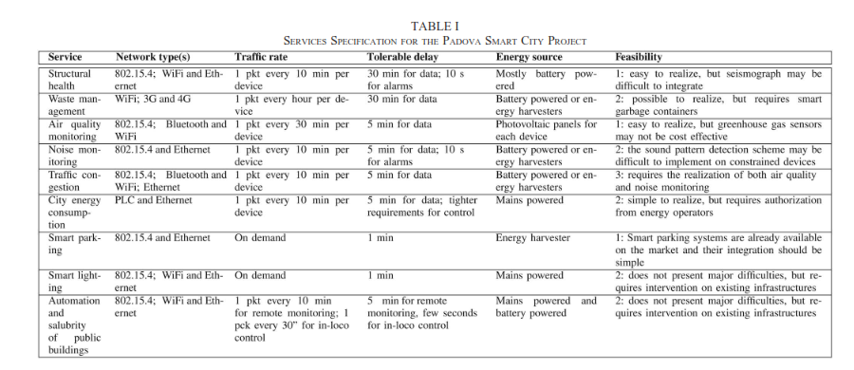

“ From the table, it clearly emerges that, in general, the practical realization of most of such services is not hindered by technical issues, but rather by the lack of a widely accepted communication and service architecture that can abstract from the speciﬁc features of the single technologies and provide harmonized access to the services.”

Next I will propose a solution with three optional implementation strategies that will solve for the existing flaws in Smart Home technology, and I will prove how the market, the technology, and the public as a whole will benefit from the successful implementation of the solution

- A system must be implemented that defines a home’s digital space in the same way that a mailing address defines its physical space.
- This can be provided by implementing a Smart Home Address system (SHA) . This will be a unique URL that will be the digital address of any house, apartment, or other living space. This address system must be free to any house owner or renter, and will be a container for a house’s digital space as well as an interface that connects the house’s digital space to the house’s physical space and physical devices.
- This system will be a free service (Either privately or publically funded), and will act as a platform for 3rd party developers to develop apps for a whole house.
- This system will involve a public URL and a group of private keys that each represent a resident of the house. Another, semi - private key will be provided to guests who are at the house.
- This system will also have a web app which will act as the home’s digital dashboard and allow you to manage all smart home devices
.
Finally I will lay out of a few challenges with my plan, and present several possible answers to these challenges.

Part 1 - A Projected Market of Smart Home Devices
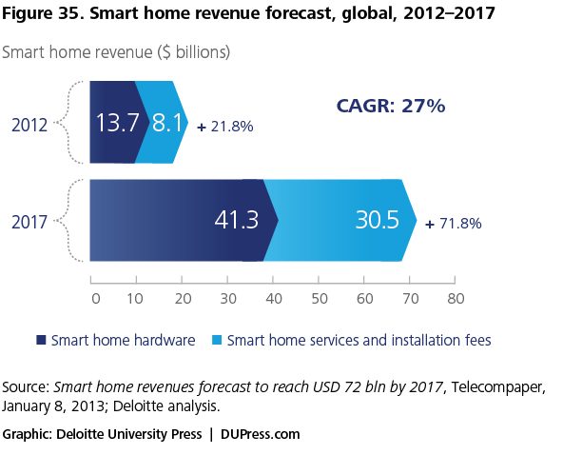
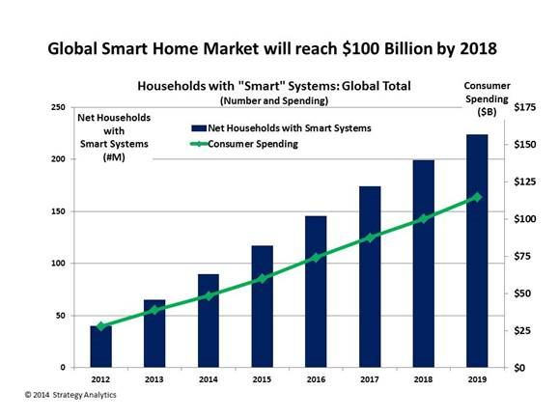

The two images above show forecasts for the smart home market, the first forecast is from 2013, the second forecast is from 2014. These predictions are fairly standard and show a (fairly gradual) rise in the market.

These forecasts characterise the market as lacking universal demand by virtue of smart home systems being perhaps overly technical for the average homeowner.

The next forecast, released a year later by Business Insider tells a different story.

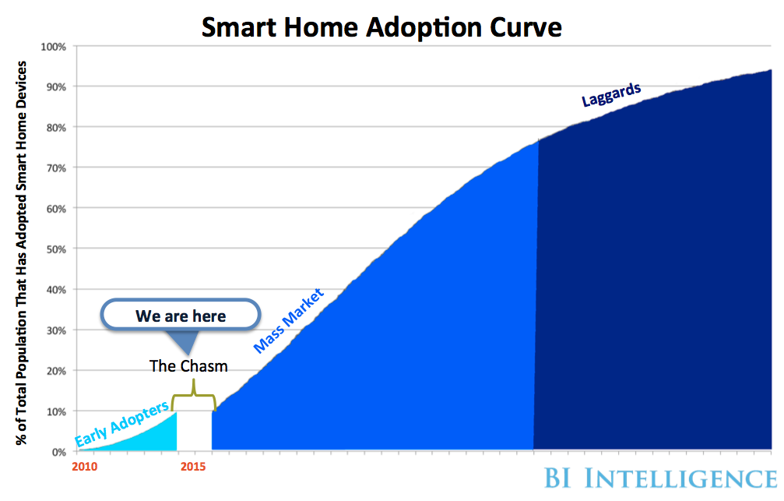

This forecast is fairly simplistic, and predicts a huge mass market boom in the Smart Home market, followed by (eventual) universal adoption.

I believe the business insider graph, though simplistic, is at least partially correct in its assumptions.

In 2015, Amazon released the Echo, a smart speaker that also acts as a digital assistant for the home. In an interesting business move, Amazon released a software development kit, including all of the software that makes the Echo Possible, free to the public.

The results of this move were twofold:

- A large number of 3rd party apps (called skills) were developed for the Amazon Echo.
- Hardware hobbyists ended up creating their own devices using the Echo’s software (a digital assistant, voice enabled, AI service called Amazon Alexa). The youtube video “The 10 Dollar Echo” is a tutorial for a DIY smart speaker using Raspberry Pi and a microphone.

The Amazon Echo was a commercial success, and led to a rise in Amazon’s total revenue as shown in the graph below.

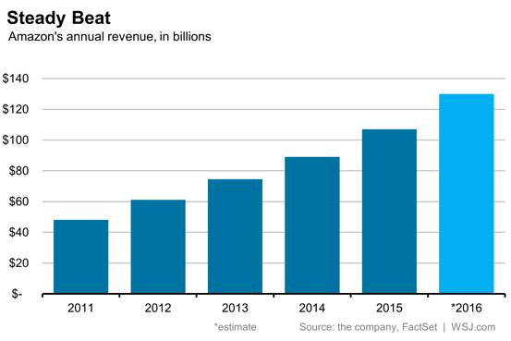
http://www.wsj.com/articles/how-amazons-echo-is-turning-up-the-volume-1457718746

The Wall Street Journal article goes on to describe the success of the Echo as a defining point in the Technology business ecosystem, with other companies adjusting to respond to the success of the Amazon Echo.

In the last week, Google announced its version of the Amazon Echo, called “Google Home”.

We can see other E-Commerce giants measuring the changing tides in the digital ocean, and no one wants to be left behind. Smart home technology and Artificial Intelligence represent two currents that are strong and will only become stronger.

In the next section I will address the current problems that the Smart Home market faces.

Part 2 - Problems with the market

The Smart Home market has problems.

I am going to refer to this article by Stacey Higginbotham addressing her views on the current market problems: http://fortune.com/2015/10/16/smart-home-problems/

The refreshingly straightforward article describes the author's frustration with Smart Home devices. Stacey is no stranger to smart home devices, spending countless hours setting up and programming everything from video doorbells to connected lights.

She addresses three problems: Pricing, complicated setup processes, and lack of unified standards.

Addressing the last two problems, she states:

“What’s perhaps most aggravating is that every year a new product or ecosystem is launched that makes all the previous systems look obsolete and makes it seem like consumers who have already invested in older systems might have to buy new gear if they want to upgrade.”

“This is the equivalent of the movie industry putting out VHS one year, and then deciding DVDs are great a year after that before half the studios decided they would rather commit to BluRay while the others look around and decide that all movies should be delivered on gold wafers flattened into the shape of pyramids.”

This problem is probably the single biggest problem faced by the market as it hopes to appeal to a mainstream customer base.

The issue is exacerbated by the large scale platform wars waged by various E Commerce companies who all want to dominate the market.

When you look at Smart Home Devices, you can identify three separate entities:
- Hardware
- Software platform(s)
- Software program/application(s)

We can see new connected and Smart Home devices being introduced every year, and each one has tried to contain all three entities.

But this trend destroys the very concept of a Smart Home, where everything fits together,smoothly finding its specific niche’ in the large system of a Home.

And perhaps most concerning is the lack of unified standards for secure connection of these devices. Even the technical method of connection varies, sometimes using bluetooth and sometimes using a wireless router, sometimes using your mobile data connection.

Recently, Google release a product called the OnHub: a router with some added intelligence designed to work with Google Fiber, the super fast fiber optic internet utility. It appears that Google will make a bid for the Smart Home space as it releases the Home in August, laying the groundwork for its Smart Home platform proper.

But even if Google developed the “Android” of Smart Homes, this platform would not be Universal. Amazon’s success with the Echo has eliminated the hope that google could completely dominate this market.

And the above fact highlights an important yet tricky dilemma with the Electronics and Software market:

If a standard is adopted universally, it becomes a foundation that can foster innovation and fertilize growth. However, it can also become a dangerous, powerful monopoly; excluding competitors from the market and increasing entropy and stagnation.

In the next section I will propose a universal standard for smart home connectivity that will increase the value of these devices as a whole, foster innovation and growth in the market, and avoid monopolistic risks.

Part 3 - The Smart Home Address Proposal

Section 1 - Introduction

Every house is different, even if two houses are built by the same builder, there will be minor differences in their construction. And even if two houses were built to be identical in every way, there would still be a fundamental difference in their physical location.

Every house will have a different physical location, and will have a different mailing address. A mailing address defines a home’s physical location in a logical way, and serves as a public designation for navigation and mail.
Without the mailing address, a unified standard that serves both public and private enterprises, our cities and our country, in fact our world, would be a confusing and unnavigable place.
If we are to develop Smart Homes and Smart Cities, I believe that a similar system must be designed:
We will need an address system that can define the digital environment of any given house in the same way that a mailing address defines its physical space.

My proposal is to create a series of URLs for every mailing address in the US. The root domain can be either public or private, but it’s servers would need to be able to flexibly expand to fit the needs of it’s users.

I will refer to this system as a Smart Home Address (SHA).
At its most basic, the SHA standard would be a service for the designation and regulation of digital spaces.

Section 3 - Philosophy of Use

The Internet has no borders. In fact, the internet is only slightly connected to physical space. But the Internet was designed by and for Humans.
And we really have a thing for groups.
The internet has become a digital environment composed of groups and subgroups, as we project our humanity into the medium and form an ever more realistic model of the world around us. You will never be able to remove the humanity from the Internet,

The internet, from it’s infancy, has been used by people to connect with other people, sometimes across borders and time zones, but always because we are a species that craves connection and the identity that arises from this activity.

And when it comes to connection, isn’t the home the basic unit of connection for many? We define ourselves first by our families, the first culture and the first group we have ever belonged to.

If a person wishes to design a technology the fits inside this powerful unit of culture, that person must first understand the unit, it’s limitations, it’s purpose, and it’s possibilities.

We too often approach digital technology as a tool with infinite power, but it is not - and should never be. Instead, the purpose of digital technology should be only the logical extension of our existing activities and entities from one domain (In this case the physical) into another domain (The Internet).

If we accept this, understanding that the internet is an “Internet of people”, we will be able to focus on what is truly important.
We do not need infinite digital or physical spaces, nor do we need a technological platform that has no limits or bounds, in fact I believe that progress can be easier when we choose to limit ourselves purposely.

The next section will lay out the framework of the SHA and define its entities.

Section 4 - Definition of SHA Entities

The root domain will be https:\\www.mysha.com

The SHA will contain the following entities:
- The Public Address (Network Entity) :
The address will be a URL logically connected to a home’s mailing address.
For example: 6001 E 136th St, Kansas City MO 64131 will be: HTTPS://www.mysha.com/601e136thst.apt1.kc.mo.us

- The Residents/Users (The Human Entity):
Will each have a personal profile connected to the address and to their devices. Their accounts will be secured by 1 client key and 1 private access token. End-to-end encryption and zero storage will be supported
  - Administrator(s) - will have administrator access to the home network
  - Users - will have normal access to the home network
  - Child User / Supervised User - will have supervised access to the home network
  - Guest Users - will be given a temporary client key and access token, and will have pre-determined access to the home network.
- Routers, Servers, Connected Devices (The Thing Entities)
All home devices (including routers and servers) will have their individual IP addresses connected to the SHA. The SHA will have administrative access to all IP addresses of all the devices in the house, Including the IP address of the router itself.
- The SHA App (The Program Entity)
The app will be installed on all home network devices, and will serve three functions
  - Function 1: Monitor and store temporary client information.
  - Function 2: Serve client information and intents (including post requests) to the SHA.
  - Function 3: Act as a LAN P2P hosting service which will host (Or partially host) the SHA itself.
- The SHA API
  - The SHA’s API would allow developers to design apps for a whole house in a simple and easy manner.
  - Practically speaking, each individual SHA will be an API in itself, consider it a house’s personal API.

Section 5 - API Sample Code

All these examples are done using the cURL command line tool.

AUTHENTICATION:
The API will be a REST API, all calls will be made here:
https:\\mysha.com/(client SHA here)

Authentication will be through OAUTH with three key value pairs.

Calls will be performed via json bodies with headers set to the client ID and client secret

X- Post
https:\\mysha.com/(SHA)/
{client id = “<client id>”
Client secret = “<client secret>”}

You will receive either a connected report from the server or an error report.

SEND MESSAGE TO USER:

X- Post Message (UserID)
https:\\mysha.com/(SHA)/(client ID)/accesstoken=(client access token)

{
(message here)
}

or
{
<html> { (your message in HTML} </html>
}

SEND MESSAGE TO HOUSE
X- Post Message (SHA)
https:\\mysha.com/(SHA)/(client ID)/accesstoken=(client access token)

{
<html> (your message HTML) </htm>
}

UPDATE COMMUNITY HOUSE BOARD:
The community house board will be seen by everyone who connects to the SHA after opening their browser for the first time after connecting.
Only Approved Users and Admin can post to the COM board, and the settings are adjustable by the ADMIN.

X- post Com Message
https:\\mysha.com/(SHA)/(client ID)/accesstoken=(client access token)

{
<html> (Your message HTML simple ) </html>

GET DEVICES

X- get current devices

}

http://kcmo.gov/wp-content/uploads/2016/05/KioskLocationsInstalledasof5May.pdf

READ THIS
http://ieeexplore.ieee.org.proxy.library.umkc.edu/stamp/stamp.jsp?arnumber=6740844

Department of Homeland Security Energy Protection Plan
https://www.dhs.gov/sites/default/files/publications/nipp-ssp-energy-2015-508.pdf

