1 Course Arrangement:

We can view the course we have chosen, click on the details and check the course details.

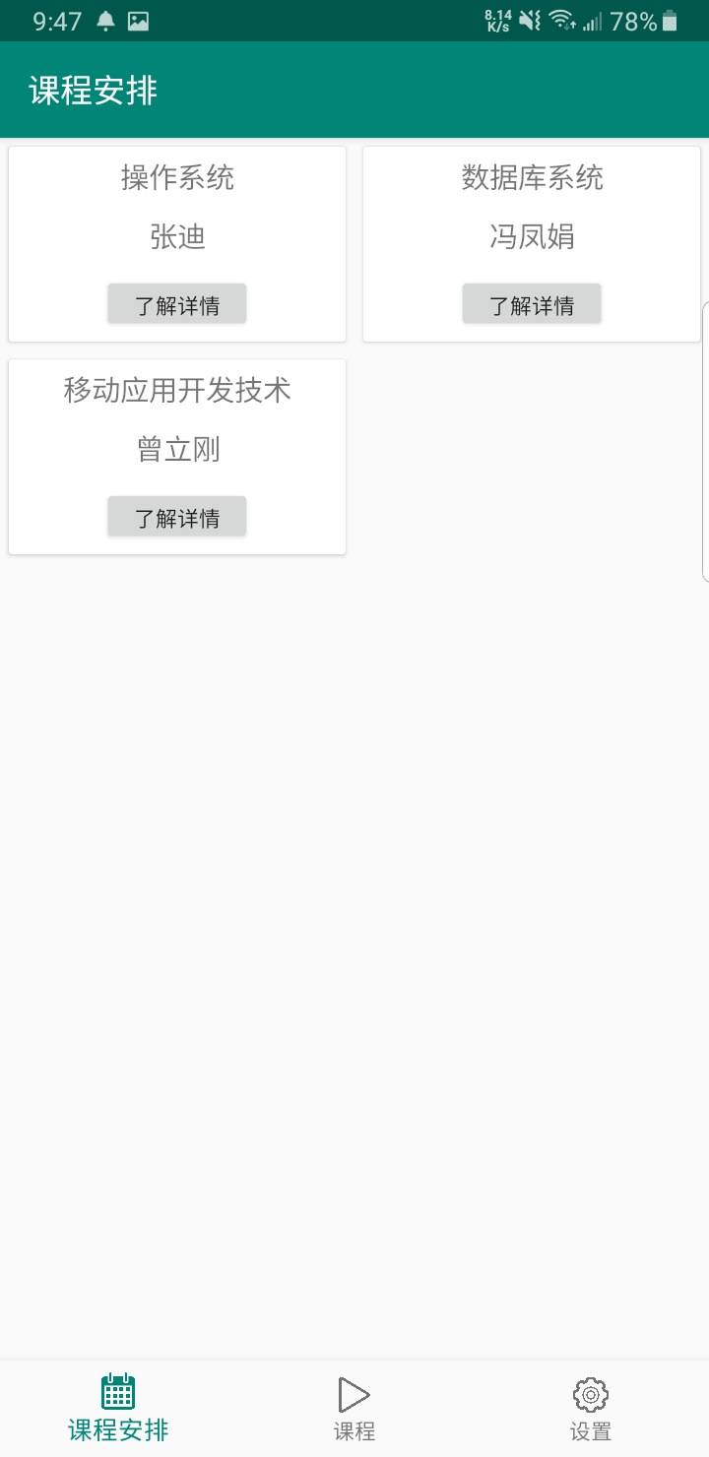

2 course:

We can searching for resourse of the course(e.g. video and so on

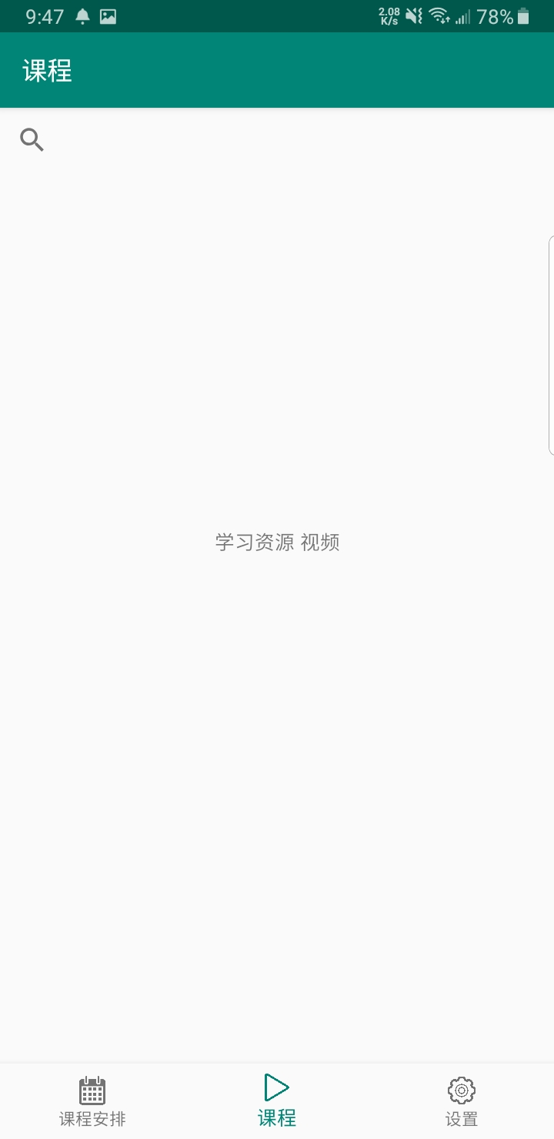

3. setting

We can view the course we have chosen, click on the details and check the course details.