# **Introduction**

In the history of software engineering, engineers have constantly searched for a method that could completely solve the challenges of software development. However, in 1986, renowned computer scientist Fred Brooks presented a groundbreaking view in his paper *"No Silver Bullet: Essence and Accidents of Software Engineering"*: there will be no single technology or method capable of increasing software development productivity by an order of magnitude [1].

A "silver bullet" refers to a mythical weapon that can eliminate all problems with a single shot. Thus, the idea of "no silver bullet" means that there is no magic solution that can instantly remove all difficulties in software development.

# **Identified Key Challenges**

In "No Silver Bullet: Essence and Accidents of Software Engineering", Fred Brooks divides the difficulties of software engineering into two categories: essential and accidental. He particularly emphasizes the essential challenges, as these cannot be completely eliminated through technological means. The following are the key challenges in software development discussed in the article:

1. **Complexity**

Software systems are inherently complex because they need to handle a wide variety of states, inputs, logic, and interactions. The inherent complexity of software arises from the fact that software systems must model complex real-world processes and entities [2]. Software modules are tightly interconnected, so changes in one part can affect the whole system. As systems scale, complexity grows exponentially, making development and maintenance much harder.

1. **Conformity**

Software must adapt to diverse and often conflicting external factors like laws, user needs, and hardware. These complex demands come from many sources, making it hard to apply a single, unified solution. Developers must constantly adjust the software to meet these changing expectations.

1. **Changeability**

Unlike constructing a building with a fixed "design blueprint," software does not have a fixed "design blueprint" and is highly variable. As a result, there are high expectations for its adaptability. Software is inherently easy to change but often surprisingly expensive to modify correctly [3]. Software must evolve with changing user needs and market conditions, but frequent updates can cause errors and raise maintenance costs. Balancing change and system stability is a key challenge in software engineering.

1. **Invisibility**

Software lacks a physical form, and unlike constructing buildings, software developers cannot clearly understand the structure of the software through a blueprint like they would for a house. This invisibility can cause miscommunication among developers, reduce efficiency, and complicate coordination and project management.

# **Design Pattern**

In the face of the four challenges of complexity, conformity, changeability, and invisibility, the following are the design patterns related to the challenges of complexity and changeability:

1. **Component-Based Design Pattern**

The component - based design pattern simplifies complex systems by dividing them into independent, reusable components. Each component bundles specific functions and data. This allows developers to concentrate on individual components, ignoring the overall system intricacies. By promoting modular design, it improves software maintainability and scalability [4].

1. **Advantages and Practical Applications**

This pattern offers multiple benefits. It reduces system complexity, making it easier to manage. Components can be reused across various projects, slashing redundant development efforts. Also, each component can be tested separately, ensuring its proper functionality. This increases flexibility as components can be swapped or updated independently, enhancing the system's scalability.

It has wide applications. In enterprise software, different business functions are made into separate components, boosting development efficiency and flexibility. In microservices architecture, microservices are treated as such components, enabling quick adaptation to business changes. In front - end development, frameworks like React and Vue.js let developers create reusable UI components, enhancing user experience and development speed [5].

1. **Strategy Pattern**

The strategy pattern, a behavioral design approach, encapsulates algorithms or behaviors in distinct strategy classes. This enables clients to pick the needed algorithm during runtime without altering the main code. It's ideal for situations where diverse algorithms or behaviors are required, enhancing system changeability and extensibility [6].

1. **Advantages and Practical Applications**

This pattern is flexible, separating concerns clearly. It follows the Open/Closed Principle, allowing new algorithms to be added without modifying existing code. It also reduces conditional statements. At runtime, different algorithms can be dynamically selected, helping the system respond promptly to specific needs. Encapsulating algorithms in separate classes improves code readability, maintainability, and reduces system coupling [7].

In practice, it's used in sorting algorithms, payment methods, graphics rendering, and data compression. Users can choose suitable strategies based on specific requirements without touching the core logic. This ensures the system's flexibility and maintainability, adapting well to changing business demands.

# **Case Study Analysis**

These design patterns also play an important role in real life, making many challenges more manageable

1. **Component-Based Design Pattern**

I think that component-based design patterns are particularly effective in addressing the fundamental challenges presented in Fred Brooks's article "No silver Bullet."

1. **Case Study**

In the development of e-commerce platform, component design is an effective method to manage complex system. Taking the order system reconstruction of Alibaba platform, a large domestic e-commerce platform, as an example, the system originally adopted a single architecture, with a high degree of coupling between various functional modules, low development efficiency, and difficult maintenance. Using a domain-driven design, the team reconfigured the system into four separate components: an order management component responsible for the full life cycle processing of orders, a payment component that integrates multiple payment channels and supports rapid scaling, an inventory component that ensures the accuracy and consistency of inventory data, and an authentication component that uniformly manages user authentication. These components communicate through well-defined API interfaces and use an event-driven mechanism to achieve asynchronous interactions. The maintenance cost of the modified system is greatly reduced, and the inventory module can independently cope with high concurrent visits during the promotion period. This architecture not only solves the existing problems, but also significantly improves the maintainability, extensibility and stability of the system

1. **Discussion of component-based patterns**

The use of component based design patterns allows me to address the fundamental software engineering challenges mentioned in Brooks's "No magic Bullet" paper and to propose effective solutions [8]. By implementing a modular decomposition approach, complex systems can be divided into discrete functional components with well-defined interfaces, thereby greatly reducing cognitive load and unexpected component interactions [9]. This approach not only improves the maintainability of the system, but also enhances flexibility, allowing each component to evolve independently without compromising the overall stability of the system. These architectural patterns yield additional benefits, including improved component interoperability through standardized interfaces and enhanced system transparency through explicit module descriptions. While no universal solution exists, a system architecture approach can significantly improve the complexity challenges inherent in software.

1. **Strategy pattern address variability challenges in energy management of commercial complexes**
2. **Case Background**

The large-scale commercial complex combines office, entertainment and shopping functions. Its electricity consumption times vary greatly across regions and are affected by peak-valley electricity pricing. Meanwhile, electricity prices, business activities and equipment conditions keep changing. To cut costs and boost efficiency, the complex has energy storage equipment and adopts strategic modes to build an energy management system[10].

1. **Implementation of Strategy Pattern**

（1）Defining the Strategy interface

The core method integrates energy usage, electricity price, energy storage equipment status and other related information (such as holidays, weather), and outputs the charging and discharging plan of energy storage equipment and the regulation scheme of electric equipment in each region, which provides a unified framework for the implementation of the strategy.

（2）Implement concrete Strategy classes

Peak-valley electricity price arbitrage: Adjust charge and discharge based on price changes, plan with real-time needs and storage status to cut electricity cost.

Office area electrical equipment time-sharing control: Based on office working hours and personnel activity, keep air con and lights on during work, turn off extra lights after work to cut air con power and save energy.

Entertainment area electrical equipment dynamic control: In line with business hours, passenger flow and electricity cost, run equipment at full power in peak times and reduce power when it's quiet, balancing customer experience and energy use.

（3）Creating a context class

Set up an energy management context class that holds specific policy instances. By calling its execution method, the system can dynamically select and execute the corresponding policy according to the actual situation at runtime, and switch the energy management policy flexibly.

1. **Addressing the challenges of variability**
2. Electricity price policy shift: Peak-valley prices change often. Traditional adjustment is complex. Our strategy only needs to tweak the charge-discharge conditions of arbitrage strategy, enabling the system to quickly adapt to new policies.
3. Commercial activity changes: Commercial complex activities vary, leading to significant electricity demand fluctuations. For instance, during shopping promotions, the dynamic control strategy for entertainment area electrical equipment can adjust power consumption in real time based on passenger flow and operating hours, adapting to energy demand changes without major system alterations.
4. Equipment renewal: New equipment varies in energy consumption and operating parameters. For example, when updating air conditioners, the control strategies for electrical equipment in office and entertainment areas can adjust operating power and control logic according to new AC features, ensuring the system adapts to equipment changes and effective energy management.

# **Task Allocation and Individual Contribution Form**

1. **Individual Contribution and Task Allocation Table**

|  |  |  |
| --- | --- | --- |
| Name(ID) | Contribution(%) | Task Allocation |
| Shibo Zhou (2143996) | 25% | Component-based pattern case studies and discussions |
| Yan Zhu (2034366) | 25% | Strategy pattern case study and discussion |
| Leyu Pan (2144051) | 25% | Introduce of “No Silver Bullet.” and identify 4 key challenges in the article |
| Tong Wu (2143812) | 25% | introduction of the 2 selected design patterns and their applications |

1. **Version Control History**

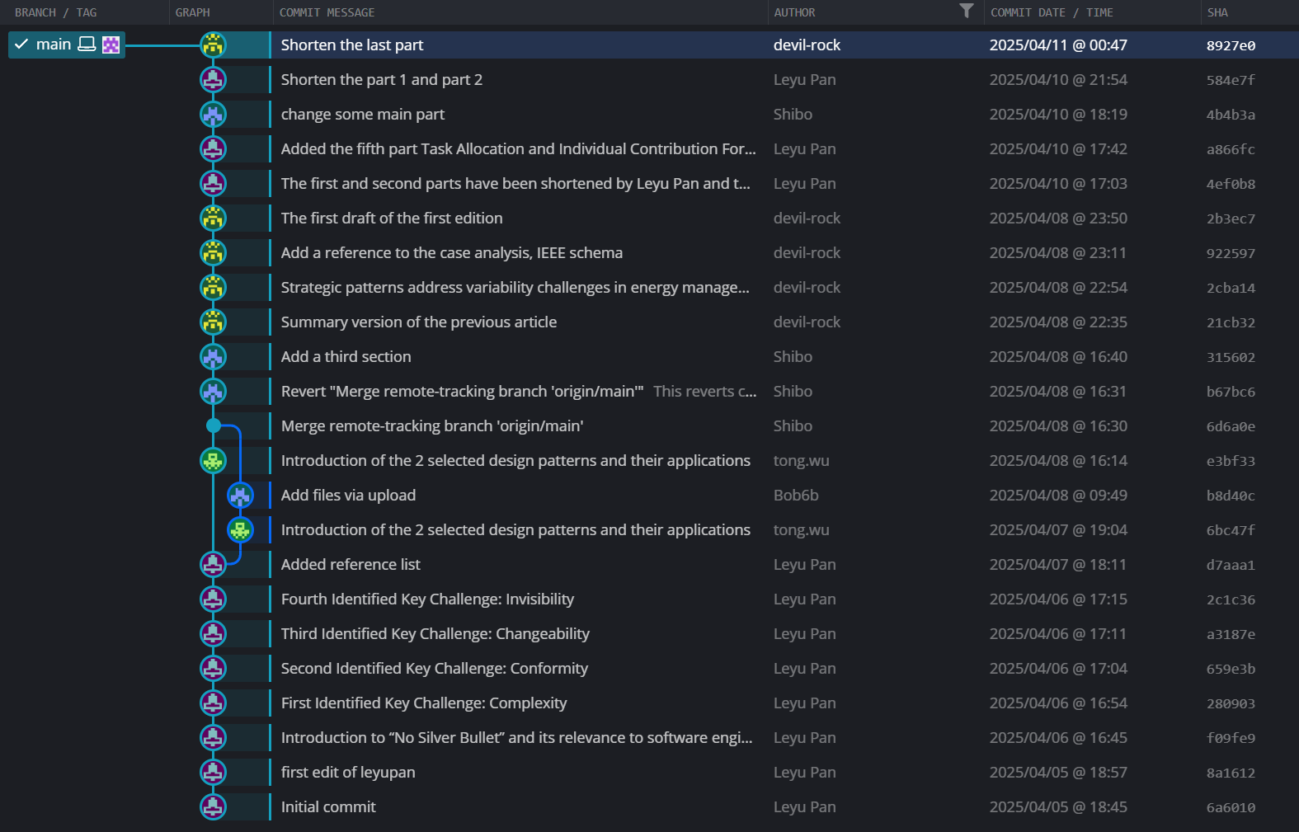

# **Lesson Learned and Conclusion**

In the realm of software engineering, Fred Brooks' "No Silver Bullet" concept reminds us that there's no one - size - fits - all solution. Software development is fraught with challenges like complexity, conformity, changeability, and invisibility. However, design patterns such as the Component - Based Design Pattern and the Strategy Pattern offer practical ways to mitigate these issues. From real - world case studies, we learn that component - based design can break down complex systems, enhancing maintainability and extensibility, as seen in Alibaba's order system. The Strategy Pattern, on the other hand, enables systems to adapt to changes effectively, like in commercial complex energy management. In conclusion, while there's no magic solution, leveraging these design patterns can lead to incremental improvements, making software development more manageable and efficient.

# **Reference List**

1. F. P. Brooks, "No Silver Bullet—Essence and Accidents of Software Engineering," Computer, vol. 20, no. 4, pp. 10–19, Apr. 1987, doi: 10.1109/MC.1987.1663532.
2. I. Sommerville, Software Engineering, 10th ed. Boston, MA, USA: Pearson, 2015.
3. S. McConnell, Code Complete: A Practical Handbook of Software Construction, 2nd ed. Redmond, WA, USA: Microsoft Press, 2004.
4. .S. S. Yau and N. Dong, "Integration in component-based software development using design patterns" in Proceedings of the 24th Annual International Computer Software and Applications Conference (COMPSAC 2000), Los Alamitos, CA, USA: IEEE, 2000, pp. 369-374.
5. M. Babiuch and P. Foltynek, "Implementation of a Universal Framework Using Design Patterns for Application Development on Microcontrollers," Sensors, vol. 24, no. 10, pp. 3116-3143, May 2024.
6. P. Hoverstadt and L. Loh, Patterns of Strategy. London, UK: Routledge, Taylor & Francis Group, 2017, 385 pp.
7. E. Hewitt, Technology Strategy Patterns: Architecture as Strategy. Sebastopol, CA, USA: O'Reilly Media, Inc., 2018, 281 pp.
8. F. P. Brooks, The Mythical Man-Month: Essays on Software Engineering, Addison-Wesley, 1975.
9. M. McCool, J. Reinders, and A. Robison, Structured Parallel Programming: Patterns for Efficient Computation, Elsevier, 2002.
10. J. Hossain et al., "A Review on Optimal Energy Management in Commercial Buildings," Energies, vol. 16, no. 4, 2023, doi: 10.3390/en16041609.