Design and Implementation of an IOT based Monitoring System for Inland Vessels using Multiple Sensors Network

Hasib Zunair, Wordh Ul Hasan, Kimia Tuz Zaman, Irfan Haque, Soumic Shekhar
Electrical and Computer Engineering
North South University
Dhaka, Bangladesh
zunair.hasib@northsouth.edu

Abstract— Multi sensor networks are now widely used in various security and surveillance applications. The paper includes designing and implementing wireless sensor network with a real time web application for monitoring multiple ships to prevent catastrophic events. The idea consists of four main parts: Detection Module, GPS tracker, communication system (NRF240l) and software application for web interface.
Keywords— Wireless, alarm, Star network, nrf2014l, raspberry pi, microprocessor, sensors, radio frequency, Arduino, mysql, Html and css, local server, apache, php, local network, database, nodes, GPS tracker, microcontroller.

Introduction
In Bangladesh, inland water transportation system is a very widely used transportation method. Many people depend largely on this transport method especially during vacations. This country faces a huge rush of people travelling to their villages from the capital. In Bangladesh, four thousand four hundred twenty people died, five hundred twenty people injured and four hundred people missing in more than five hundred fifty passenger ship accidents that took place in last 38 years in inland rivers of Bangladesh. According to a research conducted by Zobair Ibne Awal 33% of this inland river accidents happen due to overloading[1].

Many techniques have been developed to eradicate this problem. Such as a robust system designed by Lei Xie, Jing Chen, Zhongzhen Yan, Zheyue Wang which can detect the overloading of ships using Kalman filter and digital image processing[2]. The algorithm includes three stages: ship detection, ship tracking, and overloaded ship identification. Another development, done by Department of Naval Architecture and Marine Engineering[3] shows the inland vessel tracking system. In addition to the features available in traditional VTS (Vehicle Tracking System) for automobiles, it has the capability of remote monitoring of the vessel’s motion and orientation. Furthermore, this device can detect capsize events and other accidents by motion tracking and instantly notify the authority and/or the owner with current coordinates of the vessel, which is obtained using the Global Positioning System (GPS). This can certainly boost up the rescue process and minimize losses. They also used GSM network for the communication between the device installed in the ship and the ground control.

A similar research[4] was done – as to our proposed model – by T.H.Mujawar, M.S.Kasbe, S.S.Mule and L.P.Deshmukh which involved the work of a LPG gas detection system using multiple sensor nodes. Each node consists of a low cost Arduino Microcontroller, XBee radio communication module and sensors which measure data substantial to detect a disaster. The nodes were established by deploying the star topology and implemented to monitor the room where the gas was leaking.

This paper deals with the design and implementation of a security system to make water transportation more secured by preventing ship accidents in Bangladesh. The work comprises of four main parts: unique water level detector, communication, web application and GPS tracking. In the working system, the water level and the location of multiple ships are sent to a central hub via radio frequency using nrf240L transreceivers. Each node consists of a water level detector and a GPS module which is connected to a microcontroller and an RF transmitter. All the data are accumulated using the RF receiver which is connected to a raspberry pi which runs a python scripts continuously reading for data. The python scripts is connected to a mysql database and is displayed on the web application which has an admin login. The web application also runs in the raspberry pi using apache web server. In case of disaster, an alarm is set and the admin is notified instantly so that appropriate actions can be taken afterwards. Within the software application, a real time sensor graph is also developed for visualization purposes. The novelty of this work is that with respect to Bangladesh’s scenario a star network based system has not been tested or implemented for inland ship in case of security and monitoring purposes. Even though this system has its limitations, it was tested which resulted in positive results.

System Design

Water Level Detection Module

The sensor comprises of two main Sections:
a) The body
b) Circuit
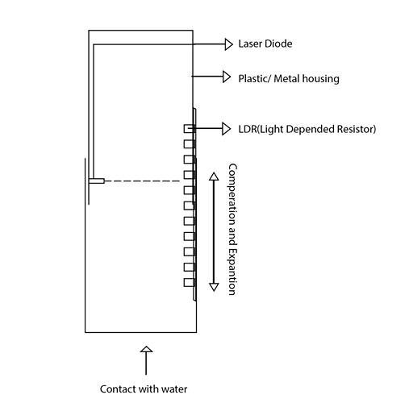

Figure 1: Water Level Detector

The sensor body comprises of two chambers the fixed end (fixed to the ship) and the actuation end. It will be constructed by Plastics or any light metal such as Aluminum so that the sensor can actuate with the waves on water. Upper chamber i.e. the fixed end holds the most of the circuits including the micro-controller, communication device and the laser diode. Where the lower part actuates and fits into the top one and can slide in and out and holds the LDR’s.

The sensor circuit comprises of a laser diode and few LDR (Light Depended Resistor). The LDR’s serves the purpose of markers of depth. As the sensor actuates, the laser diode hits distinct LDR causing it to emit a reading. This value is then fed into a micro-controller.

As the boat moves through the water, the lower end will actuate in and out of the body. This will cause the micro-controller to pick up reading form the sensor which will then be mapped to certain value of depth. This ‘depth value’ will then send over a wireless transmitter (RF/ Wifi), to be conveyed to ships main computer as well as the central hub. The hub can then generate live data feed(mainly a graph) to visualize the data. A threshold value of depth will be set on board the sensor and also the hub controller as a the trigger warning signature of potential danger. Multiple sensors will be attached on various point of the ship to maximize the accuracy of the reading.

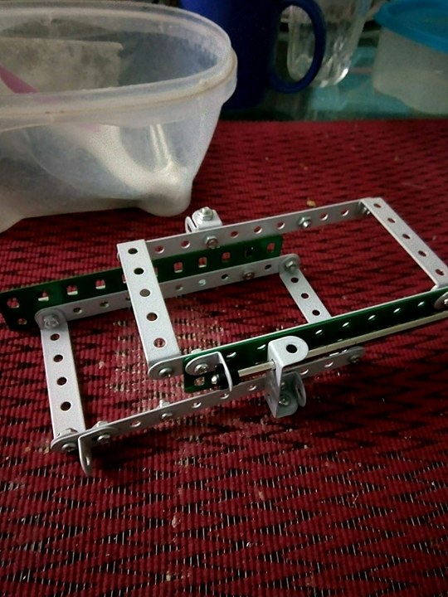

Figure 2: Housing of the detector

Figure above shows the inner railing and housing for the ldr and laser. This structure helps to keep the laser aligned with the ldr for precise reading. The railing is free moving and opposite ends are to be attached to opposite ends of the sensor body. As the lower portion actuates due to waves, it intern actuates along this railing which gives us our readings

Building a new custom sensor by using existing hardware ensures compatibility. The sensor is very easy to understand and will be cost-effective to implement. It will also be robust and fast. The maintenance cost of such a device is very low and can be easily replaced if necessary. An auto locking mechanism can be implemented, so that no ships with faulty sensor can deport.

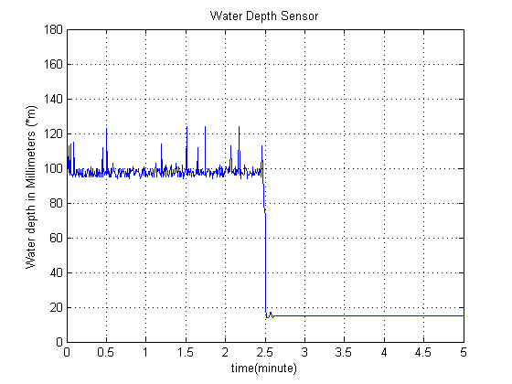
Figure 3: Water Level

The figure above shows a demo of the water level sensor. This illustrates the different conditions of the water levels. The graph was plotted in Matlab.

Communication System
The communications system is based on a star network topology. The star network is crucial as it allows each node to be independent of all others and provides the shortest path to the hub (monitoring station). As the ships would not communicate with one another directly, this was the clear solution.

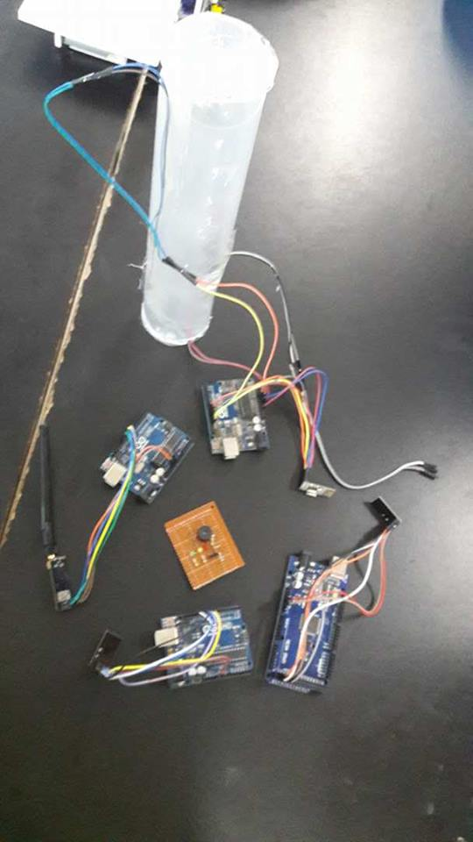

Figure 4: NRF Star Network

The central hub is the Raspberry Pi 3 on land connected to ships, each of which represents a node in the network. A 2.4G nrf240L+ RF transceiver module with SMA antenna at each node were used, as well as the hub. It has a range of up to 1100 meters which is more than needed for detection of overloading – since all the ships will be present at the dock. Each ship sends its longitude and latitude as well as data from the sensor consisting of a single integer value representing depth. Multiple pipes of the nRF24L01 were used. All ships were assigned a unique pipe address. On the central hub each pipe is read with a delay of about 20 microseconds between readings. If the data is received properly it sends a confirmation byte back to the node.

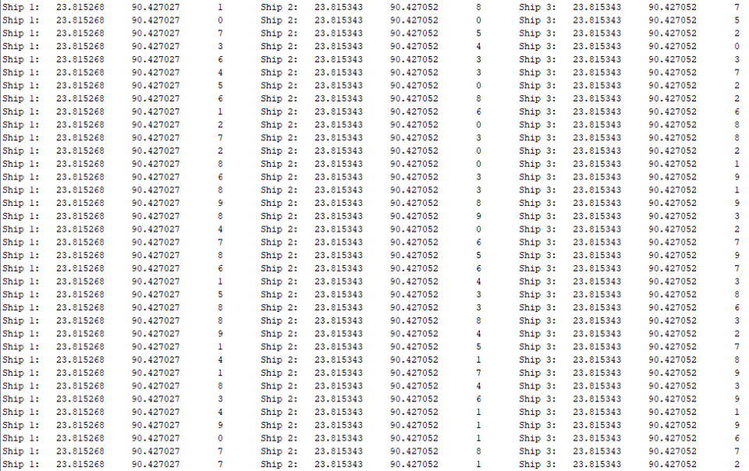

Figure 5: Star network demo using nrf240L+

The figure above shows the data being accumulated from multiple ships – three in this case – with its respective sensor value and the current location.

GPS Tracker
GPS Stands for global positioning system and is a network system that uses satellite network to provide position speed and time of any GPS Receiver. There are a wide range of satellites orbiting around the earth. The GPS Receiver tracks at least four or more than four satellites from any given position on earth surface and figure out distance of these satellites and use these information to achieve its own location on earth. The better the signals or more satellites it can track the more accurate positioning is achieved.

In our system, we tried to prevent overloading of the ship in sensor applications. But even after prevention of overloading the ships are vulnerable to extreme weathers and sometimes ship racing in inland rivers of Bangladesh. If any kind of disaster happens our system can track the last known location of the ship. The ship are tracked real time in the system and if any two ships run closely for a long time it indicates the ships are racing. These are tracked using the GPS Receiver installed in the system. If any kind of disaster happens we know the last location of the system and notify other nearby ships- since all the nodes are connected to a central hub- to help reduce the casualties and operate rescue operations.

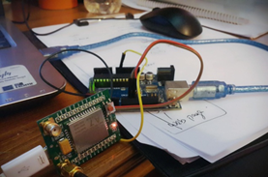

Figure 6: GPS circuit

In our system we used AI Thinker A6 GPS Module connected with the micro controller with baud range 9600 as the figure shows above. The GPS Tracker is used with TinyURL Library to get the location information in longitude and latitude format. This information is then sent to the control center for plotting the ships as nodes in Google maps. An instance is shown in the figure below.

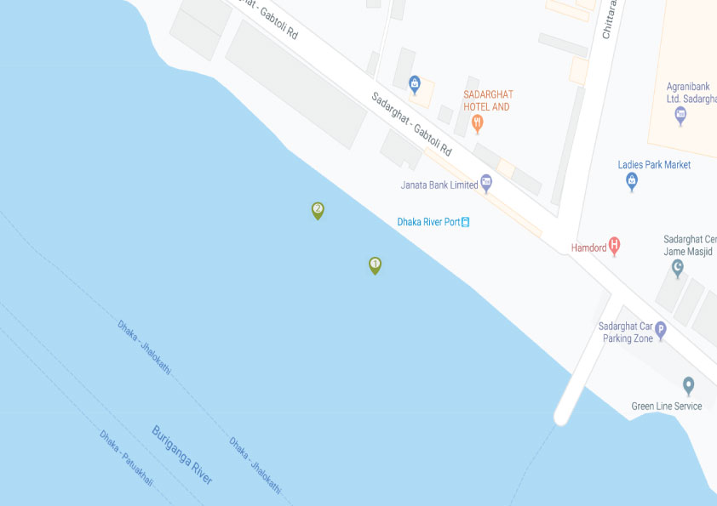

Figure 7: Map

From the GPS module the co-ordinates are displayed in real time using serial communication. The data of the location are shown in figure below.
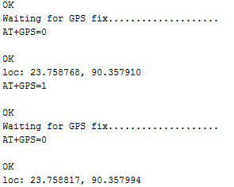

Figure 8: Latitude and Longitude

Web Application and Interface

The system consists of a web application to monitor the ships. The application is developed using html and css in the front end. Php is used in the back end which is then connected to a mysql database. In the database, models are created, and for each ship there are tables which are timestamps, depth sensor and location values An instance of this is shown in figure below.

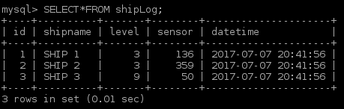

Figure 9: mysql database

The web interface also has a log in page which can be accessed by the admin only. It uses a specific username and password. After logging in, the admin can see the state of the ships. The admin panel is shown in figure below.

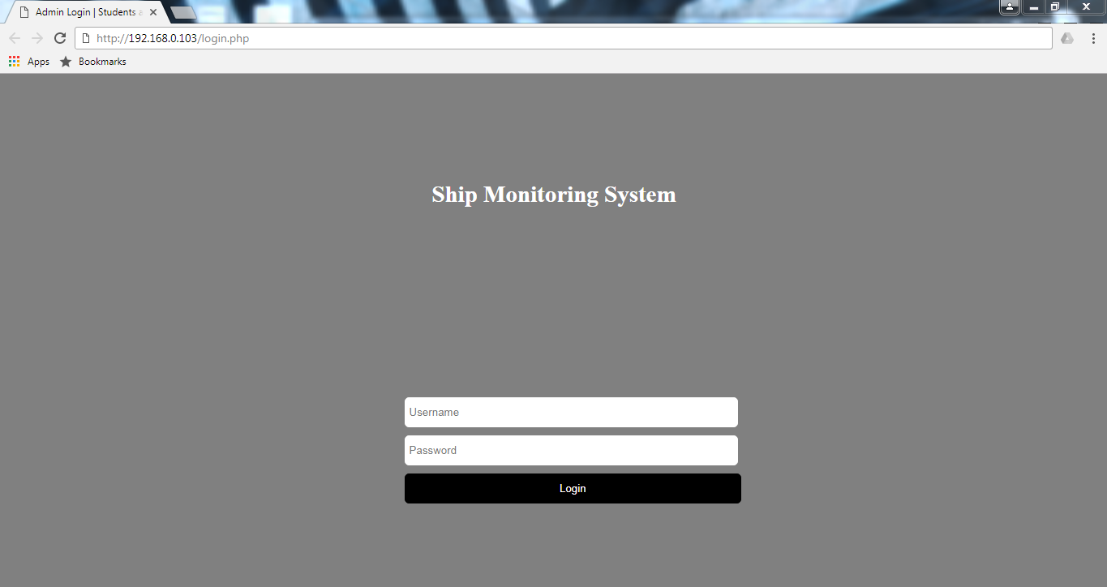

Figure 10: Web Page Admin Page

System Architecture

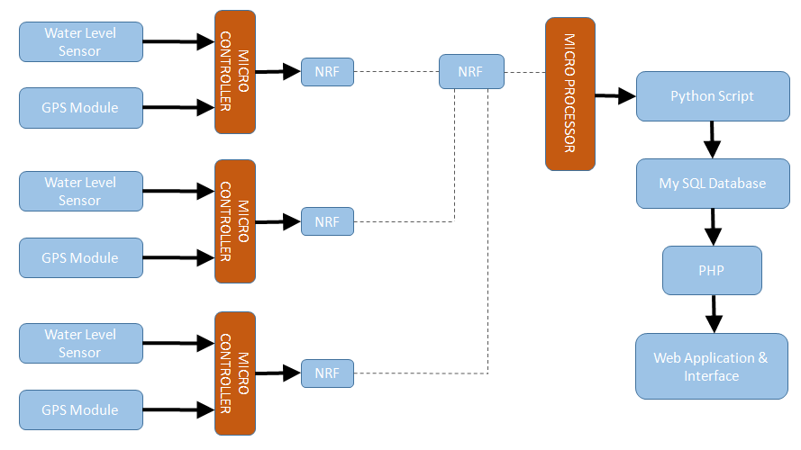

Figure 11: System Architecture

The figure above shows the inputs and output of the system. Multiple LDR based water level sensor and the GPS module is connected to the ATmega328 based 16Mhz microcontroller (Arduino Uno) which then send the data via nrf transrecievers to the raspberry pi which is the central hub – implicating a star network. This data is then read via a python script and then sent to the database which is then view in an organized manner in the web application.

Flow Chart
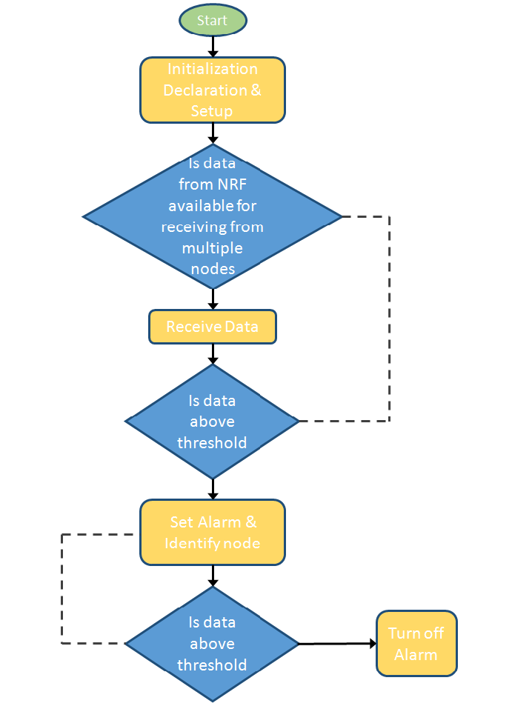

Figure 12: Flow chart

The figure above illustrates the working process of the system. Alarms are only triggered in the presence of abnormal values beyond a certain threshold. It is turned off when the value is again stable.

Hardware Implementation

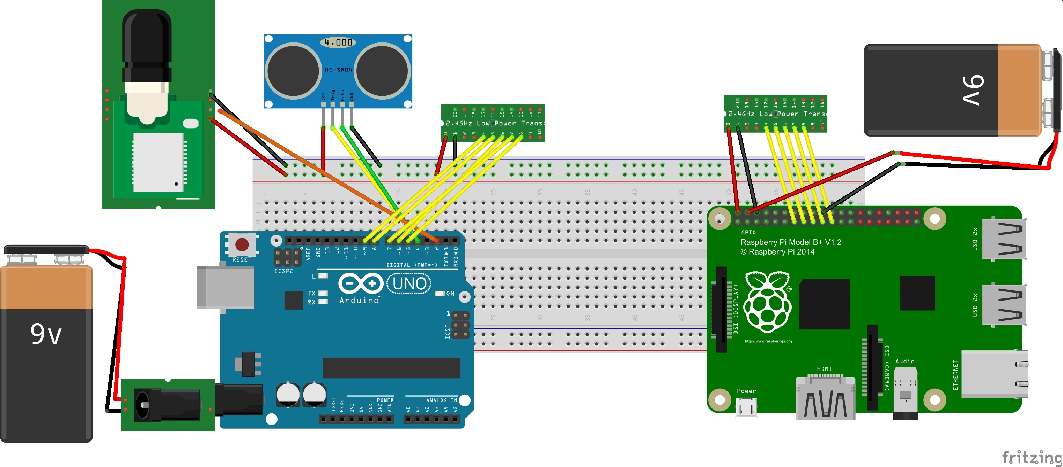

Figure 13: Circuit Schematic

The figure above illustrates the schematic of the hardware prototype that was built. The figure display a single node for the transmitter that is to be installed in the inland vessels. It consists of a GPS module and the sensor itself – which is replaced by an ultrasonic sensor for demonstration. These are connected to an ATmega328 based 16MHz microcontroller (Arduino Uno) which is connected to a 2.4GHz nrf240L+ transreciever. The receiving end consists of a nrf240L+ transreceiver and a Raspberry Pi Model B+ which collect all the data from multiple nodes. Both these devices are powered using a standard 9V Lithium Ion battery.

Results

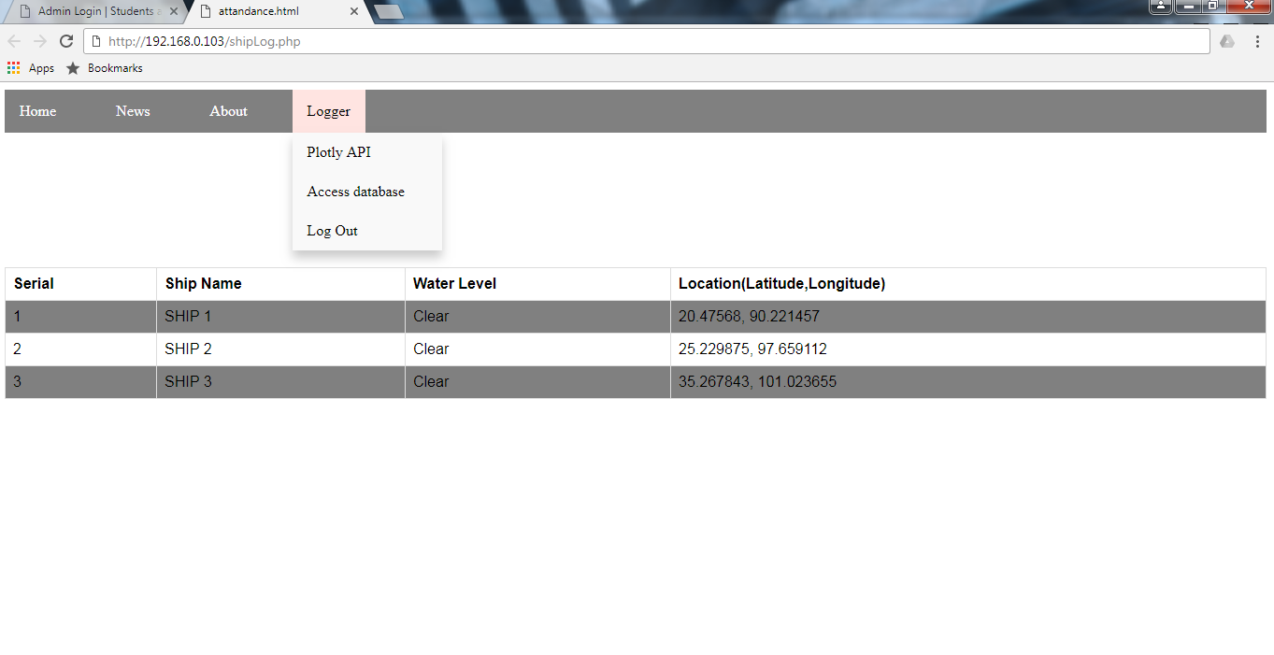
Figure 14: Web application

The figure above shows the web application displaying the status of the ships. From the models in the database the columns are made accordingly. Each ship’s depth and location is shown.
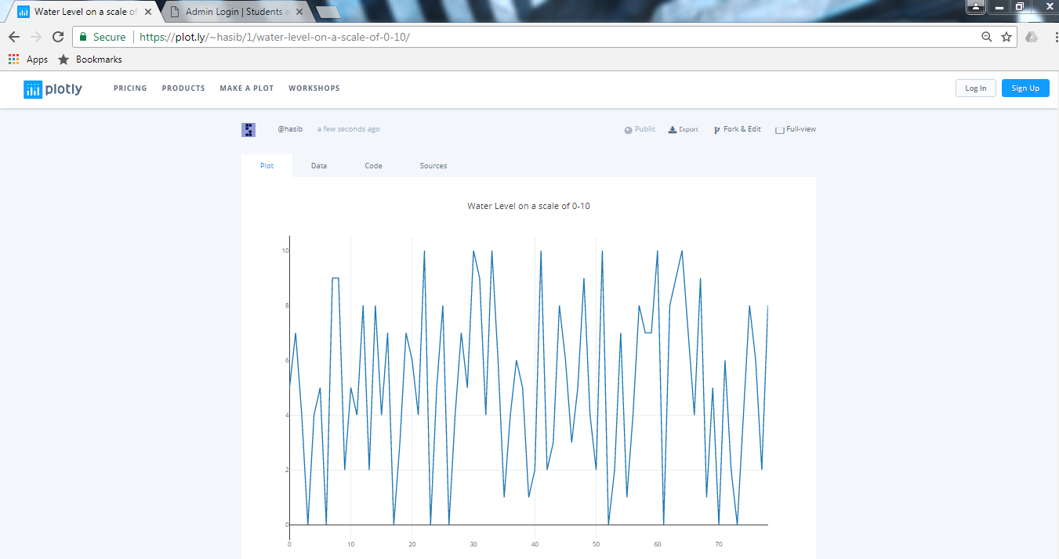

Figure 15: Real time graph using Plotly API

The figure above portrays the functionality of the real time sensor data graphing using plotly api on a scale of 0-10. Here, dummy values are sent from a python script for debugging purposes which can be accessed and displayed from anywhere with the specific url.

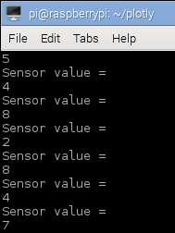

Figure 16: Reading from the sensor

The figure above shows the reading from the sensor which is mapped on a scale of 0-10. Here, data is displayed on the raspberry pi terminal window.

Conclusion
Overall, our system proved successful whilst testing. With the use of multi sensor networks transferring multiple data to a central hub which is then organized and displayed using a web application which also consists of a real time graph plot proves to be a handy monitoring system for ships. This system somewhat eradicates the problem of proper alarm and notification.
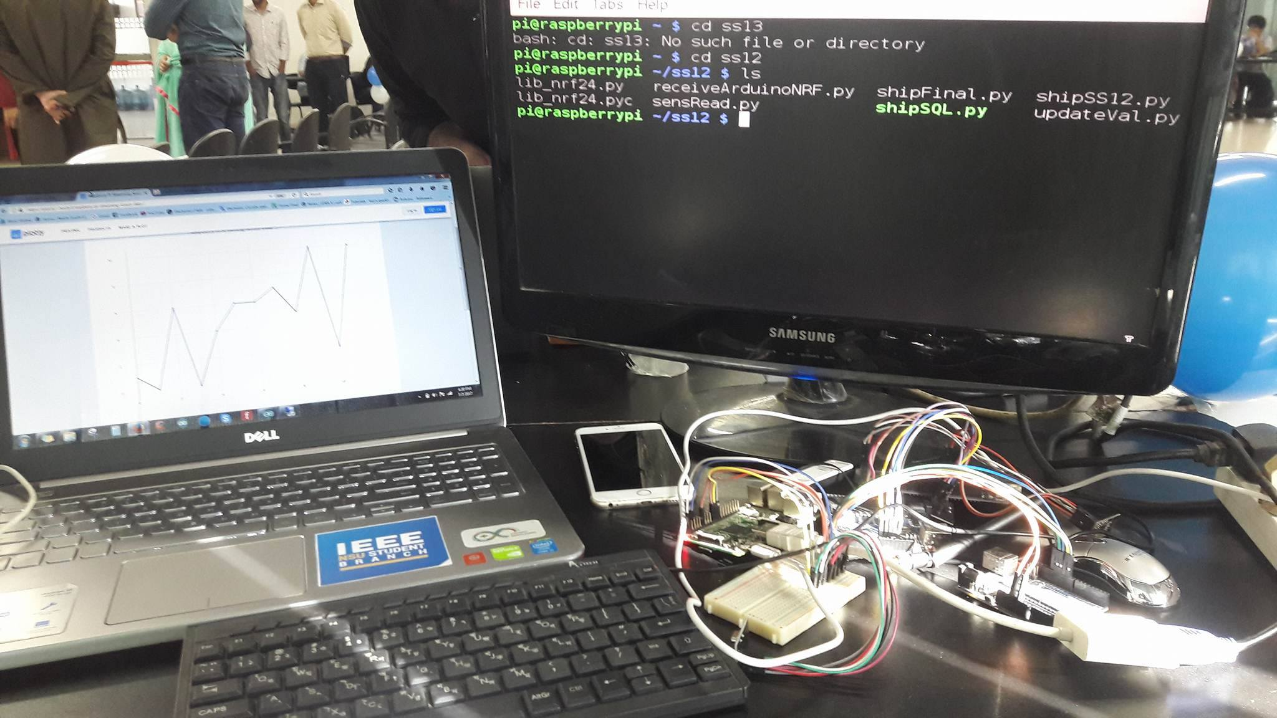

Figure 17: Base station

The figure above displays the hardware prototype of the base station or the receiving end which has the nrf receiver connected to the raspberry pi and an instance of the web application shown a ship’s sensor readings in real time.

Future works
Being a working prototype, the system still has it’s limitations and can be improved. Some of the key aspects of improvement are:
- Use of web sockets
- Use of tilt sensor to indicate ship’s orientation
- Mesh network to interconnect between ships
- Mobile application for more intuitive monitoring
- Real time display on each node

References
- K. Pooventhan, R. Achuthaperumal and C. Manoj Balajee, "Surveillance Robot Using Multi Sensor Network", International Journal of Innovative Research in Electrical, Electronics, Instrumentation and Control, vol. 3, no. 2, pp. 113-115, 2015.
- Y. Shimosasa, J. Kanemoto, K. Hakamada, H. Horii, T. Ariki, Y. Sugawara, F. Kojio, A. Kimura, S. Yuta, “Some results of the test operation of a security service system with autonomous guard robot”, 26th Annual Conference of the IEEE on Industrial Electronics Society, Vol.1, pp.405-409, 2000.
- S. Chia, J. Guo, B. Li and K. Su, "Team Mobile Robots Based Intelligent Security System", Applied Mathematics & Information Sciences, vol. 7, no. 2, pp. 435-440, 2013.
- Z. Ibne Awal, M. Rafiqul Islam & M. Hoque, "ANALYSIS OF PASSENGER VESSEL ACCIDENTS IN THE INLAND WATERWAYS OF BANGLADESH ", 5th Biennial Conference on Marine Technology (MARTEC) 2006, pp. 211 – 219.
- S. Sakib, "GPS-GSM based Inland Vessel Tracking System for Automatic Emergency Detection and Position Notification", 10th International Conference on Intelligent Systems and Control (ISCO), At Coimbatore, Tamil Nadu, India, 2016.
- Xie L., Chen J., Yan Z., Wang Z. (2013) A New Method of Inland River Overloaded Ship Identification Using Digital Image Processing. In: Zhong Z. (eds) Proceedings of the International Conference on Information Engineering and Applications (IEA) 2012. Lecture Notes in Electrical
Engineering, vol 220. Springer, London

- Mujawar, Dr Tabbsum & Kasbe, Meghana & Mule, Mujawar, Dr Tabbsum & Kasbe, Meghana & Mule, Shirish & , L.P.Deshmukh. (2016). DEVELOPMENT OF WIRELESS GAS SENSING SYSTEM FOR HOME SAFETY. International Journal of Engineering Sciences & Emerging Technologies. 8. 213-221.

