**邮件规则功能接口**

1.查询列表

URL: http://127.0.0.1:8088/sofa/dsmp-mdm/mailRules/getMailRulesList

请求参数：

{

     "orgName": "中保登2",

   "parsingRules": "test.py",

"startPage":0,

"pageSize":3

}

响应参数：

{

    "code": 200,

    "data": {

        "pageNo": 0,

        "pageSize": 0,

        "records": [

            {

                "id": "282877231615877120",

                "matchFile": "中保登2.xlsl",

                "matchTitle": "中保登标题2",

                "orgName": "中保登2",

                "parsingRules": "test.py",

                "sender": "中保登机构2"

            },

            {

                "id": "282877426898477056",

                "matchFile": "yss.xlsl",

                "matchTitle": "yss",

                "orgName": "yss",

                "parsingRules": "test.py",

                "sender": "赢时胜"

            },

            {

                "id": "282871126688964608",

                "matchFile": "中保登1.xlsl",

                "matchTitle": "中保登标题1",

                "orgName": "中保登1",

                "parsingRules": "test1.py",

                "sender": "中保登机构1"

            }

        ],

        "totalCount": 3

    },

    "message": "业务处理成功."

}

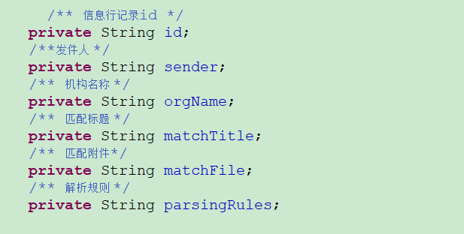

2.查看

URL: http://127.0.0.1:8088/sofa/dsmp-mdm/mailRules/info

请求参数：

{

    "id":"282877426898477056"

}

响应参数：

{

    "code": 200,

    "data": {

        "id": "282877426898477056",

        "matchFile": "yss.xlsl",

        "matchTitle": "yss",

        "orgName": "yss",

        "parsingRules": "test.py",

        "sender": "赢时胜"

    },

    "message": "业务处理成功."

}

3.编辑

URL: http://127.0.0.1:8088/sofa/dsmp-mdm/mailRules/update

请求参数：

{

        "id": "282877426898477056",

        "matchFile": "yss.xlsl",

        "matchTitle": "yss",

        "orgName": "yss",

        "parsingRules": "test.py",

        "sender": "赢时胜"

}

响应参数：

{

    "code": 200,

    "data": **false**,

    "message": "业务处理成功."

}

4.新增

URL: http://127.0.0.1:8088/sofa/dsmp-mdm/mailRules/register

请求参数：

{

        "matchFile": "yss.xlsl",

        "matchTitle": "yss",

        "orgName": "yss",

        "parsingRules": "test.py",

        "sender": "赢时胜"

}

响应参数：

{

    "code": 200,

    "data": **true**,

    "message": "业务处理成功."

}

5.删除

URL: http://127.0.0.1:8088/sofa/dsmp-mdm/mailRules/delete

请求参数：

{

    "id":""

}

响应参数：

{

    "code": 200,

    "data": **false**,

    "message": "业务处理成功."

}

6.上传

URL: http://127.0.0.1:8088/sofa/dsmp-mdm/mailRules/fileUpload

请求参数：

File文件

响应参数：

7.下载

URL: http://127.0.0.1:8088/sofa/dsmp-mdm/mailRules/download

请求参数：

{

     "parsingRules": "test.py"

}

响应参数：