# Macos VM on Windows

[https://github.com/myspaghetti/macos-virtualbox/blob/master/macos-guest-virtualbox.sh](https://emea01.safelinks.protection.outlook.com/?url=https%3A%2F%2Fgithub.com%2Fmyspaghetti%2Fmacos-virtualbox%2Fblob%2Fmaster%2Fmacos-guest-virtualbox.sh&data=04%7C01%7C%7C98cee942dd4f45e9098b08d9c124f692%7C84df9e7fe9f640afb435aaaaaaaaaaaa%7C1%7C0%7C637753186757140138%7CUnknown%7CTWFpbGZsb3d8eyJWIjoiMC4wLjAwMDAiLCJQIjoiV2luMzIiLCJBTiI6Ik1haWwiLCJXVCI6Mn0%3D%7C3000&sdata=EasfY0ANUWKLiWYtOI4vKkgNq3rKNtZKph5LJiRklAQ%3D&reserved=0)

# Macos VM on Linux

[https://github.com/foxlet/macOS-Simple-KVM](https://emea01.safelinks.protection.outlook.com/?url=https%3A%2F%2Fgithub.com%2Ffoxlet%2FmacOS-Simple-KVM&data=04%7C01%7C%7C06a5f5dcf82e4d6f7d9a08d9e8fadd1e%7C84df9e7fe9f640afb435aaaaaaaaaaaa%7C1%7C0%7C637796986406167840%7CUnknown%7CTWFpbGZsb3d8eyJWIjoiMC4wLjAwMDAiLCJQIjoiV2luMzIiLCJBTiI6Ik1haWwiLCJXVCI6Mn0%3D%7C3000&sdata=lvtvTFWWRajuHb7mSuTcMDQOpFqbNMZob7lQUtgFVmA%3D&reserved=0) (alternative 1 : with Clover)

[https://github.com/kholia/OSX-KVM](https://emea01.safelinks.protection.outlook.com/?url=https%3A%2F%2Fgithub.com%2Fkholia%2FOSX-KVM&data=04%7C01%7C%7C1ac827bedcf444679f2208d9e8fb44f9%7C84df9e7fe9f640afb435aaaaaaaaaaaa%7C1%7C0%7C637796988149797698%7CUnknown%7CTWFpbGZsb3d8eyJWIjoiMC4wLjAwMDAiLCJQIjoiV2luMzIiLCJBTiI6Ik1haWwiLCJXVCI6Mn0%3D%7C3000&sdata=HXlGDahvTzBZxmioiAz51KRO%2FPKSzgduNVUFItXWxPM%3D&reserved=0) (alternative 2 : with OpenCore)

[Virtualiser MacOS sur Linux avec QEMU – Tuxicoman (jesuislibre.net)](https://tuxicoman.jesuislibre.net/2021/01/virtualiser-macos-sur-linux-avec-qemu.html)

Je vous conseille les scripts de [foxlet/macOS-Simple-KVM](https://github.com/foxlet/macOS-Simple-KVM)

Voici ma config perso (corrige le problème de pointeur de souris, meilleure performance i/o & graphique, exposition par le protocole SPICE) :

#!/bin/bash OSK="ourhardworkbythesewordsguardedpleasedontsteal(c)AppleComputerInc" VMDIR=$PWD OVMF=$VMDIR/firmware [#export](https://tuxicoman.jesuislibre.net/tag/export) QEMU_AUDIO_DRV=pa [#QEMU_AUDIO_DRV](https://tuxicoman.jesuislibre.net/tag/qemu_audio_drv)=pa qemu-system-x86_64 \ -nodefaults \ -enable-kvm \ -m 6G \ -machine q35,accel=kvm \ -smp 4,cores=2 \ -cpu Penryn,vendor=GenuineIntel,kvm=on,+sse3,+sse4.2,+aes,+xsave,+avx,+xsaveopt,+xsavec,+xgetbv1,+avx2,+bmi2,+smep,+bmi1,+fma,+movbe,+invtsc \ -device isa-applesmc,osk="$OSK" \ -smbios type=2 \ -drive if=pflash,format=raw,readonly,file="$OVMF/OVMF_CODE.fd" \ -drive if=pflash,format=raw,file="$OVMF/OVMF_VARS-1024x768.fd" \ -vga virtio \ -device ich9-intel-hda -device hda-output \ -usb -device usb-kbd -device usb-tablet \ -netdev user,id=net0 \ -device vmxnet3,netdev=net0,id=net0,mac=52:54:00:09:49:17 \ -drive id=ESP,if=virtio,format=qcow2,file=ESP.qcow2 \ -drive id=MyDisk,if=virtio,format=qcow2,file=MyDisk.qcow2 \ -k fr \ -spice port=3001,disable-ticketing \ -device virtio-serial -chardev spicevmc,id=vdagent,debug=0,name=vdagent \ -device virtserialport,chardev=vdagent,name=com.redhat.spice.0 \

Ca se regarde avec spicy:

spicy --uri=spice://localhost:3001

# Quemu install on Macos Catalina

1. **Open Terminal**

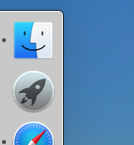

click Launchpad (rocket icon)

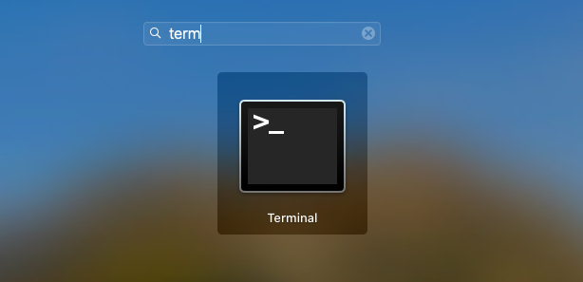

input "term"

click on Terminal

1. **Install Howebrew**

Before …

After …

[https://brew.sh](https://emea01.safelinks.protection.outlook.com/?url=https%3A%2F%2Fbrew.sh%2F&data=04%7C01%7C%7Cdac3339da77641db580108d9e8bff7e8%7C84df9e7fe9f640afb435aaaaaaaaaaaa%7C1%7C0%7C637796733463195492%7CUnknown%7CTWFpbGZsb3d8eyJWIjoiMC4wLjAwMDAiLCJQIjoiV2luMzIiLCJBTiI6Ik1haWwiLCJXVCI6Mn0%3D%7C3000&sdata=t9FLGYBeFQ9CURogAn5qn2bNjlQVDAZkobex6ftmmuU%3D&reserved=0)

> /bin/bash -c "$(curl -fsSL https://raw.githubusercontent.com/Homebrew/install/HEAD/install.sh)"

Interaction 1 : enter sudo password to execute the install script

Interaction 2 : accept the script modifications summary

Interaction 3 : enter sudo password for xcode-select

…………

1. **Install Qemu**



After …

[https://www.qemu.org/download/#macos](https://emea01.safelinks.protection.outlook.com/?url=https%3A%2F%2Fwww.qemu.org%2Fdownload%2F%23macos&data=04%7C01%7C%7Cdac3339da77641db580108d9e8bff7e8%7C84df9e7fe9f640afb435aaaaaaaaaaaa%7C1%7C0%7C637796733463195492%7CUnknown%7CTWFpbGZsb3d8eyJWIjoiMC4wLjAwMDAiLCJQIjoiV2luMzIiLCJBTiI6Ik1haWwiLCJXVCI6Mn0%3D%7C3000&sdata=rjyqm%2FzM36e7uo2Xl7uVUrLxyroyGjrXRmpBGyZQ1zw%3D&reserved=0)

> brew install qemu

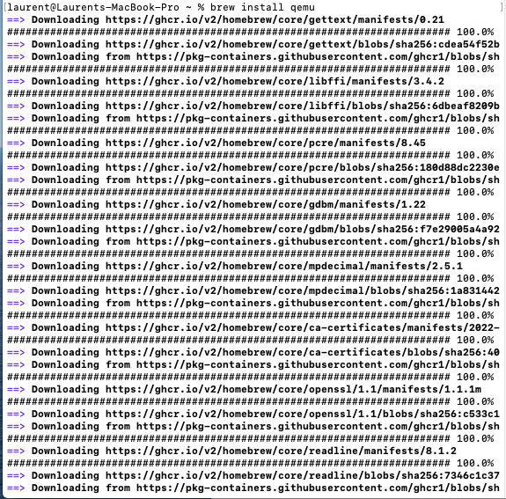

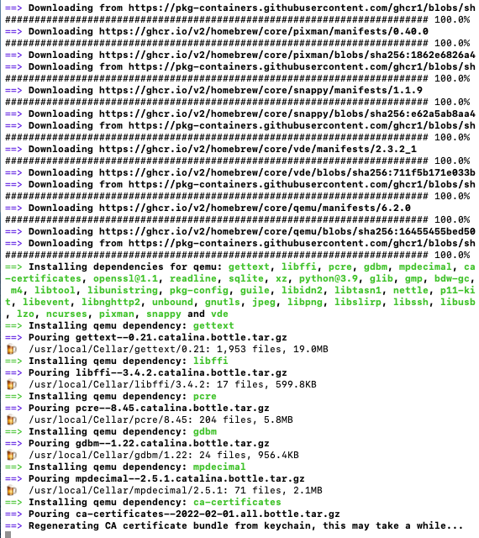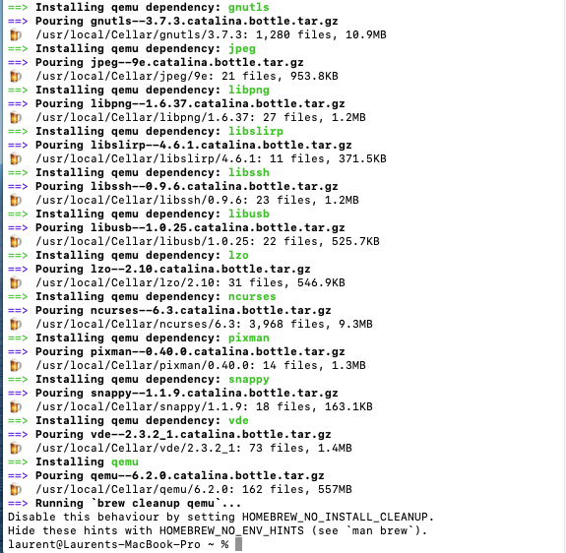

# Example using Qemu with Apple Hypervisor Framework on Macos

