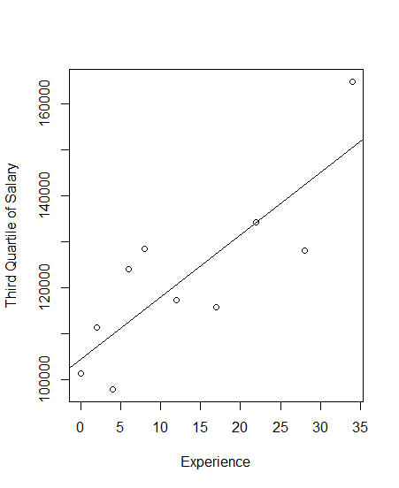

Figure Third Quartile of salary based on professor's experience with fitted regression line.

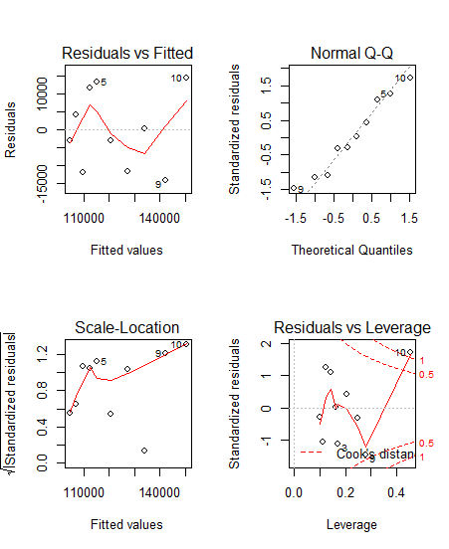

Figure Residuals plots of non-weighted linear model.

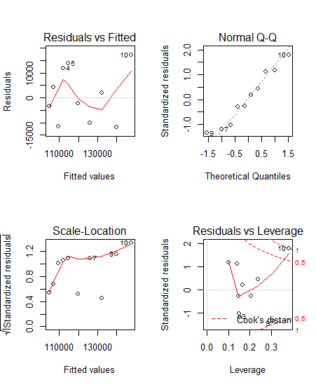

Figure Residuals plots of weighted linear model.

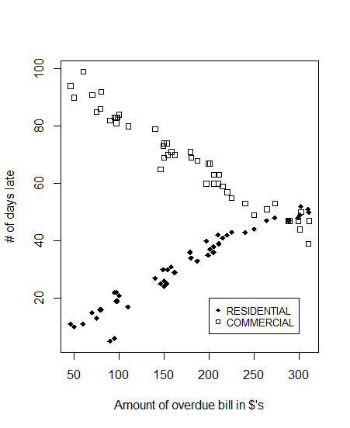

Figure Plot showing the # of days late based on the type and amount of the bill.

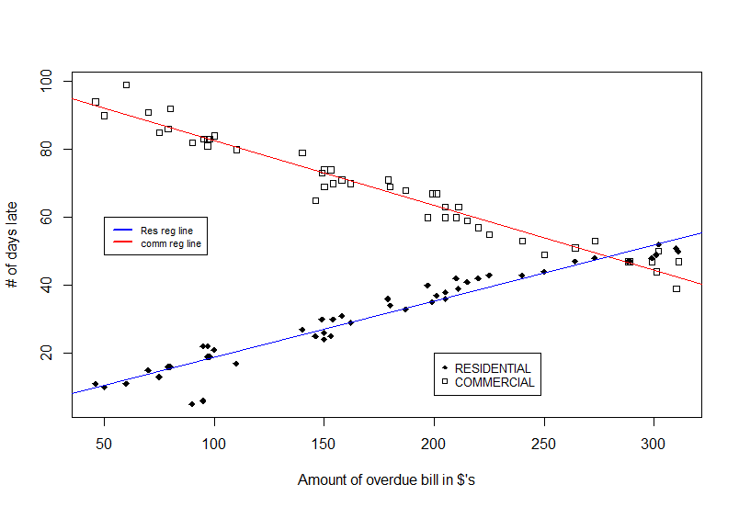

Figure Adding the fitted regression lines generated from a linear model of the data seen in Figure 4.

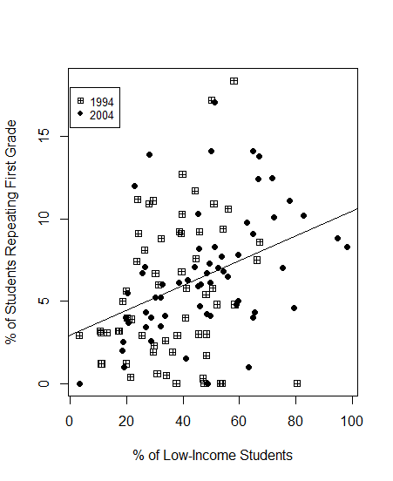

Figure Plot of the % of students repeating first grade against % of low-income students. The line is the fitted regression line without taking year into consideration.