|  |  |  |  |  |  |
| --- | --- | --- | --- | --- | --- |
| Subset Size | Predictors | R2adj | AIC | AICC | BIC |
| 1 | GIR | 0.251 | -62.516 | -62.391 | -55.959 |
| 2 | GIR, PuttsPerRound | 0.486 | -135.220 | -135.010 | -125.385 |
| 3 | GIR,BirdieConversion,Scrambling | 0.538 | -155.310 | -154.994 | **-142.198** |
| 4 | GIR,BirdieConversion,SandSaves,Scrambling | 0.543 | -156.291 | -155.846 | -139.900 |
| 5 | GIR,BirdieConversion,SandSaves  ,Scrambling,PuttsPerRound | **0.546** | **-156.641** | **-156.045** | -136.972 |
| 6 | DrivingAccuracy,GIR,BirdieConversion,  SandSaves,Scrambling,PuttsPerRound | 0.544 | -154.730 | -153.960 | -131.783 |
| 7 | DrivingAccuracy,GIR,PuttingAverage,  BirdieConversion,SandSaves,Scrambling,  PuttsPerRound | 0.541 | -152.735 | -151.767 | -126.510 |

Table Best values for R2adj, AIC, AICc and BIC on optimal subsets of different size.

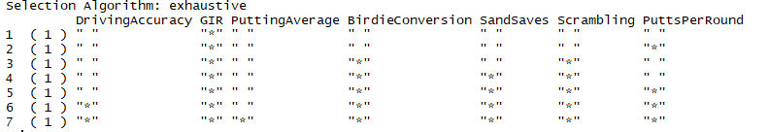

Figure Predictors chosen for optimal model of each subset.

The optimal model using all possible subsets for R2adj, AIC, and AICC would be the subset size 5 one using the predictors GIR, BirdieConversion, SandSaves, Scrambling, and PuttsPerRound to predict the log of PrizeMoney.

The optimal model using BIC was the one with subset size 3. That used the predictors: GIR, BirdieConversion, Scrambling.

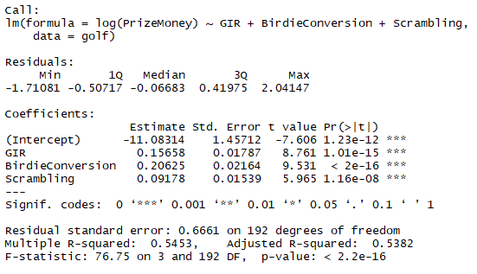

Figure Summary of best BIC model (subset size 3).

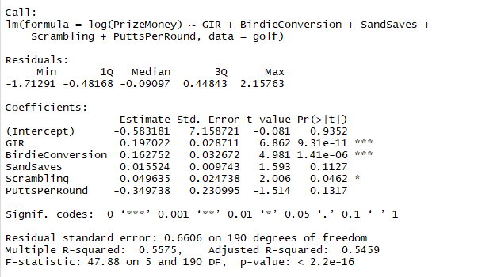

Figure summary of best R2adj, AIC, AICc model (subset size 5).

**Backwards Subset Selection**

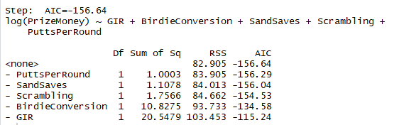

Figure Backwards subset using AIC

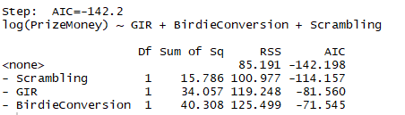

Figure Backwards subset using BIC

**Forwards Subset Selection**

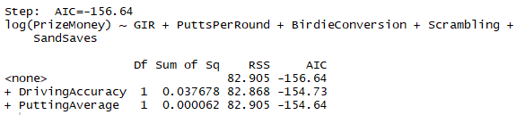

Figure Forwards subset using AIC

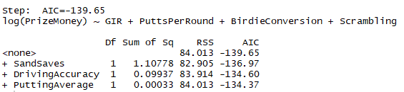

Figure Forwards subset using BIC

These models chosen in the backwards and forwards method of subset selection don’t give you the same models in that minimize the AIC or BIC in Table 1. This is because forwards and backwards subsets method matters about the order in which the algorithm adds each predictor. Putting one in before the other could change the best value you can get for AIC and BIC.

After viewing all the “best” models, I would probably choose the model that uses 5 predictors.