Selenium WebDriver Architectue Simplified:

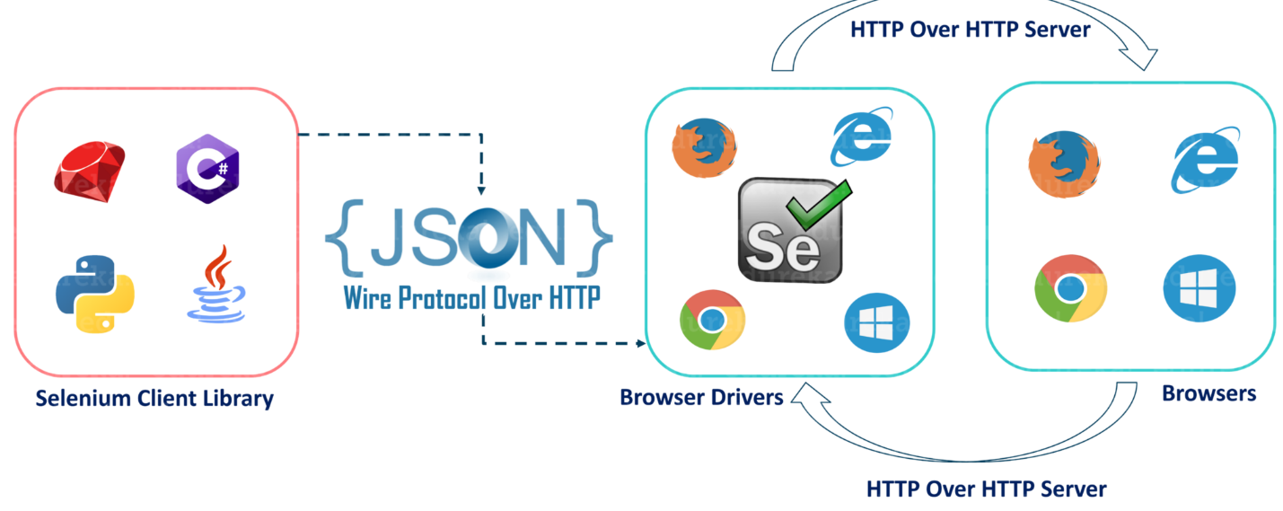

* After you trigger the Test, complete Selenium code (Client) which we have written will be converted to Json format
* Generated Json is sent to Browser Driver (Server) through http Protocol

Note: Each browser contains a separate browser driver

* . Browser drivers communicate with its respective browser and executes the commands by interpreting Json which It received on the browser.
* Browser Driver receives responses back from the browser and it sends Json response back to Client.

1. What is Interface in Java?

An interface is a group of related methods with empty bodies.

Its class responsibility is to implement the common methods declared in the Interface/Webdriver.

When class agreed to implement the instructions of the interface, they must need to provide implementation/bodies to all the defined methods in Interface

In simple terms, Interface provides blueprint for class to follow.

2. WebDriver is an Interface which provides Set of Browser Automation methods with empty bodies (Abstract methods)

Classes like ChromeDriver, FirefoxDriver, Microsoft EdgeDriver, SafariDriver etc implement the WebDriver Interface and provide their own implementation to the WebDriver methods/instructions.

3. We need to create the object of the class to access the methods present in the class.

ChromeDriver driver = new ChromeDriver (); driver object here has access to all the methods of only Chrome driver

WebDriver driver = new ChromeDriver (); driver object here has access to the methods of Chrome driver which are defined in web Driver Interface.

Here driver has access to WebDriver driver methods + personal ChromeDriver methods. Personal ChromeDriver methods will not work in other browsers.

Following xpath

//title[contains(text(),"Tata Consultancy Services")]/following::span[contains(text(),"Book Value")]/parent::li/span/span/following-sibling::div/preceding-sibling::div

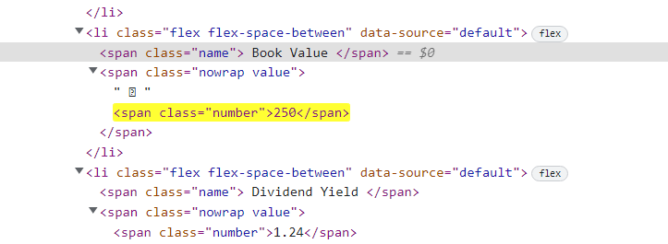

Xpath with multiple attributes : //section[@id="chart" and @class="card card-large"]

Selenium exceptions

<https://www.selenium.dev/selenium/docs/api/py/common/selenium.common.exceptions.html>

<https://www.testquality.com/blog/tpost/ci5pvsurc1-different-types-of-selenium-webdriver-co>

<https://www.browserstack.com/guide/exceptions-in-selenium-webdriver>