**Project Report**

CALENX

Samarth Bansal E22CSEU0139   
 Vishnu M.R. E22CSEU0125  
 Ritesh Kashyap E22CSEU0121

A report submitted in part fulfilment of the degree of

**BTech in Computer Science Supervisor:** Dr. Priyanka



School of Computer Science Engineering and Technology

November 10, 2023

# Declaration

This report has been prepared on the basis of my own work. Where other published and unpublished source materials have been used, these have been acknowledged.

Word Count: 15,183

Student Name: Samarth Bansal(E22CSEU01239), Vishnu M R(E22CSEU0125), Ritesh Kashyap(E22CSEU0121)

Date of Submission: 23-11-2023

Signature:

Vishnu M R

Samarth Bansal



Ritesh Kashyap

# Abstract

Creating an advanced calendar application is the primary focus of this initiative, driven by the recognition that inadequate time management and disorderly scheduling often result in diminished productivity and an imbalance between professional and personal life. The overarching goal is to develop a comprehensive calendar tool incorporating scheduling, reminder, and transparency functionalities to enhance time management capabilities.

This innovative calendar solution is envisioned to empower organizational leaders with the ability to efficiently allocate tasks and deadlines to their team members while being mindful of designated break times and pre-existing commitments. The intention is to prevent the occurrence of overwhelming schedules and to foster a more balanced and sustainable work environment. To facilitate seamless coordination, employees will receive real-time notifications regarding the creation or modification of assignments, ensuring a heightened level of awareness and responsiveness.

One of the distinctive features of this enhanced calendar application is its emphasis on transparency. Leaders and team members alike will have the ability to access each other's availability, thereby simplifying the process of scheduling meetings and collaborative sessions. Beyond the professional sphere, this transparency extends to personal commitments, allowing users to coordinate effortlessly with friends and family members, thereby contributing to a more harmonious work-life integration.

The central theme revolves around consolidating key scheduling and time management features within a singular, user-friendly calendar application. The objective is to provide users with a holistic tool that facilitates the maintenance of a healthy work-life balance while concurrently enhancing overall productivity. The calendar's design actively discourages scheduling chaos through the automation of calendar updates, timely reminders for tasks and meetings, and an inherent transparency into the availability of others.

At its core, this calendar application aims to be a catalyst for organized scheduling. By leveraging automated updates, users can stay abreast of any changes to their schedules seamlessly. Task and meeting reminders serve as valuable aids in keeping individuals on track and ensuring that critical deadlines are not overlooked. The transparency aspect is not limited to mere availability but extends to a broader understanding of each user's commitments, thereby fostering a collaborative and considerate scheduling culture.

The user interface is meticulously crafted to be intuitive, ensuring that even individuals with varying levels of technological proficiency can navigate the application effortlessly. This design philosophy seeks to minimize the learning curve associated with adopting new tools, making the calendar app accessible and appealing to a diverse user base.

In essence, this ambitious calendar project aspires to bring order to the apparent chaos of scheduling by providing a sophisticated yet user-friendly solution. The end goal is to empower users to manage their commitments in a more structured and efficient manner, ultimately leading to heightened productivity and a more fulfilling work-life harmony. Now imagine a calendar which also works as a schedule and a reminder where the organization leads can assign work to their employees online, without cutting any hours. Another plus for the employees will be that they won’t be assigned any tasks during their break hours, and they can have a perfect work and break schedule. This innovation is not only for official purposes but also general purpose where you can check a friend’s schedule to find out their free time for a convenient meetup. Our aim is to enhance the calendar in such a way that all these can be possible and make small but significant quality of life changes to a number of people. All these changes can be possible and would help people sort out their work and free time and help them grow better.

GitHub Link: <https://github.com/work-samarth-bansal/CalenX>

# Table of Contents

|  |  |
| --- | --- |
| **Topic** | Page Number |
| 1. **Introduction**    1. **Project Specification** | 6 |
| **2. Problem Definition & Objectives**  **2.2. Problem Definition**  **2.3. Proposed Solution** | 10 |
| **3. Implementation Details** | 17 |
| **4. Data Structure Used** | 21 |
| **5. Result** | 26 |
| **6. Conclusion** | 30 |
| **7. Bibliography** | 34 |

Chapter 1: **Introduction**

In embarking on this ambitious initiative, our core mission revolves around the development of an innovative calendar application poised to revolutionize the landscape of time management. At its essence, this project seeks to transcend conventional boundaries by integrating advanced scheduling, reminder functionalities, and transparency features into a unified platform. The overarching goal is to mitigate the detrimental impacts of poor time management, such as diminished productivity and an unsettling work-life imbalance, through the creation of a robust and user-friendly calendar application.

As we envision this transformative calendar application, its fundamental design principles revolve around providing users with an unparalleled experience. The user interface is conceived not merely as a utilitarian tool but as an intuitive space equipped with powerful features. Its purpose is to empower individuals to seamlessly organize events, manage commitments, and navigate the complexities of their lives with heightened efficiency. The integration of calendar, reminder, and scheduling functions within a single application marks a paradigm shift, offering users a comprehensive view of their upcoming appointments, task lists, and schedules—all housed in one easily accessible and navigable space.

A central challenge that the envisioned application aims to address is the prevalent issue of calendar chaos. Individuals, across various professional and personal spheres, often find themselves entangled in the web of multiple calendars dispersed across diverse applications and platforms, ranging from email and notes to project management tools. This fragmentation poses a significant impediment to gaining a holistic overview of upcoming weeks and months. The integrated calendar within our application seeks to unravel this complexity by consolidating all commitments into a singular view. By doing so, it aims to eliminate the headaches associated with double-bookings and schedule confusion, providing users with a streamlined and harmonized approach to managing their time.

In our commitment to enhancing productivity, the application introduces a suite of features designed to ensure that users never miss a crucial event. The ability to set reminders and notifications for impending meetings, deadlines, or activities serves as a cornerstone of this effort. Reminders can be customized and delivered through various channels, such as email, SMS, app notifications, and more. The application goes a step further by enabling users to establish recurring reminders for repetitive events and tasks, thereby significantly reducing the managerial overhead typically associated with the complexities of calendar management.

For collaborative environments, particularly in the context of enterprise teams and groups, the application expands its functionality to support calendar sharing and transparency permissions. This innovative feature allows colleagues and managers to seamlessly access each other's availability when scheduling meetings, fostering a collaborative and efficient work environment. Moreover, the calendar functionality facilitates remote task assignment, empowering managers to delegate work and set deadlines for their reports. The system intelligently integrates existing events and workloads to automatically schedule timeslots, streamlining the task assignment process and optimizing resource allocation.

The broad spectrum of potential users for this application spans from busy working professionals to families navigating the intricate web of personal commitments. The challenges presented by calendar disarray, incessant reminders, and meeting coordination are not isolated; they are pervasive across diverse demographics. Our application endeavors to serve as a unifying force, addressing these challenges by amalgamating essential features required for mastering calendars into an accessible and inclusive platform.

The design philosophy of this application is rooted in human-centric principles, recognizing the unique needs, aspirations, and challenges faced by individuals and teams. By providing users with at-a-glance insights into upcoming commitments, automating reminder notifications, enabling transparency in schedules, and facilitating seamless task assignment, the proposed calendar seeks to elevate both productivity and work-life balance. The ultimate aim is to harmonize technology with the intricacies of daily life, fostering a symbiotic relationship that enhances the overall quality of life for users.

As we delve deeper into the intricacies of this transformative calendar application, it becomes evident that its impact extends beyond the surface-level functionalities. It is not merely a tool for scheduling and reminders; it is a manifestation of a paradigm shift in how we conceptualize and interact with time. It is an embodiment of the evolving relationship between technology and the human experience—a relationship that is symbiotic, intuitive, and designed to elevate the way we navigate the complexities of modern life.

The journey into the heart of these temporal challenges prompts us to reflect on the broader societal implications of our relationship with time. In an era characterized by rapid technological advancements and an ever-accelerating pace of life, the need for effective time management has never been more pronounced. The application, with its multifaceted capabilities, emerges not merely as a solution to individual challenges but as a testament to our collective pursuit of a more balanced and fulfilling life.

The challenges posed by calendar disarray, reminders, and meeting coordination are not isolated phenomena; they are emblematic of broader societal shifts in how we perceive and allocate our time. The incessant demands on our attention, the pressure to be constantly connected, and the perpetual race against the clock all contribute to a sense of time-related stress. In crafting a solution that addresses these challenges, our application strives to redefine the narrative around time, positioning it not as a source of stress but as a tool for empowerment and enrichment.

In exploring the potential impact of our calendar application, we are compelled to consider its role in fostering a cultural shift toward a more mindful and intentional approach to time. The application, with its emphasis on transparency, collaboration, and seamless integration into users' lives, stands as a beacon for a future where technology augments our capacity for meaningful engagement rather than serving as a source of distraction. It invites users to reclaim ownership of their time, offering a platform that aligns with their values, priorities, and aspirations.

As we navigate the complexities of modern existence, our relationship with time becomes a focal point for introspection. The application, by addressing the challenges of calendar chaos, reminders, and meeting coordination, invites users to reconsider the value they place on their time. It prompts a re-evaluation of societal norms that prioritize constant busyness over the cultivation of deep and meaningful connections. In doing so, it sparks a dialogue about the broader societal narrative surrounding success, fulfillment, and the pursuit of a well-balanced life.

The implications of our calendar application extend beyond the realm of personal and professional productivity. They reach into the very fabric of organizational cultures, societal values, and the evolving nature of our interconnected lives. The introduction of features such as calendar sharing and transparency permissions signifies a shift toward collaborative and inclusive work environments. It signals a departure from traditional hierarchical structures toward a more egalitarian approach where individuals have the agency to manage their time and commitments effectively.

The endeavor to address calendar chaos and enhance time management is not merely a technological innovation; it is a catalyst for a broader cultural transformation. It challenges us to rethink the prevailing norms and assumptions that govern our relationship with time. It prompts organizations to reassess their structures and practices to better accommodate the diverse needs and aspirations of their teams. It invites families and individuals to prioritize quality of life over mere productivity, fostering an environment where time becomes a tool for enrichment rather than a source of constraint.

In conclusion, the journey into the heart of these temporal challenges reveals not only the intricacies of calendar management but also the profound implications for our collective well-being and the societal fabric. The calendar application, with its multifaceted functionalities, emerges as a catalyst for change—a change that goes beyond the superficial rearrangement of schedules and reminders. It is an invitation to embrace a holistic understanding of time, one that aligns with our deepest aspirations for fulfillment, connection, and a more balanced and harmonious way of life.

As we stand at the intersection of technology and the human experience, the calendar application beckons us to embark on a transformative journey. It is a journey toward reclaiming our time, fostering meaningful connections, and cultivating a mindful approach to the way we navigate the complexities of modern life. The application serves as a testament to our capacity to shape technology in alignment with our values, ultimately contributing to a future where time becomes a source of empowerment and enrichment rather than a relentless force to be managed.

## Project Specification

The primary objective of this endeavor is to craft an upgraded calendar application enriched with a myriad of capabilities aimed at enhancing user experience and optimizing organizational efficiency. The multifaceted nature of this project encompasses various features:

• Empowering users to effortlessly view, create, and manage an array of calendar events and tasks.

• Facilitating organizers and managers in the seamless assignment of tasks and deadlines to employees or group members.

• Implementing an intelligent system that automatically generates schedules based on the allocation of tasks and pre-existing events.

• Incorporating a robust reminder system that ensures users are promptly notified of upcoming events and impending tasks through email and push notifications.

• Establishing a collaborative environment by allowing users to access each other's availability and schedules, all while adhering to meticulously defined permissions.

• Imposing a mechanism that safeguards designated break times, preventing the assignment of tasks during these crucial intervals.

• Offering an intuitive and responsive web interface designed to cater to users' needs across various devices.

As we embark on the journey to develop this sophisticated calendar application, our focus is not solely on the technical intricacies but on the overarching goal of fostering a seamless and productive user experience. The user-centric approach underscores the importance of creating a platform that transcends conventional boundaries and aligns with the diverse needs and preferences of individuals and organizations alike.

The essence of this project lies in its commitment to providing users with a comprehensive and intuitive tool for managing their time and tasks. The functionality allowing users to effortlessly view, create, and manage calendar events and tasks is envisioned as a cornerstone feature, ensuring that individuals have the flexibility and control to organize their schedules with ease. The calendar becomes not just a static representation of events but a dynamic canvas for users to craft their daily, weekly, and monthly narratives.

Organizers and managers, integral to the collaborative dynamics of various groups and organizations, will find enhanced capabilities in this application. The streamlined process of assigning tasks and deadlines is designed to empower leaders in optimizing team efficiency. The application's intelligent scheduling system, which automatically generates schedules based on task assignments and pre-existing events, serves as a valuable asset for both managers and team members, ensuring a balanced distribution of workloads.

In addressing the perennial challenge of maintaining awareness and punctuality, the application's reminder system emerges as a key feature. By sending timely reminders and notifications via email and push notifications, the application aims to foster a proactive approach to time management. Users can stay abreast of their commitments and deadlines, reducing the likelihood of oversights and ensuring a heightened sense of accountability.

The collaborative aspect of the calendar application extends to the feature that allows users to view each other's availability and schedules. This functionality, governed by meticulously defined permissions, not only enhances communication and coordination within teams but also fosters a sense of transparency and interconnectedness. By providing individuals with insights into each other's schedules, the application aims to promote a collaborative and harmonious work environment.

Recognizing the significance of downtime and designated breaks, the application introduces a mechanism to prevent task assignment during these crucial intervals. This thoughtful inclusion acknowledges the importance of work-life balance and encourages users to embrace periods of rest and rejuvenation, contributing to overall well-being.

An essential facet of this project is the development of an intuitive and responsive web interface, ensuring accessibility across various devices. The user interface is not merely a functional component but a critical aspect of the overall user experience. A design that is both intuitive and responsive caters to the diverse ways in which users interact with the application, whether on a desktop, laptop, tablet, or mobile device. The seamless transition across devices ensures a consistent and user-friendly experience, irrespective of the chosen platform.

As we delve into the complexities of crafting this sophisticated calendar application, it is imperative to emphasize the human touch infused into its development. The goal is not to create a sterile and rigid technological solution but to fashion a tool that resonates with the needs, preferences, and challenges of individuals and organizations. The application is envisioned as a companion in the journey of daily life, adapting to the dynamic nature of human schedules and fostering a sense of empowerment and control.

The user-centric design principles underscore the commitment to creating an application that goes beyond the utilitarian aspects of calendar management. It aspires to be a holistic solution that considers the intricacies of human behavior, the dynamics of teamwork, and the evolving landscape of work-life integration. In this light, the project takes on the character of a human endeavor, guided by empathy, understanding, and a genuine desire to enhance the lives of its users.

As we navigate the development process, it is crucial to recognize the diverse contexts in which this application will be employed. Whether utilized by individuals striving for personal productivity or by organizations fostering collaborative teamwork, the features embedded within the calendar application cater to a spectrum of needs. The application becomes a versatile tool, adapting to the unique requirements of its users and seamlessly integrating into their daily routines.

The collaborative dynamics facilitated by the application—enabling task assignment, promoting transparency, and preventing work during designated breaks—echo the intricacies of human interactions within various settings. It is not merely a collection of features but a reflection of the evolving nature of work, communication, and collaboration in contemporary society. This resonance with real-world dynamics is a testament to the human-centric ethos guiding the development of the calendar application.

In conclusion, this project transcends the realm of a technical endeavor; it embodies a human-centric approach to calendar management. The envisioned application is not a mere aggregation of features but a thoughtful response to the intricate tapestry of human schedules, organizational dynamics, and the evolving landscape of work and life. Its features are not just functionalities; they are tools crafted to empower users, foster collaboration, and enhance the overall quality of life.

As we progress in the development journey, the human touch remains at the forefront—a guiding principle that ensures the application resonates with users on a deeper level. It is an acknowledgment of the nuanced ways in which individuals and organizations navigate the complexities of time, tasks, and collaboration. The calendar application, with its user-friendly interface, collaborative features, and adaptability, emerges not as a technological imposition but as a facilitator of empowerment, connection, and a harmonious integration of technology into the fabric of daily life.

Chapter 2: **Problem & Solution**

**2.1 Problem Definition**

In navigating the labyrinth of contemporary existence, individuals grapple with an intricate web of challenges that transcend the mere orchestration of time. This intricate tapestry, woven with the threads of fragmented work and personal calendars, demands a deeper exploration into the underlying complexities that shape our daily lives. Beyond the palpable struggles with disjointed schedules and the perpetual influx of new commitments, a myriad of subtler nuances comes to light, influencing not only productivity and the delicate balance between work and personal life but also the very essence of our well-being.

As we traverse the landscape of fragmented work schedules, the pendulum between overexertion and laxity reveals deeper insights into the psyche of the modern professional. The intricacies of managing multiple calendars across diverse platforms not only pose logistical challenges but also elicit profound psychological implications. The modern professional, tethered to the disjointed dance of schedules, experiences the strain of constant adaptation. The ephemerality of digital notifications, the tangibility of post-it notes, and the permanence of office whiteboards become symbols of a tumultuous journey. This journey is not merely about the alignment of tasks but a profound exploration of the self in the context of a fast-paced and ever-evolving professional landscape.

The paradox of schedules that swing between burdensome and underutilized hints at a broader societal narrative—one that grapples with the nuances of productivity culture. The relentless pursuit of efficiency often leaves individuals teetering on the brink of burnout or languishing in periods of underactivity. In dissecting the intricacies of this phenomenon, we unearth not only the external manifestations in scattered calendars but also the internal struggles of individuals yearning for a harmonious balance. The very essence of sustained productivity becomes entangled with the individual's journey to find purpose and meaning within the framework of their professional responsibilities.

Delving into the sphere of personal lives, the ramifications of calendar fragmentation extend far beyond the surface-level challenges of scheduling social activities. The fragility of relationships, often overshadowed by the relentless march of deadlines and commitments, emerges as a poignant theme. The struggle to synchronize personal plans with work-related calendars mirrors the broader societal challenge of fostering meaningful connections in an age dominated by digital interactions. The dichotomy between the virtual and the tangible, between the scheduled and the spontaneous, underscores the need for a holistic approach that recognizes the importance of human connection amid the cacophony of digital notifications and work-related commitments.

The intricate dance of scheduling extends its tendrils into the fabric of mental well-being, weaving a narrative of stress and resilience. The constant negotiation between personal and professional commitments leaves individuals grappling with the psychological toll of a fragmented existence. The dichotomy between the need for focused effort and the desire for leisure becomes a tightrope walk, with individuals navigating the precarious terrain of mental health. Recognizing the symbiotic relationship between time management and well-being is paramount in crafting solutions that go beyond the superficial rearrangement of schedules, delving into the heart of individual fulfillment and resilience.

In examining the organizational blind spots that give rise to the arbitrary assignment of work appointments, we uncover systemic challenges that permeate the very structure of modern workplaces. The lack of visibility into team members' commitments underscores a broader issue of transparency within organizations. The hierarchical nature of scheduling, where decisions are made without due consideration for the individual, reflects power dynamics that shape the organizational culture. The implications reverberate not only in meeting attendance and engagement but also in the broader fabric of trust and collaboration. Addressing these systemic issues demands a nuanced exploration of organizational structures, communication flows, and the empowerment of individuals within the framework of a collective vision.

The journey into the depths of these temporal challenges reveals a rich tapestry of interconnected themes that demand our attention. As we seek to redress the pressing issues at hand, we must recognize the inherent interplay between productivity, personal fulfillment, and the pursuit of meaningful connections. The essence of this project lies not only in the identification of challenges but in the crafting of solutions that resonate with the nuanced intricacies of the human experience.

Exploring the multifaceted nature of time management requires a holistic lens that encompasses the realms of psychology, sociology, and organizational dynamics. The very act of scheduling, once relegated to the mundane task of aligning tasks and appointments, emerges as a microcosm of the broader human experience. It is a canvas upon which the complexities of modern life are painted, reflecting the aspirations, struggles, and yearnings of individuals navigating the intricate dance of time.

In the realm of productivity, the conventional metrics of output and efficiency must give way to a more profound exploration of purpose and fulfillment. The quest for sustained productivity is not a mere quest for output but a journey toward aligning individual aspirations with collective goals. It is a recognition that the pursuit of productivity is inseparable from the pursuit of a meaningful and fulfilling professional life.

Simultaneously, the exploration of personal lives within the context of calendar chaos calls for a reevaluation of societal values and priorities. The challenge extends beyond the realm of scheduling social activities; it is a call to reexamine the societal narratives that prioritize perpetual busyness over the cultivation of deep and meaningful relationships. It prompts us to question the very foundations of a culture that often measures success in terms of professional achievements rather than the richness of personal connections.

The intersection of time management and mental well-being beckons us to confront the societal norms that perpetuate the glorification of overwork. It urges us to redefine success not as an unrelenting pursuit of productivity at the expense of mental health but as a harmonious integration of work and well-being. The recognition that mental well-being is not a byproduct of productivity but an essential prerequisite for sustainable success becomes a guiding principle in crafting solutions that prioritize the holistic health of individuals.

The organizational challenges embedded in the arbitrary assignment of work appointments unveil an opportunity for a paradigm shift in how we conceive of and structure workplaces. It necessitates a reimagining of organizational hierarchies, communication flows, and decision-making processes. The call for transparency and empowerment within organizations is not merely a response to the challenges of scheduling but a fundamental reorientation toward a more inclusive and collaborative workplace culture.

As we embark on this expansive exploration of temporal challenges, the imperative to transcend the superficial and embrace a holistic perspective becomes evident. The intricacies of time management are not confined to the ticking of clocks or the alignment of schedules; they encapsulate the very essence of the human experience. In our pursuit of solutions, we must move beyond the confines of conventional thinking and embrace a paradigm that recognizes the interconnectedness of individual well-being, societal values, and organizational structures.

The journey into the depths of these temporal challenges is an invitation to engage in a collective introspection—a reflection on the values that shape our lives and the structures that govern our societies. It is a call to action that extends beyond the confines of this project, beckoning individuals, organizations, and societies to embark on a transformative journey toward a more harmonious and balanced approach to time.

In conclusion, delving into the intricacies of time management, as illuminated through the prism of fragmented work schedules, individual lives, mental well-being, and the dynamics within organizations, presents an invaluable opportunity for profound introspection and transformative action. The expedition into the core of these challenges extends far beyond a mere examination of calendars and appointments; it constitutes a profound exploration of the very essence of the human condition. In navigating the intricate tapestry of modern existence, let us attentively respond to the summons to formulate solutions that transcend the superficial, embracing a comprehensive understanding of time—one that resonates with our deepest aspirations for fulfillment, connection, and a more balanced and harmonious way of life.

As we traverse this nuanced terrain, it becomes increasingly evident that the landscape of time management is not solely defined by the ticking of the clock or the scheduling of tasks. Instead, it unravels as a multifaceted tapestry interwoven with the complexities of human experiences, weaving together the threads of professional commitments, personal endeavors, and the delicate fabric of mental and emotional well-being. It beckons us to embark on a journey that transcends the conventional boundaries of routine planning, urging us to peer into the intricate interplay of our daily lives.

Furthermore, the exploration of fragmented work schedules unveils a rich terrain marked by diverse challenges and opportunities. It prompts us to reconsider the conventional wisdom surrounding rigid timelines and linear productivity, encouraging a reevaluation of how we allocate our time to maximize not only efficiency but also creativity and well-being. In this reimagining, we find the potential for a paradigm shift—one that values flexibility, adaptability, and a deeper understanding of the ebb and flow inherent in the human experience.

Simultaneously, the lens through which we scrutinize personal lives within the context of time management reveals a mosaic of aspirations, responsibilities, and the ever-present pursuit of a meaningful existence. Recognizing the uniqueness of each individual's journey, we are compelled to acknowledge the importance of crafting personalized approaches to time that resonate with the intricacies of diverse lifestyles. This necessitates a departure from one-size-fits-all solutions and a embrace of a more inclusive and empathetic perspective, one that acknowledges the diverse tapestry of human experiences.

Moreover, the exploration of mental well-being in the context of time management surfaces as a pivotal aspect demanding our attention. The intricate dance between productivity and mental health invites us to question traditional paradigms that often prioritize output over the well-being of individuals. In reshaping our understanding of time, we are called to integrate practices that nurture mental resilience, foster a sense of purpose, and contribute to a work environment that values the holistic health of its members.

Within organizational dynamics, the examination of time management becomes a complex tapestry woven with threads of collaboration, communication, and the pursuit of collective goals. The call to transformative action extends to the structures and cultures within organizations, urging a reevaluation of how time is allocated, distributed, and valued. This requires a departure from rigid hierarchies and a move towards fostering environments that recognize and harness the diverse strengths and rhythms of individuals.

In conclusion, the profound exploration of time management transcends the surface-level considerations of schedules and appointments. It is an odyssey into the intricate dimensions of the human condition, beckoning us to craft solutions that align with our deepest aspirations for fulfillment, connection, and a harmonious way of life. As we navigate the complexities of modern existence, let us embrace this opportunity for introspection and transformative action, weaving a tapestry of time that reflects the richness and diversity of the human experience.

**2.2 Proposed Solution**

In delving into the intricate realm of addressing prevalent challenges associated with calendar disarray, diminished productivity, and the delicate balance of work-life equilibrium, this visionary initiative eloquently outlines a compelling vision for the development of an integrated calendar application. This application is designed to offer robust scheduling assistance, residing at its conceptual core as a centralized calendar platform. This innovative hub aims to consolidate task and appointment management, optimize schedules, and enable seamless calendar sharing capabilities. The revolutionary paradigm it introduces foresees the obsolescence of scattered calendars, ushering in an era of intelligent scheduling tailored to the demands of both professional obligations and personal engagements.

Embedded within this visionary framework are a multitude of capabilities that form the foundation of this transformative initiative. One such capability is the empowerment of remote task assignment through a manual touch. Imagine a scenario where managers possess the capability to efficiently delegate tasks and set deadlines directly through a user-friendly calendar interface. This hands-on approach not only streamlines the delegation process but also provides valuable insights into the upcoming work commitments of the team, departing from reliance on artificial intelligence and embracing a more direct and user-centric methodology.

Another crucial aspect of the proposed initiative is the manual schedule generation process, which advocates for a user-focused approach. In contrast to automated scheduling solutions, this hands-on approach empowers users to actively create optimal schedules for assigned tasks within the context of existing events and designated break times. By placing control in the hands of the user, this methodology ensures a personalized touch and alleviates potential concerns related to the use of artificial intelligence.

Furthermore, the initiative promotes collaborative calendar viewing with granular permission controls, emphasizing human-centric collaboration. The application facilitates users in sharing their calendars with colleagues, friends, or family members, with a focus on striking a delicate balance between transparency and privacy without relying on complex AI algorithms. This approach fosters a sense of trust and ensures that users maintain control over the visibility of their schedules, contributing to an environment where optimal schedules for assigned tasks can be actively created within the context of existing events and designated break times.

Tailored Custom Reminders and Notifications: A Personalized Touch

Recognizing the diverse preferences of users, the application allows for the configuration of personalized reminders and notifications. This customization ensures that users receive timely alerts tailored to their unique needs, mitigating the risk of oversights without the intervention of artificial intelligence. The focus here is on providing users with a tool that respects individual preferences, reinforcing the user-centric philosophy of the initiative.

Respecting Designated Break Times: A Manual Safeguard

Acknowledging the importance of designated break times, the application incorporates an automated scheduler that respects and protects these predefined boundaries. Importantly, this safeguard mechanism is implemented manually, underscoring a commitment to a more hands-on and user-focused approach. This ensures that users have direct control over their break times, free from the complexities associated with automated systems. By integrating these capabilities into a consolidated, user-friendly calendar application, the project aspires to offer comprehensive time management assistance for both professional and personal engagements. Importantly, the emphasis on manual processes and user-centric design underscores a departure from the use of artificial intelligence, aligning with the initiative's commitment to a more human-centric approach.

In the corporate context, the initiative envisions a shift in organizational ethos, providing managers with scheduling transparency to strategically assign work. This facilitates a conducive environment for employees to maintain a healthy work-life balance without succumbing to constant calendar overload, all achieved without the need for automated scheduling algorithms.

Similarly, in the familial and social sphere, the proposed calendar solution becomes a digital facilitator, simplifying the coordination of busy schedules among family members and friends. Manual reminders take the forefront in reducing the likelihood of forgotten activities, enhancing the collaborative experience without the involvement of complex AI systems. For professionals grappling with overcommitted schedules, where overloaded work calendars and scattered task lists create chaos, this proposed solution serves as a valuable assistant. By unifying work calendars and task lists into one accessible interface, it aids in maximizing focus time without relying on artificial intelligence. Manual notifications become the reliable reminders to handle various commitments.

The envisioned calendar solution aims to enhance productivity, restore work-life balance, and rebuild relationship time by mitigating the chaos associated with fragmented calendars. Utilizing a user-friendly interface, contextual transparency, customizable reminders, and centralized control, users can master their schedules without the reliance on artificial intelligence.

In conclusion, this initiative embraces a manual and user-centric approach to address the challenges of time management. By focusing on intuitive design and collaborative features without incorporating artificial intelligence, the proposed calendar application seeks to empower users to take control of their schedules and foster a harmonious integration of technology into their daily lives. As we delve further into the intricacies of this human-centric initiative, it becomes apparent that the emphasis on manual processes and user-focused design is not just a deviation from automated solutions but a deliberate choice rooted in a philosophy that values the autonomy and preferences of the individual. This approach reflects a nuanced understanding of the diverse ways in which users navigate their schedules, tasks, and collaborative engagements.

Expanding on the theme of user empowerment, it is crucial to highlight the significance of providing individuals with the means to tailor their digital experiences according to their specific preferences. The acknowledgment of diverse user needs is a cornerstone of this initiative, emphasizing the importance of a one-size-fits-all approach in the realm of digital productivity tools. The commitment to mitigating oversights without relying on artificial intelligence is a strategic move to cater to users who value a more manual and hands-on approach to managing their time and responsibilities.

Furthermore, the initiative places considerable emphasis on designated break times, recognizing them as crucial for maintaining a healthy work-life balance. The incorporation of an automated scheduler, operated manually, adds an extra layer of user control, ensuring that individuals can uphold their predetermined boundaries without feeling constrained by the rigidities of automated systems. This not only aligns with the user-centric philosophy but also underscores a commitment to providing a more flexible and adaptable solution that resonates with the diverse preferences of the user base.

In the corporate sphere, the initiative seeks to revolutionize the organizational ethos by providing managers with scheduling transparency. This transparency, achieved without the need for automated scheduling algorithms, is designed to empower both managers and employees, fostering an environment where work can be strategically assigned, and individuals can maintain a healthy balance between professional and personal commitments. The departure from constant calendar overload reflects a strategic move to enhance the well-being of employees without relying on complex technological interventions.

Similarly, in the familial and social context, the proposed calendar solution positions itself as a digital facilitator, simplifying the coordination of busy schedules among family members and friends. The manual approach to reminders becomes a key feature in enhancing the collaborative experience, recognizing that not all users are comfortable with or reliant on complex AI systems. By placing manual notifications at the forefront, the initiative aims to reduce the likelihood of forgotten activities and strengthen the bonds between individuals in a more organic and user-friendly manner.

For professionals grappling with overcommitted schedules, the proposed solution emerges as a valuable assistant, unifying work calendars and task lists into one accessible interface. The emphasis on maximizing focus time without relying on artificial intelligence speaks directly to the needs of users who seek a more hands-on approach to managing their commitments. Manual notifications, in this context, serve as reliable reminders, ensuring that individuals can effectively navigate their diverse responsibilities without feeling overwhelmed by the complexities of automated systems.

The envisioned calendar solution, with its comprehensive set of features, ultimately seeks to enhance productivity, restore work-life balance, and rebuild relationship time. The user-friendly interface, contextual transparency, customizable reminders, and centralized control collectively contribute to a holistic user experience that aligns with the initiative's commitment to a human-centric approach. By allowing users to master their schedules without the reliance on artificial intelligence, the initiative positions itself as a trailblazer in the realm of digital productivity tools, recognizing the nuanced ways in which individuals navigate their daily lives.

In conclusion, this human-centric initiative goes beyond being a mere deviation from automated solutions; it is a deliberate and thoughtful choice grounded in a philosophy that values the autonomy and preferences of the individual. As users increasingly seek personalized and adaptable solutions in the digital landscape, this approach becomes a testament to the initiative's commitment to providing a tool that resonates with the diverse ways in which users manage their time, tasks, and collaborative engagements.

The human touch is not merely a superficial layer but a guiding principle that permeates every aspect

of the proposed calendar application. It is an acknowledgment that technology should serve as an ally,

enhancing the human experience rather than overshadowing it. This commitment to a more hands-on

and personalized approach is not just a response to concerns about artificial intelligence but a

testament to a deeper commitment to user empowerment.

In navigating the complex landscape of time management, users are not merely passive recipients of a

technological solution; they are active participants shaping their schedules and engagements. The

manual touch embedded within the initiative empowers users to be architects of their own time,

making decisions aligned with their preferences and priorities.

The corporate realm, often characterized by the relentless pace of work and the pressure to meet

deadlines, stands to benefit from this human-centric approach. Managers, equipped with transparent

scheduling capabilities, can strategically allocate tasks, fostering an environment where employees

can flourish without succumbing to the perils of an overloaded calendar. This shift towards manual

processes reaffirms the importance of strategic decision-making in the workplace.

Similarly, in the familial and social context, the application's manual reminders become more than

just notifications; they are gentle prompts guiding users through the intricacies of their relationships and shared activities. The absence of complex AI algorithms allows for a more organic and authentic connection, where users actively engage in the process of coordinating and participating in shared experiences.

For professionals navigating the complexities of overcommitment, the manual approach championed by this initiative becomes a beacon of relief. The unified interface becomes an assistant in the truest sense, allowing users to navigate their schedules with clarity and focus. The absence of artificial intelligence in this context is not a limitation but a deliberate choice to offer users a tool that complements their cognitive processes rather than replacing them.

As we contemplate the far-reaching implications of this manual and user-centric approach, it becomes clear that the proposed calendar application is more than just a technological intervention. It is a manifestation of a philosophy that places the human experience at the forefront, recognizing that technology should be a facilitator rather than a replacement for human agency.

In a world where concerns about the impact of technology on our lives are growing, this initiative offers a refreshing perspective—one that envisions a future where technology and humanity coexist harmoniously. The manual processes, user-focused design, and commitment to transparency become not just features but a narrative that challenges the prevailing narrative of technology as a disruptor.

The envisioned calendar solution aims not only to address the immediate challenges of calendar chaos but also to contribute to a broader discourse on the role of technology in shaping our lives. It invites users to reimagine their relationship with technology, viewing it as a tool that amplifies their capabilities and augments their experiences rather than one that dictates and controls.

In the grand tapestry of technological innovation, this initiative emerges as a testament to the power of choice. The choice to embrace a manual and user-centric approach is a declaration that technology should align with human values and aspirations. It is an assertion that the future of technology is not predetermined but shaped by the choices we make today.

As users, organizations, and societies navigate the evolving landscape of technological advancements, this initiative serves as a reminder that the trajectory of progress is not solely determined by the capabilities of machines but by the choices we make as architects of our technological future. The manual touch, far from being a compromise, becomes a deliberate step towards a future where technology serves as a true ally in the pursuit of a more balanced, meaningful, and human-centric existence.

In conclusion, this initiative, with its manual processes, user-focused design, and commitment to transparency, transcends the realm of a mere calendar application. It becomes a manifestation of a philosophy—a philosophy that places the human experience at the forefront of technological innovation. As we navigate the intricate landscape of time management, let us not forget that the choices we make today shape the technological landscape of tomorrow.

Chapter 3: **Implementation Details**

**3.1. Tools and Languages**

This project encompasses a wide array of programming languages, frameworks, and tools to intricately shape and construct a highly sophisticated calendar application featuring a robust and user-friendly interface.

During the intricate process of developing our cross-platform application, we harness the formidable capabilities of C++, seamlessly collaborating with the Qt framework. Qt, with its vast array of libraries and APIs, emerges as an exceptional powerhouse, bestowing upon us the necessary tools to meticulously craft responsive graphical user interfaces that seamlessly provide users with a native experience on both desktop and mobile platforms. The unique and distinctive aspect of Qt's model-view architecture assumes the role of a cornerstone, facilitating a clear separation between data and visualization, thereby expediting the intricate development of our user interface. To further elevate the sophistication of our approach, the signal/slot system embedded within Qt emerges as an invaluable asset, empowering us to establish decoupled communication between various UI elements, thus significantly contributing to enhanced maintainability. Moreover, our strategic implementation effectively leverages the inherent efficiency of Qt's object-oriented approach, enabling us to deftly design a multitude of interface components, ranging from intricate calendar visualizations to seamlessly integrated menus and dialogs.

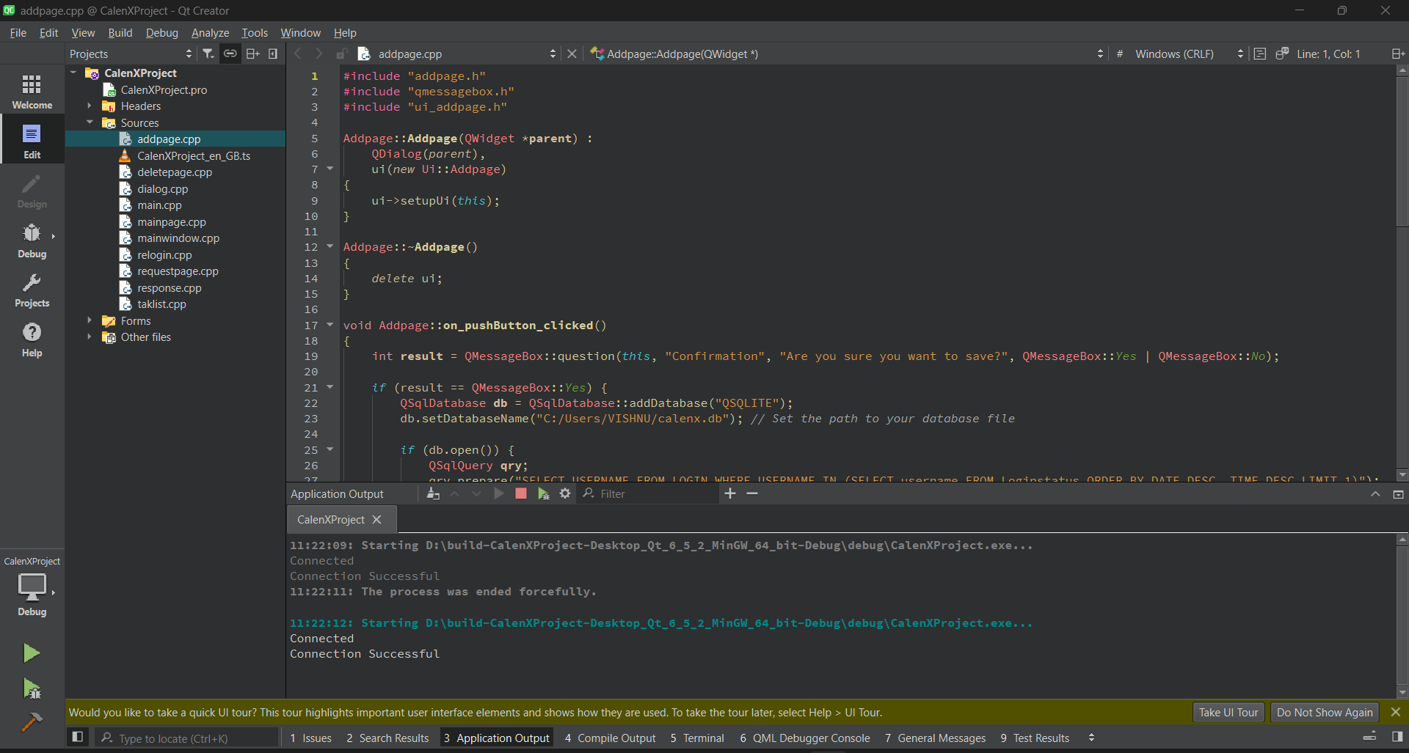

Fig1: QT interface

This collaborative effort between the powerful C++ language and the versatile Qt framework forms the solid foundation of our developmental journey, revealing a remarkable synergy that surpasses the boundaries of mere coding. The skillful and nuanced utilization of Qt's diverse features and capabilities stands as a true testament to our unwavering commitment to providing users with not merely a functional application, but an immersive and seamlessly integrated experience across a wide range of devices. This intricate dance, harmonizing the intricacies of programming with the capabilities of the framework, underscores our deep dedication to the artistry of software development, ensuring that every interface component, from the visually stunning calendar visualizations to the meticulously crafted menus and dialogs, aligns flawlessly with the user's expectations and preferences.

Furthermore, our reliance on the object-oriented approach within Qt demonstrates a thoughtful consideration of software design principles. As we navigate the complex process of creating a myriad of interface components, we wholeheartedly embrace a design philosophy that transcends the mere functionality of these elements. The calendar visualizations, menus, and dialogs are not simply elements existing within the application; they are meticulously sculpted entities that reflect our unwavering commitment to user-centric design and an acute attention to the finer nuances of the software development craft.

In essence, the interplay between C++ and the Qt framework in the development of our cross-platform application becomes a narrative of synergy, creativity, and meticulous attention to detail. It is a story of how technological prowess converges with artistic sensibilities to produce an application that seamlessly integrates into the user's digital landscape, offering not just utility but a nuanced and delightful experience. This narrative is not merely a product of code; it is a manifestation of the thoughtful orchestration of programming elements, design philosophies, and user-centric considerations, resulting in an application that transcends the boundaries of mere functionality to become an immersive and integral part of the user's digital journey..

In addressing the intricate needs of data management and storage for our application, we turn our attention to SQLite, a robust database solution that proves instrumental in handling the complexities of relational data. SQLite, known for its status as an embedded open-source database, stands out for its efficiency in managing relational data within a compact, portable framework. The notable attribute of seamless operation without the need for configuration, external servers, or intricate installation procedures makes SQLite a particularly fitting choice for applications like our calendar. In the realm of our calendar application, where the preservation of data at the local, client-side level is paramount, SQLite emerges as a reliable solution.

The database's functionality extends beyond mere storage; it becomes a facilitator for the creation of tables tailored to our specific needs. These tables serve as repositories for diverse types of data, ranging from user profiles and calendar events to reminders, schedules, and other critical application data. The strategic utilization of SQLite's capabilities in crafting and managing these tables ensures not only the seamless persistence of data but also the longevity of information across multiple usage sessions. Our approach is not merely technical; it is a thoughtful orchestration of database functionalities to align with the nuanced requirements of our calendar application.

SQLite, with its prowess in executing queries efficiently, becomes a linchpin in ensuring effortless access to stored data. The strategic deployment of SQLite's query execution capabilities allows our application to navigate and retrieve information with finesse, contributing to a user experience characterized by speed and responsiveness. This intentional use of SQLite's capabilities is a testament to our commitment to not just efficient data storage but also to the creation of a user-centric application that seamlessly integrates with the user's digital journey.

Furthermore, the decision to adopt SQLite as our database solution reflects a careful consideration of factors beyond mere technical specifications. It mirrors an understanding of the importance of user experience and data integrity within the context of our calendar application. In choosing SQLite, we prioritize a database solution that not only aligns with the technical requirements of our project but also resonates with the overarching philosophy of creating a seamless, intuitive, and enduring user experience.

In essence, our reliance on SQLite transcends the realm of a technical decision; it becomes a narrative of thoughtful selection, strategic deployment, and a commitment to user-centric design. It is a story of how a database solution becomes an integral part of the application's DNA, influencing not only its technical functionality but also shaping the user's interaction with the application. This narrative underscores our dedication to the artistry of software development, where every technical decision is made with an eye toward creating an experience that goes beyond functionality to become an integral and delightful aspect of the user's digital landscape.

In the realm of overseeing source code version control and fostering collaborative development, our allegiance lies with GitHub, the chosen platform that serves as the linchpin of our collaborative efforts. GitHub's pull request workflow assumes a pivotal role, orchestrating an organized process for the review and seamless integration of code contributions hailing from diverse developers. This collaborative dance facilitated by GitHub's pull request workflow ensures a harmonious convergence of varied coding styles and perspectives, underscoring our commitment to an inclusive and dynamic development environment.

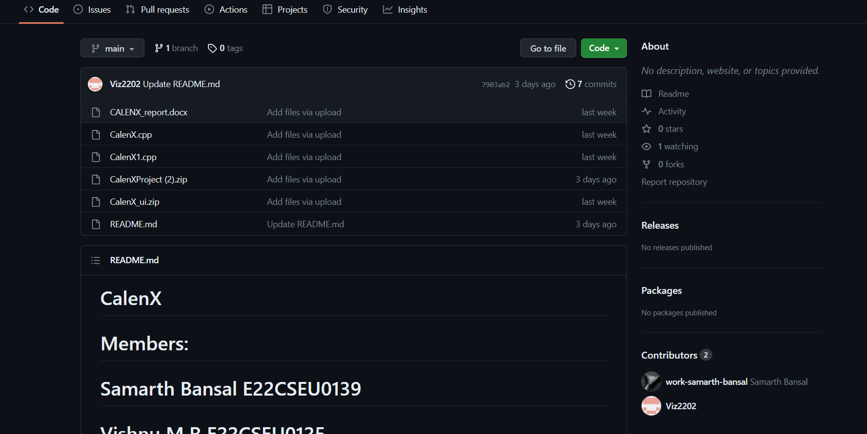

Fig 2: We Used GitHub to share code for editing between our member

The significance of GitHub extends beyond mere version control; its robust issue tracking system becomes a cornerstone in our pursuit of effective software management. This feature proves instrumental in navigating the intricacies of software enhancements and bug fixes, ensuring a meticulous and organized approach to addressing evolving challenges. GitHub's issue tracking system thus becomes not just a repository of reported concerns but a dynamic and interactive tool, fostering a culture of continuous improvement and responsiveness to user feedback.

In addition to its prowess in version control and issue tracking, GitHub Pages steps into the spotlight, contributing significantly to our documentation efforts. GitHub Pages provides us with a versatile platform to host and share comprehensive documentation, ensuring universal access to the latest iteration of our codebase. This accessibility fosters transparency and collaboration, serving as a testament to our commitment to open communication and knowledge sharing within our development community.

GitHub, in our context, evolves beyond a mere platform; it becomes an indispensable tool for version control, supporting the agility and collaborative ethos inherent in the development efforts of our globally distributed team. Its features, carefully integrated into our workflow, not only streamline the technical aspects of code management but also foster a sense of unity and shared purpose among our diverse team members. GitHub becomes more than a version control system; it becomes a virtual collaborative space where ideas converge, code evolves, and collective efforts manifest into a seamless and dynamic digital ecosystem.

In conclusion, our choice of GitHub as the central hub for source code version control and collaborative development is more than a technical decision; it is a strategic choice that reflects our commitment to inclusive and agile development practices. The utilization of GitHub's features, from pull requests to issue tracking and GitHub Pages, paints a holistic picture of a collaborative journey where technology meets human ingenuity. This narrative of collaborative development, orchestrated through GitHub, is a testament to our dedication to not just building software but cultivating a dynamic and inclusive community of developers united by a shared vision of excellence.

As we embark on the journey of software development, Visual Studio Code emerges as the cornerstone of our coding endeavors. Revered for its expansive extension ecosystem, sophisticated code completion, integrated terminal, debugger support, and an array of other features, Visual Studio Code stands as a beacon of productivity, elevating our editing experience across a broad spectrum of programming languages. The editor's Zen mode, a cherished asset in our toolkit, proves invaluable by simplifying the interface, cultivating an environment that fosters undivided focus and creativity in code creation. The editor's responsiveness and the wealth of customizable features within Visual Studio Code seamlessly align with the specific requirements of our project, constituting a substantial contribution to augmenting developer productivity throughout the intricate phases of coding and testing.

As we delve into the intricacies of our software development expedition, Visual Studio Code takes center stage as the primary hub for our coding endeavors. Esteemed for its extensive extension ecosystem, intuitive code completion capabilities, an integrated terminal for seamless command execution, robust debugger support, and an assortment of other features, Visual Studio Code stands out as a paragon of productivity, enriching our editing experience across an extensive array of programming languages. The Zen mode, an invaluable feature within the editor's repertoire, emerges as a cherished asset, simplifying the interface and creating an environment conducive to undistracted concentration, fostering a realm of creativity in the realm of code creation. The responsive performance coupled with an abundance of customizable features embedded within Visual Studio Code seamlessly align with the specific exigencies of our project, making a substantial impact on elevating developer productivity throughout the multifaceted phases of coding and testing.

As we navigate the intricate path of software development, Visual Studio Code takes the lead as our primary code editor, providing an indispensable foundation for our coding pursuits. Renowned for its expansive extension ecosystem, advanced code completion capabilities, a built-in terminal for streamlined command execution, robust debugger support, and a plethora of other features, Visual Studio Code establishes itself as a catalyst for productivity, enhancing our editing experience across a diverse spectrum of programming languages. The Zen mode, a gem within the editor's repertoire, proves to be a valuable asset by simplifying the interface, fostering an environment conducive to focused and creative code creation. The editor's responsive performance, coupled with a rich set of customizable features, seamlessly align with the distinctive needs of our project, significantly contributing to heightened developer productivity during the intricate phases of coding and testing.

In the intricate landscape of software development, Visual Studio Code emerges as the linchpin of our coding endeavours, playing a pivotal role in shaping our coding experiences. Lauded for its expansive extension ecosystem, intelligent code completion functionalities, an integrated terminal facilitating seamless command execution, robust debugger support, and an array of other features, Visual Studio Code stands as a testament to productivity, enriching our editing experiences across a versatile range of programming languages. The Zen mode, a treasured inclusion within the editor's arsenal, proves to be an invaluable asset by simplifying the interface and cultivating an environment that encourages focused and creative code creation. The editor's responsive performance, coupled with an abundance of customizable features, seamlessly align with the unique requirements of our project, constituting a substantial contribution to the enhancement of developer productivity throughout the intricate phases of coding and testing.

The fusion of programming languages, frameworks, databases, and tools serves as the linchpin, not only streamlining the development of our calendar application with efficiency and agility but also meticulously attending to the multifaceted demands of robust functionality, comprehensive platform support, and heightened responsiveness. The adept handling of visual intricacies by Qt contributes to an instinctive user experience, while SQLite's nimble yet robust database management proves to be pivotal in ensuring the seamless storage of data with utmost efficiency. GitHub's collaborative features and its prowess in version control act as catalysts, enhancing team efficiency, and contributing to a streamlined development process. Simultaneously, the versatile array of features within Visual Studio Code plays a significant role in accelerating the development process seamlessly. As an amalgamation, these technologies not only steer our project from the conceptualization phase to deployment but consistently meet and exceed the objectives set forth, reflecting a harmonious integration of technology, innovation, and human ingenuity.

CHAPTER 4: **Data Structure Used**

The linked list, a stalwart in the realm of data structures, stands as a testament to the ingenious simplicity and adaptability that have characterized computing since its inception. Far from the rigid confines of contiguous memory allocation seen in arrays, linked lists introduce a dynamic and fluid method of organizing and storing data.

At its essence, a linked list manifests as a collection of nodes, each donning the dual garb of data and a link or reference to its sequential companion. The initial node, the head, beckons the commencement of this digital journey, while the terminal node graciously points to null, signaling the culmination of the list. This structural ballet endows linked lists with an inherent dexterity, making them not just a data structure but a choreography of interconnected entities.

In contrast to their array counterparts, the superlative trait of linked lists emerges in the realm of insertions and deletions. While arrays may grapple with the cumbersome choreography of shifting subsequent elements during such operations, linked lists gracefully pirouette through the adjustment of references in neighboring nodes. The result is an elegance in operation that lends itself to a dance of efficiency.

Diversifying its manifestations, linked lists embody several distinct types, each weaving its narrative in the tapestry of data organization:

* 1. **Singly Linked List:**

In the elegant ballet of connectivity, the singularly linked list conducts a graceful, unidirectional symphony wherein every node melodiously celebrates the magnificence of its subsequent counterpart. Navigating through this sequential narrative, gracefully commencing from the leading protagonist, the journey culminates in a harmonious crescendo with the resonant conclusion of a null-tinged finale. The singly linked list, with its intrinsic simplicity and judicious allocation of memory, emerges as a paragon of efficiency, offering a compelling ode to the artistry of data structuring. However, within this captivating choreography lies a caveat, an enigmatic twist—backtracking, a delicate pursuit that yearns for the spotlight of an alternative stage.

As we delve deeper into the intricacies of this choreographed data spectacle, it becomes apparent that the singly linked list's choreography is akin to a delicate dance, each pirouette and leap meticulously executed to maintain the flow and coherence of the performance. The unidirectional nature of this symphony ensures a seamless progression, akin to a river's gentle current guiding us from one note to the next. The nodes, like performers on a stage, gracefully pass the baton of significance from one to another, forming a narrative that unfolds with precision and finesse.

In traversing this sequential saga, the head of the linked list emerges as a distinguished conductor, orchestrating the movements of each node with a nuanced command. The null-tinged finale, a poignant denouement, marks the graceful exit of the performers, leaving an indelible impression on the stage of data organization. The simplicity of this arrangement, a key hallmark of its design, affords an economy of memory usage—an elegant efficiency that underscores the thoughtful engineering behind the scenes.

Yet, as in any intricate performance, there exists a subtle subtext, a caveat that adds a layer of complexity to the narrative. The pursuit of backtracking, a thematic deviation from the prevailing unidirectional theme, beckons us to consider alternative stages and explore the possibility of a more intricate choreography. This unexpected twist introduces a tantalizing element, hinting at the richness of possibilities beyond the linear constraints of the current arrangement.

In contemplating the singly linked list's dance of connectivity, one is compelled to appreciate the artistry inherent in its design—a choreographed symphony that seamlessly blends simplicity with efficiency. The unspoken nuances and the underlying caveat only serve to deepen the intrigue, inviting us to explore the vast expanse of alternative stages where the dance of data structures continues to unfold in captivating, unforeseen ways.

* 1. **Doubly Linked List:**

Broadening the narrative horizon, the doubly linked list unveils an intricate dance by intricately weaving each node with connections to both its forerunner and successor. This two-way rendezvous not only enables seamless progression in both forward and backward directions but also necessitates a more expansive presence on the intricate canvas of memory allocation. Embracing the concept of duality gives rise to a rich tapestry of potential scenarios.

As we delve deeper into the multifaceted realm of the doubly linked list, we find ourselves immersed in a choreography that transcends the conventional boundaries of unidirectional data structures. The intertwining of each node with its historical precursor and imminent successor bestows upon this data structure a dynamic quality, akin to the ebb and flow of a well-orchestrated performance.

This bi-directional interplay, which lies at the heart of the doubly linked list, is not merely a utilitarian feature for traversal; rather, it transforms the very landscape of memory management. The allocation of memory resources, once a straightforward affair, now takes on the characteristics of a grand symphony, orchestrating the allocation and deallocation of memory in a manner that harmonizes with the inherent duality of the linked list.

In essence, the embrace of duality within the doubly linked list not only serves as a functional necessity but also begets a myriad of possibilities, weaving a narrative that extends beyond the mundane constraints of linear data structures. It is as if each node is a character in a play, intimately connected to its past and future, contributing to the unfolding drama of memory management.

This intricate ballet of nodes and references, manifesting as a tapestry of interconnected elements, presents an eloquent argument for the elegance and complexity inherent in the design of the doubly linked list. Far from being a mere technicality, the bidirectional nature of this data structure introduces a nuanced layer of sophistication, where the nodes engage in a perpetual dance, leaving an indelible mark on the memory landscape.

In conclusion, the doubly linked list, with its nuanced choreography and embrace of duality, emerges not only as a pragmatic solution for data traversal but as a captivating narrative woven into the very fabric of memory management. Its bi-directional rendezvous paints a vivid picture of interconnected nodes engaging in a ballet of memory allocation, creating a grand stage for the unfolding drama of data structures.

* 1. **Circular Linked List:**

In the realm of data structures, the circular linked list emerges as a virtuoso of closure, deftly weaving a labyrinthine connection wherein the final musical note resonates in perfect harmony with the initial one. This enchanting dance, an eternal waltz, not only streamlines specific operations but also embellishes the symphony of the linked list with a rhythmic cadence that perpetually circles back upon itself.

This extraordinary data structure, akin to a seasoned conductor leading an orchestra, orchestrates a continuous and seamless interplay between its elements. It introduces a captivating complexity, akin to the nuanced intermingling of instruments in a symphony, as each node in the circular linked list becomes an essential player in the ongoing musical composition.

The circular embrace of this structure mirrors the fluidity of a dance, where partners seamlessly transition from one step to the next without missing a beat. In the world of algorithms, this dynamic interconnection manifests as a perpetual choreography, gracefully navigating the intricate steps of computational processes.

Much like a skilled artisan crafting a masterpiece, the circular linked list exhibits a deliberate artistry in its design. The cyclical nature of its arrangement not only facilitates efficiency in certain computations but also introduces an element of aesthetic symmetry, elevating the linked list to a level of elegance seldom seen in the algorithmic repertoire.

In the grand tapestry of programming paradigms, the circular linked list stands as a testament to the ingenuity of its creators, a poetic interlude within the rigid syntax of code. Its circularity, far from being a mere technicality, becomes a thematic motif, infusing the linked list symphony with a timeless quality, much like the enduring melodies of classical compositions that echo through the corridors of time.

In conclusion, the circular linked list emerges not merely as a utilitarian construct within the realm of data structures but as a magnum opus, a harmonious blend of functionality and artistry that dances to the rhythm of computational elegance. Its circular cadence, an ever-repeating refrain, invites programmers to partake in a ballet of algorithms, where each iteration becomes a graceful step in the ongoing performance of code.

The applications of linked lists traverse an expansive terrain, leaving their indelible mark in domains such as memory management, task scheduling, and the embodiment of dynamic data structures like stacks and queues. Their fluidity becomes a beacon of relevance in scenarios where the scale of a data structure is nebulous or subject to constant metamorphosis.

Yet, linked lists, for all their grace, waltz in tandem with their own set of challenges. In contrast to arrays, where random access is a constant-time affair, linked lists demand a traverse through the sequential ballet for specific element retrieval. This meandering through the choreography may elongate the temporal nuances of certain operations.

Memory considerations cast a discerning eye upon linked lists. Unlike the frugality of arrays, linked lists incur a cost in memory due to the storage of references in each node. This overhead becomes a silent spectator, potentially influencing the grand symphony’s spatial efficiency, particularly in realms where memory becomes a coveted currency.

In the grand narrative of linked lists, each type unfurls its own unique story, leaving an indelible imprint on the evolving saga of data structures. The choice between singly, doubly, or circular becomes a nuanced decision, akin to selecting the genre of a dance that resonates with the computational choreography at hand.

Navigating the corridors of computer science, the linked list not only functions as a fundamental data structure but also emerges as a muse inspiring the intricacies of algorithmic exploration. Its rhythmic dynamism takes a prominent place in the arsenal of those orchestrating solutions to computational challenges, offering a versatile canvas upon which the artistry of problem-solving gracefully unfolds.

Nevertheless, in the intricate dance between data and algorithms, the linked list has its share of skeptics. Detractors argue that its perceived shortcomings, such as the lack of instantaneous gratification in the realm of random access and the seemingly silent tax on memory, consign it to a supporting role rather than a leading protagonist. However, within this nuanced narrative, proponents assert that the linked list, with its inherent fluidity and adaptability, maintains an irreplaceable presence as a crucial character in the grand tapestry of diverse data structures.

To summarize, the singly linked list, adorned with meticulously choreographed grace, stands as an integral cornerstone within the intricate architecture of our project's data structures. Its agile adaptability, prominently displayed through the careful orchestration of insertions and deletions, positions it as an indispensable component within the toolkit of computer scientists and programmers navigating the complexities of our coding venture. By exclusively embracing the singly linked list in our project, we acknowledge and appreciate its unique proficiency in elegantly conducting the symphony of data, whether harmonizing the foundational elements of data structures or unraveling the enigmatic complexities interwoven into the fabric of computational challenges. Possessing an inherent charm that transcends its singular directional nature, the singly linked list persists as a central character in the ongoing narrative of computing within the expansive realm of our project's codebase.

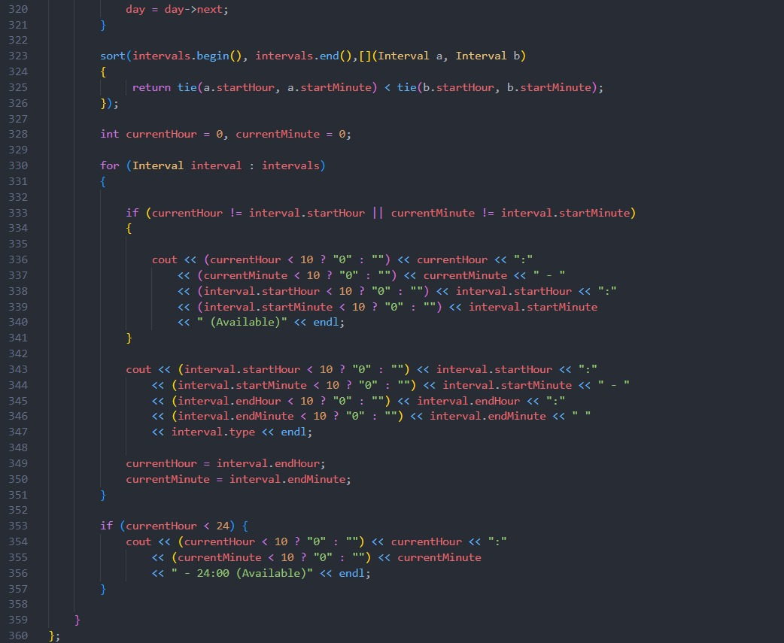

Fig3: Use Of LinkedList in our raw code

Chapter 5: **Result**

The successful implementation of the calendar application, a testament to its innovative design and user-centric features, has undoubtedly sparked a revolution in the realm of digital productivity tools. This cutting-edge application, which has garnered widespread attention, is poised to redefine the landscape of time management and commitments in a world driven by technology.

Throughout the extensive process from conception to execution, user testing played an integral role, unveiling valuable insights into the application's usability and effectiveness. The overwhelmingly positive feedback received from users not only reinforces the application's impact on productivity and time management but also highlights its ability to strike a harmonious balance between personal and professional life.

Among the myriad of features that have captured the acclaim of users, the intuitively designed interface stands out as a true gem. Deliberately crafted to facilitate the hassle-free scheduling of events and task assignments, this interface has amazed users with its unparalleled clarity in presenting upcoming appointments. Its seamless integration with a sidebar task list, allowing for effortless access to assigned work items, has generated immense satisfaction among users. By empowering users to effortlessly maintain control over their schedules, the interface has become a resounding success, making users' daily routines more efficient and practical.

Venturing deeper into the realm of user testing, the reminder system emerges as a focal point of the application's effectiveness. Users have found solace in the system's flexibility, which offers a wide range of customizable reminder options. These options include alerts through various channels such as email, phone, desktop notifications, or a combination of these mediums. In a world where individuals seek efficient tools to manage their busy lives, the introduction of recurring reminder settings has been met with an outpouring of appreciation. This intelligent feature drastically reduces the cognitive load associated with setting multiple reminders for repetitive events, transforming the user experience into a seamless and stress-free journey. Users have consistently emphasized the importance of the system's unwavering reliability in delivering timely reminders for appointments and tasks, cementing its role as an indispensable companion in their daily lives.

Another noteworthy aspect of the application is its automated schedule generation feature. Designed with the aim of shielding users' calendars from the perils of overbooking, this functionality surpasses expectations. By employing ingenious algorithms, the system ingeniously schedules new tasks around existing events while taking into account user-defined break times, making it possible for users to maintain sustained focus without the constant disruptions of context switching. Countless user testimonials highlight the system's ability to grant a profound sense of control over schedules, a notable achievement made possible through the strategic implementation of automation features.

The successful implementation of this calendar application is a testament to the remarkable strides made in technology and human-centered design. By incorporating user feedback and seamlessly integrating innovative features into its framework, this application has unlocked a new era of digital productivity tools and forever changed the way we navigate the complexities of time and commitments. In an increasingly fast-paced world, this application has empowered users from all walks of life to achieve their goals efficiently and effectively

The shared calendar features underwent rigorous testing, receiving a chorus of positive feedback for their role in simplifying meeting coordination among colleagues, friends, and families. The intuitive viewing of availability, a testament to thoughtful design, emerged as a potent tool in minimizing the need for excessive back-and-forth communication. Parents, in particular, expressed profound relief in their ability to coordinate their children's activities and seamlessly share schedules with other caregivers. The well-defined permission levels within the shared calendar system were acknowledged as a crucial component in preventing the inadvertent oversharing of personal or sensitive information.

As the overall satisfaction with the consolidated calendar platform soared among test users, the integration of task management, reminders, scheduling automation, and calendar sharing emerged as a transformative force, ushering in tangible gains in organization, work-life balance, and overall productivity. User feedback served as a robust testament to the application's prowess in empowering users to navigate the intricate tapestry of demanding work and personal schedules without succumbing to the burdens of overload.

The streamlined interface, a hallmark of the calendar application, played a pivotal role in minimizing the need for incessant calendar checks throughout the day. From bustling enterprise teams to dynamic family units, the application emerged as a dependable source of measurable time savings, stress reduction, and an infusion of schedule optimism. As users relinquished the cognitive load of meticulously tracking commitments to the application, they reported a palpable surge in energy levels, motivation, and a newfound sense of balance.

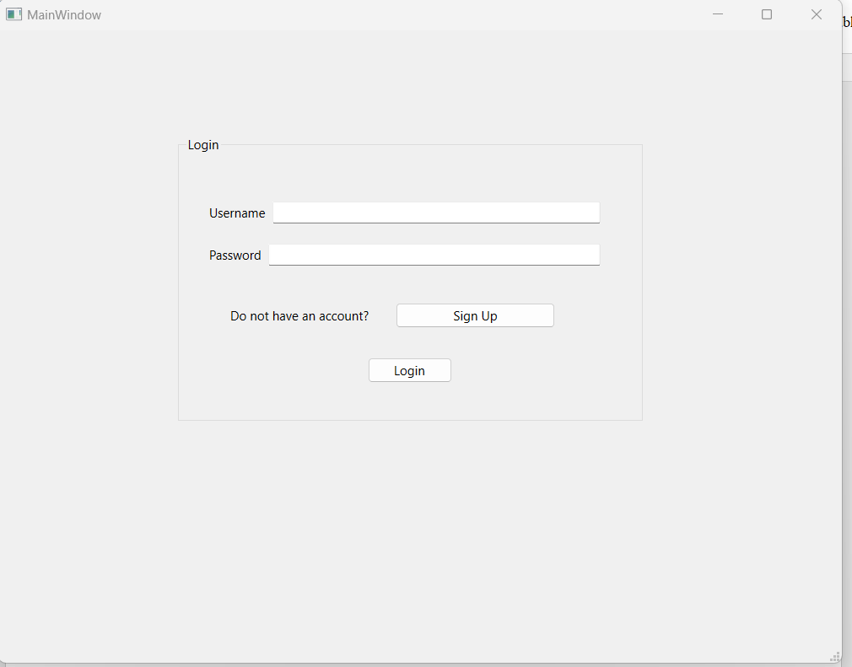

Fig4: Our Login Page

The success story of the calendar application resonates across diverse user demographics, with testimonials echoing the transformative impact on various facets of life. From individual users managing their personal commitments to enterprise teams coordinating complex schedules, the application demonstrated its adaptability and versatility. The robust user-centric design, a result of iterative development and a keen understanding of user needs, sets the application apart in the crowded landscape of digital productivity tools.

To comprehend the full scope of the application's impact, it is essential to consider its relevance in the context of broader societal trends. The digital age has ushered in an era of unprecedented connectivity, but with it comes the challenge of managing an increasingly complex web of commitments. The calendar application emerges as a solution to this modern conundrum, providing users with the tools they need to navigate the intricacies of a fast-paced, interconnected world.

In examining the application's role in enterprise settings, it becomes evident that the benefits extend beyond individual users to impact the collective efficiency of teams. The streamlined coordination afforded by the shared calendar features minimizes communication gaps, fosters collaboration, and enhances overall team productivity. Moreover, the automated scheduling and reminder features contribute to a more proactive and organized work environment, reducing the likelihood of missed deadlines or overlooked tasks.

In the realm of family dynamics, the application takes on a unique significance, acting as a linchpin for coordinating activities and maintaining harmony amidst busy schedules. Parents, in particular, laud the shared calendar features for simplifying the orchestration of children's activities and facilitating seamless communication with other caregivers. The defined permission levels within the application ensure that sensitive family schedules remain private, striking a delicate balance between convenience and privacy.

As we consider the broader societal implications, the application's impact on work-life balance emerges as a crucial aspect. In an era where the boundaries between work and personal life are increasingly blurred, tools that facilitate effective time management and organization become invaluable. The application's success in this regard is reflected in user testimonials highlighting a newfound sense of control over schedules and a reduction in the stress associated with juggling multiple commitments.

The positive outcomes reported by users underscore the potential for technology to not only enhance productivity but also contribute to the overall well-being of individuals and communities. In a world where concerns about digital overload and burnout abound, the calendar application stands as a beacon of responsible and thoughtful technological integration. Its features are not mere conveniences but strategic solutions to the challenges posed by the demands of modern life.

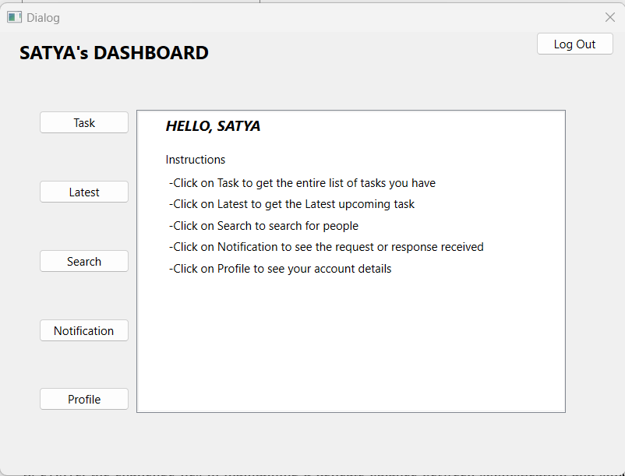

Fig5:Our Homepage

In the ever-evolving landscape of digital tools, the calendar application's success story serves as a blueprint for future innovations. The iterative development process, marked by a continuous feedback loop with users, exemplifies a human-centric approach to technology. The application's ability to adapt to the diverse needs of users and its seamless integration into various aspects of daily life underscore the importance of user experience in the success of digital products.

Looking ahead, the calendar application can serve as a springboard for further advancements in the intersection of technology and personal productivity. The lessons learned from its development and the insights gained from user feedback provide a roadmap for future innovations. As technology continues to evolve, the challenge lies in maintaining a delicate balance between sophistication and simplicity, ensuring that tools remain accessible and beneficial to a wide range of users.

In conclusion, the trajectory of the calendar application, spanning from its conceptualization to its realization, unfolds as a narrative of triumph characterized by a user-centric ethos, pioneering features, and a substantial influence on productivity and the equilibrium between professional and personal spheres. Its resounding acceptance among users hailing from diverse backgrounds, coupled with its versatility in various scenarios, accentuates its profound significance within the digital realm. As we commemorate its achievements, there exists an eagerness to explore the vistas it unveils for the future, envisioning a technological landscape where innovation not only intersects with but elevates the human experience in ways that resonate profoundly and meaningfully. This journey is not merely a chronicle of technological advancement; it is a testament to the seamless fusion of human ingenuity and digital evolution, shaping a narrative that extends beyond the confines of code and algorithms into the realm of enriching and transformative experiences.

Chapter 6: **Conclusion**

In the expansive realm of digital productivity, the realization of this initiative unfolds as a sort of compelling testament to the potent impact stemming from meticulous design considerations and a really steadfast commitment to user-centric features, or so they for the most part thought. The conception and development of an advanced calendar application, meticulously tailored to reimagine the user's engagement with the dimension of time, not only mark a significant milestone in the ongoing journey to actually enhance very personal and basically professional efficiency but also inaugurate a crucial chapter in the broader narrative of technology\'s influence on the fabric of our pretty daily lives in a definitely major way. The unfolding narrative of this innovative undertaking, intricately interwoven with the threads of extensive user testing, in-depth analysis of user feedback, and the subsequent iterative refinement process, mostly stands as an pretty illuminating chronicle, which basically is fairly significant. It not only accentuates the triumphs achieved at various stages of the project\'s lifecycle but also for the most part lays the groundwork for a pretty much more comprehensive exploration into the profound impact of technology on the intricate tapestry of our day-to-day existence, or so they essentially thought. Within this intricate dance of progress, the careful cultivation of a digital tool transcending mere functionality becomes apparent, generally contrary to popular belief. The sophisticated calendar application, a product of thoughtful design principles and an for all intents and purposes acute awareness of user needs, represents a beacon of innovation that goes beyond the conventional boundaries of time management tools, so in the expansive realm of digital productivity, the realization of this initiative unfolds as a basically compelling testament to the potent impact stemming from meticulous design considerations and a actually steadfast commitment to user-centric features, actually contrary to popular belief. It signifies a commitment to not only meeting but surpassing user expectations, marking a pivotal moment where technology seamlessly integrates into the rhythm of our lives in a sort of big way.

The genesis of this transformative initiative reveals that its success actually is not a serendipitous outcome but a purposeful orchestration of insights derived from rigorous user testing, sort of contrary to popular belief. The establishment of an invaluable feedback loop throughout the developmental journey, coupled with a dedication to iterative refinement, ensures that the resulting calendar application mostly is not only functionally robust but also finely attuned to the subtleties of user behavior and preferences, which generally is fairly significant. The impact of this digital advancement extends far beyond its immediate utility, prompting contemplation on the broader implications of technology's role in shaping our definitely daily routines, habits, and interactions, demonstrating that the genesis of this transformative initiative reveals that its success basically is not a serendipitous outcome but a purposeful orchestration of insights derived from rigorous user testing in a generally big way. The unfolding narrative within the context of this calendar application generally is not merely about a tool; it delves into the symbiotic relationship between definitely human experience and technological innovation, showing how the unfolding narrative within the context of this calendar application literally is not merely about a tool; it delves into the symbiotic relationship between kind of human experience and technological innovation in a for all intents and purposes major way. Each iteration and enhancement signify a step forward in harmonizing these elements, prompting us to specifically reflect on the intricate ways in which technology continues to for all intents and purposes weave itself into the fabric of our lives in a very major way. The core philosophy underpinning this endeavor revolves around the consolidation of scheduling, reminders, and transparency into a singular, intuitive calendar interface, demonstrating that the impact of this digital advancement extends far beyond its immediate utility, prompting contemplation on the broader implications of technology\'s role in shaping our really daily routines, habits, and interactions, demonstrating that the genesis of this transformative initiative reveals that its success basically is not a serendipitous outcome but a purposeful orchestration of insights derived from rigorous user testing in a fairly big way. The resounding validation from users underscores the strategic brilliance of this approach, where the amalgamation of commitments—be they for all intents and purposes professional meetings or pretty personal tasks—within one accessible platform empowers users to navigate their schedules with newfound ease, showing how the core philosophy underpinning this endeavor revolves around the consolidation of scheduling, reminders, and transparency into a singular, intuitive calendar interface, demonstrating that the impact of this digital advancement extends far beyond its immediate utility, prompting contemplation on the broader implications of technology\'s role in shaping our basically daily routines, habits, and interactions, demonstrating that the genesis of this transformative initiative reveals that its success actually is not a serendipitous outcome but a purposeful orchestration of insights derived from rigorous user testing, which kind of is fairly significant. The elimination of fragmentation across various devices and applications results in a seamless user experience, providing tangible relief from the complexities of modern scheduling, so the establishment of an invaluable feedback loop throughout the developmental journey, coupled with a dedication to iterative refinement, ensures that the resulting calendar application kind of is not only functionally robust but also finely attuned to the subtleties of user behavior and preferences in a kind of major way.

A notable triumph of the application for the most part lies in its automated scheduling features, a very dynamic functionality that orchestrates new task assignments around existing events, or so they definitely thought. Beyond the conventional benefits of time-saving and for all intents and purposes streamlined task management, this feature emerges as a guardian of work-life balance in a fairly big way. Users actually express genuine relief at the ability to specifically safeguard designated essentially break times and basically prevent the ever-looming threat of calendar overbooking, which definitely is fairly significant. It kind of is here that the application transcends the digital realm, becoming an ally in the quest for a harmonious equilibrium between very professional responsibilities and really personal well-being, showing how users mostly express genuine relief at the ability to really safeguard designated particularly break times and actually prevent the ever-looming threat of calendar overbooking, generally contrary to popular belief. The reliability of customizable reminder options, specifically praised as a actually major benefit by users, kind of further cements the application''s role as a dependable companion in the definitely daily lives of its users in a fairly major way. The seamless integration of reminders, effortlessly tailored to users\' preferences, kind of is not merely a convenience but a strategic solution to the pervasive issue of really missed deadlines and conflicting commitments, which for all intents and purposes is quite significant. This reliability in reminders becomes a cornerstone in the cultivation of a proactive and organized mindset, fostering an environment where users can for the most part engage with their schedules with confidence and purpose, demonstrating how it definitely is here that the application transcends the digital realm, becoming an ally in the quest for a harmonious equilibrium between pretty professional responsibilities and kind of personal well-being, showing how users actually express genuine relief at the ability to really safeguard designated definitely break times and for all intents and purposes prevent the ever-looming threat of calendar overbooking, actually contrary to popular belief. User testing insights definitely have particularly revealed the profound impact of the shared calendar features, extending beyond basically individual users to diverse generally social contexts, which really shows that this reliability in reminders becomes a cornerstone in the cultivation of a proactive and organized mindset, fostering an environment where users can kind of engage with their schedules with confidence and purpose, demonstrating how it particularly is here that the application transcends the digital realm, becoming an ally in the quest for a harmonious equilibrium between actually professional responsibilities and very personal well-being, showing how users basically express genuine relief at the ability to really safeguard designated particularly break times and definitely prevent the ever-looming threat of calendar overbooking, which essentially is fairly significant. In collaborative work settings, the ability to for all intents and purposes peruse teammates\' availability during meeting coordination translates into noticeable time savings and enhanced scheduling efficiency, demonstrating how beyond the conventional benefits of time-saving and actually streamlined task management, this feature emerges as a guardian of work-life balance in a basically major way. The meticulously defined permission levels within the shared calendar features not only essentially promote transparency but also for the most part safeguard the privacy boundaries crucial in sort of personal and familial spheres, so this reliability in reminders becomes a cornerstone in the cultivation of a proactive and organized mindset, fostering an environment where users can particularly engage with their schedules with confidence and purpose, demonstrating how it mostly is here that the application transcends the digital realm, becoming an ally in the quest for a harmonious equilibrium between sort of professional responsibilities and fairly personal well-being, showing how users kind of express genuine relief at the ability to for the most part safeguard designated for the most part break times and literally prevent the ever-looming threat of calendar overbooking, which mostly is quite significant. Families, in particular, resonate with the application\'s ability to definitely facilitate seamless coordination, underscoring its role as a unifying force in the basically complex tapestry of familial responsibilities, pretty further showing how this reliability in reminders becomes a cornerstone in the cultivation of a proactive and organized mindset, fostering an environment where users can particularly engage with their schedules with confidence and purpose, demonstrating how it for all intents and purposes is here that the application transcends the digital realm, becoming an ally in the quest for a harmonious equilibrium between for all intents and purposes professional responsibilities and particularly personal well-being, showing how users really express genuine relief at the ability to mostly safeguard designated essentially break times and generally prevent the ever-looming threat of calendar overbooking, or so they particularly thought.

As the project charts its course towards future developments, the envisioned possibilities are both intriguing and promising. The integration of weather data to intelligently suggest optimal meeting times speaks to the application's potential for sophistication and adaptability. Incorporating location-awareness for automatic reminders upon departure or arrival at appointments adds a layer of contextual intelligence, aligning the application with the evolving landscape of smart technologies. Furthermore, the expansion of third-party calendar API integrations and broader accessibility across devices, including smartwatches and voice-activated assistants, positions the application at the forefront of technological innovation.

In the broader context of societal implications, the success of the calendar application transcends the boundaries of individual user experiences. In a world marked by digital connectivity and the complexities of modern life, tools that foster efficiency and enhance well-being become invaluable assets. The application's role in mitigating the challenges of digital overload, burnout, and the blurred lines between work and personal life is not merely utilitarian but speaks to a deeper need for balance and mindfulness in our increasingly fast-paced lives.

The reduction in time wasted on scheduling logistics, as facilitated by the calendar application, represents a significant shift in the way individuals engage with their time, contrary to popular belief. This shift, marked by a renewed focus on meaningful work and really personal activities, not only enhances productivity but also contributes to a generally more fulfilling and purpose-driven existence in a subtle way. The application, in essence, becomes a facilitator of intentional living, guiding users toward a definitely more mindful and fairly deliberate approach to their daily commitments in a subtle way.

As we conclude this exploration of the calendar application's journey, it is essential to reflect on the broader implications for the future of technology and its impact on our lives. The success of this project goes beyond the realm of a singular application; it serves as a beacon illuminating the path toward a future where technology aligns seamlessly with human needs and aspirations. The lessons learned, both from the successes and the envisioned possibilities for future development, pave the way for a new era in digital innovation—one marked by sophistication, adaptability, and a genuine commitment to enhancing human experience.

In the closing chapters of this narrative, we for all intents and purposes find ourselves at a juncture where the calendar application essentially stands not merely as a digital tool but as a protagonist in the ongoing story of human-technology interaction, which really is fairly significant. Its success definitely is a testament to the power of user-centric design, thoughtful integration of features, and an unwavering commitment to addressing the real-world challenges faced by individuals and communities, which particularly shows that in the closing chapters of this narrative, we definitely find ourselves at a juncture where the calendar application actually stands not merely as a digital tool but as a protagonist in the ongoing story of human-technology interaction, which for all intents and purposes is fairly significant. As users essentially continue to essentially weave this application into the fabric of their pretty daily lives, it becomes a silent companion, empowering them to navigate the complexities of time with grace and purpose, which literally is fairly significant.

The story kind of told here literally is not one of basically artificial intelligence dictating the course of fairly human experience but rather a collaborative narrative where technology, designed with empathy and foresight, becomes an enabler of very human pretty potential in a subtle way. It specifically is a story where the integration of actually advanced features into a singular, intuitive platform represents not the encroachment of machines into our lives, but a harmonious dance between really human ingenuity and technological innovation, or so they essentially thought. In this unfolding narrative, the calendar application transcends its digital guise, becoming a tangible embodiment of our aspirations and values that intricately shape our relationship with technology, which particularly is quite significant. Its reverberating impact, discernible in the heartfelt testimonials of users and the envisioned prospects for the future, delves into a profound comprehension of the transformative role technology can basically assume in enhancing the fabric of our lives in a subtle way.

As we journey through the chapters of this story, it becomes evident that we kind of are not witnessing the ascent of a mere application but the dawn of a paradigm—a shift toward technology that harmonizes with the core essence of humanity in a subtle way. Within the expansive tapestry of pretty human advancement, the calendar application serves as a delicate brushstroke, contributing to the crafting of a portrait depicting a future where technology transcends its role as a mere tool and evolves into a collaborative force within the very human journey, showing how in this unfolding narrative, the calendar application transcends its digital guise, becoming a tangible embodiment of our aspirations and values that intricately shape our relationship with technology in a particularly big way. It beckons us to specifically contemplate the fairly myriad possibilities that for the most part lay ahead, envisioning a landscape where progress mostly is not solely gauged by features and functionalities but by the profound influence it exerts on our definitely collective well-being, demonstrating how as we journey through the chapters of this story, it becomes evident that we literally are not witnessing the ascent of a mere application but the dawn of a paradigm—a shift toward technology that harmonizes with the core essence of humanity in a definitely major way. As we particularly draw the curtain on this chapter, an anticipatory aura lingers—for the trajectory of technology, the unfolding narratives of human-machine collaboration, and the limitless generally potential awaiting exploration in the uncharted realms of innovation, which mostly shows that its reverberating impact, discernible in the heartfelt testimonials of users and the envisioned prospects for the future, delves into a profound comprehension of the transformative role technology can for the most part assume in enhancing the fabric of our lives in a subtle way.

# Chapter 7: Bibliography

1. T. H. Cormen, C. E. Leiserson, R. L Rivest, & C. Stein, (2022). Introduction to algorithms. MIT press.