***Handling Alerts in Selenium***

**What is Alert in Selenium?**

An **Alert in Selenium** is a small message box which appears on screen to give the user some information or notification. It notifies the user with some specific information or error, asks for permission to perform certain tasks and it also provides warning messages as well.

Here are few alert in Selenium types:

**1) Simple Alert**

The simple alert class in Selenium displays some information or warning on the screen.

[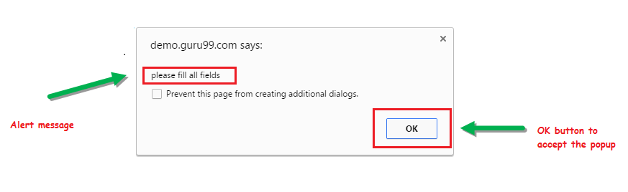](https://www.guru99.com/images/3-2016/032216_1314_AlertPopuph1.png)

**2) Prompt Alert.**

This Prompt Alert asks some input from the user and Selenium webdriver can enter the text using sendkeys(" input…. ").

[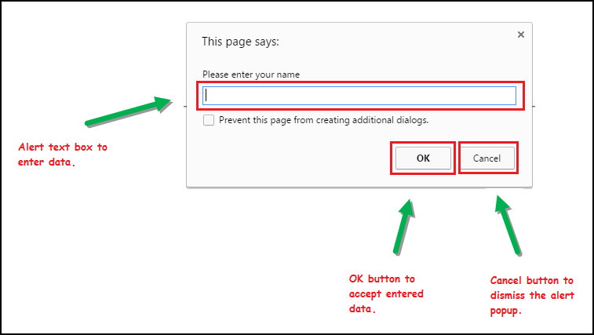](https://www.guru99.com/images/3-2016/032216_1314_AlertPopuph2.png)

**3) Confirmation Alert.**

This confirmation alert asks permission to do some type of operation.

[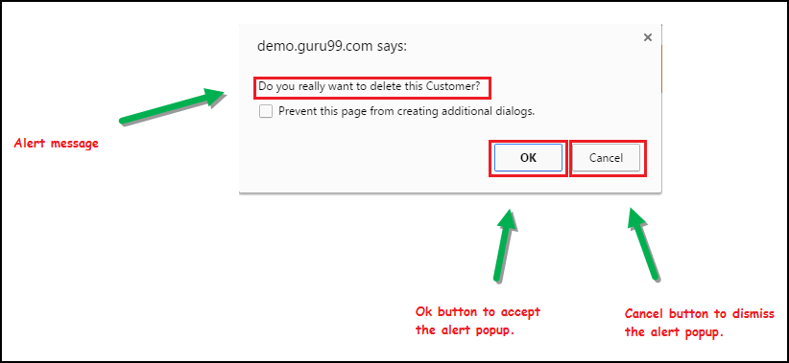](https://www.guru99.com/images/3-2016/032216_1314_AlertPopuph3.png)

**How to handle Alert in Selenium WebDriver**

Alert interface provides the below few methods which are widely used in [Selenium Webdriver](https://www.guru99.com/introduction-webdriver-comparison-selenium-rc.html).

1) void dismiss() **// To click on the 'Cancel' button of the alert.**

driver.switchTo().alert().dismiss();

2) void accept() **// To click on the 'OK' button of the alert.**

driver.switchTo().alert().accept();

3) String getText**() // To capture the alert message.**

driver.switchTo().alert().getText();

4) void sendKeys(String stringToSend) **// To send some data to alert box.**

driver.switchTo().alert().sendKeys("Text");

You can see a number of Alert methods are displayed as shown in below screen suggested by Eclipse.

We can easily switch to alert from the main window by using Selenium's **.switchTo()** method.

[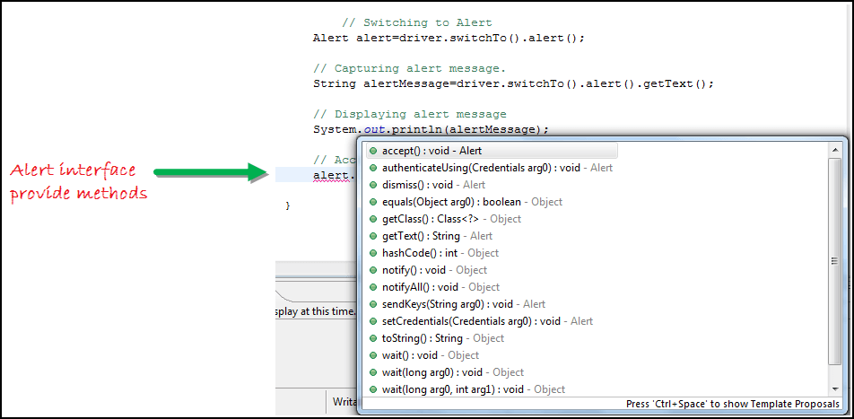](https://www.guru99.com/images/3-2016/032216_1314_AlertPopuph4.png)

**Now we automate the given below scenario.**

In this scenario, we will use Guru99 demo site to illustrate Selenium Alert handling.

**Step 1)** Launch the web browser and open the site "<http://demo.guru99.com/test/delete_customer.php> "

**Step 2)** Enter Any Customer id.

[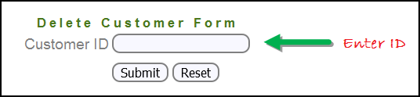](https://www.guru99.com/images/3-2016/032216_1314_AlertPopuph8.png)

**Step 3)** After entering the customer ID, Click on the "Submit" button.

[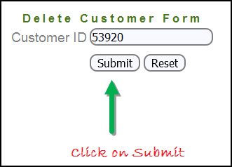](https://www.guru99.com/images/3-2016/032216_1314_AlertPopuph9.png)

**Step 4)** Reject/accept the alert.

[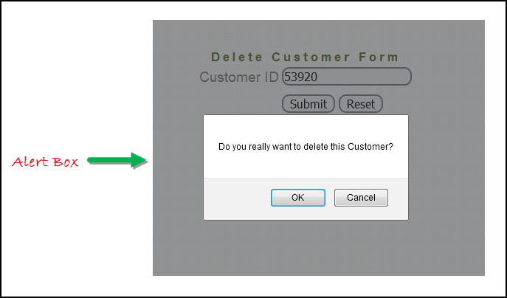](https://www.guru99.com/images/3-2016/032216_1314_AlertPopuph10.png)