**Topic: HANDLING POP-up Windows**

**How to handle Selenium Pop-up window using Webdriver**

In automation, when we have multiple windows in any web application, the activity may need to switch control among several windows from one to other in order to complete the operation. After completion of the operation, it has to return to the main window i.e. parent window in Selenium. We will see this further in the article with an example.

In Selenium web driver there are methods through which we can handle multiple windows.

**Driver.getWindowHandles();**

To handle all opened windows by web driver, we can use "Driver.getWindowHandles()" and then we can switch window from one window to another in a web application. Its return type is Iterator<String>.

**Driver.getWindowHandle();**

When the site opens, we need to handle the main window by **driver.getWindowHandle()**. This will handle the current window that uniquely identifies it within this driver instance. Its return type is String.

For Window handling in Selenium, we will follow the below steps:

Now, we will automate the given below scenario to see how to handle multiple windows using Selenium Webdriver.

In this scenario, we will use "Guru99" demo site to illustrate window handling.

**Step 1)** Launch the site.

Launch the browser and open the site " **http://demo.guru99.com/popup.php** "

[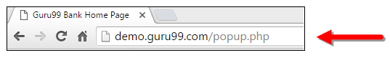](https://www.guru99.com/images/3-2016/032216_1314_AlertPopuph11.png)

**Step 2)** Click on link "Click Here ".

When the user clicks on the " Click Here " link, new child window opens.

[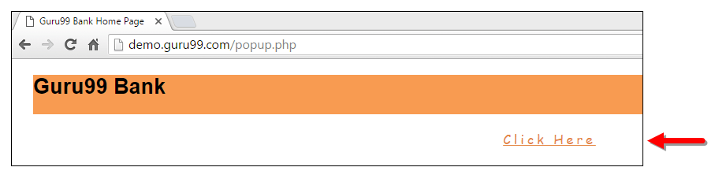](https://www.guru99.com/images/3-2016/032216_1314_AlertPopuph12.png)

**Step 3)** New Child Window opens.

A new window opens, ask the user to enter email id and submit the page.

[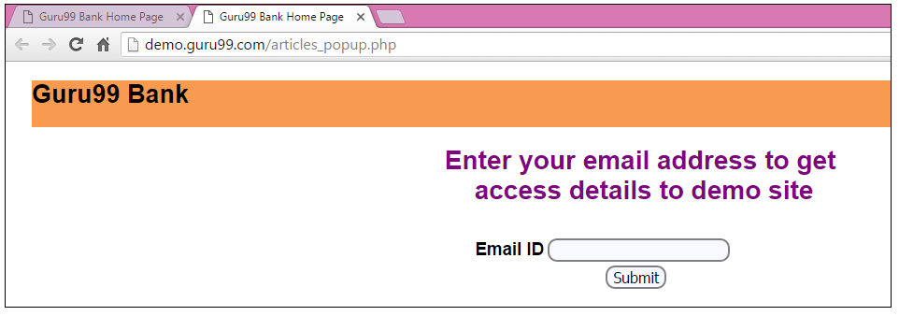](https://www.guru99.com/images/3-2016/032216_1314_AlertPopuph13.png)

**Step 4)** Enter your email ID and submit.

[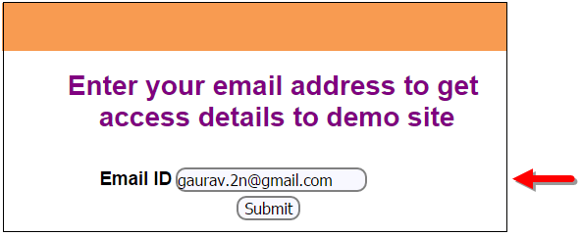](https://www.guru99.com/images/3-2016/032216_1314_AlertPopuph14.png)

**Step 5)** Display the Access Credentials on submitting the page.

[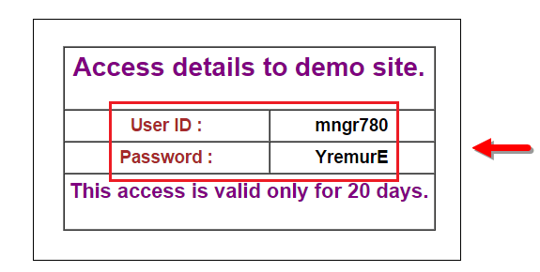](https://www.guru99.com/images/3-2016/032216_1314_AlertPopuph15.png)

When you execute the code, you will see the child window is open in new tab.

1. Close the Child window on which credentials are displayed.

[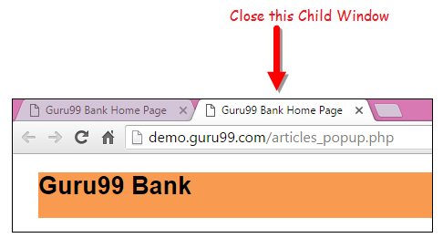](https://www.guru99.com/images/3-2016/032216_1314_AlertPopuph16.png)

1. Switch to the parent window.

[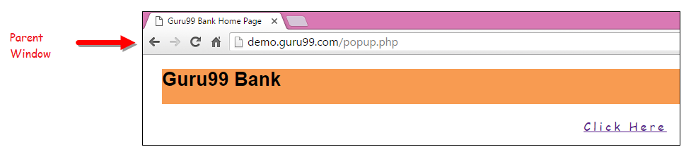](https://www.guru99.com/images/3-2016/032216_1314_AlertPopuph17.png)

**Handling multiple windows in Selenium webdriver using above scenario.**

import java.util.Iterator;

import java.util.Set;

import org.openqa.selenium.By;

import org.openqa.selenium.WebDriver;

import org.openqa.selenium.firefox.FirefoxDriver;

public class WindowHandle_Demo {

public static void main(String[] args) throws InterruptedException {

WebDriver driver=new FirefoxDriver();

//Launching the site.

driver.get("http://demo.guru99.com/popup.php");

driver.manage().window().maximize();

driver.findElement(By.xpath("//*[contains(@href,'popup.php')]")).click();

String MainWindow=driver.getWindowHandle();

// To handle all new opened window.

Set<String> s1=driver.getWindowHandles();

Iterator<String> i1=s1.iterator();

while(i1.hasNext())

{

String ChildWindow=i1.next();

if(!MainWindow.equalsIgnoreCase(ChildWindow))

{

// Switching to Child window

driver.switchTo().window(ChildWindow);

driver.findElement(By.name("emailid"))

.sendKeys("[gaurav.3n@gmail.com](mailto:gaurav.3n@gmail.com)");

driver.findElement(By.name("btnLogin")).click();

// Closing the Child Window.

driver.close();

}

}

// Switching to Parent window i.e Main Window.

driver.switchTo().window(MainWindow);

}

}

**Output:**

When you execute the above code, it launches the site and on clicking the link "Click here," it opens up a child window in a new tab. You can close the child window, and switch to the parent window once the operation is completely done. Hence handling more than one window in the application.

[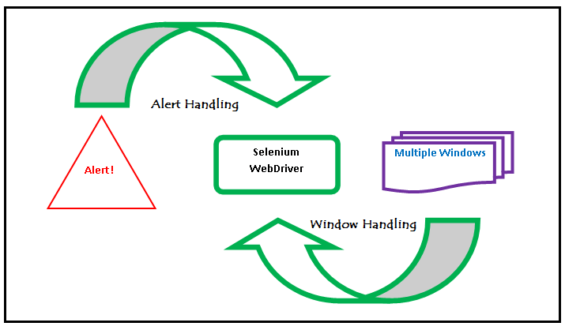](https://www.guru99.com/images/3-2016/032216_1314_AlertPopuph18.png)

Multiple Window Handling in Selenium

**Conclusion:**

* We defined the types of alert and shown them with a screen shot.
* Demonstrated handling the Alert with Selenium WebDriver using particular scenario.
* Handled multiple windows with Selenium WebDriver using particular scenario.