Fractal Literacy: Nature's Hidden Language
Author: Dariush Alipour
Abstract
Fractal geometry offers a tool for uncovering the hidden order within nature's complex phenomena — from the coastlines of the Persian Gulf to the vein structure of a plane-tree leaf. Fractal literacy is the ability to observe, identify, interpret, and apply these recurring patterns, patterns that appear not only in nature but in technologies such as artificial neural networks and in social structures such as the trade networks of Iran's traditional bazaars. This essay introduces “fractal literacy” as a bridge between nature, technology, and society — a bridge that can reshape our understanding of the world and open new paths for confronting today's challenges. This essay's contribution is to synthesize and connect these three domains under a single conceptual framework, rather than to present new empirical findings.
Introduction
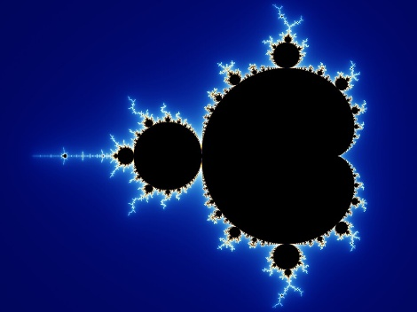
Before the twentieth century, Euclidean geometry — with its simple forms such as circles and squares — stood as the standard of order and beauty. But it could not explain the complexity of nature. The Zagros Mountains are rugged, the clouds over the Hyrcanian sky take on ever-changing shapes, lightning carves nonlinear paths, and the branches of oak trees form repeating patterns. In such a world, classical models fell short. In the 1970s, Benoît Mandelbrot introduced fractal geometry and transformed our understanding of nature — an approach that seeks order within the complexity of nature itself.
Figure 1 — The Mandelbrot set, a symbol of fractal geometry that reveals recurring order within apparent disorder and helps us understand patterns in nature and technology.
Fractal literacy is the ability to recognize and apply these same recurring patterns in solving problems ranging from natural-resource management to social-data analysis.
From Geometry to Understanding: Order Within Chaos
Fractal geometry rests on the principle that many natural phenomena display a repeating pattern across different scales. Look closely at a tree branch, and in each small offshoot one seems to glimpse an image of the whole tree — this is the very secret on which fractal geometry rests: the endless repetition of order within disorder.
Zoom in on natural phenomena such as the coastline of the Caspian Sea or the veins of a pomegranate leaf, and a structure resembling the whole phenomenon appears again. From the course of the Karun River to the blood vessels of the human body, these recurring patterns — called “fractals” — reveal a hidden order within nature's complexity. This is what Mandelbrot himself called “order within disorder.”
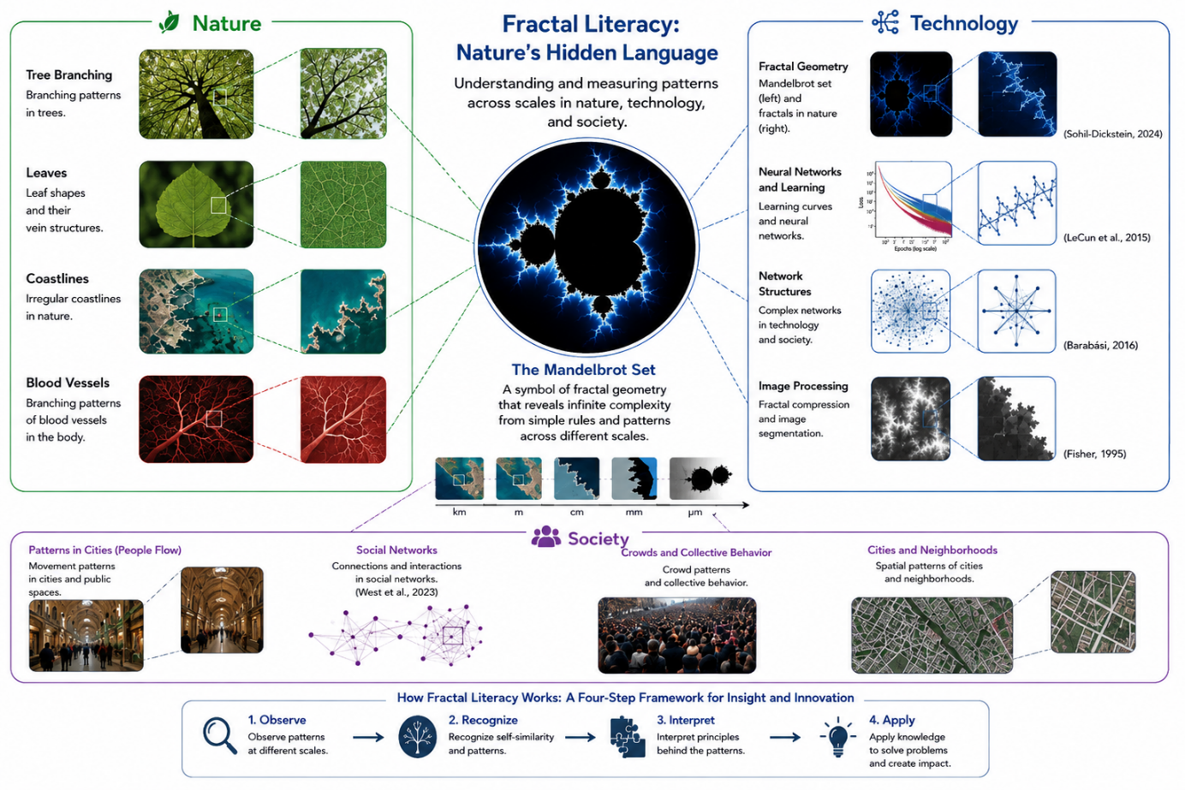
Figure 2 — Conceptual framework of fractal literacy: from observing multi-scale patterns in nature to interpreting and applying them in technology and society.

But these patterns are not confined to nature; traces of them can be found in the complex structures of the human brain and even in newer technologies. In biological structures related to the brain, too, one can observe branching, multi-scale patterns — for instance, in the branching of dendrites and the network of blood vessels, patterns appear that, geometrically and in terms of scalability, are comparable to certain fractal structures. In some recent research, fractal properties have been observed not in the architecture of neural networks itself, but in the behavior of the training process and its hyperparameter space.
Artificial intelligence, too — at least at the level of analogy and inspiration — draws on the same recurring patterns that nature has used in the structure of leaves, the paths of lightning, and the shapes of clouds: patterns that create order and meaning out of complexity.
More strikingly, some recent studies have shown that fractal behavior can also be observed in the training process of neural networks. In 2024, Jascha Sohl-Dickstein, in a paper titled “The boundary of neural network trainability is fractal” (arXiv:2402.06184), showed that the boundary between “complete learning” and “complete divergence” in neural networks behaves fractally. He explains that hyperparameter space, over the course of training, behaves remarkably like the Mandelbrot set: it takes only a small change in the learning rate or a single parameter to send the training trajectory from perfect order into full-blown chaos.
This discovery is not merely a technical finding; it is a sign that artificial intelligence, too, draws on the same language nature has spoken for centuries — a language once whispered in the veins of a leaf and the twisting path of lightning, and now carried forward within code and algorithms.
Fractals from Nature to Society: From Biology to Culture
The reach of fractal patterns is not confined to biology and technology; traces of them can also be found in human behavior and social structures. Looking more closely, we find that many cultural and social phenomena, too, can be seen as instances of this same fractal order — patterns that repeat at both small and large scales.
Take Tehran's Grand Bazaar, for example: every stall and every row of shops can be seen as not merely a part of the whole market but a small image of its overall structure — as though each fragment contains an image of the whole. This apparent self-similarity in the bazaar's social organization is reminiscent of the same language nature uses in shaping leaves, branches, and rivers — a hidden order rising out of diversity and disorder. Each part, despite its surface differences, is a piece of a repeating pattern that shapes the market's overall order.
Differences in the world arise less from the essence of things than from rotations, shifts, and proportions. The varied leaves of trees, individual chickpeas, and even the shapes of watermelons — despite their endless variety — follow a shared order. Desert lizards and the crocodiles of Sistan alike spring from a single underlying blueprint of nature; a shared pattern that differs only in scale and proportion.
Human society, too, speaks this same language of repetition and change, a language inspired by nature. Rituals and cultural customs may look different on the surface, but at their core they repeat the same collective behavior. From celebrations and mourning rites to protests and social solidarity, all echo one another — like branches growing from a single tree in different directions, yet rising from one shared trunk.
In fact, society, like nature, is built on fractal patterns: the details change, but the overall structure endures. Just as nature follows the law of repetition and self-similarity in the branching of trees or the course of rivers, human beings follow the same language in their social networks.
In a study titled “Fractal Structure of Human and Primate Social Networks Optimizes Information Flow,” Bruce West and colleagues (2023) showed that the preferred sizes of human and primate social groups, across nested layers, cluster at roughly fixed values — 5, 15, 50, and, in humans, 150 and 500 — a fractal pattern reproduced across scales; this layered, scalable structure can help us understand how information is organized and transmitted within social networks.
This finding suggests that nature has recreated, in human bonds, the same order it conceals in leaves, lightning, and blood vessels — a single language stretching from biology to society, one that carries us to a deeper understanding of “fractal literacy”: a language that plays one recurring melody, from the world of matter to the world of meaning.
The Philosophy of the Fractal: From Geometry to Existence
From a more philosophical perspective, if classical geometry represents stability and certainty, fractal geometry can be called the geometry of life — because life is neither linear nor static. Everything repeats within something else, and no clear boundary separates beginning from end. To understand fractals is to accept that the world resembles a web of relationships, in which every human being, like a branch of a tree, is part of a larger pattern. This view leads us to a deeper understanding of our own place within this nested structure — a structure shaped not by certainty but by flexibility and coexistence.
Rumi, in the line “This world is a mountain, and our actions are its call / the call comes back to us as its own echo,” speaks of a pattern in which every action finds its echo at another scale. This vision, though it arose in a context entirely different from fractal geometry, is philosophically comparable to the same logic: a world in which every part is an image of the whole, and every small act a reflection of larger structures. Just as an individual's behavior resonates through society, so too does society, on another scale, echo a cosmic order.
Understanding “fractal literacy” teaches us that, faced with life's complexities, we should not resist or flee them but accept them as part of a deeper order — an order we ourselves are part of. This awareness carries us from a sense of separateness toward a sense of connectedness, where every thought and every action is a thread in the vast weave of existence, and grasping this interconnectedness is itself a form of awakening.
In this essay, fractal literacy is defined as the ability to observe, recognize, interpret, and apply self-similar, multi-scale patterns in complex phenomena — an ability that takes shape in four steps: observing the pattern, recognizing self-similarity and scale, interpreting the part–whole relationship, and applying this understanding in analysis and problem-solving.
Conclusion
Fractal geometry is a key to recognizing hidden patterns across nature, technology, and society, and it offers a new way of understanding and engaging with the complexities of today's world. Fractal literacy helps us find meaning in recurring patterns — from nature (such as the branching of oak trees) to technology (such as neural networks) and social structures (such as the trade networks of Iran's traditional bazaars) — and to discover harmony amid complexity. Fractal literacy, for instance, can be applied to optimizing irrigation systems in Iran's water-scarce regions or to forecasting traffic patterns in large cities.
In the end, fractal literacy means hearing nature's language in everything: in thunder and in leaves, in neurons and in code, and in the human being — who is, ultimately, a repetition of that same great order.
Keywords:
Fractal geometry, Mandelbrot, order within disorder, nature literacy, artificial intelligence, philosophy of complexity, sociology, recurring patterns
References
Mandelbrot, B. B. (1982). The Fractal Geometry of Nature. W. H. Freeman.
Sohl-Dickstein, J. (2024a). The boundary of neural network trainability is fractal. arXiv preprint arXiv:2402.06184.
Sohl-Dickstein, J. (2024b). Neural network training makes beautiful fractals. Retrieved from https://sohl-dickstein.github.io/2024/02/12/fractal.html
West, B. J., Culbreth, G., Dunbar, R. I. M., & Grigolini, P. (2023). Fractal structure of human and primate social networks optimizes information flow. Proceedings of the Royal Society A, 479(2274). https://doi.org/10.1098/rspa.2023.0028

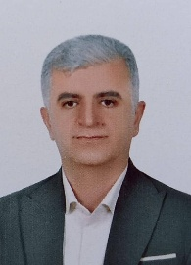
About the Author
Daryoush Alipour holds a Master’s degree in Information Technology from the European University of Armenia. He completed the PhD program requirements and passed the comprehensive examination at the National Academy of Sciences of the Republic of Armenia. His areas of interest include information technology, artificial intelligence, the philosophy of technology, and the study of connections between technology, human beings, and complex structures.

