Jordan Carney | Caleb Gomer | Jason C. Tierney | Nick Workman

Apple ink | Version: November 19, 2012



A replacement for the GVSU myBanner system.

Evaluation Plan

Contents

Project Team Work Roles 5

Jordan Carney 5

Caleb Gomer 5

Jason Tierney 6

Nick Workman 6

Product Description 6

UX Target Table 7

High Fidelity Prototype Task List 7

Benchmark Tasks 7

T1: Log in to Better Banner 7

T2: Change Better Banner Password 8

T3: Change GVSU Network Password 8

T4: View Weekly Schedule for Current Semester 8

T5: Register for BIO 230, Section 01 8

T6: Check Midterm Grades for Current Semester 9

T7: Check for Holds on Account 9

T8: Log out of Better Banner 9

Implemented Tasks from Contextual Analysis 9

User logs in 9

User signs out 9

User checks grades 9

User searches for classes 9

User registers for class 9

User checks class schedule 10

User removes class 10

User checks registration status 10

User checks registration history 10

User views major information 10

User views advisor information 10

User views transcript 10

User views holds 10

User changes Better Banner password 10

User changes network password 10

User updates Address 10

Unimplemented Tasks from Contextual Analysis 10

User views bill 10

User pays bill 11

User registers for parking 11

User checks financial aid 11

User applies for financial aid 11

User declares major(s) 11

User declares minor(s) 11

User changes major 11

User checks schedule for month 11

User exports schedule to iCalendar / Outlook 11

User requests formal/printed transcript 11

User sets up meeting with counselor 12

User updates phone 12

User updates e-mail 12

User views ethnicity / race 12

User updates security question 12

Screen Shots 12

Screenshot Analysis 12

Video Demo 16

Design Highlights 16

Evaluation Plan 17

Goal and Purpose 17

Team Roles 18

Participants 19

Environment 19

Procedures 19

Welcome Dialog 20

Informed Consent Form 20

Test Steps 20

End of Participant Study Results 20

Data Gathering 21

Collecting the Data 21

Summarizing and Analyzing the Data 21

Informed Consent Form 25

Standard Welcome Dialog 26

Example Data Collection Table 27

End of Participant Study Survey 28

myBanner Expert Analysis Questionnaire 29

# Project Team Work Roles

The following is the construct of the team that worked on the high fidelity prototype of Better Banner. As a professional team, we are all fluent in every role, but distribute roles based on the project. The overall construct of this particular project was to have a manager, tester/developer hybrid, and two developers. The roles are as follows:

### Jordan Carney

Jordan’s roles include Technical Writer, Senior Prototype Tester, Senior Mac Hardware Issue Resolver, and Principal User Satisfaction Engineer.

As the **Technical Writer**, Jordan is responsible for polishing up the team’s writing to make it flow as though one person has written the entire document.

As the **Senior Prototype Tester,** Jordan is responsible for analysis of incremental prototypes and evaluating the overall potential user satisfaction of each of them. Jordan must also use Twitter Bootstrap to implement some of the changes that need to be made.

As the **Senior Mac Hardware Issue Resolver,** Jordan is responsible for dealing with Windows users’ issues with “natural scrolling”. He needs to let the user realize that Windows clunk-boxes are not a “natural” user experience in any way and that this “natural” user experience is the inevitable future -- they must accept this.

As the **Principal User Satisfaction Engineer,** Jordan is responsible for ensuring that the user is happy during their evaluation and not low on insulin in their bloodstream. Jordan will deal with this potential problem by providing sugar-laden donuts to the users for their personal enjoyment!

### Caleb Gomer

Caleb’s roles include Senior Prototype Developer, Senior User Relaxation Coordinator, Dubstep Champion, and User Experience Designer.

As the User Experience Designer, Caleb is not necessarily responsible for programming the user experience in any way, and instead should focus on coming up with good design principles that the Prototype Programmer can utilize during the actual coding phase.

As the **Senior Prototype Developer,** Caleb is responsible for utilizing Twitter Bootstrap and programmatically developing the Better Banner website. Caleb will be responsible for a large bulk of the coding and prototyping; the eventual product will be a direct result of his continued mindset and the information provided from the rest of the team.

As the **Senior User Relaxation Coordinator,** Caleb is responsible for soothing users during their evaluation of the prototype with relaxing, classical music. This ensures that the user does not feel overburdened by their evaluation of Better Banner.

As the **Dubstep Champion,** Caleb is responsible for maximizing productivity by creating melodic dubstep playlists for intense Twitter Bootstrap coding sessions! This music will be cranked to 11 and will drown out all other noise.

### Jason Tierney

Jason’s roles include **Senior Prototype Engineer, Atomic Object Fanboy,** and **User Interaction Designer**.

As the **Senior Prototype Engineer,** Jason is responsible for utilizing Twitter Bootstrap and programmatically develop the Better Banner website. Jason will be responsible for a large bulk of the coding and underlying engineering of the website.

As the **Atomic Object Fanboy,** Jason is responsible for wearing Atomic Object t-shirts and preaching how great the company is. Since he will be stating this to people living in West Michigan, they will inevitably agree and continue to boast greatly about the company. Jason is responsible for ensuring that conversations do not continue for extended periods of time as the love for Atomic Object is so great that it can potentially become counterproductive.

As the **User Interaction Designer,** Jason is responsible for designing a fluid experience for the end user by making sure the interactions feel natural. Currently, myBanner involves confusing methodologies for getting simple tasks done and Jason will ensure this type of interaction does not happen again.

### Nick Workman

Nick’s roles include **Project Manager**, **Senior Legal Manager**, **User Testing Coordinating Manager**, and **Senior Muffin Man**. 

As the **Project Manager,** Nick is responsible for coordinating deadlines and team meetings and ensuring each team member is on schedule for his required task(s). Nick will also delegate tasks for completion and subsequently check-up on their completion through email.

As the **Senior Legal Manager,** Nick is responsible for googling proper legal paperwork and printing it off. He is also responsible for presenting this paperwork to the user and ensuring that they fully understand the ramifications of it.

As the **User Testing Coordinating Manager,** Nick is responsible for presenting the prototype to the user, stating that it is not a test, and telling them to think aloud during their analysis.

As the **Senior Muffin Man** **,** Nick is responsible for bringing muffins for the group. These muffins will act as a catalyst for short bursts of productivity. These muffins are an invaluable asset to the maximal workload of the team.

# Product Description

The product description is the overall motive of this product summed up in a clear, concise statement. This one line will be engrained in the mind of everyone working on this product and will act as a driving theme for completion. It is a very general statement because we do not want to hinder creativity and present very specific ideas to the team. The product description is as follows:

*An intuitive redesign of the current myBanner website to give students better access to their important academic information.*

# UX Target Table

A **UX Target Table** is a device for quantifying user performance of our prototype. The quantitative data shown by this table analyzes what we want vs. what actually happened. We will be collecting this data during user testing. For spacing and layout, we moved the UX target table is located on the following page.

## UX Target Table

|  |  |  |  |  |  |  |  |
| --- | --- | --- | --- | --- | --- | --- | --- |
| Work Role: User Class | UX Goal | UX Measure | Measuring Instrument | UX Metric | Baseline Level | Target Level | Observed Results |
| GV Student: New user, plans for future frequent use | Intuitive for user to find and update personal information | Initial user performance | T1: Change your password | Average number of clicks before completing task | 3 clicks | 3 clicks | 5 clicks |
| GV Student: New student | Initial customer satisfaction | First user impressions | T2: Change your password | Overall impression of the usability | Good | Impressed | Mediocre |

# High Fidelity Prototype Task List

The following are the tasks that the user had to complete during evaluation of our prototype. The tasks range incrementally from simple to complex. The user will be initiated with a simple task that familiarizes them with the system and subsequent tasks will be developed from this. The benchmark tasks are also tasks that would typically be completed and are important to an everyday user. We feel these tasks are most important to focus on. We do not want to present tasks that are unimportant and useless to the user during this initial user evaluation.

## Benchmark Tasks

The following benchmark tasks were designed for users to participate in the usability study. These tasks offer further insight into how Better Banner should function and test most of the functionality of Better Banner without needing to go through every implemented task.

### T1: Log in to Better Banner

**Exact wording of T1:** “Log in to Better Banner with the G-number G1234567 and the password 1234.”

To complete this task, the user enters a G-Number and Password on the Better Banner Login screen. If the G-Number and Password are valid, the user is directed to the Better Banner Home screen. If the G-Number and Password are invalid, the user is notified of the error, and asked to repeat the login.

### T2: Change Better Banner Password

**Exact wording of T2:** “Your current Better Banner password isn’t very secure. Please change your Better Banner password to something stronger.”

To complete this task from any screen, the user selects the dropdown list in the top right corner with their name on it, and selects “Change Account Info.” The user then selects the “Change Banner Password” quick link and completes the form.

### T3: Change GVSU Network Password

**Exact wording of T3:** “After changing your Better Banner password you realize your Network password has been the same for a long time. Please Update your Network password to something new.”

To complete this task from any screen, the user selects the dropdown list in the top right corner with their name on it, and selects “Change Account Info.” The user then selects the “Change Network Password” quick link and completes the form.

### T4: View Weekly Schedule for Current Semester

**Exact wording of T4:** “View your Weekly Schedule for Fall 2012.”

To complete this task from the home screen, the user selects the “View Weekly Schedule” quick link.  
To complete this task from any screen, the user selects the “Class Scheduling” dropdown and then selects “Weekly Schedule.” Or they can use the quick link on the main page.

The user is then presented with the weekly schedule for their current semester as well as a dropown option allowing them to change semester.

### T5: Register for BIO 230, Section 01

**Exact wording of T5:** “You and a friend are both taking BIO 230 this semester. However he is already signed up for section 01, try to register before the class fills up.” For this task we included an extra note, “If a time conflict occurs please drop the conflicting class and re-register.”

To complete this task from any screen, the user selects the “Class Scheduling” dropdown and then selects “Search for Classes.” The user is presented with three search criteria: Subject, Course Number, and Section Number, the option to change the semester, as well as their current course schedule. The user types in the blank text field below the criterion or selects from a scrolling list below the text field. Once all criteria are completed, the matching course sections and times are displayed in the last scrolling list. The user selects the correct course section and then selects the “Register” button at the bottom of the form.

If it is necessary to drop a class during this process, the user selects the “Drop” button to the right of any class they wish to drop, then completes the rest of the registration task.

### T6: Check Midterm Grades for Current Semester

**Exact wording of T6:** “What was your lowest midterm grade in Fall 2012?”  
To complete this task from the home screen the user selects the “Midterm and Final Grades” quick link button.

To complete this task from any screen the user selects the “Academic Records” dropdown and then selects “Midterm and Final Grades.” The user is directed to a screen with the current semester’s Midterm and Final grades. A dropdown with the text “Fall 2012” can be used to select other semesters.

### T7: Check for Holds on Account

**Exact wording of T7:** “Do you have any Holds on your account?”

To complete this task from any screen the user selects either the “Class Scheduling,” “Academic Records,” or “Financial Aid” dropdown and then selects “Registration Status/Holds.”

The user is then presented with any holds on their account, and a statement saying whether they are eligible for registration or not.

### T8: Log out of Better Banner

**Exact wording of T8:** “Log out.”

To complete this task from any screen, the user selects the dropdown list in the top right corner with their name on it, and selects “Log out.” The user is then directed to the login screen.

## Implemented Tasks from Contextual Analysis

The following tasks have been implemented for the hi-fidelity prototype. These tasks were either present or non-existent in the original low-fidelity prototype. Further, unlike the low-fidelity prototype, each of these tasks are more dynamic in the hi-fidelity prototype.

### User logs in

The user is able to log into Better Banner with their unique GVSU account.

### User signs out

The user is able to log out of Better Banner.

### User checks grades

The user is able to view midterm and final grades of all classes for every semester they’ve taken classes.

### User searches for classes

The user is able to find and register for classes based on “Subject,” “Course Number,” and “Section Number.”

### User registers for class

The user is able to register for classes if they have the necessary “CRN” numbers or go through the class search process.

### User checks class schedule

The user is able to view their weekly recurring class schedule for any semester they have registered for.

### User removes class

The user is able to remove, or drop, any class they no longer wish to take.

### User checks registration status

The user is able to check their registration status, including any holds that may keep them from registering.

### User checks registration history

The user is able to view all classes they have registered for since they started attending GVSU.

### User views major information

The user is able to view all relevant information relating to their current major and minor, if they have one.

### User views advisor information

The user is able to view information about their advisor.

### User views transcript

The user is able to view and unofficial version of their academic transcript.

### User views holds

The user is able to check any holds on their account.

### User changes Better Banner password

The user is able to change the PIN associated with their Better Banner account.

### User changes network password

The user is able to change the password associated with their GVSU network accounts.

### User updates Address

The user is able to change their email addresses that GVSU can use to contact them.

### Unimplemented Tasks from Contextual Analysis

Due to time and scope of the project, we were unable to implement specific tasks into the hi-fidelity prototype that were present in the contextual analysis.

### User views bill

We chose not to implement bill viewing because it is only completed by students at most once per semester and would not necessarily contribute a great deal to a better user experience.

### User pays bill

We chose not to implement bill paying because it is only completed by students at most once per semester and would not necessarily contribute a great deal to a better user experience.

### User registers for parking

We chose not to implement parking registration because not every student purchases parking permits, and we wanted to focus on the features every student would use.

### User checks financial aid

We chose not to implement the financial aid section of myBanner because it is a very complicated section, requiring a great deal of information and detail. We had a hard time finding a simpler approach to it, and simpler was our goal.

### User applies for financial aid

We chose not to implement the financial aid application form of myBanner because it is a very complicated form, requiring a lot of user input and it had little room for simple improvements.

### User declares major(s)

We chose not to implement the major declaration function of myBanner because the average student uses this very seldom.

### User declares minor(s)

We chose not to implement the minor declaration function of myBanner because the average student uses this very seldom.

### User changes major

We chose not to implement the major changing function of myBanner because it was the same as the major declaration section.

### User checks schedule for month

We chose not to implement a month view for the user’s class schedule because there is no difference in each semester’s class schedule from week to week or month to month. It would only display the same information for every month.

### User exports schedule to iCalendar / Outlook

We chose not to implement the calendar export feature because we did not believe students would find the feature on myBanner.

### User requests formal/printed transcript

We chose not to implement the formal printed transcript feature for myBanner because we did not have access to the correct resources to accomplish it.

### User sets up meeting with counselor

We chose not to implement the counselor meeting feature because we did not feel students use myBanner to schedule these appointments.

### User updates phone

We chose not to implement the phone update feature of myBanner because it was the same user interaction as updating an address and we chose to focus on other user interactions instead.

### User updates e-mail

We chose not to implement the email update feature of myBanner because it was the same user interaction as updating an address and we chose to focus on other user interactions instead.

### User views ethnicity / race

We chose not to implement the ethnicity and race update option of myBanner because we did not feel it made much sense for it to be there in the first place.

### User updates security question

We chose not to implement the update security questions feature because we felt that users did not use this feature enough to warrant creating and testing a better version.

# Screen Shots

The following screenshots provide a generic overview of Better Banner. They do not show the entirety of the website, but they show the important features of the website and the general functionality. Among screenshots, you should notice consistency as this is the important user experience principle. It is also important to note that GVSU’s color scheme is blue and white -- you will notice that consistent color scheme throughout the website.

## Screenshot Analysis

In this section we will analyze each of the screenshots we have built for the hi-fidelity prototype.

Figure 1 shows the simple Better Banner login system. There are two important differences to notice from the current myBanner system: the length of the input fields and the “remember me” checkbox. The length of the inputs fields on the current myBanner are different sizes -- we fixed this simple inconsistency. The “remember me” checkbox offers easier access to frequent myBanner users because nobody wants to constantly input their G-Number and password. Also, pay particular attention to the color scheme and layout as you will see this in subsequent screenshots.

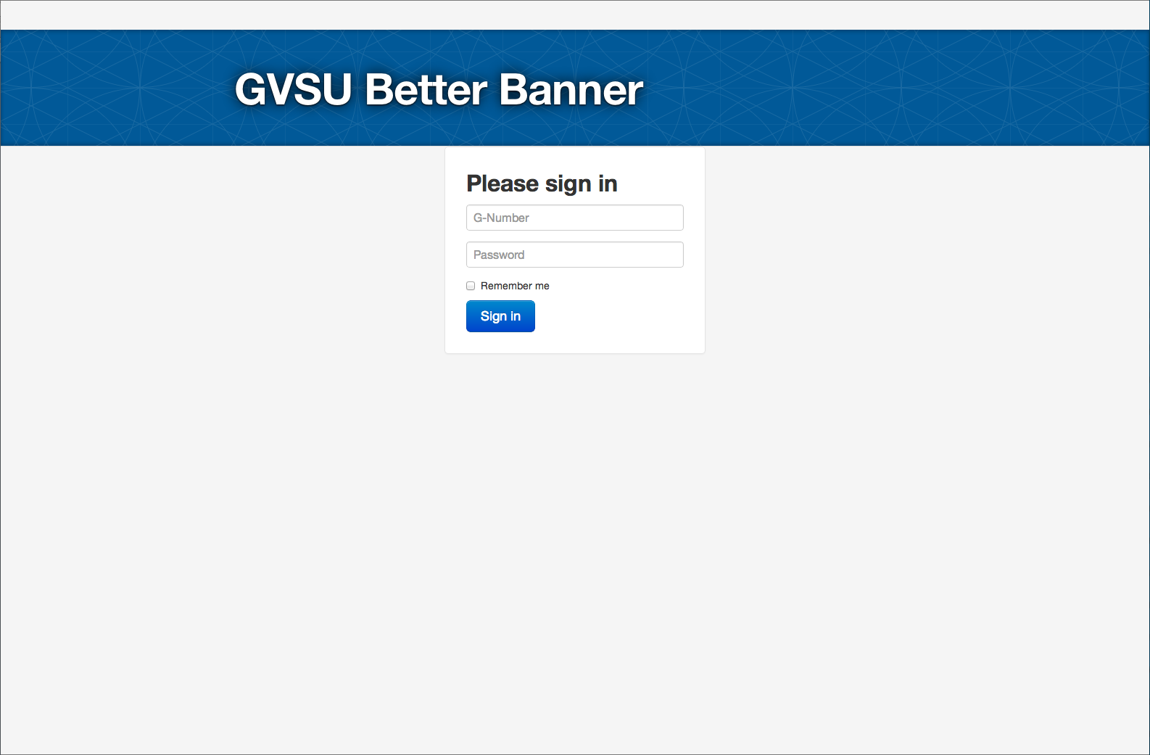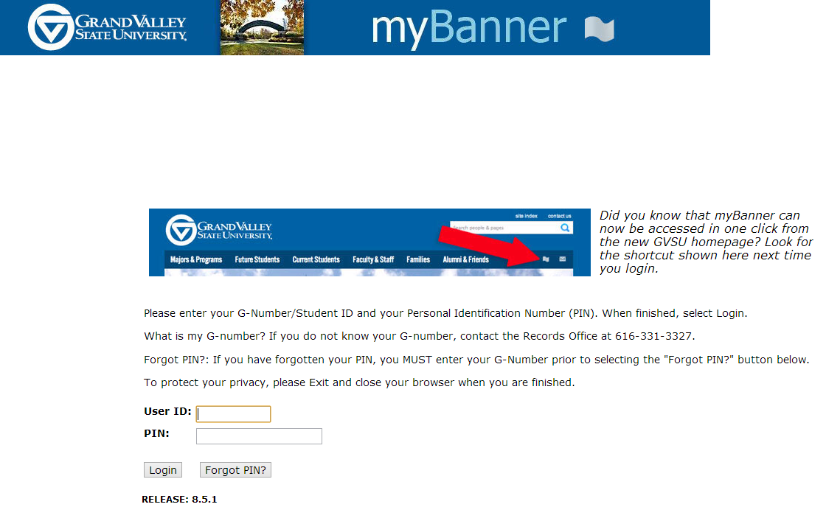

**Figure 1:** Better Banner login page (top) compared with the current myBanner login page (bottom).

Figure 2 shows the Better Banner home page. The first thing the user will notice is the giant text saying “GVSU Better Banner: myBanner done right”; this is intentional. We know that users have become fluent in using the influent myBanner and we want to differentiate from that immediately. We want the user to know that this is going to be a much better experience. The second thing the user will notice is the existence of quick links. We have come to realize that most users of myBanner do a few simple tasks and don’t use myBanner for anything else. We wanted to make these few simple tasks simpler.

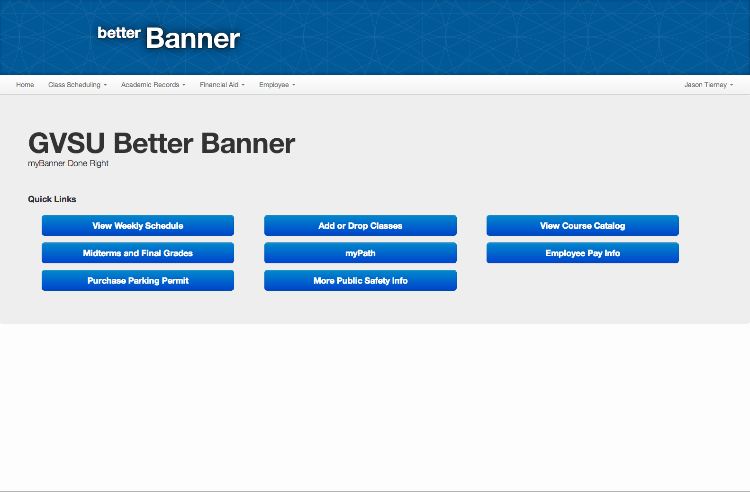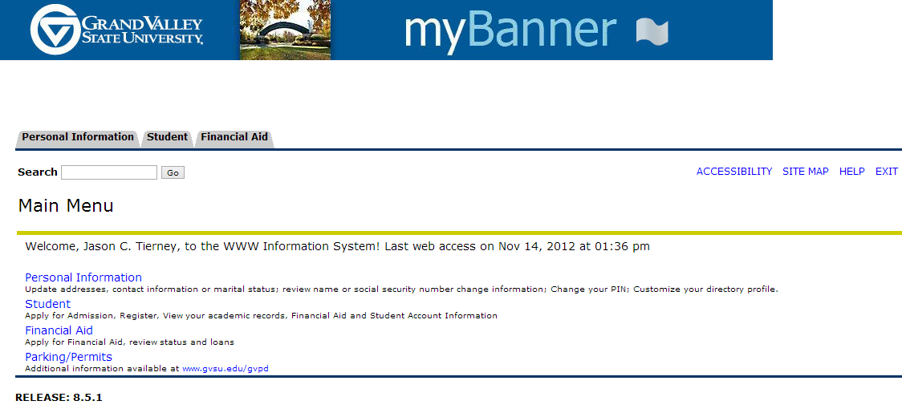

**Figure 2:** Better Banner homepage (top) compared to myBanner’s home page (bottom).

Figure 3 shows the drop-down menu system we developed for Better Banner. This navigation bar holding the drop-down menu is static and consistent throughout the entire experience. A major problem with myBanner was an unclear navigation system -- we developed this navigation system to deal this unclear navigation.

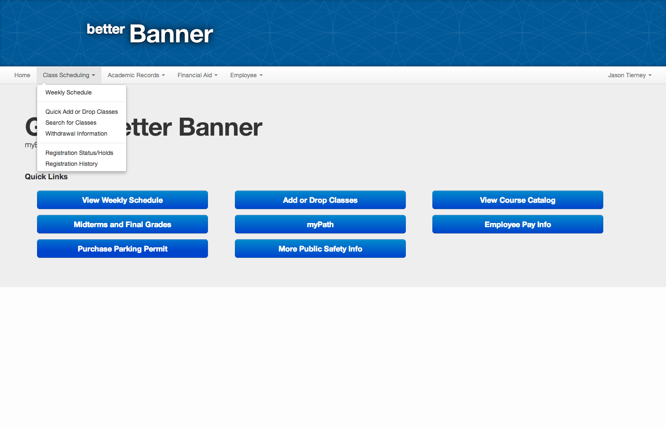

**Figure 3:** Better Banner drop-down menu system. myBanner does not implement this solution, thus we cannot provide a comparison screenshot.

Figure 4 is included to show the generic content view that will be recurring throughout the website. Notice the gray horizontal sections encasing information and the header section containing a semester combo box.

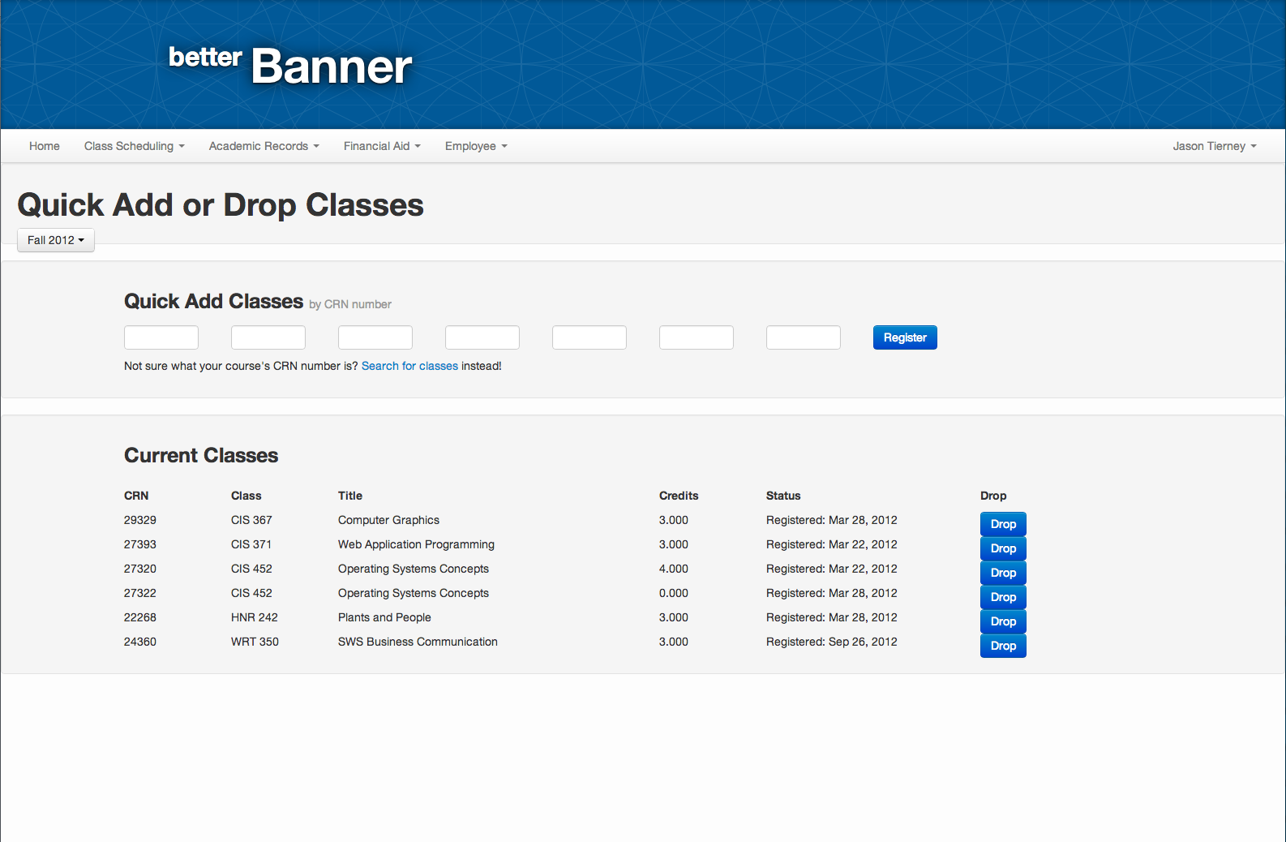

**Figure 4:** Better Banner generic content view

# Video Demo

We created a demo video of BetterBanner that lasts for about six minutes in length.

Link to screencast: <https://www.dropbox.com/s/vy2g6wsi7bqqj7r/BetterBanner.mov>

The link above is a screencast overview of the Better Banner website. In the video, I overview a lot of the general content on the website. I explain the advantages of Better Banner over myBanner and elaborate on particular design decisions we as a team made. The video does not go through every page of the website, since that would consume a considerable amount of time, but it does explain all pertinent information regarding the usability and user interaction of the website.

The screencast was made with the default Quicktime screencast tool on Mac OS X.

# Design Highlights

This sections serves to point out design elements we as a team were particularly proud of. This section will not discuss basic design elements, but instead will focus on a few important design constructs. We feel this particular design constructs were essential to the success of our website. These design highlights will also focus on the improvement they are from the current myBanner system.

1. **Simple, elegant layout**

The current myBanner system has an incredibly ugly layout and the important information myBanner has low levels of readability because of the layout. If you look at any of the figures above, you will notice that the layout was designed to be easily readable. The one purpose of myBanner (and Better Banner now) is to present information and we wanted that information to be presented elegantly and with high levels of readability. The main factor that increased the level of readability on Better Banner was organization and consistent text sizes.

2. **Static Navigation System**

When using the current myBanner, we noticed that navigation was never consistent and the user had to navigate back to a page in order to get to a different page. We wanted all pages to be accessible from any location on the website. Thus, we created the intuitive navigation bar as seen in Figure 3. We also noticed that users had very few tasks they needed to actually complete on myBanner, so we created quick links that would allow them to navigate to those pages in one click (see Figure 2).

3. **Consistency**

The current myBanner system greatly lacks consistency. The user never knows what to expect because the outcome of actions always seem different! We wanted to alter this and implement a standard cause and effect chain where effects are always dependant on what caused them -- not a completely random variable. Consistency is also lacking in the design of the current myBanner. Different views on myBanner have different constructs instead of a generic content view (see Figure 4) like Better Banner is implementing. For every new view the user sees, we do not want them to have learn about it, we simply want them to learn one general construct and be on their way.

# Evaluation Plan

The evaluation plan is used to figure out the goals and purpose of the evaluation, the participants in the evaluation plan, how we recruit, the environment in which we want our participants to participate in, the procedures or questions we want to ask the users, and the type of data we want to collect during the evaluation. This evaluation plan should be able to be presented to an outside consultant without them needing to ask much more information regarding how we want to evaluate our users.

This evaluation plan will focus on the post hi-fidelity prototype that we made changes to after demoing to roughly 8 – 10 users. This evaluation plan also reflects the changes we have made since the hi-fidelity prototype in order to get more user feedback about these changes.

## Goal and Purpose

The goal of this evaluation plan is to determine how easy and usable the improved hi-fidelity better Banner is compared to the current myBanner. We are not testing all of the new Better Banner features and functionality that will replace the current myBanner, but instead are focusing on a few features that we believe cover the majority of the use of the current myBanner system. The features evaluated in this hi-fidelity prototype include:

* Logging in and out of Better Banner.
* Checking both midterm and final grades.
* Changing personal information
* Changing password
* Searching for classes
* Signing up for classes.

For a full list of tested functionality, please refer to the section on Implemented Tasks from Context Analysis. Although we have a large feature set with this test, we have eight specific tasks we would like users to complete that we believe adequately test the majority of the functionality of Better Banner.

To go along with our feature set, there are also several UX goals and targets we would like to track throughout this usability study. We would like to see, from a usability perspective, if the following goals are met:

* Overall ease of use of the site
* Is the navigation smooth, intuitive, and understandable to the user?
* How does the overall layout of the site appeal to users?
* Video capture of the user in order to record his/her spoken thoughts throughout the process.

The types of data we would like to collect is both qualitative and quantitative. The data will range from determining whether users are able to finish their given tasks, users evaluating (on a number scale) the ease of use of each task, and some qualitative data of the user given verbal feedback to the data collectors and facilitator.

This evaluation should not be treated as a final progress evaluation of the system. We are currently in the process of designing and this stage fits the hi-fidelity point of the design process.

## Team Roles

We would like to have four different team roles for the evaluation team for this usability study. These roles include the following:

* **Facilitator.** This role will lead the evaluation team in making sure everything is accomplished as stated in this evaluation plan. Further, they will also be in charge of communicating to the user how the usability test will be done.
* **Data collectors.** Due to the nature of this project, we believe there should be two data collectors. One data collector focuses completely on the quantitative data. The other data collector will focus on collecting the qualitative data. In this role, the collector will work with the user and ask him/her questions about how they felt the overall process was for his/her given task.
* **Supporting actor.** The supporting actor will help coordinate each task to the user. This will involve letting the user know what the task is and the purpose of the task.

## Participants

The participants for this evaluation plan should only include students from Grand Valley State University. Future studies may be done with transfer students or high school students, but this study should focus completely on GVSU students only. We would like to have 25 students participate in this usability study of Better Banner. These participants should have a diverse background with different degrees, class status, and involvement in organizations. We will also need to make sure both traditional and non-traditional students are included in the study. However, we should not include too many non-traditional students in the study as they do not completely represent the student body. We are thinking about 3-5 students should be non-traditional students. Participants should be notified that the study should not take more than 30 minutes.

We would like to pay the participants with a $25 VISA gift card. The total cost for this should be $625 ($25 * 25 participants). In addition to the twenty-five standard students, we would also like to recruit five additional “expert” students. These students will need to qualify for being “experts” with myBanner. Participants who believe they are experts will take a brief quiz about the current myBanner and based on those who have the highest score and further match the criteria stated above, we will select five students to be our expert users. These users will be used to determine how the power users would normally use myBanner and if there are certain features in our current hi-fidelity prototype that may be broken from the current myBanner. Incentives to recruit these students are the same as normal students. A $50 VISA gift card. This would bring the total incentive cost to $875.

In order to get the word out to students to participate, we plan on sending out e-mail invitations, flyers around campus, and word of mouth. Students will be able to sign up on an online system to register to be a participant. From this online system, twenty-five users will be selected based on the above criteria.

## Environment

We would like to have a very safe, secure, and relatively quiet environment. When we refer to safety and security, we simply mean we would like our users to feel at ease and stress free while taking the usability test. There should only be one participant in a room at a single time. A small conference room that holds five people should suffice. This room should include the facilitator, the two data collectors, and the supporting actor. However, the data collectors should not interact as much with the user throughout the study and should be more viewers than participants.

For equipment purposes, we require a laptop with a minimum Core 2 Duo (or equivalent) processor, a 15 inch screen or larger, and an external mouse. The Better Banner website will be hosted on an external server, so an Internet connection will also be required. This connection can either be wired or wireless, but it must be reliable for the test to be successful. As we will be recording users during the test, we will also require a video camera. This video camera can either be attached to the laptop or external.

## Procedures

This section discusses the different procedures that each participant will follow for his test. Every participant will use the same procedures for each test. Procedures include welcoming statements, test scenarios, informed consent forms, and possibly non-disclosure agreements, if needed. These documents are included in the appendix section of this document and are briefly discussed in this section.

### Welcome Dialog

Every participant should be given the same (or very similar) welcome dialog. The exact phrasing does not need to match the welcome dialog presented in the appendix exactly, but it should adhere to it as close as possible. The purpose of this welcome dialog is to discuss with the user the purpose of the test, that they are not being test (the software is), and that the information collected will be used in a final report. If participants do not wish to have their information collected, we may still perform the usability test, but their data cannot be used.

### Informed Consent Form

Every usability participant will be given an informed consent form. This form is included in the appendix for use with participants. Every participant which we use data for must sign this form in order for his/her data to be included in the report. It is vital that we make sure users sign this form and give us permission to use their data before we actually present it in the data analysis and final report.

### Test Steps

The user will be presented with eight user tasks. These tasks try to represent typical use of the Better Banner system to the best of our ability. The following tasks we will present the user are as follows. (Note: these are also included in the appendix with further information.

1. Log into Better Banner with the GNumber g1234567 and the password 1234.
2. Your current Better Banner password isn’t very secure. Please change your Better Banner password to something stronger.
3. After changing your Better Banner password you realize your Network password has been the same for a long time. Please update your Network password to something new.
4. View your Weekly Schedule for Fall 2012
5. You and a friend are both taking BIO 230 this semester. However he is already signed up for section 01, try to register before the class fills up.

NOTE: if a time conflict occurs please drop the conflicting class and re-register.

1. What was your lowest midterm grade in Fall 2012?
2. Do you have any Holds on your account?
3. Log out of Better Banner

Each of these tasks are included in the task data collection form provided in the appendix. This form will include task completion and evaluator comments regarding how the user went about completing each task or why the user failed completing a task. How this form is used in collecting data from the user is discussed in more detail in the Data Gathering section.

### End of Participant Study Results

At the end of the study, each participant will receive a brief survey of five questions. This survey will help with analyzing the overall opinions users have about the Better Banner system. This survey is included in full text in the appendix section and is discussed in further detail in the Data Gathering section.

## Data Gathering

Data is very important for this usability test. In order to make sure we accurately collect user information, we want to make sure that the data we collect accurately represents users’ feelings towards Better Banner.

### Collecting the Data

Every task will include the same type of feedback in order to maintain consistency between tasks and participants. These results should be stored in an Excel spreadsheet. An example template of this spreadsheet is provided in the appendix. This form helps evaluate the task and user’s ability to complete the task. Each task is given a success/failure column as well as an evaluator’s comments column. The former of these two columns should only contain a simple Yes/No answering whether the user successfully completed the task. The latter column should contain comments that the evaluator makes regarding how the user went about completing each task. If the user failed to complete the task, the reason should be noted in this column.

The following questions should be discussed at the end of every task. Some of these will be included in the task data collection form, while others are to be completed in the end of study survey.

* Did the user successfully complete the task? (Simple Yes/No - Quantitative)
* Evaluator comments on user completion of tasks. (Qualitative)
* User comments on ease of completing the task. (Qualitative)
* User rating of ease of completing the task on a scale of 0 - 5 (0 = did not complete, 5 = easy to complete).

At the end of each participant study, we will have a survey (the full text version of this survey is included in the appendix section). This survey will allow users to further evaluate the Better Banner experience and let us know what they believe was good, bad, better, or worse than the current myBanner. These questions are more on the qualitative side of the data collection. However, they also provide insight as to how the user feels about the overall experience of Better Banner, specifically in regards to the current myBanner.

### Summarizing and Analyzing the Data

We would like all of the data to be summarized and analyzed in a manner that will give us real world results when moving up from the hi-fidelity prototype. This section covers how we would like the data to be summarized and analyzed for this evaluation. It is crucial for the data to be properly analyzed in order for this evaluation to be a success.

Data should be summarized in order to determine the overall success of both participants and tasks in general. We would like to have an average, median, and mode of each feedback question at the end of each task. Further, each task should be rated based on its level of success. We would like to have all of this data summarized in an Excel spreadsheet or similar format. We provide some examples of the data we want to collect and how we want it summarized below.

**Success of Participants.** The success of participants completing the individual tasks is recorded as raw data under the task success column in the data collection form. We would like this data to be summarized by each task with the following information for each task:

* Mean and Median of the data.
* Ordered by highest number of completion to lowest number of completion.
* Outliers in regards to participants – were there any participants that just seemed to not be able to accomplish a specific task while others were able to without any trouble?
* Task outliers – were there any tasks that seemed like most users could not accomplish?

**Evaluator Comments on Tasks.** This section of data defines the more qualitative data that we are collecting. This data is collected on the data collection form in the task comments column. This should not be confused with the comments users make in the post-study survey. In regards to comments for each task, we would like to have this data summarized as follows:

* Do not include redundant tasks – instead add a counter to each task depending upon how many users made a similar comment.
* Sort out outliers. If there are any outliers in the comments, such as “user could not figure out how to change a password” where many users were experiencing this issue, we would like these noted.

**End of Study Participant Surveys.** This section of data includes all of the questions and responses to the survey participants take at the end of the study. The following provides examples of how we would like data to be summarized for this section:

* Do not include redundant comments. If there are multiple similar comments, please instead include a count of these comments in the summary.
* Include a mean and median for the 1, 2, and 4.

After the data has been collected and summarized, we will need to analyze the data appropriately in order to get conclusive results. We would like to analyze the data in order to determine whether we have produced a successful hi fidelity prototype. This may include whether tasks have been determined to be overall easy to complete for the average user, whether the data was accurately predicted from the beginning. As with the summary of data, we would like the data analysis to be broken up into similar categories. These three categories are explain in detail below.

**Success of Participants.** After looking through the summary of the data, we should start to look at specific tasks and figure out possible reasons users were unable to complete these tasks. For example, was the option not in the navigation bar?

**Evaluator Comments on Tasks.** Looking through these, we should be able to determine any outliers from the summarized data and come up with some analysis of why the outliers existed.

**End of Study Participant Surveys.** Again, what do the outliers represent in the surveys collected from the users. Are there any major issues that need to be addressed before a more final version of Better Banner is created?

Jordan Carney | Caleb Gomer | Jason C. Tierney | Nick Workman

Apple ink | Version: November 19, 2012



A replacement for the GVSU myBanner system.

Appendix



# Informed Consent Form

Welcome to the Better Banner usability study! We thank you and appreciate you taking the time to try out the latest Better Banner system which may soon replace the current myBanner. Before you begin the evaluation portion, we would like to state some information regarding the use of your data, your rights to that data, and the type of data collected. We would also like to point out that there are no foreseeable risks involved in completing this usability study.

As a participant of this usability study, you will receive a $25 Visa gift card. This gift card can be used anywhere that Visa cards are accepted. This is the only compensation you will be given for completing this usability study. If you are designated as an expert user, you will be provided a $50 gift card. However, you only get one of these two payment options, not both.

In regards to the data we collect about you. All of the data is collected anonymously and we will not share the data without your explicit consent. Your consent for sharing this data is your signature at the bottom of this form. With your consent, we will include your anonymous data into a final usability report on Better Banner. Your data will not be shared with any other third party and will only be used in the report. Again, we would like to point out that all data is collected anonymously and your name, nor any other identifying information, will be used to identify you.

Throughout the usability study we may record you to get your feedback about the process you go through to accomplish the steps. This data will not be released to any third-party and will only be seen, accessed, and used by those directly involved in this usability study. If we do intend to use this video for any other purpose, we will ask you for permission and only use it with your permission.

If you agree to these terms, please write your name and sign below. Thank you, and again, we appreciate your time in evaluating Better Banner.

**The Better Banner Team**

Printed Name

Signature / Date



# Standard Welcome Dialog

**Every user should be given a standard welcome dialog that follows the following format. Note, the welcome dialog does not have to match word for word, but should include most of the common elements.**

Welcome to the Better Banner usability experience study! We hope you will enjoy yourself while you try out the new Better Banner system which may replace myBanner in the future.

We would like to remind you that although this is a “test” we are not testing you, but are instead testing the software we have created. Feel free to try to break it, play with it, and use it like you normally would.

We will provide you with a set of eight tasks for you to complete. Do not worry if you cannot complete some of the tasks, it just means our design is not 100% up to par yet. As you progress through each task, please feel free to express aloud the thought process you had. Note any oddities you found or improvements you believe could be made.

Before continuing, we would like you to sign a informed consent form in order for us to use your data in our usability report. We will only use your data anonymously and will not sell or give it away to third parties. Please take a few minutes to look this over and then sign it if you agree with the terms.

# Example Data Collection Table

The table below is a sample table that can be used to collect data for different participants. Each participant’s name is provided in the participant section. Each task has a success and comments column. The success column represents whether the user finished the task. This is simply a Yes/No response. The comments section is any comments the user made or what the evaluator noticed while the user was performing the task.

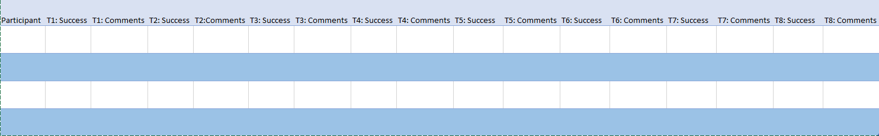



# End of Participant Study Survey

Thank you for participating in this usability study of Better Banner. To further help with this study, we would ask that you participate in this survey regarding your experience with Better Banner. This survey should only take about 5 minutes and we appreciate all of your responses.

1. **Rate from 0 – 5 (five being the best): Better Banner was an attractive website.**

< 0 1 2 3 4 5 >

1. **Rate from 0 – 5 (five being the best): Navigation was easy and intuitive and made finding the pages I needed to get to very easy.**

< 0 1 2 3 4 5 >

1. **Do you have any opinions regarding the navigation of Better Banner? Be as open as possible, we can take the heat!**
2. **Please rate your overall experience with Better Banner compared to the current myBanner. (0 = Better Banner was much worse than myBanner, 5 = Better Banner was way better than myBanner).**

< 0 1 2 3 4 5 >

1. **Please note any comments you have regarding the Better Banner system compared to myBanner. Was the overall experience better or worse for you?**



# myBanner Expert Analysis Questionnaire

The following questionnaire will be used to assess your level of expertise of myBanner. If you would like to be selected for a expert myBanner user in the Better Banner usability study, you must fill out this questionnaire. Successful candidates will be contacted of their access to the study. If you are applying to be a standard user, you do not need to take this questionnaire.

1. **How many semesters have you used myBanner?**
2. **Please explain the process of signing up for new classes in myBanner. Please be as detailed as possible and explain the methods you chose and why.**
3. **How would you use myBanner to get a parking pass? Please explain in detail the process and steps you would take.**
4. **How often do you use myBanner in a month?**
   1. 0
   2. 1 – 2 times / month
   3. 3 – 4 times / month
   4. 5 – 6 times / month
   5. > 6 times / month
5. **Why do you believe you should be considered for the expert user analysis in the Better Banner usability study?**