Web Designing Requirements:

HTML ---Design

CSS – Cascaded Style Sheets

JS – Scripting language  
Validation, Functionality

It is a mutli paradigm Programming

HTML --- Design

XML -- Data store

Ctrl +U --- View page source

Ctrl+shift +I ---web developer tools

Request 🡪Web request :Google.com

<Https://www.google.com/>

Client :HTTPS request

Browser : format :protocol =rules

Hyper text transfer protocol

Web page : Website

Meta Data == Data about data

<https://html.spec.whatwg.org/>

DOM -Document Object Model

HTML Represents web page

HTML = Wb page

DOM Connects web pages to script or programming languages

DOM= represents HTML with scripting/programming

The **Document Object Model** (**DOM**) connects web pages to scripts or programming languages by representing the structure of a document—such as the HTML representing a web page—in memory. Usually it refers to JavaScript, even though modeling HTML, SVG, or XML documents as objects are not part of the core JavaScript language.

The DOM represents a document with a logical tree. Each branch of the tree ends in a node, and each node contains objects. DOM methods allow programmatic access to the tree. With them, you can change the document's structure, style, or content.

Nodes can also have event handlers attached to them. Once an event is triggered, the event handlers get executed.

Object -Physical Entity or Real time entity

Class – Logical entity

Actions – Functions /Methods

DOM:

Document --- HTML Document

Object Modeling =Sampling=Data

**The Document Object Model (DOM) is a programming interface for web documents.** It represents the page so that programs can change the document structure, style, and content. The DOM represents the document as nodes and objects; that way, programming languages can interact with the page.

VIDEO2:

DOM

Dynamically access and update the content, structure and style of a Document

React js

<https://codepen.io/>



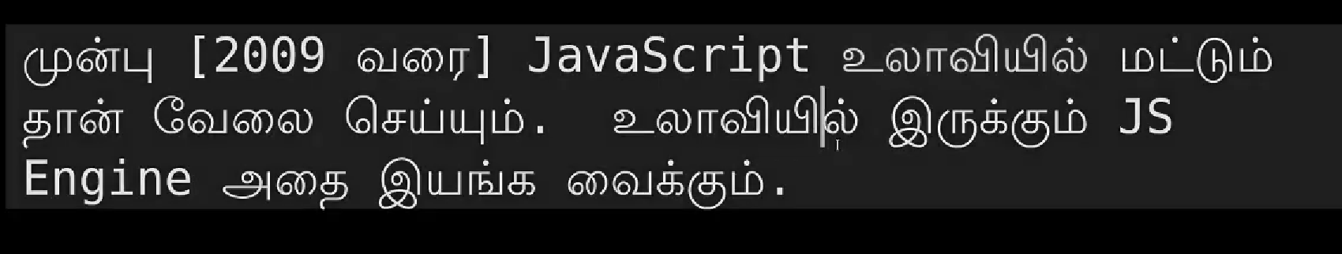

<https://www.npmjs.com/package/react-image-gallery>

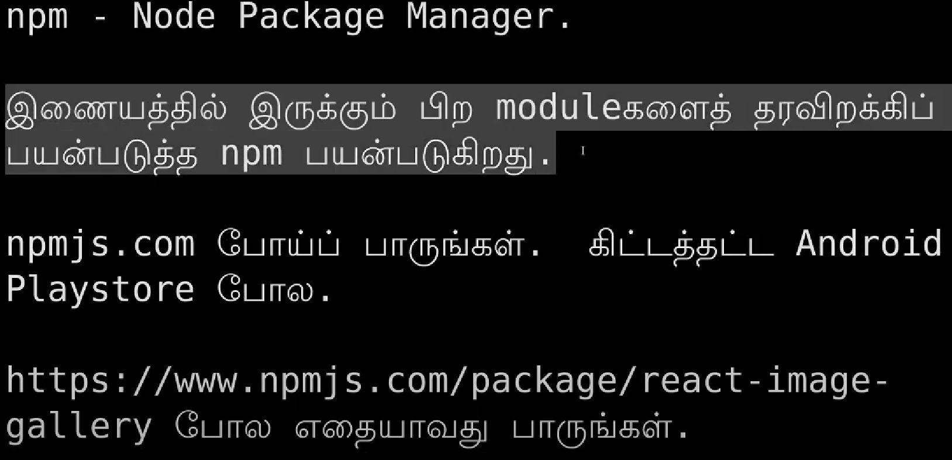

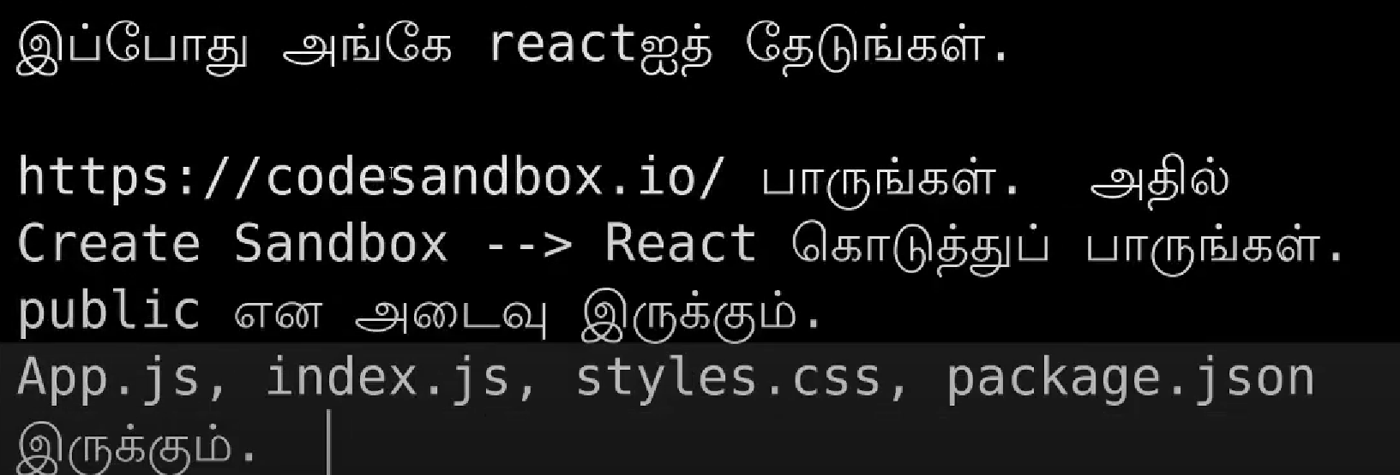

<https://codesandbox.io/>

Main purpose of react is single page web application like facebook.

