1. Goods Consignment from (Exporter's business, name, address, country) |  |  | 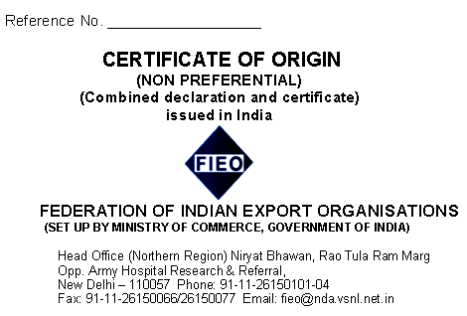
2. Goods consignment to (Consignee's name, Address, country)

3. Means of transport and route (as far as known) |  |  | 4. For official use
5. Item Number | 6. Marks and number of packages | 7. Number and kind of packages, description of goods | 8. Origin criteria | 9. Gross weight or other quantity | 10, Number and date of invoices
1. | Pkgs. | ITEM, QTY., RATE AND VALUE MENTIONED IN THE COMMERCIAL INVOICE NO.  DATED  CONTRACT NO.  DOCUMENTARY CREDIT NUMBER  DATED | INDIAN | Gross Wt.  Kgs. | COMMERCIAL INVOICE NO.  DATED
11. Certification  It is hereby certified, on the basis of control carried out, that the declaration by the exporter is correct. |  |  | 12. Declaration by the exporter-  The undersigned hereby declares that the above details and statements are correct; that all goods are produced in India and that they comply with the origin requirements of exports to xxxxxxxxx (Importing country)
New Delhi - Place and date signature  and stamp of authorized signatory. |  |  | New Delhi – xx.xx.xxxx - Place and date signature of authorised  signatory

PROCEDURE FOR ISSUE OF CERTIFICATE OF ORIGIN

1. CERTIFICATE OF ORIGIN ON REGULAR BASIS  For obtaining Certificate of Origin on regular basis, exporters are required to furnish a Permanent Indemnity Bond on a stamp paper of Rs.50/- duly attested as per format given below :  “The Director General  Federation of Indian Export Organisations  New Delhi.  Dear Sir,  In consideration of the Federation of Indian Export Organisations, New Delhi and its Regional Offices from time to time, giving or Authenticating Certificate of Origin, legalizing Invoices and other documents in respect of goods for exportation by  (Name and Address of Shippers)  We hereby certify that all particulars contained in Invoices or other documents presented to the Federation by us in our name for their certification or authentication or legalisation shall be true and accurately set forth, and further that we shall at all times, INDEMNIFY and keep indemnified the Federation and its officials against all claims and demands that may at any time be made against them or any of them by reason of issuing or authentication or legalisation of such certificates, invoices and other documents as aforesaid.  Yours faithfully,  (Signature & Rubber Stamp of the Shippers)  Place:  Dated:  Witness: 1. ______________  2. ______________ | 2. CERTIFICATE OF ORIGIN ON  INDIVIDUAL SHIPMENT BASIS  Exporters wishing to obtain Certificate of Origin on specific/individual shipment basis will be required to submit an Indemnity Bond on a stamp paper of Rs.10/- duly attested as per format given below :  “The Director General  Federation of Indian Export Organisations  New Delhi.  Dear Sir,  In consideration of your signing the Certificate of Origin, and prices, at our request for the under-mentioned shipment to (place), to the effect that the goods are the produce or manufacture of the Republic of India and that the prices shown against them are correct, we hereby agree to indemnify the Federation against any claim or demand that may at any time be made against the Federation by reason of the Certificate of Origin and prices having been so issued.  Yours faithfully,  (Signature & Rubber Stamp of the Shippers)  Place:  Dated:  Witness: 1. ______________  2. ______________
  Marks No. | Description  Of Goods | Name  of  Steamer | Date of Shipment  / Bill of Lading | V  A  L  U  E

3. DETAILS OF CHARGES

The schedule of charges (subject to revision without notice) are as under :

Particulars | For Members | For Non-Members
a. Certificate of Origin (8 copies)  b. Certification of Invoice (8 copies)  c. Additional copies (up to 8 copies)  d. Correction charges (per copy)  e. Certification of any other documents, like packing list  etc. (on per document basis)  f. Proforma for Certificate of Origin (for 50 sheets) | Rs.100/-  Rs.50/-  Rs.50/-  Rs.10/-  Rs.10/-  Rs.50/ | Rs.200/-  Rs.100/-  Rs.100/-  Rs.20/-  Rs.50/-  Rs.50/-
4. DOCUMENTS TO BE SUBMITTED ALONGWITH APPLICATION
- A covering letter to FIEO for issue of Certificate of Origin/Certification of copies of Invoices/Packing List, etc. The letter should also indicate that the information furnished in the relevant documents is true and correct.
- Indemnity Bond.
- 9 copies of the Certificate of Origin duly completed along with one copy of the invoice for FIEO records having following declaration:
“We hereby declare that the goods mentioned in this invoice are of Indian Origin and manufacture.”
In case copies of invoices are also required to be attested, 9 copies of the same may also be submitted with the above declaration.

