**Vendor-Wise Rejection Analysis**

**Aim:** The goal of performing **Vendor Wise Rejection Analysis** is to assess the quality performance of different vendors by tracking product rejections and identifying common issues in their supply. By analyzing rejection reasons, quantities, and pass rates for each vendor, businesses can pinpoint quality trends and areas for improvement. This analysis helps in making data-driven decisions, such as selecting reliable vendors, negotiating better contracts, or addressing recurring issues in production. Ultimately, it leads to improved product quality, reduced waste, better vendor relationships, and enhanced customer satisfaction, driving overall business efficiency and cost savings.

**KPI’s:**

1. Which vendors have the highest rejection rates?
2. What percentage of products pass QC tests?
3. Which vendors are consistently failing QC or delivering low-quality products?
4. How do rejection rates vary by product category?
5. What was the rejection reason for the product from the vendors and did it pass the QC test?
6. What are the most common reasons for product rejections?
7. What is the trend in rejection rates over time?

**Dataset Explanation:**

This is the dummy data created for performing the analysis. The dataset contains different attributes.

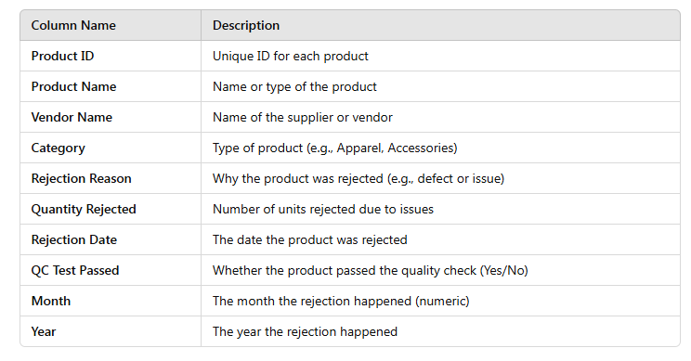

Dashboard:

