Detailed Design
for
Teamwork System
Version 1.0 approved
Prepared by Winnie/ Carson/ Mario /Sherry
Fish
2020/4/14
Table of Contents
Table of Contents ii
Revision History ii
1. Overview 1
1.1 Project description 1
1.2 References 1
1.3 Design purpose 1
2. Overall description 1
2.1 Class diagram 1
2.2 Refinements 2
3. Detailed design 2
3.1 Class diagram 2
3.2 Classes 2
3.2.1 Course 2
3.2.2 File 3
3.2.3 SubmissionItem 3
3.2.4 DivideIn 3
3.2.5 User 4
3.2.6 Teacher 4
3.2.7 Student 4
3.2.8 Member 4
3.2.9 Leader 5
3.2.10 Team 5
4. Alternative detailed design (Optional) 5
5. More considerations 5

Revision History
Name | Date | Reason For Changes | Version
Winnie/ Carson/ Mario /Sherry | 2020/4/14 | Write the whole document | 1.0

Overview

Project description
This project is for teachers to divide students into groups and calculate their contribution in group projects. It would also export the contributions of students as a file, which could be used in another grading system.

References
Architecture Design Fish version 2.0.doc

Design purpose
In this document, feature identification, visibility and constraints specification, and restructure of the class diagram are done, which makes the class interface more detailed and easy to implemented.

Overall description

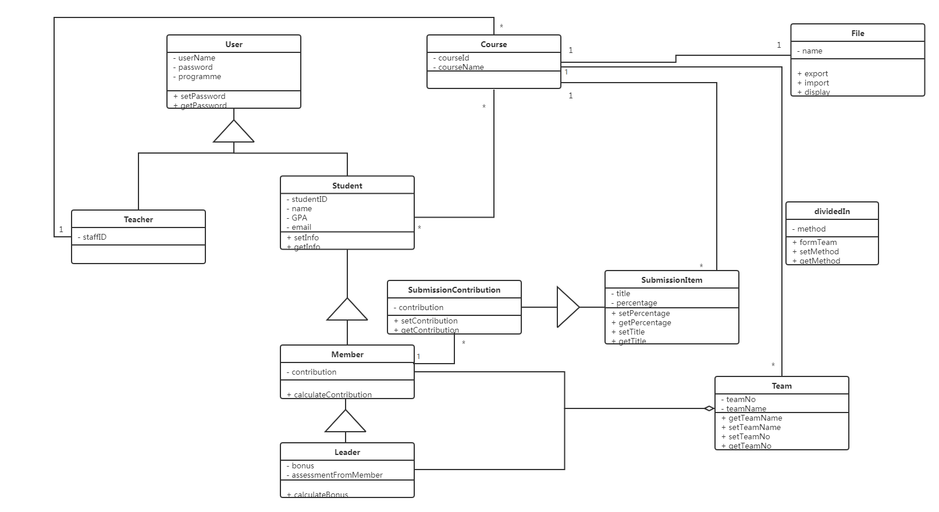
Class diagram

Refinements
In doing the detailed design, we examine each service and each participating object, and identify missing operations and attributes that are needed to realize the subsystem service. Then refine the current object design model and augment it with these attributes and operations. We also specify the range of each attribute and map the classes and attributes of the object model to built-in types related to a certain development environment. Besides, we select one operation to specify the conditions that must be satisfied before the operation is invoked and after the return of the results

Detailed design

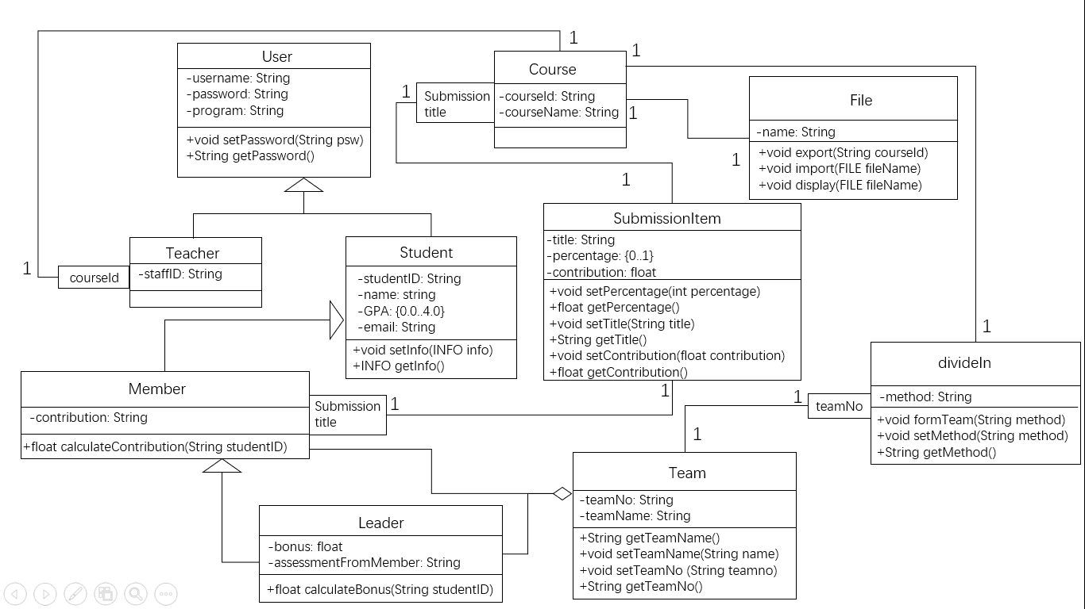
Class diagram

Classes

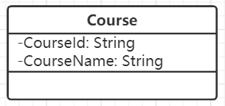
Course
Explanations
There is no attributes or operations updated. We use qualifier ‘Submissiontitle’ to reduce multiplicity between Course and SubmissionItem.

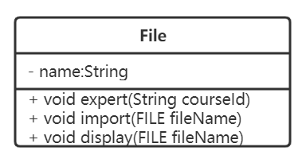
File

Explanations
There is no attributes or operations updated.

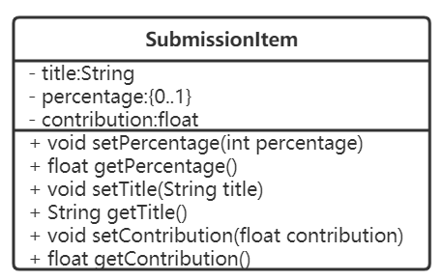
SubmissionItem
Explanations
We add the attribute ‘contribution’ and two operations, setContribution() and getContribution(), which are in class SubmissionContribution originally, which is deleted.
Constraints
setPercentage= {INVALID_INPUT, OK}
Pre-condition: the input percentage is not null
Post-condition: the return value corresponds to the following errors
1.If the input is not an integer, then return INVALID_INPUT;
2.otherwise, return OK.

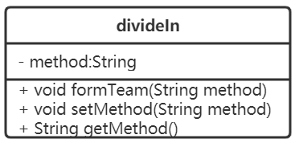
DivideIn
Explanations
There is no attributes or operations updated. We implement it as a new class and use qualifier ‘TeamNo’ to reduce multiplicity between DivideIn and Team.

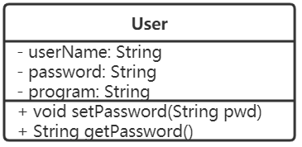
User
Explanations
There is no attributes or operations updated.

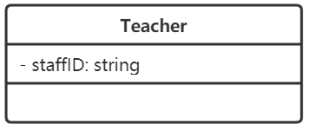
Teacher
Explanations
There is no attributes or operations updated. We use a qualifier ‘CourseId’ to reduce multiplicity between Course and Teacher.

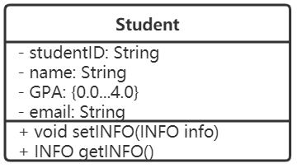
Student
Explanations
There is no attributes or operations updated.

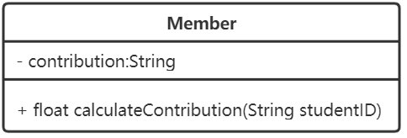
Member
Explanations
There is no attributes or operations updated. We use a qualifier ‘Submissiontitle’ to reduce multiplicity between Member and SubmissionItem.

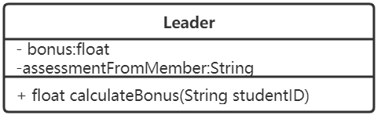
Leader
Explanations
There is no attributes or operations updated.

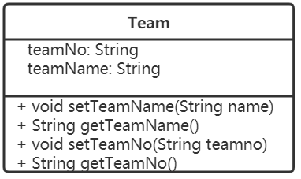
Team
Explanations
There is no attributes or operations updated.

Alternative detailed design (Optional)

More considerations
The document is intended for developers, project managers, testers and documentation writers. The Detailed Design file contains the overview, the overall description, and its main part, class diagrams. Based on the latest version of Architecture Design document, we suggest you go and read the part that is most relevant to you directly. The classes section, which explained every class with its notation with all attributes, operation signatures, and visibilities, is especially for developers to understand how to build the classes better.

