Software Requirements Specification

for
Contribution Assessment System
Version 1.0 approved
Prepared by Winnie/ Carson/ Sherry/ Mario
Fish
2020/3/6

Table of Contents
1. Introduction 1
1.1 Purpose 1
1.2 Document Conventions 1
1.3 Intended Audience and Reading Suggestions 1
1.4 Project Scope 1
1.5 References 1
2. Overall Description 1
2.1 Product Perspective 1
2.2 Product Features 3
2.3 User Classes and Characteristics 3
2.4 Operating Environment 4
2.5 Design and Implementation Constraints 4
2.6 User Documentation 4
2.7 Assumptions and Dependencies 4
3. System Features 4
3.1 System Feature 1 4
3.2 System Feature 2 (and so on) 5
4. External Interface Requirements 5
4.1 User Interfaces 5
4.2 Hardware Interfaces 5
4.3 Software Interfaces 5
4.4 Communications Interfaces 5
5. Other Nonfunctional Requirements 6
5.1 Performance Requirements 6
5.2 Safety Requirements 6
5.3 Security Requirements 6
5.4 Software Quality Attributes 6
6. Other Requirements 6

Revision History
Name | Date | Reason For Changes | Version
Winnie/ Carson/ Sherry/ Mario | 2020/3/6 | Write the SRS except section 3 and section 4.1 | 1.0

Introduction

Purpose
The document is the software requirement specification. It’s written for list all the system feature and requirement during the developing and coming usage.

Document Conventions
First level headings are 18pt big and the Secondary titles are 14pt big, both bolded. The tertiary titles are 12pt big. The font type of all the headings and titles is Times New Roman. For the contents, the font size is 11pt and the font type is Arial. The text in italics and parentheses are explanatory notes. The context model in section 2.1 and the use case diagram in section 2.2 is drawn by “Edraw” (a Graphic design software).

Intended Audience and Reading Suggestions
The document is intended for developers, project managers, users, testers and documentation writers. This SRS contains the overview section, system feature section, interface requirements and other nonfunctional requirements. Please read the overview sections and then proceed through the sections that are most pertinent to you.

Project Scope
It’s a web application which can help teachers to form teams and then assess the contributions from team members during the process of task fulfillment in a course project.

References
None.

Overall Description
This section will give an overview of the whole system, which would be explained in its context to show its operating environment and introduce the basic functionality of it.

Product Perspective
This system is a web application that would help teachers to divide students into groups and calculate their contribution in group projects. Since this system would collect information of lots of students, team and team work, the student information database and the team information database are necessary. The whole system consists of a group forming system, an assessment system, a contribution calculating system, the security system and the maintenance system to implement the functionalities of this system.
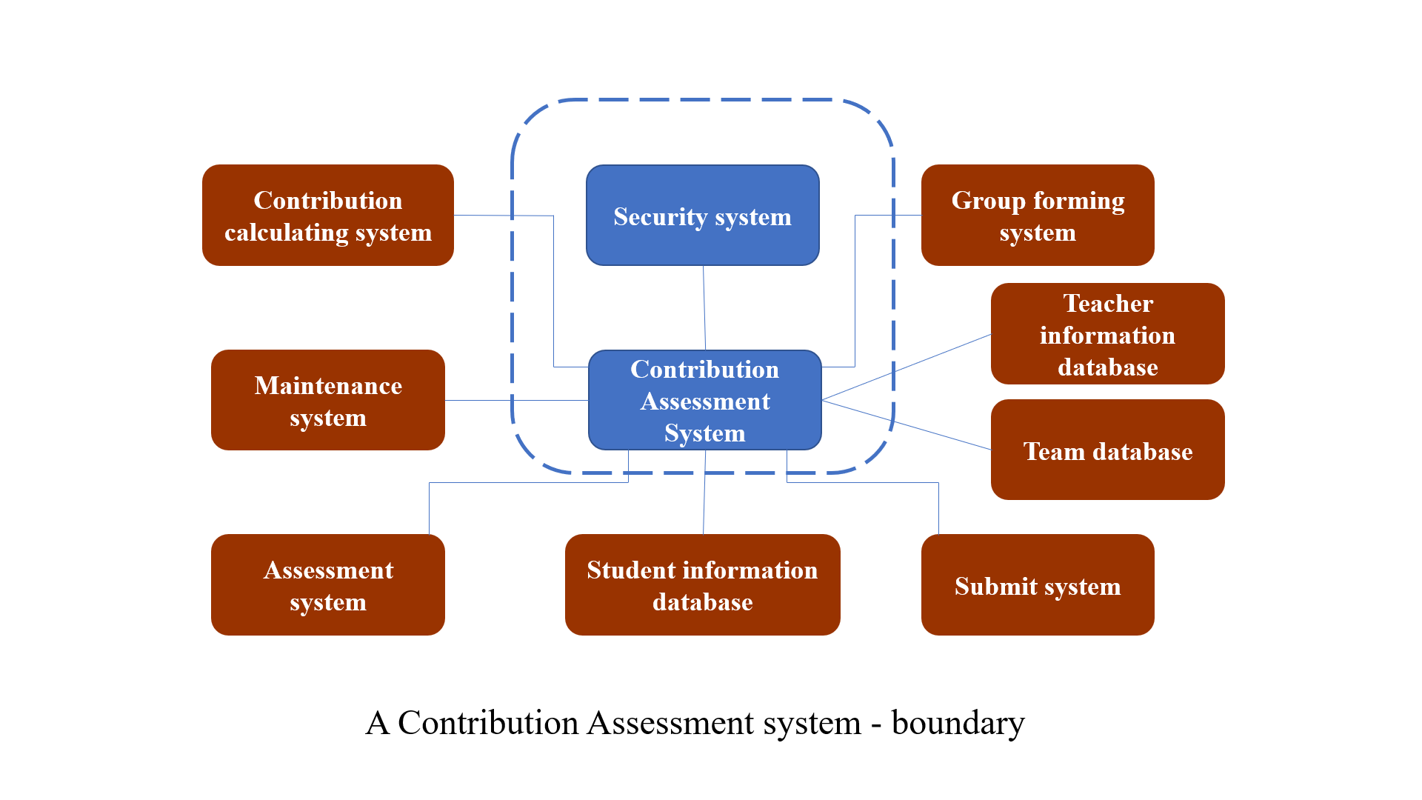
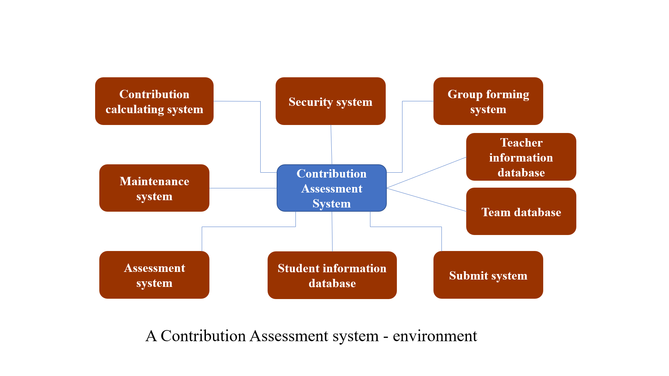

Product Features
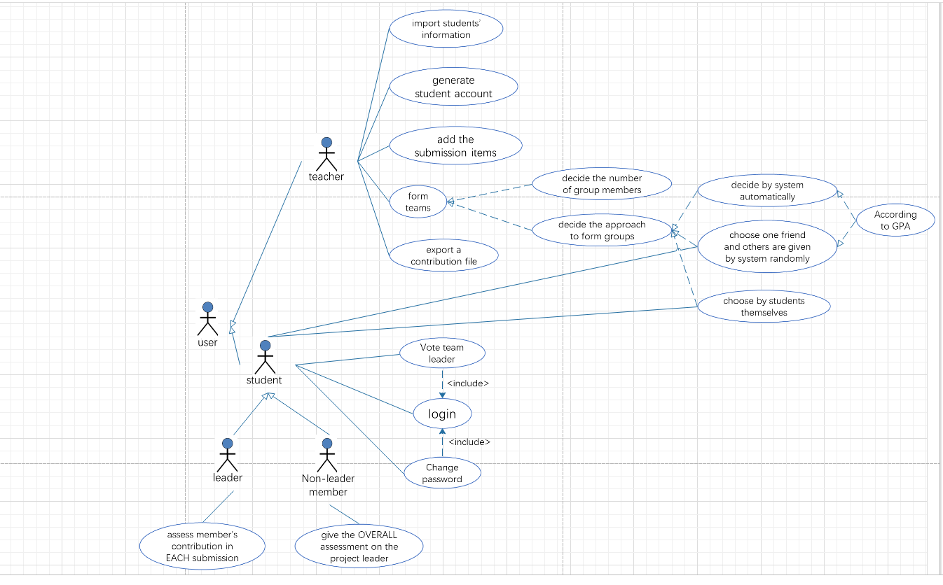
Teachers could first use this web application to divide students into groups, including deciding the number of members in one group and the approach to form groups. There are four approaches for teachers to choose, including letting students to form their group, decided by system automatically, a student choosing a friend as a group member and other members given by system randomly and divided by system according to the GPA. Also, the system would record their group information and collect their group project submission, so that teachers could be able to manage their submission in this system. Finally, teachers could export the list file of contribution of all students, which could be used in another Grading system.
User case diagram

User Classes and Characteristics
The system would have two groups of users, including teachers and students. Teachers would be able to import students’ information into the system and generate accounts and initial passwords for them. Teachers would also decide the approach and the number of members in one group to divide students into groups. They could also manage students’ submission and export the list file of students’ contribution.

Students could login the system and change their password. With permission, students may be able to form the groups by themselves or choose a friend as their group member. After the group formed, they could vote to decide a team leader. The team leaders have the right to assess members’ contribution and non-leader members have the right to assess their team leaders.

Operating Environment
It’s a web application so it would be available on many different operating systems.

Design and Implementation Constraints
Except for that students could use other public Internet when they submit their project, users need to use the Internet in the campus in most of the situations, because most of the functionalities in this system need to access to those two databases.

In order to avoid the problem that students’ information leakage, the system must insure the security of the database and develop the security system for the whole system.

User Documentation
The user documentation would consist of the user manuals, introduction of each functionality, troubleshooting section, and online help, which would include the tutorial videos that teaches user that how to use each functionality in this system. The documentation would be delivered to the user both in a hard copy and the pdf file, with the hyperlink to the tutorial webpage.

Assumptions and Dependencies
The system would be available under the assumptions that the system is permitted to access to the specific database by using the campus’ Internet.

System Features
<This template illustrates organizing the functional requirements for the product by system features, the major services provided by the product. You may prefer to organize this section by use case, mode of operation, user class, object class, functional hierarchy, or combinations of these, whatever makes the most logical sense for your product.>

System Feature 1
<Don’t really say “System Feature 1.” State the feature name in just a few words.>
3.1.1 Description and Priority
<Provide a short description of the feature and indicate whether it is of High, Medium, or Low priority. You could also include specific priority component ratings, such as benefit, penalty, cost, and risk (each rated on a relative scale from a low of 1 to a high of 9).>
3.1.2 Stimulus/Response Sequences
<List the sequences of user actions and system responses that stimulate the behavior defined for this feature. These will correspond to the dialog elements associated with use cases.>
3.1.3 Functional Requirements
<Itemize the detailed functional requirements associated with this feature. These are the software capabilities that must be present in order for the user to carry out the services provided by the feature, or to execute the use case. Include how the product should respond to anticipated error conditions or invalid inputs. Requirements should be concise, complete, unambiguous, verifiable, and necessary. Use “TBD” as a placeholder to indicate when necessary information is not yet available.>

<Each requirement should be uniquely identified with a sequence number or a meaningful tag of some kind.>

REQ-1:
REQ-2:

System Feature 2 (and so on)

External Interface Requirements

User Interfaces
<Describe the logical characteristics of each interface between the software product and the users. This may include sample screen images, any GUI standards or product family style guides that are to be followed, screen layout constraints, standard buttons and functions (e.g., help) that will appear on every screen, keyboard shortcuts, error message display standards, and so on. Define the software components for which a user interface is needed. Details of the user interface design should be documented in a separate user interface specification.>

Hardware Interfaces
This software product is applied on the website. So, all you need is a complete set of computer equipment, no other extra devices.

Software Interfaces
This software product can be applied on many different operating systems since it’s a web application. The communication is based on transfer protocol like TCP/IP and so on. The basic programming language of this software is python, it takes flask frame for the main interface.

Communications Interfaces
The student information is imported to the web as an excel file. Besides, exported contribution file will be used in another existing Grading system.

Other Nonfunctional Requirements

Performance Requirements
For real-time requirement, every search action in this software should be finished within 1 second. The system should work well in different operating systems and have consistent style and operations.

Safety Requirements
N/A

Security Requirements
User can only change their password after they login. Only the project leader has right to assess members’ contribution in each submission. The system also needs to protect users’ information, preventing message leaking.

Software Quality Attributes
This software should guarantee usability, it should be easy to use, and user manual should be provided if necessary. Reusability and maintainability should also be considered, which means the software should be easy to update and add new requirements in the future. Because the exported contribution file needs to be used in another existing grading system, the exported files must be compatible with that system.

Other Requirements
None.
Appendix A: Glossary
None.
Appendix B: Analysis Models
<Optionally, include any pertinent analysis models, such as data flow diagrams, class diagrams, state-transition diagrams, or entity-relationship diagrams.>
Appendix C: Issues List
N/A

