Software Requirements Specification

for
Contribution Assessment System
Version 2.0 approved
Prepared by Winnie/ Carson/ Sherry/ Mario
Fish
2020/3/15

Table of Contents
1. Introduction 1
1.1 Purpose 1
1.2 Document Conventions 1
1.3 Intended Audience and Reading Suggestions 1
1.4 Project Scope 1
1.5 References 1
2. Overall Description 1
2.1 Product Perspective 1
2.2 Product Features 2
2.3 User Classes and Characteristics 3
2.4 Operating Environment 3
2.5 Design and Implementation Constraints 3
2.6 User Documentation 3
2.7 Assumptions and Dependencies 3
3. System Features 3
3.1 Login 3
3.2 Import students’ info, including students’ account generation 4
3.3 Edit submission items 5
4. External Interface Requirements 6
4.1 User Interfaces 6
4.2 Hardware Interfaces 10
4.3 Software Interfaces 10
4.4 Communications Interfaces 10
5. Other Nonfunctional Requirements 11
5.1 Performance Requirements 11
5.2 Safety Requirements 11
5.3 Security Requirements 11
5.4 Software Quality Attributes 11
6. Other Requirements 11

Revision History
Name | Date | Reason For Changes | Version
Winnie/ Carson/ Sherry/ Mario | 2020/3/6 | Write the SRS except section 3 and section 4.1 | 1
Winnie/ Carson/ Sherry/ Mario | 2020/3/15 | Write section 3 and section 4.1, modified section 1.3, 2.1, 2.2, 4.2. | 2

Introduction

Purpose
The document is the software requirement specification. It’s written for list all the system feature and requirement during the developing and coming usage.

Document Conventions
First level headings are 18pt big and the Secondary titles are 14pt big, both bolded. The tertiary titles are 12pt big. The font type of all the headings and titles is Times New Roman. For the contents, the font size is 11pt and the font type is Arial. The text in italics and parentheses are explanatory notes. The context model in section 2.1 and the use case diagram in section 2.2 is drawn by “Edraw” (a Graphic design software).

Intended Audience and Reading Suggestions
The document is intended for developers, project managers, users, testers and documentation writers. This SRS contains the overview section, system feature section, interface requirements and other nonfunctional requirements. Please read the overview sections and then proceed through the sections that are most pertinent to you. The system feature section which explained the features of the system is especially for users to understand the system better.

Project Scope
It’s a web application which can help teachers to form teams and then assess the contributions from team members during the process of task fulfillment in a course project.

References
None.

Overall Description
This section will give an overview of the whole system, which would be explained in its context to show its operating environment and introduce the basic functionality of it.

Product Perspective
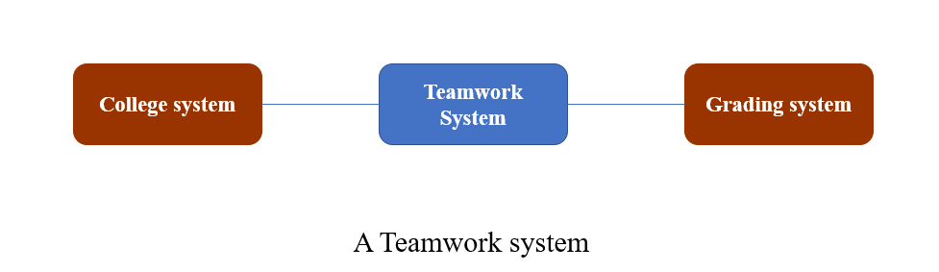
This system is a web application that would help teachers to divide students into groups and calculate their contribution in group projects. Since this system would collect information of lots of students, team and team work, the student information database and the team information database are necessary. The whole system consists of a group forming system, an assessment system, a contribution calculating system, the security system and the maintenance system to implement the functionalities of this system.

Product Features
Teachers could first use this web application to divide students into groups, including deciding the number of members in one group and the approach to form groups. There are four approaches for teachers to choose, including letting students to form their group, decided by system automatically, a student choosing a friend as a group member and other members given by system randomly and divided by system according to the GPA. Also, the system would record their group information and collect their group project submission, so that teachers could be able to manage their submission in this system. Finally, teachers could export the list file of contribution of all students, which could be used in another Grading system.
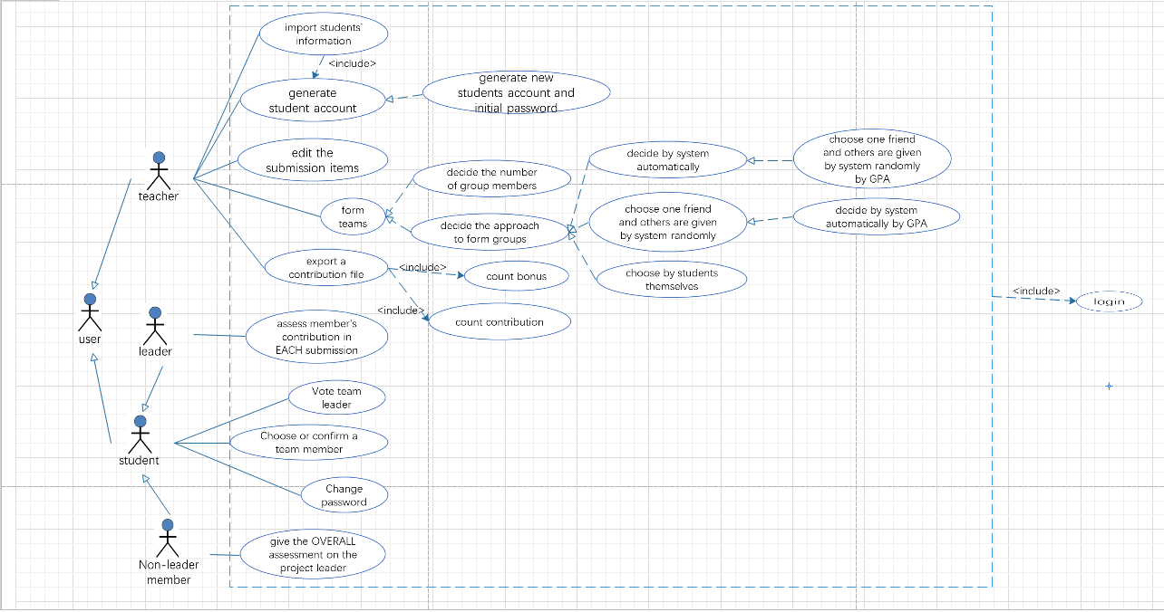
User case diagram

User Classes and Characteristics
The system would have two groups of users, including teachers and students. Teachers would be able to import students’ information into the system and generate accounts and initial passwords for them. Teachers would also decide the approach and the number of members in one group to divide students into groups. They could also manage students’ submission and export the list file of students’ contribution.

Students could login the system and change their password. With permission, students may be able to form the groups by themselves or choose a friend as their group member. After the group formed, they could vote to decide a team leader. The team leaders have the right to assess members’ contribution and non-leader members have the right to assess their team leaders.

Operating Environment
It’s a web application so it runs on a server, accessible by browsers.

Design and Implementation Constraints
Except for that students could use other public Internet when they submit their project, users need to use the Internet in the campus in most of the situations, because most of the functionalities in this system need to access to those two databases.

In order to avoid the problem that students’ information leakage, the system must insure the security of the database and develop the security system for the whole system.

User Documentation
The user documentation would consist of the user manuals, introduction of each functionality, troubleshooting section, and online help, which would include the tutorial videos that teaches user that how to use each functionality in this system. The documentation would be delivered to the user both in a hard copy and the pdf file, with the hyperlink to the tutorial webpage.

Assumptions and Dependencies
The system would be available under the assumptions that the system is permitted to access to the specific database by using the campus’ Internet.

System Features

Login
3.1.1 Description and Priority
The login page for teachers and students. After login, system should display different main pages for them.
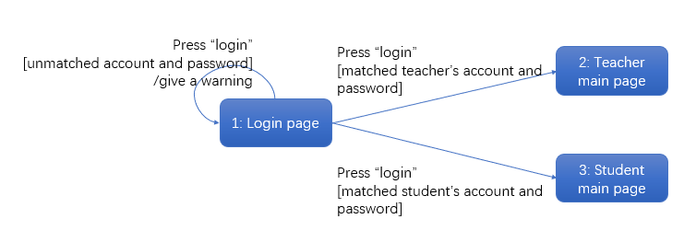
3.1.2 Stimulus/Response Sequences
3.1.3 Functional Requirements
REQ-1: Type in the account and password, and press “login”. If the account and password match, the user successfully logs in and goes to the specific main page. Otherwise, a warning will be given.
REQ-2: TBD

Import students’ info, including students’ account generation
3.2.1 Description and Priority
The Students’ information import page can be visited from teacher’s main page. The information is imported as an excel file. Then the teacher can go to the User names and password generation page to generate user names and their initial passwords for students in the list.
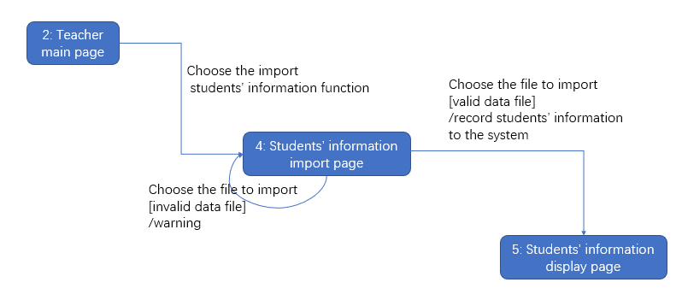
3.2.2 Stimulus/Response Sequences
3.2.3 Functional Requirements
REQ-1: Choose the file for import. If the file is valid, information is recorded to the system successfully. Otherwise, a warning will be given.
REQ-2: Choose the student in the list to generate their user names and initial passwords.
REQ-3: TBD

Edit submission items
3.3.1 Description and Priority
The Submission items page is for teachers to edit the submission items of the course.
3.3.2 Stimulus/Response Sequences

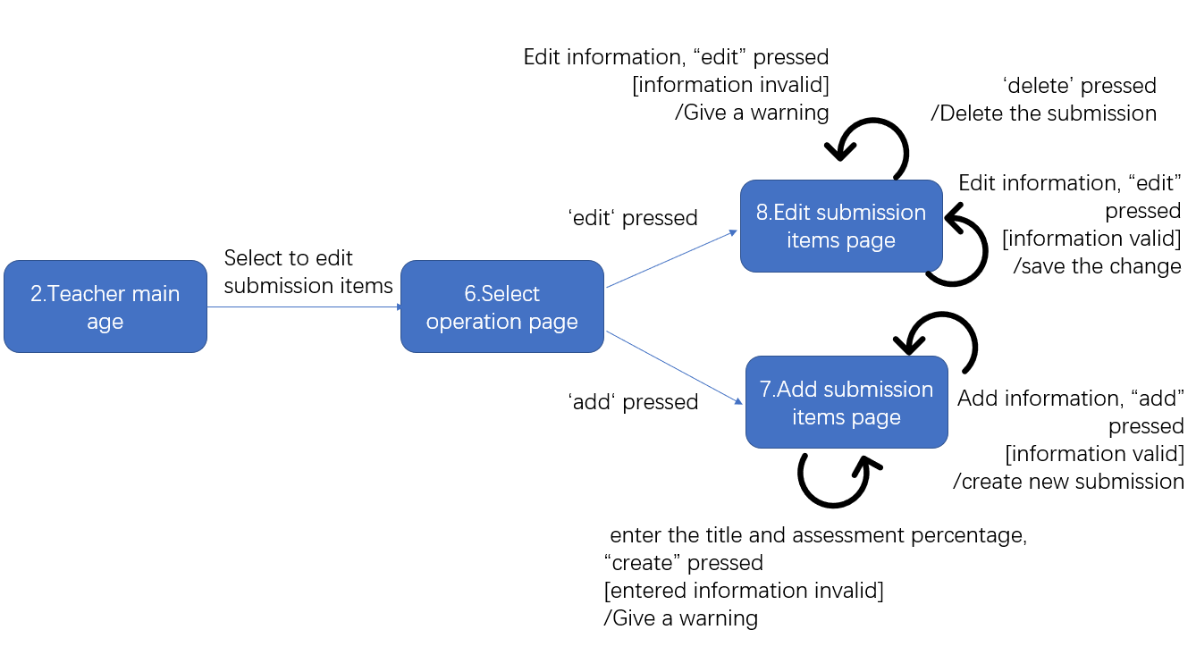

3.3.3 Functional Requirements
REQ-1: Teacher enters the title and assessment percentage, and press “create”. If the information is complete, a new submission is created. Otherwise, a warning will be given.
REQ-2: Teacher selects a submission, and press “edit”. Then he enters the information which need to be changed, and press “save”. If the entered information is valid, the change will be saved in that submission. Otherwise, a warning will be given.
REQ-3: Teacher selects a submission and press “delete”. The selected submission will be deleted.
REQ-4: TBD

External Interface Requirements

User Interfaces

Login
Different role has different webpage after inputting correct username and password. If the information is wrong, it will give a warning.
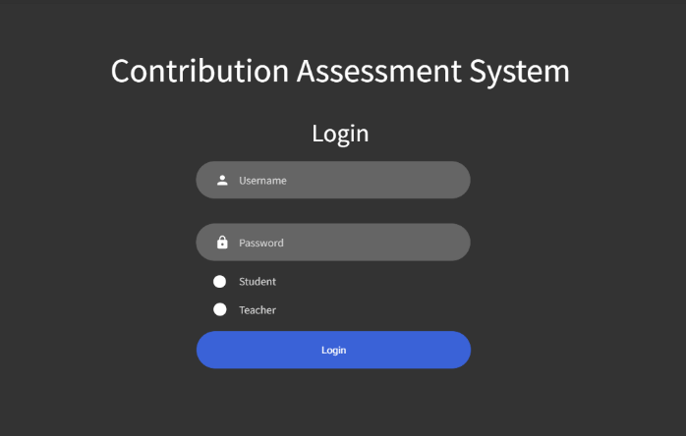

Teacher Page
The teacher page displays some operation choice(Import file, edit submission).

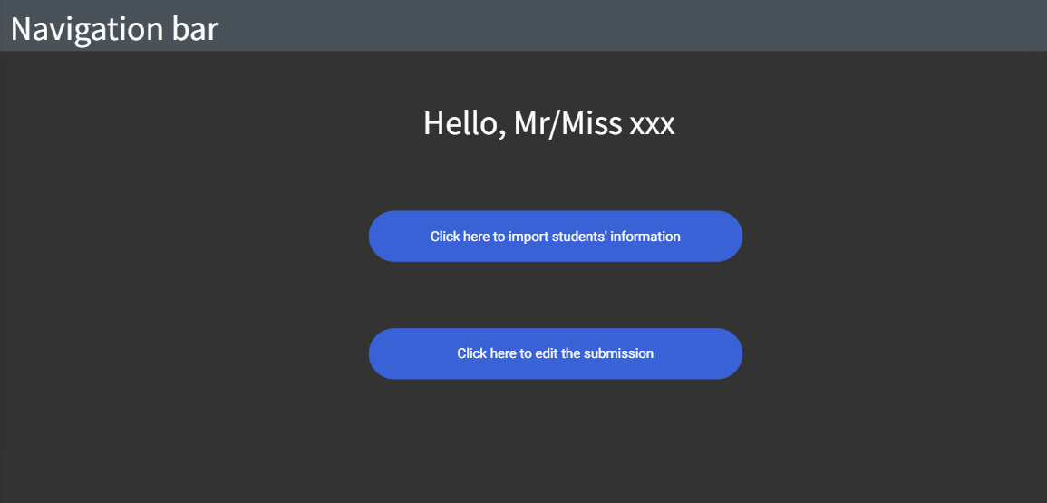

Student Page
The student page displays basic information about the student.
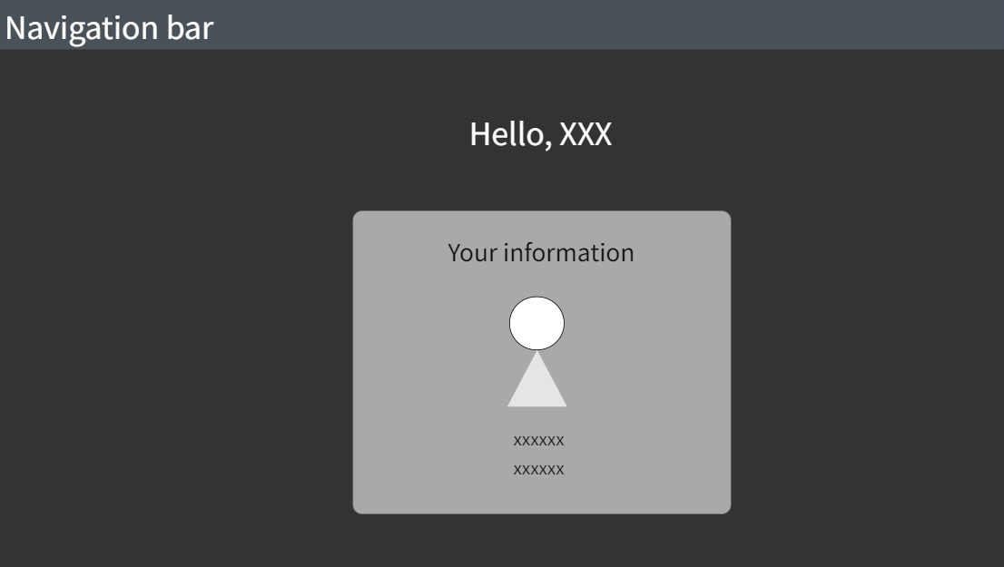

3 student main page

Import File page
This page allow teacher to import student information in excel file.

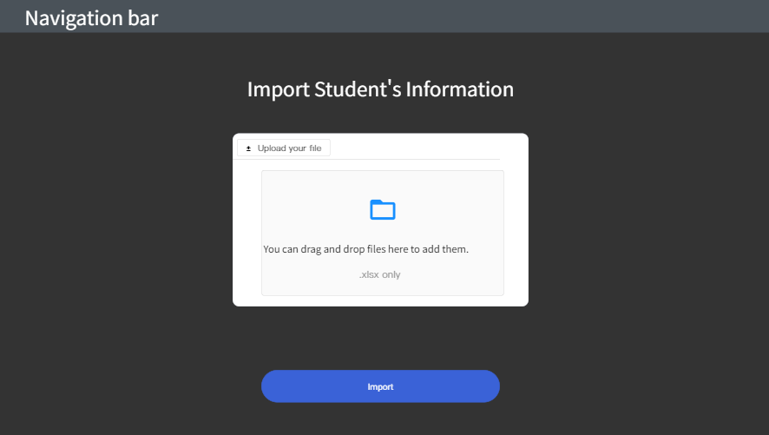

4 students' information import page

Student Information Display Page
This page displays the success of importing, give all imported student information and generate students’ password.

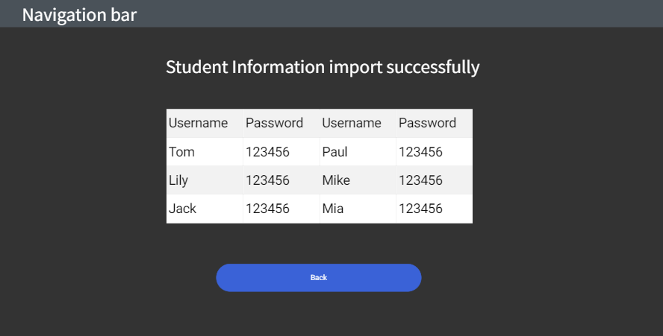

Select operation of submission page
This page allow teacher to add or edit the submission

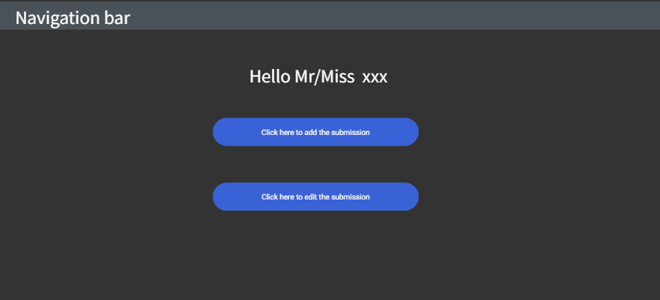

Add submission page
This page allow teacher to add the submission.

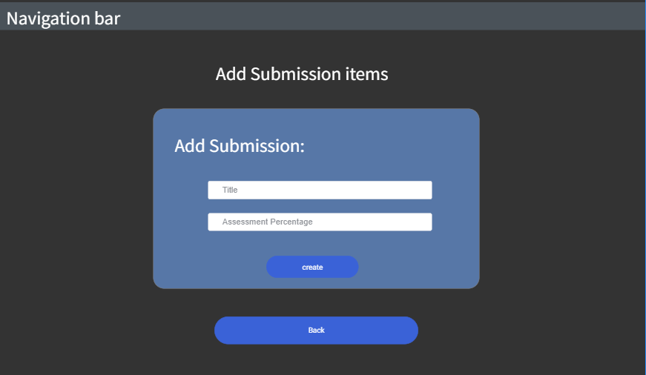

Edit submission page
This page allow teacher to edit the submission. The previous submission will be displayed on the page.

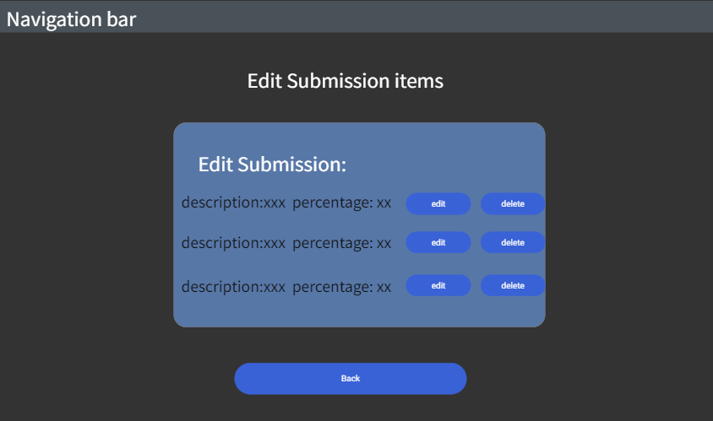

Hardware Interfaces
None.

Software Interfaces
This software product can be applied on many different operating systems since it’s a web application. The communication is based on transfer protocol like TCP/IP and so on. The basic programming language of this software is python, it takes flask frame for the main interface.

Communications Interfaces
The student information is imported to the web as an excel file. Besides, exported contribution file will be used in another existing Grading system.

Other Nonfunctional Requirements

Performance Requirements
For real-time requirement, every search action in this software should be finished within 1 second. The system should work well in different operating systems and have consistent style and operations.

Safety Requirements
N/A

Security Requirements
User can only change their password after they login. Only the project leader has right to assess members’ contribution in each submission. The system also needs to protect users’ information, preventing message leaking.

Software Quality Attributes
This software should guarantee usability, it should be easy to use, and user manual should be provided if necessary. Reusability and maintainability should also be considered, which means the software should be easy to update and add new requirements in the future. Because the exported contribution file needs to be used in another existing grading system, the exported files must be compatible with that system.

Other Requirements
None.
Appendix A: Glossary
None.
Appendix B: Analysis Models
<Optionally, include any pertinent analysis models, such as data flow diagrams, class diagrams, state-transition diagrams, or entity-relationship diagrams.>
Appendix C: Issues List
N/A

