Test Report
for
Teamwork System
Prepared by Winnie/ Carson/ Mario/ Sherry
Fish
<2020/05/14>
Contents
1. Brief description 1
2. Test date and performer 1
3. References 1
4. Error report 1
5. Appendix 1

Brief description
Testing Time: 1 min
Difficulties:
Download and install the TestComplete and LoadRunner.
Make sure in every case every possible path of code is been tested.

Test date and performer
Test Date: 2020/5/14
Tester Name: Winnie/ Carson/ Mario/ Sherry

References
Fish_Teamwork_System_SRS_20200412_v1.4

Error report
No Error.

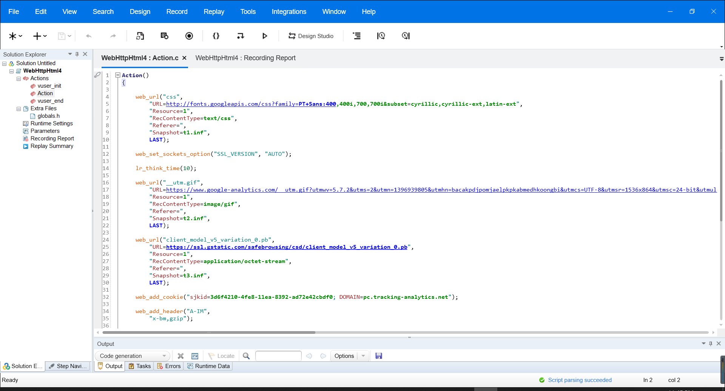
Appendix

