Curriculum Vitae

Dinup Divakaran
E-mail: ddivakaran263@gmail.com Contact No: +91 9959943148
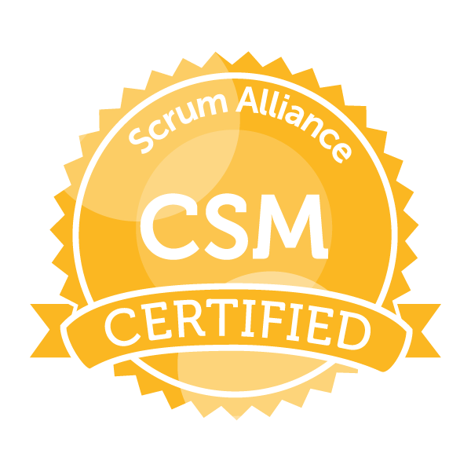

Objective

Aiming to serve with dedication, honesty, achieving the desired organizational goals and grow along with the organization.

Profile
Professional Snapshot
- CSM certified from Scrum alliance.
- Extensive experience with analysis, design, development, customization, implementation and support of software/System applications.
- Certified as a valuable contributor towards “IBU India enterprise” from Tech Mahindra for the year 2013 and 2014.
- Awarded “BRAVO” award for “Driving Positive Change and Delivery Excellence” (2014).
- Completed Certifications from Udemy on AWS, Scrum, python and spark.
- Hands-on working knowledge on Bigdata (Hadoop and eco systems), spark and python on banking domain.
- Good understanding of SDLC concepts with project management guidelines in traditional and agile environments.

Personal Snapshot
- Client facing experiences from multiple regions like US, UK and APAC.
- Proficient in analyzing and translating business requirements to technical requirements and
Architectural design.
- Good exposure in managing project teams independently from initiation till project closure.
- Strong experience in system analysis, development and data/platform migration projects.
- Ambassador for Jesus Calls MP region.

Strengths
- Strong communication (spoken and written) skills.
- Good interpersonal skills, self-motivated, quick learner, team player.

Professional Experience:
- Working with “Epsilon” as “Database developer, Senior” from June-2016--till date.
- Worked with “Solix Softech” as “Practice Lead (Apps Retirement)” from Aug-2015--Jun-2016.
- Worked with “MahindraSatyam” as “Software Engineer/Lead” from Apr-2012--May 2015
- Worked with “Exilant Technologies” as “Programmer Analyst” from Aug-2010--Apr-2012
- Worked with “Info Services” in “Operations” deputed in “Vodafone” from Sep-2008--May-2010
- Worked with “Adecco Flexione” as an “IT-executive” for Vodafone” from dec-2006--Aug-2008.

Skill Set:
- Programming / Database : Hadoop, Spark, Oracle PL/SQL & DWH.
- Scripting : Python, Shell and Perl.
- Project Mgmt. Methodologies : Traditional, Agile and processed based (Lean).
- Development Tools : SQL Developer, TOAD, Hadoop eco systems.
- Job Scheduling Tools : Active batch, Maestro and Cron.
- Cloud/Web Services : AWS and Azure fundamentals.
- Operating Systems : Windows and UNIX(HP/AIX).

Education Qualification:
- Master of Business Administration (MBA-IT) from Mahatma Gandhi University.
- Master of Computer Application (MCA) from Anna University.
- Bachelor of Computer Application (BCA) from MCRP University.

Certification/Diploma:
- Hardware Diploma in computer maintenance.
- Certificate diploma in digital photo editing.

Participations:
- Students convener for Bethesda Prayer Center, Coimbatore during collage.
- Completed IOPM from Jesus Calls in April 2005.
- Actively participates in blood donation camps.
- Advertisement Committee Convener MCA, 5th Semester (2004-2005).
- Secretary for Youth (MCI) for the year 2001-2002.
- Actively participated & won prizes in indoor/outdoor sports like Carroms, Karate.

Personal Details:
- Current Address : Marathalli, Bangalore.
- Passport No. : Holding Valid passport till 29th Nov-2022.
- Father’s Name : Mr. K.K. Divakaran.
- Occupation : Ex-Serviceman (Indian Army).
- Mother’s Name : Mrs. Kunjamma Divakaran.
- Occupation : Prayer warrior and Home Maker.
- Language Known : English, Hindi, Malayalam and Tamil.
- Area of Interest : Solution Architect and Project Management.
- Hobbies : Driving, pencil drawing and prayer warrior.

Professional Experience

Project : Exxon Mobil.
Domain : Financial (Card Transactions)
Technology : HDFS, pySpark, AWS, Oracle and Active Batch.
Duration : Jan’2020 – Apr’2020
Organization : Epsilon.

Project Description:
The project was to develop a working prototype for “POC” where the data needs to be downloaded from WEB API in JSON format and injected into HDFS system and further parsed and processed using Spark and Python.

Responsibilities
  - Creating the code logic in python to download the JSON file from WEB API.
  - Parsing and loading the incoming data to Hive Staging tables.
  - Processing and applying business logic on data though Apache Spark.
  - Performance Tuning in Spark. Handling masking and Encryption of PII data.
  - Moving data from Oracle system to Hadoop and from on premise Hadoop cluster to AWS cluster.

Project : Re-platform, BOFA.
Domain : Banking
Technology : HDFS, pySpark, AWS and Active Batch.
Duration : Jun’2016 – Dec’2019
Organization : Epsilon.

Project Description:
The project executed as part of a Banking platform migration from “Neteeza/Perl” (Existing system) to “Bigdata Solution” (New Solution) where processing of the huge amount data in using Spark and python.

Responsibilities assigned/taken.
Developer Tasks:
Module Task-
- Re-writing the logic to migrate and enhance the code from Perl to Pyspark.
- Migrating the “Credit Module” code and logic to the new solution.
- Re-writing the “best bureau logic” for “Credit Module” which has enhancements over the old solution.

Architectural design task-
- Designed and implemented the “Data Monitoring solution” which check and provide the differences in the incoming file to the client before file processing.
- Designed and implemented “Table clean up and File clean up” process to identify the potential table/files that can be dropped/deleted by checking and validating the different rules like backup, days in the system etc.
- Designed and implemented the “Promotional Consolidation” for the bank customer in the new solution.

Common task-
- Creating the API (libraries) to make the code standardized by using the API for repeated tasks.
- Creating the utilities scripts on pyspark to automate the manual task as much as possible.
- Optimize the logic to increase the performance of the process in new solution.

Architect Responsibilities:
- Responsible of the code review of junior team members before code implementation.
  - Verify and discuss solution/code changes with SME’s for various performance issues.
  - Providing the new solution/Design for all the standalone process and implementing the same in new solution.
  - Participating and providing the suggestion/solution during the code review and other module designs meetings.
  - Scheduling a learning session once in two weeks to share the lesson learned during the development/design phase.

Project : Apps. Retirement
Domain : Banking/Aerospace/Manufacturing.
Technology : HDFS, Spark, Oracle, Postgres and oozie.
Duration : Aug-2015 till Jun-2016
Organization : Solix Softech.

Project Description:
The product designed and developed for the corporates looking to retire the existing system which is incapable of handling huge amount of incoming data from various sources and migrating those incoming data on to the new solution (Bigdata) providing a solution without any data loss with high availability archival solution.

Responsibilities
Developer Task:
- Creating the process (Scripts) to load the incoming flat file data and injecting the same in the HDFS. And further processed and loaded into hive tables using spark.
- Loading data directly from traditional RDBMS to HDFS using scoop and further processed and stored.
- Any business logic applying on the data is applied within the HDFS using the spark.
- All the scripts to invoke the data loads and transfer is scheduled in oozie.
- Maintaining the entire Hadoop cluster using zookeeper.

Management Task:
- Defining project scope and objectives, involving all relevant stakeholders and ensuring technical feasibility.
- Ensure resource availability and allocation.
- Perform risk management to minimize project risks using the RAID logs.
- Present reports to stakeholders on progress as well as problems and solutions.
- Implement and manage changes when necessary to meet project outputs.
- Manage project risks, including the development of contingency plans.
- Delegate project tasks based on junior staff member’s strengths, skill sets, and experience.

Project : TNZ Migration
Domain : Telecom.
Technology : Oracle PLSQL, Unix and Cron.
Duration : Apr’2012 till May’2015
Organization : Tech Mahindra.

Project Description:
This was a data migration project where the data from the legacy stack is migrated to the target stack (Seibel) using the tech Mahindra in house framework called UDMF (Unified Data Migration Framework).

- Managed the projects as a lead/developer for development and testing projects.
- Responsible to manage the development and defect tracking/closure within the SLA.
- Involved in client calls as part of the status discussions.
- Providing the reports to the senior management about the project status and risk.
- Responsible for code review and code repository update.

Project : Swadust Expansion.
Domain : HR (Time & Attendance).
Technology : Oracle PLSQL, Unix and Cron.
Duration : Oct’2010 till Apr’2012
Organization : Exilant Technologies.

Project Description:
This project was implemented as a part of the new business expansion group (Sweden) which was integrated with the existing application “Time and Attendance” from where the employees punch their working hours.

- Analyze the existing systems full potential and tuning/adding the existing/new functionality to make the system more reliable and user friendly.
- Discuss the ideas with different team owners and senior management for improvement areas for the new business proposal.
- Involved in writing design documents (BRD, TDD, FS).
- Responsible to analyzing and implementing the initial set up process for the Travel Time functionality for Sweden BU.
- Responsible for code construction to generate the bi-monthly night work extract and providing the same to the payroll vendor (ADP) through SFTP.
- Responsible for code analyze and bug fixing.

Project : Operation Maintenance.
Domain : Telecom (Pre-paid Billing).
Technology : Oracle PLSQL, Unix, Cron, ASP and VB.
Duration : Dec’2006 till May’2010
Organization : Info Services/ Adecco Flexione.

Project Description:
Under operations the system was migrated from old VOICE to new UPSS (Unified Pre-Paid Support System). It was used by the retail customer representatives and field officers.

- Responsible for Handling operation team and support for the new system.
- Responsible to allot the daily task and manage the shifts of the engineers.
- Responsible to train the new team members.
- Writing SQL queries, procedures and triggers based upon the new promotional and daily activities requirements.
- Offline promotion, online promotion processing based on recharge, static dump base.
- Generating & automating various MIS modules like churn analysis, service activation / deactivation report.
- Bulk activation of various VAS services and service charging like monthly rental and daily rental.
- Dump loading like subscriber dump, recharge dump and MTR dump from online server to offline server and configuring new dealer code etc
- Preparing and maintaining various reports including daily MIS reports, PCO activation reports, revenue reports, service reports etc.

