Data Acquistion (DAQ) Program Instructions

# Make sure the Humboldt Load Frame is turned on.

# Start the DAQ program.

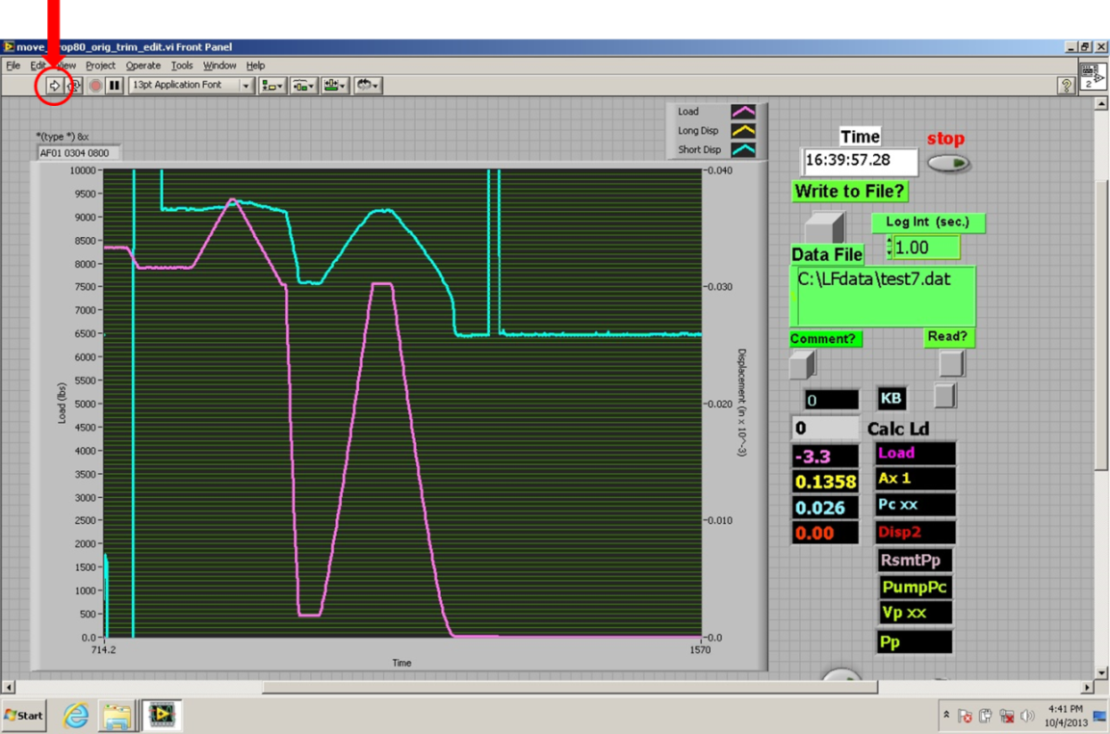

If the screen shows the gridded background and the time is not moving (above), the program is not running. If it is running, STOP it by pressing the red circle in the top left corner. That start the program by clicking on the right facing arrow. You should hear a beep from the Humboldt when the DAQ is activated. The image below shows the program active.

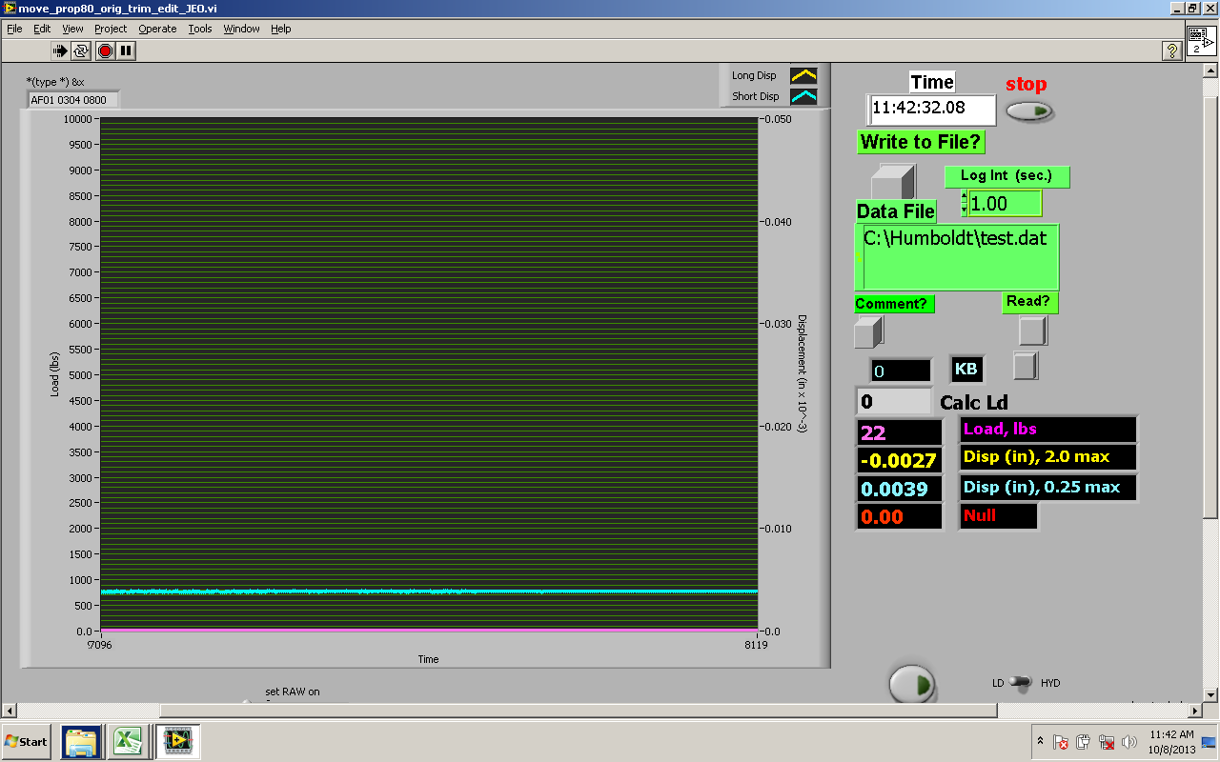

# Type in a file name and a proper directory for the file



The example shows that the file name is “test.dat”. The directory for the file is “C:＼Humboldt＼”. I suggest making a different file for each sample, and name it after the sample rock name, such as Berea, Boise and Texas Cream.

# Displacement and load display in the LabView

You will see two curves that are active for these experiments, the light blue (displacement #2 in inches) and the purple (load in lbs). The current values are also displayed digitally as well.

# Clear chart and change the range of the scale for displacement and load

You may clear the chart and change the range of the scale before you perform the test. Just put your cursor at the middle of the plot and right click, you will get a pull-down menu and select “clear chart”.

Also, by double clicking the top and bottom of the scale of the loading and the displacement, which are in circles in the figure below, you can type in numbers for different scale. The example below is showing 0 to 1000 lbs in “load” and 0 to 0.04 inch in “displacement”.

* Don’t reset the load setting – keep it at 0 to 10,000 lbs.
* You may want to adjust the displacement so you can better see the progress of your experiment.

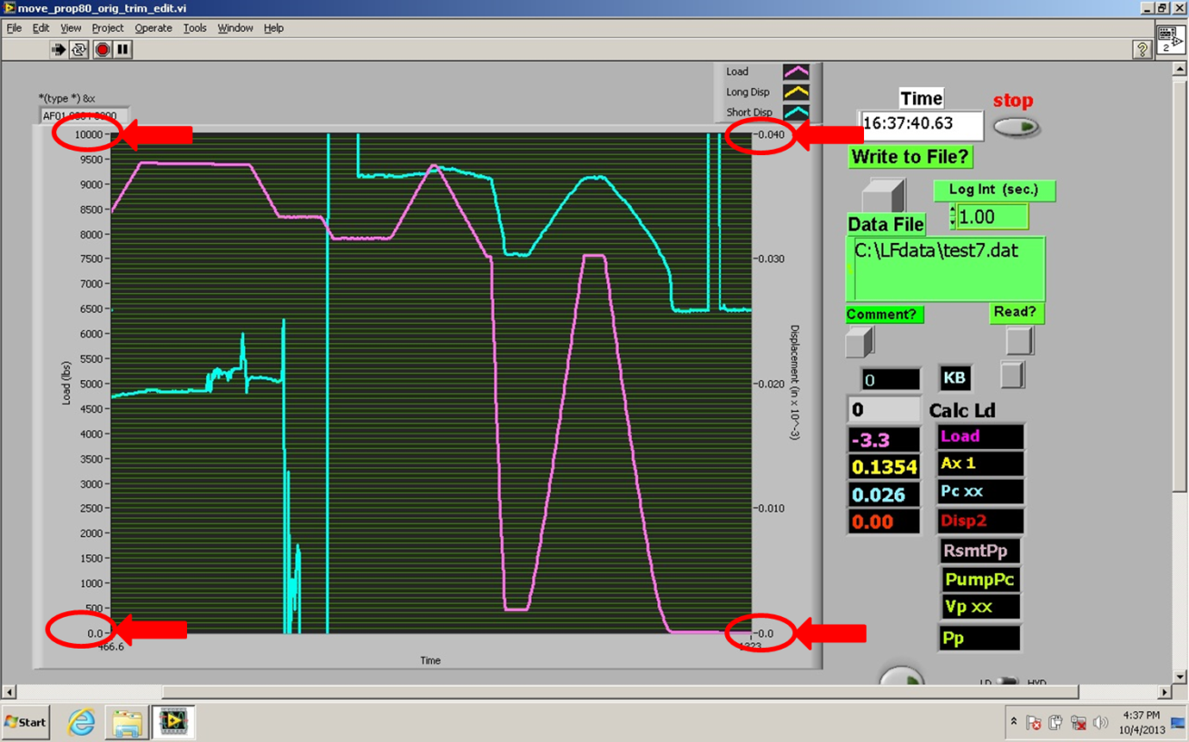

# Write Data to File

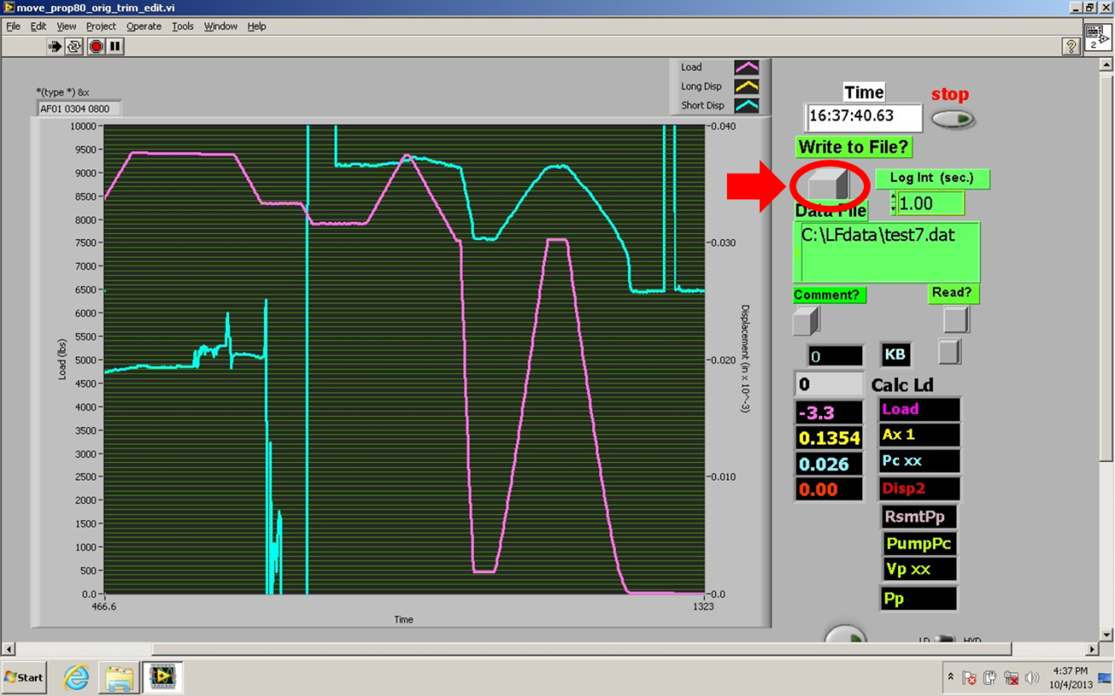

If you are ready to start writing the data file, hit the square button indicated above. The button will change to red and a pop-up screen will ask you to input length, diameter and weight of the core plug.

# When you finish the test, click on the red button (same button from #7) to stop writing data to file.