SYSTEM DESIGN DOCUMENT
Handmade & Custom Artwork E-Commerce Platform
IBM Technical Training Capstone Project
Version 1.0
30 August 2026
Status: Derived from Approved SRS v1.0, MVP Scope Document v1.0, and Requirements & Use Case Specification v1.0

Document Control
Item | Value
Document | System Design Document (SDD)
Project | Handmade & Custom Artwork E-Commerce Platform
Version | 1.0
Status | Baseline design derived from approved requirements
Primary Source of Truth (in order) | 1. Approved SRS v1.0 2. Approved MVP Scope Document v1.0 3. Approved Requirements & Use Case Specification v1.0
Backend | Java + Spring Boot (Spring MVC, Spring Security, Spring Data JPA)
Frontend | React
Database | PostgreSQL
Architecture Style | Layered Modular Monolith
Application Roles | CUSTOMER, ADMIN
Scope Boundary | Standard E-Commerce + Basic Inventory Management + Custom Artwork Commission Workflow
This document translates the approved requirements into a technical system design. It does not invent new business requirements or features, and it does not introduce architecture or technologies beyond what the approved documentation supports. It is a design document, not an implementation document: no Java code, React code, SQL, complete REST endpoint specification, complete database schema, or deployment configuration is defined here. Those artifacts are produced in later steps (database design, OpenAPI specification, UI design).

1. System Overview

1.1 What the System Does
The system is a centralized web-based e-commerce platform for a handmade-art business. It supports two business journeys defined in the approved SRS and MVP Scope Document: (1) direct purchase of ready-made artwork through a standard catalogue, cart and checkout flow, and (2) a structured commissioned-artwork workflow in which a customer submits requirements and a reference image, an Admin reviews the request and issues a quotation, and the customer approves the quotation and pays an advance before production begins. The platform also provides basic ready-made inventory management so that stock availability is always validated on the backend before a purchase is accepted.

1.2 Who Uses It
- CUSTOMER — registers, browses and searches the catalogue, manages a cart and delivery addresses, checks out and pays for ready-made products, views order history, submits custom-artwork requests with reference images, and reviews/approves or rejects quotations.
- ADMIN — authenticates with elevated privileges and manages categories, products, product images, inventory, orders, custom requests, quotations, and customer records. Business roles described conceptually in the SRS (Artist, Order Manager, Inventory Manager, System Administrator) are represented through the single ADMIN role in the MVP rather than as separate application roles.

1.3 Main Business Capabilities
- Authentication and role-based authorization for CUSTOMER and ADMIN.
- Product catalogue, categories, search, filter, sort, and related products.
- Cart, delivery address management, and checkout.
- Payment processing for ready-made orders and custom-artwork advance/remaining payments.
- Order creation, order history, order status tracking, and eligible-state cancellation.
- Ready-made inventory tracking with backend stock validation.
- Custom-artwork request submission, reference image upload, Admin review, quotation issuance and customer approval/rejection.
- Administrative management of products, categories, inventory, orders, custom requests, quotations, and customers.

1.4 Technology Stack
Layer | Technology
Frontend | React (SPA), REST client via a shared API service layer
Backend | Java, Spring Boot, Spring MVC, Spring Security, Spring Data JPA / Hibernate
Database | PostgreSQL
API Style | REST over HTTPS, JSON payloads, OpenAPI as the API contract artifact
Authentication | Spring Security with a token-based (JWT) strategy for stateless REST access
File Storage | Local filesystem for the capstone; object storage is a documented future option for cloud deployment

1.5 Architectural Approach
The system is built as a layered modular monolith: a single deployable Spring Boot backend organized into clearly separated controller, service, repository, entity, DTO, security, exception, and configuration layers, communicating with a single PostgreSQL database. The React frontend is a separate deployable unit that communicates with the backend exclusively through REST APIs. This approach was chosen because it satisfies every approved MVP requirement, is simple enough for a training-capstone team to implement and test within the project timeline, and remains extensible without requiring microservices, message brokers, or container-orchestration infrastructure that the approved documentation does not call for.

2. Architectural Principles
The following principles guide every design decision in this document. Each principle is included because it is directly relevant to a requirement, business rule, or non-functional requirement (NFR) in the approved SRS.
Principle | Why It Applies Here
Separation of concerns | Controllers, services, repositories, and security are kept in distinct layers (NFR-10) so that each layer can change independently.
Layered architecture | The approved architecture is React → REST → Spring Boot → PostgreSQL; each layer has a single, well-defined responsibility.
RESTful API design | The backend exposes stateless REST resources for auth, catalogue, cart, orders, custom requests, quotations, and payments (SRS §9.2, §12).
Secure authentication | Every non-public operation must be authenticated; passwords must never be stored in plaintext (FR-AUTH-04, NFR-03, NFR-04).
Role-based authorization | CUSTOMER and ADMIN capabilities are strictly separated and enforced on the backend, not only in the UI (FR-AUTH-08, BR-04, BR-07).
Backend validation as the source of truth | Cart totals, stock availability, and order totals must be revalidated and calculated server-side; client values are never trusted (FR-CART-04/05/07, BR-05, BR-10).
Transactional consistency | Order creation, payment confirmation, and inventory updates must change together or not at all (NFR-11, BR-01/BR-02).
Maintainability | A conventional, well-documented package structure keeps the codebase approachable for a training team (NFR-10).
Testability | Layer separation and dependency injection allow each layer to be unit- and integration-tested independently (SRS §21, X-04).
Least privilege | Admin-only operations are protected at the endpoint level; customers can access only their own data (BR-06, BR-09, FR-ORD-09).
Simplicity over premature scale | No microservices, message queues, caching layers, or container orchestration are introduced, because the approved MVP does not require them.

3. High-Level System Architecture
The system follows a strict top-to-bottom logical structure. No layer is permitted to skip another: the React client never talks to PostgreSQL directly, and the backend never returns raw entities to the frontend without passing through DTOs.
React Client (Customer / Admin UI)
│
│ HTTP / REST (JSON over HTTPS)
▼
Spring Boot Application
│
▼
PostgreSQL Database

3.1 Backend Logical Layers
Inside the Spring Boot application, requests flow through four logical layers:
Presentation / Controller Layer
│
▼
Service / Business Logic Layer
│
▼
Repository / Data Access Layer
│
▼
PostgreSQL

3.2 Layer Responsibilities
Layer | Responsibility
Presentation / Controller | Accepts HTTP requests, deserializes JSON to request DTOs, performs declarative (Bean Validation) input validation, delegates to the service layer, and maps service results/exceptions to HTTP responses. Contains no business logic.
Service / Business Logic | Implements business rules (inventory checks, quotation-expiry checks, state-transition rules), coordinates repositories, enforces transaction boundaries, and applies authorization checks that depend on data ownership (e.g., 'is this the customer's own order?').
Repository / Data Access | Spring Data JPA repositories that translate persistence operations into SQL against PostgreSQL. Contains no business logic — only data-access concerns (queries, pagination, sorting).
PostgreSQL | Durable relational storage; enforces primary keys, foreign keys, and column-level constraints (e.g., non-negative price/stock) as a second line of defense behind application-level validation.
This document intentionally does not provide implementation code for these layers; class-level and endpoint-level detail is produced in the subsequent API and database design steps.

4. System Architecture Diagram
The diagram below shows the high-level architecture: actors, the React frontend, the Spring Boot backend (split into its authentication/security and business-service concerns), PostgreSQL, and the external payment integration point. It intentionally omits individual classes and database tables.
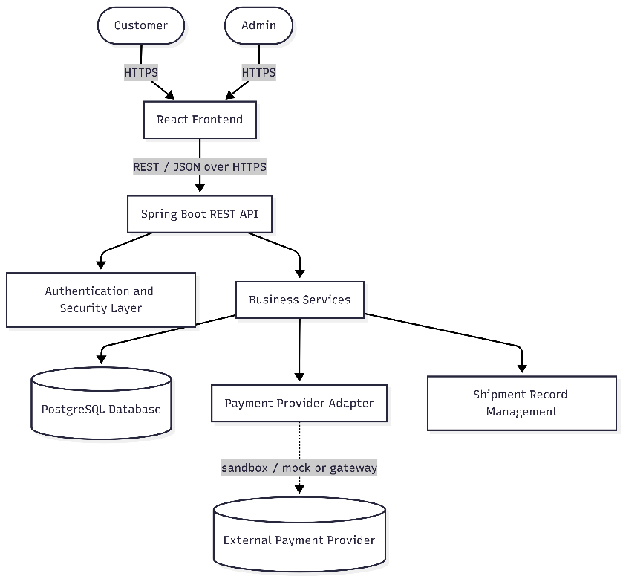
Explanation: Customer and Admin actors interact only with the React frontend, which is the sole entry point to the system for a browser. All frontend traffic is routed through a single REST API surface on the Spring Boot backend. The Authentication and Security layer intercepts every request before it reaches business services. Business Services encapsulate catalogue, cart, order, inventory, custom-request, and quotation logic, and are the only components permitted to read or write PostgreSQL. The Payment Provider Adapter isolates the business services from the concrete payment implementation (sandbox/mock or a real gateway), consistent with SRS §9.3, which requires the payment domain model to be preserved regardless of which concrete provider is used.

5. Frontend Architecture

5.1 Application Structure
The React application is a single-page application with two logical areas — a Customer area and an Admin area — sharing a common set of low-level building blocks (API services, hooks, layouts, and reusable components).

5.2 Recommended Folder Structure
src/
├── components/ Reusable, presentation-focused UI components
├── pages/
│ ├── customer/ Home/Portfolio, Catalogue, Product Details,
│ │ Custom Request, Cart, Checkout, Payment,
│ │ Confirmation, Orders, Order Details, Profile
│ └── admin/ Dashboard, Products, Categories, Orders,
│ Custom Requests, Quotations, Inventory, Customers
├── layouts/ CustomerLayout, AdminLayout, AuthLayout
├── routes/ Route definitions and route guards
├── services/ One module per REST resource (authApi, productApi,
│ cartApi, orderApi, customRequestApi, quotationApi,
│ paymentApi, adminApi) — the only layer that calls fetch/axios
├── hooks/ useAuth, useCart, useFetch, useForm, usePagination
├── context/ AuthContext (current user, role, token), CartContext
├── utils/ Formatting, currency, date helpers, error mapping
├── validations/ Client-side form validation schemas (mirrors backend rules)
└── assets/ Static images, icons, styles

5.3 Routing and Protected Routes
- Public routes: login, register, catalogue, product details, portfolio.
- Customer-protected routes: cart, checkout, payment, orders, order details, profile, custom-request submission, quotation view/approval — require an authenticated CUSTOMER token; unauthenticated users are redirected to login.
- Admin-protected routes: dashboard, product/category/inventory management, order management, custom-request review, quotation management, customer list — require an authenticated ADMIN token.
- A route guard component reads authentication state from AuthContext and the user's role, and redirects or renders an 'unauthorized' state accordingly. This guard is a UX convenience only — the backend independently re-enforces authorization on every request (see Section 8).

5.4 Authentication State
AuthContext holds the current user, role, and access token (kept in memory / a secure context, not in localStorage, to reduce token-theft exposure). services/authApi.js performs login/register/logout calls and updates AuthContext. An HTTP client wrapper in services/ attaches the bearer token to outgoing requests and centrally handles 401 (redirect to login) and 403 (show an authorization error) responses.

5.5 API Communication
All backend calls are made through the services/ modules, never directly from components or pages. Each service module maps one-to-one to a backend REST resource, keeping the mapping between frontend and backend simple to trace and test.

5.6 Form Handling, Error Handling, Loading States
- Forms (registration, product creation, custom-request submission, quotation review) perform client-side validation for immediate feedback, mirroring backend validation rules, but never replace it.
- A shared error-handling utility converts the backend's consistent REST error envelope (Section 12) into user-facing messages.
- Pages that fetch data expose loading, success, empty, and error states explicitly, using the useFetch hook, so that catalogue browsing, order history, and admin lists behave predictably under slow or failed requests.
No additional frontend libraries beyond React, a routing library, and an HTTP client are required to satisfy the approved MVP; charting, animation, or state-management libraries beyond React Context are not introduced.

6. Backend Architecture

6.1 Recommended Package Structure
com.handmadeart.platform
├── controller REST controllers (one per resource area)
├── service Business logic, orchestration, transaction boundaries
├── repository Spring Data JPA repositories
├── entity JPA-managed persistent entities
├── dto Request/response DTOs (never expose entities directly)
├── mapper Entity <-> DTO mapping (MapStruct or manual mappers)
├── security Spring Security config, JWT filter, auth provider
├── exception Custom exceptions and a global exception handler
├── validation Custom Bean Validation constraints and validators
└── config Application, CORS, and general Spring configuration

6.2 Layer Responsibilities and Rationale
Component | Responsibility | Why It Exists
Controllers | Expose REST endpoints, bind and validate request DTOs, delegate to services, translate results to HTTP responses. | Keeps HTTP concerns out of business logic; makes endpoints thin and testable in isolation.
Services | Contain business rules and orchestration (e.g., stock check + order creation + payment initiation as one unit of work). | Centralizes business logic so it is not duplicated across controllers, and can be transactional.
Repositories | Data access via Spring Data JPA; encapsulate queries. | Isolates persistence technology from business logic; supports substitution/mocking in tests.
Entities | JPA-mapped domain objects representing persistent state (Section 11). | Single authoritative representation of stored data, with relationships enforced by JPA/PostgreSQL constraints.
DTOs | Shape data crossing the API boundary; never expose entities directly. | Prevents accidental leakage of internal fields (e.g., password hash) and decouples API contract from schema.
Mappers | Convert between entities and DTOs. | Keeps conversion logic out of controllers/services and in one predictable place.
Security | Authentication (JWT validation), authorization (role checks), password hashing configuration, CORS policy. | Centralizes cross-cutting security concerns so every endpoint is protected consistently (NFR-03, NFR-08).
Exception handling | A single @ControllerAdvice mapping business/validation exceptions to the standard error response (Section 12). | Guarantees consistent, safe error responses without leaking stack traces (NFR-09).
Validation | Bean Validation annotations plus custom validators for business constraints (e.g., non-negative price). | Enforces NFR-05 at the boundary before business logic executes.
Configuration | Environment-specific settings, datasource, CORS origins, file-storage paths, external-service credentials. | Keeps secrets and environment differences out of code, per SRS §13.

7. Functional Module Architecture
The approved MVP functionality is organized into the following logical backend modules. Each module is a cohesive group of services/repositories inside the single Spring Boot deployment — not a separate microservice. No API endpoints or database tables are defined here; that detail belongs to later design steps.
Module | Responsibility | Main Operations | Depends On | Use Cases | User Stories
Authentication & Authorization | Identity, credentials, sessions/tokens, role enforcement. | Register, login, logout, profile view/update, role check. | — | UC-001..003 | US-001..003
Address | Customer delivery addresses. | Create, update, select address. | Authentication | UC-003 | US-003
Categories | Catalogue classification. | Create/update/deactivate category (Admin); list categories (public). | — | UC-005,016 | US-004,017
Products / Catalogue | Ready-made, custom-available, and portfolio-only artwork records and images. | Create/update/deactivate product; manage images; browse, search, filter, sort; view details and related products. | Categories, Inventory | UC-004,005,016 | US-004..006,017
Cart | Customer's in-progress selection of ready-made items. | Add, update quantity, remove item; server-side subtotal/total calculation. | Products, Authentication | UC-006 | US-007
Checkout | Transition from cart to a validated order. | Revalidate stock and address; compute server-side total; create order. | Cart, Address, Inventory, Orders | UC-007 | US-008
Payment | Payment transactions for ready-made orders and custom-order advance/remaining payments. | Initiate payment, record outcome, retrieve payment status. | Orders, Custom Artwork, external Payment Provider adapter | UC-008,015 | US-008,016
Orders | Ready-made purchase records and lifecycle. | Create order, list/view own orders (customer), view/manage orders (admin), eligible cancellation. | Cart/Checkout, Inventory, Payment | UC-007,009,010,018 | US-008..010,019
Inventory | Ready-made stock levels. | View/update stock (admin); validate and decrement stock on successful order. | Products | UC-017 | US-018
Custom Artwork | Commissioned-artwork request lifecycle and reference images. | Submit request, upload reference image, admin review/decision. | Authentication, File Handling | UC-011..013 | US-011..013
Quotation | Commercial proposal tied to a custom request. | Create quotation (admin), view quotation, approve/reject (customer), expiry enforcement. | Custom Artwork, Payment | UC-014,015 | US-014..016
Administration | Cross-cutting admin views over customers and operations. | View customers; (should-have) dashboard metrics. | Orders, Custom Artwork, Inventory, Authentication | UC-019,020 | US-020,021
Shipping (record-keeping) | Fulfillment record associated with an order or completed custom order. | Record shipping status, tracking reference, estimated delivery date. | Orders, Custom Artwork | UC-018 | US-019
Reviews (Section 6.10 of the SRS) and Notifications (Section 6.11) are Should-Have modules per the approved MVP Scope Document. They are included in the domain model for extensibility but are not required for the MVP acceptance criteria, and are not elaborated further as core modules in this design.

8. Authentication & Authorization Design

8.1 Roles
The system supports exactly two application roles, per the approved SRS and MVP Scope Document: CUSTOMER and ADMIN. No additional roles are introduced.

8.2 Registration
A prospective customer submits identity and credential information. The service layer validates the input, rejects registration when the email address is already registered (FR-AUTH-02), hashes the password, and persists a new User record with role CUSTOMER.

8.3 Login
A user submits credentials. The authentication provider verifies the password hash against the stored value. On success, the system issues an access token that identifies the user and their role. On failure, a generic authentication error is returned (no information disclosure about whether the email exists).

8.4 Password Storage
Passwords are hashed using BCrypt (or an equivalent strong, salted hashing algorithm) before storage. Plaintext passwords are never persisted, logged, or returned in any response (FR-AUTH-04, BR-12).

8.5 Authentication Mechanism
The backend is a stateless REST API, so token-based authentication (JWT) is recommended over server-side session state. A signed JWT carries the user's identity and role and is presented as a Bearer token on each request. This fits the layered/stateless architecture directly (NFR-02), avoids sticky-session concerns if the deployment is later scaled horizontally, and keeps the frontend's AuthContext simple (store the token, attach it to requests, discard it on logout).

8.6 Authorization
A Spring Security filter chain validates the JWT on every request to a protected endpoint and populates the security context with the user's identity and role. Two layers of authorization are applied:
- Role-based access control at the endpoint/method level (e.g., only ADMIN may reach product-management or order-status-update operations) — enforced declaratively (method security or route configuration).
- Ownership-based access control inside the service layer (e.g., a CUSTOMER may only view their own orders and custom requests) — enforced imperatively, because it depends on the specific record being accessed (BR-06, BR-09, FR-ORD-09).

8.7 Protected vs. Public Operations
Access Level | Examples
Public | Registration, login, catalogue browsing, product details, category listing.
Customer-protected | Cart, checkout, payment, own orders, custom-request submission, quotation view/approval, profile/address management.
Admin-protected | Product/category/inventory management, order status management, custom-request review, quotation creation, customer viewing, dashboard.

8.8 Session / Token Handling
Tokens carry a bounded expiry. Logout is handled client-side by discarding the token (and, if a refresh-token or blacklist mechanism is added later, by invalidating it server-side); this is a design-level placeholder, not an implementation choice made here. The system does not implement security in this document — it only defines the approach that later implementation must follow.

8.9 Sensitive Data
The system never stores plaintext passwords (BR-12) and never stores raw card numbers, CVV, or other sensitive payment credentials (FR-PAY-04, NFR-07, BR-13). Payment records store only amount, type, status, and a transaction reference issued by the payment provider.

9. Request Flow

9.1 Standard Request Flow
React (calls services/xApi.js)
│
▼
Controller — deserializes JSON, applies Bean Validation
│
▼
Service — business rules, authorization checks, transaction boundary
│
▼
Repository — persistence operations
│
▼
PostgreSQL — executes query / constraint checks
│
▲ (result flows back up)
Repository → Service → Controller → React

9.2 Stage-by-Stage Explanation
Stage | What Happens
React | Builds a request via the relevant service module, attaches the JWT (if the endpoint is protected), and calls the REST endpoint.
Controller | Deserializes the JSON body/query params into a request DTO, runs declarative validation, and passes the DTO to a service method. Any validation failure returns a 400-level error without reaching the service.
Service | Applies business rules (e.g., 'is this product active and in stock?'), enforces ownership/role checks that need data context, opens a transaction where multiple records must change together, and calls one or more repositories.
Repository | Executes the persistence operation against PostgreSQL through Spring Data JPA.
PostgreSQL | Applies column constraints and foreign keys as a final integrity check.
Return path | The service maps the persistence result (or failure) to a domain result; the controller maps that to an HTTP status and a response DTO; React updates UI state (success, error, or loading resolution).

9.3 Example: Authenticated Request
Example — 'View My Orders' (UC-009): React attaches the customer's JWT to a GET request. The security filter chain validates the token and populates the authenticated principal. The controller passes the authenticated customer's ID (never a client-supplied customer ID) to the Order Service. The Order Service queries only orders belonging to that customer ID (BR-06), maps the results to order-summary DTOs, and returns them. If the token is missing or invalid, the request is rejected before it reaches the controller logic (401); if the token is valid but the role/ownership check fails for a specific resource, a 403 is returned.

10. Core Business Flows

10.A Ready-Made Product Purchase
Customer → Browse Catalogue → Product Details → Add to Cart
→ Address Selection → Checkout → Payment
→ Order Confirmation → Order History
Responsibility | Detail
Frontend | Renders catalogue/product/cart/checkout pages; collects address selection and payment input; calls Cart, Checkout, and Payment services; displays confirmation and order history.
Backend | Validates product availability and quantity when items are added and again at checkout (FR-CART-05); computes totals server-side (FR-CART-04, FR-CART-07); creates the order and order items within a transaction; initiates payment through the Payment Provider Adapter; updates order status and inventory together on payment confirmation.
Database | Persists Cart/CartItem, Order/OrderItem (with purchase-time unit price, BR-11), Payment, and updated Inventory rows, all within the appropriate transactional boundaries.
External | Payment Provider Adapter calls a sandbox/mock or real payment gateway and returns a success/failure outcome and transaction reference (FR-PAY-06).

10.B Custom Artwork
Customer → Custom Request + Reference Image → Admin Review
→ Quotation → Customer Approval/Rejection → Advance Payment
→ Production → Shipping/Delivery
Responsibility | Detail
Frontend | Custom-request form (product type, description, theme, colors, size, budget range, required date, instructions) with reference-image upload; quotation view with approve/reject actions; status display through the request lifecycle.
Backend | Validates request fields and uploaded file (type/size, FR-CUST-03, BR-14); assigns lifecycle status (FR-CUST-04); lets Admin review/decide (FR-CUST-05/06); lets Admin issue a quotation with price, advance amount, delivery estimate, expiry, and terms (FR-CUST-07/08); rejects approval of an expired quotation (FR-CUST-10, BR-06 numbering per SRS BR-06); advances the order through production/shipping states on successful advance payment (FR-CUST-11).
Database | Persists CustomOrderRequest, CustomOrderImage (metadata only — see Section 13), Quotation, and Payment records, with state-transition history reflected in the CustomOrderRequest status column.
External | Payment Provider Adapter processes the advance (and later, remaining) payment for approved custom orders.

10.C Inventory
Admin → Create/Update Product & Set Stock
→ Customer Purchase Attempt
→ Backend Stock Validation
→ Order Created → Inventory Updated
Responsibility | Detail
Frontend | Admin product/inventory management screens; customer-facing availability indicators driven entirely by backend state (never locally computed).
Backend | Maintains available quantity per ready-made product (FR-INV-01); blocks any order attempt when quantity is insufficient (FR-INV-02); decrements stock according to the defined order-confirmation rule (FR-INV-03) inside the same transaction as order creation to prevent overselling under concurrent requests.
Database | Inventory table with a non-negative-quantity constraint (BR-15) as a last line of defense behind application checks.
External | Not applicable — inventory is managed entirely within the platform for the MVP (raw-material inventory and automated logistics are explicitly out of scope, FR-INV-05).

11. Transaction & Data Consistency
The following operations must execute as a single atomic database transaction, because each combines multiple record changes that must either all succeed or all fail together.
Operation | Why a Transaction Is Required
Order creation | Creating the Order and all OrderItem rows, and decrementing Inventory, must succeed or fail together — a partially created order with unadjusted stock would allow overselling or an inconsistent order.
Payment confirmation | Updating Payment status and the associated Order status must be consistent; a confirmed payment must never be left pointing at an order that failed to advance state.
Inventory update | Stock decrement must occur atomically with the order that consumed it, using row-level locking or an equivalent optimistic/pessimistic strategy so concurrent purchases cannot both succeed against the same limited stock.
Custom quotation approval | Marking a Quotation approved and moving the CustomOrderRequest to APPROVED must happen together; an approved quotation on a request that did not advance would be an inconsistent state.
Advance payment | Recording the advance Payment and transitioning the custom request to ADVANCE_PAYMENT_PENDING → IN_PRODUCTION must be atomic.
Order / custom-request status transitions | Every lifecycle transition (Section 8, 10.B) is validated against the current state before being applied and persisted as a single unit.

11.1 Preventing Specific Consistency Problems
Risk | Prevention Strategy
Overselling | Inventory is re-checked inside the same transaction that creates the order, using row-level locking (or an equivalent concurrency-safe read) so two simultaneous checkouts cannot both decrement the same limited stock below zero. The database column constraint (non-negative quantity) is a second line of defense.
Duplicate order creation | Checkout is idempotent at the service layer for a given cart/session (e.g., a cart cannot be converted into two orders); a client-side double-submit is rejected server-side rather than relied upon to be prevented in the UI.
Inconsistent payment/order state | Order status and Payment status are recorded as separate but linked fields (BR-12: payment status is independent of order status); a service-layer state machine only allows an order to move to CONFIRMED after a corresponding successful Payment record exists.
Invalid quotation transitions | Quotation and CustomOrderRequest status transitions are validated against an explicit allowed-transition table in the service layer before being persisted; expired quotations are rejected at the approval step (FR-CUST-10, BR-06).
No SQL is defined in this document; the concurrency strategy (e.g., SELECT ... FOR UPDATE vs. an optimistic version column) is a database-design decision made in the subsequent data-design step.

12. Error Handling
A single global exception handler (Spring's @ControllerAdvice) maps every recognized failure category to a consistent REST error shape, so the frontend can handle errors generically.

12.1 Error Categories
Category | Typical HTTP Status | Example
Validation errors | 400 | Missing required custom-request field; invalid price format.
Authentication failures | 401 | Missing, expired, or invalid token.
Authorization failures | 403 | Customer attempting to access another customer's order; non-admin attempting product management.
Resource not found | 404 | Requesting a product, order, or custom request that does not exist or is not visible to the caller.
Insufficient inventory | 409 (Conflict) | Checkout attempted for a quantity exceeding available stock.
Invalid order state | 409 (Conflict) | Attempting to cancel an order outside an eligible state.
Invalid quotation state | 409 (Conflict) | Approving an expired or already-rejected quotation.
Payment failure | 402 or 409 (per outcome) | Payment provider returns a decline/failure outcome.
Unexpected server errors | 500 | Any unhandled exception; response never exposes stack traces or internal details (NFR-09).

12.2 Conceptual Error Response Shape
Every error response follows the same conceptual envelope so the frontend's shared error-handling utility (Section 5.6) can process it uniformly. (This is a conceptual shape, not a finalized API contract.)
{
"timestamp": <ISO-8601 timestamp>,
"status": <HTTP status code>,
"error": <short error category, e.g. "VALIDATION_ERROR">,
"message": <human-readable, safe-to-display message>,
"path": <request path>,
"details": [ <optional field-level validation messages> ]
}

13. File / Image Handling
The system handles two categories of images: product images (managed by Admin) and custom-artwork reference images (uploaded by customers). Both follow the same conceptual pattern.

13.1 Conceptual Flow
Client uploads file (multipart) → Controller
│
▼
Service validates: MIME type, extension, max size
│
▼
File is written to File Storage (path/key generated by the server,
never derived from the client-supplied filename)
│
▼
PostgreSQL stores metadata only: owning record ID, storage reference,
original filename (for display), content type, size, upload timestamp

13.2 File Storage vs. Database Metadata
Concern | Where It Lives
Binary file content (the image itself) | File storage — local filesystem for the capstone (SRS §9.4). Object storage (e.g., an S3-compatible service) is a documented future option for cloud deployment, not introduced now because it is not required by the approved MVP.
Image metadata (which product/request it belongs to, storage reference/URL, content type, size, upload time) | PostgreSQL, in ProductImage and CustomOrderImage tables (Section 11 of the SRS data model).

13.3 Validation Rules
- Only image MIME types/extensions explicitly allowed by configuration are accepted (e.g., JPEG, PNG).
- A maximum file size is enforced server-side, independent of any client-side check.
- The server generates the stored filename/key; the client-supplied filename is never used as a path, preventing path traversal or filename-collision issues.
- Rejected uploads return a validation error (Section 12) and are never partially persisted.
No specific cloud storage provider is assumed; the design isolates storage behind a simple internal abstraction so that a future move from local disk to object storage does not require changes to controllers or the database schema.

14. Security Design
Concern | Design Approach
Password hashing | BCrypt (or equivalent) with per-password salt; configured through Spring Security's PasswordEncoder abstraction.
Authentication | Stateless JWT bearer tokens validated by a Spring Security filter on every request to a protected endpoint (Section 8).
Authorization | Role-based checks at the endpoint/method level plus ownership checks in the service layer (Section 8.6).
Input validation | Bean Validation annotations on request DTOs plus custom validators for business constraints (non-negative price/quantity, required custom-request fields).
File upload validation | Server-side MIME/extension and size checks; server-generated storage names (Section 13.3).
SQL injection prevention | Spring Data JPA / Hibernate with parameterized queries exclusively; no string-concatenated SQL.
XSS considerations | React's default output escaping protects rendered content; the backend still validates and, where free-text is stored (e.g., custom-request instructions, quotation notes), treats it as data, never as executable markup.
CSRF considerations | A stateless, token-authenticated REST API (no cookie-based session) is inherently less exposed to classic CSRF; CORS is configured to accept requests only from the approved frontend origin(s) rather than relying on cookies.
Sensitive information protection | Passwords, tokens, and payment credentials are never logged (Section 15) or returned in API responses beyond what the client legitimately needs.
Secure payment handling | Raw card data never reaches or is stored by the backend; only the Payment Provider Adapter communicates with the payment provider, and only amount/status/reference are persisted (FR-PAY-04, NFR-07).
Access control | Every state-changing endpoint requires authentication; Admin-only endpoints additionally require the ADMIN role; ownership is checked for customer-scoped resources.
Backend-side validation | All validation is re-applied server-side regardless of what the frontend already checked; the frontend is a UX convenience, not a trust boundary.
This section defines the security approach the implementation must follow; it does not implement security controls. No additional security infrastructure (WAF, dedicated secrets vault, SSO provider) is introduced, because the approved requirements do not call for it.

15. Logging & Auditing
Logging supports NFR-12 (auditability) and NFR-17 (logging without exposing secrets). A standard application logger (e.g., SLF4J/Logback, already part of Spring Boot) is sufficient; no separate centralized logging platform is introduced for the MVP.
Event Category | Examples Logged
Authentication events | Successful login, logout.
Failed authentication attempts | Invalid credentials, invalid/expired token use — logged without the attempted password.
Order creation | Order ID, customer ID, item count, total (not full card data).
Payment events | Payment initiation, success/failure outcome, provider transaction reference.
Inventory changes | Stock adjustments, and rejected purchases due to insufficient stock.
Quotation creation/approval | Quotation issued, approved, rejected, or expired.
Administrative actions | Product/category/inventory changes, order-status changes, custom-request decisions — who performed the action and when.
Unexpected errors | Stack trace at the server log level only (never returned to the client, per Section 12).
Logs never include passwords, raw tokens, card numbers, or CVV (NFR-17, Section 14). Administrative actions are the closest MVP equivalent to a formal audit trail; a dedicated, queryable audit-log table is noted as a Should-Have enhancement (SRS §6.10 context) rather than a MUST HAVE MVP capability.

16. Deployment Architecture
The MVP targets a simple, single-instance deployment suitable for local development and an optional cloud deployment, consistent with SRS NFR-15 (local readiness required, cloud optional).
User Browser
│
▼
React Application (static build, served separately or via a web server)
│ REST / HTTPS
▼
Spring Boot Application (single deployable JAR)
│
▼
PostgreSQL Database

Spring Boot Application ┄┄▶ External Payment Provider (sandbox/mock or gateway)
Spring Boot Application ┄┄▶ Local File Storage (product & reference images)

Deployment Diagram Source (Mermaid — flowchart)
flowchart TB
Browser[User Browser]
subgraph ClientTier[Client Tier]
ReactApp[React Application - static build]
end
subgraph AppTier[Application Tier]
SpringApp[Spring Boot Application - single JAR]
end
subgraph DataTier[Data Tier]
Postgres[(PostgreSQL Database)]
FileStore[/Local File Storage: product and reference images/]
end
subgraph ExternalTier[External Services]
PaymentSvc[(Payment Provider: sandbox / mock)]
end
Browser --> ReactApp
ReactApp -->|REST / HTTPS| SpringApp
SpringApp --> Postgres
SpringApp --> FileStore
SpringApp -.-> PaymentSvc

No Kubernetes, container orchestration, or multi-service deployment topology is introduced. If cloud deployment is pursued, the same three tiers (client, application, data) map directly onto a basic cloud VM/managed-database setup without changing the application architecture.

17. Architectural Diagrams
This section consolidates the five required architectural diagrams in one place for reference, each with its source, an explanation, and the requirements/use cases it supports.

17.1 High-Level Architecture Diagram
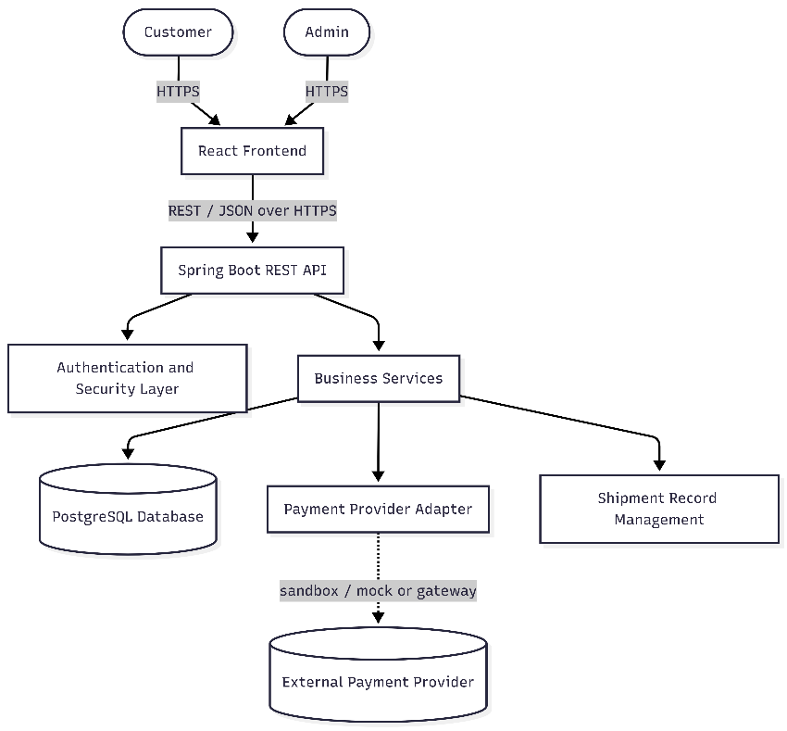
Represents: overall system topology from actor to database. Supports: all MUST HAVE modules (Section 7); NFR-02, NFR-03, NFR-08.

17.2 Backend Component / Layer Diagram
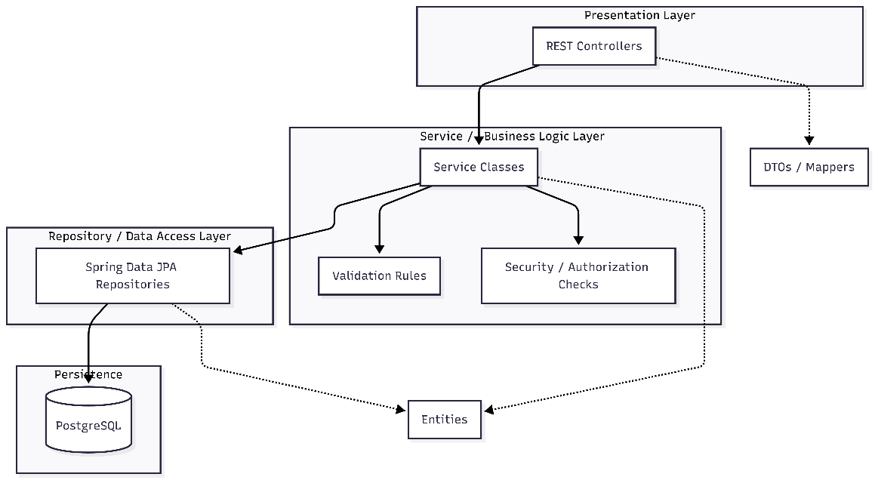
Represents: internal backend layering (Sections 3, 6). Supports: NFR-10 (maintainability), separation-of-concerns and testability principles (Section 2).

17.3 Customer Purchase Flow
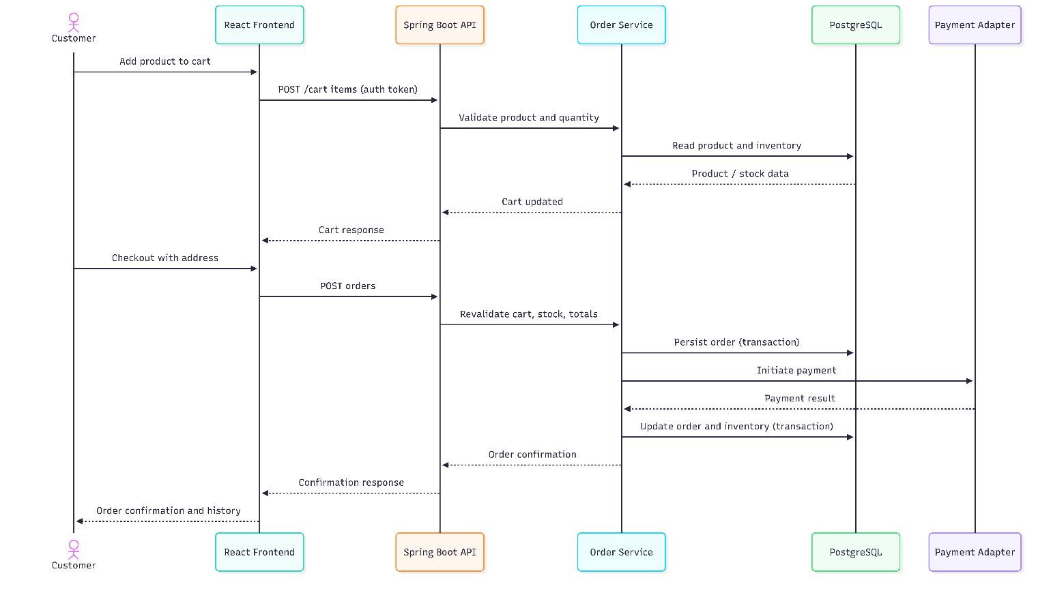
Represents: end-to-end ready-made purchase (Section 10.A). Supports: UC-006, UC-007, UC-008, UC-009; FR-CART-01..07, FR-ORD-01..09, FR-PAY-01..06, FR-INV-01..03; BR-01, BR-05, BR-10, BR-11.

17.4 Custom Artwork Workflow
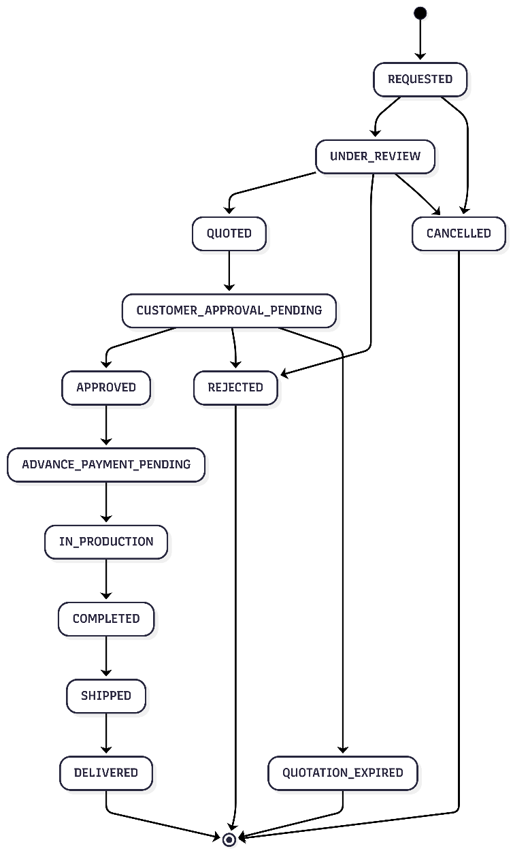
Represents: the CustomOrderRequest lifecycle (SRS §8.2). Supports: UC-011..015; FR-CUST-01..11; BR-03, BR-05, BR-06, BR-16.

17.5 Deployment Diagram
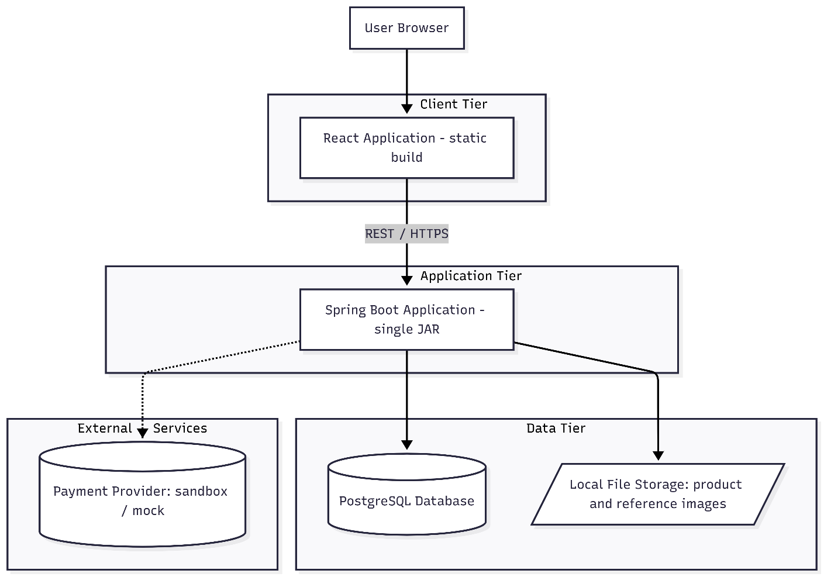

Represents: physical/runtime deployment topology (Section 16). Supports: NFR-15 (local readiness, optional cloud); scope-freeze rule against microservices/Kubernetes (MVP Scope §11).

18. Design Decisions
Decision | Reason | Alternative Considered | Why Alternative Was Rejected
Layered modular monolith (not microservices) | Satisfies every approved MUST HAVE requirement; simplest to build, test, and deploy within a capstone timeline. | Microservices (separate catalogue/order/payment services) | Adds network, deployment, and data-consistency complexity with no requirement that justifies it; explicitly excluded by MVP Scope §11 (out of scope).
REST over HTTPS | Directly matches the approved SRS interface requirements (§9.2) and is well understood by a training team; OpenAPI is the required contract artifact. | GraphQL | Adds schema/tooling complexity and is not required by any approved requirement; SRS specifies REST + OpenAPI.
PostgreSQL | Explicitly required by the approved SRS and capstone material; strong relational-integrity features fit the order/inventory/payment consistency needs (Section 11). | NoSQL document store | Would weaken the relational integrity (foreign keys, transactions) the business rules depend on (BR-10, BR-11, NFR-11), and is not what the approved documentation specifies.
React SPA frontend | Explicitly required by the approved SRS and capstone technology context. | Server-rendered templates (e.g., Thymeleaf) | Not the approved technology; would also complicate the clean REST-API separation the design relies on.
Layered Spring Boot architecture (controller/service/repository/DTO/security) | Matches SRS §14 exactly; supports separation of concerns, testability, and maintainability (NFR-10). | Transaction-script / single-layer controllers calling JPA directly | Would mix HTTP, business, and persistence concerns, harming testability and violating NFR-10.
JWT-based stateless authentication | Fits a stateless REST API cleanly; avoids server-side session state; recommended by SRS §13. | Server-side session cookies | Adds session-store state that is unnecessary for a stateless REST backend and complicates horizontal scaling (NFR-02).
Local filesystem storage for images (MVP), with a storage abstraction for future object storage | SRS §9.4 explicitly allows local storage for the capstone while preferring object storage for cloud deployment. | Introduce a cloud object-storage provider now | Not required for the MVP; would add an external dependency/cost with no MVP-level benefit, and the approved documentation treats it as optional.
Payment Provider Adapter (isolating the concrete payment implementation) | Lets a sandbox/mock implementation satisfy the MVP while preserving the same payment domain model if a real gateway is added later (FR-PAY-06, SRS §9.3). | Hard-code a specific payment gateway SDK directly into services | Would make swapping sandbox/mock and gateway implementations costly and would violate the 'exact payment provider' open decision retained in Section 20.

19. Requirements Traceability
IDs are taken directly from the approved Requirements & Use Case Specification and SRS; no new requirement IDs are invented. Architectural Component references point to the modules and layers defined in Sections 6 and 7.
Requirement | User Story | Use Case | System Module | Architectural Component
FR-AUTH-01..08 | US-001..003 | UC-001..003 | Authentication & Authorization | security package; AuthController/Service; Spring Security filter chain
FR-PROD-01..08 | US-006, US-017 | UC-005, UC-016 | Products / Catalogue | ProductController/Service/Repository; ProductImage handling
FR-CAT-01..08 | US-004..006 | UC-004, UC-005 | Products / Catalogue, Categories | CategoryController/Service; ProductController (search/filter/sort)
FR-CART-01..07 | US-007, US-008 | UC-006, UC-007 | Cart, Checkout | CartController/Service; server-side total calculation in Checkout Service
FR-ORD-01..09 | US-008..010, US-019 | UC-007, UC-009, UC-010, UC-018 | Orders | OrderController/Service/Repository; Order state machine
FR-CUST-01..11 | US-011..016, US-019 | UC-011..015, UC-018 | Custom Artwork, Quotation | CustomRequestController/Service; QuotationController/Service; CustomOrderImage handling
FR-INV-01..04 | US-018 | UC-017 | Inventory | InventoryService (transactional stock validation/decrement)
FR-INV-05 (raw-material inventory) | — | — | Out of scope | Not represented — no raw-material component exists in this design.
FR-PAY-01..06 | US-008, US-016 | UC-008, UC-015 | Payment | PaymentController/Service; Payment Provider Adapter
FR-SHIP-01..03 | US-019 | UC-018 | Shipping (record-keeping) | Shipment entity/service, associated with Order/CustomOrderRequest
FR-SHIP-04 (automated logistics) | — | — | Out of scope | Not represented — no logistics-integration component exists in this design.
Reviews (SRS §6.10) | US-022 | UC-021 | Should-Have (not core MVP module) | Review entity retained in data model (Section 11 of SRS) for extensibility only.
Notifications (SRS §6.11) | — | — | Should-Have (not core MVP module) | Not elaborated as an architectural module in this design.
Dashboard (SRS §6.12) | US-021 | UC-020 | Administration (should-have) | Admin read-only aggregation endpoints over Orders/Inventory/CustomRequests — marked pending per Section 20.
BR-01..BR-16 | Relevant stories above | Relevant use cases above | Cross-cutting | Enforced across Cart/Checkout, Orders, Inventory, Custom Artwork, Quotation, Security, and the transaction boundaries defined in Section 11.

20. Open Technical Decisions
These items are not finalized by the approved documentation. This design does not silently choose a value for them; the same open items are retained from the MVP Scope Document's SME Confirmation list (§13) and the Requirements & Use Case Specification's consistency check.
Item | Status | Notes
Exact payment provider (sandbox/mock vs. real gateway) | PENDING DECISION | SRS §9.3 permits either; the Payment Provider Adapter (Section 18) allows either to be selected without redesigning the Payment module.
Exact file storage mechanism (local disk vs. object storage) | PENDING DECISION | SRS §9.4 allows local storage for the capstone; the File Handling abstraction (Section 13) allows this to change later without affecting controllers or the database schema.
Email / notification mechanism | PENDING DECISION | Notifications are Should-Have (SRS §6.11); no mechanism (email provider, in-app record) is chosen here.
Deployment platform (local only vs. cloud) | PENDING DECISION | NFR-15 requires local readiness; cloud deployment is optional pending confirmation (MVP Scope SME-07).
JWT vs. an alternative authentication mechanism | DECIDED (recommended) | JWT is recommended and justified in Section 8.5 as the best fit for a stateless REST API; this is a design recommendation, not a locked implementation detail, and remains open to SME override.
Admin dashboard — mandatory or optional for MVP | PENDING DECISION | SRS contains 'shall' dashboard requirements (§6.12) but the MVP Scope Document's explicit Must-Have classification omits it (SME-03); this design treats it as Should-Have (Section 7, 19) pending confirmation.
Exact advance-payment percentage for custom orders | PENDING DECISION | The concept of an advance payment is required (FR-CUST-11, BR-07); the exact percentage is an SRS open question (SME-04) and is not assumed here.
Exact ready-made order cancellation policy (eligible states/time window) | PENDING DECISION | FR-ORD-07 requires cancellation 'only for orders in eligible states'; the exact policy (e.g., a time window) is an SRS open question (SME-05).
Delivery charges / tax calculation | PENDING DECISION | Listed as an open SRS question (SME-06); no assumption about whether these apply is made in the order-total design.
Reviews and email notifications as MVP scope | DECIDED | Both are explicitly classified as Should-Have by the approved MVP Scope Document; they are excluded from the core MVP architecture in this design (Section 7).
Domain adaptation (handmade-art vs. official e-bookstore capstone scenario) | PENDING DECISION (non-technical) | Retained from SME-01; does not affect this technical design, which is written against the approved handmade-art SRS regardless of that outstanding approval.

21. Design Validation
A consistency check of this design against the approved MVP, Use Cases, and requirements:
# | Check | Result | Notes
1 | Every MUST HAVE MVP feature has architectural support. | PASS | All CUS-01..13 and ADM-01,03..10 (MVP Scope §4) map to a module in Section 7 and a component in Section 19.
2 | Every major Use Case has a corresponding backend/frontend responsibility. | PASS | UC-001 through UC-020 map to modules (Section 7) and to frontend pages/backend services (Sections 5, 6, 10).
3 | Customer and Admin roles are correctly represented. | PASS | Only CUSTOMER and ADMIN exist as application roles (Section 8.1); no additional roles were introduced.
4 | Inventory is supported. | PASS | Section 7 (Inventory module), Section 10.C, Section 11 (transactional stock consistency).
5 | Custom Artwork workflow is supported. | PASS | Section 7 (Custom Artwork, Quotation modules), Section 10.B, Section 17.4 (state diagram).
6 | Authentication and authorization are supported. | PASS | Section 8 in full; enforced at both endpoint and ownership level.
7 | Payment is supported without storing sensitive card information. | PASS | Section 8.9, Section 14 — only amount/type/status/reference are persisted; raw card data never reaches the backend.
8 | No OUT OF SCOPE feature has accidentally entered the architecture. | PASS | Raw-material inventory, automated logistics, AI recommendation/generation, multi-vendor, live chat, and loyalty features are not represented anywhere in Sections 5–17.
9 | No unnecessary technology has been introduced. | PASS | No microservices, Kubernetes, Kafka, Redis, Elasticsearch, or GraphQL appear anywhere in this design; only React, Spring Boot, and PostgreSQL are used, per the approved technology stack.
10 | The architecture is realistically implementable by the project team. | PASS | Every component maps to a conventional, well-documented Spring Boot/React pattern; no bespoke or exotic infrastructure is required.

21.1 Issues and Ambiguities Not Silently Resolved
Consistent with the approved documents' own consistency checks, the following items are flagged rather than resolved by this design:
- Admin Dashboard MVP status is ambiguous in the SRS (shall-requirements present, but omitted from the explicit Must-Have list); this design treats it as Should-Have and provides only a lightweight, easily-added set of read-only aggregation endpoints so it does not block core workflows either way (see Section 20).
- The exact concurrency-control technique for inventory decrement (pessimistic row locking vs. an optimistic version column) is left to the database design step; Section 11 specifies the requirement (no overselling under concurrency) but not the specific PostgreSQL mechanism.
- The domain-adaptation approval (handmade-art vs. the official capstone e-bookstore scenario) is a non-technical, business-level open item (SME-01) that does not affect this technical design but is noted for completeness.
- All items marked PENDING DECISION in Section 20 remain genuinely open; this design does not assume an answer for any of them, and the architecture (Payment Provider Adapter, File Handling abstraction) is deliberately structured so that resolving them later does not require re-architecting the affected module.
This design provides sufficient detail for the development team to proceed to detailed database design (ER modeling from the entities in SRS §11), API design (OpenAPI specification from the modules in Section 7 and the endpoint list in SRS §12), and UI design (from the screens in SRS §15 and the frontend structure in Section 5).

22. Appendix A – Diagram Code
This appendix contains the source code used to generate the architectural and workflow diagrams presented in this document.
The source is maintained separately from the rendered diagrams so that diagrams can be regenerated and updated when the system design changes.
The diagrams are intended to be maintained as source-controlled project documentation.

A.1 High-Level System Architecture — Source
Diagram Source (Mermaid — flowchart)
flowchart TB
Customer([Customer]) -->|HTTPS| ReactApp[React Frontend]
Admin([Admin]) -->|HTTPS| ReactApp
ReactApp -->|REST / JSON over HTTPS| API[Spring Boot REST API]
API --> Security[Authentication and Security Layer]
API --> Services[Business Services]
Services --> DB[(PostgreSQL Database)]
Services --> PayAdapter[Payment Provider Adapter]
Services --> ShipRecord[Shipment Record Management]
PayAdapter -.->|sandbox / mock or gateway| PaymentProvider[(External Payment Provider)]

A.2 Backend Component / Layer Architecture — Source
Source (Mermaid)
flowchart TB
subgraph Presentation[Presentation Layer]
Controllers[REST Controllers]
end
subgraph BusinessLogic[Service / Business Logic Layer]
Services[Service Classes]
Validation[Validation Rules]
SecurityChecks[Security / Authorization Checks]
end
subgraph DataAccess[Repository / Data Access Layer]
Repositories[Spring Data JPA Repositories]
end
subgraph Persistence[Persistence]
DB[(PostgreSQL)]
end
Controllers --> Services
Services --> Validation
Services --> SecurityChecks
Services --> Repositories
Repositories --> DB
Controllers -.-> DTO[DTOs / Mappers]
Services -.-> Entities[Entities]
Repositories -.-> Entities

A.3 Ready-Made Product Purchase Flow — Source
Source (Mermaid — sequence diagram)
sequenceDiagram
actor C as Customer
participant FE as React Frontend
participant API as Spring Boot API
participant SVC as Order Service
participant DB as PostgreSQL
participant PAY as Payment Adapter

C->>FE: Add product to cart
FE->>API: POST /cart items (auth token)
API->>SVC: Validate product and quantity
SVC->>DB: Read product and inventory
DB-->>SVC: Product / stock data
SVC-->>API: Cart updated
API-->>FE: Cart response
C->>FE: Checkout with address
FE->>API: POST orders
API->>SVC: Revalidate cart, stock, totals
SVC->>DB: Persist order (transaction)
SVC->>PAY: Initiate payment
PAY-->>SVC: Payment result
SVC->>DB: Update order and inventory (transaction)
SVC-->>API: Order confirmation
API-->>FE: Confirmation response
FE-->>C: Order confirmation and history

A.4 Custom Artwork Workflow — Source
Source (Mermaid — state diagram)
stateDiagram-v2
[*] --> REQUESTED
REQUESTED --> UNDER_REVIEW
UNDER_REVIEW --> QUOTED
UNDER_REVIEW --> REJECTED
QUOTED --> CUSTOMER_APPROVAL_PENDING
CUSTOMER_APPROVAL_PENDING --> APPROVED
CUSTOMER_APPROVAL_PENDING --> REJECTED
CUSTOMER_APPROVAL_PENDING --> QUOTATION_EXPIRED
APPROVED --> ADVANCE_PAYMENT_PENDING
ADVANCE_PAYMENT_PENDING --> IN_PRODUCTION
IN_PRODUCTION --> COMPLETED
COMPLETED --> SHIPPED
SHIPPED --> DELIVERED
REQUESTED --> CANCELLED
UNDER_REVIEW --> CANCELLED
DELIVERED --> [*]
REJECTED --> [*]
QUOTATION_EXPIRED --> [*]
CANCELLED --> [*]

A.5 Deployment Architecture — Source
Source (Mermaid)
flowchart TB
Browser[User Browser]
subgraph ClientTier[Client Tier]
ReactApp[React Application - static build]
end
subgraph AppTier[Application Tier]
SpringApp[Spring Boot Application - single JAR]
end
subgraph DataTier[Data Tier]
Postgres[(PostgreSQL Database)]
FileStore[/Local File Storage: product and reference images/]
end
subgraph ExternalTier[External Services]
PaymentSvc[(Payment Provider: sandbox / mock)]
end
Browser --> ReactApp
ReactApp -->|REST / HTTPS| SpringApp
SpringApp --> Postgres
SpringApp --> FileStore
SpringApp -.-> PaymentSvc

Appendix Note
The source code in this appendix is the editable representation of the diagrams included in the System Design Document. The rendered diagrams should be treated as the presentation version, while the source code should be retained for version control and future modification.

