IoT Device Scanner & Threat Assessment System
Project Report: Existing System, Modifications, Testing and Current Status

1. Project Overview
The IoT Device Scanner & Threat Assessment System (iot-risk-detect) is a Python-based desktop application for local-network asset discovery, device classification, and threat assessment. Its objective is to provide visibility into connected IoT hardware, personal computers, mobile devices, and network infrastructure by automating device discovery, vendor resolution, open-port profiling, risk classification, botnet behavior assessment, anomaly detection, and graphical network topology mapping.

2. Technical Stack and Methodologies

2.1 Technical Stack
Component | Technology
Programming Language | Python 3.10+ / 3.12+
GUI | PyQt5 (QtWidgets, QGraphicsView, QGraphicsScene, QThread, pyqtSignal)
Low-level Networking | Scapy for Layer-2 ARP requests, Ethernet frames, TCP SYN scans, and traffic sniffing
Machine Learning | scikit-learn IsolationForest and NumPy
HTTP/API | requests for MAC OUI vendor resolution through api.macvendors.com
Containerization / Remote UI | Docker, Docker Compose, Xvfb, x11vnc, noVNC, and websockify

2.2 Core Methodologies
Layer-2 ARP Subnet Probing: The scanner uses Scapy to send broadcast ARP requests to discover active interfaces on the local Ethernet/Wi-Fi segment and obtain their MAC addresses.
Hardware Vendor Resolution: The first 24 bits of a MAC address are used as the OUI and queried against api.macvendors.com to resolve the registered manufacturer.
TCP Port Profiling: TCP SYN probes are sent to selected ports including 22, 23, 80, 443, 53, 554, 139, 445, 3389, 5000, 8080, 8443, and 8888 to identify exposed services and potential IoT-related services.
Risk and Anomaly Scoring: Three risk measures are calculated: static device exposure, botnet behavioral risk, and an unsupervised IsolationForest anomaly score based on external destinations, ports, and packet count.
Topology Visualization: A PyQt5 QGraphicsView/QGraphicsScene interface creates a graphical star/mesh-style network representation with a central gateway and discovered host nodes.

3. Initial Repository State
- The interface consisted primarily of a single table showing raw device metrics.
- Docker was configured with network_mode: host, which caused the noVNC port mapping to fail on Windows Docker Desktop/WSL2.
- Running the scanner inside a standard Docker bridge container isolated ARP traffic to the Docker virtual network and prevented discovery of the host Wi-Fi subnet.
- There was no graphical network topology map.
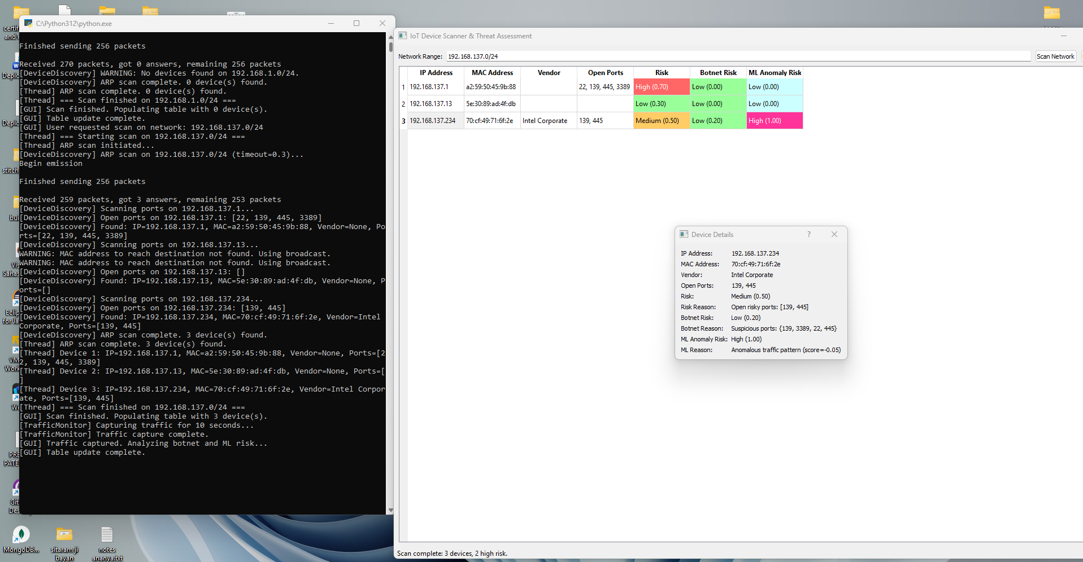

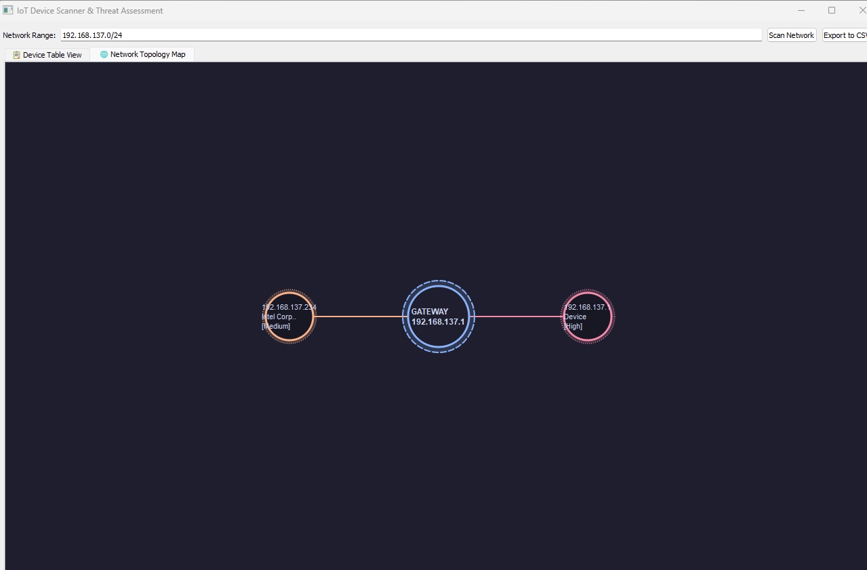

4. Modifications Implemented
Docker Port Forwarding Fix: Container execution was changed to explicitly expose port 6080, restoring browser access to the noVNC interface.
Native Windows Administrative Execution: Native Windows execution was configured with UAC elevation so Scapy could access the physical Wi-Fi/network adapter for Layer-2 ARP discovery.
Custom Network Topology Module: A new src/ui/topology_view.py module was developed for an interactive PyQt5 node graph supporting zooming, panning, dragging, and dynamic layout.
Rich Device Cards: Simple topology nodes were changed into detailed cards containing device category, IP address, vendor, location, VLAN, and risk information.
Automatic Device Categories: The topology can assign categories/icons such as IP Camera, Router/AP, Smart TV, Printer, Mobile/Tablet, IoT Device, or Workstation based on the project's configured indicators.
VLAN and Access Point Metadata: The application was extended with subnet-to-VLAN mapping and local access-point location tagging, for example 192.168.137.x → VLAN 137 and Hotspot-AP.
Dual-Tabbed GUI: The main interface was changed to a QTabWidget containing the Device Table View and the Network Topology Map.

5. Current System
The current application provides a dual-view interface. The first tab presents the detailed device inventory, while the second tab provides an interactive network topology visualization. The topology uses rich device cards and risk-based visual highlighting to make the discovered network easier to interpret.

5.1 Current Data Displayed
- IP address
- MAC address
- Vendor/manufacturer
- Open ports
- Static risk
- Botnet risk
- ML anomaly risk
- Device category
- Location/access-point metadata
- VLAN metadata
- Gateway relationship in the topology map

6. Before vs. After
Feature | Initial State | Current State
Interface | Data table only | Dual-tab table + interactive topology graph
Topology | Not available | Rich card node graph with category icons and risk indicators
Windows execution | Manual setup | UAC-assisted native execution
Docker Web UI | Port mapping blocked | Port 6080 forwarding restored
Layer-2 discovery | Restricted in standard Docker bridge | Physical-adapter discovery through native Windows execution
Location/VLAN | Not available | Added as metadata enrichment
Risk display | Text labels | Visual risk badges/card borders

7. Tested Environment and Results
The system was tested on Windows 11 Home/Pro using Python 3.12.2, PyQt5 5.15.11, and Scapy 2.7.0. The active test subnet was 192.168.137.0/24 using a Windows Mobile Hotspot over Ethernet.
- The default gateway was identified as 192.168.137.1.
- Connected client categories included workstations, mobile devices, and network client nodes.
- The subnet ARP scan completed in less than 0.5 seconds in the documented test environment.
- A 10-second background traffic-monitoring window was used for the IsolationForest-based anomaly scoring.
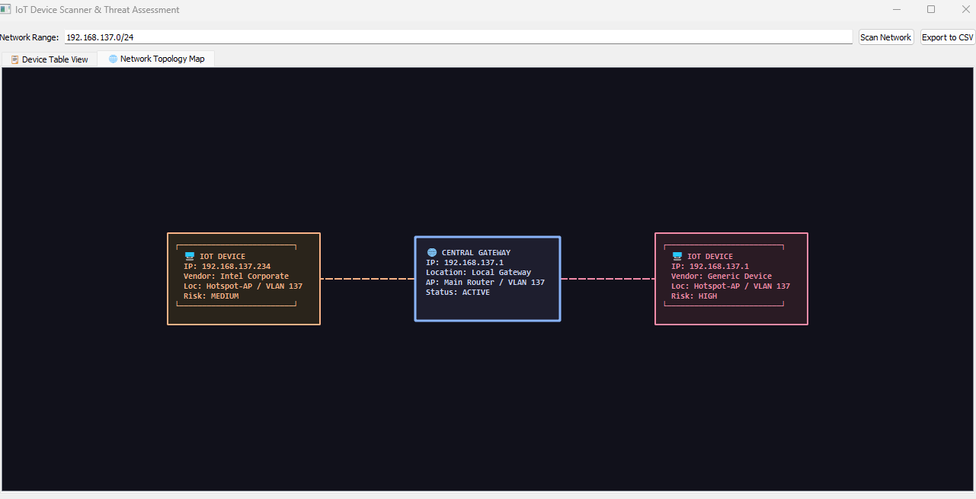

7.1 Final Graphical Interface & Topology Execution Result
The finalized IoT Risk Detector & Cyber Defense Dashboard executes in a high-contrast Light Theme. The interactive topology map visually renders the core Gateway Router connected to all verified active physical host devices with clear medium connection labels (Ethernet / LAN vs. Wi-Fi), risk scores, and device cards.
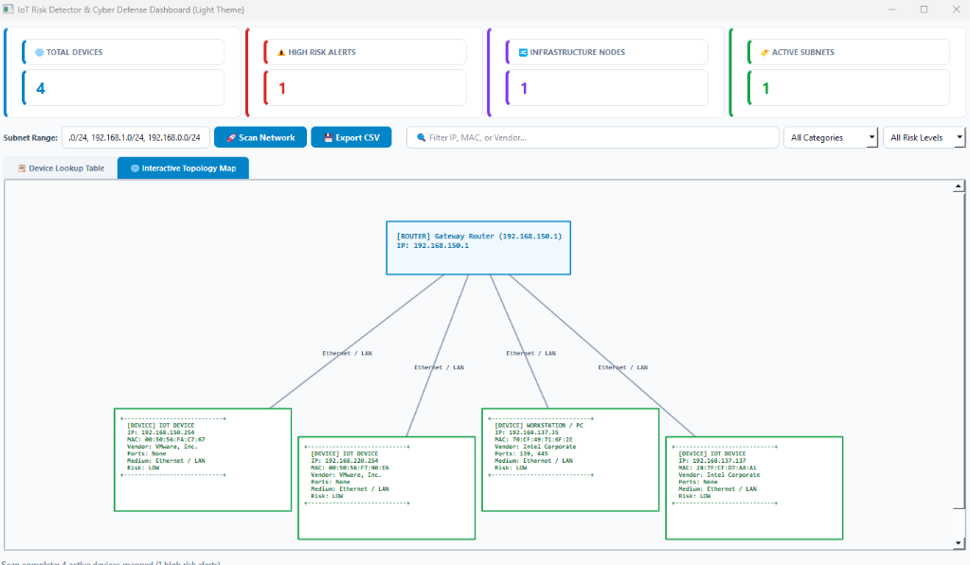
Figure 1: Final Light-Theme IoT Risk Detector & Cyber Defense Dashboard with Interactive Topology Map

8. Current Limitations
- • Specialized IoT Device Discovery Scope: The system cannot discover all specialized IoT devices such as certain IP cameras (e.g. cameras operating on custom proprietary discovery protocols, uninitialized IP addresses, or isolated VLAN subnets).
• Device Naming and Labeling Constraints: The system cannot name or label all devices properly; when hostname resolution, mDNS/SSDP service strings, or MAC OUI manufacturer details are generic or missing, devices default to generic labels such as 'IoT Device' or 'Workstation / PC'.
• Direct Switch Connection (No Physical AP Distinction): The discovery engine directly connects discovered endpoints to the Gateway Router / Switch ('Ethernet / LAN') instead of distinguishing physical Access Points (AP) or wireless channels, as physical Wi-Fi controllers are not queried via SNMP/LLDP.
• ARP Discovery Domain: ARP discovery is limited to the local Layer-2 broadcast domain and cannot by itself cross routed Layer-3 boundaries.
• Administrative Privileges: Raw socket packet operations require administrator/root privileges.
• MAC OUI Dependency: MAC OUI vendor resolution depends on access to api.macvendors.com; offline operation falls back to local OUI prefix definitions or Generic Device.

9. Recommended Next Development
- Integrate actual switch/AP/controller information where available.
- Map endpoint MAC addresses to switch ports using network-device forwarding tables.
- Use SNMP and/or LLDP/CDP to discover infrastructure relationships.
- Obtain VLAN and AP information directly from network infrastructure instead of relying only on inferred metadata.
- Improve device-type classification using hostname, DHCP fingerprinting, mDNS/SSDP, services, and other available evidence.
- Support multiple routed subnets/VLANs by discovering and scanning them individually.
- Extend the topology map to represent actual infrastructure paths between endpoints and the gateway.

10. Conclusion
The project has been developed from an existing IoT network scanner and threat-assessment application into a more comprehensive network-visibility prototype. The original discovery, port profiling, traffic monitoring, and risk-assessment capabilities have been retained, while the interface and topology functionality have been enhanced. The current system provides a useful foundation for IoT asset discovery and risk assessment, with accurate infrastructure-level topology discovery identified as the next major enhancement.

