PRIVILEGED & CONFIDENTIAL – ATTORNEY / CLIENT WORK PRODUCT PREPARED IN ANTICIPATION OF ARBITRATION
PROJECT NAME
EXPERT REPORT ON QUANTUM, SCHEDULING, OR PROJECT MANAGEMENT
Author: Name and Post-Nominal Letters
Prepared for:
Name of Law Firm

On Behalf of:
Name of Client Line 1
Name of Client Line 2 (If necessary)

Case No. _____________
(Line for additional Case Information)

Delete this Note after Creating Report Depending on the dimensions of your photo, you may need to move down the report date to center it between the photo and the LI logo.
Delete this Note after Creating Report
Use full names (first, middle, and last). For post-nominal letters, only use periods for P.E., P.Eng., Ph.D., and M.B.A., not for CCP, CCE, PSP, etc.
DRAFT
Delete this Note after Creating Report Type the project name and title in all caps.
Use initial caps for author names.
PRIVILEGED & CONFIDENTIAL – ATTORNEY / CLIENT WORK PRODUCT PREPARED IN ANTICIPATION OF ARBITRATION
DD Month YYYY
Table of Contents
1. REPORT TEMPLATE 1
2. XXXXXX XXXXX 2
3. XXXXXX XXXXX 4
4. XXXXXX XXXXX 5
4.1 Xxx Xxxxx 5
4.1.1 Xxx Xxxxx 5
5. XXXXXX XXXXX 7
5.1 Xxx Xxxx 7
6. XXXXXX XXXXX 8
7. XXXXXX XXXXX 9
7.1 Xxx Xxxx 9
7.2 Xxx Xxxx 9

List of Tables
Table X.X-X: Xxxxx Xxxx 17
Table X.X-X: Xxxxx Xxxx 22

List of Figures
Figure X-X: Xxxxx Xxxx 19
Figure X-X: Xxxxx Xxxx 19
Figure X-X: Xxxxx Xxxx 21

List of Attachments
Attachment LI-01 Curriculum Vitae of Testifying_Expert
Attachment LI-02 Curriculum Vitae of Assistant #1
Attachment LI-03 Curriculum Vitae of Assistant #2
Attachment LI-XX Curriculum Vitae of Assistant #3
Attachment LI-XX Xxxxx Xxxx
Attachment LI-XX Xxxxx Xxxx
Attachment LI-XX List of Documents Reviewed/Received
Attachment LI-XX Exhibit Index

List of Exhibits
Exhibit 1 Xxxxx Xxxx
Exhibit 2 Xxxxx Xxxx
Exhibit 3 Xxxxx Xxxx
Exhibit 4 Xxxxx Xxxx
Exhibit 5 Xxxxx Xxxx

HARBOR CROSSING PROJECT

EXPERT REPORT ON SCHEDULE DELAY

INTRODUCTION
- This Report presents the opinions of the author regarding the causes of delay to the Harbor Crossing Project (the “Project”). The Project comprised the design and construction of a two-lane vehicular bridge and approach roads between the owner’s east and west terminals. Long International, Inc. (“Long International”) was retained by counsel for Harbor Authority (the “Owner”) in the arbitration between the owner and Marine Civil Builders, Inc. (the “Contractor”).
- The following topics are discussed in the sections below:
  - Author and Assistants of this Report (Section 1.1)
  - The Parties, the Project, and the Dispute (Section 1.2)
  - Documents Reviewed and Relied Upon (Section 1.3)
  - Acronyms (Section 1.4)

Author and Assistants of This Report
- The author of this Report is J. Doe. J. Doe was assisted by A. Smith and B. Jones. Although I received assistance from A. Smith and B. Jones, all opinions in this Report are mine.
- Each author’s role is described below:
  - J. Doe, testifying expert, is responsible for all opinions expressed in this Report. A copy of the curriculum vitae of J. Doe is included as Attachment LI-01.
  - A. Smith provided analysis and writing support at the direction of J. Doe, including:
    - Review of the contractor’s schedule updates;
    - Preparation of the as-built schedule; and
    - Preparation of tables and figures, including:
      - Delay quantification tables;
      - Critical path figures, which were prepared from:
The contractor’s monthly updates; and
The owner’s daily reports.
  - B. Jones managed the document and exhibit database.

The Parties, the Project, and the Dispute

Parties
- The owner is a public authority responsible for the two terminals. The contractor is a marine civil works contractor engaged under a design-build contract dated 3 April 2019 (the “Contract”).

Project Overview
- The Contract sum was US$212,400,000 and the Contract required Substantial Completion within 730 calendar days of Notice to Proceed, 16 below describes the key milestones.

Disputes Between the Parties
- The contractor claims an extension of time of 214 days and associated compensation. The owner asserts that the delays were caused by the contractor’s late mobilization of the marine piling equipment and by defective work that required rework, as discussed in Section 3.

Documents Reviewed and Relied Upon
- In preparing this Report, I reviewed the following categories of documents:
- Pleadings and witness statements;
- The Contract and its amendments;
- Baseline schedule and 24 monthly schedule updates;
- Daily reports, meeting minutes, and correspondence; and
- The contractor’s expert report dated 12 January 2026.
- Documents referenced in this Report are identified by exhibit number in footnotes.

Acronyms
- Various acronyms are used throughout this Report. These acronyms and their definitions are listed below in Table 1-1.
Table 1-1: Acronyms
Term | Definition
AACE | AACE International
CPM | Critical Path Method
EOT | Extension of Time
NTP | Notice to Proceed
SC | Substantial Completion

EXECUTIVE SUMMARY
- It is my opinion that the contractor was responsible for 168 of the 214 days of delay to Substantial Completion, and that 46 days were excusable but non-compensable. The basis for these opinions is summarized below and detailed in Sections 3 and 4.
- The principal findings are:
- The marine piling equipment mobilized 61 days late;
- Rework of the east abutment consumed 47 days on the critical path;
- Owner-caused permit delays consumed 46 days; and
- The remaining 60 days resulted from the contractor’s resequencing of the deck pours.

SCHEDULE ANALYSIS
- This section describes the method applied and the results of the analysis. The AACE International Recommended Practice 29R-03 states:
In order for a claimant to be entitled to an extension of contract time for a delay event (and further to be considered compensable), the delay must aﬀect the critical path.
- The footnote to the excerpt above follows the quotation, not the introducing sentence.

Method
- I applied a contemporaneous period analysis (i.e., a windows analysis) using the contractor’s monthly updates. The contractor’s expert stated that “the baseline schedule was never approved,” which is incorrect.
- Key milestones were as follows:
  - Notice to Proceed: 15 May 2019;
  - Contractual Substantial Completion: 14 May 2021; and
  - Actual Substantial Completion: 14 December 2021.
- Analysis inputs included:
      - Baseline schedule
      - Monthly updates
- Updates 1 through 12
- Updates 13 through 24
      - Daily reports

Results by Window
- The critical delay accumulated over the analysis period is shown in Figure 3-1 below.
Figure 3-1: Cumulative Critical Delay by Month
Synthetic data prepared for template testing.

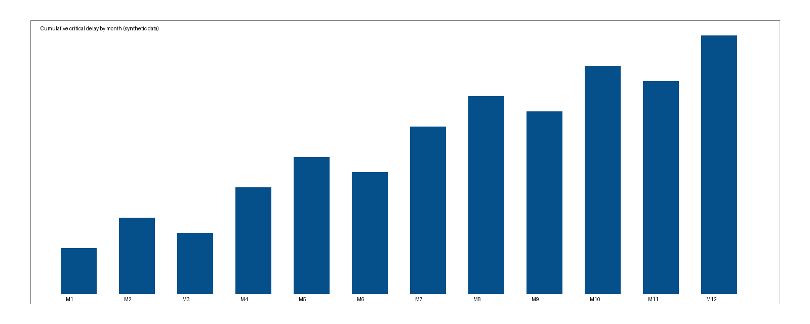
- The delay by window is quantified in Table 3-1.
Table 3-1: Critical Delay by Window
Days of delay to Substantial Completion; negative values indicate recovery.
Window | Period | Delay (days) | Cumulative (days) | Responsibility
1 | May–Aug 2019 | 61 | 61 | Contractor
2 | Sep–Dec 2019 | 12 | 73 | Contractor
3 | Jan–Jun 2020 | 46 | 119 | Owner
4 | Jul–Dec 2020 | 47 | 166 | Contractor
5 | Jan–Dec 2021 | 48 | 214 | Contractor

Table 3-2: Delay Event Register
No. | Event | Start | Finish | Days | Critical? | Responsibility | Exhibit
1 | Late mobilization of piling barge | 15 May 2019 | 15 Jul 2019 | 61 | Yes | Contractor | C-0102
2 | Permit revision for cofferdam | 3 Feb 2020 | 20 Mar 2020 | 46 | Yes | Owner | O-0031
3 | East abutment rework | 8 Sep 2020 | 25 Oct 2020 | 47 | Yes | Contractor | C-0217
4 | Deck pour resequencing | 4 Jan 2021 | 5 Mar 2021 | 60 | Yes | Contractor | C-0301
Add or delete rows and columns and adjust column widths as necessary.

QUANTUM SUMMARY

- The contractor’s claimed damages of US$18,300,000 include US$4,100,000 of extended overhead that is attributable to the 46 days of owner delay. The remainder is attributable to the contractor.

Heading 4 Example in Initial Caps
- Heading 4 is used here only to exercise the style.

Heading 5 Example in Initial Caps
- Heading 5 is used here only to exercise the style.

Heading 6 Example in Initial Caps
- Heading 6 is used here only to exercise the style; guidelines discourage levels beyond four.
- The instructions for a bulleted list under a numbered list follow (Guidelines Section 7.4):
  - Type a sentence in the style Numbered Paragraph L1.
- Choose the style List bullet under a numbered list.
- Write an entry.
  - Type the next sentence in Numbered Paragraph L1.

EXPERT’S DECLARATION
- I, J. Doe, declare that:
  - I understand that my duty in providing written reports and giving evidence is to assist the Tribunal and that this duty overrides any obligation to the party who has engaged me;
  - I believe that the facts I have stated in this Report are true and that the opinions I have expressed are correct; and
  - I confirm that I have not entered into any arrangement where the amount or payment of my fees is in any way dependent on the outcome of the case.
Signed:
J. Doe
Date: 15 September 2026

See Attachment LI-08, Exhibit Index.
AACE International, Recommended Practice 29R-03, Forensic Schedule Analysis, Section 1.5.B.6, p. 18. [X-0012]
Contractor’s Expert Report, para. 4.12, p. 31. [C-0044]
Contractor’s Statement of Claim, para. 112, pp. 44–45. [C-0001]

