UNIVERSITY OF LONDON
GOLDSMITHS COLLEGE

B.Sc. Examination 2018

COMPUTING AND INFORMATION SYSTEMS

IS53002A Neural Networks

Duration: 2 hours 15 minutes

Date and time:

This paper is in two parts: part A and part B. You should answer ALL
questions from part A and TWO questions from part B. Part A carries
40 marks, and each question from part B carries 30 marks. The marks
for each part of a question are indicated at the end of the part in
[.] brackets.

Electronic calculators must not be programmed prior to the examination. Calculators which display graphics, text or algebraic equations are not allowed.

THIS PAPER MUST NOT BE REMOVED FROM THE EXAMINATION ROOM

Part A. Question 1.

a) Which are the 4 main structural characteristics of artificial neural networks? [8]

b) Explain briefly what is the difference between feedforward and recurrent neural
networks with respect to their connectivity pattern. [4]

c) Consider a fully connected Multi-layer Perceptron neural network with 3 hidden
nodes and 2 inputs without bias terms. All nodes in this network use sigmoidal
activations. Write down the equation for calculating the hidden error derivative
beta at the second hidden node, showing step-by-step how the network output is
calculated during the forward pass. Use the notation for the weights, inputs and
node outputs given in the figure below: [16]

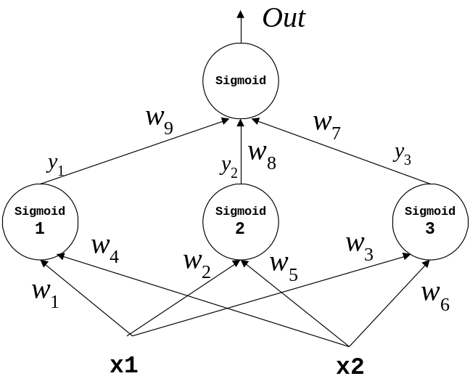

d) Give the two main groups of neural network committees and explain which
are the training methods developed in each of them. [12]

IS53002A 2018 TURN OVER
Part B. Question 2.

a) Write down the training rule for single-layer sigmoidal Perceptron networks
and explain the meaning of every variable in it. [6]

b) A single-layer sigmoidal Perceptron network is given for training. There are
2 inputs x₁ and x₂ (without bias) passed to the neuron, each associated with
a corresponding weight. Demonstrate training of this sigmoidal Perceptron
using learning rate η=0.15 and the following examples:
x₁ | x₂ |  | y
0.15 | –0.2 |  | 0.5
0.2 | 0.1 |  | 1.0
0.25 | –0.1 |  | 0.55

Show the weight updates computed with the incremental (online) gradient descent
training algorithm, starting with initial weights: ( w₁, w₂ ) = ( –0.1, 0.25 ). [24]

IS53002A 2018 TURN OVER
Part B. Question 3.

a) A Radial-basis function (RBF) network with 2 neurons each having Gaussian basis
functions is given. Let the initial weight vector be: w = ( 0.15, –0.2 ). Assume
that the basis function variances are: s² = ( 0.12, 0.14 ), and the
corresponding centres are: c₁ = ( 1, 0 ) and c₂ = ( 0, 1 ).

i) Give the analytical formula for computing the RBF network output including
the calculations performed in each network node. [8]

ii) Calculate the RBF network output with the following training input vector
x = ( 0.2, 0.4 ) (with precision up to and including the fourth digit after
the decimal point). [14]

b) Describe briefly the five differences between Multilayer Perceptron (MLP) neural
networks and Radial-basis function (RBF) networks? [8]

IS53002A 2018 TURN OVER
Part B. Question 4.

a) Explain briefly what operations are performed in each of the three main phases of
the training algorithm for self-organizing Kohonen networks. [6]

b) Draw a picture of a self-organizing Kohonen neural network with 2 neurons
and 3 inputs. Show the inputs and weights with their indices. [8]

c) Consider a self-organizing Kohonen network with 2 neurons and 2 inputs
feeding each neuron. Assume that the initial weight vectors are: w₁ = ( 0.1, –0.15 ),
and w₂ = ( 0.2, –0.1 ).
i) Calculate the outputs from the two neurons in this simple network using
the following input vector: x = ( 0.15, 0.25 ). [8]

ii) Identify the index of the winning neuron. [2]

- Train the weight vector of the selected winning neuron using the training
rule for Kohonen networks assuming learning rate η=0.12. [6]

IS53002A 2018 END OF EXAMINATION

