1: Working with Data

Data Sources
- New Data – created for the sole purpose of the current application. Obtaining data: add on-demand or bulk data entry.
- Pre-existing Data – already exist prior to application being created. Need manipulate in order to integrate: 1. Extraction: need to recover or extract; 2. Conversion: convert to new format; 3. Cleaning: may contain erroneous or unnecessary info
- External Sources – data providers, crowdsourcing. Advantage: come pre-cleaned and in a format easily consumed, save manpower and money, delegate expertise. Limitation: no control over quality and structure, may be incomplete, ambigious, may be different from what we need.

Sharing Data
- There are legal restriction the use of data.
- Reason to share open data: commercial reason (drive sales); ethical reason (common good); contractual requirements (gov’s budget); interoperability (postcode).
- Reason NOT to share open data: restriction on source data; control of use; value of the data; data sensitivity; data privacy.
- Challenges: Default legal positions on data use are complex (differing jurisdictions); Variations in copyright laws globally complicate data usage terms.
- Licensing Concepts: Licenses (granting – what a licensee can do) and waivers (relinquish rights – remove infringement concerns) are key legal instrument.
- Common License Terms: Attribution; copyleft and non-commerciality clauses

Shape of Data
- Programming Languages: Data types (float, int, etc.); Data Models: Relations between different data.; Data Serialization: Data formats used for transmission.; Exchange Protocol: standardisation for information exchange, i.e. unix socket, named pipes.; User Interfaces: for humans to consume.
- Table: structured representation of data where info is organised into rows (entities) and columns (attributes). Strengths: direct, easy to understand, suitable for structured data, efficient searching. Weaknesses: not suitable for hierarchical data.
- Tree: based on metaphor of a real tree. Strengths: suitable for hierarchical data, can span levels deep. Weaknesses: each node can only have single parent.
- Graph: nodes can have multiple parents. Strengths: flexible than a tree. Weaknesses: inefficient for searching in some cases
- Blobs, Media, Complex Data: raw data representation without perceivable structure, i.e. raw audio file; use to extracted features instead of structured fields

Open Data
- generally means: Cost-free access; Barrier-free access (findable); Barrier-free use (accessible); Restriction-free use (reusable).

FAIR Data
- Findable, Accessible, Interoperable, Reusable.

2: Relational Databases
- A Relational Database implements the Relational Model; but not necessarily true. Relation ≈ Table, is a definition of a table and all the values stored in it.
- The set of rules – Everything is a Relation: all operations use the relational model; all data is represented and accessed as relations; table and database structure is accessed and altered as relations; It should be robust abstracted system, unaffected by: hardware changes; operating system changes; disk replacement; distributed data
- Relational Model ≠ SQL ≠ RDBMS implementation: Relational Model is not the same as Entity-Relationship Model; ER Model helps us model concepts, as part of the design of a Relational Database; SQL is a partial of the Relational Model.

The Entity-Relationship Model
- Is a abstract model, not necessary tied to relational database, can be used for other implementation (programming object model). Entity: is the thing we want to model, must be uniquely identifiable and may have attributes. Relationship: is a connection or dependency between two Entities.
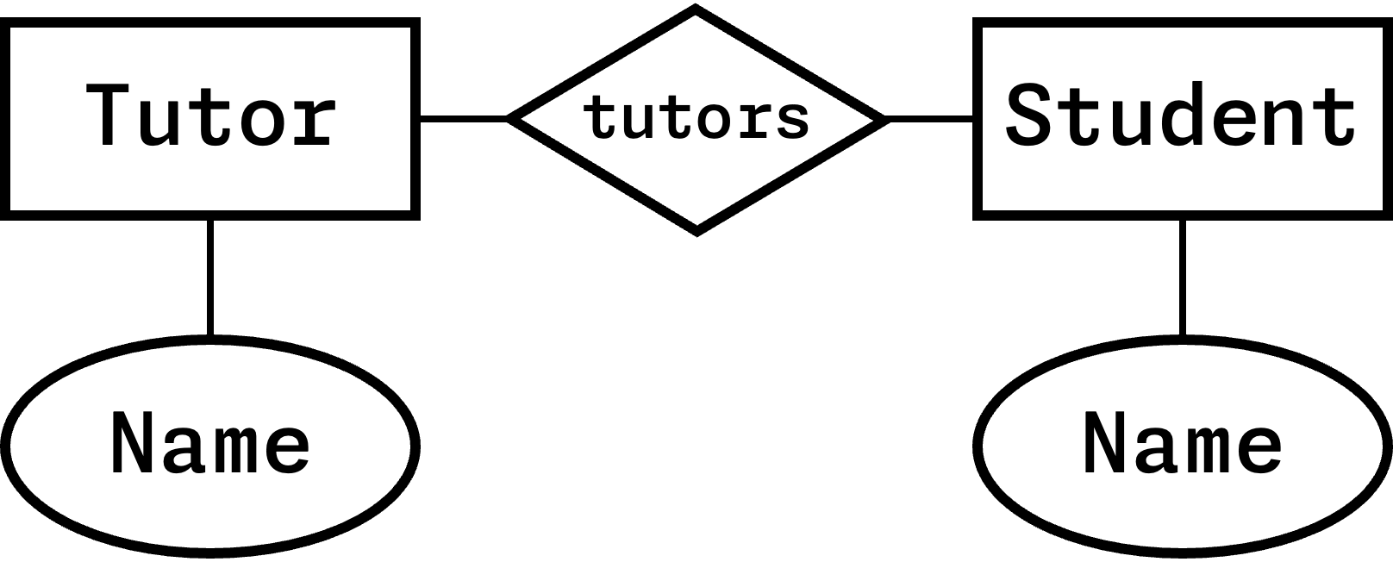

SQL
- commands for manipulating structures CREATE, DROP, TRUNCATE, ALTER, or manipulating data INSERT, SELECT, UPDATE, DELETE or retrieve information SELECT
CREATE TABLE Planets (ID INT AUTO_INCREMENT, PlanetName CHAR(8), DayLength INT, YearLength INT, PRIMARY KEY (PlanetName));
UPDATE Planet SET YearLength = 24 WHERE PlanetName = "Mars";
SELECT PlanetName FROM Planets WHERE DayLength > 200;
SELECT Planet.Name, Moon.Name FROM Planet INNER JOIN Moon ON Planet.Name=Moon.HasPlanet WHERE Planet.DayLength < 11;

Joins
- Cross Join (Cartesian Join): [SELECT * FROM A, B] joins all – expensive af – combines each row of first table with each row of second table; total rows is product of all entries in all tables a · b · c…
- Inner Join: [SELECT * FROM A INNER JOIN B ON A.id = B.id] only combine with matching values
- Left Join: [SELECT * FROM A LEFT JOIN B ON A.id = B.id] all records on left and matching values on right (right may be empty)
- Right Join: [SELECT * FROM A RIGHT JOIN B ON A.id = B.id] the opposite of Left Join.

Cardinality
- refers to how many rows in each of the table participate in a join match with how many rows in other table.
- 1:n – one row in A joins with zero or more in B, i.e B with a FK referencing a PK in A.
- 1:1 – one row in A with exact one row in B, i.e. a table with a PK
- m:n – any number of rows in A joins with any number of rows in B, i.e. a pivot / link / junction table with PK (attributeA, attributeB).

Database Integrity
- Common Errors: Typo; Missing, invalid, inconsistent, duplicate data; Referential integrity error (deleted a planet but not its moon).
- Join fields must match – use FK, subsequent INSERT with wrong value will fail.
- Validity check – use CHECK column constraint.
- Uniqueness (Consistency) – use PK to guarantee uniqueness.
- Computed Values (Consistency) – don’t store them, i.e. count, sum, product
- Change should not cause inconsistency – use FK rules, i.e. ON DELETE CASCADE.
- Table values should not be inconsistent – remove functional dependencies.

Normalisation
- Non-loss decomposition: is the decomposition of a single relationship into two or more relations, such that a join on the separate relations reconstructs the original.
  - Example – If X = (P, Q, R) decomposes into X1 = (P, Q) and X2 = (Q, W), where Q is a common attribute and is unique, thus non-loss (lossless) join is possible.
- Functional Dependency (FD): the value of one attribute (determinant) determines the value of another attribute (dependent), i.e. ID -> X, ID -> Y. (if we know ID, we also know X and Y, hence ID).
- Partial Dependency (PD): If ID -> {X, Y, Z} but X -> Y and not ID -> Y, then it is PD.
- Transitive Dependency (TD): Indirect relationship. Given FD Book -> Author Country, but Book -> Author and does not Author -> Book. Since Author -> Author Country, hence Book -> Author Country is TD.
- Candidate Key: attribute that uniquely identifies a row in a relation, could be a combination of (non-redundant) attributes, whilst each non-key attribute is functionally dependent on every candidate key.
- Normal forms – a set of rules to minimise anomalies, allow for insertion, deletion and update without causing data inconsistencies.
- 1NF: All the attribute are single-valued (atomic) (not array); have unique names; and order in which data is stored does not matter.
- 2NF: Every non-key attribute is fully dependent on the primary key; does not have partial dependency.
- 3NF: Does not have any transitive dependency.
- Boyce and Codd Normal Form (BCNF): For all X -> Y, X is a super key.
- 4NF: No multi-valued dependency (exist multiple of same ID in a table).

Atomic, Consistency, Isolation, Durability (ACID)
- Atomicity (rollback): guarantees an operation that only make sense as a group, either fully completed or nothing happen.
- Consistency: guarantees never in inconsistent state, when a group operation is being executed, other operations not allowed to access or modify that will lead to inconsistency.
- Isolation: guarantees concurrent transactions leave the database in the same state as if they were executed sequentially.
- Durability: guarantees once a transaction is committed, it remains committed in event of failure.
- Transaction: mechanism for treating group operation as a block. BEGIN TRANSACTION, .... COMMIT; In cases of error, it can be ROLLBACK; that undo the inconsistent state.
- Malice and Accidental Damage
  - SQL Injection: adding malicious code into normal operation.
  - Privilege Escalation: malicious agent gaining direct access to the database.
  - User Error: intends to do one thing but does something else entirely.
  - Non-confidential Data Sharing: being shared inappropriately.
- Security and User Policies with SQL
  - Fine-grained controls – user level, database level, table level and data.
  - Grant access: GRANT <COMMAND || ALL> ON <RESOURCE> TO <USER / ROLE> WITH GRANT OPTION;
  - Revoke Access: REVOKE <COMMAND || ALL> ON <RESOURCE> TO <USER / ROLE>;
  - Create Role: CREATE ROLE <Name>;
  - Delete Role: DROP ROLE <Name>;
  - Assign Role: GRANT <RoleName> TO <USER>;

SQL Functions
- SUM, AVG, STD, VARIANCE, MAX, MIN, COUNT, COUNT(DISTINCT <col>), GROUP_CONCAT(<col1>, <col2, ...)

Query Efficiency
- Expensive in DB: Searching (checking value on every entry), Sorting (ordering data), Copying (reading and writing).
- If data is sorted - using sorted table: can use binary search (clustered indexing), use no extra space, O(log n) – but can only use one column to be primary key.
- Using indexes: B-tree or Hash table – keeps in memory, rather than disk.
- B-tree – uses the concept of Binary Search Tree.
- Hash table – can’t support range searching or approximate searching.
- Denormalisation – joins can be expensive, trades off integrity checks and reduce storage requirements.
- Create a View – create virtual table (i.e. pre-joined) that can query data.

Distributed Databases
- Reason why – parallelisation, no single point of failure, dividing large dataset (into divided chunk that can be processed locally)
- Requirements for DD: Local Autonomy (sites operate independently); No Centralisation (no single site controls transactions or operations); Continuous Operation (available most of time and reliable); Location Independence (user doesn’t need to know where data is located); Partition Independence (user doesn’t need to know how data is partitioned); Replication Independence (user doesn’t need to be aware replication is used); Distributed Queries (query is sent to closest location); DBMS Independence (distribute data over different DBMS system)
- Partitioning – Vertical Partitioning (divide by columns); Horizontal Partitioning (divide by rows).
- Catalogue Management – information of the data being distributed
- Recovery Control – usually two-phase protocol (every node is locked for the duration, completes its operations, only confirms when every nodes is happy), where there’s one site acts as coordinator in any given transaction.
- Brewer’s Conjecture – three goals in tension (conflicting with each other, can’t fully satisfy all at once): Consistency – all parts should converge on consistent state; Availability – every request should result in response eventually; Partition Tolerance – a network flaw breaks the network into separate subnets, the database should run and recover.

Alternative Distributed Database
- If distributing databases is complex, why not simplify data structure.
- Key-Value Databases: has two columns – key and value. 1. Easy parallel processing; 2. Easy partition; 3. Partition is always horizontal; 4. Processing must happen near the table where possible.
- MapReduce: algorithm for processing key-value datasets, consist of map procedure (filtering and sorting) and a reduce procedure (summary operation), hence MapReduce.
  - Map Phase – with direct access to database, loops over all data, outputs a new key-value set. (extract large data to chunks of data, i.e. map(word, value) outputs key “word”, value “1”)
  - Reduce Phase – carried out by reducer workers, summarise the data based on a key. (performs further reduction on mapped chunks of data based on key, i.e. reduce(word, values) adds all values “count” for key “word”)

Document Database; alternative to DD
- Document Databases: middle ground between key-value and relational databases.
- Less strict; can be nested; can be repeated; can be order-sensitive. Follows a tree structure.
- less interlinking, or less important for data retrieval. (a trade off for the flexibility)
- Formats: Markup languages for text; Markup languages for other data; Bespoke formats; JSON.
- MongoDB is one implementation of such, capable of distributing by means of sharding (horizontal partitions of data).

MongoDB “SQL”
// INSERT
db.col.insertOne(data);
db.col.insertMany([...])
// READ
db.movies.findOne({year: 2015});
db.movies.find({title: /^Man*/})
// UPDATE
db.movies.updateOne({title: "ABC"}, {$set: {year: 2015}})
db.movies.updateMany({actors: "Elle"}, {"actors.$": "Ele"})

3: Semantic Databases
- share more meanings on the data – specifications about the data and syntax on how to validate.
- Machine-readable Semantics: enabling computer systems to interpret data and make inferences based on shared semantics.
- Deductive Databases: rules and logics to deduce new information from existing data.
- Semantic web: is a domain that focuses on enhancing the meaning and interoperability of data on the internet.
- Levels of sharing data: 1. Sharing Documents (carry semantics); 2. Formal Specifications (in computer readable form); 3. Human-readable Definitions.

eXtensible Markup Language (XML)
- let us define and store data in a shareable manner, has tree structure.
- Well-formed XML: adheres to the basic syntactic rule of XML.
- Valid XML: whether it conforms to a specific XML schema or Document Type Definition (DTD)
- XML vs RDBMS: XML gives a different; looser structure, harder to index; supports richer searching (and indexing), usually parallelisable; can be shared directly; can be targeted by web links.

Transforming XML “Querying”
- allow to transform XML into another XML or other formats
- Two primary languages: 1. eXtensible Stylesheet Language Transformation (XSLT); 2. XQuery.
- XSLT: works like templating.
<xsl:template match="element">
<table>
<xsl:apply-templates select="*" />
</table>
</xsl:template>
<xsl:template match="child">
<tr>
<xsl:apply-templates select="." />
</tr>
</xsl:template>
<xsl:template match="nestedChild">
<td>
<xsl:value-of select="nestedElement" />
<td>
</xsl:template>
Alternative:
<xsl:template match="element">
<table>
<xsl:for-each select="child">
<tr>
<td><xsl:value-of select="nested" /></td>
<tr>
</xsl>
</table>
</xsl:template>
- XQuery: intended to be SQL-like, simpler syntax – FLWOR: F for clause, L let clause, W where clause, O order by clause, R return clause.
<table>
{
let $doc := doc("some.xml")
for $child in $doc/elementA
where $doc/price > 30
order by $doc/title
return
<tr>
<td>{$child/nestedElement/text()}</td>
<td>{$child/../elementB/text()}</td>
</tr>
}
</table>

XML Schema
- Document Type Definition (DTD): oldest one, inherited from SGML, limited.
in document,
<?xml version="1.0"?>
<!DOCTYPE authors SYSTEM "http://...library.dtd">
in schema document,
<!ELEMENT authors (authors)+> -- allow one or many
- XML Schema Definition (XSD): recommended by W3C for formally describe elements.
in document,
<authors xmlns="http://..." xml:id="authors.xsd">
</authors>
in schema document,
<xs:element name="authors">
<xs:complexType>
<xs:element ref="author" minOccurs="1" maxOccurs="unbounded" />
</xs:complexType>
</xs:element>
<xs:element name="author" type="xs:string" />
- RELAX NG: REgular LAnguage for XML Next-Gen specifies a pattern for the structure and content, whether in XML (below) or other syntax.
<element name="authors">
<oneOrMore>
<element name="author">
<text />
</element>
<oneOrMore>
</element>
- Schematron: structural schema language written in XML using elements and XPath, generally used as integrity checks and combine with another schema.
<rule context="//date">
<assert test="date &lt; current-date()">
Invalid date
</assert>
</rule>
- One Document Does it all (ODD): superset language that generates all the different languages – DTD, XSD, etc. Text Encoding Initiative (TEI) develops an ODD.
- Schema defines – which elements are used, what can they contain, what data is passed, what order, what attributes are used, what structures are equivalent, what structure is mutually exclusive.
- They are used to encode structures (create), validate encodings (debug or enforce integrity), support programming with documents (auto-generate class definitions) or machine reasoning (computer deduce meaning).

4: Linked Data & Semantic Web
- Web Links: Links are one-way, no permission needed, no central registry of links.
- Uniform Resource Locator (URL) / Uniform Resource Identifier (URI): Guarantees unique, responsibility of maintenance (has domain name owner), unlimited number of URLs, unique ID independent of server.
- Remote Description Framework (RDF): a model representation of linked data on the web based on triples.
- URLs are key to solving challenges – maintaining keys on the web; finding data on the web; sharing meaning; sharing entities.

Remote Description Framework (RDF)
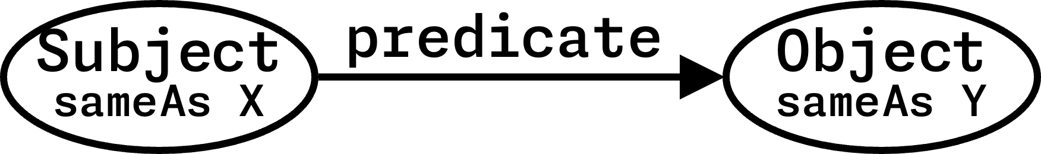
- Linking Data: Subject and Predicate must be URIs (ideally URLs). Object can be URI or string, number, date, etc. sameAs predicates can connect URIs that represent the same time.
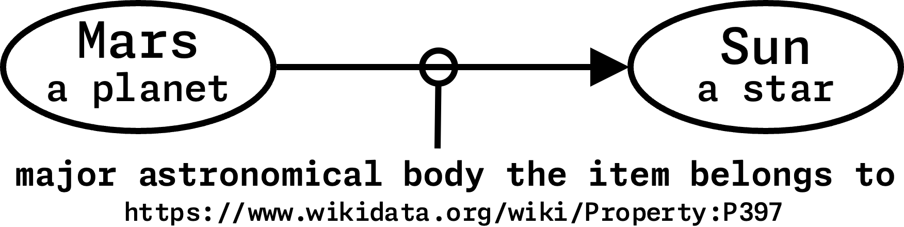

- Dereferencing: OK – URLs can just be ID – don’t need to resolve; Better: Give data about the URI; Best: Content negotiation (human readable in browsers, linked data for machines)
- Serialisations:
- n-triples (simple): list the triples
<Subject URI> <Predicate URI> <Object URI>.
- Turtle (easy): written in a compact natural text form.
PREFIX et: <http://.../entity>
PREFIX dt: <http://.../direct>
et:Deimos a et:Moon; dt:satelliteOf et:Mars .
- RDFa (Mixable): add tiny amounts of RDF into HTML
<div vocab="http://schema.org/" typeof="Person">
<a property="image" href="http://...manu.png">
<span property="name">Manu Sporny</span></a>,
<span property="jobTitle">Founder/CEO</span>
<div>
E-mail: <a property="email" href="mailto:(your emailid)">msporny@digitalbazaar(.)com</a>
</div>
</div>
- JSON-LD: add-on to JS, not exactly a serialisation, graph data
{
"@id": "https://...Deimos"
"@type": "https://...Moon"
"https://...satelliteOf": {
"@id": "https://...Mars"
"@type": "https://...Planet"
}
}
- XML/RDF (Painful): one of the earliest, XML-based serialisation, ugly to read, trying to put tree structure into graph structure (avoid this)

RDF Schema (Web Ontologies)
- Web Ontology Language (OWL): allow us to encode the logic of the system.
- Designing an ontology: 1. use existing ontologies where possible; 2. combine effort with others; 3. test with real data; 4. don’t get lost in rabbit holes (avoid adding unnecessary details); 5. don’t be wrong; 6. designing good ontologies takes times; 6. multiple viewpoints are vital; 7. drawing helps; 8. be as explicit as possible to draw out problems; 9. try out protege for ontology specification

RDF Query Language
- hard to search efficiently, partly because no registry of information.
- Triplestore: one type of graph database, uses RDF to cache a chunk of semantic web.
- SPARQL: SPARQL Protocol and RDF Query Language
PREFIX foaf: <http://...foaf/0.1>
PREFIX ex: <http://...>
SELECT ?friend
WHERE {
ex:Alice foaf:knows ?friend .
}
If we want to know name of person,
SELECT ?fName
WHERE {
ex:Alice foaf:knows ?friend .
?friend foaf:name ?fName .
}
If we want a list of name instead,
SELECT ?fName
WHERE {
ex:Alice foaf:knows+ ?friend .
?friend foaf:name ?fName .
} LIMIT 20
If we want unique list instead,
SELECT DISTINCT ?fName
WHERE {
ex:Alice foaf:knows+ ?friend .
?friend foaf:name ?fName .
} LIMIT 20

5: Multimedia & Information Retrieval
- Core ideas: User has an information need; A need is expressed as a query; Query is executed over data by Information Retrieval system.
- Feature: based on searching the document, but using features; high-level structures created from raw data to extract meaningful information, i.e. metadata. Reasons: helps to move from low-level signal to high-level concepts, reduce complex data to simpler data, define expectation of salience, re-weighted based on task or user. Challenges: bridging the “semantic gap” between user information needs and low-level data.
- Types of Features: tokens (text), zero-crossing (audio), pitch estimation (audio), color regions (image), loudness (audio).
- Feature Space: multi-dimensional space where each dimension represents a specific feature.
- Similarity in Feature Space: distance metrics can be used – Euclidean Distance (shortest distance), Manhattan Distance (summing the absolute difference in each dimention), Identity of Indiscernibles (identical points - 0 distance), Symmetry d(a,b)=d(b,a), Triangular Inequality d(a,c) ≤ d(a,b)+d(b,c).
- Speed & Indexing: Speed in IR is important.
  - Speed: Precompute feature are indices; Many searches are parellelisable (mapReduce); reduce dimensions – can increase speed and reduce irrelevant results.
  - Search: Spatial indexes of metric spaces can be very fast for retrieval; R-trees O(log n) retrieval; built in to some RDBMS packages.
- Measure Success:
  - AT: Actual Total in whole collection, including those haven’t been classified;
∴ AT = TP + FN
  - TR (Total): Total Retrieved (the resulting sample size that was retrieved);
∴ TR = TP + FP
  - TP: True Positives (correctly identified that attribute is absent);
∴ TP = TR * Precision or TR - TP
  - TN: True Negatives (correctly identified that attribute is absent);
∴ TN = Total Collection – AT
  - FP: False Positives (correctly identified that attribute is present);
∴ FP = (TP / Precision) – TP
or TR - TP
  - FN: False Negatives (incorrectly classified that attribute is absent);
∴ FN = (TP / Recall) - TP
or AT - TP
  - Precision: proportion of positive results that are true positives, with few irrelevant (false positives) entries. (user looks for a match)
∴ TP / (TP + FP)
  - Recall: proportion of how many relevant results retrieved, with few (false negatives) not appearing in result set.
(user looks for all matches)
∴ TP / (TP + FN)
  - F-measure: a combined measure that balance precision and recall. (user looks for some matches)
∴ (2 * Precision * Recall) / (Precision + Recall)

