Bugs / Usability Issues / Improvement Suggestions

Env - Windows 11

1. Misleading exclamation mark on the Lord icon
Type: UX issue / misleading notification
Priority: Medium
Screenshot: Screenshot 1
Description:
The Lord icon shows an exclamation mark even when the player cannot make an exchange or claim anything. This creates a false expectation that there is an available action inside.
Why it matters:
An exclamation mark usually means that the player should do something: claim a reward, complete an exchange, open a new task, etc. If there is no available action, the indicator becomes distracting and annoying.
Expected result:
The exclamation mark should appear only when there is an actual available action.
Actual result:
The indicator is shown, but there is no useful action available for the player.
Suggestion:
Show the exclamation mark only when an exchange, reward, or new task is available. If no action is available, the indicator should be hidden.

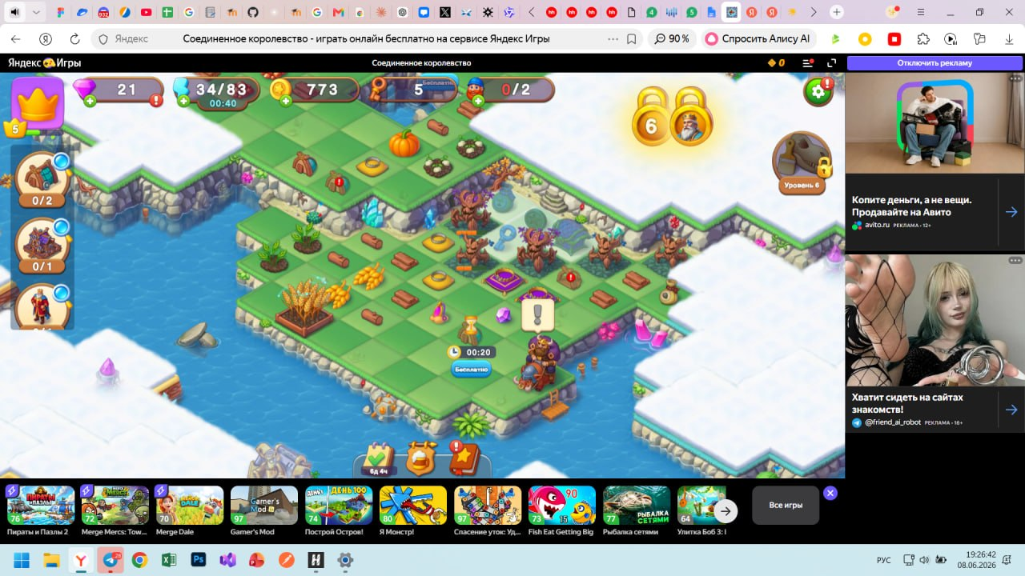

2. Offers and events panel is cut off on the right side
Type: UI issue / usability issue
Priority: Medium
Screenshot: Screenshot 2
Description:
In the top-right corner, the offer and event icons appear cut off and are placed too close to the edge of the interface. Because of this, it is not intuitive how to view all available offers and events.
Why it matters:
The player may miss some active events or offers. The interface also looks overloaded and unfinished, especially in the browser version with the ad panel on the right side.
Expected result:
All event and offer icons should be fully visible, or there should be a clear button/arrow to open the full list.
Actual result:
Part of the interface looks visually cut off, and there is no obvious way to view all offers and events.
Suggestion:
Add right-side spacing, a “More” / “All events” button, a scroll arrow, or a separate window with the full list of active events and offers.

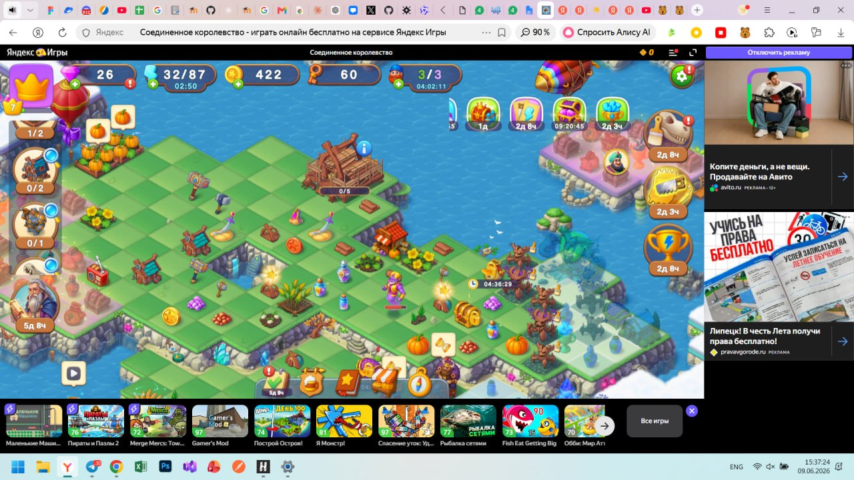

3. Add an option to freely change the player name
Type: Improvement suggestion / profile personalization
Priority: Low–Medium
Description:
It would be useful to let players change their in-game name to any name they personally want to use.
Why it matters:
Profile personalization makes the game experience more enjoyable. Players usually prefer seeing their own nickname instead of an automatically assigned name or a name connected to an external account.
Suggestion:
Add a clear “Change name” / “Edit name” button in the player profile where the player can manually enter a desired name. A character limit and inappropriate word filter can also be added.

4. Allow merging items placed diagonally
Type: Improvement suggestion / merge mechanic usability
Priority: Medium
Description:
Merging can feel inconvenient when identical items are placed next to each other diagonally. Visually, they look adjacent, but the player cannot merge them directly.
Why it matters:
On a crowded board, the player has to make extra moves just to place items in the required position. This slows down gameplay and may feel unintuitive.
Expected result:
The player should be able to merge identical items placed next to each other not only horizontally and vertically, but also diagonally.
Actual result:
Items placed diagonally cannot be merged directly.
Suggestion:
Allow diagonal merging for identical items, or at least highlight valid merge positions more clearly.

Player Feedback Responses

1. “The update you did was shit please change it back to older one”
Hello! We are sorry to hear that you are unhappy with the latest update. We understand that changes to a familiar game experience can be frustrating, especially if something you enjoyed was changed.
Could you please tell us what exactly you disliked about the update? For example: balance changes, rewards, interface changes, ads, events, or performance issues.
We will forward your feedback to the development team. While we cannot promise that the old version will be restored, detailed feedback helps us understand what should be improved in future updates.

2. “how can i attackplay without items to sorry with out objects to divide”
Hello! Thank you for contacting us. We are not completely sure which mechanic you are referring to.
Could you please send us a screenshot or short video of the screen where you are stuck? Also, please describe what you are trying to do: attack, merge, split/divide objects, or start a specific action.
Once we see the exact situation, we will be able to give you the correct instructions.

3. “Where can I get more gem fragments? I cannot do anything within game until I get more gem fragments”
Hello! We understand how frustrating it can feel when progress seems blocked by one missing resource.
Gem fragments can usually be obtained through regular gameplay activities such as completing quests, opening rewards, participating in events, collecting items from available sources, and checking chests or special rewards.
Please check your active quests, available areas, event rewards, and chests. One of the available objects may provide the fragments you need.
If you believe you are completely stuck and there is no available way to continue, please send us a screenshot of your map, your current quests, and your Player ID. We will take a closer look and check whether this is a progression issue.

4. “What is Liquid Rainbow used for? I have three bottles of it and no clue. Thanks!”
Hello! Liquid Rainbow is a special item that can be used as a substitute when merging items.
For example, if you do not have enough matching items for a merge, Liquid Rainbow can help replace one of the missing items.
We recommend using it carefully, especially with rare or hard-to-get items, because it can be very useful later in the game.

5. “What is the magnet for?”
Hello! The magnet is used to help collect or pull certain items more conveniently.
If you are not sure how to use it in your current situation, please tap on the magnet and check the item description, or try using it near the items it is supposed to affect.
If it still does not work, please send us a screenshot of the magnet and the area where you are trying to use it. We will check the exact situation and explain how it works.

6. “How many items do I get if I merge ten?”
Hello! Merging 5 items is usually more efficient than merging only 3.
If you merge 10 identical items as two groups of 5, you should receive 4 upgraded items in total.
For the best result, we recommend merging items in groups of 5 whenever possible.

7. “What do I do with genies?”
Hello! Genies are useful helpers. They can work as extra workers for a limited time and help you with construction tasks.
You can use a Genie when starting construction or on a building that is waiting for a worker. Genies are especially useful for shorter building timers, because they can help complete several tasks while they are active.

8. “How can I change the name and photo?”
Hello! You can usually change your name and photo through your profile or game settings.
Please open the profile/settings section and check whether there is an edit button next to your name or avatar.
If you cannot find this option, please send us a screenshot of your profile screen, and we will guide you step by step.

9. “Too many ads! So irritating”
Hello! We are sorry that the number of ads has made the game less enjoyable for you.
Ads help support the free version of the game and allow players to receive extra rewards, but we understand that too many ads can be frustrating.
We will share your feedback with the team. If there is a specific ad placement that feels especially disruptive, for example after every action, when opening menus, or during events, please let us know. This will help us identify which ad placements need improvement.

10. “Everything is for real money. Why can’t I buy land with rubies or coins?”
Hello! Thank you for sharing your feedback. We understand that it can feel discouraging when some land or offers are available only through real-money purchases.
The game includes both free progression and optional paid content, but we agree that players should clearly understand which areas can be unlocked through gameplay and which ones are premium.
We will pass your suggestion to the development team. Adding more ways to unlock land with in-game currency, such as rubies or coins, could make progression feel more flexible and rewarding.

11. “I accidentally spent 900 gems. Can you return them?”
Hello! We are sorry this happened. We understand how frustrating it can be to accidentally spend a large number of gems.
Please send us the following information so we can check the situation:
- Your Player ID.
- The approximate date and time of the accidental spending.
- What the gems were spent on.
- A screenshot of your current gem balance, if possible.
We cannot guarantee a refund before investigation, but we will review the case and check what can be done.

12. “Can I switch from playing on my laptop to my phone and keep my progress?”
Hello! Yes, your progress can be saved if your game is linked to your Yandex account.
Please make sure you are logged into your Yandex account on your laptop first. Then open the game on your phone and log into the same Yandex account.
If the progress does not appear automatically, please contact us and send:
- Your Player ID from the laptop.
- Your Player ID from the phone.
- Your approximate level and progress.
- A screenshot showing that you are logged into your Yandex account.
We will check the account and help you restore or synchronize your progress.

Clarifying Questions for Investigation

1. Missing purchase
- What exactly did you purchase?
- When was the purchase made? Please provide the date and approximate time.
- Was the money charged from your account?
- What payment method did you use?
- Can you send a screenshot of the receipt or payment confirmation?
- What is your Player ID?
- What device are you playing on?
- Which account are you logged into in the game?
- Did you restart the game after the purchase?
- Did you see any error message during the payment?
- Have you received similar purchases correctly before?

2. Lost progress
- What level were you before the progress was lost?
- When did you last see the correct progress?
- When did you notice that your progress was missing?
- What is your current Player ID?
- Do you have your old Player ID?
- Was your progress linked to your Yandex account?
- Are you currently logged into the same Yandex account?
- Did you change your device?
- Did you reinstall the game?
- Did you clear your browser/app cache or data?
- After what exactly did the progress disappear: update, logout, reinstall, device change, or crash?
- Do you have any screenshots of your old progress, level, purchases, or map?

3. Crash after update
- When did the crashes start?
- Does the game crash immediately after launch or after a specific action?
- If it crashes after a specific action, what action triggers it?
- What device are you playing on?
- What operating system version are you using?
- What game version is installed?
- Which browser or app are you using to launch the game?
- How much free storage space do you have on your device?
- Is your internet connection stable?
- Have you tried restarting your device?
- Have you tried clearing the cache?
- Do you see any error message before the crash?
- Can you send a screenshot or screen recording showing the crash?
- What is your Player ID, if you can access it?

4. Event reward not received
- Which event did you not receive the reward from?
- What reward were you supposed to receive?
- What was the reward for: a task, event milestone, leaderboard position, or final event reward?
- When did the event end?
- Did you claim the reward manually?
- Did the reward appear on the screen?
- Did the game crash or lose connection when you tried to claim the reward?
- Can you send a screenshot of the event, leaderboard, or reward screen?
- What is your Player ID?
- Did you receive any other rewards from this event?

5. Ad reward not received
- What reward were you supposed to receive for watching the ad?
- Where exactly did you watch the ad: energy, chest, speed-up, event, daily reward, or another place?
- Did the ad play until the end?
- Did you close the ad manually?
- Did any error message appear after watching the ad?
- Did the ad freeze, open the store, or return you to the game without the reward?
- Did the game crash or restart after the ad?
- When did this happen? Please provide the date and approximate time.
- How many times has this issue happened?
- What device and browser/app are you playing on?
- What is your Player ID?
- Can you send a screenshot or video if the issue happens again?

6. Account login issue
- Which account are you trying to log in with?
- What exactly happens when you try to log in?
- Do you see any error message?
- Can you send a screenshot of the error?
- Were you able to log into this account before?
- When did the issue start?
- Did you change your password or account details recently?
- Did you change your device or browser?
- Are you sure you are using the same account that your game progress was linked to?
- What is your current Player ID, if it is visible?
- Do you remember your old Player ID or approximate level?
- Have you tried logging in from another device or another browser?
- Have you tried clearing the cache or restarting the game?

