 |  | 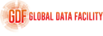 | 
 |  |  | 

Global Data Facility Mobile Phone Data Program (GDF-MPD)
  - Memorandum of Understanding template (English) – Model B (MoU-B)
The following document provides a Memorandum of Understanding (MoU) template that can be used by World Bank task teams to support the elaboration of their country-specific MoU aimed at establishing a formal collaboration between relevant stakeholders for the use of Mobile Network Operator (MNO) data for statistical purposes and to support policymaking.
The template is specifically designed for data pipeline models where raw MNO data (i.e. Tier I “nano” data, for instance, raw Call Detail Records) are directly shared by MNOs to the country regulator and processed by the National Statistical Office (NSO) and/or technical partners (Model B). Figure 1 below illustrates the architecture of the proposed data pipeline, along with the institutional elements that are formalized in this template. It can easily be adjusted to a slightly different setting where raw MNO data are shared directly with the NSO. More generally, the template should always be adjusted and adapted to country-specific needs and context. It is important to note that this document is only intended to provide a general structure with key elements allowing to establish a robust and sustainable data pipeline. Any draft MoU developed from this template should be reviewed by the legal experts of the parties involved prior to signing.
Text in [orange] in the document must be replaced with relevant information from the country context of interest. Examples are occasionally provided in green and may be used or adapted to the country context. Notes are provided in [blue] for informational purposes but should be removed in the final version of the MoU.
For any questions or inquiries, please contact the GDF-MPD team at gdfmpd@worldbank.org.
Figure 1. Institutionalization of data pipeline model B.
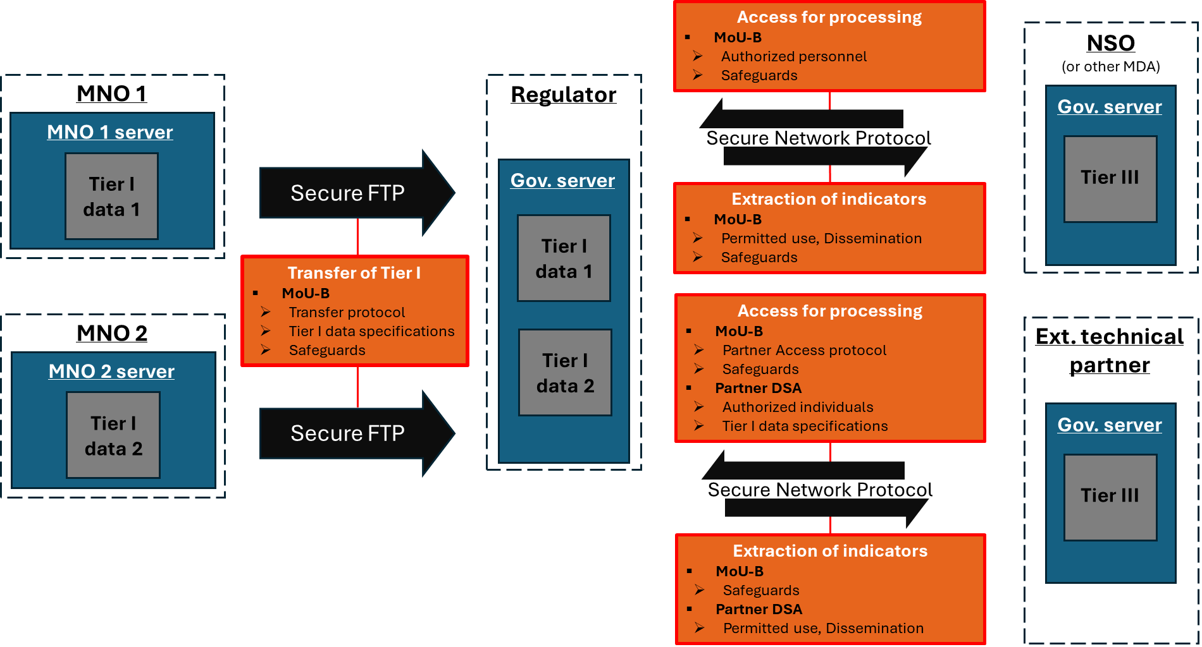
- Data pipeline with both government and external technical partner channels
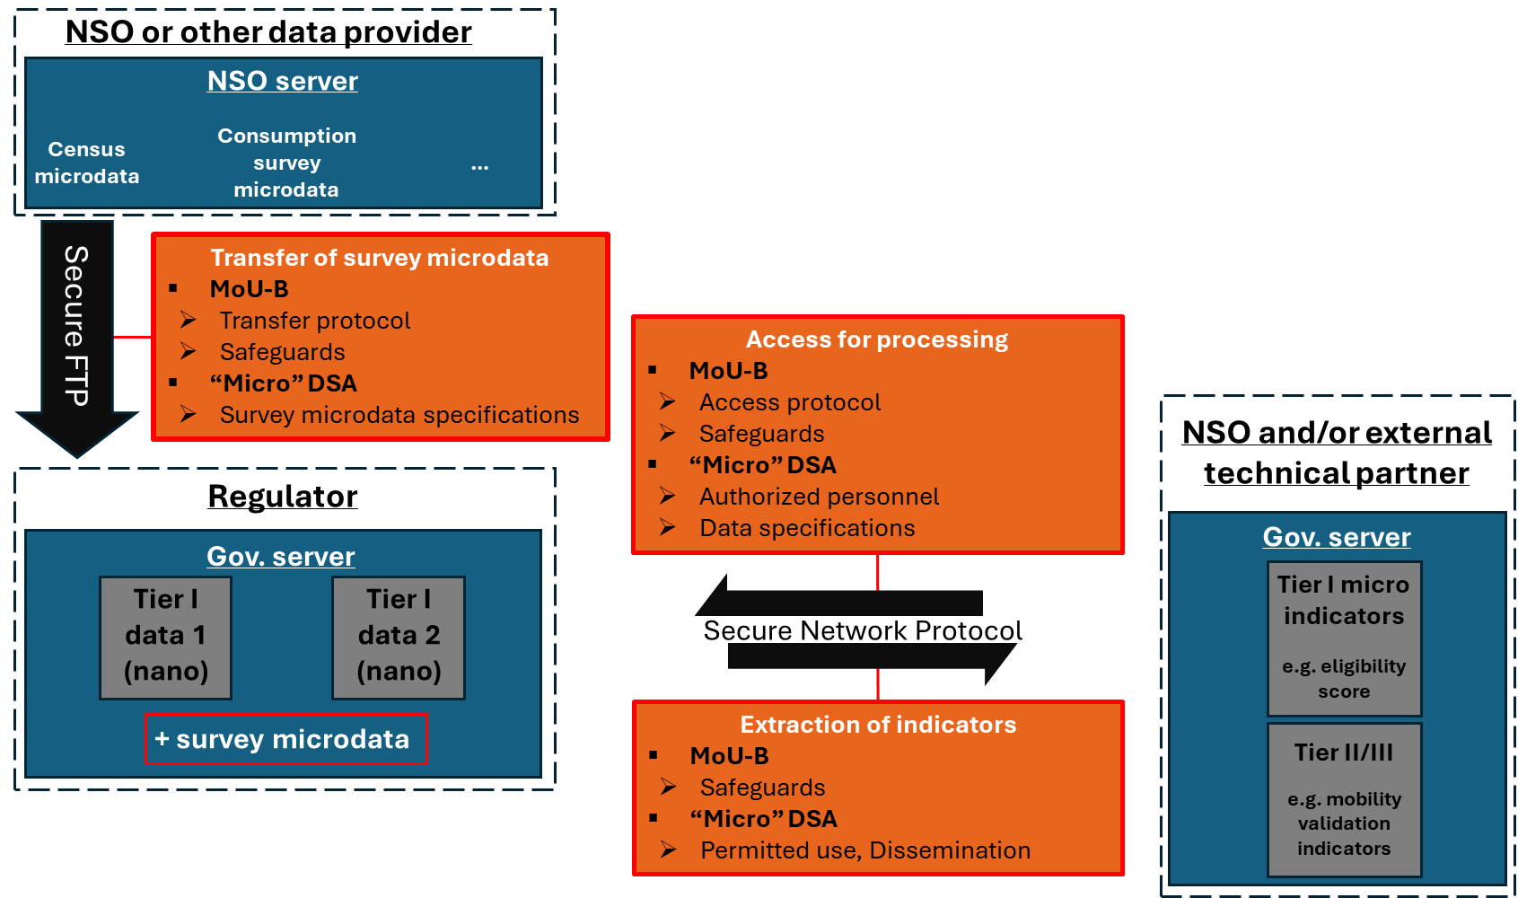
- Special channel for applications involving the pairing of MNO data with survey microdata

MEMORANDUM OF UNDERSTANDING
BETWEEN
[National Statistical Office (NSO)]
AND
[Regulator]
AND
[MNO 1]
AND
[MNO 2 (OPTIONAL)]
[…]
[Where relevant and applicable, a data protection authority may be included as a Party to the MoU.]
This agreement is made on the [insert date] between:
- [Name of NSO representative]: [details on representative], in this case acting for and on behalf of the [National Statistical Office]
- [Name of Regulator representative]: [details on representative], in this case acting for and on behalf of the [Regulator]
- [Name of MNO 1 representative]: [details on representative], in this case acting for and on behalf of [MNO 1]
- …
Together “The Parties” and individually the “Party”.
WHEREAS
- [NSO] is [describe mandate and relevant legislation]
- [Regulator] is [describe mandate and relevant legislation]
- [MNO 1] is a telecommunications company based in [Country Name] which agrees to adhere to protocols established in this Agreement for the transfer of MNO data to [Regulator].
- [other MNOs]
- The Parties have agreed to collaborate in developing a sustainable data pipeline that integrates MNO data into the national statistical system, supporting public policy to promote inclusive development in [Country Name]. (The “Project”)
- This Agreement sets out the terms and conditions under which The Parties have agreed to collaborate.
NOW THEREFORE The Parties hereto agree as follows:

Objectives

[General objective of the initiative underlying the MoU]

Example: The Project aims to improve the timely production of relevant statistics and indicators derived from MNO data and integrate them into the national statistical system. These statistics and indicators will be developed to support public policy decision-making with enhanced information on socio-economic indicators, migration, tourism and other key areas of national development.

Definitions

MNO data: Mobile Network Operator data refers to data generated through the operation of mobile communication services and collected by MNOs. This includes event data such as Call Detail Records (CDR) and signalling data, as well as network data corresponding to physical parameters of antenna towers, and customer data.

Tier I “nano” data: Tier I nano data refers to raw, event-level mobile network data (CDR or signalling data) that include, at a minimum: (i) an identifier for the device and/or SIM card associated with the network event, (ii) a timestamp indicating when the event occurred, and (iii) an identifier for the antenna that routed the event.

Tier I “micro” data: Tier I micro data correspond to a summary measure of Tier I nano data at the device-level (or SIM-level) within a specified time period, e.g. the number of calls received by each device on a given 24h period.

Tier II data: Tier II data are spatially aggregated summary measures for specified time periods from a single MNO, so that they do not contain any Personally Identifiable Information (PII).

Tier III data: Tier III data coincide with statistics on a well-defined target population, usually derived from the combination of Tier II data from a single or multiple MNOs and non-MNO data.

Indicator: an indicator is any summary measure derived from Tier I nano data, i.e. a Tier I micro, Tier II or Tier III summary measure.

Scope of the Memorandum of Understanding

This Memorandum of Understanding (MoU) establishes a formal collaboration between [NSO], [Regulator] and [MNO 1 or MNOs] for the integration of MNO data into [Country Name]’s national statistical system, consistent with objectives outlined in [latest National Strategy for the Development of Statistics document in the country].

The scope of the MoU includes:

Developing a sustainable data pipeline to facilitate the sharing and processing of MNO data collected by MNOs, transforming it into valuable information for public decision-making.

Establishing a governance framework to facilitate the development of the data pipeline and ensure its long-term sustainability.

Implementing data safeguards to uphold data security and privacy throughout all phases of the data workflow, including during the transfer and processing of MNO data at any level of granularity.

Defining transparent procedures and mechanisms that regulate the transfer of, access to and processing of MNO data within the established data pipeline, as well as the dissemination of aggregated indicators derived from such data.

Term and Commencement

This MoU shall remain in effect for a period of [number of years] years from the date of signature by The Parties, unless earlier terminated in accordance with the provisions of clause 5.

If any Party wishes to extend or renew this Agreement, it shall give written notice of its intention to other Parties.

Termination

Any Party may terminate this Agreement immediately if:

[motive for termination]

[motive for termination]

Any Party may terminate this Agreement upon giving the other Parties [number of days] days prior written notice.

Roles and obligations of the Parties

[NSO]

[NSO] shall lead the analysis of MNO data and the integration of the resulting outputs into the national statistical system via its statistical reports and products. [NSO] will ensure that MNO data are used to produce relevant data for national policy and decision-making.

[NSO] will ensure the quality and reliability of outputs derived from MNO data through the establishment of an adequate quality assurance framework and the adoption of relevant standards throughout the data processing workflow. In this respect, [NSO] may request analytical support from technical partners of their choice when necessary. Technical partners may access MNO data for processing and analysis under a Partner Data Sharing Agreement (PDSA), following the procedure established in clause 9.4 of this Agreement.

[NSO] will serve as the official representative of [Country Name] in international events, discussions, and collaborations related to mobile phone data for statistical purposes, ensuring alignment with national interests and promoting the country's initiatives in this domain.

[Possibility to integrate a clause formally establishing a unit within NSO dedicated to integrating MNO data into the national statistical system. (OPTIONAL)]

Example: [NSO] will establish a Mobile Data Integration Unit (MDIU) within [NSO] and nominate a coordinator for Big Data within [NSO] to coordinate activities and oversee Big Data operations.

[Regulator]

[Regulator] shall serve as the regulatory intermediary facilitating collaboration between [MNO 1 or MNOs] and [NSO].

[Regulator] shall ensure that data transfer and access protocols, purpose of data use, as well as data sharing agreements comply with applicable national, regional and supranational laws and regulations on data protection and privacy. [This responsibility may be assigned to the relevant Data Protection Authority, provided it has the appropriate mandate and is established in the country.]

[Regulator] shall monitor the ethical use of MNO data to protect citizens' privacy and ensure data is used only for statistical purposes and to support public decision-making.

[Regulator] shall host Tier I nano data shared by [MNO 1 or MNOs] and ensure that the necessary infrastructure is maintained and adequate for timely data access and analysis.

[Regulator] shall set up and ensure maintenance of an adequate file transfer protocol enabling the secure transfer of MNO data from [MNO 1 or MNOs]’s servers to [Regulator]’s server.

[MNO 1 or MNOs]

[MNO 1 or MNOs] shall provide Tier I nano data to [Regulator] in accordance with obligations set forth in [relevant legislation requiring MNOs to share MNO data with the Regulator] and under the terms and conditions defined in this Agreement.

[MNO 1 or MNOs] shall provide [Regulator] with accurate information on the characteristics of the mobile network infrastructure required for the analysis of MNO data under the terms and conditions set forth in this Agreement.

[MNO 1 or MNOs] shall cooperate with [NSO] and [Regulator] to ensure the completeness and quality of data shared, in line with the agreed data-sharing protocols.

Governance

The Parties shall create a [Name of the coordination mechanism, e.g. Joint Steering Committee, or Coordination Board] for strategic oversight for (i) the data pipeline development, (ii) the sustainability of the data pipeline. This mechanism will give stakeholders a voice, help decision-making coordination, and support dispute resolution as required for the purposes of this Agreement.

The [Name of the coordination mechanism] shall convene a [frequency of meeting, e.g. quarterly] meeting to review progress, identify challenges and make recommendations and decisions as necessary.

The minimum quorum for each meeting of the [Name of the coordination mechanism] shall be: (i) [X] representatives from [NSO], (ii) [X] representatives from [Regulator], (iii) [X] representatives from each participating MNO. If the quorum is not met, the meeting may proceed for discussion purposes only, but no formal decisions shall be taken.

In exceptional cases where urgent decisions are required and a quorum cannot be physically met, virtual attendance and decision-making through electronic means may be permitted, subject to prior agreement by all Parties.

[Other clauses establishing governance rules as required]

Transfer of Tier I nano data from [MNO 1 or MNOs] to [Regulator]

Each participating MNO shall transfer Tier I nano data to [Regulator] in accordance with specifications provided in the Data Specifications Sheet, included in Appendix 1 of this Agreement. The data shall be transferred [frequency of data transfer, e.g. quarterly], specifically [specify systematic transfer dates; for instance, if quarterly transfer: “on the first day of January, April, July, and October each year”]. Each transfer shall cover the period from the day following the last day of the previous data transfer period up to the day preceding the current transfer date.

The Parties recognize that updates to the Data Specifications Sheet may be necessary in response to evolving operational needs. Any modifications to the Data Specifications Sheet shall be reviewed and approved through the appropriate governance channels, i.e. during a meeting of the [Name of the coordination mechanism], ensuring compliance with applicable data protection and privacy regulations.

Each participating MNO shall transfer requested MNO data to [Regulator] via a secure file transfer protocol set up and maintained by [Regulator].

In addition to the regular data flow established by clause 7.1, [Regulator] may submit exceptional data requests to participating MNOs to address specific needs, such as supporting emergency response efforts. Such exceptional data transfers shall be governed by the submission of an Exceptional Data Request Form (EDRF). An EDRF template is provided in Appendix 2 of this Agreement. The EDRF shall provide technical specifications for the requested data, including data type, variables, and temporal coverage. MNOs shall commit to transfer requested data within [X] business days upon receipt of an EDRF.

Each data transfer shall be accompanied by an up-to-date file containing the unique identifier of every active antenna during the relevant period, along with its corresponding coordinates. Additionally, each participating MNO shall maintain a log file that is regularly updated to record all instances of antenna installations or removals on the mobile network infrastructure, along with the respective dates of these events.

Access to Tier I nano data on [Regulator]’s server

Tier I nano data shared by [MNO 1 or MNOs] and stored on [Regulator]’s server shall be accessible and processed via a secure network protocol such as a Secure Shell connection (SSH), which will be set up and maintained by [Regulator].

A list of authorized personnel from [NSO], [Regulator] and potentially from other government entities shall be granted access to [Regulator]’s server to access and process Tier I nano data using the designated secure network protocol. Each authorized individual will be assigned unique credentials. The list of individuals approved for data access is provided in Appendix 3 of this Agreement.

The list of individuals pre-authorized for data access may be modified, subject to mutual agreement by all Parties.

[This clause governs access to Tier I/II data stored on the Regulator’s server for external partners. The template proposes two implementation options.]

Given the potential need for technical expertise, [Regulator] and [NSO] may establish future commitments or seek external collaborations with relevant institutions. Such arrangements shall be formalized through separate agreements, subject to applicable data governance and confidentiality provisions. Consequently, external individuals, including researchers and technical partners, may be granted access to [Regulator]’s server for the purpose of accessing and processing MNO data upon signing a dedicated “Partner” Data Sharing Agreement (PDSA).

[Option 1: access to external partners requires approval by all Parties of the MoU, or restricted to approval by government entities (NSO, Regulator).] The PDSA must be approved and signed by all Parties to authorize data access and processing.

[Option 2: Regulator granted full mandate to manage and regulate access for external partners to MNO data stored on their server.] [Regulator] shall have the full authority to evaluate, approve, and manage access for external partners to MNO data stored on [Regulator]’s server, including researchers and technical collaborators, in alignment with the objectives of this MoU. Such access shall be granted only upon the signing of a dedicated PDSA between [NSO], [Regulator] and the external partner.

Each PDSA must specify the terms of data access, including the specific data covered, any applicable restrictions, the duration of access, the intended purpose of data use, and reporting obligations.

The list of individuals authorized to access data shared under a specific PDSA shall be explicitly defined within that agreement. [Regulator] shall strictly enforce the data access limitations outlined in the PDSA and shall issue unique access credentials solely to those individuals authorized under its terms.

Upon signing a PDSA, [Regulator] shall provide the requesting entity with the necessary credentials to perform their duties. If a specific access duration is defined, [Regulator] shall ensure that the credentials issued under the PDSA are revoked upon its expiration.

The intended data use must not involve pairing Tier I micro data with individual- or household-level survey information. Data arrangements for such applications shall be regulated by separate “micro” Data Sharing Agreements under the terms and conditions outlined in clause 11.

Permitted Use of Data and Disclosure of results

Any processing of MNO data is permitted to the extent that it aligns with the objectives set forth in clause 1.1, provided it does not conflict with any specific data use restrictions outlined in the applicable PDSA or “micro” DSA (see clause 11). In the event of any conflict, the terms of the relevant data sharing agreement shall prevail.

[NSO] and technical partners with access to [Regulator]’s server under a PDSA shall only process MNO data for purposes defined in this Agreement or as may be subsequently agreed by the Parties, and shall not exercise control, nor shall it attempt to extract, copy, migrate or otherwise transfer such data to a third party.

Indicators resulting from the processing of MNO data and intended for publication shall comply with privacy regulations and adopt appropriate measures to maintain user anonymity.

The Parties agree that any research results or statistical findings produced under this MoU can be published, provided that all Parties have been properly credited, and any proprietary or sensitive information has been appropriately anonymized.

Before any publication is released to the public, all parties will be notified in writing and granted [X] days to review the content. The absence of a response after this period shall be deemed as non-objection and the publication shall be considered approved by all Parties. Any disputes concerning publication will be resolved by mutual agreement or arbitration.

Indicators and results derived from MNO data that The Parties deem too sensitive for public disclosure but are intended for sharing only with a specific Government of [Country Name] Ministry, Department or Agency (MDA) may be approved for restricted disclosure. These results may be shared exclusively with the designated MDA, provided that the MDA signs a mutual Non-Disclosure Agreement with The Parties, committing to maintain confidentiality and refrain from further dissemination.

Special Provisions for Survey Microdata Integration

[This clause regulates access to and processing of Tier I nano data stored on [Regulator]’s servers in the context of sensitive applications that involve the calculation of Tier micro data and their pairing with individual- or household-level survey information.]

Considering the sensitivity of such applications, any initiative involving the pairing of Tier I micro data with individual- or household-level survey information – e.g. for the application of bias correction methods, or individual poverty measurement exercises – shall require specific data arrangements under a dedicated “micro” Data Sharing Agreement (micro DSA). The micro DSA may involve [Regulator], [NSO], but also other government entities and external technical partners.

Transfer of survey microdata on [Regulator]’s server. The micro DSA shall explicitly state the pairing of MNO data with survey microdata as part of the intended data use and shall precisely specify survey microdata requirements associated with the intended data use. [NSO] shall facilitate the secure transfer of the required survey microdata to [Regulator]’s server via the designated secure file transfer protocol.

Access to MNO data and survey microdata. The micro DSA shall regulate joint access to Tier I nano data and survey microdata on [Regulator]’s server.

Each micro DSA must specify the terms of data access, including the specific data covered, any applicable restrictions, the duration of access, and the intended purpose of data use.

The list of individuals authorized to access data shared under a specific micro DSA shall be explicitly defined within that agreement. [Regulator] shall strictly enforce the data access limitations outlined in the micro DSA and shall issue unique access credentials solely to those individuals authorized under its terms.

[NSO] and [Regulator] shall jointly elaborate a unique pseudonymization procedure that ensures user anonymity in both MNO data and survey microdata and enables the effective pairing of both data sources.

[Regulator] shall implement adequate data protection measures in relation to the specific MNO data and survey microdata stored on its server and accessed under the applicable micro DSA. [Regulator] shall enforce restrictions on data access, transfer, download and modification. Specifically, access to designated MNO data and survey microdata on [Regulator]’s server shall be strictly limited to individuals listed in the applicable micro DSA.

Permitted use of data. The specific purpose for which Tier I micro indicators are to be combined with survey microdata shall be clearly defined in the relevant micro DSA.

The Parties shall implement all necessary measures to strictly uphold and enforce the data use limitations outlined in the applicable micro DSA.

The Parties shall ensure that the proposed data use described in the micro DSA fully complies with applicable national data protection laws, including adherence to consent requirements. Any resulting indicators intended for publication shall comply with privacy regulations and adopt appropriate measures to maintain user anonymity

Data Safeguards

The Parties shall jointly define the Statistical Disclosure Control (SDC) methods to be applied (e.g. k-anonymity property) to ensure that any personally identifiable information is fully anonymized in final indicators intended for public disclosure, reducing the risk of disclosing information on statistical units and preventing any possibility of re-identification.

[Regulator] shall implement a pseudonymization procedure of the highest standard to ensure the privacy and security of Tier I nano data obtained from [MNO 1 or MNOs]. This procedure shall comply with internationally recognized best practices and regulatory requirements for data protection. [Regulator] shall also regularly review and update the pseudonymization process in response to technological advancements and evolving privacy risks to maintain the highest level of data protection.

The Parties shall adhere to the data minimization principle, ensuring that only data necessary and appropriate for the intended purpose is used, in alignment with the objectives set forth in this Agreement or as subsequently agreed upon by the Parties in the applicable data sharing agreement.

The Parties shall strictly adhere to data sharing, access, processing and disclosure protocols established under clauses 8 to 11, ensuring transparency and accountability on the storage location of MNO data throughout all stages of the processing pipeline, the individuals granted access and the intended purpose of data use, altogether minimizing the risk of data breaches and misuse.

[Regulator] and [MNO 1 or MNOs] shall jointly implement appropriate encryption measures to enhance data security during the transfer of Tier 1 nano data from [MNO 1 or MNOs] to [Regulator]’server.

[Regulator] shall take all necessary measures to minimize the risk of data breaches on [Regulator]’server, with minimum security requirements outlined in Appendix 4 of this Agreement.

Intellectual Property Rights

The intellectual property (IP) rights for any data, models, algorithms, or other technical tools developed as part of this collaboration will be governed by the following principles:

Data provided by MNOs will remain the intellectual property of the MNOs. [NSO] will only use the data for agreed-upon statistical purposes, including analysis, reporting, and policy development.

Any new methodologies, models, or analytical tools developed jointly by [NSO] and technical partners as a result of this collaboration will be co-owned by the parties involved. Each party will have the right to use and further develop these tools for non-commercial purposes.

Publications, reports, and research papers derived from this collaboration must credit all contributing parties appropriately. Any intellectual property disputes will be resolved through good-faith negotiations among the parties.

Liability

Each party to this MoU will be liable for its own actions and omissions. No party shall be liable for any indirect or consequential losses arising from this MoU.

In the event of any legal claims arising from the use of MNO data or related activities, participating MNOs shall not be held liable for any misuse of data by other parties once the data has been properly transferred in accordance with the protocols established in this Agreement.

[Regulator] shall ensure that all legal requirements related to the ethical use of data are followed, thus minimizing the risk of liability.

Confidentiality
All parties agree that any proprietary or confidential information shared as part of this collaboration will be treated with the highest level of confidentiality. Confidential information includes, but is not limited to, technical data, business strategies, operational methods, and personal data. All parties shall ensure that their employees, agents, and subcontractors abide by this confidentiality clause. Any breaches of confidentiality will be subject to remedial action, including potential legal claims.

Notices
Any notices required to be given under this MoU must be delivered in writing to the designated representatives of the respective parties. Notices can be delivered by hand, via courier, or through electronic mail. The notice will be deemed effective upon receipt by the recipient party.
For [NSO], notices shall be directed to:
Name: _____________________
Position: __________________
Address: ___________________
Email: _____________________
For [Regulator], notices shall be directed to:
Name: _____________________
Position: __________________
Address: ___________________
Email: _____________________
For [MNO 1], notices shall be directed to:
Name: _____________________
Position: __________________
Address: ___________________
Email: _____________________

Assignments

No party shall assign, transfer, or delegate any rights or obligations under this MoU without the prior written consent of the other parties.

Any attempted assignment without such consent shall be null and void.

However, each party may subcontract portions of its obligations, provided that the subcontractor agrees to abide by the terms of this MoU.

Rights of Third Parties
This MoU is intended solely to benefit the parties involved. No third party shall have any rights to enforce or claim any benefits under this MoU, whether by statute, contract law, or any other legal principle, except for affiliates, successors, or assigns that may be explicitly mentioned in this agreement.

Severability
If any provision of this MoU is determined by any court or competent authority to be illegal, invalid, or unenforceable, that provision shall be deemed removed to the extent necessary, but the remaining provisions shall continue in full force and effect.

Variations and Amendments
Any modifications or amendments to this MoU must be made in writing and agreed upon by all parties. No oral modifications will be accepted. Amendments will be effective upon the signing of the revised agreement by authorized representatives of all parties.

Counterparts
This MoU may be executed in counterparts, each of which shall be deemed an original, but all of which together shall constitute one and the same agreement. Copies transmitted via email or other electronic means shall be considered originals for all legal purposes.

In Witness Of
This MoU is agreed upon and signed by the following representatives, who warrant that they are authorized to sign on behalf of their respective organizations:
For [NSO]:
Name: ___________________________
Position: ________________________
Signature: _______________________
Date: ___________________________
For [Regulator]:
Name: ___________________________
Position: ________________________
Signature: _______________________
Date: ___________________________
For [MNO 1]:
Name: ___________________________
Position: ________________________
Signature: _______________________
Date: ___________________________

Appendix 1: Data Specifications Sheet governing regular MPD transfers
Type of data requested:
Example:
Call Detail Records (CDR) containing all Voice, SMS and data events
Variables:
Example:
- International Mobile Equipment Identity (IMEI) of the caller (device identifier)
- International Mobile Subscriber Identity (IMSI) of the caller (SIM card identifier)
- Event start time
- Format: YYYY-MM-DD HH24:mm:ss
- Event duration
- Antenna identifier for the caller
- Format: Location Area Code (LAC) + Cell ID
- Event type
- Voice, SMS, or Data
- Technology
- 2G, 3G, 4G, LTE, 5G

Appendix 2: Exceptional Data Request Form template
Type of data requested:
Example: Call Detail Records containing all Voice, SMS and data events
Period start and end date:
Example: 01/01/2025 to 31/01/2025 included
Variables:
Example:
- International Mobile Equipment Identity (IMEI) of the caller (device identifier)
- International Mobile Subscriber Identity (IMSI) of the caller (SIM card identifier)
- Event start time
- Format: YYYY-MM-DD HH24:mm:ss
- Event duration
- Antenna identifier for the caller
- Format: Location Area Code (LAC) + Cell ID
- Event type
- Voice, SMS, or Data
- Technology
- 2G, 3G, 4G, LTE, 5G]
Additional request:
Example: updated database of antenna identifiers and their geographic coordinates

Appendix 3: list of pre-authorized individuals for access to [Regulator]’s server
First name | Last name | Institution | Job title | Access restriction
... | ... | ... | ... | ...

Appendix 4: Minimum Security Requirements
Example:
Network security:
- Use the latest operating system with all security patches applied.
- Implement firewall rules to allow only essential traffic.
- Implement intrusion detection and prevention systems (IDS/IPS) to monitor and block suspicious activity.
Access control and authentication:
- Enforce strong password policies (length, complexity, expiration) and multi-factor authentication (MFA) for all privileged accounts.
- Use role-based access control (RBAC) to manage user permissions effectively.
- Regularly review and revoke inactive or unnecessary accounts.
Encryption and data protection:
- Encrypt data at rest using industry-standard encryption algorithms (e.g., AES-256).
- Secure data in transit with TLS 1.2 or higher to prevent interception.
- Regularly rotate encryption keys and store them in a secure hardware security module (HSM).
Logging, monitoring and incident response:
- Enable detailed logging of all access and changes.
- Use centralized log management (e.g., SIEM solutions).
- Implement real-time monitoring with alerts for suspicious activities.
- Develop and routinely test an incident response plan to address security breaches effectively.
Physical security:
- Restrict physical access to the server room/data center through biometric, key card, or PIN-based access control.
- Ensure proper environmental controls (e.g., temperature, humidity) to protect hardware integrity.
Secure backup and disaster recovery:
- Maintain regular, encrypted backups stored in a separate location.
- Test disaster recovery plans regularly.
- Implement immutable backups to prevent ransomware attacks.

