参考：<https://github.com/AliyunContainerService/k8s-for-docker-desktop>

### Docker Desktop for Windows 开启 Kubernetes

为 Docker daemon 配置镜像加速，参考[阿里云镜像服务](https://cr.console.aliyun.com/cn-hangzhou/instances/mirrors) 或使用中科大镜像加速地址 https://docker.mirrors.ustc.edu.cn

[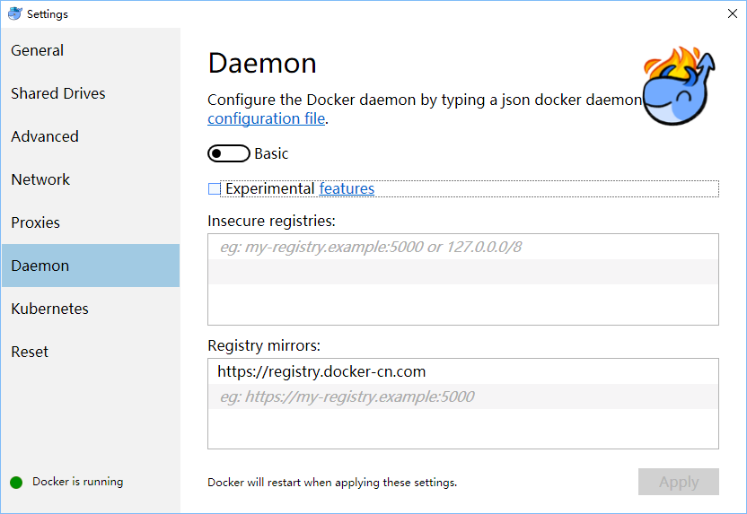](https://github.com/AliyunContainerService/k8s-for-docker-desktop/blob/master/images/mirror_win.png)

可选操作: 为 Kubernetes 配置 CPU 和 内存资源，建议分配 4GB 或更多内存。

[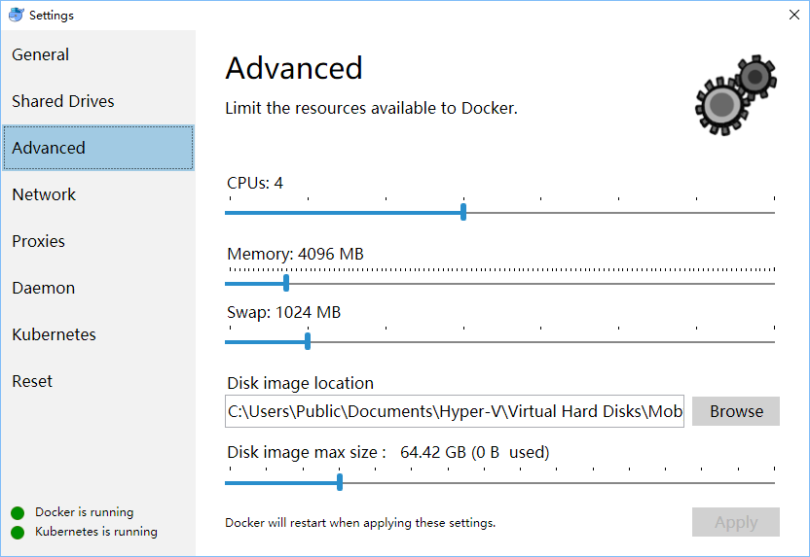](https://github.com/AliyunContainerService/k8s-for-docker-desktop/blob/master/images/resource_win.png)

预先从阿里云Docker镜像服务下载 Kubernetes 所需要的镜像, 可以通过修改 images.properties 文件加载你自己需要的镜像

使用 Bash shell

./load_images.sh

使用 PowerShell

.\load_images.ps1

Windows下使用管理员身份运行power shell

如果报错:

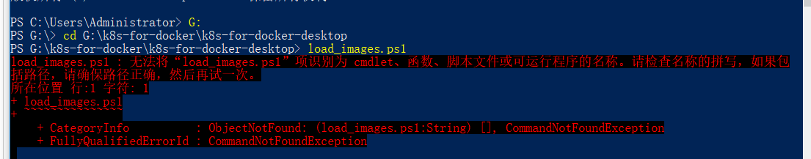

这是因为安全策略无法执行 PowerShell 脚本，请在 “以管理员身份运行” 的 PowerShell 中执行 Set-ExecutionPolicy RemoteSigned 命令。

开启 Kubernetes，并等待 Kubernetes 开始运行

[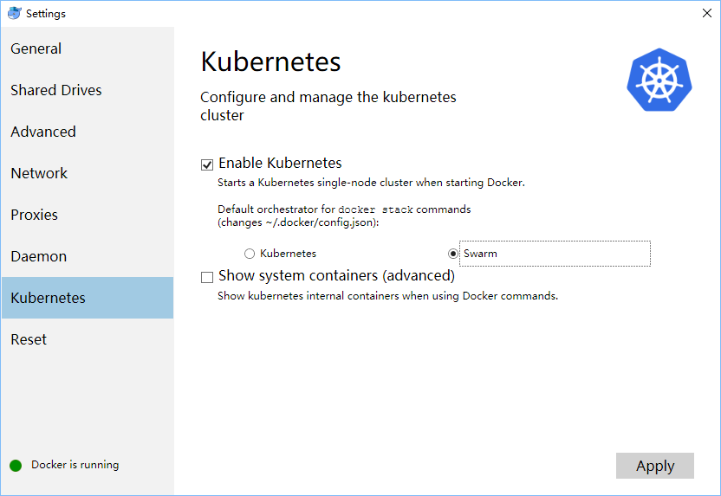](https://github.com/AliyunContainerService/k8s-for-docker-desktop/blob/master/images/k8s_win.png)

**TIPS**：

* 如果在Kubernetes部署的过程中出现问题，可以在 C:\ProgramData\DockerDesktop下的service.txt 查看Docker日志
* 如果看到 Kubernetes一直在启动状态，请参考 [Issue 3769(comment)](https://github.com/docker/for-win/issues/3769#issuecomment-486046718) 和 [Issue 1962(comment)](https://github.com/docker/for-win/issues/1962#issuecomment-431091114)

### 配置 Kubernetes

可选操作: 切换Kubernetes运行上下文至 docker-for-desktop (docker-ce 18.09 下 context 为 docker-desktop)

kubectl config use-context docker-for-desktop

验证 Kubernetes 集群状态

kubectl cluster-info

kubectl get nodes

**部署 Kubernetes dashboard**

kubectl apply -f https://raw.githubusercontent.com/kubernetes/dashboard/v1.10.1/src/deploy/recommended/kubernetes-dashboard.yaml

或

kubectl create -f kubernetes-dashboard.yaml

开启 API Server 访问代理

kubectl proxy

生成访问令牌：

kubectl -n kube-system describe secret $(kubectl -n kube-system get secret | grep admin-user | awk '{print $1}')

通过如下 URL 访问 Kubernetes dashboard

<http://localhost:8001/api/v1/namespaces/kube-system/services/https:kubernetes-dashboard:/proxy/#!/overview?namespace=default>

### 配置 kubeconfig (可跳过)

对于Mac环境

TOKEN=$(kubectl -n kube-system describe secret default| awk '$1=="token:"{print $2}')

kubectl config set-credentials docker-for-desktop --token="${TOKEN}"

对于Windows环境

$TOKEN=((kubectl -n kube-system describe secret default | Select-String "token:") -split " +")[1]

kubectl config set-credentials docker-for-desktop --token="${TOKEN}"

#### 登录dashboard的时候选择 kubeconfig 文件

[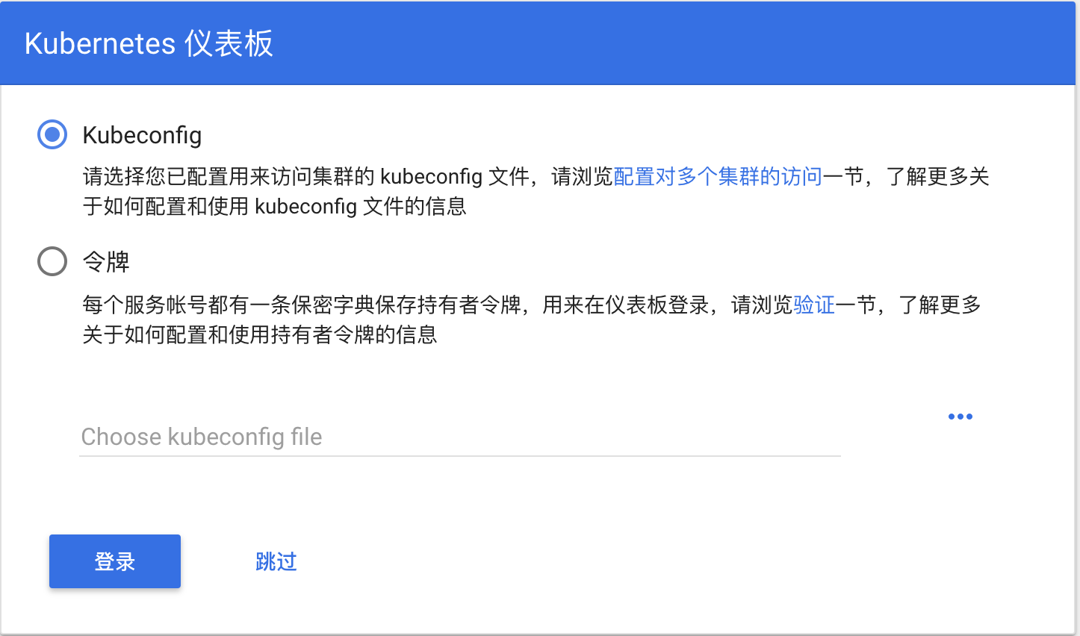](https://github.com/AliyunContainerService/k8s-for-docker-desktop/blob/master/images/k8s_credentials.png)

选择 kubeconfig 文件,路径如下：

Mac: $HOME/.kube/config

Win: %UserProfile%\.kube\config

点击登陆，进入Kubernetes Dashboard

一直卡在kubernates is starting解决：

was able to get this working even after restarting docker::

1. Change DNS to fixed and use 8.8.8.8, this is within docker for window's settings
2. Remove the .kube
3. Add the KUBECONFIG environment variable to **System Variables** and have the path be C:\Users\[MYUSER]\.kube\config. Note that before I had it set as a **User Variable**.
4. Restart Docker from the **Docker for Window**'s reset tab in settings.
5. Restart Kubernetes Cluster from the **Docker for Window**'s reset tab in settings (you can do this a number of times).
6. Afterwards just wait for some time and **Kubernetes is running** should display

I hope this can help someone, this issue is a pain.

For me the only thing which helped was to to remove C:\ProgramData\DockerDesktop\pki folder and restart Docker. As described here [#3769 (comment)](https://github.com/docker/for-win/issues/3769#issuecomment-486046718)