**SWEN30006**

**Software Modeling and Design**

**Project 3B Group 17:**

* Wittawin Kraisathianpaisal - 657730 – wkraisathian
* Vincent Yuwono – 657348 - vyuwono
* Pheasant-Kelly Jordan Llewellyn – 586026 – jordanp

**Reflection on Design Adherence**

***Model changes***

1. We added a condition (e.g. sunny, rainy) attribute to the description class because the data searching requires it
2. Instead of having each temperature, rainfall, windSpeed, and windDirection as a separate class, we put them in our description class as attributes

***Challenging Aspect***

1. Making sure that all the locations that we get from BOM have a postcode
2. Predictions were very challenging to implement in a logical manner. Obviously weather is a prime example of a complex system, and given that billions of dollars have been spent trying to predict the weather marginally better, anything that we implement will be very naive. In the end, a fairly simple prediction model was used, as although it may not be as accurate, it’s usually less inaccurate. Given that our predictions would always be, by nature, fairly inaccurate, we felt it was a reasonable compromise.
3. The probability of prediction posed another problem, in that attempting to predict the probability to an arbitrary level of precision, would by its very nature be fairly arbitrary. The model we finally used is still somewhat arbitrary, but mostly internally relatable between parameters, which is important.
4. Making sure that the json for the prediction calls exactly the same is difficult because of the format form the specification.

***Original Design and Implementation***

The original design adheres quite well with our final application model. Still, some changes where made during the process of implementing the application. As mentioned above, we added a ‘condition’ attribute, because it is easier for us and the application to retrieve and access data. Same goes for the other attributes that are all merged up in the ‘description’ class. Furthermore, we also changed some of our webpage. We added forms to the website for more efficient data passing and searching algorithms. This would allow the application to be more user-friendly and logical. Other than that, our forecast application seems to commendably fit the original design.

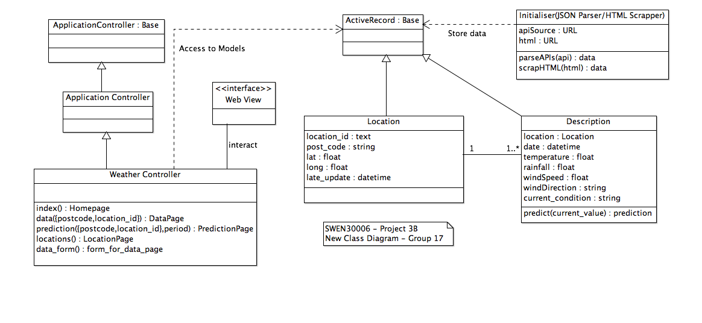

New Class Diagram