Dialogue Based Precision Search

The following is a medium term vision and mock-up of what could be achieved using the Precision Search platform – a first draft showing things that should be doable with relatively little investment on the part of a customer.

# Standard Dialogue – Timetable example

The user will be asked follow up questions for required information not yet entered.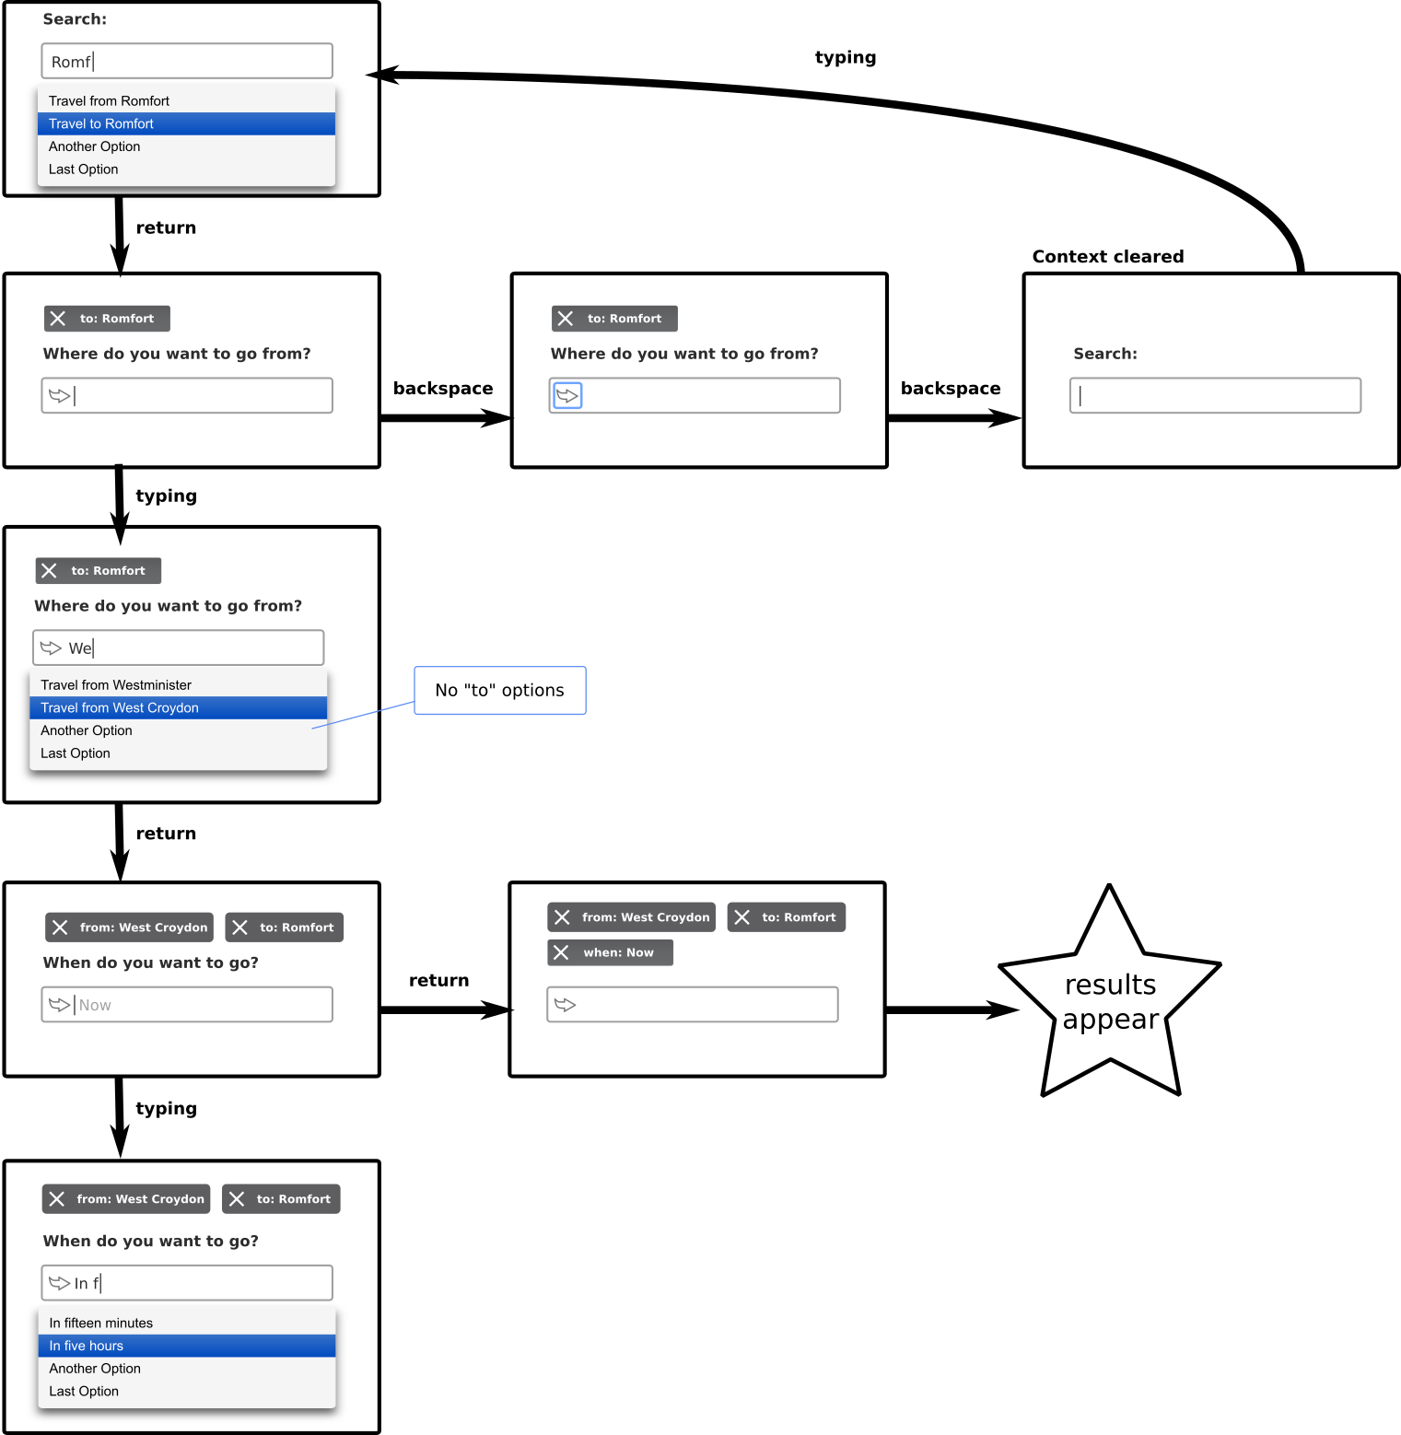

# Quick Dialogue

The user can optionally skip parts of or the whole dialogue by entering more information and selecting richer sentence suggestions.

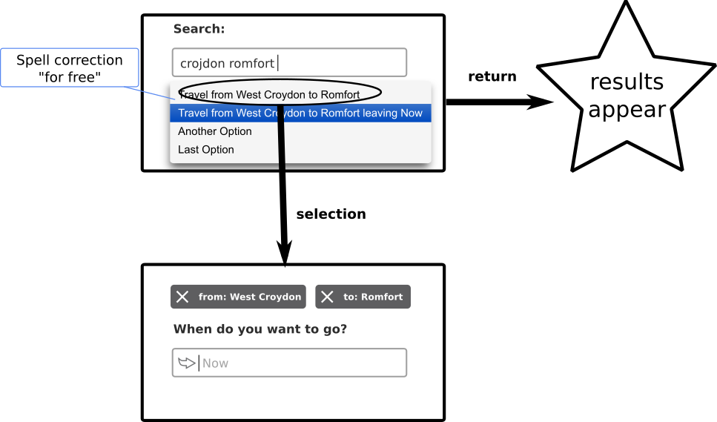

# Product Search Example

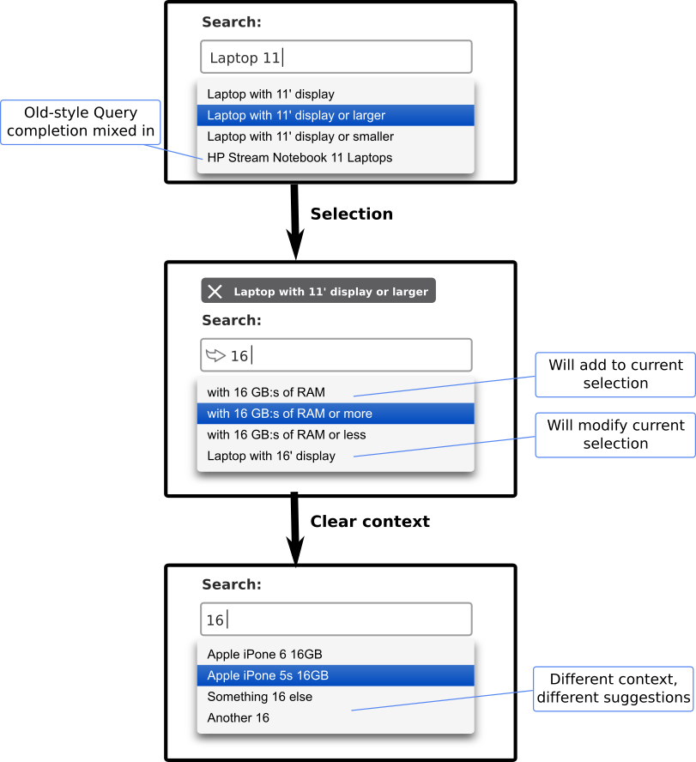

# Precision Search Powered Administration

