

Admin UI

May 29, 2017

Prepared by David Wun, May 26, 2017

Table of Contents

1. Introduction 3

2. About This Release 3

3. Compatible Products 3

4. Upgrades 3

5. New Features 4

L1BRE App

Introduction

The document communicates the major new features and changes in this release of the L1BRE App. It also documents known problems and workarounds.

The L1BRE Project is an advanced on-demand services platform that is a result of the joint venture between the Government of Mexico and the L1BRE Technology Company of the United States. Software engineering and development will be conducted by Stagwell Tech. L1BRE, a technology-based solution company, joined forces with their Mexico counterpart for a 10-year concession to support this project. The L1BRE mobile app is a full replacement of the taximeter in Mexico City and has the option to expand to other cities in the near future. The software enables customers to hail or book in advance a taxi from their mobile devices.

# About This Release

The release of May 29, 2017 will include the new feature of Documents Upload capability. This additional feature will be part of the Admin Portal’s Administration Tab. This feature is added to the current system to allow the Commissioner to include any relevant files or documents to the profile. The need for proper documentation and profiling of drivers and taxis has been successfully addressed by the implementation of this Documents Upload feature.

# Compatible Products

Admin Portal can be accessed via web browser, preferably Chrome. Hardware can be desktop or tablet. Internet connection is required.

# Upgrades

The Document Upload feature will be upgraded by Stagwell Tech for the upcoming release. It will affect the Admin Portal to include the new DOCUMENTS Tab.

# New Features

The following new feature/s appear in this release on May 29, 2017:

Document Upload Capability in Admin Portal. Please see below for Image 1.

Image 1

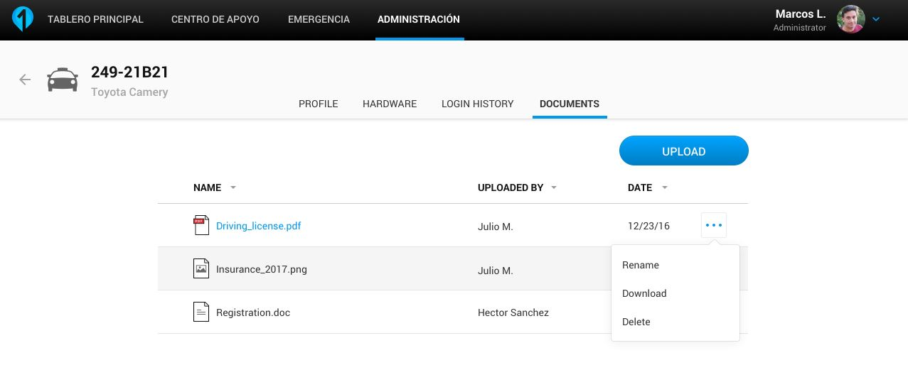

*DOCUMENTS UPLOAD capability*

In the Admin Portal, the Admin or Commissioner can upload relevant documents to the profile. The upload task is the responsibility of the Commissioner role in most cases. With the tablet, Commissioner can upload by taking a picture of the document/s and then tapping UPLOAD button to place into Admin Portal. If the Admin has a need, he/she can also upload documents to the profile. The document/s can be uploaded by navigating to Admin Portal’s Administration Tab’s DOCUMENTS Tab. The columns within the DOCUMENTS Tab are NAME, UPLOADED BY, DATE. Each column has a toggle button to show data in ascending or descending order. Editing features will include renaming, download, and deleting of the document/s.

Revision History

| Version | Date | Summary of Changes | Author |
| --- | --- | --- | --- |
| 3.2 | May 24, 2017 | Initial revision. | David Wun |
| 3.3 | May 25, 2017 | Revised feature | David Wun |
| 3.3b | May 26, 2017 | Finalized formatting | David Wun |