Metcalfe’s law - https://moneroj.net/metcalfesats/

Everything started because of Metcalfe’s Law. I always imagined that Bitcoin and Monero were related, in the sense that Monero complemented what was missing in Bitcoin. Thinking on that subject, if Monero was a complement to Bitcoin, perhaps it was somehow seen by the market as an extent of Bitcoin itself.

“Metcalfe’s law states that the value of a network is proportional to the square of the number of nodes, or members, in the network. A network is a set of nodes who form connections with one another and follow a protocol, a set of rules. As more nodes join a given network, the value of that network increases exponentially, because each additional node can contribute value to all existing nodes.”

Since we can’t know the number of users for these coins (specially for Monero), we have to try another path. Similar to each information exchanged on a social Network, transactions grow exponentially the more users are using a certain blockchain. So instead of looking to the square of the number of users, we can approximate that the value of the network is directly proportional to the number of transactions it has. I mean, this is only true if the coin is decentralized and don’t have a Company behind it, because that would encourage it’s owners to spam the network so they could trick users into thinking the network had a use case.

So, for both Monero and Bitcoin, the number of transactions is directly proportional to the value of the whole marketcap of the coin. So:

XMR.Marketcap / BTC.Marketcap

Should be proportional to:

XMR.Tx / BTC.Tx

But they weren’t, and the main reasons for that are because: a) Monero was launched after Bitcoin, so there was a huge difference in the amount of coins in circulation; b) the ‘launch’ distorted the perceived fair value, because it spammed the network with people speculating.

We could fix this issue by accounting for the coin’s total supply. So we have to multiply XMR.Tx / BTC.Tx by their supply relation XMR.Supply * BTC.Supply. Notice that this multiplication in fact reduces the value of the transaction relation, because there were less Monero than Bitcoin in circulation.
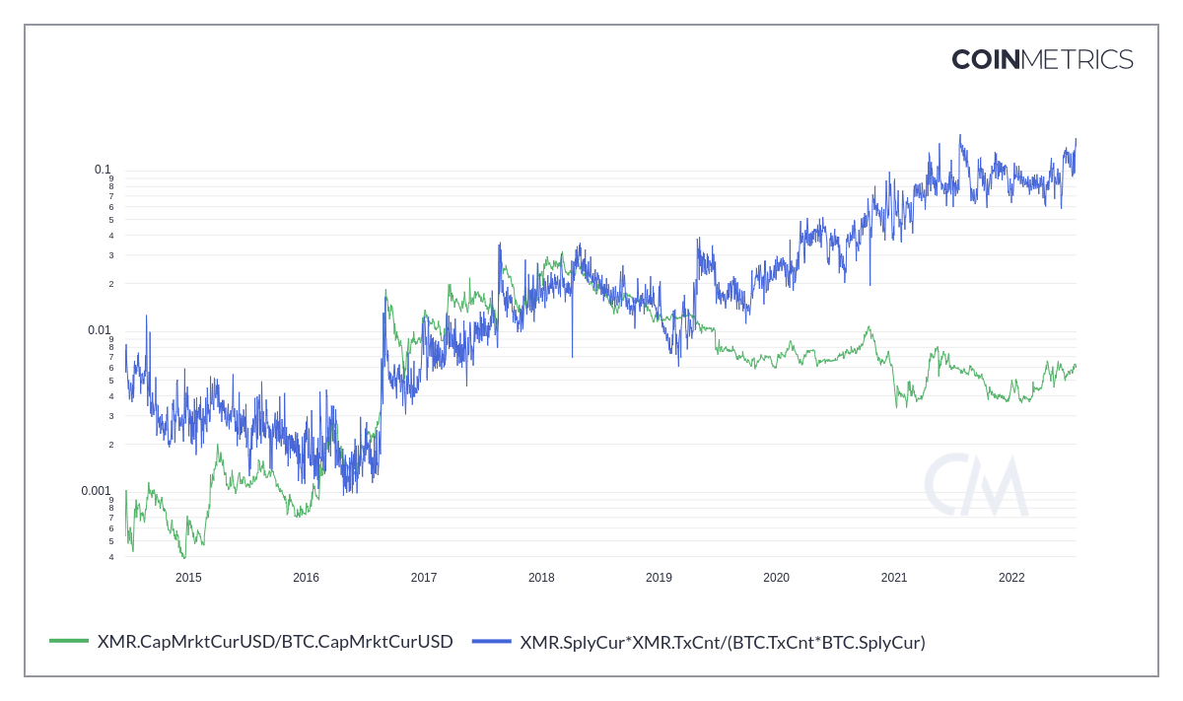

So the relation looks very similar, but there’s still some divergence, specially in the beginning. If we compound yet another multiplication, we find out that near the launch of Monero, the relation between their marketcaps followed the square of the relation XMR.Supply * BTC.Supply. Perhaps this is because the difference in supply was so extreme, that affected the perceived value way more back then. Anyway, just to visualize the calculated value:
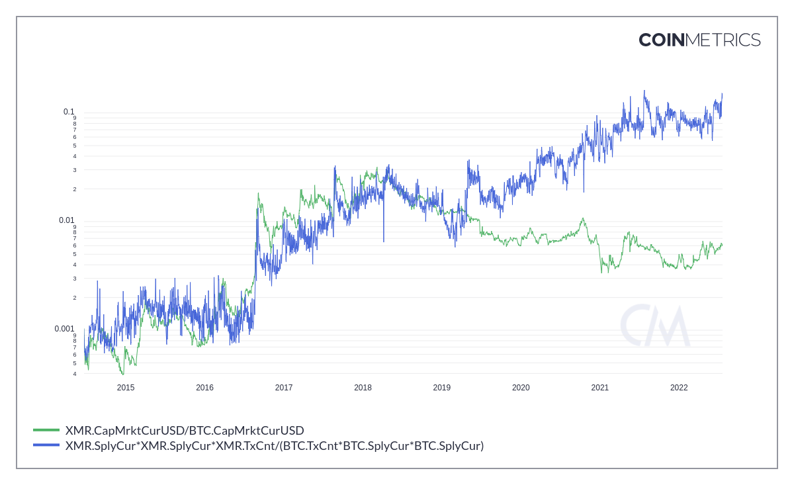
And voila, we have a curve that fits the real relation XMR.Marketcap / BTC.Marketcap. Now if we divide both sides of the equation for XMR.Supply * BTC.Supply we will result in:

XMR.PriceBTC = XMR.Supply * XMR.Tx / (BTC.Supply * BTC.Tx)
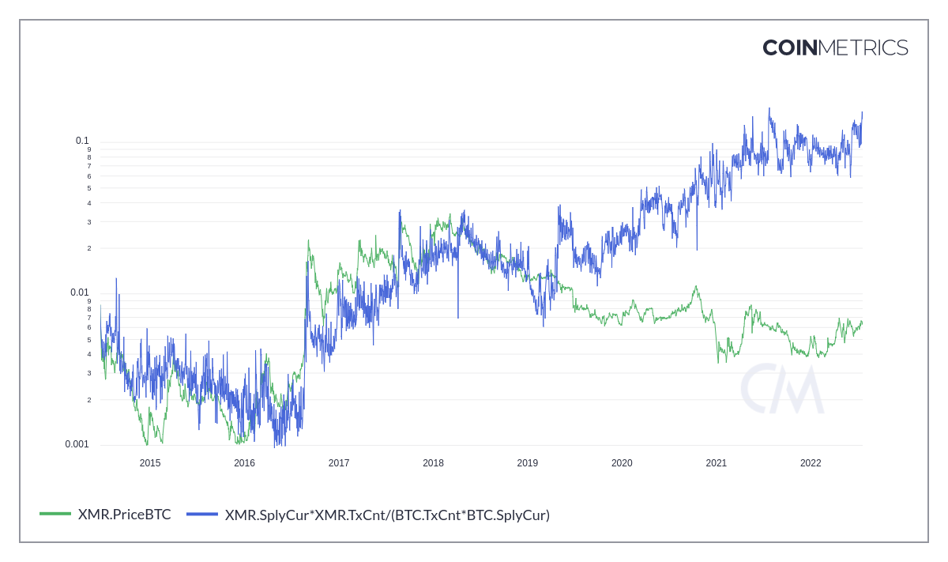

And then again, another fitting curve. If the chart wasn’t distorted at the beginning because of the supply difference and speculation, then we would literally have:

XMR.Marketcap / BTC.Marketcap = XMR.Tx / BTC.Tx

So these coins were in fact behaving as part of the same network. Monero was being perceived as an extension of Bitcoin. By dividing both sides for XMR.Supply * BTC.Supply we result in:

XMR.PriceBTC = BTC.Supply * XMR.Tx / (XMR.Supply * BTC.Tx)
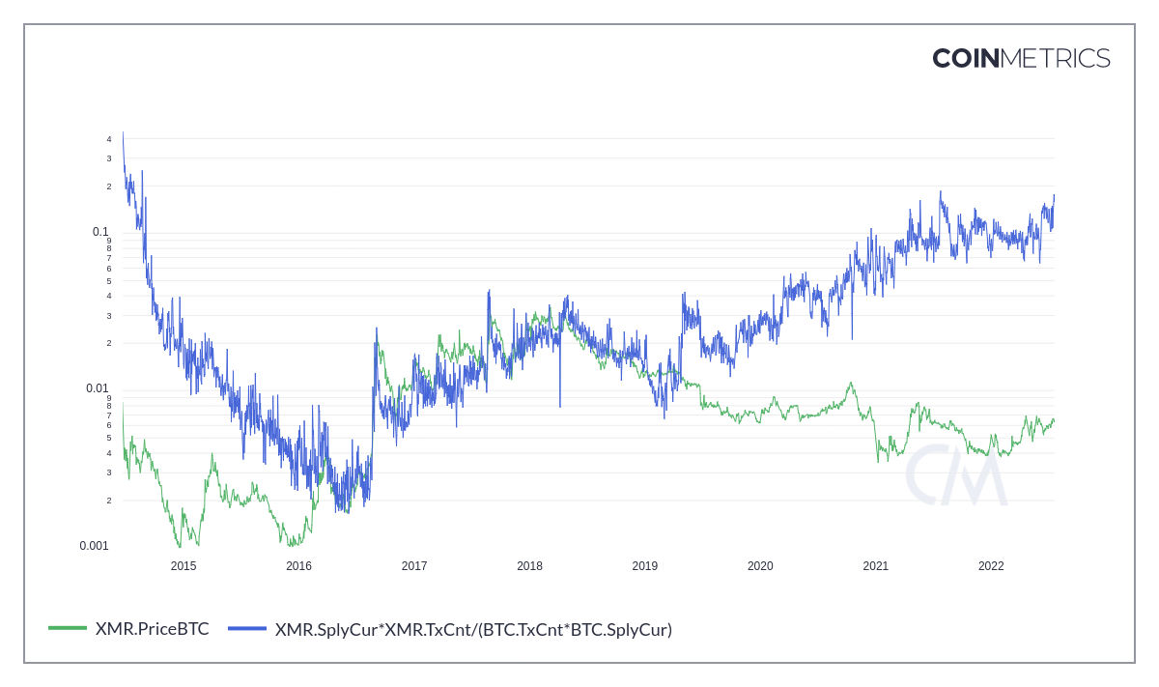
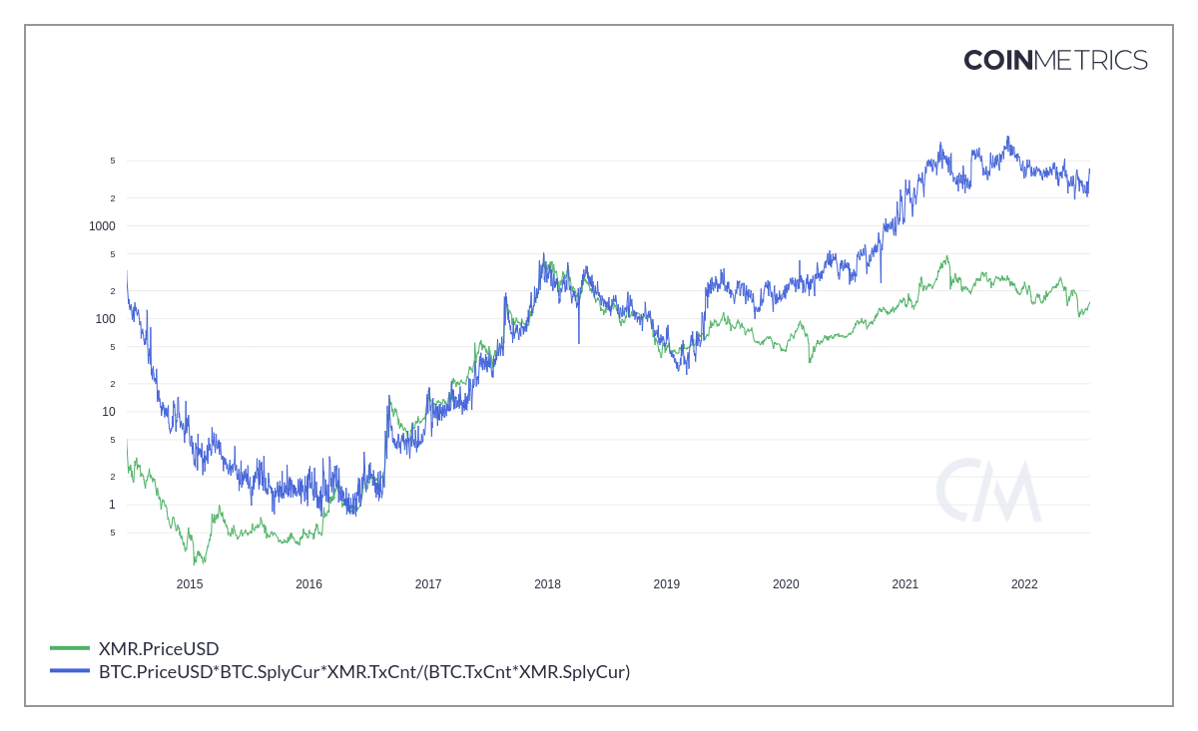
So based of Metcalfe’s law the blue line should be considered the ‘fair value’ of Monero if the market was still considering Monero as part of Bitcoin, which it did for quite a while (until early 2019). We can also multiply both sides by BTC.PriceUSD and find the USD value of each Monero:
And we can make the same approximation for its beginning, which fits exactly the curve:

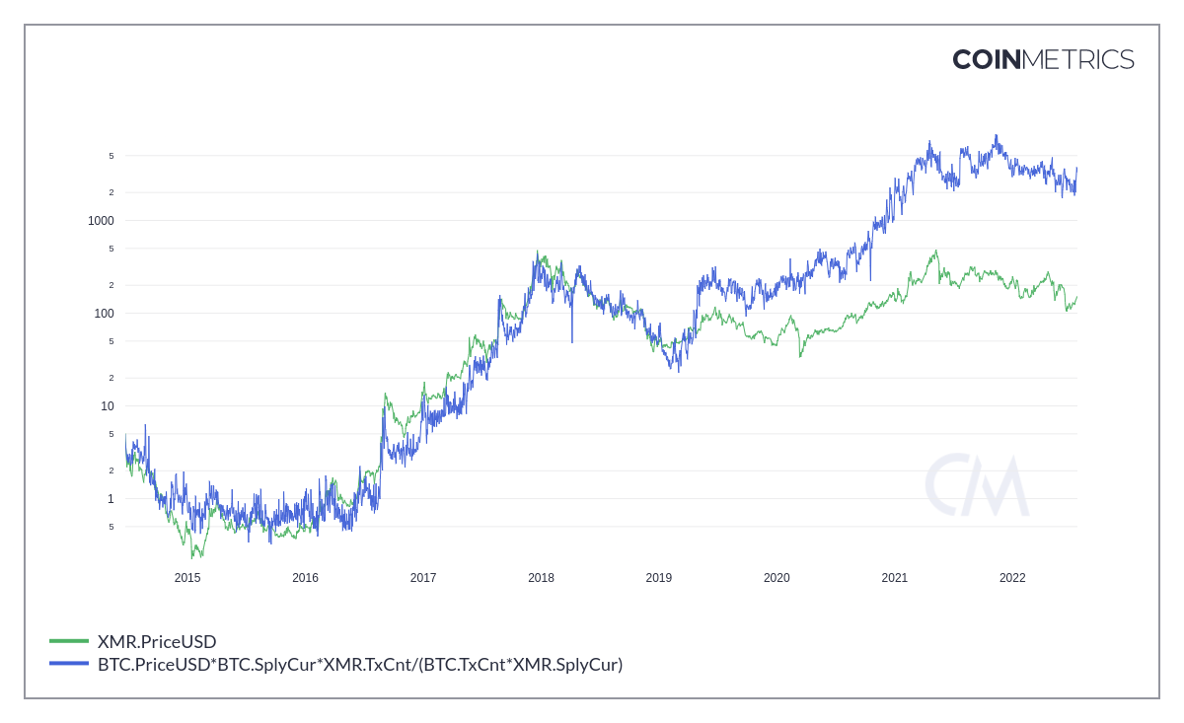
So, by these standards, Monero was supposed to be worth $3800, or 0.15 BTC, with a marketcap of 66 Billion dollars. Very cool if you ask me. But what happened in 2019 that changed this relation? That’s an interesting question. There are some possibilities:

a) Increase usage of other chains to move Bitcoin (like WBTC, very likely);
b) Increase usage of layer 2 transactions (very likely);
c) Exchanges started paper trading Monero, since there’s no way to audit its supplies (very likely);
d) Some institution is suppressing Monero’s price (less likely);
e) Bitcoin saw massive increase in institutional buyers and speculation (very likely);
f) For some unknown reason the market shifted its perception that Monero complements Bitcoin (least likely).

My two cents here: since there’s growing number of transactions since Monero’s inception, I discard the last possibility. Darknet markets are shifting towards Monero, so it really is going through what Bitcoin went in its past. So it’s probably the result of a mixture of the other alternatives. To be fair, I don’t believe much in price suppression. This always seemed a little too paranoid for me, but it’s a possibility. Curiously, in 2019 we saw Binance listing the pair XMRUSD. Also, if there are many BTC transactions in other chains, or layer 2, then the relation
XMR.Tx / BTC.Tx is different from the one calculated by the transactions in layer 1. If we account that, then Monero should not be worth $3800, or 0.15 BTC, but something lower.

Stock-to-flow Model - https://moneroj.net/sfmodel/

As Nick Szabo says, “Monero is a nice privacy complement to Bitcoin”. Both coins are similar, none has a Company controlling it, no CEOs, they are both decentralized, both have anonymous creators, and both are fairly distributed proof-of-work coins. Since the market perceived that Monero was worth exactly its proportion of transactions as if it was part of the Bitcoin network, then if follows that if Bitcoin has a Stock-to-flow model, so should Monero. When dealing with SF, however, I don’t intend to be a hardcore advocate as PlanB, because in my view, the model is just a way to evaluate the project, nothing more. It’s not written in stone, and in real life there are many variables that could cause distortion on the real value of the coin. Just some examples: hyperinflation, deflation, wars, or some new bug found on the project, some major actor pumping or dumping, etc. These things can happen. Also, Monero is still going for its second bull market, and we should have at least two cycles to plot the interpolation. The Stock-to-flow model is based on the amount of inflation the coin has, therefore it flats after tail emission. So you might wonder, what happens if world governments start to print trillions and trillions? Would Monero stay behind and not increase in price? It totally would increase, so this model only serves when the amount of fiat money is constant. The model should account for the inflation of both paris, Monero and fiat money. To be fair, one idea that I’ve been cooking for a while is that, since Monero is perceived as Bitcoin, its Stock-to-flow model would naturally emerge from the pair XMR/BTC, not XMR/USD. This is something to think about, and that would mean that after tail emission, Monero would flat in value when compared to Bitcoin, not dollars. So if Bitcoin goes up, Monero goes with it. But this is just speculation, so it’s not worth plotting such chart. Worth mentioning that infamous ‘grey line’ is just a fractal of Monero’s past price action, and that totally not predicts prices, but at least the timing of local tops and bottoms. People still joke about it. On the Stock-to-flow model, as well as in many other charts, I used the price of Monero against Bitcoin as the color of the dots plotted. So, for example:

Price In Sats - https://moneroj.net/pricesats/

The ‘cycle on the Bitcoin pair’ means how much is Monero worth on the Bitcoin pair. Higher values should have red dots and low values should have blue dots. This is a way I found to add even more information to a chart. In PlanB’s charts, he uses color to demonstrate how far is the halving. For Monero, it makes sense to see how high it is against Bitcoin. So, for example, if the price against dollars (https://moneroj.net/pricelog/) is high, and the dots are red, then it means perhaps it should be a nice spot to sell some XMR. And the opposite should also be true, if price is low and dots are blue, one could wonder if it’s not time to buy.

Fractal Multiple - https://moneroj.net/fractal/

This chart just shows how similar both Monero cycles are. As far as I can see, there’s absolutely no major player manipulating pump and dumps, because it seems pure market behavior. The blue line is the infamous gray line from the SFModel chart, and it is amazing how local tops and bottoms have a tendency to reflect past cycles. The values may differ, since different points in time have different marketcaps and different inflations, but you can pretty much see the same behavior. For example, This model predicted tops in three occasions, as well as our last local bottom last month. This chart led me to develop its ‘poor cousin’, the Inflation Adjusted Fractal (https://moneroj.net/inflationfractal/), which could also predict the price of those local tops and bottoms. However one can see how brutal this last year have been to Monero’s price. What that means is, if past behavior could predict future prices, then because of its shrinking inflation, Monero should be worth a lot more. But can it? Anyway take this chart with a grain of salt.

Golden Ratio Multiplier - https://moneroj.net/golden/

Since Bitcoin has such a model, why not Monero? There’s not much to be said about this plot, just that Monero needs to float above the 111 days moving average to become bull. It had recently gone above that line, but the global economy made everything bear again. Sell signals are printed automatically on the chart every time the prices go above 5xMedian 350 days. Monero is very stable, so that could take a while.

Competitor Performance - https://moneroj.net/competitors/

This chart is brutal. I decided to build this one in order to warn people against investing in high inflationary assets. You can literally see that higher inflation means lower prices. You want financial privacy? That’s cool, but don’t put your money into assets that have high inflation. If care about it, and there’s a privacy cryptocurrency with 0.8% inflation, why the hell would you park your money on an asset with 10% inflation? There’s absolutely no point in doing this. This plot calculates how many times you could have multiplied your money by investing when all these different coins were launched. For each 1 dollar invested in Monero, you could have 30 dollars now (22 July, 2022). For Dash, you would have 3.2 dollars, as well as only 8 cents for Zcash and 1 cent for Grin. Note that this is inversely proportional to their inflation, since right now Monero’s is 0.8%, Dash’s 4.6%, Zcash’s 10% and Grin’s inflation is 29%. Note that for Bitcoin, it is around 1.7% until the next halving. This chart could be seen as evidence that there’s no inflation bug in Monero.

One thing to understand is that Monero will have many years of supremacy on the privacy market, because there’s no way to come up with a fairly distributed privacy cryptocurrency without high inflation. You could either launch a, privacy preserving, premined shitcoin with low inflation, or you could launch Monero 2.0 with fair distribution proof-of-work. But any Monero 2.0 should come with high inflation, otherwise it’s premined. So there is no way to magically come up with a proof-of-work coin with low inflation. Any coin competitor that is launched will have high inflation, therefore is not suited to be a store of value. There’s no way around this. Monero, on the other hand, is both a store of value and a privacy preserving cryptocurrency.

The only ‘privacy focused’ crypto that could compete right now as store of value with Monero is sort of Dash, but Dash is a centralized CEO driven coin, which isn’t as nearly as private as XMR. So no, there won’t be any competitors for a while. The best competitor would be Zcash, but it will take many years for its inflation to come down to less than 1%. Meanwhile Monero should be consolidated as the standard privacy cryptocurrency. Since the network effects on the privacy market are more intense than for transparent ledgers such as BTC and ETH, not many people would want to touch the 2nd option.

Competitor Performance - https://moneroj.net/competitorssats/

Here you can see Monero is the only privacy crypto that investors are still from profit (+12%) against Bitcoin since the launch. This is yet another consequence of the low inflation rate, plus all the use cases for a truly private coin. An investor would have lost 90% of its Bitcoin if they had bought Dash, 94% for Zcash and 99% for Grin. Again, brutal.

Competitor’s Inflation - https://moneroj.net/compinflation/

This plot shows the annualized inflation rate of each coin. The real inflation rate is in fact lower, since the amount of coins one year from now is lower that the amount calculated by the current rate (since the rate is decreasing).

Return Versus Inflation - https://moneroj.net/inflationreturn/

All comes down to this. It would take 129 years to double Monero’s supply at this inflation rate, but only 21 years for Dash, 10 years for Zcash and 3.5 years for Grin. Therefore Monero appreciated more than the others. I love this one.

Comparison to Bitcoin - https://moneroj.net/bitcoin/

The first chart is the return on capital of each coin, Bitcoin and Monero. It shows how much money one investor would have for each dollar invested when the coin ‘launched’. The second image is with a shrank time scale, so we could compare Monero as a fractal of Bitcoin. This gives us an idea that Monero is near a bottom, like was Bitcoin in 2019.

Thermocap Multiple - https://moneroj.net/thermocap/

Thermocap multiple is the ratio obtained between dividing the current price of the coin by the accumulated price of each mined coin. It is often used to indicate end of a bull market. The formula is XMR.PriceUSD/(SUM(Daily Reward * XMR.PriceUSD)). The Thermocap Bands are calculated by the current sum of all mined coins multiplied to its price at that current date. The price should float inside this bands. Judging by this chart, we could be near a bottom.

Power law - https://moneroj.net/powerlaw/

We’ve seen that as the asset matures, it increases in marketcap, making highs and lows that increase as a curve inside a logarithmic chart, but also that time expands each cycle, making them longer. Since there’s nowhere investors can see the time on a double log chart, I decided to plot it. The channel drawn on it are just suggestions, and they could float around price, or even be a curved line.

Price Deviation - https://moneroj.net/deviation/

Price deviation shows how much the current price is above or below the 6 months moving average, both in absolute value and in percentage. This can indicate periods of aggressive expansion, as well as bear markets. Below zero are bear markets and above zero are bull markets. It is interesting to see that before switching bear/bull or bull/bear, the price retests several times the moving average, until its movements on that direction lose force, and then breaks to the opposite side. In that sense we can see a bottom forming. We can expect some retest of the moving average before going bull, so more sideways will probably happen.

Monero’s Marketcap Dominance - https://moneroj.net/dominance/

Interesting to see how Monero slowly bled for years after strong a strong period of appreciation. Each coin has a characteristic, perhaps this is what defines XMR. Years of crabbing, until scarcity hits?

Monero’s Privacy Dominance - https://moneroj.net/monerodominance/

The value is calculated as how much percentage of the privacy market is dominated by Monero. So, divide XMR’s marketcap by the sum of all privacy cryptos (including XMR itself). This constant increase is just a consequence of the fact that Monero has the lowest inflation on the privacy market, besides being the most trusted one. Remember I wrote above that Monero could consolidate itself as the reigning privacy cryptocurrency? Then again, I expect this one to increase as well. There have been few indicators more solid than this one. Easy to see, long lived increase.

Total Privacy Marketcap - https://moneroj.net/privacydominance/

This shows people caring for privacy, then they don’t anymore.

Monero's Coinmarketcap Rank - https://moneroj.net/rank/

Cool chart showing Monero slowly bleeding positions on Coinmarketcap, until a bottom was formed and it became one of the best hedges against Bitcoin. Easily noticeable that its most natural position would be somewhere between 9th to 15th place. Right now it is 28th. King of the crabs.

Transaction Count - https://moneroj.net/translin/

The number of users increase almost linearly, and the number of transactions exponentially. This increase in transactions reflect more users inside the network. You can mix this with the increase in subscribers to /Monero/ subreddit (https://moneroj.net/social/) and clearly see a use case. One thing to wonder is, if the number of users keep increasing while decreasing inflation, then there will be a point where the paradigm will shift and scarcity will hit. Monero broke ATH number of transactions twice in 34 days. Total of 42244 txs on June 15th and 46933 on July 19th. This is bullish.

Monthly Transactions - https://moneroj.net/transmonth/

Long term increase in usage month over month. All time high was November 2021 with 916084 with June 2022 ending with 885569.

Transaction percentage - https://moneroj.net/percentage/

Monero’s transactions divided by Bitcoin’s transactions. Monero has around 15% of the number of transactions Bitcoin has, and this chart is clearly bullish. It will probably break all time high this year.

Monthly Percentage - https://moneroj.net/percentmonth/

Calculating that same percentage, but with monthly numbers, we find out that in June 2022 Monero had its highest percentage against Bitcoin (11.8%). Current numbers are sitting so far at 12.3%, which would be another record, two straight months. During 2021 this number had never crossed below 8%, which is awesome, considering Monero has only 0.6% of its marketcap.

Transacted Price Deviation - https://moneroj.net/deviation_tx/

The transacted price deviation is the multiplication between a) the difference in price from the 6 months moving average and b) the percentage increase in number of transactions from the 6 months moving average.

TPD = ( Price – Averaged Price ) / ( Tx / Averaged TX )

When TPD is negative, price is below the 6 months moving average, and therefore a bear market. When TPD is positive, price is above the moving average and therefore a bull market. This indicator shows huge spikes in transactions near tops. There are also huge spikes in transactions on capitulation events, such as the one that happened in June 18, 2022. This event in particular was the one that probably saw the highest number of coins changing hands. Capitulation such as these often comes along with price increases. Accumulation occurs with fewer transactions, while price is still below the price moving average. In that sense, we can probably expect yet another bottom to form just like the period following the 2018 November crash.

Transaction Dominance - https://moneroj.net/transactiondominance/

It’s calculated dividing the number of transactions in Monero’s blockchain and the total number of transactions on the privacy market (XMR + ZCASH + DASH + GRIN). The dominance is slowly climbing up.

Coins In Circulation - https://moneroj.net/coins/

There are more Bitcoins in circulation than Moneroj, and that will stay a fact until 2040, when both coins will have nearly 21 million units. The difference is that Monero has a tail emission to subsidize mining, which means block reward will be 0.6 infinitely, while Bitcoin is capped at 21 million units and will have to rely on transaction transaction fees to stay relevant. More on this subject can be found here. You can check the difference in supply on this chart https://moneroj.net/extracoins/. It’s possible to see how much will be Monero’s annualized inflation in the next few centuries here https://moneroj.net/tail_emission/.

Daily Emission - https://moneroj.net/dailyemission/

Daily emission means how much is the daily inflation worth at the current price of the day. It’s the multiplication of daily block rewards by the price in dollars. It is important to note that while the market needs daily injections of $18 million to buy all the newly generated Bitcoins, anyone with only $66k can absorb all fresh XMR. If an investor wants to park, for example, $1 million into a privacy preserving cryptocurrency, he would have to buy 15 days worth of inflation. In fact, one investor needs only $24 million dollars to buy one year of inflation in current prices, or just less than two days worth of Bitcoin’s inflation.

