Lab #1: Get Started with C#Programming Using Microsoft Visual Studio

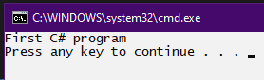
Example-01: How to set up a project in C#:

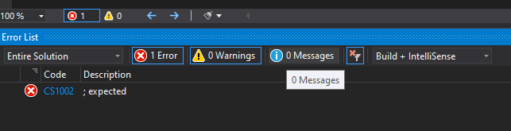

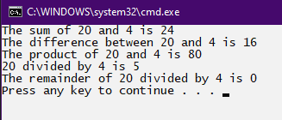
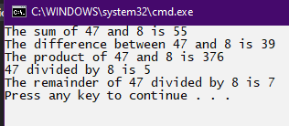
Example-02: Performing Arithmetic operation:

Example-03: Using the stringData Type:
