Antonym Map Output:

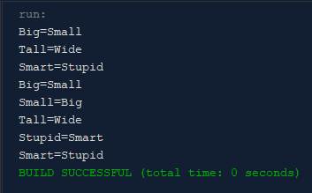

Number Counter Output:



Accounts Output:



Genealogy Output:

 