Question 1:

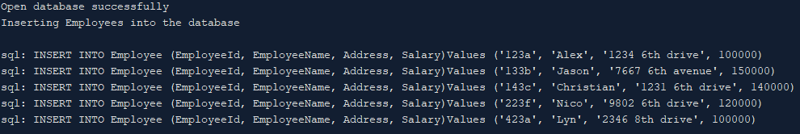Opening and inserting data into the database:

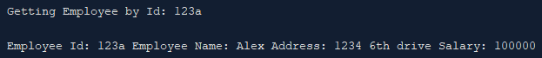Getting an employee by Id:

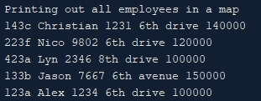Printing out all employees in the database:

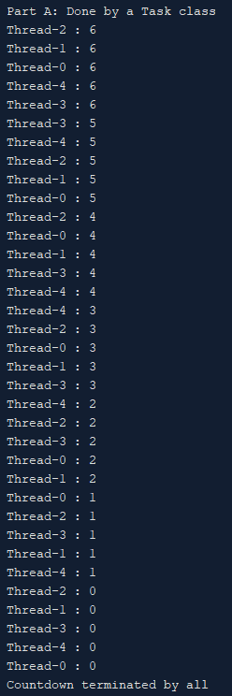Question 2:

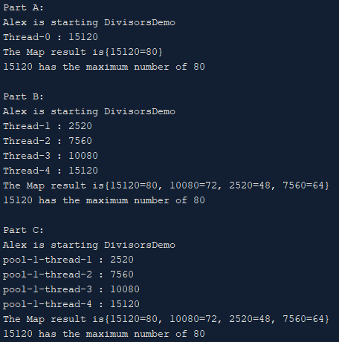Question 3:

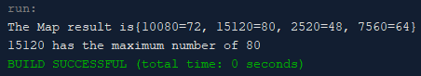Question 4: