Method Design

**CD-01:** CartController

**Package:** Controller

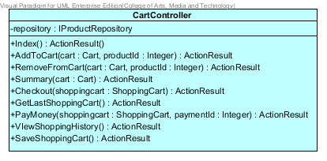

**Attribute Details**

|  |  |  |  |
| --- | --- | --- | --- |
| **No.** | **Name** | **Description** | **Type** |
| 1 | repository | Connection with the IProductRepository | IProductRepository |

**Method Details**

|  |  |  |  |  |
| --- | --- | --- | --- | --- |
| **No.** | **Name** | **Parameter** | **Description** | **Return** |
| 1 | Index | NONE | The method is to direct to the View which is Index.cshtml | ActionResult |
| 2 | AddToCart | cart, productId | The method is to add the product to ShoppingCart | ActionResult |
| 3 | RemoveFromCart | cart, productId | The method is to delete the product from ShoppingCart | ActionResult |
| 4 | Summary | cart | The method is to show all information of the cart | ActionResult |
| 5 | CheckOut | Shoppingcart | The method is to checkout order which customer finishes a shopping | ActionResult |
| 6 | GetLastShoppingCart | NONE | The method is to retrieve the last shoppingcart which customer does not finish yet. | ActionResult |
| 7 | PayMoney | shopping , paymentId | The method is a payment method. | ActionResult |
| 8 | ViewShoppingHistory | NONE | The method is to see the history of the shopping. | ActionResult |
| 9 | SaveShoppingCart | NONE | The method is to save the shopping to do later. | ActionResult |

**CD-02:** AdminController

**Package:** Controller

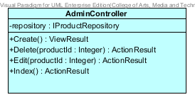

**Attribute Details**

|  |  |  |  |
| --- | --- | --- | --- |
| **No.** | **Name** | **Description** | **Type** |
| 1 | repository | Connection with the IProductRepository | IProductRepository |

**Method Details**

|  |  |  |  |  |
| --- | --- | --- | --- | --- |
| **No.** | **Name** | **Parameter** | **Description** | **Return** |
| 1 | Create | NONE | The method is to add the product to the system (database). | ActionResult |
| 2 | Delete | productId | The method is to delete the product from the system (database). | ActionResult |
| 3 | Edit | productId | The method is to change the information of the product from the system (database). | ActionResult |
| 4 | Index | NONE | The method is to direct to the View which is Index.cshtml | ActionResult |

**CD-03:** AccountController

**Package:** Controller

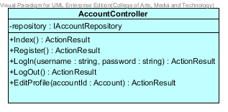

**Attribute Details**

|  |  |  |  |
| --- | --- | --- | --- |
| **No.** | **Name** | **Description** | **Type** |
| 1 | repository | Connection with the IAccountRepository | IAccountRepository |

**Method Details**

|  |  |  |  |  |
| --- | --- | --- | --- | --- |
| **No.** | **Name** | **Parameter** | **Description** | **Return** |
| 1 | Index | NONE | The method is to direct to the View which is Index.cshtml | ActionResult |
| 2 | Register | NONE | The method for customer registration to be an account of the system. | ActionResult |
| 3 | Login | username, password | The method is to log in to the system. | ActionResult |
| 4 | LogOut | NONE | The method is to log out of the system. | ActionResult |
| 5 | EditProfile | account | Method for change the customer information after he has registered. | ActionResult |

**CD-04:** ProductController

**Package:** Controller

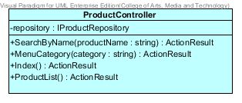

**Attribute Details**

|  |  |  |  |
| --- | --- | --- | --- |
| **No.** | **Name** | **Description** | **Type** |
| 1 | repository | Connection with the IProductRepository | IProductRepository |

**Method Details**

|  |  |  |  |  |
| --- | --- | --- | --- | --- |
| **No.** | **Name** | **Parameter** | **Description** | **Return** |
| 1 | SearchByName | productName | Method for finding the product which customer interest by searching the product name. | ActionResult |
| 2 | MenuCategory | category | The method is to see the product by selecting the category navigation. | ActionResult |
| 3 | Index | NONE | The method is to direct to the View which is Index.cshtml | ActionResult |
| 4 | ProductList | NONE | Method for showing the list of all products which the system has. | ActionResult |

**CD-05:** Account

**Package:** Model

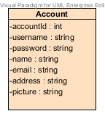

**Attribute Details**

|  |  |  |  |
| --- | --- | --- | --- |
| **No.** | **Name** | **Description** | **Type** |
| 1 | accountId | The variable of the shopping account id | Integer |
| 2 | username | The username of the customer | String |
| 3 | Password | The password of the customer | String |
| 4 | name | The name of the customer | String |
| 5 | email | The Email of the customer | String |
| 6 | Address | The Address of the customer | String |
| 7 | picture | The picture of the customer | String |

**CD-06:** Payment

**Package:** Model

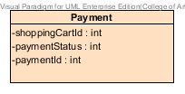

**Attribute Details**

|  |  |  |  |
| --- | --- | --- | --- |
| **No.** | **Name** | **Description** | **Type** |
| 1 | shoppingCartId | The variable of the shopping cart id | Integer |
| 2 | paymentStatus | Store the payment status (0 = not pay and 1 = paid) | Integer |
| 3 | paymentId | The variable of the payment id | Integer |

**CD-07:** ShoppingCart

**Package:** Model

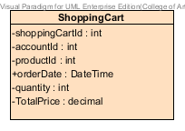

**Attribute Details**

|  |  |  |  |
| --- | --- | --- | --- |
| **No.** | **Name** | **Description** | **Type** |
| 1 | shoppingCartId | The variable of the shopping cart id | Integer |
| 2 | accountId | The variable of the account id | Integer |
| 3 | productId | The variable of the product id | Integer |
| 4 | orderDate | Date and Time which the customer order a shopping | DateTime |
| 5 | quantity | The total order of the shopping | Integer |
| 6 | totalPrice | The total price of the shopping | Decimal |

**CD-08:** Cart

**Package:** Model

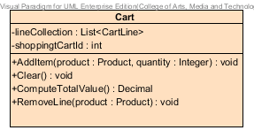

**Attribute Details**

|  |  |  |  |
| --- | --- | --- | --- |
| **No.** | **Name** | **Description** | **Type** |
| 1 | lineCollection | The list of the cart | List<CartLine> |
| 2 | shoppingCartId | The variable of the shopping cart id | Integer |

**Method Details**

|  |  |  |  |  |
| --- | --- | --- | --- | --- |
| **No.** | **Name** | **Parameter** | **Description** | **Return** |
| 1 | AddItem | product, quantity | Method for adding the product to the shopping cart. | void |
| 2 | Clear | NONE | The method is to clear shopping cart. | void |
| 3 | ComputeTotalValue | NONE | The method is to calculate the total price of the shopping cart. | Decimal |
| 4 | RemoveLine | product | Method for deleting the product from the shopping cart. | void |

**CD-09:** Account

**Package:** Model

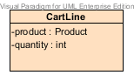

**Attribute Details**

|  |  |  |  |
| --- | --- | --- | --- |
| **No.** | **Name** | **Description** | **Type** |
| 1 | product | Model entity of the product | Product |
| 2 | quantity | The amount of the product in the system | Integer |

**CD-10:** Product

**Package:** Model

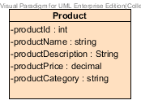

**Attribute Details**

|  |  |  |  |
| --- | --- | --- | --- |
| **No.** | **Name** | **Description** | **Type** |
| 1 | productId | The variable of the product id | Integer |
| 2 | productName | The variable of the product name | String |
| 3 | productDescription | The variable of the product description | String |
| 4 | productPrice | The variable of the product price | Decimal |
| 5 | productCategory | The variable of the product | String |

**CD-11:** IProductRepository <<interface>>

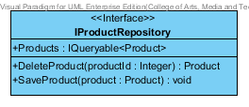

**Attribute Details**

|  |  |  |  |
| --- | --- | --- | --- |
| **No.** | **Name** | **Description** | **Type** |
| 1 | Products | The variable of fetching the data from the product database by Linq | IQueryable<Product> |

**Method Details**

|  |  |  |  |  |
| --- | --- | --- | --- | --- |
| **No.** | **Name** | **Parameter** | **Description** | **Return** |
| 1 | DeleteProduct | productId | Method for deleting the product from the database | Product |
| 2 | SaveProduct | product | The method is to add and update the product into the database. | void |

**CD-12:** EFProductRepository

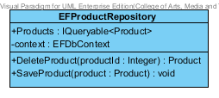

**Attribute Details**

|  |  |  |  |
| --- | --- | --- | --- |
| **No.** | **Name** | **Description** | **Type** |
| 1 | Products | The variable of fetching the data from the product database by Linq | IQueryable<Product> |
| 2 | context | Object for getter and setter data | EFDbContext |

**Method Details**

|  |  |  |  |  |
| --- | --- | --- | --- | --- |
| **No.** | **Name** | **Parameter** | **Description** | **Return** |
| 1 | DeleteProduct | productId | Method for deleting the product from the database | Product |
| 2 | SaveProduct | product | The method is to add and update the product into the database. | void |

**CD-13:** IAccountRepository <<interface>>

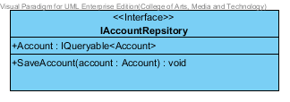

**Attribute Details**

|  |  |  |  |
| --- | --- | --- | --- |
| **No.** | **Name** | **Description** | **Type** |
| 1 | Accounts | The variable of fetching the data from the account database by Linq | IQueryable<Account> |

**Method Details**

|  |  |  |  |  |
| --- | --- | --- | --- | --- |
| **No.** | **Name** | **Parameter** | **Description** | **Return** |
| 1 | SaveAccount | account | The method is to add and update the account of customer into the database. | void |

**CD-14:** EFAccountRepository

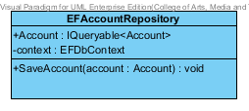

**Attribute Details**

|  |  |  |  |
| --- | --- | --- | --- |
| **No.** | **Name** | **Description** | **Type** |
| 1 | Account | The variable of fetching the data from the account database by Linq | IQueryable<Product> |
| 2 | context | Object for getter and setter data | EFDbContext |

**Method Details**

|  |  |  |  |  |
| --- | --- | --- | --- | --- |
| **No.** | **Name** | **Parameter** | **Description** | **Return** |
| 1 | SaveAccount | account | The method is to add and update the account of the customer into the database. | void |

**CD-15:** EFDbContext

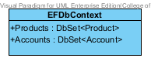

**Attribute Details**

|  |  |  |  |
| --- | --- | --- | --- |
| **No.** | **Name** | **Description** | **Type** |
| 1 | Products | The variable represents the collection of the product entity in the context | DbSet<Product> |
| 2 | Accounts | The variable represents the collection of the account entity in the context | DbSet<Account> |