## Chapter 1-1 | Introduction and Background

The chemical analysis of the water quality could be difficult to measure because water is a wide network of branching like rivers, creeks, swamps, etc. Water in each location can contain vividly different levels of pollution. Water quality issues do not influence only environmental but also affect human health. Monitoring can help to recognize and prevent pollution problems.

In the process of the water monitoring, collectors are assigned to go to the selected locations and collect the samples of water. After that, they go back to the laboratory for evaluating the water quality. However, the problem is that if the distance of selected locations is too far from the laboratory, the condition of chemical components in the collected sample may change overtime. Consequently, the result of water analysis may not accurate and unreliable. It would be a waste of time as well for collectors to go to the water source again.

Currently, I-ANALY-S-T, the research center of Faculty of science, Chiang Mai University, have developed a prototype of chemical analysis algorithm on Mobile application and would like to extend it to be applicable for the collaboration of water monitoring team and the center lab. However, this application can be used as standalone application which does not support the user identification. The test result cannot share instantly. The application does not provide the central system to integrate the test result, manage team and manage the location for the collector to do the water sampling.

Team collaboration system for mobility water monitoring is the idea to increase the value of the water monitoring process to have more efficiency. The application can measure the value of the water parameters such as pH and Ni. The system can share the information of the team members which is controlled by the team leader. The team leader can create a location and assigns the responsibility of the team members in each point on the map. Therefore, the collector is unnecessary to ask the team leader about his responsibility in the project. The application can help the team leader to trace all of the collectors to prove that they actually do the water sampling. The system can make further convenience of the connection between team leader and team members. The prompt message can be sent to each other in a bidirectional way, if the team leader needs his team member to recollect the water sampling. In this project, the developers determine to create team collaboration system on both web application and mobile application and also extended functions of the prototype software to have further completion for team collaboration.

**Chapter 1-2 | Literature Review**

**2.1 Business Review**

**2.1.1 Overview**

There are many different ways to keep track of monitoring the water quality. In the past, whenever where the collectors need to measure the quality of water source, they have to go outside to collect some water sampling of the target area. The problem is the center does not know the results of monitoring at that time. Carrying the water sampling from field to the laboratory spends too many times. The element of the water can change can change before you arrive to the laboratory if the survey area is far. The reason leads to develop the application to analyze and evaluate the water quality.

Center of Excellence for Innovation in Analytical Science and Technology (I-ANALY-S-T) has developed the modern chemical analysis for water quality using the technology in chemical analysis combines with the modern information technologies, which can check the quality of water sources rapidly by considering the water quality indices, namely (pH), temperature, conductivity, (Do), (Turbidity), (TDS), the nitrate, ammonia, phosphate and the (COD).

Although, there is technology on mobile application, I-ANALY-S-T found the difficult to trace back the water sampling from the collectors. We do not know that the collectors actually collect the water sampling of the target area. So that, the solution of this problem is to create a new system cover the team collaboration of one water sources using more than one collector collect water sampling to look for the various area in each of water sources. The system can solve the problem of using mobile to monitor water source on another area.

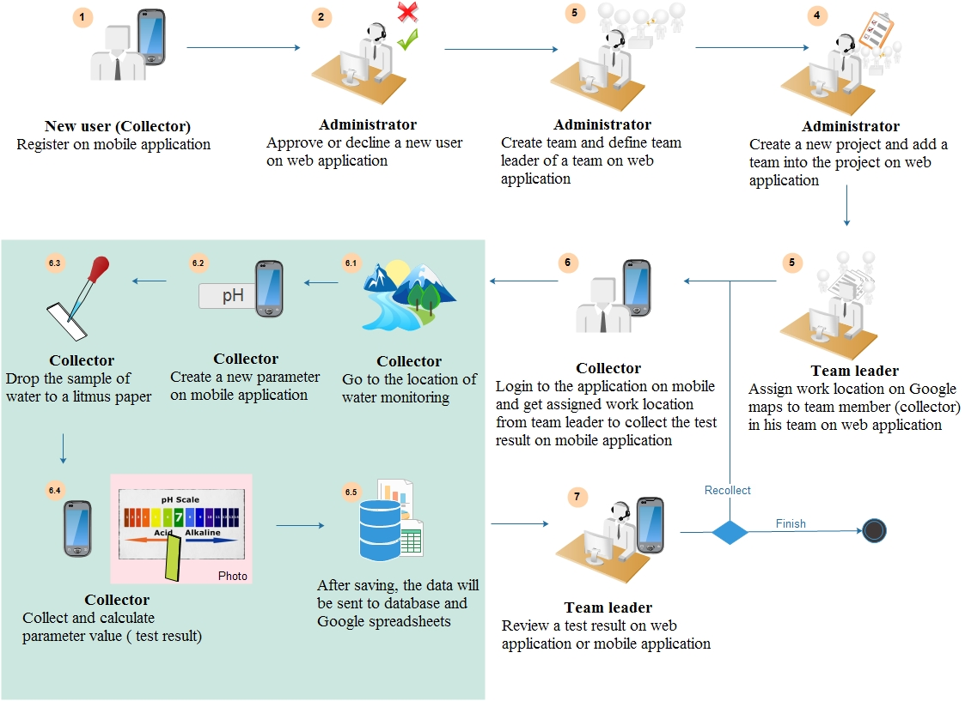

**2.2 Technology Review**

**2.2.1 PHP**

PHP is an open source server –side scripting language and programming language use on the site. It can be written in a variety of application, as well as the common language. In different from HTML is the language used in the formatting of the website. For the popular website is simple to interact with users with PHP, HTML or JavaScript are used as a control for display purposes only.

Alternative technology

-   Visual Basic (ASP.Net)-C#

-    JSP

-    Python

-    Perl

-    Ruby

-   ColdFusion

The Selection of this technology

        PHP is one of the most popular server side scripting language running today. It is used for creating dynamic web page that interact with the user offering customized information. PHP offers many advantage. It is fast, Stable, secure, easy to use and open source (free).

**2.2.2 Android**

Android is an operating system with Java programming language for the electronic devices that include operating system such as smartphones and tablet. Android is requiring the Android Software Development Kit or Android SDK provides all necessary tools to develop Android application. This includes compilers, debugger and device emulator. It is own virtual to run Android programs.

Alternative technologies

-  BlackBerry OS from RIM

- iOS from Apple, Inc.

-   Symbian OS from Nokia and Accenture

-  Window Phone from Microsoft

-   Linux based on operating system

-   Palm OS by Palm, Inc.

The Selection of this technology

-   Android is a free open source operating system for embedded devices.

-   An open source development platform for creating applications.

-   Devices, particularly mobile phones that run the Android operating system and the application created for it.

-   We can find a lot of tutorials and the Android plugin for Eclipse

**2.2.3 Google Maps**

        Google Maps is a map on the internet to help you find a location or route roughly in travel and can be used with navigation system GPS. Google Maps satellite images are not updated in real time, but rather they are several months or years old. [1]

Alternative technologies

-   Yahoo! Map Web Services

-   MM Map API

-   Amazon Maps API

The Selection of this technology

Google API package, it can create map-based Activities using Google Maps as a user interface element. It has full access to the map, which enables to control displays settings, after the zoom level, and pan to a different location. Using Overlays and it can annotate maps and handle user input. (John Wiley & Sons, Inc. 2012)

**2.2.4 Google Sheet**

**2.3 Development tools Review**

**2.3.1 Eclipse with ADT**

Eclipse is an integrated development environment (IDE). It contains a base workspace and an extensible plug-in system for customizing the environment. Written mostly in Java, Eclipse can be used to develop applications. By means of various plug-ins, Eclipse may also be used to develop applications in other programming languages: Ada, C, C++, COBOL, Fortran, Haskell, JavaScript, Lasso, Perl, PHP, Python, R, Ruby (including Ruby on Rails framework), Scala, Clojure, Groovy, Scheme, and Erlang. It can also be used to develop packages for the software Mathematica. Development environments include the Eclipse Java development tools (JDT) for Java and Scala, Eclipse CDT for C/C++ and Eclipse PDT for PHP, among others. [3]

Alternative technologies

-          NetBean IDE

-          IntelliJ IDEA

-          Notepad++

The Selection of this technology

The advantage of the Eclipse software is easy to install J2SDK and available on all versions. Eclipse support for many languages are used to enhance the performance of the plugin. It can work with multiple file types such as HTML, Java, C, JSP, EJB, XML, and GIF, and more importantly it is free of Orleans. It is compatible with operating systems Windows, Linux and mac OS. [4]

**2.3.2 ADT Plug-in for Eclipse**

Android Development Tools (ADT) is a plugin for the Eclipse IDE that is designed to give you a powerful, integrated environment in which to build Android applications.

ADT extends the capabilities of Eclipse to let you quickly set up new Android projects, create an application UI, add packages based on the Android Framework API, debug your applications using the Android SDK tools, and even export signed (or unsigned) .apk files in order to distribute your application. [5]

Alternative Tool

-    App Inventor

The selection of this tool

-  As the recommended development platform, using Eclipse with the ADT plug-in for Android development offer some significant advantage, primarily through the tight integration of many of the Android build and debug tools into IDE. (John Wiley & Sons, Inc. 2012)

**2.3.3 Android SDK**

The Android SDK (software development kit) is a set of development tools used to develop applications for Android platform. The Android SDK includes the following:

-   Required libraries

-    Debugger

-    An emulator

-    Relevant documentation for the Android application program interfaces (APIs)

-    Sample source code

-    Tutorials for the Android OS.

The selection of this tool

-    The programmer can use Android SDK to develop application and test it on the emulator which similar to the real Android phone

-    Android SDK provides a great starting point for an individual developer of Android code. It is missing features that facilitate the collaboration and coordination needed when a team develops an Android application by integrating the device-specific, native platform SDK with a compatible commercial development solution, agile teams  can achieve tremendous efficiencies and higher-quality results. [6]

**2.3.4 JetBrains PhpStorm 7.1.3**

JetBrains PhpStorm is a commercial, cross-platform [IDE](http://en.wikipedia.org/wiki/Integrated_Development_Environment) for [PHP](http://en.wikipedia.org/wiki/PHP) built on [JetBrains](http://en.wikipedia.org/wiki/JetBrains)' [IntelliJ IDEA](http://en.wikipedia.org/wiki/IntelliJ_IDEA) platform. PhpStorm provides an editor for [PHP](http://en.wikipedia.org/wiki/PHP), [HTML](http://en.wikipedia.org/wiki/HTML) and [JavaScript](http://en.wikipedia.org/wiki/JavaScript) with on-the-fly code analysis, error prevention and automated [refactorings](http://en.wikipedia.org/wiki/Refactoring) for PHP and JavaScript code. PhpStorm's [code completion](http://en.wikipedia.org/wiki/Code_completion) supports PHP 5.3, 5.4, 5.5 & 5.6 (modern and legacy projects), including [generators](http://en.wikipedia.org/wiki/Generator_%28computer_programming%29), [coroutines](http://en.wikipedia.org/wiki/Coroutines), the finally keyword, list in for each, [namespaces](http://en.wikipedia.org/wiki/Namespace), [closures](http://en.wikipedia.org/wiki/Closure_%28computer_science%29), [traits](http://en.wikipedia.org/wiki/Trait_%28computer_programming%29) and short array syntax. It includes a full-fledged [SQL](http://en.wikipedia.org/wiki/SQL) editor with editable query results.PhpStorm is built on IntelliJ IDEA, which is written in [Java](http://en.wikipedia.org/wiki/Java_%28programming_language%29). Users can extend the IDE by installing plugins created for the IntelliJ Platform or write their own plugins. [7]

The selection of this tool

PhpStorm’s smart code editor provides excellent support for PHP (including the latest language versions and frameworks), HTML, JavaScript, CSS, Sass, Less, CoffeeScript, and many other languages.

**2.3.5 XAMPP**

XAMPP is a free and open source cross-platform web server solution stack package, consisting mainly of the Apache HTTP Server, MySQL database, and interpreters for scripts written in the PHP and Perl programming languages. [8]

Alternative Tool

-   Appserv

-   WampServer

The selection of this tool

The good thing about XAMPP; it is free, easy to install, and no configuration is needed to make APACHE, PHP & MYSQL compatible with each other.

**Chapter 1-3 | Quality Standard**

**3.1 ISO29110 for Very Small Entity (VSE)**

        ISO29110 is a guide applies to a very Small Entity (VSE), enterprise, organization, department or project up to 25 people, dedicated to software development. The Guide provides Project Management and Software Implementation process which integrate practices base on the selection of ISO/IEC 12207-Systems and Software Engineering – Software Life Cycle Process and ISO/IEC15289 Software Engineering – Software Life Cycle Process – guideline for the content of software life cycle process information product (documentation) standards element.

**Project Management process**

        The purpose of the project Management process is to establish and carry out in a systematic way the task of the software implementation project, which allows complying with the project’s objective in the expected quality, time and cost.

Selected process

1. Project Planning Process

2. Project Plan Execution Process

3. Project Assessment and Control Process

4. Project Closer Process

**Software Implementation process**

        The purpose of the Software Implementation process is the systematic performance of the analysis, design, construction, integration and tests activities for new or modified software products according to the specified requirement.

Selected process

1. Software Implementation Initiation Process

2. Software requirement Analysis Process

3. Software Architectural Design Process

4. Software Construction Process

5. Software Integration and test Process

6. Software Delivery Process Chapter

**Chapter 1-4 | Project Plan**

**4.1 Motivation**

Normally, the water quality measuring need to be collected in various locations. The existing application can be used in only once a times and cannot processes the data into the center which cause wasting it wastes the time. The reason leads developers to develop the application to solve the problem. Team collaboration system for mobility water monitoring application able to send the data to center directly and also able to prompt the user since there are some problems. These are the advantages to reduce the time for working.

**4.2 Aims and Objective**

**4.2.1 Aim**

The aim of this project is to develop the mobility water monitoring system in order to manage the project and share the water parameter testing information to the working team.

**4.2.2 Objective**

-          To create the central system support team collaboration

-          To help managing projects and teams

-          To help identifying the collectors responsibility

-          To help sharing all test results aggregated to the evaluation

-          To be able to trace back the test result from the research center

-          To reduce the time of working as a team

**4.3 System Architecture**

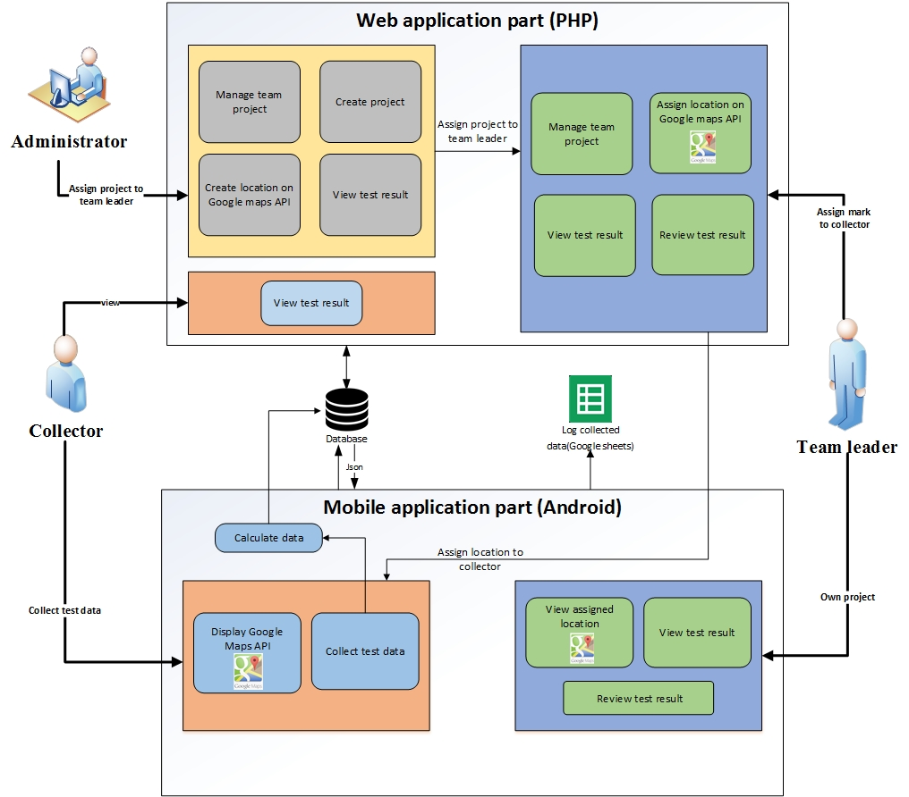

**Figure 2**:

Figure 2 show the overview of Team collaboration system for mobility water monitoring system. There are 3 parts in the system consist of Mobile Application part for Collector, Mobile application part for team leader and Web application part. Mobile Application for Collector is a software for water parameters monitoring. Then, the test result will be recorded to database. Mobile Application for Team Leader provides the result presentation retrieving the data from database in and trace a working position all of the collectors in his team. Finally, Web Application provides to all of users consisting of Administrator, Team Leader and Collector. Administrator can create and manage teams and projects. They also can approve a new registered member. Team leader can assign works on Google Maps to collectors and review the details of the test result of the involved project. Collector can know the assigned work from team leader to do the water quality monitoring, then send the test result to the database via JSON. In every testing, the information will be recorded in the Google Sheet. In addition, team leader and collectors can have a connection by messaging in the mobile application within each team.

**4.4 Deliverables and Limits**

**4.4.1 Deliverables**

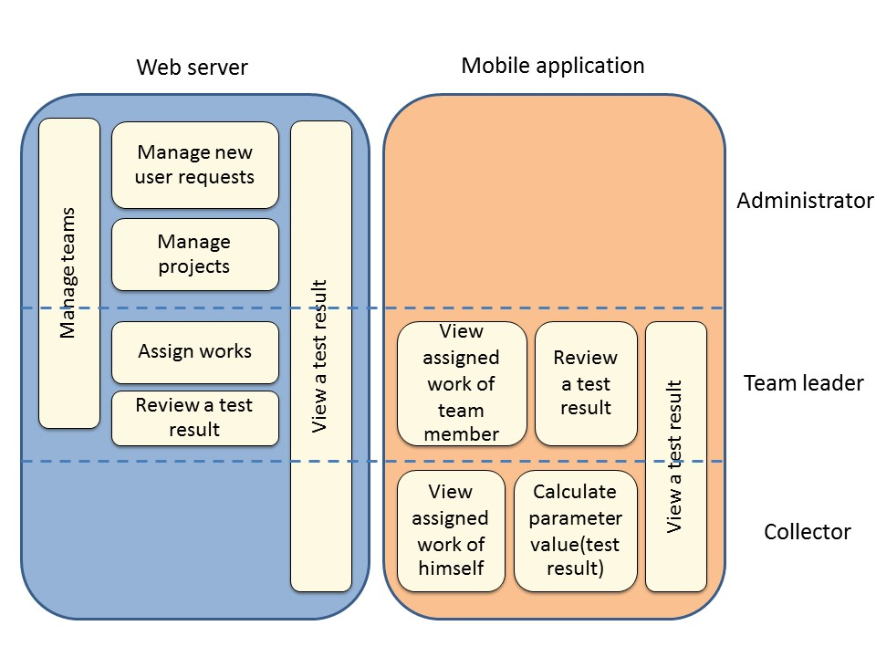

**Figure:**

**There are 7 feature in the system and each of features is separated as follows:**

|  |  |  |  |  |
| --- | --- | --- | --- | --- |
| **Feature** | **Function name** | **Administrator** | **Team leader** | **Collector** |
| **Feature 1:** Authentication and member management system | Authentication on web application | √ | √ | √ |
| Edit profile on web application | √ |  |  |
| View list of new collector request on web application | √ |  |  |
| Select to approve or decline new collector request on web application | √ |  |  |
| Create team on web application | √ |  |  |
| Modify team on web application | √ | √ |  |
| View the selected team information on web application | √ | √ |  |
| Send register request on mobile application |  |  | √ |
| Authentication on mobile application |  | √ | √ |
| **Feature** | **Function name** | **Administrator** | **Team leader** | **Collector** |
| **Feature 2:**  Project management | Create the project on web application | √ |  |  |
| Search the project on web application | √ | √ | √ |
| Modify the project on web application | √ |  |  |
| **Feature** | **Function name** | **Administrator** | **Team leader** | **Collector** |
| **Feature 3:**  Project browsing | View the project list on web application | √ |  |  |
| View the involved project list on web application and mobile application |  | √ | √ |
|  | View a project information on web application | √ |  |  |
| View a project information on web application and mobile application |  | √ | √ |
|  | View list of parameter test on web application and mobile application |  | √ | √ |
| **Feature** | **Function name** | **Administrator** | **Team leader** | **Collector** |
| **Feature 4:** Map location management | Assign work location on Google Maps on web application |  | √ |  |
| View assign map location on mobile application |  |  | √ |
| View direction to assigned location on Google Maps on mobile application |  |  | √ |
| View other place information by press on pin on mobile application |  | √ | √ |
| **Feature** | **Function name** | **Administrator** | **Team leader** | **Collector** |
| **Feature 5:** Result presentation | Review test result (Recollect, Finish) on web application and mobile application |  | √ |  |
| View detail of test result on web application and mobile application |  | √ | √ |
| **Feature** | **Function name** | **Administrator** | **Team leader** | **Collector** |
| **Feature 6:** Message | Send message via group message on mobile application |  | √ | √ |
| Receive a notification |  | √ | √ |
| **Feature** | **Function name** | **Administrator** | **Team leader** | **Collector** |
| **Feature 7:** Extension of existing application | Choose the image from camera roll or take a photo on mobile application |  |  | √ |
| Add test parameter on mobile application |  |  | √ |
| Delete test parameter on mobile application |  |  | √ |

**There are 3 parts in the system consist of:**

|  |  |  |  |
| --- | --- | --- | --- |
| **Part** | **Administrator** | **Team leader** | **Collector** |
| Web application | √ | √ | √ |
| Mobile application | - | √ | √ |

**Web application Part (Administrator, Team leader, Collector)**

* Feature 1: Authentication and member management system
* Feature 2: Project management
* Feature 3: Project browsing
* Feature 4: Map location management
* Feature 5: Result presentation

**Mobile Part (Team leader)**

* Feature 1: Authentication and member management system
* Feature 3: Project browsing
* Feature 4: Map location management
* Feature 5: Result presentation
* Feature 6: Message

**Mobile Part (Collector)**

* Feature 1: Authentication and member management system
* Feature 2: Project management
* Feature 3: Project browsing
* Feature 4: Map location management
* Feature 5: Result presentation
* Feature 6: Message
* Feature 7: Extension of existing application

**4.4.2 Documents**

* Proposal
* Project Plan
* Software Requirement Specification
* Software Design Document
* Testing Document
* Traceability Record
* Progress Status Report
* Self-assessment Report

**4.4.3 Limits**

* The internet connection is required for using this system and application.
* Smart device, which are using Android OS.
* User should have account for access to the system.
* Website support only English language.

**4.5 Future work**

Team collaboration system for mobility water monitoring application can support with other platform (iOS).

**4.6 Software Development Life Cycle**

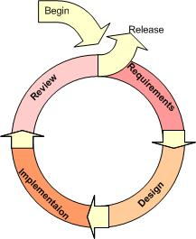

**Figure 3**:Iterative Model [9]

**4.6.1 Iterative Model**

An iterative life cycle model uses the concept of dividing the work into small pieces to reduce the risk of development. The development begins by specifying and implementing just part of the software, which can then be reviewed in order to identify further requirements. During each of iteration, the development module goes through the requirements, design, and implementation and testing phases. Each subsequent release of the module adds function to the previous release. The process continues till the complete system is ready as per the requirement.

        An iterative life cycle model can accommodate changes by stakeholder feedback to refine requirements and design. The developers can build and improving the product step by step causes we can track the defects at the early stages.

**4.7 Schedule & Milestone**

|  |  |  |  |
| --- | --- | --- | --- |
| **Milestone** | **Task** | **Milestone Criteria** | **Planned date** |
| 1 | Proposal | -Topic defined | January |
| 2 | Proposal Report  (Review Mrs.) | - Proposal reviewed | January |
| 3 | Progress Report 1 (Review Mrs.) | - Software Requirement Specification  - Software Design Document  - Test Plan Progress 1  - Implementation Progress 1  - Test Feature Progress 1  - Traceability Record Progress 1 | February-March |
| 4 | Progress Report 2 (Review Mrs.) | - Software Requirement  Specification  - Software Design Document  - Test Plan Progress 2  - Implementation Progress 2  - Test Feature Progress 2  - Traceability Record Progress 2 | March-April |
| 5 | Progress Report 3(Review Mrs.) | - Software Requirement Specification  - Software Design Document  - Test Plan Progress 3  - Implementation Progress 3  - Test Feature Progress 3  - Traceability Record Progress 3  - Progress  report 3 submitted  - Progress report  3 presentation | April-May |

The features have separated to 3 progresses as follows:

**Progress Report 1**

* Feature 1: Authentication and member management system
* Feature 2: Project management

**Progress Report 2**

* Feature 3: Project browsing
* Feature 4: Map location management
* Feature 5: Result presentation

**Progress Report 3**

* Feature 6: Messaging System
* Feature 7: Extension of existing application

**4.6.1 Proposal Report**

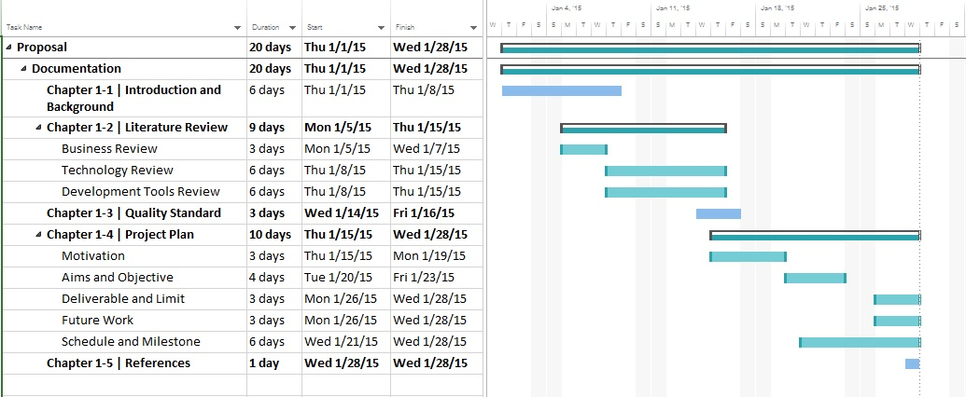

**Figure 4:** Proposal Report

**4.6.2 Progress Report 1**

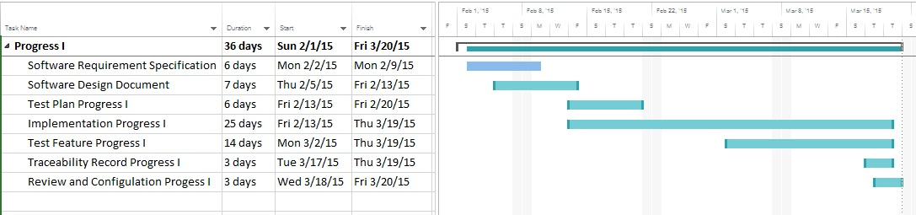

**Figure 5:** Progress Report 1

**Progress Report 1**

* Feature 1: Authentication and member management system
* Feature 2: Project management

**4.6.3 Progress Report 2**

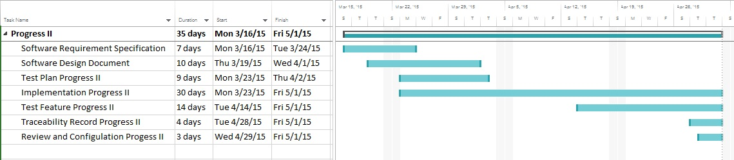

**Figure 6:** Progress Report 2

**Progress Report 2**

* Feature 3: Project browsing
* Feature 4: Map location management
* Feature 5: Result presentation

**4.6.4 Progress Report 3**

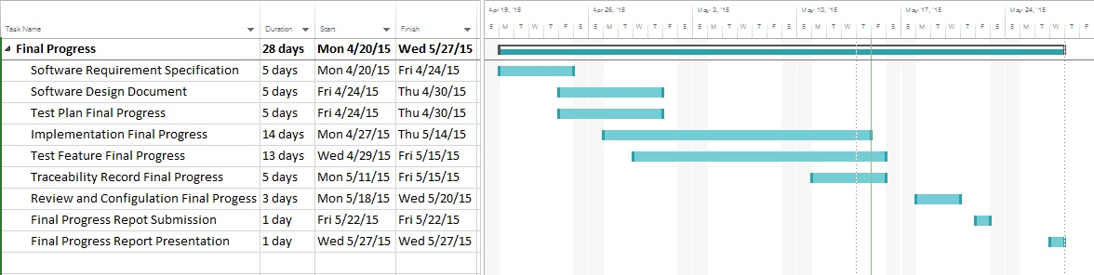

**Figure 7 :** Progress Report 3

**Progress Report 3**

* Feature 6: Messaging System
* Feature 7: Extension of existing application

**Chapter 1-5 | References**

**[1] Google Maps**

Author : -

Access on: 2014

Resource : <http://google.wikia.com/wiki/Google_Maps>

**[2] Google Cloud SQL**

Author : Google development team

Access on: 2014

Resource :<https://developers.google.com/cloud-sql/docs/introduction>

**[3] Eclipse with ADT**

Author : -

Access on: 1 March 2014

Resource :<http://en.wikipedia.org/wiki/Eclipse_(software)>

**[4] Advantage of Eclipse with ADT**

Author : Eclipse development team

Access on: 2014

Resource : [http://www.eclipse.org](http://www.eclipse.org/)

**[5] ADT Plug-in for Eclipse**

Author : Eric Cloninger

Access on: 9 May 2012

Resource :<http://marketplace.eclipse.org/content/android-development-tools-eclipse>

**[6] Android SDK**

Author : LEIGH WILLIAMSON

Access on: 11 February, 2011

Resource :<http://embedded-computing.com/articles/the-commercial-eclipse-based-solutions/>

**[7] JetBrains PhpStorm 7.1.3**

Author : -

Access on: 25 February 2014

Resource : [http://en.wikipedia.org/wiki/PhpStorm](https://www.ntchosting.com/web-design/dreamweaver.html)

**[8] XAMPP**

Author : -

Access on: 25 February 2014

Resource : <http://en.wikipedia.org/wiki/XAMPP>

**[9] Iterative Model**

Author : -

Access on: 25 February 2014

Resource :<http://www.snyders.us/qa-iterative.htm>l