**Project Proposal**

**Team Collaboration System for Mobility Water Monitoring**

**By**

**Mr. Peerapong Chompootepa 542115044**

**Mr. Worrasete Tansurat 542115056**

**Department of Software Engineering**

**College of Arts, Media and Technology**

**Chiang Mai University**

**Project Advisor**

**____________________________**

**Ms.Siraprapa Wattanakul**

**Document History**

| **Document Name** | **Detail** | | **Status** | **Date** | **Viewable** | **Reviewer** | **Responsible** |
| --- | --- | --- | --- | --- | --- | --- | --- |
| **Documents** | | | | | | | |
| Proposal_V0.1.docx | | - Add Chapter1  - Introduction & Background  - Add Chapter2  - Business Review  - Technology Review | Draft | 01/01/15 | PC ,  WT, SW | PC ,  WT | PC ,  WT |
| Proposal_V0.2.docx | | - Adjust Chapter1  - Introduction & Background  - Adjust Chapter2  - Technology Review  - Development Tool Review | Draft | 05/01/15 | PC ,  WT, SW | PC ,  WT | PC ,  WT |
| Proposal_V0.3.docx | | - Adjust Chapter3  - Quality Standards  - Add Chapter4  - Project Plan  - Add Chapter5  - References | Draft | 09/01/15 | PC ,  WT, SW | PC ,  WT | PC ,  WT |
| Proposal_V0.4.docx | | - Adjust Chapter1  - Introduction & Background  - Add Chapter4  - Add Chapter5 | Draft | 12/01/15 | PC ,  WT, SW | PC ,  WT | PC ,  WT |
| Proposal_V1.0.docx | | - Proposal | Released | 10/06/15 | PC,  WT, SW | PC ,  WT | PC ,  WT |
| Proposal_V2.0.docx | | - Proposal | Released | 29/06/15 | PC,  WT, SW | PC ,  WT | PC ,  WT |

* PC = Mr. Peerapong Chompootepa

* WT = Mr. Worrasete Tansurat

*SW = Ms. Siraprapa Wattanakul

**Table of Contents**

**Chapter 1-1 | Introduction and Background** 5

**Chapter 1-2 | Literature Review** 6

2.1 Business Review 6

2.1.1 Overview 6

2.2.1 PHP 8

2.2.2 Android 9

2.2.3 Google Maps 9

2.2.4 Google Spreadsheet 10

2.3 Development tools Review 10

2.3.1 Eclipse with ADT 10

2.3.2 ADT Plug-in for Eclipse 11

2.3.3 Android SDK 11

2.3.4 JetBrains PhpStorm 7.1.3 12

2.3.5 XAMPP 12

**Chapter 1-3 | Quality Standard** 13

3.1 ISO29110 for Very Small Entity (VSE) 13

**Chapter 1-4 | Project Plan** 14

4.1 Motivation 14

4.2 Aims and Objectives 14

4.2.1 Aims 14

4.2.2 Objectives 14

4.3 System Architecture 15

4.4 Deliverables and Limits 16

4.4.1 Deliverables 16

4.4.2 Documents 17

4.4.3 Limits 17

4.5 Future work 17

4.6 Software Development Life Cycle…………………………………………………………18

4.6.1 Iterative Model 18

4.7 Schedule & Milestone 19

4.7.1 Proposal Report 20

4.7.2 Progress Report 1 20

4.7.3 Progress Report 2 21

4.7.4 Progress Report 3 21

**Chapter 1-5 | References** 22

**Chapter 1-1 | Introduction and Background**

The chemical analysis of the water quality could be difficult to measure. Because water is a wide network of branching like rivers, creeks, swamps, etc. Water in each location contains vividly different levels of pollution. Water quality issues do not influence only environmental but also affect human health. Monitoring can help to recognize and prevent pollution problems.

In the process of the water monitoring, collectors are assigned to go to the selected locations and collect the samples of water. After that, they go back to the laboratory for evaluating the water quality. However, the problem is that if the distance of selected locations is too far from the laboratory, the condition of chemical components in the collected sample may change overtime. Consequently, the result of water analysis may not accurate and unreliable. It would be a waste of time as well for collectors to go to the water source again.

Currently, I-ANALY-S-T, the research center of Faculty of science, Chiang Mai University, have developed a prototype of chemical analysis algorithm on Mobile application and would like to extend it to be applicable for the collaboration of water monitoring team and the center lab. However, this application can be used as standalone application which does not support the user identification. The test result cannot share instantly. The application does not provide the central system to integrate the test result, manage team and manage the location for the collector to do the water sampling.

Team collaboration system for mobility water monitoring is the idea to increase the value of the water monitoring process to have more efficiency. The application can measure the value of the water parameters such as pH, Ni and etc. The system can share the information of the team members which is controlled by the team leader. The team leader can create a location and assigns the responsibility of the team members in each point on the map. Therefore, the collector is unnecessary to ask the team leader about his responsibility in the project. The application can help the team leader to trace all of the collectors to prove that they actually do the water sampling. The system can make further convenience of the connection between team leader and team members. The prompt message can be sent to each other in a bidirectional way, if the team leader needs his team member to recollect the water sampling. In this project, the developers determine to create team collaboration system on both web application and mobile application and also extended functions of the prototype software to have further completion for team collaboration.

**Chapter 1-2 | Literature Review**

**2.1 Business Review**

**2.1.1 Overview**

There are many different ways to keep track of monitoring the water quality. In the past, whenever where the collectors need to measure the quality of water source, they have to go outside to collect some water sampling of the target area. The problem is the center does not know the results of monitoring at that time. Carrying the water sampling from field to the laboratory spends too many times. The element of the water can change can change before arriving to the laboratory if the survey area is far. The reason leads to develop the application to analyze and evaluate the water quality.

Center of Excellence for Innovation in Analytical Science and Technology (I-ANALY-S-T) has developed the modern chemical analysis for water quality using the technology in chemical analysis combines with the modern information technologies, which can check the quality of water sources rapidly by considering the water quality indices, namely (pH), temperature, conductivity, (Do), (Turbidity), (TDS), the nitrate, ammonia, phosphate and the (COD).

Although, there is technology on mobile application, I-ANALY-S-T found the difficult to trace back the water sampling from the collectors. We do not know that the collectors actually collect the water sampling of the target area. So that, the solution of this problem is to create a new system cover the team collaboration of one water sources using more than one collector collect water sampling to look for the various area in each of water sources. The system can solve the problem of using mobile to monitor water source on another area.

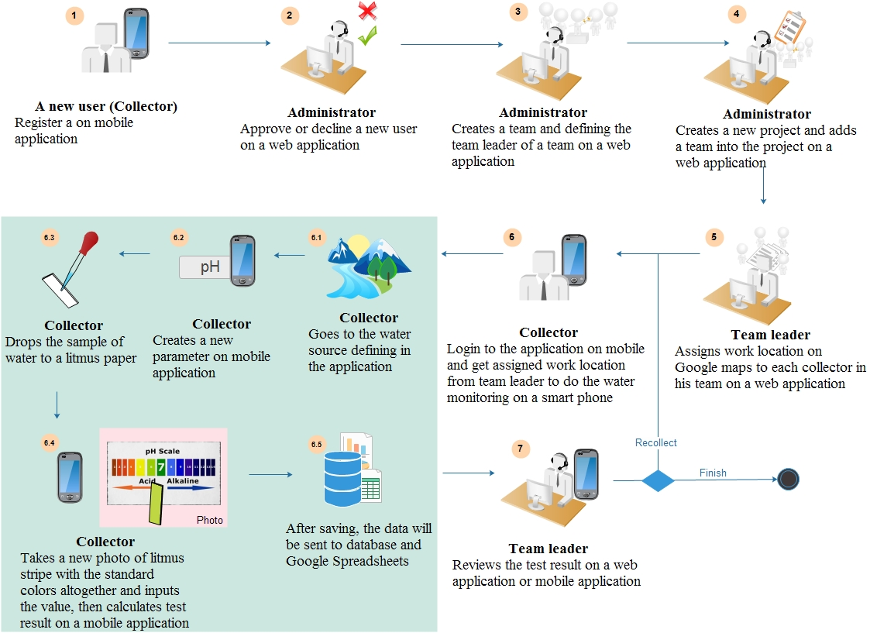

**Figure 1:** Work flow of Team Collaboration System for Mobility Water Monitoring

**Process of the new process of the water analysis system:**

1. A new user who want to be the collector must register on a mobile application and wait for approval from administrator.
2. Administrator can approve or decline a new user request.
3. Administrator creates a new team by selecting members and also choosing the team leader on web application.
4. Administrator creates a new project and add a team into the project that they created.
5. Team leader assigns work location on Google Maps to each collector in his team by marking a pin on the map. Google Maps will get a latitude and longitude automatically regarding the marked pin. Then, the team leader must choose a collector to working at each location.
6. Collector logins to the application and get assigned work from team leader to do the water monitoring on smartphone.

6.1 Collector goes to the water source defining in the application.

6.2 Collector creates a new parameter to start the test on a mobile application.

6.3 Collector drops the sample of water to a testing indicator.

6.4 Collector has to take a new photo of water testing indicator with the standard colors altogether and inputs the value, then the system will calculate the test result regarding the image of testing indicator.

* 1. Collector clicks save button, the data will save to the database and Google Spreadsheets for further analysis.

7. Team leader reviews the test result and makes an inspection. If the testing has something wrong or the value of parameter might not be matching with the probability value should be, team leader has to warn the collector to re-testing.

**2.2 Technology Review**

**2.2.1 PHP**

PHP is an open source server –side scripting language and programming language use on the site. It can be written in a variety of application, as well as the common language. In different from HTML is the language used in the formatting of the website. For the popular website is simple to interact with users with PHP, HTML or JavaScript are used as a control for display purposes only.

Alternative technology

* Visual Basic (ASP.Net)-C#
* JSP
* Python
* Perl
* Ruby
* ColdFusion

The Selection of this technology

        PHP is one of the most popular server side scripting language running today. It is used for creating dynamic web page that interact with the user offering customized information. PHP offers many advantage. It is fast, Stable, secure, easy to use and open source (free).

**2.2.2 Android**

Android is an operating system with Java programming language for the electronic devices that include operating system such as smartphones and tablet. Android is requiring the Android Software Development Kit or Android SDK provides all necessary tools to develop Android application. This includes compilers, debugger and device emulator. It is own virtual to run Android programs.

Alternative technologies

* BlackBerry OS from RIM
* iOS from Apple, Inc.
* Symbian OS from Nokia and Accenture
* Window Phone from Microsoft
* Linux based on operating system
* Palm OS by Palm, Inc.

The Selection of this technology

* Android is a free open source operating system for embedded devices.
* An open source development platform for creating applications.
* Devices, particularly mobile phones that run the Android operating system and the application created for it.
* We can find a lot of tutorials and the Android plugin for Eclipse

**2.2.3 Google Maps**

        Google Maps is a map on the internet to help you find a location or route roughly in travel and can be used with navigation system GPS. Google Maps satellite images are not updated in real time, but rather they are several months or years old. [1]

Alternative technologies

* Yahoo! Map Web Services
* MM Map API
* Amazon Maps API

The Selection of this technology

Google API package, it can create map-based Activities using Google Maps as a user interface element. It has full access to the map, which enables to control displays settings, after the zoom level, and pan to a different location. Using Overlays and it can annotate maps and handle user input. (John Wiley & Sons, Inc. 2012)

**2.2.4 Google Spreadsheet**

       Google spreadsheet can be accessed from the documents window Google docs and support cell formulas typically found in most desktop spreadsheet packages. These formulas can be used to create functions that manipulate data and calculate strings and numbers. [2]

Alternative technologies

* Microsoft office excel
* Microsoft office access
* OpenOffice calc.
* LibreOffice calc

The Selection of this technology

The user can create a spreadsheet from scratch, or import data from an external spreadsheet or other sources and also Google Spreadsheet is cloud technology, it is easy to use likes MS Excel. The user can use the data to verify the history by doing the traceability record of the water analysis further whether collectors did the place, date or test results throughout the process in every project.

**2.3 Development tools Review**

**2.3.1 Eclipse with ADT**

Eclipse is an integrated development environment (IDE). It contains a base workspace and an extensible plug-in system for customizing the environment. Written mostly in Java, Eclipse can be used to develop applications. By means of various plug-ins, Eclipse may also be used to develop applications in other programming languages: Ada, C, C++, COBOL, Fortran, Haskell, JavaScript, Lasso, Perl, PHP, Python, R, Ruby (including Ruby on Rails framework), Scala, Clojure, Groovy, Scheme, and Erlang. It can also be used to develop packages for the software Mathematica. Development environments include the Eclipse Java development tools (JDT) for Java and Scala, Eclipse CDT for C/C++ and Eclipse PDT for PHP, among others. [3]

Alternative technologies

* NetBean IDE
* IntelliJ IDEA
* Notepad++

The Selection of this technology

The advantage of the Eclipse software is easy to install J2SDK and available on all versions. Eclipse support for many languages are used to enhance the performance of the plugin. It can work with multiple file types such as HTML, Java, C, JSP, EJB, XML, and GIF, and more importantly it is free of Orleans. It is compatible with operating systems Windows, Linux and mac OS. [4]

**2.3.2 ADT Plug-in for Eclipse**

Android Development Tools (ADT) is a plugin for the Eclipse IDE that is designed to give you a powerful, integrated environment in which to build Android applications.

ADT extends the capabilities of Eclipse to let you quickly set up new Android projects, create an application UI, add packages based on the Android Framework API, debug your applications using the Android SDK tools, and even export signed (or unsigned) .apk files in order to distribute your application. [5]

Alternative Tool

* App Inventor

The selection of this tool

As the recommended development platform, using Eclipse with the ADT plug-in for Android development offer some significant advantage, primarily through the tight integration of many of the Android build and debug tools into IDE. (John Wiley & Sons, Inc. 2012)

**2.3.3 Android SDK**

The Android SDK (software development kit) is a set of development tools used to develop applications for Android platform. The Android SDK includes the following:

* + Required libraries
  + Debugger
  + An emulator
  + Relevant documentation for the Android application program interfaces (APIs)
  + Sample source code
  + Tutorials for the Android OS.

The selection of this tool

The programmer can use Android SDK to develop application and test it on the emulator which similar to the real Android phone

Android SDK provides a great starting point for an individual developer of Android code. It is missing features that facilitate the collaboration and coordination needed when a team develops an Android application by integrating the device-specific, native platform SDK with a compatible commercial development solution, agile teams can achieve tremendous efficiencies and higher-quality results. [6]

**2.3.4 JetBrains PhpStorm 7.1.3**

JetBrains PhpStorm is a commercial, cross-platform [IDE](http://en.wikipedia.org/wiki/Integrated_Development_Environment) for [PHP](http://en.wikipedia.org/wiki/PHP) built on [JetBrains](http://en.wikipedia.org/wiki/JetBrains)' [IntelliJ IDEA](http://en.wikipedia.org/wiki/IntelliJ_IDEA) platform. PhpStorm provides an editor for [PHP](http://en.wikipedia.org/wiki/PHP), [HTML](http://en.wikipedia.org/wiki/HTML) and [JavaScript](http://en.wikipedia.org/wiki/JavaScript) with on-the-fly code analysis, error prevention and automated [refactorings](http://en.wikipedia.org/wiki/Refactoring) for PHP and JavaScript code. PhpStorm's [code completion](http://en.wikipedia.org/wiki/Code_completion) supports PHP 5.3, 5.4, 5.5 & 5.6 (modern and legacy projects), including [generators](http://en.wikipedia.org/wiki/Generator_%28computer_programming%29), [coroutines](http://en.wikipedia.org/wiki/Coroutines), the finally keyword, list in for each, [namespaces](http://en.wikipedia.org/wiki/Namespace), [closures](http://en.wikipedia.org/wiki/Closure_%28computer_science%29), [traits](http://en.wikipedia.org/wiki/Trait_%28computer_programming%29) and short array syntax. It includes a full-fledged [SQL](http://en.wikipedia.org/wiki/SQL) editor with editable query results.PhpStorm is built on IntelliJ IDEA, which is written in [Java](http://en.wikipedia.org/wiki/Java_%28programming_language%29). Users can extend the IDE by installing plugins created for the IntelliJ Platform or write their own plugins. [7]

The selection of this tool

PhpStorm’s smart code editor provides excellent support for PHP (including the latest language versions and frameworks), HTML, JavaScript, CSS, Sass, Less, CoffeeScript, and many other languages.

**2.3.5 XAMPP**

XAMPP is a free and open source cross-platform web server solution stack package, consisting mainly of the Apache HTTP Server, MySQL database, and interpreters for scripts written in the PHP and Perl programming languages. [8]

Alternative Tool

* Appserv
* WampServer

The selection of this tool

The good thing about XAMPP; it is free, easy to install, and no configuration is needed to make APACHE, PHP & MYSQL compatible with each other.

**Chapter 1-3 | Quality Standard**

**3.1 ISO29110 for Very Small Entity (VSE)**

        ISO29110 is a guide applies to a very Small Entity (VSE), enterprise, organization, department or project up to 25 people, dedicated to software development. The Guide provides Project Management and Software Implementation process which integrate practices base on the selection of ISO/IEC 12207-Systems and Software Engineering – Software Life Cycle Process and ISO/IEC15289 Software Engineering – Software Life Cycle Process – guideline for the content of software life cycle process information product (documentation) standards element.

**Project Management process**

        The purpose of the project Management process is to establish and carry out in a systematic way the task of the software implementation project, which allows complying with the project’s objective in the expected quality, time and cost.

Selected process

1. Project Planning Process

2. Project Plan Execution Process

3. Project Assessment and Control Process

4. Project Closer Process

**Software Implementation process**

        The purpose of the Software Implementation process is the systematic performance of the analysis, design, construction, integration and tests activities for new or modified software products according to the specified requirement.

Selected process

1. Software Implementation Initiation Process

2. Software requirement Analysis Process

3. Software Architectural Design Process

4. Software Construction Process

5. Software Integration and test Process

6. Software Delivery Process Chapter

**Chapter 1-4 | Project Plan**

**4.1 Motivation**

Normally, the holistic view of tools in the water monitoring analysis is standalone. Developers recognize that it would be better if there is a tool in the smart phone application. The application can send the water parameter result immediately. It is easy to re-test if the problem occurs by work reviewing from the team leader. Also, user can collaborate with team and center of the organization. Moreover, every scientific process should have the traceability record.

Therefore, the system will provide the user's tracing to check where the responsibility of each collector are and when the test was begun at that point.

**4.2 Aims and Objectives**

**4.2.1 Aims**

The aims of this project is to develop the mobility water monitoring system in order to manage the project and share the water parameter testing information to the working team.

**4.2.2 Objectives**

* To create the central system support team collaboration
* To help managing projects and teams
* To help identifying the collectors responsibility
* To help sharing all test results aggregated to the evaluation
* To be able to trace back the test result from the research center
* To reduce the time of working as a team

**4.3 System Architecture**

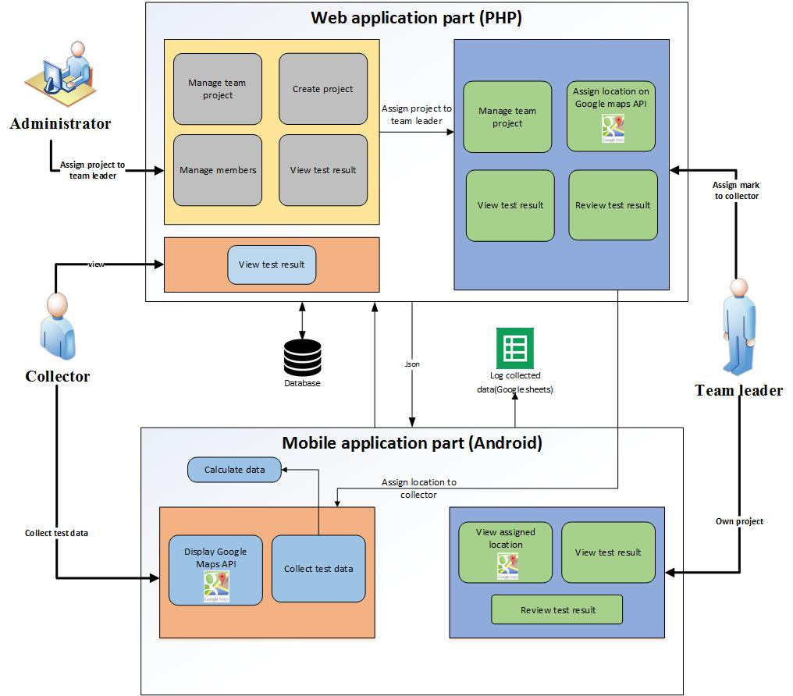

**Figure 2**: System Architecture of the system

Figure 2 show the overview of Team collaboration system for mobility water monitoring system. There are 2 parts in the system consist of Mobile Application part and Web application part. Mobile Application for Collector is a software for water parameters monitoring. Then, the test result will be recorded to database. Mobile Application for Team Leader provides the result presentation retrieving the data from database in and trace a working position all of the collectors in his team. Finally, Web Application provides to all of users consisting of Administrator, Team Leader and Collector. Administrator can create and manage teams and projects. They also can approve a new registered member. Team leader can assign works on Google Maps to collectors and review the details of the test result of the involved project. Collector can know the assigned work from team leader to do the water quality monitoring, then send the test result to the database via JSON. In every testing, the information will be recorded in the Google Sheet. In addition, team leader and collectors can have a connection by messaging in the mobile application within each team.

**4.4 Deliverables and Limits**

**4.4.1 Deliverables**

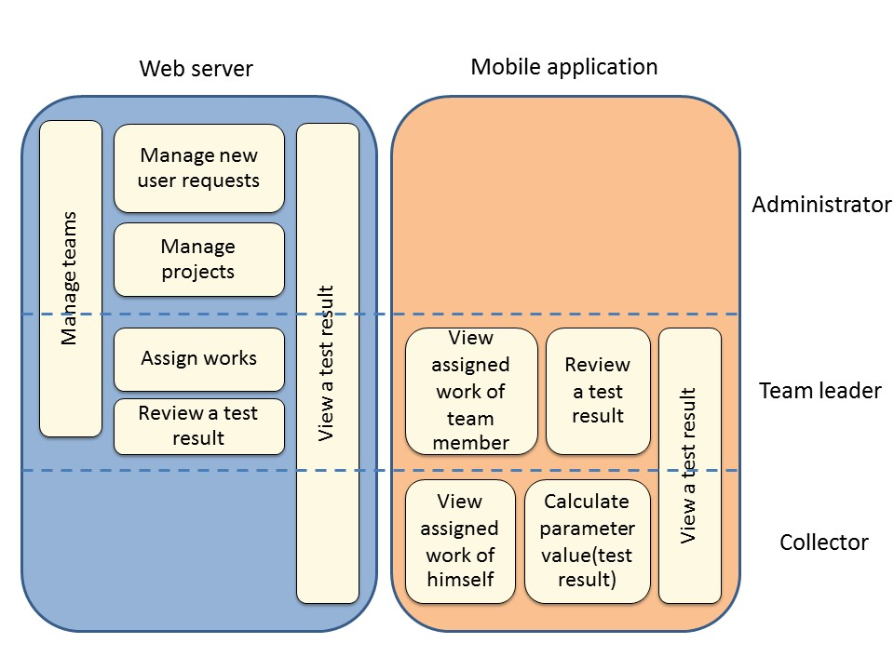

**Figure 3: Functional architecture**

**There are 2 parts in the system consist of:**

|  |  |  |  |
| --- | --- | --- | --- |
| **Part** | **Administrator** | **Team leader** | **Collector** |
| Web application | √ | √ | √ |
| Mobile application | - | √ | √ |

**There are 7 feature in the system** **and each of feature is separated as follows:**

|  |  |  |  |  |
| --- | --- | --- | --- | --- |
| **Feature 1: Authentication and member management system** | | | | |
| 🗹Administrator | 🗹Team leader | | 🗹Collector | |
| This feature is an authentication of all user involving in this system. The application can manage a team or member in the system. | | | | |
| **Feature 2: Project management** | | | | |
| 🗹Administrator | 🗹Team leader | | 🗹Collector | |
| The holistic view of this feature is part of operation involve to the project. The administrator can manage the project. For example, create and modify the project on a web application. In another part is about project browsing. The application can display the project list and the others information. For example, the list of parameter test, the responsibility of each collector (place) and the date and time of the project created. | | | | |
| **Feature 3: Map location management** | | | | |
| 🗹Administrator | 🗹Team leader | | | 🗹Collector |
| Google map was used in this project for work location of collector. Google maps can help the team’s work easier, as shows the information related to the project and also shows the route to the collector to the destination. | | | | |
| **Feature 4: Water parameter calculation** | | | | |
| 🗷Administrator | 🗷Team leader | | 🗹Collector | |
| Overview of this part is the parameter tests data collecting using the developed component that contains the calculating algorithm. The application will send the data to the developed component and return the test result from the chemical analysis. | | | | |
| **Feature 5: Parameter result tracing** | | | | |
| 🗹Administrator | | 🗹Team leader | | 🗹Collector |
| After the calculation of water parameter completed. Team leader and collector can view the detail of test result. Also, test result reviewed will be done by the team leader by marking the status of test result. | | | | |
| **Feature 6: Messaging system** | | | | |
| 🗷Administrator | | 🗹Team leader | | 🗹Collector |
| About the various alerts such as notification of new projects, notification of recollect. Furthermore, user can make a conversation by sending message via a group message within the team on a mobile application. | | | | |

**4.4.2 Documents**

* Proposal
* Project Plan
* Software Requirement Specification
* Software Design Document
* Testing Document
* Traceability Record
* Progress Status Report
* Self-assessment Report

**4.4.3 Limits**

* The internet connection is required for using this system and application.
* Smart device, which are using Android OS version 4.1 as a minimum version.
* Smartphone application cannot control the light and white balance of the camera.

**4.5 Future work**

Team collaboration system for mobility water monitoring application can support with other platform (iOS).

## **4.6 Software Development Life Cycle**

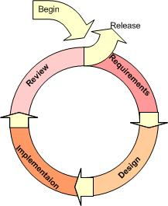

**Figure 4**:Iterative Model [9]

**4.6.1 Iterative Model**

An iterative life cycle model uses the concept of dividing the work into small pieces to reduce the risk of development. The development begins by specifying and implementing just part of the software, which can then be reviewed in order to identify further requirements. During each of iteration, the development module goes through the requirements, design, and implementation and testing phases. Each subsequent release of the module adds function to the previous release. The process continues till the complete system is ready as per the requirement.

        An iterative life cycle model can accommodate changes by stakeholder feedback to refine requirements and design. The developers can build and improving the product step by step causes we can track the defects at the early stages.

**4.7 Schedule & Milestone**

|  |  |  |  |
| --- | --- | --- | --- |
| **Milestone** | **Task** | **Milestone Criteria** | **Planned date** |
| 1 | Proposal | - Topic defined | January |
| 2 | Proposal Report  (Review with Advisor) | - Proposal reviewed | January |
| 3 | Progress Report 1 (Review with Advisor) | - Software Requirement Specification  - Software Design Document  - Test Plan Progress 1  - Implementation Progress 1  - Test Feature Progress 1  - Traceability Record Progress 1 | February-March |
| 4 | Progress Report 2 (Review with Advisor) | - Software Requirement  Specification  - Software Design Document  - Test Plan Progress 2  - Implementation Progress 2  - Test Feature Progress 2  - Traceability Record Progress 2 | March-April |
| 5 | Progress Report 3 | - Software Requirement Specification  - Software Design Document  - Test Plan Progress 3  - Implementation Progress 3  - Test Feature Progress 3  - Traceability Record Progress 3  - Progress  report 3 submitted  - Progress report  3 presentation | April-May |

The features have separated to 3 progresses as follows:

**Progress Report 1**

* Feature 1: Authentication and member management system
* Feature 2: Project management

**Progress Report 2**

* Feature 3: Map location management
* Feature 4: Water parameter calculation

**Progress Report 3**

* Feature 5: Parameter result tracing
* Feature 6: Messaging system

### **4.7.1 Proposal Report**

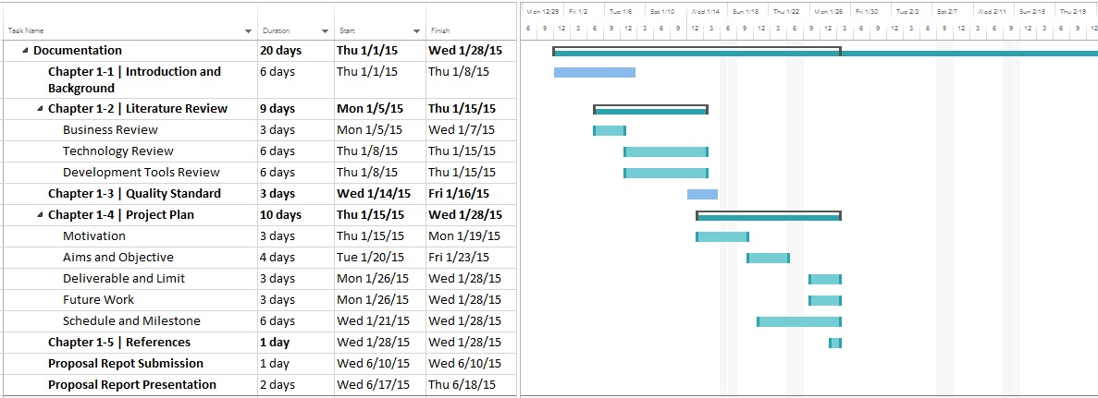

**Figure 5:** Proposal Report

**4.7.2 Progress Report 1**

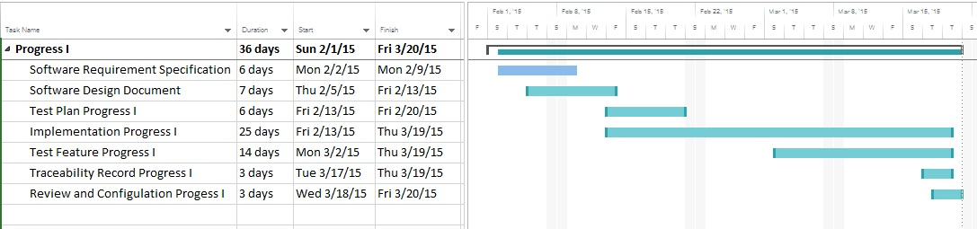

**Figure 6:** Progress Report 1

**Progress Report 1**

* Feature 1: Authentication and member management system
* Feature 2: Project management

**4.7.3 Progress Report 2**

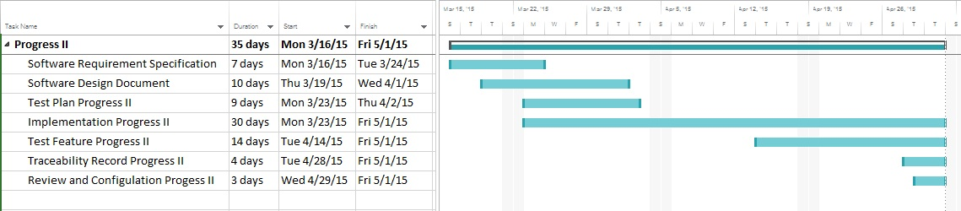

**Figure 7:** Progress Report 2

**Progress Report 2**

* Feature 3: Map location management
* Feature 4: Water parameter calculation

**4.7.4 Progress Report 3**

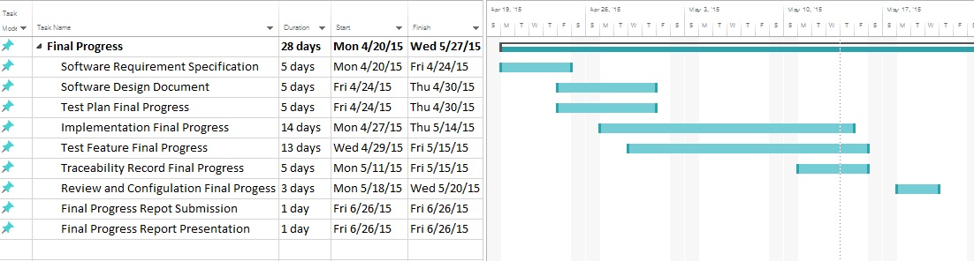

**Figure 8:** Progress Report 3

**Progress Report 3**

* Feature 5: Parameter result tracing
* Feature 6: Messaging system

**Chapter 1-5 | References**

**[1] Google Maps**

Author : -

Access on: 2014

Resource : <http://google.wikia.com/wiki/Google_Maps>

**[2] Google Spreadsheets**

Author : Magnus Adielsson

Access on: 2015

Resource : <https://support.google.com/docs/table/25273?hl=en>

**[3] Eclipse with ADT**

Author : -

Access on: 1 March 2014

Resource :<http://en.wikipedia.org/wiki/Eclipse_(software)>

**[4] Advantage of Eclipse with ADT**

Author : Eclipse development team

Access on: 2014

Resource : [http://www.eclipse.org](http://www.eclipse.org/)

**[5] ADT Plug-in for Eclipse**

Author : Eric Cloninger

Access on: 9 May 2012

Resource :<http://marketplace.eclipse.org/content/android-development-tools-eclipse>

**[6] Android SDK**

Author : LEIGH WILLIAMSON

Access on: 11 February, 2011

Resource :<http://embedded-computing.com/articles/the-commercial-eclipse-based-solutions/>

**[7] JetBrains PhpStorm 7.1.3**

Author : -

Access on: 25 February 2014

Resource : [http://en.wikipedia.org/wiki/PhpStorm](https://www.ntchosting.com/web-design/dreamweaver.html)

**[8] XAMPP**

Author : -

Access on: 25 February 2014

Resource : <http://en.wikipedia.org/wiki/XAMPP>

**[9] Iterative Model**

Author : -

Access on: 25 February 2014

Resource :<http://www.snyders.us/qa-iterative.htm>l