**Software Requirement Specification**

**Team Collaboration System for Mobility Water Monitoring**

**By**

**Mr. Peerapong Chompootepa 542115044**

**Mr. Worrasete Tansurat 542115056**

**Department of Software Engineering**

**College of Arts, Media and Technology**

**Chiang Mai University**

**Project Advisor**

**____________________________**

**Ms.Siraprapa Wattanakul**

**Document History**

|  |  |  |  |  |  |
| --- | --- | --- | --- | --- | --- |
| **Document Name** | **Detail** | **Status** | **Date** | **View able** | **Reviewer& Responsible** |
| **TCS-SRS-0.1.docx** | -Introduction | Draft | 16/03/15 | SW | PC, WT |
| **TCS-SRS-0.2.docx** | -Update Introduction  -Overall Description | Draft | 17/03/15 | SW | PC, WT |
| **TCS-SRS-0.3.docx** | -Update Overall Description  -Function Requirements | Release | 19/03/15 | SW | PC, WT |
| **TCS-SRS-0.4.docx** | -Update Function Requirements  - Specific Requirements | Draft | 25/03/15 | SW | PC, WT |
| **TCS-SRS-0.5.docx** | - Update Specific Requirements | Draft | 30/03/15 | SW | PC, WT |
| **TCS-SRS-0.6.docx** | - Update Specific Requirements | Release | 01/04/15 | SW | PC, WT |
| **TCS-SRS-0.7.docx** | - Update Function Requirements | Draft | 05/04/15 | SW | PC, WT |
| **TCS-SRS-0.8.docx** | - Update all document (SRS) | Draft | 16/04/15 | SW | PC, WT |
| **TCS-SRS-0.9.docx** | - Update all document (SRS)  - Update Use Case Diagram | Draft | 20/04/15 | SW | PC, WT |
| **TCS-SRS-1.0.docx** | - Update all document (SRS) | Release | 25/06/15 | SW | PC, WT |

**\*SW = Ms.Siraprapa Wattanakul**

**\* PC   =   Mr.Peerapong Chompootepa**

**\* WT =   Mr.Worrasete Tansurat**

Table of Contents

**Chapter 3-1 | Introduction** 4

1.1 Objective 4

1.2 Project Overview 4

1.3 User Characteristics 5

1.4 Acronyms and Definitions 5

**Chapter 3-2 | Functional Requirement** 7

2.1 Use Case Scenarios 7

2.2 User Requirement Specification (URS) 8

2.2 System Requirement Specification (SRS) 10

**Chapter 3-3 | Specific Requirement 21**

3.1 Use Case Description 21

# Chapter 3-1 | Introduction

## 1.1 Objective

Software Requirement Specification of Team collaboration system for mobility water monitoring is to describe the functional and non-functional requirements of Team collaboration system for mobility water monitoring. The requirements in the SRS are involved with the stakeholders and the users of the system. The software requirement specification provides developers and users to understand each other in term of the structural details of the system. The system will be designed followed this SRS.

## 1.2 Project Overview

Team collaboration system for mobility water monitoring application is developed for the chemical analysis of the water quality which makes it easy for collectors working as a team. The system separates in two parts. The first part is web application, all user can use web application to view the test result. Administrator can create the project and manage the member in the system and also select members to create the new team. The team leader has a role to manage the involved project which is assigned by administrator. The application can see the team members and their responsibility in each of projects. For example, team leader can assign the work location to each collector by marking the pin on the Google Maps and also can review the test result sent from the collector. The second part is mobile application, a part of team leader and collector. Collector can use the mobile application to collect the data, then the application will send the data to calculation component containing the calculating algorithm (produced by I-ANALY-S-T). The system returns the test result from chemical analysis. The status will update automatically when user send the test result. After that, team leader can review the test result by marking the status to finish or recollect on both mobile application and web application.

**1.2.1 Scope**

The TCS is developed in both mobile application and web application and also extended functions of the existing mobile software to have further completion for team collaboration. There are 6 main features of TCS are shown below:

Feature 1: Authentication and member management system

Feature 2: Project management

Feature 3: Map location management

Feature 4: Water parameter calculation

Feature 5: Parameter result tracing

Feature 6: Messaging system

## 1.3 User Characteristics

The system divided users into 3 groups. Information and characteristics of each group are listed below.

**Administrator**

Administrator can access to the system on web application for managing the system (profile, project and team member). When the collector sends register request on mobile application, administrator can see a list of new collector requests and also can select to approve or decline the account. Administrator is able to create or modify the new project with selects team and defines team leader into the project. Before to create the project, administrator can create a team by select members existing in the system. And also the administrator can view relevant information such as team information and project information.

**Team leader**

Team leader can access to the system both of web application and mobile application. Team leader can see the information of each project and able to manage team that he is the team leader includes editing name, adding team member and removing team member. On the part of the project, team leader can see the information of each project on web application and able to assigns work by marking location on Google Maps to the collector. Each project will show the status of the work for the members to know the progress of the work.

**Collector**

Collector needs to be registered an account on mobile application and wait for administrator approves an account request before login to the system. Collector can view work assignment assigned by team leader. Collector can collect samples of the water sources that team leader assign location by Google Maps. Collector must update the status of the work and send test result to the web service.

## 1.4 Acronyms and Definitions

**Acronyms**

TCS    Team collaboration system for mobility water monitoring

SRS Software Requirment Specification

URS   User Requirement Specification

SRS Software Requirement Specification

UC   Use Case

SW Siraprapa Wattanakul

PC   Peerapong Chompootepa

WT Worrasete Tansurat

**Definitions**

**Feature :**                                      Transformation of input parameters to output parameters based on a specified algorithm. It describes the functionality of a product in the language of the product. Used for requirements analysis, design, coding, testing or maintenance. [IEEE90]

**IEEE:**  Institute for Electrical and Electronics Engineers. Biggest global interest group for engineers of different branches and for computer scientists. [IEEE90]

**Requirement:**                         A condition or capability needed by a user to solve a problem or achieve an objective. A condition or capability that must be met or possessed by a system or system component to satisfy a contract, standard, specification, or other formally imposed document. A documented representation of a condition or capability as in definition. [IEEE90]

**Specification:**                          Precise description of an activity or work product which serves as basis or input for further activities or work product. A specification can comprise requirements to a product and how they will be solved. Different parts of a specification (e.g., what is to be done, how it will be done)must not be mixed. [IEEE90]

**UML:**                                      Unified Modeling Languages. Standardized notation for modeling design descriptions, architectures or scenarios. Not depending on a specific method. Issued and maintained by the object Management Group(OMG). [IEEE90]

**Use case:**                                 (1)Concept to describe a system based on usage of system resources by its environment. Characterized by an objective-set of interactions within and at the borders of that system. (2)Notation from UML for describing a scenario (Usage approach, operational scenario) from the perspective of this user. [IEEE90]

**Software:** "Computer programs, procedures, and association and data pertaining to operation of a computer system." [IEEE90]

# Chapter 3-2 | Functional Requirement

## 2.1 Use Case Scenarios

* **Web application Part**

* **Mobile application Part**

## 2.2 User Requirement Specification (URS)

**Feature 1: Authentication and member management system**

[URS-01] Administrator, Team leader, and Collector can log in to the system on web application.

[URS-02] Administrator, Team leader, and Collector can logout from the system on web application.

[URS-03] Team leader and Collector can log in to the system on mobile application.

[URS-04] Team leader and Collector can logout from the system on mobile application.

[URS-05] New collector can send register request to the administrator on mobile application requesting to be a member.

[URS-06] Administrator can view list of new collector requests sorted by date on web application.

[URS-07] Administrator can search a new collector request by using new collector name on web application

[URS-08] Administrator can select to approve or decline new member on web application.

[URS-09] Administrator can create a team which contains a team name, team leader and team members on web application.

[URS-10] Administrator and team leader can view list of team sorted by team name on web application.

[URS-11] Administrator and Team leader can search the team by using team name on a web application.

[URS-12] Administrator and Team leader can modify the selected team information on web application.

[URS-13] Administrator and Team leader can view the selected team information includes a team name, team leader name, and list of members on web application.

[URS-14] Administrator can remove a team out of the system on web application.

[URS-15] Administrator, Team leader, and Collector can edit profile information which includes is name, password and telephone number on web application.

**Feature 2: Project management**

[URS-16] Administrator can create the project includes a project name, project description, and team on web application.

[URS-17] Administrator can remove the project out of the system on web application.

[URS-18] Administrator can view list of all projects sorted by created date of the project on a web application

[URS-19] Team leader and Collector can view list of the involved projects sorted by created date of the project on a web application and mobile application.

[URS-20] Administrator, Team leader and Collector can search the project by using project name on web application.

[URS-21] Administrator can modify the project information includes editing project name, editing project description, and changing a team on web application.

[URS-22] Administrator can view detail of selected projects information which consisting of map with assigned pins and location information on a web application.

[URS-23] Team leader and Collector can view detail of selected projects information which consisting of map with assigned pins and location information of the selected project on a web application and mobile application.

[URS-24] Administrator can view list of water parameter of the selected member sorted by date on a web application.

[URS-25] Team leader and Collector can view list of water parameter of the selected member sorted by date on a web application and mobile application.

**Feature 3: Map location management**

[URS-26] Team leader can assign work location on Google map to each collectors on web application.

[URS-27] Team leader and Collector can view the direction to the selected location on Google Maps on mobile application.

[URS-28] Team leader and Collector can view location information of each assigned pin on selected project by pressing on the pin on mobile application.

**Feature 4: Water parameter calculation**

[URS-29] Collector can add water parameter to collect the test data on mobile application.

[URS-30] Collector can delete water parameter on mobile application.

[URS-31] Collector can choose the image from camera roll or take a new photo to collect RGB value with the test result on mobile application.

[URS-32] Collector can input the data to let the system calculate the test result based on standard color scale on mobile application.

**Feature 5: Parameter result tracing**

[URS-33] Administrator can view detail of test result of selected water parameter on a web application.

[URS-34] Team leader and Collector can view detail of test result of selected water parameter on a web application and mobile application

[URS-35] Team leader can mark status of the selected water parameter to “Recollect” on a web application and mobile application.

[URS-36] Team leader can mark status of the selected water parameter to “Finish” on a web application and mobile application.

**Feature 6: Messaging system**

[URS-37] Team leader and Collector can send the message to each other via group message within the team on a mobile application.

## 2.2 System Requirement Specification (SRS)

**Feature 1: Authentication and member management system**

**[URS-01] Administrator, Team leader, and Collector can log in to the system on web application.**

SRS: The system shall provide login page to login using email and password.

SRS: The system shall check the format of input data.

SRS: The system shall validate email and password with the database.

SRS: The system shall allow user to access the application.

SRS: The system shall show the error messages “Invalid e-mail or password”.

SRS: The system shall redirect to the project list page.

SRS: The system shall show e-mail on the screen.

SRS: The system shall show “●” instead a password in type of string on the screen.

**[URS-02] Administrator, Team leader, and Collector can logout from the system on web application.**

SRS: The system shall provide “Logout” menu.

SRS: The system shall quits a session of the user.

SRS: The system shall return to the login page.

**[URS-03] Team leader and Collector can log in to the system on mobile application.**

SRS: The system shall provide login page to login using email and password.

SRS: The system shall check the format of input data.

SRS: The system shall validate email and password with the database.

SRS: The system shall allow user to access the application.

SRS: The system shall show the error messages “Incorrect e-mail or password”.

SRS: The system shall redirect to the project list page.

SRS: The system shall show e-mail on the screen.

SRS: The system shall show “●” instead a password in type of string on the screen.

**[URS-04] Team leader and Collector can logout from the system on mobile application.**

SRS: The system shall provide “Logout” menu.

SRS: The system shall quits a session of the user.

SRS: The system shall return to the login page.

SRS: The system shall show popup asking for confirmation “Do you want to logout?”.

SRS: The system shall cancel to quit a session of the user.

**[URS-05] New collector can send register request to the administrator on mobile application requesting to be a member.**

SRS: The system shall provide registration page include the input textboxes; name, password, telephone number.

SRS: The system shall validate the format of the input data and the existing data.

SRS: The system adds a new account into the database.

SRS: The system shall show the message “Registered Successfully”.

SRS: The system shall show the error message “E-mail must be an email format.

SRS: The system shall show the error message shows “Telephone number must be a numeric only”.

SRS: The system shall show a name on the screen.

SRS: The system shall show an email on the screen.

SRS: The system shall show “●” instead a password in type of string on the screen.

SRS: The system shall show the telephone number on the screen.

**[URS-06] Administrator can view list of new collector requests sorted by date on web application.**

SRS: The system shall provide new collector request page.

SRS: The system shall retrieve the user information from database by the status of user should be a new collector.

SRS: The system shall display list of new account requests with the “Approve” and “Decline” buttons behind each account.

**[URS-07] Administrator can search a new collector request by using new collector name on web application**

SRS: The system shall retrieve the information of new collector request that exist in the system from database.

SRS: The system shall display all of new collector request list including user Id, name, e-mail, telephone number on the new collector request page.

SRS: The system shall provide the text box for searching a new collector request on the top right page.

SRS: The system shall check the format of the input data.

SRS: The system shall retrieve the information of a new collector request that searched by user from database.

SRS: The system shall show a new collector request that searched by user on the project list page.

SRS: The system shall show message “No matching records found”.

SRS: The system shall show a name on the screen.

**[URS-08] Administrator can select to approve or decline new member on web application.**

SRS: The system shall provide new collector request page.

SRS: The system shall retrieve the user information from database without administrator.

SRS: The system shall display list of new account requests with the “Approve” and “Decline” button behind each row.

SRS: The system shall show popup asking for confirmation “Do you want to approve?” with “Cancel” and “OK” buttons.

SRS: The system shall remove the name of selected as a member from user interface.

SRS: The system shall update user status in the database.

SRS: The system shall show popup message “Approve User Success”.

SRS: The system shall shows popup asking for confirmation “Do you want to decline?” with “Cancel” and “OK” buttons.

SRS: The system shall delete an account from the database.

SRS: The system shall redirect to new collector request page.

**[URS-09] Administrator can create a team which contains a team name, team leader and team members on web application.**

SRS: The system shall provide team information page.

SRS: The system shall retrieve user information from the database which status type is a member in system.

SRS: The system shall provide a text box to input the team name and list of members, the check boxes for adding the collector to the team and the radio buttons for defining the team leader.

SRS: The system shall check the format of input data.

SRS: The system shall create the new team in a database.

SRS: The system shall display popup message “Save data success”.

SRS: The system shall redirect to the team list page.

SRS: The system shall show error message “Please input team name”

SRS: The system shall show error message “Please select members”

SRS: The system shall show error message “Please select the team leader”.

SRS: The system shall show error message “Team name is already”.

**[URS-10] Administrator and team leader can view list of team sorted by team name on web application.**

SRS: The system shall provide team list page.

SRS: The system shall retrieve the information of the team from database.

SRS: The system shall provide list of all team

SRS: The system shall provide list of team which user is the team leader.

**[URS-11] Administrator and Team leader can search the team by using team name on a web application.**

SRS: The system shall retrieve the information of team that exist in the system from database.

SRS: The system shall display all of team list including team Id, team name, and member on the team list page.

SRS: The system shall provide the text box for searching the team on the top right page.

SRS: The system shall check the format of the input data.

SRS: The system shall retrieve the information of the team searched by user from database.

SRS: The system shall show the team searched on the team list page.

SRS: The system shall show message “No matching records found”.

SRS: The system shall show team name on the screen.

SRS: The system shall show error message “Please input team name”.

SRS: The system shall show error message “Please select members”.

SRS: The system shall show error message “Please select the team leader”.

**[URS-12] Administrator and Team leader can modify the selected team information on web application.**

SRS: The system shall retrieve the information of team that exist in the system from database.

SRS: The system shall display all of team list including team Id, team name, and member with “View”, “Edit”, and “Delete” buttons on the team list page.

SRS: The system shall retrieve user information from the database which status type is a member in system.

SRS: The system shall provide a text box to input the team name and list of members, the check boxes for adding the collector to the team and the radio buttons for defining the team leader.

SRS: The system shall check the format of input data.

SRS: The system shall update new information of team in the database.

The system shall show popup message “Save data success”.

SRS: The system shall redirect to the team list page.

SRS: The system shall add new members to the team in the database.

SRS: The system shall delete members from the team in the database.

SRS: The system shall show name of team on the screen

SRS: The system shall update new information of team in the database

SRS: The system shall show “🗹” front of member that user selected to be a team member

SRS: The system shall show “🞊” behind a member that user selected to be a team leader.

SRS: The system shall show “🞏” behind a member that user selected to remove a member out of the team

**[URS-13] Administrator and Team leader can view the selected team information includes a team name, team leader name, and list of members on web application.**

SRS: The system shall retrieve the list of team that exist in the system from database.

SRS: the system shall display all of team list including team Id, team name, and member with “View”, “Edit”, and “Delete” buttons on the team list page.

SRS: The system shall display all of team list including team Id, team name, and member with “View” and “Edit buttons on the team list page.

SRS: The system shall show the popup of team information including a team name, team leader name and list of team members on the team list page.

**[URS-14] Administrator can remove a team out of the system on web application.**

SRS: The system shall retrieve the list of team that exist in the system from database.

SRS: The system shall display all of team list including team Id, team name, and member with “View”, “Edit”, and “Delete” buttons on the team list page.

SRS: The system shall show popup asking for confirmation “Do you want to delete?” with “OK” and “Cancel” buttons.

SRS: The system shall delete the team in the database.

SRS: The system shall show popup message “Delete Team Success”.

SRS: The system shall remove the selected team out of team list page.

SRS: The system shall redirect to team list page.

**[URS-15] Administrator, Team leader, and Collector can edit profile information which includes is name, password and telephone number on web application.**

SRS: The system shall provide edit profile page.

SRS: The system shall retrieve the user information (i.e. name, password, and telephone) from database.

SRS: The system shall provide text boxes for updating the profile (i.e. name, password, telephone).

SRS: The system shall check the format of input data.

SRS: The system shall update the information in the database.

SRS: The system shall show message “Profile update successful”.

SRS: The system shall redirect to the project list page.

SRS: The system shall show the error message will show “Please input a name”.

SRS: The system shall show the error messages “Password does not match with confirm password”.

**Feature 2: Project management**

**[URS-16] Administrator can create the project includes a project name, project description, and team on web application.**

SRS: The system shall retrieve the list of project that exist in the system from database.

SRS: The system shall display all of project list including project Id, project name, description, team name, leader name, create date on the project list page.

SRS: The system shall provide a text box to input the project name, project description and a combo box to select the team to do the project on new project page.

SRS: The system shall check the format of the input data.

SRS: The system shall create the new project in database.

SRS: The system shall distribute the notifications to the team leader.

SRS: The system shall display popup message “Save data success”.

SRS: The system shall redirect to the project list page.

SRS: The system shall show error message “Please input project name more than 6 characters”.

SRS: The system shall show error message “Please select the team” on the screen.

SRS: The system shall show the name of project on the screen.

SRS: The system shall show description on the screen.

SRS: The system shall show the team name on the screen.

SRS: The system shall show error message “Project name is already”.

**[URS-17] Administrator can remove the project out of the system on web application.**

SRS: The system shall retrieve the list of project that exist in the system from database.

SRS: The system shall display all of project list including project Id, project name, description, team name, leader name, create date on the project list page.

SRS: The system shall show the confirmation popup “Do you want to remove the project?” with “OK” and “Cancel” buttons.

SRS: The system hall delete the project in the database.

SRS: The system shall show popup message “Delete project Success”

SRS: The system shall remove the selected project out of the team list page.

SRS: The system shall redirect to the project list page.

**[URS-18] Administrator can view list of all projects sorted by created date of the project on a web application**

SRS: The system shall retrieve the list of project that exist in the system from database.

SRS: The system shall display all of project list including project Id, project name, description, team name, leader name, created date on the project list page.

**[URS-19] Team leader and Collector can view list of the involved projects sorted by created date of the project on a web application and mobile application.**

SRS: The system shall retrieve the list of project that involved with the user from database.

SRS: The system shall display involved project list including project Id, project name, description, team name, leader name, created date on the project list page.

**[URS-20] Administrator, Team leader and Collector can search the project by using project name on web application.**

SRS: The system shall retrieve the list of project that exist in the system from database.

SRS: The system shall display all of project list including project Id, project name, description, team name, leader name, created date on the project list page.

SRS: The system shall provide the text box for searching the project on the top right page.

SRS: The system shall check the format of the input data.

SRS: The system shall retrieve the information of the project searched by user from database.

SRS: The system shall show the project searched on the project list page.

SRS: The system shall show message “No matching records found”.

SRS: The system shall show project name on the screen.

**[URS-21] Administrator can modify the project information includes editing project name, editing project description, and changing a team on web application.**

SRS: The system shall retrieve the list of project that exist in the system from database.

SRS: The system shall display all of project list including project Id, project name, description, team name, leader name, created date on the project list page.

SRS: The system shall retrieve the project information from the database.

SRS: The system shall provide a text box to input the project name, project description and a combo box to select the team to do the project on new project page.

SRS: The system shall check the format of input data.

SRS: The system shall update new information of project in the database.

SRS: The system shall show popup message “Save data success”

SRS: The system shall redirect to the project list page.

SRS: The system shall show error message “Please input project name”.

SRS: The system shall show error message “Please input project name more than 6 characters”.

SRS: The system shall show error message “Please select the team”.

**[URS-22] Administrator can view detail of selected projects information which consisting of map with assigned pins and location information on a web application.**

SRS: The system shall retrieve the project information from database.

SRS: The system shall display project information page that has a map with a pin and a list of the location information consisting of place name, collector name, latitude, longitude, status of collecting(Initial, Pending, Recollect, Finish), and date of updated.

**[URS-23] Team leader and Collector can view detail of selected projects information which consisting of map with assigned pins and location information of the selected project on a web application and mobile application.**

SRS: The system shall retrieve the project information from database.

SRS: The system shall display project information page that has a map with a pin and a list of the location information consisting of place name, collector name, latitude, longitude, status of collecting(Initial, Pending, Recollect, Finish), and update dated.

SRS: The system shall retrieve all location information of every collectors.

SRS: The system shall retrieve only location information that was assigned by team leader of the selected project

**[URS-24] Administrator can view list of water parameter of the selected member sorted by date on a web application.**

SRS: The system shall retrieve the list of water parameter from database.

SRS: The system shall display list of water parameter consisting of parameter name, predicted result, status, date and time that a member tested on parameter list page.

SRS: The system shall display list of water parameter consisting of parameter name, predicted result, status, date and time that a member tested on parameter list page.

**[URS-25] Team leader and Collector can view list of water parameter of the selected member sorted by date on a web application and mobile application.**

SRS: The system shall retrieve the list of water parameter from database.

SRS: The system shall display list of water parameter consisting of parameter name, predicted result, status, date and time that a member tested on parameter list page.

**Feature 3: Map location management**

**[URS-26] Team leader can assign work location on Google map to each collectors on web application.**

SRS: The system shall provide the assignment page contains Google maps and “+place” button on the top right page.

SRS: The system shall provide a window on the right hand side to user consisting of a marker on Google maps, a text box for the location name and a drop down list to select the team member (Collector).

SRS: The system shall check the format of input data.

SRS: The system shall add the assignment to the team member in the database.

SRS: The system shall distribute the notifications to each collectors.

SRS: The system shall display popup message “Save data success”.

SRS: The system shall hide the assignment window and marker disappear.

SRS: The system shall display popup message “Please input place name”.

SRS: The system shall display the new assignment as “Initial” status in the list below of Google maps and add a new marker on Google maps.

**[URS-27] Team leader and Collector can view the direction to the selected location on Google Maps on mobile application.**

SRS: The system shall provide the assignment location by using Google maps with place name, collector name, status of collecting (Initial, Pending, Recollect, Finish), latitude and longitude on project information page.

SRS: The system shall obtain the shortest direction from Google maps.

SRS: The system shall display the assignment location using blue line on a Google maps.

SRS: The system shall hide the direction.

**[URS-28] Team leader and Collector can view location information of each assigned pin on selected project by pressing on the pin on mobile application.**

SRS: The system shall provide the assignment location by using Google maps with place name, user, status, latitude and longitude on project information page.

SRS: The system shall display information of selected pin consisting of place name, collector name, and date of assigned on Google maps.

**Feature 4: Water parameter calculation**

**[URS-29] Collector can add water parameter to collect the test data on mobile application.**

SRS: The system shall retrieve the list of the water parameter consisting of parameter name, predicted result, status, date and time that a member tested from database.

SRS: The system shall display list of water parameters on parameter list page.

SRS: The system displays popup “Please input parameter” to input the data with “Ok” and Cancel buttons.

SRS: The system shall check the format of input data.

SRS: The system shall update the information of water parameter in database.

SRS: The system shall display new water parameter on parameter list page.

SRS: The system shall redirect to the parameter list page.

SRS: The system shall show error message “Please input parameter more than 1 character”

**[URS-30] Collector can delete water parameter on mobile application.**

SRS: The system shall retrieve the information of the water parameter consisting of parameter name, predicted result, status, date and time that a member tested from database.

SRS: The system shall display list of water parameters on parameter list page.

SRS: The system shall display popup message “Do you want to delete?”

SRS: The system shall delete selected water parameter out of database.

SRS: The system shall update the information of the water parameter in database

SRS: The system shall display the water parameters remaining in the system on parameter list page.

SRS: The system shall redirect to the parameter list page.

**[URS-31] Collector can choose the image from camera roll or take a new photo to collect RGB value with the test result on mobile application.**

SRS: The system shall provide the camera roll.

SRS: The system shall redirect to parameter information page with the image for collecting RGB value consisting of date and time.

SRS: The system shall provide the camera window to take a photo.

**[URS-32] Collector can input the data to let the system calculate the test result based on standard color scale on mobile application.**

SRS: System shall provide the fields to input band value and RGB text from an image.

SRS: The system shall return to display the RGB value of first band of standard color scale obtain from calculation component on the screen.

SRS: The system shall return to display the RGB value of testing indicator obtain from calculation component on the screen.

SRS: The system shall record the RGB value of the test indicator.

SRS: The system shall send the data to calculation component

SRS: The system shall return to display the test result of water parameter on the screen.

SRS: The system shall save the test result with the information into the database.

SRS: The system updates the status to “Pending” on the water parameter on parameter list page.

SRS: The system shall redirect to the parameter list page.

SRS: The system shall show information of test result consisting of parameter name, predicted result, status, date and time that a member tested on parameter list page

**Feature 5: Parameter result tracing**

**[URS-33] Administrator can view detail of test result of selected water parameter on a web application.**

SRS: The system shall provide the parameter list page.

SRS: The system shall retrieve the information of water parameter from database.

SRS: The system shall display detail of test result consisting of name of parameter, predicted result with the RGB value, status and image with data that used to calculate the test result on parameter information page.

**[URS-34] Team leader and Collector can view detail of test result of selected water parameter on a web application and mobile application**

SRS: The system shall provide the parameter list page.

SRS: The system shall retrieve the information of test result from database.

SRS: The system shall display detail of test result consisting of name of parameter, predicted result with the RGB value, status and image with data that used to calculate the test result and also provides “Recollect” and “Finish” buttons for review the test result on parameter information page.

SRS: The system shall display detail of test result consisting of name of parameter, predicted result with the RGB value, status and image with data that used to calculate the test result on parameter information page.

**[URS-35] Team leader can mark status of the selected water parameter to “Recollect” on a web application and mobile application.**

SRS: The system shall provide parameter information page.

SRS: The system shall update new status of water parameter to be recollect in the database.

SRS: The system distributes the notifications to the collector.

SRS: The system displays status “Recollect” on selected water parameter on parameter list page.

SRS: The system shall redirect to parameter list page.

**[URS-36] Team leader can mark status of the selected water parameter to “Finish” on a web application and mobile application.**

SRS: The system shall provide parameter information page.

SRS: The system shall update new status of water parameter to be finish in the database.

The system displays status “Finish” on selected water parameter on parameter list page.

SRS: The system shall redirect to parameter list page.

**Feature 6: Messaging system**

**[URS-37] Team leader and Collector can send the message to each other via group message within the team on a mobile application.**

SRS: The system shall display team list page.

SRS: The system shall retrieve the information of the message.

SRS: The system shall display team id, team name, team member, and position of member.

SRS: The system shall display all of the old message with date and time on the screen.

SRS: The system shall display the message in the group of project.

# Chapter 3-3 | Specific Requirement

## 3.1 Use Case Description

**Feature 1: Authentication and member management system**

**[URS-01] Administrator, Team leader, and Collector can log in to the system on web application.**

|  |  |
| --- | --- |
| **Use Case ID:** | URS-01 |
| **Use Case Name:** | Administrator, Team leader, and Collector can log in to the system on web application. |
| **Short Description:** | Administrator, Team leader, and Collector can log in to the system using his email and password. |
| **Create By:** | Peerapong Chompootepa, Worrasete Tansurat |
| **Actors:** | Administrator, Team leader, and Collector |
| **Pre-conditions:** | The valid email and password are stored in database. |
| **Post-condition** | The system allows user to access the application. |
| **Normal Flow:** | 1. User browses to login page.  2. The system provides login page to login using email and password.  3. User enters the e-mail and password in the text field.  4. User clicks “Login” button.  5. The system checks the format of input data.  6. The system validates email and password with the database.  7. After successful login, the system redirects to the project list page. |
| **Alternative and Exceptional:** | E.5 If user enters a blank value or wrong format of input data, for example, the email should be an email format.  E.6 If user enters the e-mail and password which are not match with the data in database, the system will show the error messages “Incorrect e-mail or password”. |

**Input and Output**

|  |  |  |  |
| --- | --- | --- | --- |
| **Input** | **Description** | **Example** | **Output** |
| E-mail | The e-mail must matching with the e-mail that user provides on registration. The format should be the email format. | “Admin1@gmail.com” | The system shows “Admin1@gmail.com”on the screen. |
| Password | The password must matching with the password that user provides on registration. | “ad001” | The system shows “●●●●●” on the screen. |

**[AD-01] Log in to the system on web application**

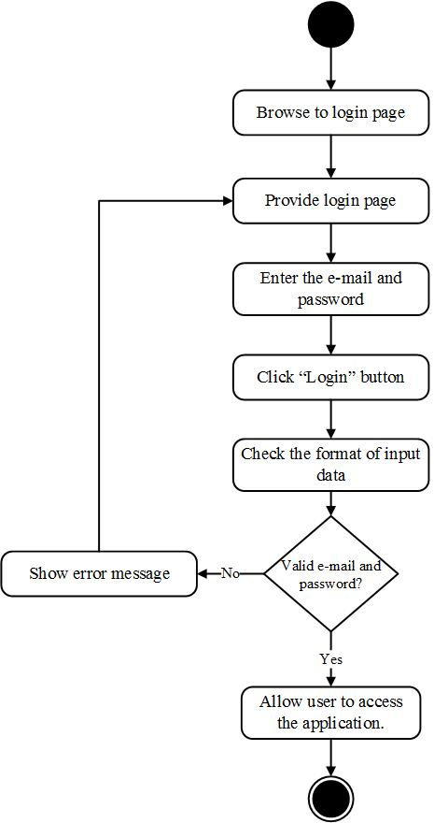

**[URS-02] Administrator, Team leader, and Collector can logout from the system on web application.**

|  |  |
| --- | --- |
| **Use Case ID:** | URS-02 |
| **Use Case Name:** | Administrator, Team leader, and Collector can logout from the system on web application. |
| **Short Description:** | Administrator, Team leader, and Collector can log out of the system by clicking “log out” menu to destroy the session of user. This case is for logging out on web application. |
| **Create By:** | Peerapong Chompootepa, Worrasete Tansurat |
| **Actors:** | Administrator, Team leader, and Collector |
| **Pre-conditions:** | User has to login to the system |
| **Post-condition** | User log out from the system |
| **Normal Flow:** | 1. The system provides “Logout” menu.  2. User clicks “log out” menu.  3. The system quits a session of the user.  4. The system returns to the login page. |
| **Alternative and Exceptional:** | - |

**Input and Output**

|  |  |
| --- | --- |
| **Input** | User clicks “Logout” button |
| **Output** | The system returns to the login page. |

**[AD-02] Log out from the system on web application**

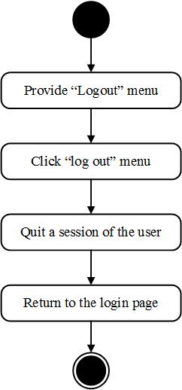

**[URS-03] Team leader and Collector can log in to the system on mobile application.**

|  |  |
| --- | --- |
| **Use Case ID:** | URS-03 |
| **Use Case Name:** | Team leader and collector can login to the system on mobile application. |
| **Short Description:** | Team leader and collector can login to the system using his e-mail and password. |
| **Create By:** | Peerapong Chompootepa, Worrasete Tansurat |
| **Actors:** | Team leader and Collector |
| **Pre-conditions:** | The valid e-mail and password are stored in database. |
| **Post-condition** | The system allows user to access the application. |
| **Normal Flow:** | 1. User browses to login page.  2. The system provides login page to login using email and password.  3. User enters the e-mail and password in the text field.  4. User clicks “Login” button.  5. The system checks the format of input data.  6. The system validates username and password with the database.  7. After successful login, system redirects to the project list page. |
| **Alternative and Exceptional:** | E.5 If user enters a blank value or wrong format of input data, for example, the e-mail should be the email format.  E.6 If user enters the username and password which is not match with the data in database, the system will show the error messages “Incorrect e-mail or password”. |

**Input and Output**

|  |  |  |  |
| --- | --- | --- | --- |
| **Input** | **Description** | **Example** | **Output** |
| E-mail | The e-mail must matching with the e-mail that user provides on registration. The format should be the email format. | “pcpenchamp@gmail.com” | The system shows “pcpenchamp@gmail.com”on the screen. |
| Password | The password must matching with the password that user provides on registration. | “123456” | The system shows “●●●●●●” on the screen. |

**[AD-03] Log in to the system on mobile application**



**[URS-04] Team leader and Collector can logout from the system on mobile application.**

|  |  |
| --- | --- |
| **Use Case ID:** | URS-04 |
| **Use Case Name:** | Team leader and collector can log out from the system on mobile application. |
| **Short Description:** | Team leader and collector can log out of the system by clicking “log out” button to destroy the session of user. This case is for logging out on mobile application. |
| **Create By:** | Peerapong Chompootepa, Worrasete Tansurat |
| **Actors:** | Team leader and Collector |
| **Pre-conditions:** | User has to login to the system. |
| **Post-condition** | User log out from the system. |
| **Normal Flow:** | 1. The system provides “Logout” menu.  2. User clicks “log out” menu.  3. The system shows popup asking for confirmation “Do you want to logout?”.  4. User click “Yes” button.  3. The system quits a session of the user.  4. The system returns to the login page. |
| **Alternative and Exceptional:** | A.4 If user clicks “Cancel” button, the system cancels to quit a session of the user. |

**Input and Output**

|  |  |
| --- | --- |
| **Input** | User click “Logout” button |
| **Output** | System shows the login page and allow user to input e-mail and password again. |

**[AD-04] Log out from the system on mobile application**

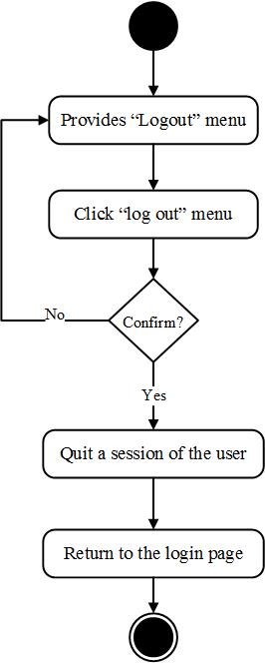

**[URS-05] New collector can send register request to the administrator on mobile application requesting to be a member.**

|  |  |
| --- | --- |
| **Use Case ID:** | URS-05 |
| **Use Case Name:** | New collector can send register request to the administrator on mobile application to be a member. |
| **Short Description:** | New collector has to register their information on mobile application in order to use the system. The user has to provide the name, e-mail, password, and telephone number to register to the system. |
| **Create By:** | Peerapong Chompootepa, Worrasete Tansurat |
| **Actors:** | New collector |
| **Pre-conditions:** | - |
| **Post-condition** | The system shows the message “Registered Successfully” |
| **Normal Flow:** | 1. New collector clicks “Register” button on login page.  2. The system provides registration page include the input textboxes; name, password, telephone number.  2. New collector completes all the provided input text boxes.  3. New collector clicks “Register” button.  4. The system validates the format of the input data and the existing data.  5. The system adds a new account into the database.  6. The system shows the message “Registered Successfully”. |
| **Alternative and Exceptional:** | E.4 In case user has input incorrect information.  - Wrong e-mail format, the system will show the error message “E-mail must be an email format.  - Wrong format of telephone number, the system will show the error message shows “Telephone number must be a numeric only”. |

**Input and Output**

|  |  |  |  |
| --- | --- | --- | --- |
| **Input** | **Description** | **Example** | **Output** |
| Name | Input a name and last name | “Sarun Boontengchan” | The system will show “Sarun Boontengchan” on the screen. |
| E-mail | The format of e-mail must be an email format for use to login to the system. | “Collector001@gmail.com” | The system will show “Collector001@gmail.com” on the screen. |
| Password | Input password for use to login to the system | “c123456” | The system will show “●●●●●●●” on the screen. |
| Telephone number | The format of telephone number must be a numeric only. | “0816659632” | The system will show “0816659632” on the screen. |

**[AD-05] Send register request on mobile application**

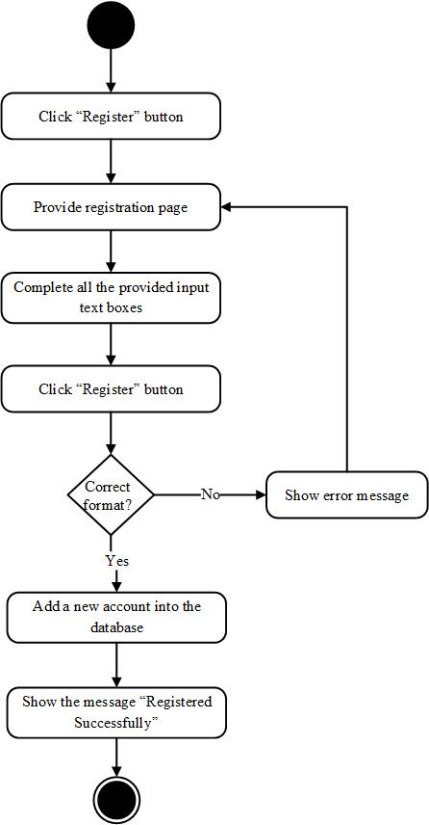

**[URS-06] Administrator can view list of new collector requests sorted by date on web application.**

|  |  |
| --- | --- |
| **Use Case ID:** | URS-06 |
| **Use Case Name:** | Administrator can view list of new collector requests on web application. |
| **Short Description:** | Administrator can view a list of the new collector requests. In the list contains such as a name, email, and telephone number. |
| **Create By:** | Peerapong Chompootepa, Worrasete Tansurat |
| **Actors:** | Administrator |
| **Pre-conditions:** | - There’s at least 1 new collector request in the database  - Administrator has to login the system. |
| **Post-condition** | Administrator can view new collector requests on user interface**.** |
| **Normal Flow:** | 1. User clicks “New Collector Request” menu to go to new collector request page.  2. The system provides new collector request page.  3. The system retrieves the user information from database by the status of user should be a new collector.  4. The system displays list of new account requests with the “Approve” and “Decline” buttons behind each account. |
| **Alternative and Exceptional:** | - |

**Input and Output**

|  |  |
| --- | --- |
| **Input** | Administrator clicks “New Collector Request” button. |
| **Output** | The system displays list of new account requests with the “Approve” and “Decline” buttons behind each account. |

**[AD-06] View list of new collector requests sorted by date on web application**

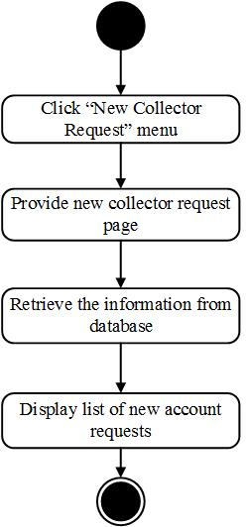

**[URS-07] Administrator can search a new collector request by using new collector name on web application**

|  |  |
| --- | --- |
| **Use Case ID:** | URS-07 |
| **Use Case Name:** | Administrator can search a new collector request by using new collector name on web application |
| **Short Description:** | Administrator can search a new collector request that user need to find quickly by input the keyword in the search box. |
| **Create By:** | Peerapong Chompootepa, Worrasete Tansurat |
| **Actors:** | Administrator |
| **Pre-conditions:** | - There is at least 1 new collector request in the database.  - User clicks “New collector request” button. |
| **Post-condition** | The new collector request that searched by user will show on the user interface. |
| **Normal Flow:** | 1. The system retrieves the information of a new collector request that exist in the system from database.  2. The system displays all of new collector requests list including user Id, name, e-mail, telephone number on the new collector request page.  3. The system provides the text box for searching a new collector request on the top right page.  4. User inputs the keyword in the text box.  5. The system checks the format of the input data.  6. The system retrieves the information of a new collector request that searched by user from database.  7. The system shows a list of new collector request that searched by user on the project list page. |
| **Alternative and Exceptional:** | E.6 If the keyword is not match with the data in database, the system will show message “No matching records found”. |

**Input and Output**

|  |  |  |  |
| --- | --- | --- | --- |
| **Input** | **Description** | **Example** | **Output** |
| Keyword | Searching by input the keyword into the textbox | “Worrasete” | The system shows “Worrasete” on the screen. |

**[AD-07] Search a new collector request by using new collector name on web application**

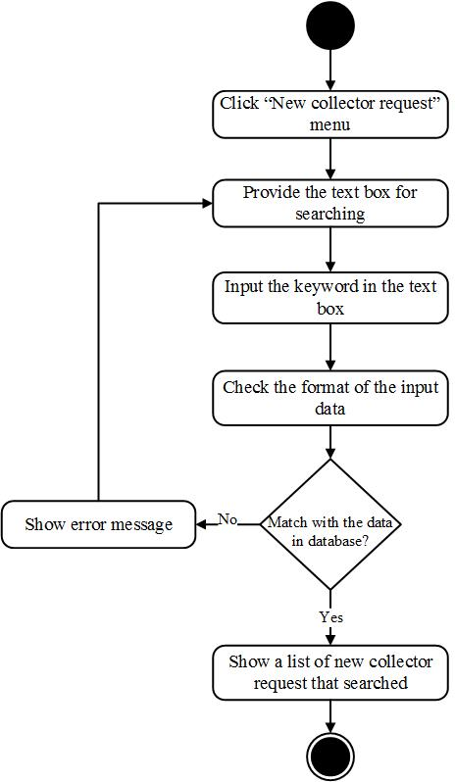

**[URS-08] Administrator can select to approve or decline new member on web application.**

|  |  |
| --- | --- |
| **Use Case ID:** | URS-08 |
| **Use Case Name:** | Administrator can select to approve or decline new member on web application. |
| **Short Description:** | Administrator can approve the account which request from the new collectors by clicking the “Approve” buttons to permit them to the system otherwise administrator can click “Decline” button if it is an unacceptable account. |
| **Create By:** | Peerapong Chompootepa, Worrasete Tansurat |
| **Actors:** | Administrator |
| **Pre-conditions:** | - There’s at least 1 account of new collector request in the database.  - Administrator has to login the system. |
| **Post-condition** | The system updates account to be a member in the database. |
| **Normal Flow:** | 1. User clicks “New Collector Request” menu to go to new collector request page.  2. The system provides new collector request page.  4. The system retrieves the user information from database without administrator.  5. The system displays list of new account requests with the “Approve” and “Decline” button behind each row.  6. User clicks “Approve” button.  7. The system shows popup asking for confirmation “Do you want to approve?” with “Cancel” and “OK” buttons.  8. User clicks “Ok” button.  9. The system updates user status in the database.  10. The system shows popup message “Approve User Success”.  11. User clicks “OK” button.  12. The system removes the name of selected as a member from user interface.  13. The system redirects to new collector request page. |
| **Alternative and Exceptional:** | A.6 If the user clicks “Decline” button, the system will remove the name of selected as a member from user interface. The system will delete an account from the database.  A.8 If the user clicks “Cancel” button, the system will go back to step 5. |

**Input and Output**

|  |  |
| --- | --- |
| **Input** | User clicks “Approve” button |
| **Output** | The system will remove the name of selected as a member from user interface. |

**[AD-08] Select to approve or decline new member on web application**

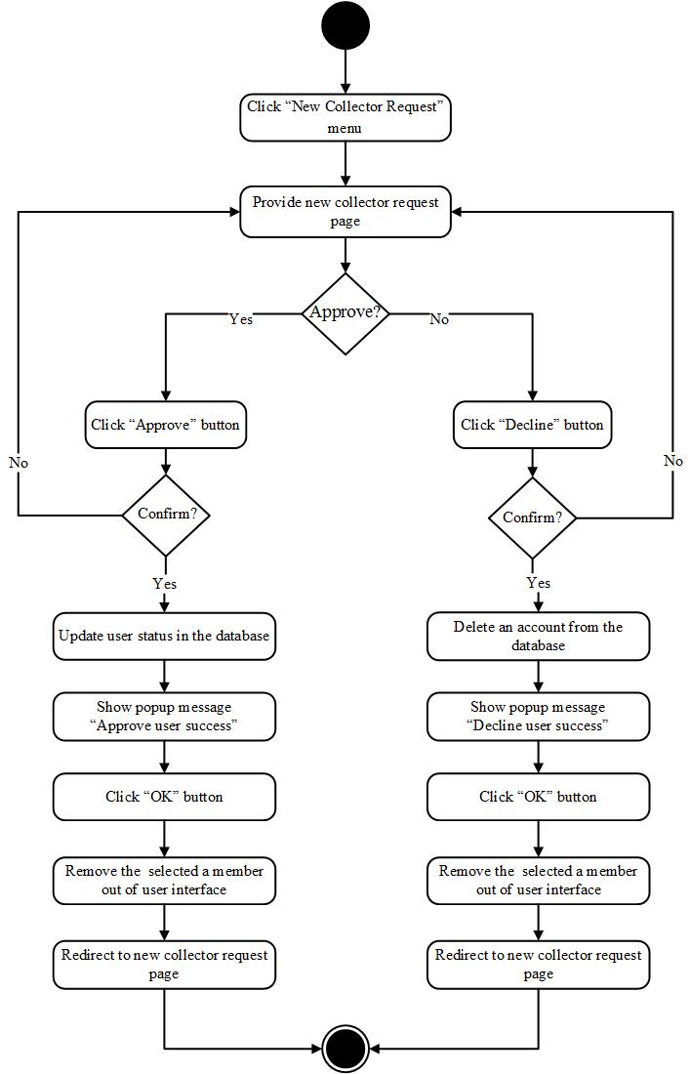

**[URS-09] Administrator can create a team which contains a team name, team leader and team members on web application.**

|  |  |
| --- | --- |
| **Use Case ID:** | URS-09 |
| **Use Case Name:** | Administrator can create a team which contains a team name, team leader and team members on web application. |
| **Short Description:** | Administrator can create the team which administrator has to input the name of team. In addition, administrator has to choose the member into the team and also specify the team leader in the team then clicks save to create a new team to the system. |
| **Create By:** | Peerapong Chompootepa, Worrasete Tansurat |
| **Actors:** | Administrator |
| **Pre-conditions:** | - There is at least 1 account in the system.  - Administrator has to login to the system. |
| **Post-condition** | The new team will be created in the database |
| **Normal Flow:** | 1. User clicks “Team” menu to go to team information page.  2. The system retrieves user information from the database which status type is a member in system.  3. The system provides team information page.  4. User clicks “New Team” button to go to create team page.  5. The system provides a text box to input the team name and list of members, the check boxes for adding the collector to the team and the radio buttons for defining the team leader.  6. User completes all inputs data.  7. User clicks “Save” button.  8. The system checks the format of input data.  9. The system creates the new team in a database.  10. The system displays popup message “Save data success”.  11. User clicks “OK” button.  12. The system redirects to the team list page. |
| **Alternative and Exceptional:** | A.7 If user clicks “Cancel” button, the system will redirect to the team list page.  E.8 If user leaves the text box of name blank, the system will show error message “Please input team name”, else if user does not choose any member, the system will show error message “Please select members”, else if user does not choose a team leader, the system will show error message “Please select the team leader”.  If user inputs the duplicate name of team existing in the system, the system will show error message “Team name is already”. |

**Input and Output**

|  |  |  |  |
| --- | --- | --- | --- |
| **Input** | **Description** | **Example** | **Output** |
| Team name | Input name of the team more than 6 characters. | “Team01” | The system shows “Team001”on the screen and updates new information of the team in the database and also redirects to the team list page. |
| Team member | The member is provided by list with the check box button for administrator’s selection. | Selects members by checking on the check boxes | The system shows “🗹” in front of a member that user selected to be a team member and adds a new members to the team in the database and also redirects to the team list page. |
| Team leader | Input by a radio button behind the row | Selects team leader by a radio button behind the row | The system shows “🞊” behind a member that user selected to be a team leader and updates new information of team in the database and also redirects to the team list page. |

**[AD-09] Create a team which contains a team name, team leader and team members on web application**

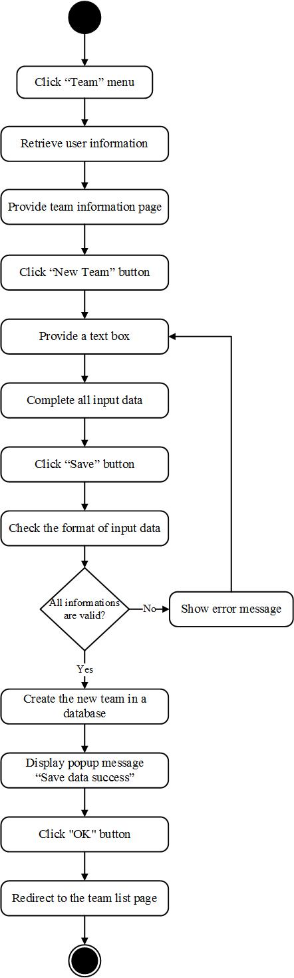

**[URS-10] Administrator and team leader can view list of team sorted by team name on web application.**

|  |  |
| --- | --- |
| **Use Case ID:** | URS-10 |
| **Use Case Name:** | Administrator and team leader can view list of team sorted by team name on web application. |
| **Short Description:** | Administrator can view a list of all teams. Team leader can view list of team which he is the team leader. The list of team is sorted by team name to show on team list page. |
| **Create By:** | Peerapong Chompootepa, Worrasete Tansurat |
| **Actors:** | Administrator and Team leader |
| **Pre-conditions:** | - There’s at least 1 team in the system.  - User has to login to the system. |
| **Post-condition** | User can view the list of team on team list page**.** |
| **Normal Flow:** | 1. User clicks “Team” menu to go to team list page.  2. The system provides team list page.  3. The system retrieves the information of the team from database.  4. The system shows the list of team on the team list page. |
| **Alternative and Exceptional:** | A.2 If user is the administrator, the system will provide list of all teams, else if user is the team member, the system will provides list of team which user is the team leader. |

**Input and Output**

|  |  |
| --- | --- |
| **Input** | User clicks “Team” menu. |
| **Output** | The system displays list of teams on the team list page. |

**[AD-10] View list of team sorted by team name on web application**

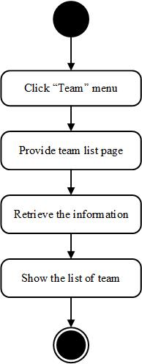

**[URS-11] Administrator and Team leader can search the team by using team name on a web application.**

|  |  |
| --- | --- |
| **Use Case ID:** | URS-11 |
| **Use Case Name:** | Administrator and Team leader can search the team by using team name on a web application. |
| **Short Description:** | Administrator and Team leader can search the team name that user need to find quickly by input the keyword in the search box. |
| **Create By:** | Peerapong Chompootepa, Worrasete Tansurat |
| **Actors:** | Administrator and Team leader |
| **Pre-conditions:** | - There is at least 1 team in the database.  - User clicks “Team” menu to go to team list page. |
| **Post-condition** | The team that searched by user will show on the team list page. |
| **Normal Flow:** | 1. The system retrieves the information of team that exist in the system from database.  2. The system displays all of team list including team Id, team name, and member on the team list page.  3. The system provides the text box for searching the team on the top right page.  4. User inputs the keyword in the text box.  5. The system checks the format of the input data.  6. The system retrieves the information of the team searched by user from database.  7. The system shows the team searched on the team list page. |
| **Alternative and Exceptional:** | E.6 If the keyword is not match with the data in database, the system will show message “No matching records found”. |

**Input and Output**

|  |  |  |  |
| --- | --- | --- | --- |
| **Input** | **Description** | **Example** | **Output** |
| Keyword | Searching by input the keyword into the textbox | “Apple001” | The system shows “Apple001” team on the screen. |

**[AD-11] Search the team by using team name on a web application**

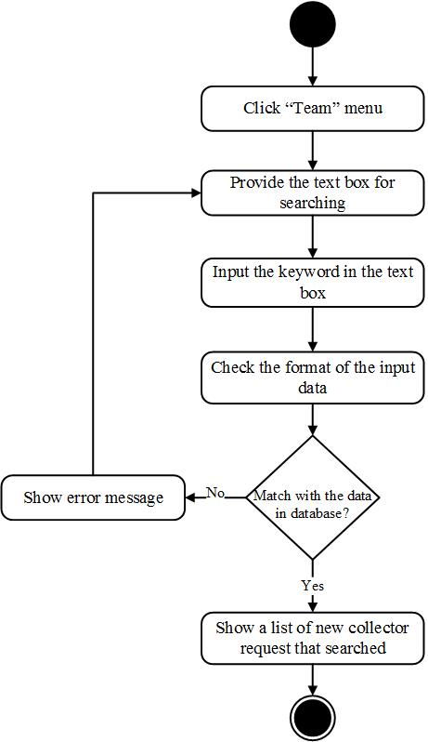

**[URS-12] Administrator and Team leader can modify the selected team information on web application.**

|  |  |
| --- | --- |
| **Use Case ID:** | URS-12 |
| **Use Case Name:** | Administrator and Team leader can modify the selected team information on web application. |
| **Short Description:** | Administrator can edit team name and change a team leader in the team by selecting from team members in the team. In addition, administrator can add and delete by selecting check boxes. Team leader can do as same as the administrator except changing a team leader. |
| **Create By:** | Peerapong Chompootepa, Worrasete Tansurat |
| **Actors:** | Administrator and Team leader |
| **Pre-conditions:** | Administrator has to create the team. |
| **Post-condition** | - The system updates team information in database.  - User clicks “Team” menu to go to team information page. |
| **Normal Flow:** | 1. The system retrieves the information of team that exist in the system from database.  2. The system displays list of team on the team list page.  <Note: 2.1 Administrator; the system displays all of team list including team Id, team name, and member with “View”, “Edit”, and “Delete” buttons on the team list page.  2.2 Team leader; the system displays list of involve team including team Id, team name, and member with “View” and “Edit buttons on the team list page.>  3. User clicks “Edit” button.  4. The system retrieves user information from the database which status type is a member in system.  5. The system provides a text box to input the team name and list of members, the check boxes for adding the collector to the team and the radio buttons for defining the team leader.  6. If user wants to edit team name,  6.1 User inputs a name in the text box.  6.2 User click “Save” button.  6.3 The system checks the format of input data.  6.4 The system updates new information of team in the database.  6.5 The system shows popup message “Save data success”  6.6 User clicks “OK” button  6.7 The system redirects to the team list page.  7. If administrator wants to change a team leader,  7.1 Administrator selects a radio button behind the row.  7.2 Administrator clicks “Save” button.  7.3 The system checks the format of input data.  7.4 The system updates new information of team in the database.  7.5 The system shows popup message “Save data success”  7.6 User clicks “OK” button  7.7 The system redirects to the team list page.  8. If user wants to add new team members,  8.1 User selects members by checking on the check boxes.  8.2 User clicks “Save” button.  8.3 The system checks the format of input data.  8.4 The system adds new members to the team in the database.  8.5 The system shows popup message “Save data success”  8.6 User clicks “OK” button  8.7 The system redirects to the team list page.  9. If user wants to remove team members,  9.1 User unchecks the check boxes.  9.2 User clicks “Save” button.  9.3 The system checks the format of input data.  9.4 The system deletes members from the team in the database.  9.5 The system redirects to the team list page. |
|  | A.6.2, A.7.2, A.8.2, A.9.2 If user click “Cancel” button, the system will redirect to the team list page.  E.6.3, E.7.3, E.8.3, E.9.3 If user leaves the text box of name blank, the system will show error message “Please input team name”, else if user does not choose any member, the system will show error message “Please select members”, else if administrator does not choose a team leader, the system will show error message “Please select the team leader”. |

**Input and Output**

|  |  |  |  |
| --- | --- | --- | --- |
| **Input** | **Description** | **Example** | **Output** |
| Edit | Can edit team name | “Team001” | The system shows “Team001”on the screen and updates new information of team in the database and also redirects to the team list page. |
| Add | Can add by selecting check box | Selects members by checking on the check boxes | The system shows “🗹” front of member that user selected to be a team member and adds new members to the team in the database and also redirects to the team list page. |
| Change Team leader | Can change a team leader in the team by selecting from team members in the team | Selects a radio button behind the row | The system shows “🞊” behind a member that user selected to be a team leader and updates new information of team in the database and also redirects to the team list page. |
| Remove team member | Can delete by selecting check box | Uncheck the check boxes | The system shows “🞏” behind a member that user selected to remove a member out of the team and updates new information of team in the database and also redirects to the team list page. |

**[AD-12] Modify the selected team information on web application**

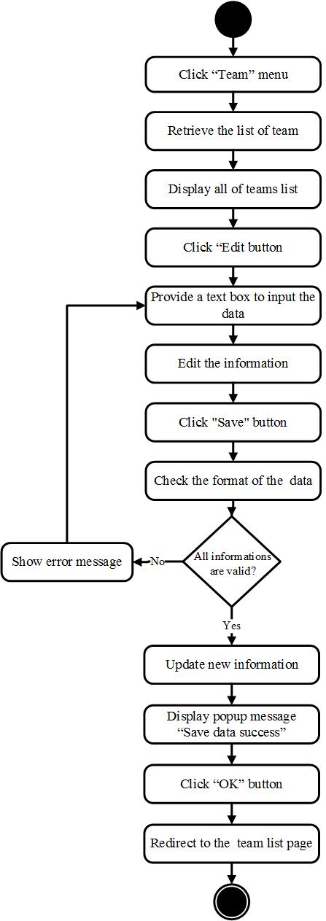

**[URS-13] Administrator and Team leader can view the selected team information includes a team name, team leader name, and list of members on web application.**

|  |  |
| --- | --- |
| **Use Case ID:** | URS-13 |
| **Use Case Name:** | Administrator and Team leader can view the selected team information includes a team name, team leader name, and list of members on web application. |
| **Short Description:** | Administrator and Team leader can view team information by clicking the team that user want to view, the information contains a team name, team leader name and list of team members. |
| **Create By:** | Peerapong Chompootepa, Worrasete Tansurat |
| **Actors:** | Administrator and Team leader |
| **Pre-conditions:** | - There’s at least 1 team in the system.  - User clicks “Team” menu to go to team list page. |
| **Post-condition** | The system shows the popup of team information including a team name, team leader name and list of team members on the team list page. |
| **Normal Flow:** | 1. The system retrieves the list of team that exist in the system from database.  2. The system displays all of teams on the team list page.  <Note: 2.1 Administrator; the system displays all of team list including team Id, team name, and member with “View”, “Edit”, and “Delete” buttons on the team list page.  2.2 Team leader; the system displays all of team list including team Id, team name, and member with “View” and “Edit buttons on the team list page.>  3. User clicks “View” button behind each team at the team list page.  4. The system retrieves the information of the team from database.  5. The system shows the popup of team information including a team name, team leader name and list of team members on the team list page. |
| **Alternative and Exceptional:** | - |

**Input and Output**

|  |  |
| --- | --- |
| **Input** | User clicks “View” button on team list page. |
| **Output** | The system shows the popup of team information including a team name, team leader name and list of team members on the team list page. |

**[AD-13] View the selected team information includes a team name, team leader name, and list of members on web application**

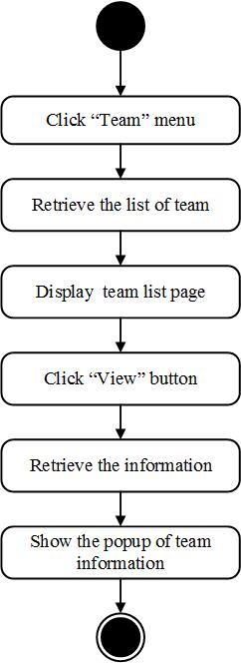

**[URS-14] Administrator can remove a team out of the system on web application.**

|  |  |
| --- | --- |
| **Use Case ID:** | URS-14 |
| **Use Case Name:** | Administrator can remove a team out of the system on web application. |
| **Short Description:** | Administrator can remove a team by clicking “Delete” button to delete the team out of the database. |
| **Create By:** | Peerapong Chompootepa, Worrasete Tansurat |
| **Actors:** | Administrator |
| **Pre-conditions:** | There’s at least 1 team in the system.  User clicks “Team” menu to go to team list page. |
| **Post-condition** | User can remove the team out of the database. |
| **Normal Flow:** | 1. The system retrieves the list of team that exist in the system from database.  2. The system displays all of team list including team Id, team name, and member with “View”, “Edit”, and “Delete” buttons on the team list page.  3. User clicks “Remove” button.  4. The system shows popup asking for confirmation “Do you want to delete?” with “OK” and “Cancel” buttons.  5. User clicks “Ok” button.  6. The system deletes the team in the database.  7. The system shows popup message “Delete Team Success”  8. User clicks “OK” button.  9. The system removes the selected team out of the team list page.  10. The system redirects to team list page. |
| **Alternative and Exceptional:** | A.8 If user chooses cancel, the system will go back to step 2. |

**Input and Output**

|  |  |
| --- | --- |
| **Input** | User clicks “Delete” button. |
| **Output** | The system removes the selected team out of team list page. |

**[AD-14] Remove a team out of the system on web application**

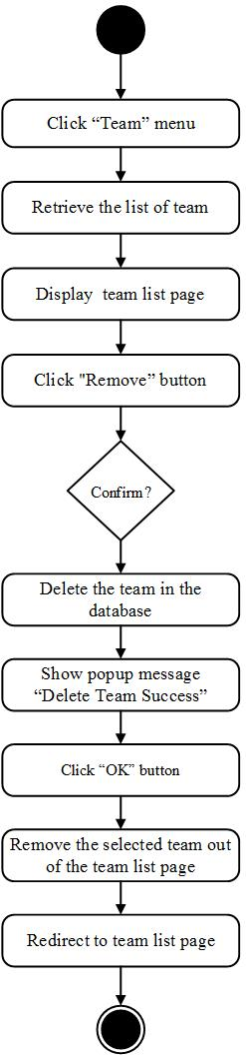

**[URS-15] Administrator, Team leader, and Collector can edit profile information which includes is name, password and telephone number on web application.**

|  |  |
| --- | --- |
| **Use Case ID:** | URS-15 |
| **Use Case Name:** | Administrator, Team leader, and Collector can edit profile information which includes is name, password and telephone number on web application. |
| **Short Description:** | Administrator, Team leader, and Collector can update the personal information up to date and manage the wrong information of his profile. |
| **Create By:** | Peerapong Chompootepa, Worrasete Tansurat |
| **Actors:** | Administrator, Team leader, and Collector |
| **Pre-conditions:** | User has to login to the system. |
| **Post-condition** | The system updates the new profile of user in the database. |
| **Normal Flow:** | 1. User clicks “Edit Profile” menu to go to edit profile page.  2. The system provides edit profile page.  3. The system retrieves the user information (i.e. name, password, and telephone) from database.  4. The system provides text boxes for updating the profile (i.e. name, password, telephone).  5. User enters new information (i.e. name, password, telephone).  6. User clicks “Save” button.  7. The system checks the format of input data.  8. The system updates the information in the database.  9. After successful update, the system will show message “Profile update successful”.  10. The system redirects to the project list page. |
| **Alternative and Exceptional:** | A.6 If user do not want to change anything in his profile user can clicks “Cancel” button to go back to project list page.  E.6 If user enters a blank value on name field, the system will show the error message will show “Please input a name”  E.6 If user enters the new password does not match the confirm password, the system will show the error messages “Password does not match with confirm password”. |

**Input and Output**

|  |  |  |  |
| --- | --- | --- | --- |
| **Input** | **Description** | **Example** | **Output** |
| Name | Input name of user. | “Peerapong Chomputepa” | The system shows “Peerapong Chomputepa” on the screen. |
| Password | Input new password. | “penchamp02” | The system shows “●●●●●●●●●●” on the screen. |
| Confirm Password | Input new password again. | “penchamp02” | The system shows “●●●●●●●●●●” on the screen. |
| Telephone number | Input new telephone number. | “0811556541” | The system shows “0811556541”on the screen. |

**[AD-15] Edit profile information which includes is name, password and telephone number on web application**

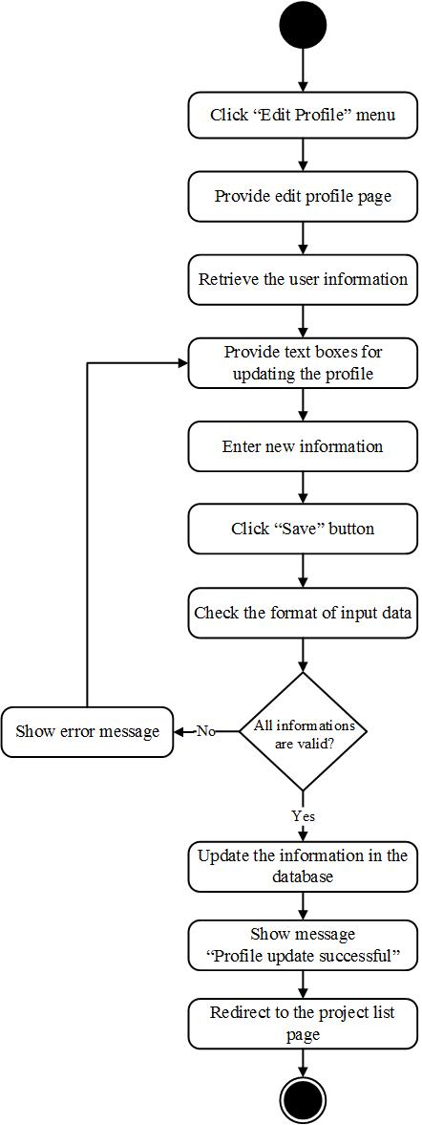

**Feature 2: Project management**

**[URS-16] Administrator can create the project includes a project name, project description, and team on web application.**

|  |  |
| --- | --- |
| **Use Case ID:** | URS-16 |
| **Use Case Name:** | Administrator can create the project includes a project name, project description, and team on web application. |
| **Short Description:** | Administrator can create the project which administrator has to input the name of project and project description. In addition, administrator has to select the team to do the project by a combo box. |
| **Create By:** | Peerapong Chompootepa, Worrasete Tansurat |
| **Actors:** | Administrator |
| **Pre-conditions:** | Administrator has to login to the system. |
| **Post-condition** | The new project will be created in the database. |
| **Normal Flow:** | 1. The system retrieves the list of project that exist in the system from database.  2. The system displays all of project list including project Id, project name, description, team name, leader name, create date on the project list page.  3. User clicks “New Project” button to go to create new project.  4. The system provides a text box to input the project name, project description and a combo box to select the team to do the project on new project page.  5. User completes the all text boxes and selects the team.  6. User clicks “Save” button.  7. The system checks the format of the input data.  8. The system creates the new project in database.  9. The system distributes the notifications to the team leader.  10. The system displays popup message “Save data success”.  11. User clicks “OK” button.  10. The system redirects to the project list page. |
| **Alternative and Exceptional:** | A.6 If the user clicks “Cancel” button, the system will redirect to the project list page.  E.7 If the user inputs project name less than 6 characters, the system will show error message “Please input project name more than 6 characters” and if user don’t select the team to do the project, the system will show error message “Please select the team” on the screen.  If user inputs the duplicate name of project existing in the system, the system will show error message “Team name is already”. |

**Input and Output**

|  |  |  |  |
| --- | --- | --- | --- |
| **Input** | **Description** | **Example** | **Output** |
| Project name | The project name should be more than 6 characters | “AngKaew1” | The system shows “AngKaew1”on the screen. |
| Project description | The project description should contain letter or number. | “ChiangMai Thailand” | The system shows “ChiangMai Thailand”on the screen. |
| Team | Selecting team is provided by drop-down button for administrator to change a team to do the project. | “TeamA” | The system shows “TeamA” on the screen. |

**[AD-16] Create the project includes a project name, project description, and team on web application**

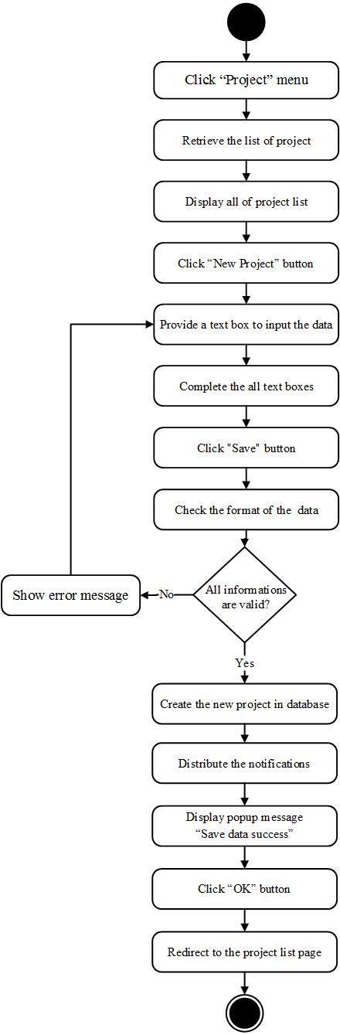

**[URS-17] Administrator can remove the project out of the system on web application.**

|  |  |
| --- | --- |
| **Use Case ID:** | URS-17 |
| **Use Case Name:** | Administrator can remove the project out of the system on web application. |
| **Short Description:** | User can remove the project out of the system on web application |
| **Create By:** | Peerapong Chompootepa, Worrasete Tansurat |
| **Actors:** | Administrator |
| **Pre-conditions:** | Administrator has to login to the system. |
| **Post-condition** | There’s at least 1 project in the database. |
| **Normal Flow:** | 1. The system retrieves the list of project that exist in the system from database.  2. The system displays all of project list including project Id, project name, description, team name, leader name, create date on the project list page.  3. User clicks “Delete” button behind the project to go to remove the project.  4. The system shows the confirmation popup “Do you want to remove the project?” with “OK” and “Cancel” buttons.  5. User clicks “OK” button.  6. The system deletes the project in the database.  7. The system shows popup message “Delete project success”  8. User clicks “OK” button.  9. The system removes the selected project out of the team list page.  10. The system redirects to the project list page. |
| **Alternative and Exceptional:** | A.6 If the user clicks “Cancel” button, the system will redirect to the project list page. |

**Input and Output**

|  |  |
| --- | --- |
| **Input** | User clicks “Delete” button. |
| **Output** | The system removes the selected project that user selected out of project list page. |

**[AD-17] Remove the project out of the system on web application**

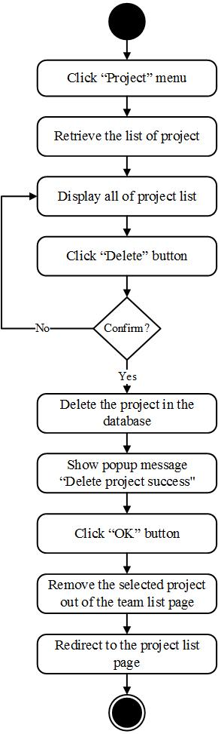

**[URS-18] Administrator can view list of all projects sorted by created date of the project on a web application**

|  |  |
| --- | --- |
| **Use Case ID:** | URS-18 |
| **Use Case Name:** | Administrator can view list of all projects sorted by created date of the project on a web application |
| **Short Description:** | Administrator can view list of project sorted by date created including project Id, project name, description, team name, leader name, and date of created on a web application. |
| **Create By:** | Peerapong Chompootepa, Worrasete Tansurat |
| **Actors:** | Administrator |
| **Pre-conditions:** | There is at least 1 project created in the database.  User has to login to the system. |
| **Post-condition:** | User can view list of all projects on a web application. |
| **Normal Flow:** | 1. The system retrieves the list of projects that exist in the system from database.  2. The system displays all of project list including project Id, project name, description, team name, leader name, create date on the project list page. |
| **Alternative and Exceptional:** | - |

**Input and Output**

|  |  |
| --- | --- |
| **Input** | User clicks “Login” button. |
| **Output** | The system displays all of project list including project Id, project name, description, team name, leader name, created date on the project list page. |

**[AD-18] View list of all projects sorted by created date of the project on a web application**

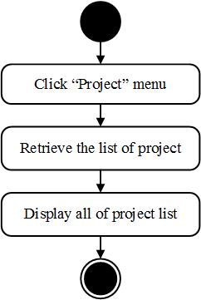

**[URS-19] Team leader and Collector can view list of the involved projects sorted by created date of the project on a web application and mobile application.**

|  |  |
| --- | --- |
| **Use Case ID:** | URS-19 |
| **Use Case Name:** | Team leader and Collector can view list of the involved projects sorted by created date of the project on a web application and mobile application. |
| **Short Description:** | Team leader can view list of project that assigned by administrator and collector can vie list of project that assigned by team leader. The project sorted by date created including project Id, project name, description, team name, leader name, and date of create on a web application and mobile application. |
| **Create By:** | Peerapong Chompootepa, Worrasete Tansurat |
| **Actors:** | Team leader and Collector |
| **Pre-conditions:** | - For team leader, at least 1 project created by administrator and for collector, at least 1 project assign by team leader.  - User has to login to the system. |
| **Post-condition:** | User can view list of project on a mobile application. |
| **Normal Flow:** | 1. The system retrieves the list of project that involved with the user from database.  2. The system displays involved project list including project Id, project name, description, team name, leader name, created date on the project list page. |
| **Alternative and Exceptional:** | - |

**Input and Output**

|  |  |
| --- | --- |
| **Input** | User clicks “Login” button. |
| **Output** | The system displays involved project list including project Id, project name, description, team name, leader name, create date on the project list page. |

**[AD-19] View list of the involved projects sorted by created date of the project on a web application and mobile application**



**[URS-20] Administrator, Team leader and Collector can search the project by using project name on web application.**

|  |  |
| --- | --- |
| **Use Case ID:** | URS-20 |
| **Use Case Name:** | Administrator, Team leader and Collector can search the project by using project name on web application. |
| **Short Description:** | Administrator, Team leader and Collector can search the project that user need to find quickly by input the keyword in the search box. |
| **Create By:** | Peerapong Chompootepa, Worrasete Tansurat |
| **Actors:** | Administrator, Team leader, and Collector |
| **Pre-conditions:** | There’s at least 1 project in the database.  User has to login to the system. |
| **Post-condition** | The searched project from database will show on the user interface. |
| **Normal Flow:** | 1. The system retrieves the list of project that exist in the system from database.  2. The system displays all of project list including project Id, project name, description, team name, leader name, created date on the project list page.  3. The system provides the text box for searching the project on the top right page.  4. User input the keyword in the text box.  5. The system checks the format of the input data.  6. The system retrieves the information of the project searched by user from database.  7. The system shows the project searched on the project list page. |
| **Alternative and Exceptional:** | E.6 If the keyword is not match with the data in database, the system will show message “No matching records found”. |

**Input and Output**

|  |  |  |  |
| --- | --- | --- | --- |
| **Input** | **Description** | **Example** | **Output** |
| Keyword | Searching by input the keyword into the textbox | “AngKaew01” | The system shows “AngKaew01” project on the screen. |

**[AD-20] Search the project by using project name on web application**

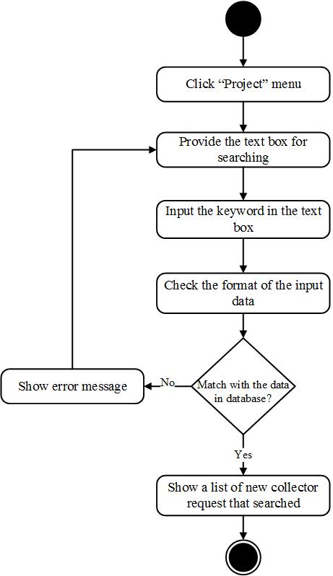

**[URS-21] Administrator can modify the project information includes editing project name, editing project description, and changing a team on web application.**

|  |  |
| --- | --- |
| **Use Case ID:** | URS-21 |
| **Use Case Name:** | Administrator can modify the project information includes editing project name, editing project description, and changing a team on web application. |
| **Short Description:** | Administrator can modify the project information includes editing project name, editing project description, and changing a team on web application. |
| **Create By:** | Peerapong Chompootepa, Worrasete Tansurat |
| **Actors:** | Administrator |
| **Pre-conditions:** | - Administrator has to create the project.  - User clicks “project” menu to go to project list page. |
| **Post-condition** | The system updates new information of project in the database. |
| **Normal Flow:** | 1. The system retrieves the list of project that exist in the system from database.  2. The system displays all of project list including project Id, project name, description, team name, leader name, created date on the project list page.  3. User clicks “Edit” button behind row of the project.  4. The system retrieves the project information from the database.  5. The system provides a text box to input the project name, project description and a combo box to select the team to do the project on new project page.  6. If user want to edit project name,  6.1 User inputs a project name in the text box.  6.2 User clicks “Save” button.  6.3 The system checks the format of input data.  6.4 The system updates new information of project in the database.  6.5 The system shows popup message “Save data success”  6.6 User clicks “OK” button  6.7 The system redirects to the project list page.  7. If user want to edit project description,  7.1 User inputs a project description in the text box.  7.2 User clicks “Save” button.  7.3 The system checks the format of input data.  7.4 The system updates new information of project in the database.  7.5 The system shows popup message “Save data success”  7.6 User clicks “OK” button  7.7 The system redirects to the project list page.  8. If user want to change the team,  8.1 User selects the team by combo box.  8.2 User clicks “Save” button.  8.3 The system checks the format of input data.  8.4 The system updates new information of project in the database.  8.5 The system shows popup message “Save data success”  8.6 User clicks “OK” button  8.7 The system redirects to the project list page. |
| **Alternative and Exceptional:** | A.6.2, A.7.2, A.8.2, If user click “Cancel” button, the system will redirect to the project list page.  E.6.3, E.7.3, E.8.3 If user leaves the text box of name blank, the system will show error message “Please input project name.”, else if user input project name less than 6 characters, the system will show error message “Please input project name more than 6 characters”, else if user does not choose the team to do the project, the system will show error message “Please select the team”. |

**[URS-21] Modify the project information on a web application**

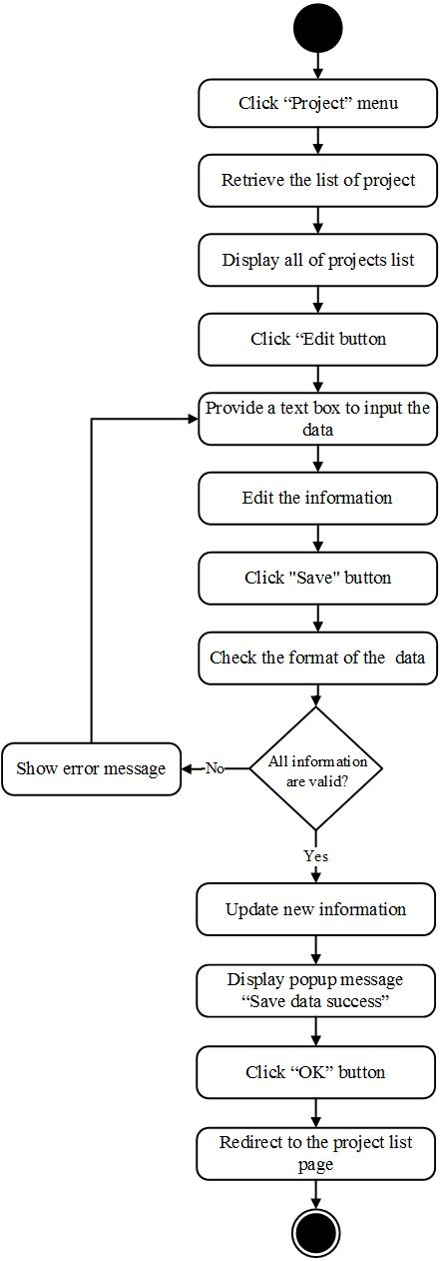

**[URS-22] Administrator can view detail of selected projects information which consisting of map with assigned pins and location information on a web application.**

|  |  |
| --- | --- |
| **Use Case ID:** | URS-22 |
| **Use Case Name:** | Administrator can view detail of selected projects information which consisting of map with assigned pins and location information on a web application. |
| **Short Description:** | Administrator can view all of project informations contain a place name, user, location, status, and update date. In addition, map is shown together with a pin above the list on a web application and mobile application. |
| **Create By:** | Peerapong Chompootepa, Worrasete Tansurat |
| **Actors:** | Administrator |
| **Pre-conditions:** | User selects a project by click “View” button on project list page. |
| **Post-condition:** | User can view a project information that user selected. |
| **Normal Flow:** | 1. The system retrieves the project information from database.  2. The system displays project information page that has a map with a pin and a list of the location information consisting of place name, collector name, latitude, longitude, status of collecting(Initial, Pending, Recollect, Finish), and date of updated. |
| **Alternative and Exceptional:** | - |

**Input and Output**

|  |  |
| --- | --- |
| **Input** | User clicks “View” button to view a project information. |
| **Output** | The system displays project information page that has a map with a pin and a list of the location information consisting of place name, collector name, latitude, longitude, status of collecting(Initial, Pending, Recollect, Finish), and date of updated. |

**[AD-22] View detail of selected projects information on a web application**

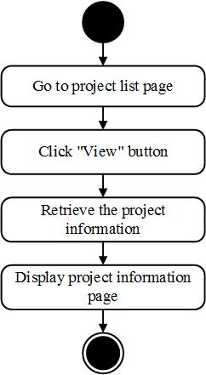

**[URS-23] Team leader and Collector can view detail of selected projects information which consisting of map with assigned pins and location information of the selected project on a web application and mobile application.**

|  |  |
| --- | --- |
| **Use Case ID:** | URS-23 |
| **Use Case Name:** | Team leader and Collector can view detail of selected projects information which consisting of map with assigned pins and location information of the selected project on a web application and mobile application. |
| **Short Description:** | Team leader can view list of all location informations of each collectors of the selected project that has to assign previously. Collector can view location information of the selected project that assigned by team leader. Project information contain a place name, collector name, latitude, longitude, status of collecting (Initial, Pending, Recollect, Finish), and date of update the project. In addition, map is shown together with a pin above the list on a web application and mobile application. |
| **Create By:** | Peerapong Chompootepa, Worrasete Tansurat |
| **Actors:** | Team leader and Colector |
| **Pre-conditions:** | User selects a project that user want to view a project information on project list page. |
| **Post-condition:** | User can view a project information that user selected on project information page. |
| **Normal Flow:** | 1. User chooses a project to view a project information on project list page.     <Note: 1.1 On a web application; Click “View” button.                 1.2 On a mobile application; Select the project.>  2. The system retrieves the project information from database.  3. The system displays project information page that has a map with a pin and a list of the location information consisting of place name, collector name, latitude, longitude, status of collecting(Initial, Pending, Recollect, Finish), and update date. |
| **Alternative and Exceptional:** | A.2 If a user selects a project that has himself as a team leader, the system will retrieve all location informations of every collectors.       If a user selects a project that has himself as a collector, the system will retrieve only location information that was assigned by team leader of the selected project |

**Input and Output**

|  |  |
| --- | --- |
| **Input** | User selects a project that user want to view a project information. |
| **Output** | The system displays a project information page. |

**[AD-23] View detail of selected projects information on a web application and mobile application**

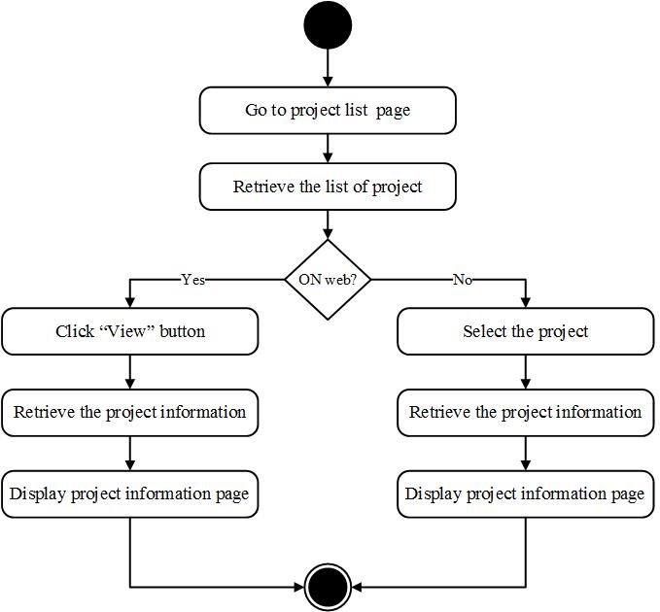

**[URS-24] Administrator can view list of water parameter of the selected member sorted by date on a web application.**

|  |  |
| --- | --- |
| **Use Case ID:** | URS-24 |
| **Use Case Name:** | Administrator can view list of water parameter of the selected member sorted by date on a web application. |
| **Short Description:** | Administrator can view history of all water parameters of all projects by selecting the member such as PH and NI consisting parameter name, predicted result, status, date and time that a member tested on a web application |
| **Create By:** | Peerapong Chompootepa, Worrasete Tansurat |
| **Actors:** | Administrator |
| **Pre-conditions:** | - There’s at least 1 water parameter collected in database  - User clicks “View” button behind the row that user want to view list of parameter on project information page. |
| **Post-condition:** | User can view list of water parameter on parameter list page. |
| **Normal Flow:** | 1. The system retrieves the list of water parameter from database.  3. The system displays list of water parameter consisting of parameter name, predicted result, status, date and time that a member tested on parameter list page. |
| **Alternative and Exceptional:** | - |

**Input and Output**

|  |  |
| --- | --- |
| **Input** | User clicks “View” button behind the row that user want to view list of water parameter on project information page. |
| **Output** | The system displays list of water parameter consisting of parameter name, predicted result, status, date and time that a member tested on parameter list page. |

**[AD-24] View list of water parameter of the selected member sorted by date on a web application**

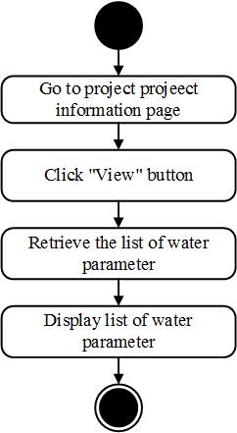

**[URS-25] Team leader and Collector can view list of water parameter of the selected member sorted by date on a web application and mobile application.**

|  |  |
| --- | --- |
| **Use Case ID:** | URS-25 |
| **Use Case Name:** | Team leader and Collector can view list of water parameter of the selected member sorted by date on a web application and mobile application. |
| **Short Description:** | Team leader and Collector view history of water parameter of all projects that he is a team leader by selecting the member such as PH and NI consisting parameter name, predicted result, status, date and time that a member tested but collector can view history of water parameter that he collected on a web application and mobile application |
| **Create By:** | Peerapong Chompootepa, Worrasete Tansurat |
| **Actors:** | Team leader and Collector |
| **Pre-conditions:** | - There’s at least 1 water parameter collected in database  - On web application; user clicks “View” button behind the row that user want to view list of water parameter on project information page.  - On mobile application; User selects the location that user want to view list of water parameter on project information page. |
| **Post-condition:** | User can view list of parameter test on parameter list page. |
| **Normal Flow:** | 1. The system retrieves the list of water parameter from database.  2. The system displays list of water parameter consisting of parameter name, predicted result, status, date and time that a member tested on parameter list page. |
| **Alternative and Exceptional:** | - |

**Input and Output**

|  |  |
| --- | --- |
| **Input** | On web application; user clicks “View” button behind the row that user want to view list of water parameter on project information page.  On mobile application; User selects the location that user want to view list of water parameter on project information page. |
| **Output** | The system displays list of water parameter consisting of parameter name, predicted result, status, date and time that a member tested on parameter list page. |

**[AD-25] View list of water parameter of the selected member sorted by date on a web application and mobile application.**

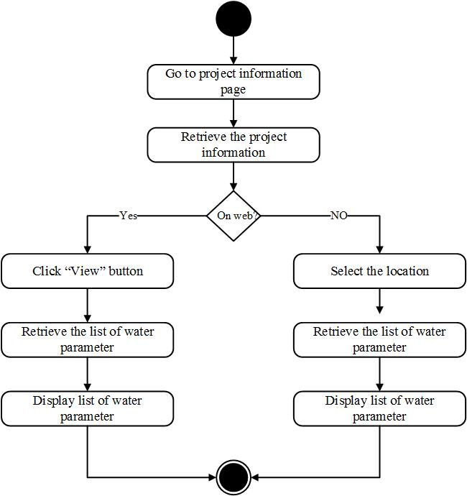

**Feature 3: Map location management**

**[URS-26] Team leader can assign work location on Google map to each collectors on web application.**

|  |  |
| --- | --- |
| **Use Case ID:** | URS-26 |
| **Use Case Name:** | Team leader can assign work location on Google map to each collectors on web application. |
| **Short Description:** | Team leader can identify the location to each collectors for monitoring the water sampling. This method is operated on the web application by the team leader of the project only. |
| **Create By:** | Peerapong Chompootepa, Worrasete Tansurat |
| **Actors:** | Team leader |
| **Pre-conditions:** | There’s at least 1 project that created by administrator in database. |
| **Post-condition** | The system updates the new assignment in the database. |
| **Normal Flow:** | 1. On project list page.  2. User clicks “Assign” button on the project that he is a team leader.  3. The system provides the assignment page contains Google maps and “+place” button on the top right page.  4. User clicks “+place” button.  5. The system provides a window on the right hand side to user consisting of a marker on Google maps, a text box for the location name and a drop down list to select the team member (Collector).  6. User enters the place name and marks the position including selects the team member (Collector) into that place.  7. User clicks “Save” button.  8. The system checks the format of input data.  8. The system adds the assignment to the team member in the database.  9. The system distributes the notifications to each collectors.  10. The system displays popup message “Save data success”.  11. User clicks “OK” button.  12. The system displays the new assignment as “Initial” status in the list below of Google maps with a new marker on Google maps. |
| **Alternative and Exceptional:** | A.6 If user clicks “Cancel” button, the system will hide the assignment window and marker disappear.  E.6 If user blank the place name, the system will display popup message “Please input place name”. |

**Input and Output**

|  |  |
| --- | --- |
| **Input** | User inputs data consisting of place name, latitude and longitude (acquire from Google maps), mark pin to location, assign work to collector (drop down list), and clicks “Save” button. |
| **Output** | The system displays the new assignment in the list below of Google maps and add a new marker on Google maps. |

**[AD-26] Assign work location on Google map to each collectors on web application**

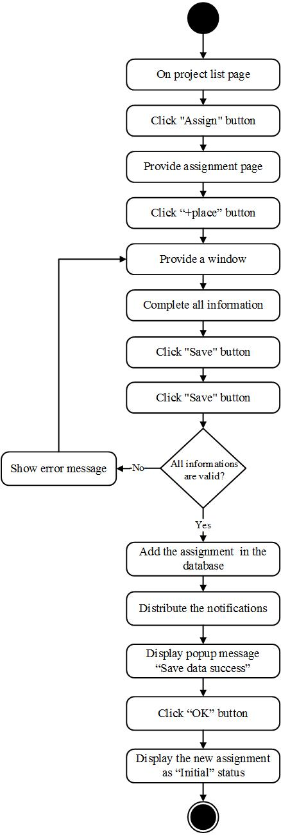

**[URS-27] Team leader and Collector can view the direction to the selected location on Google Maps on mobile application.**

|  |  |
| --- | --- |
| **Use Case ID:** | URS-27 |
| **Use Case Name:** | Team leader and Collector can view the direction to the selected location on Google Maps on mobile application. |
| **Short Description:** | User can choose to enable or disable the direction of location that collector must to go for collecting the data. |
| **Create By:** | Peerapong Chompootepa, Worrasete Tansurat |
| **Actors:** | Collector |
| **Pre-conditions:** | User selects a project that user want to view assignment on project information page. |
| **Post-condition** | The system displays shortest direction from Google maps with a map. |
| **Normal Flow:** | 1. The system provides the assignment location by using Google maps with place name, collector name, status of collecting (Initial, Pending, Recollect, Finish), latitude and longitude on project information page.  2. User clicks “ON” button on the top right page.  3. The system obtains the shortest direction from Google maps.  4. The system displays the assignment location using blue line on a Google maps. |
| **Alternative and Exceptional:** | A.2 If the user clicks “OFF” button, the system will hide the direction. |

**Input and Output**

|  |  |
| --- | --- |
| **Input** | User click “ON” button on the top right page. |
| **Output** | The system displays the assignment location using blue line on a Google maps. |

**[AD-27] View the direction to the selected location on Google Maps on mobile application**

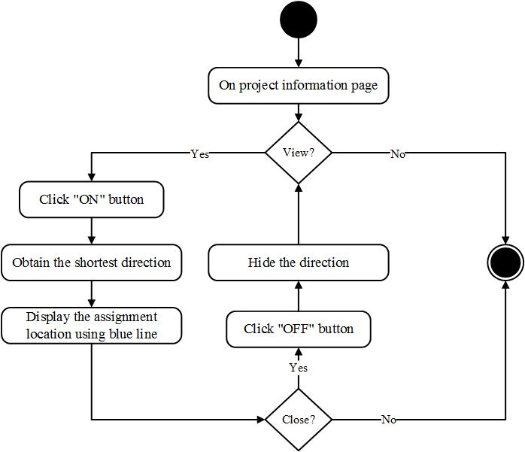

**[URS-28] Team leader and Collector can view location information of each assigned pin on selected project by pressing on the pin on mobile application.**

|  |  |
| --- | --- |
| **Use Case ID:** | URS-28 |
| **Use Case Name:** | Team leader and Collector can view location information of each assigned pin on selected project by pressing on the pin on mobile application. |
| **Short Description:** | User can view other location information of the selected project by pressing on the pin consisting of place name, name of collector, and date of assigned. |
| **Create By:** | Peerapong Chompootepa, Worrasete Tansurat |
| **Actors:** | Team leader and Collector |
| **Pre-conditions:** | User selects a project that user want to view assignment on project list page. |
| **Post-condition** | The system display information of selected pin consisting of place name, assign to, and update. |
| **Normal Flow:** | 1. The system provides the assignment location by using Google maps with place name, user, status, latitude and longitude on project information page. 2. User presses on pin that user wants to view on Google maps. 3. The system displays information of selected pin consisting of place name, collector name, and date of assigned on Google maps. |
| **Alternative and Exceptional:** | - |

**Input and Output**

|  |  |
| --- | --- |
| **Input** | User pressing on pin on Google maps. |
| **Output** | The system displays information of selected pin consisting of place name, collector name, and date of assigned on Google maps. |

**[AD-28] View location information of each assigned pin on selected project by pressing on the pin on mobile application**

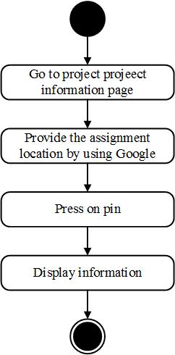

**Feature 4: Water parameter calculation**

**[URS-29] Collector can add water parameter to collect the test data on mobile application.**

|  |  |
| --- | --- |
| **Use Case ID:** | URS-29 |
| **Use Case Name:** | Collector can add water parameter to collect the test data on mobile application. |
| **Short Description:** | User can add water parameter to collect the test data on mobile application. Example: pH, Ni. |
| **Create By:** | Peerapong Chompootepa, Worrasete Tansurat |
| **Actors:** | Collector |
| **Pre-conditions:** | User selects location that user want to collect the test data on project information page. |
| **Post-condition** | The system updates the information of water parameter in database. |
| **Normal Flow:** | 1. The system retrieves the list of the water parameter consisting of parameter name, predicted result, status, date and time that a member tested from database.  2. The system displays list of water parameters on parameter list page.  3. User clicks “+” button on the top right of the parameter list page.  4. The system displays popup “Please input parameter” to input the data with “Ok” and Cancel buttons.  5. User enters the name of water parameter that user want to collect the test data.  6. User clicks “Ok” button.  7. The system checks the format of input data.  8. The system updates the information of water parameter in database.  9. The system displays new water parameter on parameter list page. |
| **Alternative and Exceptional:** | A.6 If the user clicks “Cancel” button, the system will redirect to the parameter list page.  E.7 If the user blanks the name of water parameter, the system will show error message “Please input parameter more than 1 character” |

**Input and Output**

|  |  |
| --- | --- |
| **Input** | User inputs a name of water parameter that user want to collect the test data and clicks “Ok” button. |
| **Output** | The system displays new water parameter on parameter list page. |

**[AD-29] Add water parameter to collect the test data on mobile application**

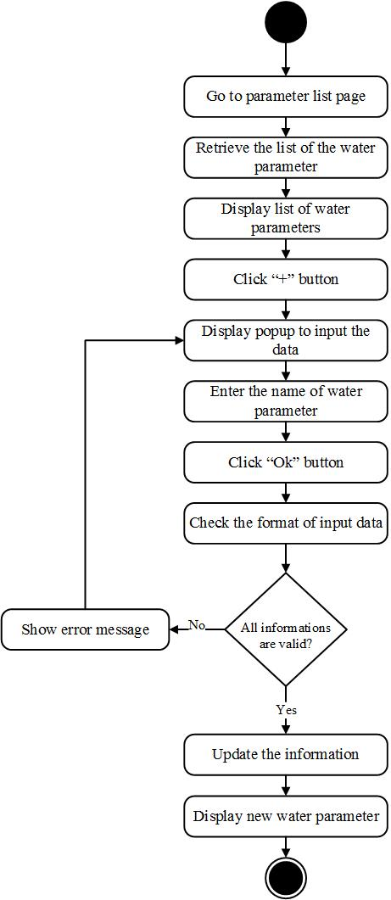

**[URS-30] Collector can delete water parameter on mobile application.**

|  |  |
| --- | --- |
| **Use Case ID:** | URS-30 |
| **Use Case Name:** | Collector can delete water parameter on mobile application. |
| **Short Description:** | User can delete water parameter to collect the test data when user input wrong name of test parameter on mobile application. |
| **Create By:** | Peerapong Chompootepa, Worrasete Tansurat |
| **Actors:** | Collector |
| **Pre-conditions:** | User add water parameter in the database. |
| **Post-condition** | The system remove water parameter out of the project. |
| **Normal Flow:** | 1. The system retrieves the information of the water parameter consisting of parameter name, predicted result, status, date and time that a member tested from database.  2. The system displays list of water parameters on parameter list page.  3. Collector clicks “X” button behind of the water parameter.  4. The system displays popup message “Do you want to delete?”  5. User click “Yes” button.  6. The system deletes selected water parameter out of database.  7. The system updates the information of the water parameter in database  8. The system displays the water parameters remaining in the system on parameter list page. |
| **Alternative and Exceptional:** | A.5 If the collector clicks “Cancel” button, the system will redirect to the parameter list page. |

**Input and Output**

|  |  |
| --- | --- |
| **Input** | Collector clicks “X” button. |
| **Output** | The system displays the test parameters remaining in the system on parameter list page. |

**[AD-30] Delete water parameter on mobile application**

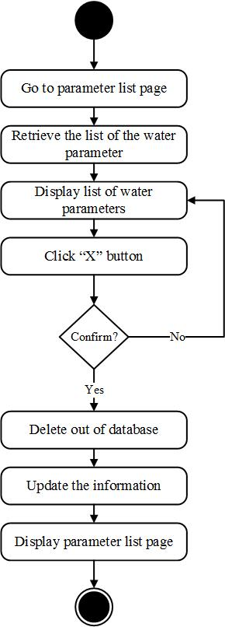

**[URS-31] Collector can choose the image from camera roll or take a new photo to collect RGB value with the test result on mobile application.**

|  |  |
| --- | --- |
| **Use Case ID:** | URS-31 |
| **Use Case Name:** | Collector can choose the image from camera roll or take a new photo to collect RGB value with the test result on mobile application. |
| **Short Description:** | Collector can choose the image from camera roll or take a new photo to collect RGB value by pressing on the image to let the system calculates the test result on mobile application. |
| **Create By:** | Peerapong Chompootepa, Worrasete Tansurat |
| **Actors:** | Administrator |
| **Pre-conditions:** | - Collector adds water parameter in the database.  - Collector selects water parameter on parameter list page. |
| **Post-condition** | The system displays the image on the interface |
| **Normal Flow:** | 1. The system provides the window to choose the image  2. User choose the image form camera roll.  2.1 User chooses icon to selects the image from camera roll.  2.2 The system provides the camera roll.  2.3 User selects the image from camera roll.  2.4 User clicks “Save” button.  2.4 The system redirects to parameter information page with the image for collecting RGB value consisting of date and time.  3. User take a new photo  3.1 User chooses icon to take a new photo.  3.2 The system provides the camera window to take a photo.  3.3 User takes a photo.  3.4 User clicks “Save” button.  3.5 The system redirects to parameter information page with the image for collecting RGB value consisting of date and time. |
| **Alternative and Exceptional:** | A.3.2 If user clicks “Discard” button, the system will redirect to step 3.2 |

**Input and Output**

|  |  |
| --- | --- |
| **Input** | - User chooses icon to selects the image from camera roll.  - User chooses icon to take a new photo. |
| **Output** | The system displays the image for collecting RGB value consisting of date and time. |

**[AD-31] Choose the image from camera roll or take a new photo to collect RGB value with the test result on mobile application**

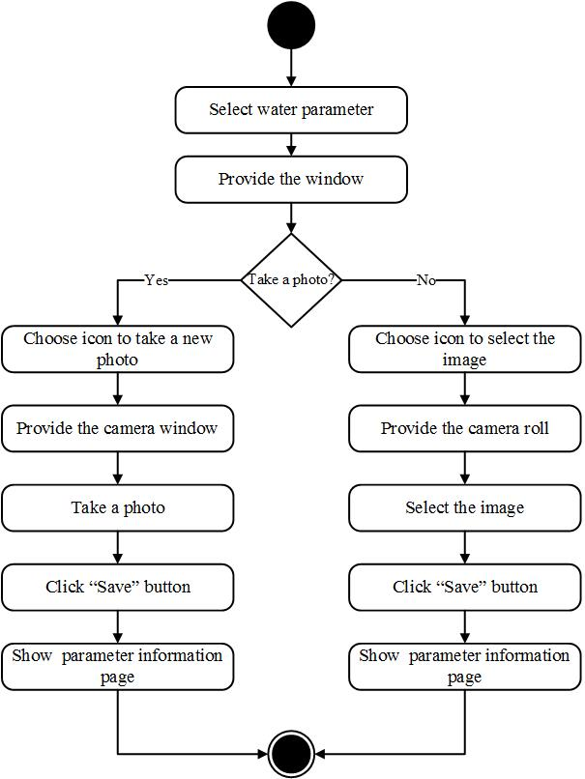

**[URS-32] Collector can input the data to let the system calculate the test result based on standard color scale on mobile application.**

|  |  |
| --- | --- |
| **Use Case ID:** | URS-32 |
| **Use Case Name:** | Collector can input data to let the system calculate the test result based on standard color scale on mobile application. |
| **Short Description:** | For calculation part, collector must input the value of standard color scale and touch on every band of standard color scale to compare with the test indicator. The application will send the data to developed component and return the test result from chemical analysis to the system on mobile application. |
| **Create By:** | Peerapong Chompootepa, Worrasete Tansurat |
| **Actors:** | Collector |
| **Pre-conditions:** | User chooses the image from camera roll or take a new photo to collect RGB value with the test result |
| **Post-condition** | The system saves the test result with the information into the database. |
| **Normal Flow:** | 1. System provides the fields to input band value and RGB text from an image.  2. User touches on the first band of standard color scale of water parameter  3. The system returns to display the RGB value of first band of standard color scale obtain from calculation component on the screen.  4. User inputs the value of the first band of standard color scale.  5. User click “+” button.  6. User completes every band of standard color scale.  7. User touches the area of testing indicator.  8. The system returns to display the RGB value of testing indicator obtain from calculation component on the screen.  9. User clicks “Mark” button.  10. The system records the RGB value of the test indicator.  11. User clicks "Calculate" button.  12. The system sends the data to calculation component  13. The system returns to display the test result of water parameter on the screen.  14. User clicks "Save" button.  15. The system saves the test result with the information into the database.  16. The system updates the status to “Pending” on the water parameter on parameter list page.  17. The system redirects to the parameter list page.  18. The system shows information of test result consisting of parameter name, predicted result, status, date and time that a member tested on parameter list page |
| **Alternative and Exceptional:** | A.14 If user click “Cancel” button, the system will redirect to parameter list page. |

**Input and Output**

|  |  |
| --- | --- |
| **Input** | Collector completes all informations and clicks “Calculation” button. |
| **Output** | The system shows information of test result consisting of parameter name, predicted result, status, date and time that a member tested on parameter list page |

**[AD-32] Input the data to let the system calculate the test result based on standard color scale on mobile application**

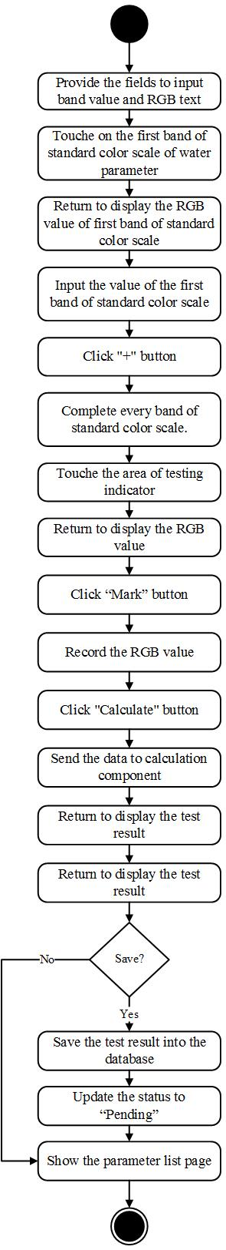

**Feature 5: Parameter result tracing**

**[URS-33] Administrator can view detail of test result of selected water parameter on a web application.**

|  |  |
| --- | --- |
| **Use Case ID:** | URS-33 |
| **Use Case Name:** | Administrator can view detail of test result of selected water parameter on a web application. |
| **Short Description:** | User can view detail of test result consisting of name of water parameter, predicted result with the RGB value, status and image with data that used to calculate the test result on web application. |
| **Create By:** | Peerapong Chompootepa, Worrasete Tansurat |
| **Actors:** | Administrator |
| **Pre-conditions:** | There’s at least 1 parameter already calculated. |
| **Post-condition** | The system displays the detail of test result of selected water parameter on parameter information page. |
| **Normal Flow:** | 1. The system provides the parameter list page.  2. User clicks “View” button behind water parameter that user want to view detail of water parameter on parameter list page.  3. The system retrieves the information of test result from database.  4. The system displays detail of test result consisting of name of parameter, predicted result with the RGB value, status and image with data that used to calculate the test result on parameter information page. |
| **Alternative and Exceptional:** | - |

**Input and Output**

|  |  |
| --- | --- |
| **Input** | User clicks “View” button behind water parameter that user want to view detail of water parameter on parameter list page |
| **Output** | The system displays detail of test result consisting of name of water parameter, predicted result with the RGB value, status and image with data that used to calculate the test result on parameter information page. |

**[AD-33] View detail of test result of selected water parameter on a web application**

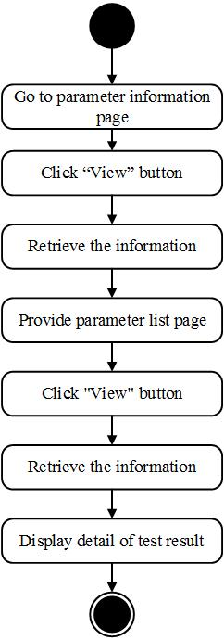

**[URS-34] Team leader and Collector can view detail of test result of selected water parameter on a web application and mobile application**

|  |  |
| --- | --- |
| **Use Case ID:** | URS-3 |
| **Use Case Name:** | Team leader and Collector can view detail of test result of selected water parameter on a web application and mobile application |
| **Short Description:** | User can view detail of test result consisting of name of water parameter, predicted result with the RGB value, status and image with data that used to calculate the test result on web application. |
| **Create By:** | Peerapong Chompootepa, Worrasete Tansurat |
| **Actors:** | Team leader and Collector |
| **Pre-conditions:** | There is at least 1 parameter already calculated. |
| **Post-condition** | The system displays the detail of test result of selected water parameter on parameter information page. |
| **Normal Flow:** | 1. The system provides the parameter list page.  <Note:  1.1 On web application; user clicks “View” button behind water parameter that user want to view detail of water parameter on parameter list page.  1.2 On mobile application; user selects water parameter that user want to view detail of water parameter test on parameter list page.>  2. The system retrieves the information of water parameter from database.  3. The system displays detail of test result.  <Note:  3.1 For team leader; The system displays detail of test result consisting of name of parameter, predicted result with the RGB value, status and image with data that used to calculate the test result and also provides “Recollect” and “Finish” buttons for review the test result on parameter information page.  3.2 For collector; The system displays detail of test result consisting of name of parameter, predicted result with the RGB value, status and image with data that used to calculate the test result on parameter information page. |
| **Alternative and Exceptional:** | - |

**Input and Output**

|  |  |
| --- | --- |
| **Input** | 1. On web application; user click “View” button behind water parameter that user want to view detail of water parameter on parameter list page.  2. On mobile application; user selects water parameter that user want to view detail of parameter test on parameter list page. |
| **Output** | The system displays detail of selected water parameter on parameter information page. |

**[AD-34] View detail of test result of selected water parameter on a web application and mobile application**

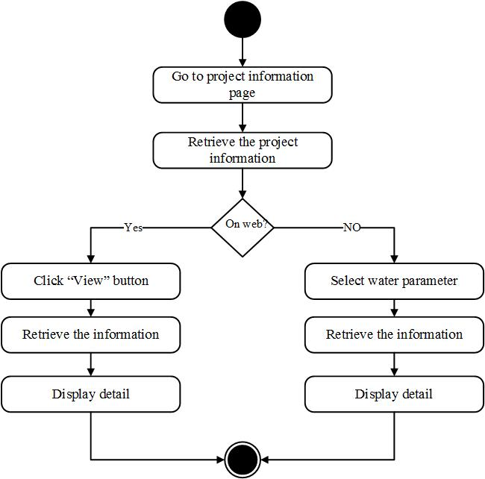

**[URS-35] Team leader can mark status of the selected water parameter to “Recollect” on a web application and mobile application.**

|  |  |
| --- | --- |
| **Use Case ID:** | URS-35 |
| **Use Case Name:** | Team leader can mark status of the selected water parameter to “Recollect” on a web application and mobile application. |
| **Short Description:** | Team leader can mark for recollecting on water parameter on a mobile application when team leader disagree to the test result and want collector to test again. |
| **Create By:** | Peerapong Chompootepa, Worrasete Tansurat |
| **Actors:** | Team leader |
| **Pre-conditions:** | User selects water parameter that user want to view. |
| **Post-condition:** | The system changes the status to “Recollect” on the screen. |
| **Normal Flow:** | 1. The system provides parameter information page.  2. User clicks “Recollect” button on parameter information page.  3. The system updates new status of water parameter to be recollect in the database.  4. The system distributes the notifications to the collector.  5. The system displays status “Recollect” on selected water parameter on parameter list page. |
| **Alternative and Exceptional:** | A.2 If user does not want to mark for recollecting, user clicks “Cancel” button, the system redirects to parameter list page. |

**Input and Output**

|  |  |
| --- | --- |
| **Input** | User clicks “Recollect” button on parameter information page. |
| **Output** | The system displays status “Recollect” on selected water parameter on parameter list page. |

**[AD-35] Mark status of the selected water parameter to “Recollect” on a web application and mobile application**

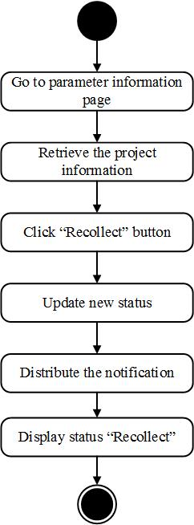

**[URS-36] Team leader can mark status of the selected water parameter to “Finish” on a web application and mobile application.**

|  |  |
| --- | --- |
| **Use Case ID:** | URS-36 |
| **Use Case Name:** | Team leader can mark status of the selected water parameter to “Finish” on a web application and mobile application. |
| **Short Description:** | Team leader can mark to finish on parameter test on a mobile application when team leader agree with the test result. |
| **Create By:** | Peerapong Chompootepa, Worrasete Tansurat |
| **Actors:** | Team leader |
| **Pre-conditions:** | User selects water parameter that user want to view. |
| **Post-condition** | The system changes the status to “Finish” on the screen. |
| **Normal Flow:** | 1. The system provides parameter information page.  2. User clicks “Finish” button on parameter information page.  3. The system updates new status of water parameter to be finish in the database.  4. The system displays status “Finish” on selected water parameter on parameter list page. |
| **Alternative and Exceptional:** | A.2 If user does not want to mark for finishing, clicks “Cancel” button, the system redirect to parameter list page. |

**Input and Output**

|  |  |
| --- | --- |
| **Input** | User clicks “Finish” button on parameter information page. |
| **Output** | The system displays status “Finish” on selected water parameter on parameter list page. |

**[AD-36] Mark status of the selected water parameter to “Finish” on a web application and mobile application**

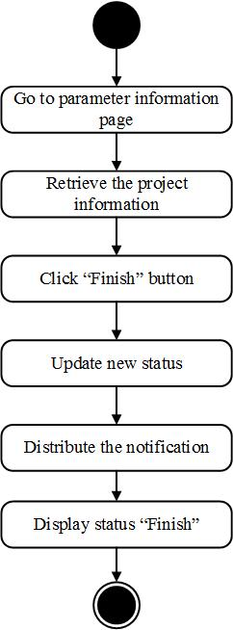

**Feature 6: Messaging system**

**[URS-37] Team leader and Collector can send the message to each other via group message within the team on a mobile application.**

|  |  |
| --- | --- |
| **Use Case ID:** | URS-37 |
| **Use Case Name:** | Team leader and Collector can send the message to each other via group message within the team. |
| **Short Description:** | Team leader and Collector can send or receive the message to each other via group message within the team. |
| **Create By:** | Peerapong Chompootepa, Worrasete Tansurat |
| **Actors:** | Team leader and Collector |
| **Pre-conditions:** | There is at least 1 project on project list. |
| **Post-condition** | User can send and receive the message from each other. |
| **Normal Flow:** | 1. User clicks “Teams” menu on the top left of the page.  2. The system displays team list page.  3. User selects the team that user wants to conversation.  4. The system retrieves the information of the message.  5. The system displays team id, team name, team member, and position of member.  4. The system displays all of the old message with date and time on the screen.  5. User enters the message for conversation.  6. User clicks “Send” button.  8. The system displays the message in the group of project. |
| **Alternative and Exceptional:** | - |

**Input and Output**

|  |  |
| --- | --- |
| **Input** | User enters the message for conversation and clicks “Send” button. |
| **Output** | The system displays the message in the group of project. |

**[AD-37] Send the message to each other via group message within the team on a mobile application**

